Table 2 Scope of the synthesis of aryl-benzoquinone derivatives (ABQ).
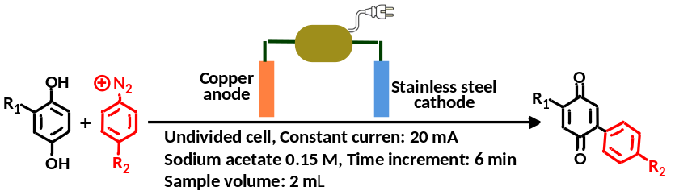
Entry | Starting compounds | Electrolysis time.(min) | Product |  | Name | Yield%
1 | R₁ = -H  R₂ = -NO₂ | 70 | 4'-Nitro-[1,1'-biphenyl]-2,5-dione | 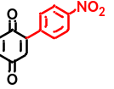 | ABQ1 | 71.3
2 | R₁ = -H  R₂ = -H | 70 | [1,1'-biphenyl]-2,5-dione | 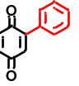 | ABQ2 | 70.4
3 | R₁ = -H  R₂ = -OCH₃ | 130 | 4'-Methoxy-[1,1'-biphenyl]-2,5-dione | 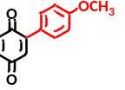 | ABQ3 | 86.4
4 | R₁ = -H  R₂ = -Cl | 70 | 4'-Chloro-[1,1'-biphenyl]-2,5-dione | 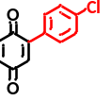 | ABQ4 | 51.3
5 | R₁ = -H  R₂ = -Br | 70 | 4'-Bromo-[1,1'-biphenyl]-2,5-dione | 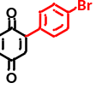 | ABQ5 | 39.1
6 | R₁ = -H  R₂ = -I | 70 | 4'-Iodo-[1,1'-biphenyl]-2,5-dione | 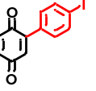 | ABQ6 | 80.4
7 | R₁ = -H  R₂ = -F | 70 | 4'-Fluoro-[1,1'-biphenyl]-2,5-dione | 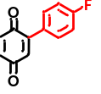 | ABQ7 | 72.8
8 | R₁ = -CH₃  R₂ = -NO₂ | 70 | 4-Methyl (and 3-methyl) -4'-nitro-[1,1'-biphenyl]-2,5-dione  isomers ratio%: 58.9/41.1ª | 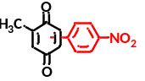 | ABQ8 | 66.7
9 | R₁ = -CH₃  R₂ = -Cl | 70 | 4'-Chloro-4-methyl (and 3-methyl) -[1,1'-biphenyl]-2,5-dione  isomers ratio%: 50.4/49.6 | 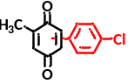 | ABQ9 | 43.3
10 | R₁ = -CH₃  R₂ = -Br | 130 | 4'-Bromo-4-methyl (and 3-methyl) -[1,1'-biphenyl]-2,5-dione  isomers ratio%: 50.4/49.6 | 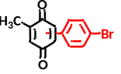 | ABQ10 | 38.4
11 | R₁ = -CH₃  R₂ = -I | 70 | 4'-Iodo-4-methyl (and 3-methyl) -[1,1'-biphenyl]-2,5-dione  isomers ratio%: 49.8/50.2 | 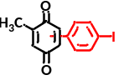 | ABQ11 | 62.3
ªThe ratio of the isomers was calculated from ¹H NMR spectrum using the signals intensity of methyl group.

