Table 1. Self-reported data of the participants from the pre-and post-game surveys.
 | Virtual P-Game  Hungary (n=29, this study) | Face-to-face P-Game  Hungary (n=30) | Face-to-face P-Game  Globally (n=788)
Background of the participants
Educational  background | 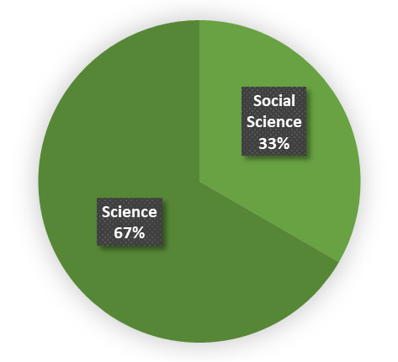 | 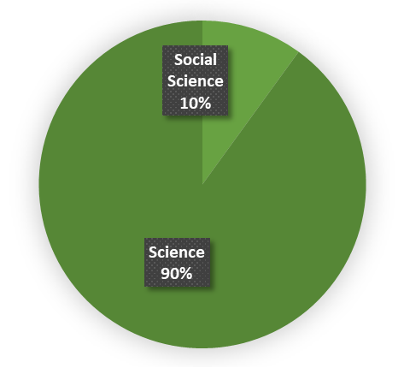 | 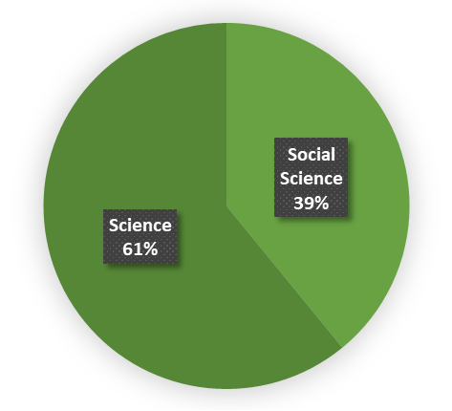
Level of education | 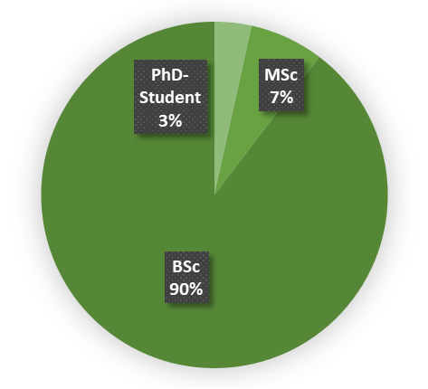 | 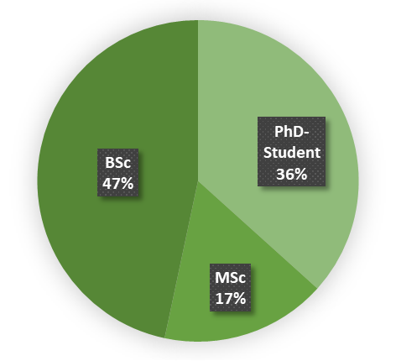 | 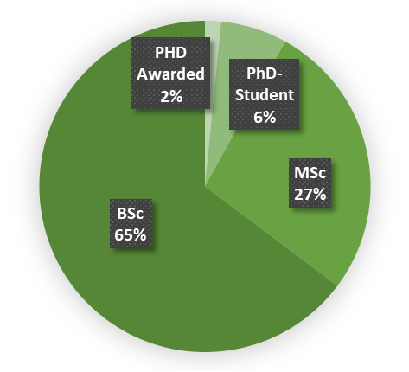
Gender | 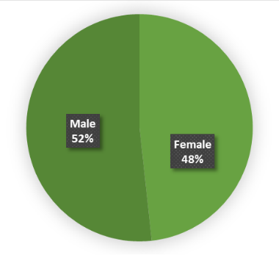 | 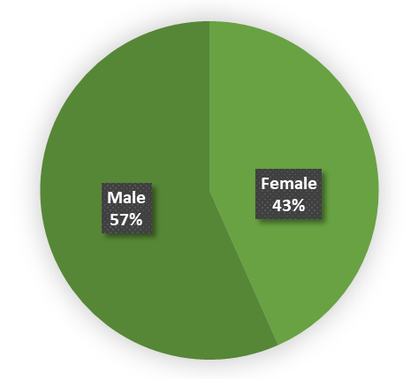 | 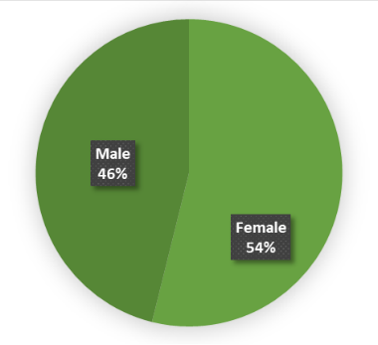
Age | 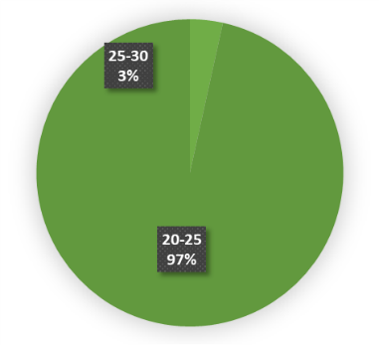 | 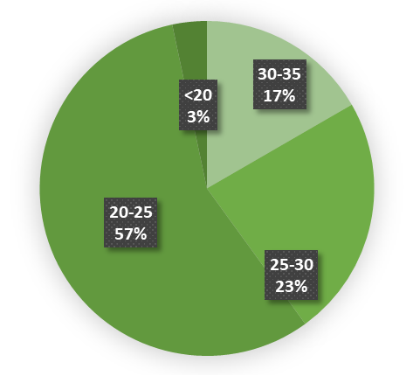 | 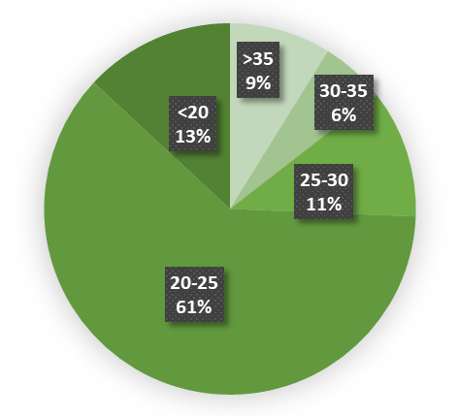
Self-reported knowledge on phosphorus science
Pre-Game | 1.72±1.36 | 1.50±0.86 | 1.56±0.98
Post-Game | 3.24±1.61 | 2.56±0.94 | 3.00±1.04
%Change¹ | +88.4±82.5 % | +70.7±48.1 % | +92.3±66.2 %
Hedges’ G | 1.02 | 1.16 | 1.43
Self-reported knowledge on negotiation science/practice
Pre-Game | 2.34±1.39 | 1.97±1.07 | 1.83±1.03
Post-Game | 3.64±1.38 | 3.03±0.96 | 3.12±1.02
%Change¹ | +55.6±39.1 % | +53.81±33.83 % | +70.5±45.9 %
Hedges’ G | 0.94 | 1.04 | 1.26
The SD of the % Change was calculated applying the principles of uncertainty propagation [33].

