Supplementary information for
Quantum light sources with configurable lifetime leveraging parity-time symmetry
Nuo Chen,^{1,9} Wen-Xiu Li,^{2,3,9} Yun-Ru Fan,^{2,3,*} Hang-Hang Li,¹ Hong Zeng,^{2,3} Wu-Qiang Chi,¹
Heng Zhou,⁴ Hao Li,⁵ Li-Xing You,⁵ Guang-Can Guo,^{2,3,6,7} Qiang Zhou,^{2,3,6,7, †} Jing Xu,^{1,8, ‡}
and Xin-Liang Zhang^{1,8,§}
¹School of Optical and Electronic Information & Wuhan National Laboratory for Optoelectronics,
Huazhong University of Science and Technology, Wuhan 430074, China
²Institute of Fundamental and Frontier Sciences, University of Electronic Science and Technology of China,
Chengdu 611731, China
³Key Laboratory of Quantum Physics and Photonic Quantum Information, Ministry of Education,
University of Electronic Science and Technology of China, Chengdu 611731, China
⁴Key Lab of Optical Fiber Sensing and Communication Networks, School of Information and Communication Engineering, University of Electronic Science and Technology of China, Chengdu 611731, China
⁵National Key Laboratory of Materials for Integrated Circuits,
Shanghai Institute of Microsystem and Information Technology, Chinese Academy of Sciences, Shanghai 200050, China
⁶Center for Quantum Internet, Tianfu Jiangxi Laboratory, Chengdu 641419, China
⁷CAS Key Laboratory of Quantum Information, University of Science and Technology of China, Hefei 230026, China
⁸Optics Valley Laboratory, Hubei 430074, China
⁹These authors contributed equally: Nuo Chen, Wen-Xiu Li
*Corresponding author: Yun-Ru Fan (yunrufan@uestc.edu.cn)
†Corresponding author: Qiang Zhou (zhouqiang@uestc.edu.cn)
‡Corresponding author: Jing Xu (jing_xu@hust.edu.cn)
§Corresponding author: Xin-Liang Zhang (xlzhang@hust.edu.cn)

Content
S1: System analysis methods 3
S2: Spectra characterizations 7
S3: Critical coupling condition of pump resonance 10
S4: Experimental details and extraction of photon lifetime 13
S5: Device design 15
Reference: 18

S1: System analysis methods
We use temporal coupled mode theory (TCMT) to analyze the synthetic supermodes of signal (idler as the same) resonance, while the total transmission spectrum of the system is simulated using the transfer matrix method (TMM) since the TCMT can only perform one single resonance. The parameters used in the two models are noted in Fig. S1.
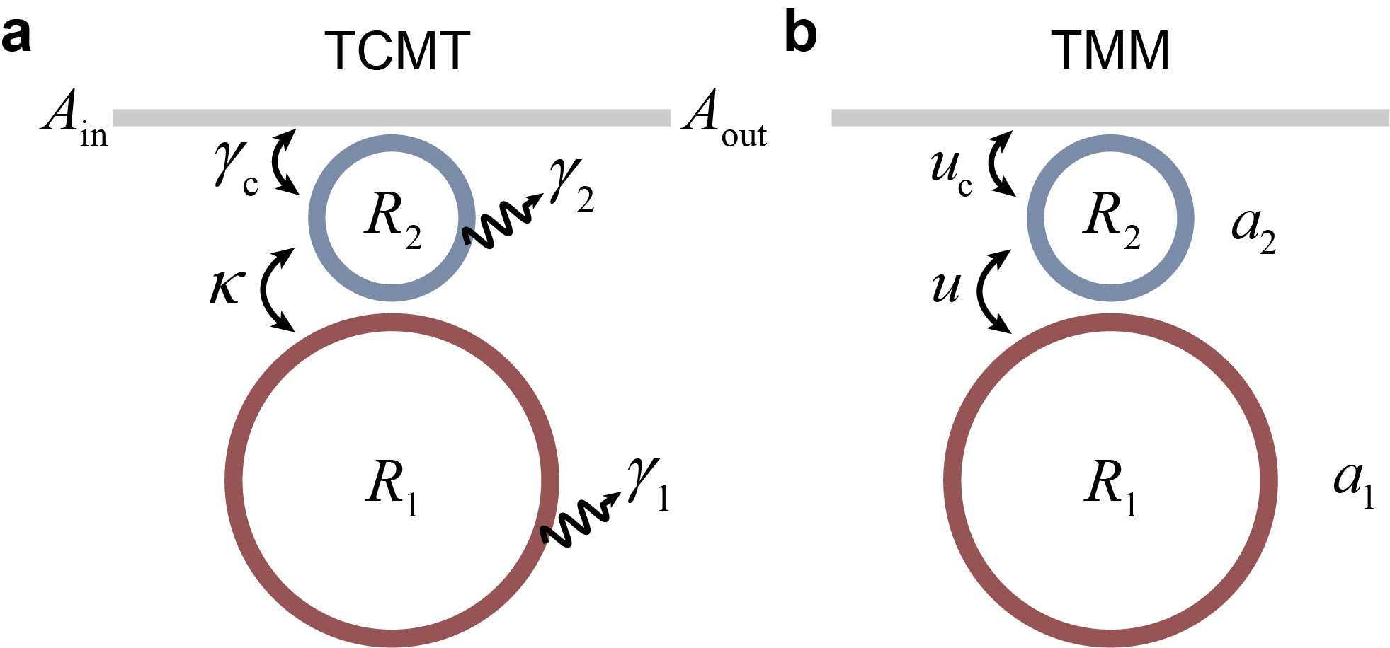
Fig. S1. Notations of TCMT and TMM parameters.
According to TCMT, the coupled mode equations can be written as [1,2]
$$\left\{\begin{aligned}\frac{dA_{1}}{dt}=-iω_{1}A_{1}-\frac{γ_{1}}{2}A_{1}-iκA_{2} \\ \frac{dA_{2}}{dt}=-iω_{2}A_{2}-\frac{γ_{2}+γ_{c}}{2}A_{2}-iκA_{1}-\sqrt{γ_{c}}A_{in} \\ A_{out}=A_{in}+\sqrt{γ_{c}}A_{2}\end{aligned}\right.$$
(S1)
where $A_{1}$ and $A_{2}$ are the intracavity mode fields of the main ring and auxiliary ring, $ω_{1}$, $ω_{2}$ are the corresponding resonant frequencies, respectively. $A_{in}$ and $A_{out}$ are the input and output fields in the bus waveguide, respectively. According to Eq. (S1), the modal vector $A={\left(\begin{matrix}A_{1} & A_{2}\end{matrix}\right)}^{T}$ obeys ${idA}/{dt}=\hat{H}A-i\sqrt{γ_{c}}{\left(\begin{matrix}0 & A_{in}\end{matrix}\right)}^{T}$, where the non-Hermitian Hamiltonian $\hat{H}$ is expressed as the Eq. (1) in the main text [1,2]:
$$\hat{H}=\left[\begin{matrix}ω_{1}-i\frac{γ_{1}}{2} & κ \\ κ & ω_{2}-i\frac{γ_{2}+γ_{c}}{2}\end{matrix}\right]$$
(S2)
The coupled supermodes of the PT-symmetric system can be characterized by the complex eigenfrequencies of the Hamiltonian [1,2]:
$$ω_{±}=\left[\frac{1}{2}(ω_{1}+δω)-\frac{i}{4}\left(γ_{2}+γ_{c}+γ_{1}\right)\right]±\frac{1}{4}\sqrt{16κ^{2}-{\left(γ_{2}+γ_{c}-γ_{1}\right)}^{2}}$$
(S3)
where we substitute $δω=ω_{2}-ω_{1}$, the detuning between the two rings. The exceptional point (EP) of the system is at the degenerate point $κ={\left|γ_{2}+γ_{c}-γ_{1}\right|}/4$ when $δω=0$ (the two rings are aligned). In our design, since the ring-waveguide coupling decay rate $γ_{c}$ is far larger than the intrinsic losses of the rings, i.e., $γ_{c}≫γ_{1}≈γ_{2}$, the EP is approximated as $κ={γ_{c}}/4$.
Equation (S1) can be transformed into the following by substituting $A_{k}=A_{k}e^{-iωt}$:
$$\left\{\begin{aligned}\frac{dA_{1}}{dt}=-iΔ_{1}A_{1}-\frac{γ_{1}}{2}A_{1}-iκA_{2} \\ \frac{dA_{2}}{dt}=-iΔ_{2}A_{2}-\frac{γ_{2}+γ_{c}}{2}A_{2}-iκA_{1}-\sqrt{γ_{c}}A_{in} \\ A_{out}=A_{in}+\sqrt{γ_{c}}A_{2}\end{aligned}\right.$$
(S4)
where $Δ_{k}=ω-ω_{k}{}_{}$
is the frequency detuning between the resonance frequencies $ω_{k}$ ($k=1, 2$) and the frequency of the input light $ω$.
Consider the steady state, i.e., $dA_{k}/dt=0$, the transmission spectrum can be derived as [1,2]:
$$T_{TCMT}={\left|\frac{A_{out}}{A_{in}}\right|}^{2}={\left|1+\frac{2γ_{c}\left(iΔ_{1}-γ_{1}\right)}{{4κ}^{2}+\left({2iΔ}_{1}-γ_{1}\right)\left({2iΔ}_{2}-γ_{2}-γ_{c}\right)}\right|}^{2}$$
(S5)
and the intracavity intensity enhancement (IE) of the main ring (photon DOS in the main text) can be also derived as [1,2]:
$${IE}_{TCMT}={\left|\frac{A_{1}}{A_{in}}\right|}^{2}={{FSR}_{1}\left|\frac{4iκ\sqrt{γ_{c}}}{{4κ}^{2}+\left({2iΔ}_{1}-γ_{1}\right)\left({2iΔ}_{2}-γ_{2}-γ_{c}\right)}\right|}^{2}$$
(S6)
where ${FSR}_{1}$ is the free spectral range of the main ring. We will later use Eq. (S5) to fit the transmission spectrum to determine the system parameters.
Although the TCMT gives a clear physical picture of the PT-symmetric system, it involves some approximations and fails to fit multiple resonances. The TMM is thus applied to analyze the complete system response. Since the TMM is a widely used analysis method for microresonators [1], here, we directly present the transmission equation and intracavity IE of the main ring:
$$T_{TMM}={\left|\frac{r_{c}-a_{2}χe^{{iφ}_{2}}}{1-r_{c}a_{2}χe^{{iφ}_{2}}}\right|}^{2}$$
(S7)
$${IE}_{TMM}={\left|\frac{-iua_{1}e^{{iφ}_{1}}}{1-ra_{1}e^{{iφ}_{1}}}∙\frac{-iu_{c}\sqrt{a_{2}}e^{i\frac{φ_{2}}{2}}}{1-r_{c}a_{2}χe^{{iφ}_{2}}}\right|}^{2}$$
(S8)
where $a_{1}$, $a_{2}$ are the roundtrip field attenuation factors of the main ring and the auxiliary ring, respectively. $u_{c}$, $u$ are the coupling coefficients between the bus waveguide and the auxiliary ring, and between the two rings, respectively. $r_{c}$ and $r$ are the corresponding transmission coefficients at the coupling regions, satisfying $u_{c}^{2}+r_{c}^{2}=1$ and $u^{2}+r^{2}=1$ under lossless coupling approximation. $φ_{1}$, $φ_{2}$ are the phase shifts of input light traveling per roundtrip in the main ring and the auxiliary ring, respectively. $χ$ is the transmission of the main ring in the subsystem composed of the main ring and the coupling waveguide of the auxiliary ring in the ring-ring coupling region [1]:
$$χ=\frac{r-a_{1}e^{{iφ}_{1}}}{1-ra_{1}e^{{iφ}_{1}}}$$
(S9)
Equations (S7) and (S8) will be used to fit the complete system response in S2: Spectra characterizations.

We list the parameters conversion relationship of two methods below:
Table. S1. Parameters’ conversion relationship between TCMT and TMM
TCMT |  | TMM |  | Relationship
Intrinsic loss of the main ring | $$γ_{1}$$ | Roundtrip field attenuation of the main ring | $$a_{1}$$ | $$γ_{1}=-\frac{2lna_{1}}{t_{1}}$$
Intrinsic loss of the auxiliary ring | $$γ_{2}$$ | Roundtrip field attenuation of the auxiliary ring | $$a_{2}$$ | $$γ_{2}=-\frac{2lna_{2}}{t_{2}}$$
Coupling decay rate between auxiliary ring and bus-waveguide | $$γ_{c}$$ | Coupling coefficient between the auxiliary ring and bus waveguide | $$u_{c}$$ | $$γ_{c}=-\frac{2lnr_{c}}{t_{2}}$$
Coupling rate between the two rings | $$κ$$ | Coupling coefficient between the two rings | $$u$$ | $$κ=\frac{u}{\sqrt{t_{1}t_{2}}}$$
In table S1, $t_{i}$ is the roundtrip time of the ring, $i=1,2$.

S2: Spectra characterizations
The experimental setup of the spectral test of the device is sketched below.
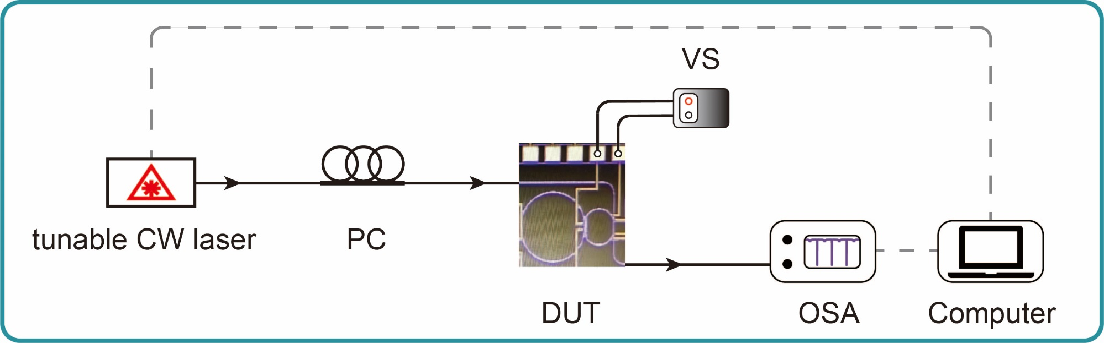
Fig. S2. Experimental setup of spectral test. A tunable CW laser is scanned from 1520 nm to 1580 nm to characterize the device’s transmission spectrum. The dashed grey lines are the electronic feedback and control signal path. PC: polarization controller, DUT: device under test, VS: voltage source, OSA: optical spectrum analyzer.
A tunable continuous wave (CW) laser with an output power of -15 dBm is scanned from 1520 nm to 1580 nm. The spectra of misaligned (0 V) and aligned (6.6 V) cases are given in Fig. S3. The fiber-to-chip coupling loss is estimated to be 4 dB per facet.
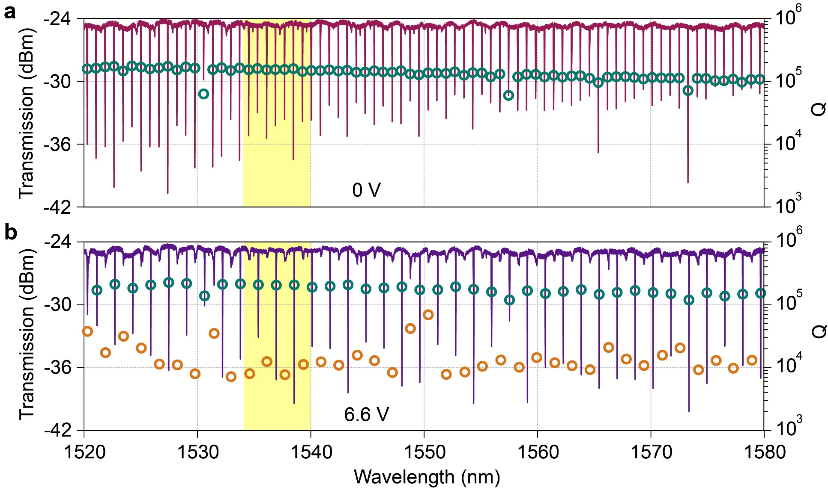
Fig. S3. Spectra of the device from 1520 nm to 1580 nm under 0 V and 6.6 V. a Transmission spectrum of the device under 0 V bias (left axis). b Transmission spectrum of the device under 6.6 V bias (left axis). The highlighted yellow regions ranging from 1534 nm to 1540 nm are the zoomed-in figures (Fig. 2) in the main text. The green circles in a and b are marks of the high Q-factors of the main ring (right axis). The orange circles in b are the merged low Q-factors (right axis). The resonances exhibit a high-Q-low-Q distribution over a large range when the two rings are aligned.
We fitted the transmission spectra of the system using TMM in the range of 1534 nm to 1540 nm, as shown in Fig. S4a (0 V) and S4b (6.6 V). The corresponding simulated intracavity IEs in the main ring are given in Fig. S4c and S4d.
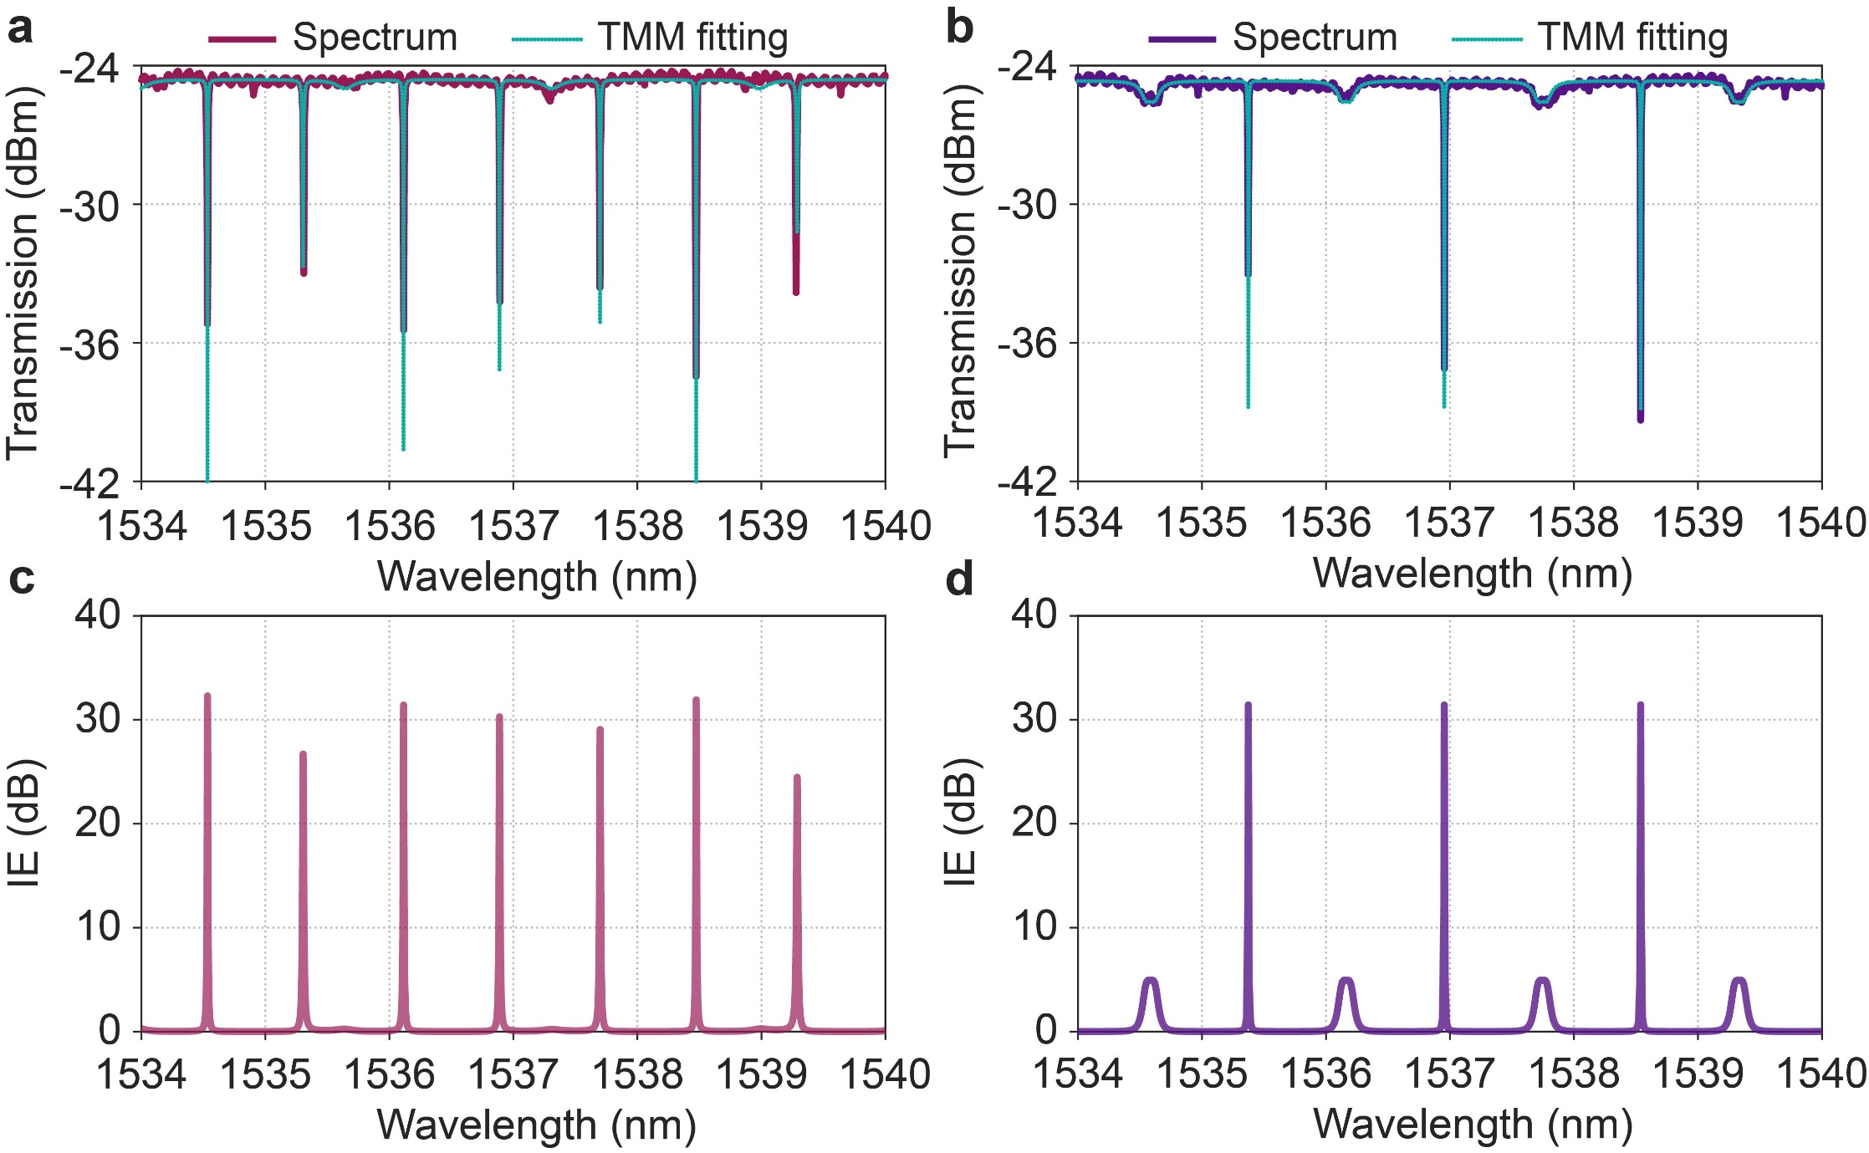
Fig. S4. Spectra fittings. a Transmission spectrum and TMM fitting under 0 V bias. b Transmission spectrum and TMM fitting under 6.6 V bias. c Simulated intracavity IE of the main ring under 0 V bias. d Simulated intracavity IE of the main ring under 6.6 V bias.
The rings are designed with the radii of $R_{1}=228 nm$ and $R_{2}=114 nm$, respectively. The TMM parameters are extracted from the spectra fittings: $a_{1}=0.985$, $a_{2}=0.993$, $u_{c}=0.73$, $u=0.32$. The waveguide loss is determined to be 0.45 dB/cm. The waveguide effective index is $n_{0}=2.085$. The effective thermal tuning module is capable of tuning the resonance with an intensity of 58 pm/V (about 0.385 nm from 0 V bias to 6.6 V bias, near half of the FSR of the main ring).
According to the parameter relationships in Table. S1, the PT-symmetrically coupled resonance (e.g., signal resonance centered at 1534.6 nm) is also analyzed using TCMT. Figure S5 plots a comparison between TCMT (Eq. (S5)) and TMM (Eq. (S7)) fittings at the signal resonance, showing good consistency between the two methods. The TCMT parameters are: $γ_{1}=γ_{2}=3.0 GHz$, $γ_{c}=146.8 GHz$, $κ=45.5 GHz$ (given in the main text). The theoretical predicted EP is at $κ_{EP}=38.2 GHz$, while the actual ring-ring coupling strength is $κ=45.5 GHz$, indicating that the system is operated in the PT-symmetric regime (exhibits a slight mode splitting) and close to the EP.
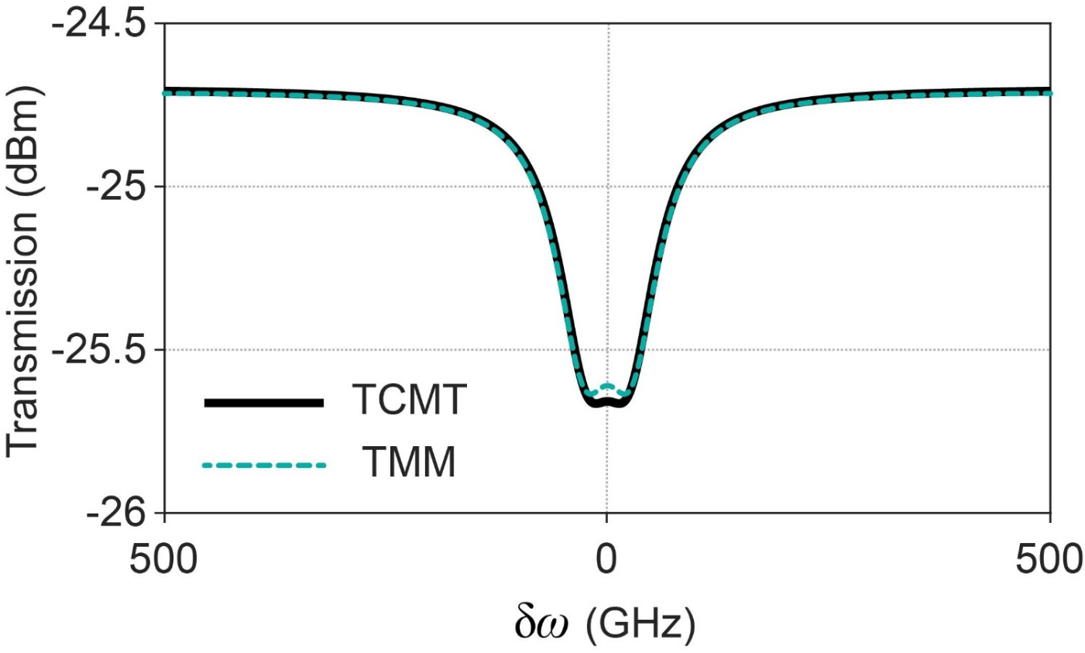
Fig. S5. Comparison of TCMT and TMM. Zoomed in spectral fitting lines of the signal resonance (centered at 1534.6 nm) using TCMT and TMM, which show good consistency. The x-axis is converted into an angular frequency axis.

S3: Critical coupling condition of pump resonance
In case of that the two rings are aligned, the pump resonance centered at 1536.9 nm is regarded as critically coupled, featuring a relatively high extinction ratio (ER) and a high Q factor. This is counter-intuitive since the coupling coefficient between the ring system and the bus waveguide is very large. In the TCMT model, the pump resonance can be regarded as operating in the deep PT-symmetrically broken regime [1]. Here, for simplicity, we equivalently transform the dual-ring system into a single ring to analyze the effective coupling coefficient of the critically coupled pump resonance.
Using TMM, the main ring can be equivalent to coupling with a bus waveguide directly, with an equivalent coupling coefficient $u_{c}^{'}$, as denoted in Fig. S6.
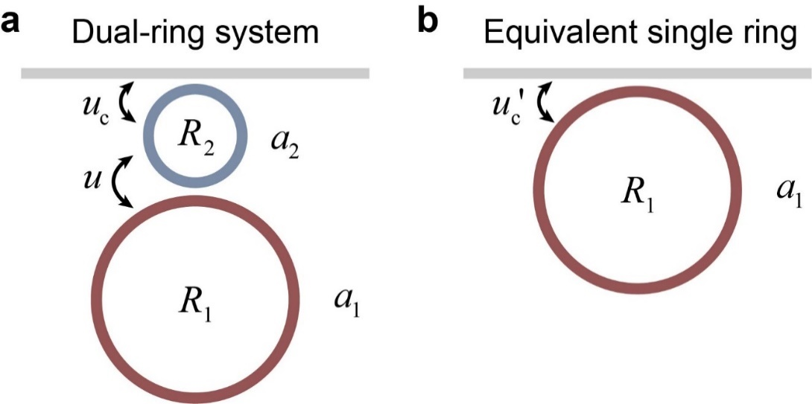
Fig. S6. Notations of TMM and equivalent single-ring system at the pump resonance. a TMM model of the dual-ring system. b equivalent single ring. The main ring is coupled to the bus waveguide with an equivalent coupling coefficient $u_{c}^{'}$.
The transmission of the equivalent single ring can be derived as
$$T_{single-ring}={\left|\frac{r_{c}^{'}-a_{1}e^{{iφ}_{1}}}{1-r_{c}^{'}a_{1}e^{{iφ}_{1}}}\right|}^{2}$$
(S10)
where $r_{c}^{'}$ is the equivalent transmission coefficient at the coupling region and satisfies $u_{c}^{'2}+r_{c}^{'2}=1$ under lossless coupling approximation. Comparing Eq. (S9) and here Eq. (S10), the $r_{c}^{'}$ should be found to analyze critical coupling conditions. Combining Eq. (S7) and Eq. (S9), it can be deduced that
$$T_{TMM}={\left|\frac{\frac{r_{c}-a_{2}re^{{iφ}_{2}}}{r_{c}r-a_{2}e^{{iφ}_{2}}}-a_{1}e^{{iφ}_{1}}}{\frac{1-r_{c}a_{2}re^{{iφ}_{2}}}{r_{c}r-a_{2}e^{{iφ}_{2}}}-\frac{r_{c}a_{2}e^{{iφ}_{2}}-r}{a_{2}e^{{iφ}_{2}}-r_{c}r}a_{1}e^{{iφ}_{1}}}\right|}^{2}$$
(S11)
At the pump resonance, the auxiliary ring is at the anti-resonant point with a phase shift $φ_{2}=π$, so that the roundtrip phase accumulation is $\exp\left(iφ_{2}\right)=-1$. Meanwhile, the coupling strength between the ring system is much larger than the intrinsic loss of the auxiliary ring, thus the intrinsic loss of the auxiliary ring can be safely ignored, yielding $a_{2}=1$. Including all the conditions, Eq. (S11) is simplified as
$$T_{TMM}={\left|\frac{\frac{r_{c}+r}{r_{c}r+1}-a_{1}e^{{iφ}_{1}}}{1-\frac{r_{c}+r}{r_{c}r+1}a_{1}e^{{iφ}_{1}}}\right|}^{2}$$
(S12)
Comparing Eq. (S10) and Eq. (S12), the equivalent transmission coefficient can be obtained
$$r_{c}^{'}=\frac{r_{c}+r}{r_{c}r+1}$$
(S13)
Using Eq. (S13), with the fitted coefficients $u_{c}=0.73$ and $u=0.32$, we can determine the equivalent coupling coefficient between the main ring and the bus waveguide at the pump resonance: $u_{c}^{'}=0.142$. Figure S7 gives a comparison of the transmission of the dual-ring system (Eq. (S7)) and that of the equivalent single-ring system (Eq. (S10) with equivalent transmission coefficient in Eq. (S13)). A good consistency shows the reasonable critical coupling ($u_{critical-couping}=0.17$, a high-Q factor resonance with an infinite ER), and thus the equivalent single-ring method can be applied to delicately design the device.
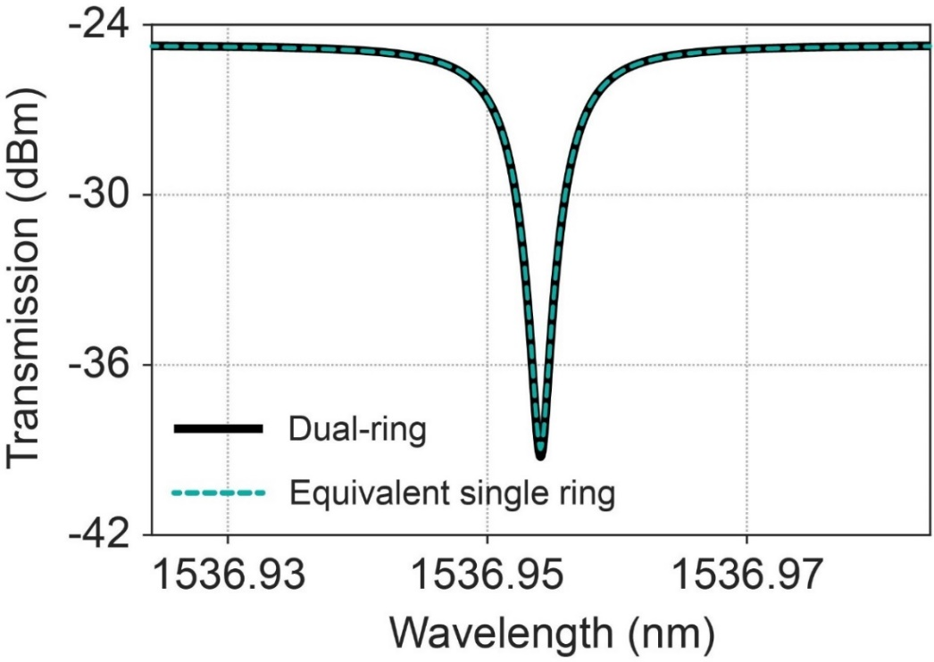
Fig. S7. Comparison of dual-ring transmission spectrum using TMM and equivalent single-ring system at the pump resonance.

S4: Experimental details and extraction of photon lifetimes
Figure S8 documents the insertion losses at each node in the test system during the coincidence counts experiment (after the EDFA).
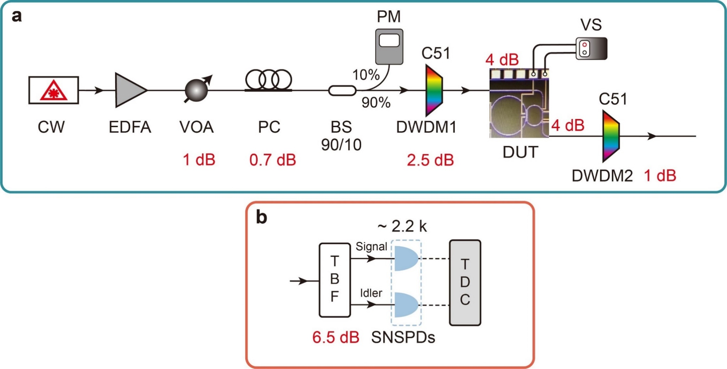
Fig. S8. System insertion losses in the coincidence counts experiment. The highlighted red notes in a the photon-pairs generation links and b the detection links represent the insertion losses of the experimental devices or the coupling losses between the fiber and the chip.
In the main text, the coincidence counts vs. pump power is given. Here, Fig. S9 records the raw single side counts of the signal and idler channels under different applied voltages.
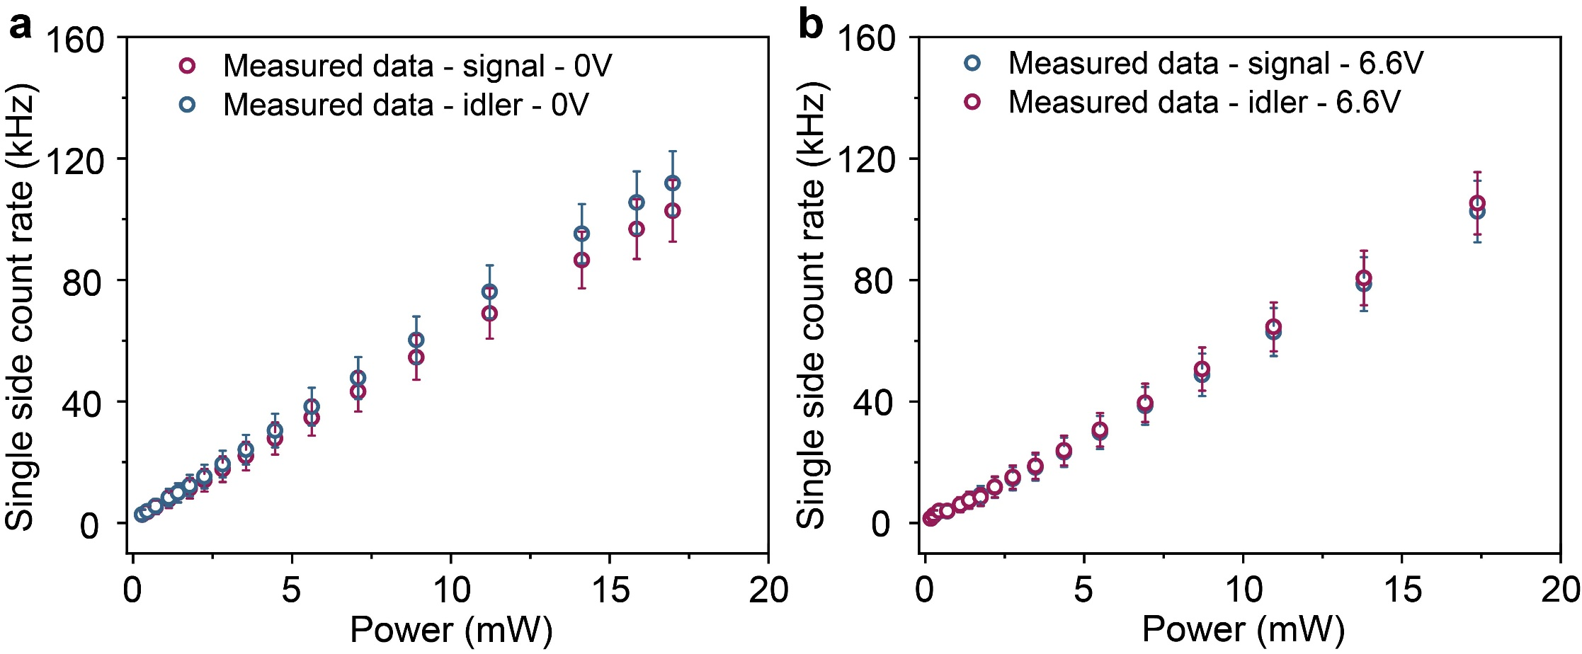
Fig. S9. Single side photon count rates of 0 and 6.6 V.
Next, the time jitters of test channels are measured using the autocorrelation counting experiment [3]. The setup is given in Fig. S10.
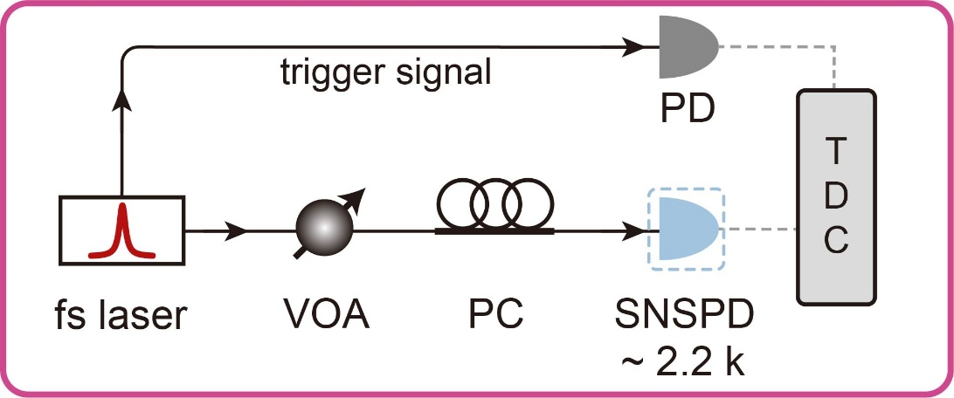
Fig. S10. Experimental setup for time jitter test.
The combined time jitters of the superconducting nanowire single-photon detector (SNSPD) and the time-to-digital converter (TDC) are determined. A femtosecond pulsed laser (fs laser, PFL-200M, Alnair Labs) with a generated pulse width of 570 fs and a repetition rate of 40 MHz is used as the seed light. The femtosecond pulses are depleted by a variable optical attenuator (VOA) to the single photon light level. The single photon light is then passed to a polarization controller (PC) and sent to the SNSPD. The TDC recorded the coincidence events between the SNSPD and the trigger signal that comes from the laser detected by a photodiode (PD). The coincidence counts (CCs) of channel 1 (signal channel in the main text) and channel 2 (idler channel in the main text) are given in Fig. S11.
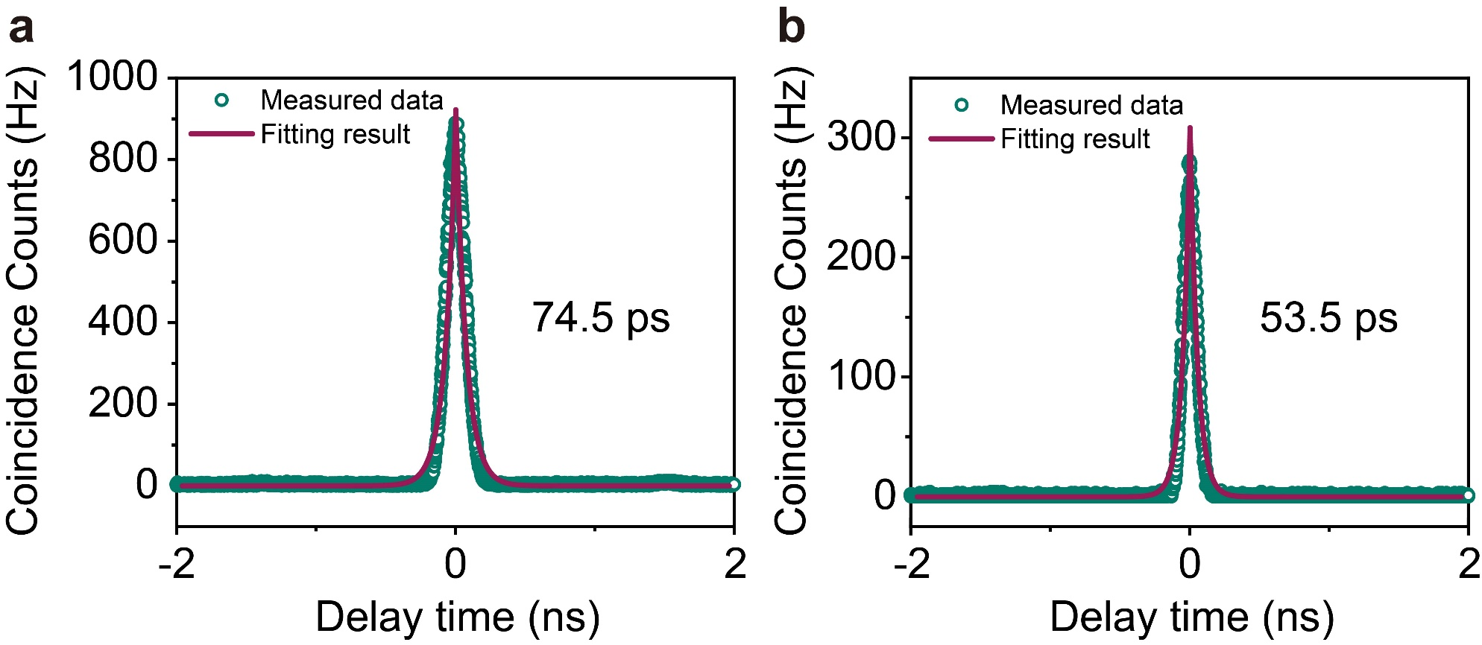
Fig. S11. Measured results of time jitters. a Time jitter of channel 1 (signal channel). b Time jitter of channel 2 (idler channel).
By double exceptional fittings, the time jitters of the two channels are extracted, $J_{channel 1}=74.5 ps$ and $J_{channel 2}=53.5 ps$, respectively. According to Eq. (5) in the main text, the actual photon lifetimes are thus calculated by excluding the jitters of test devices.

S5: Device design
Our design offers a method to delicately adjust the photon lifetime on an integrated platform. According to theoretical analysis, the adjustable range of the photon lifetime is determined by the ratio of ring-waveguide coupling strength to the intrinsic loss of the main ring: $γ_{c}/2γ_{1}$. By reducing the waveguide losses and enhancing the intrinsic Q factor of the microring, we can achieve a wider adjustable range of photon lifetime. Meanwhile, the higher the intrinsic Q factor of the microring, the greater the photon-pairs generation rate (PGR) yields.
In the experiment, the measured waveguide loss is 0.45 dB/cm, corresponding to an intrinsic decay rate of $γ_{1}=3.0 GHz$. Using TMM, with the intrinsic decay rate determined, we can scan the two coupling coefficients to confirm the adjustable range of photon lifetime. Figure S12a shows the achievable photon lifetime tuning contrast ratio (i.e., $γ_{c}/2γ_{1}$) of our system for intrinsic losses of 0.45 dB/cm. Together with TMCT, the EPs in the parameter space are plotted by yellow lines. Our device is working near the EP, as marked by the red star. The grey area is the mode-splitting region (regarded as two separate resonances) and is not considered. For comparison, a 0.1 dB/cm loss of waveguide is also simulated in Fig. S12b (corresponding to $γ_{1}=0.67 GHz$, with an intrinsic Q of about $1.8×{10}^{6}$), showing a larger tuning contrast ratio upper to 80-fold.
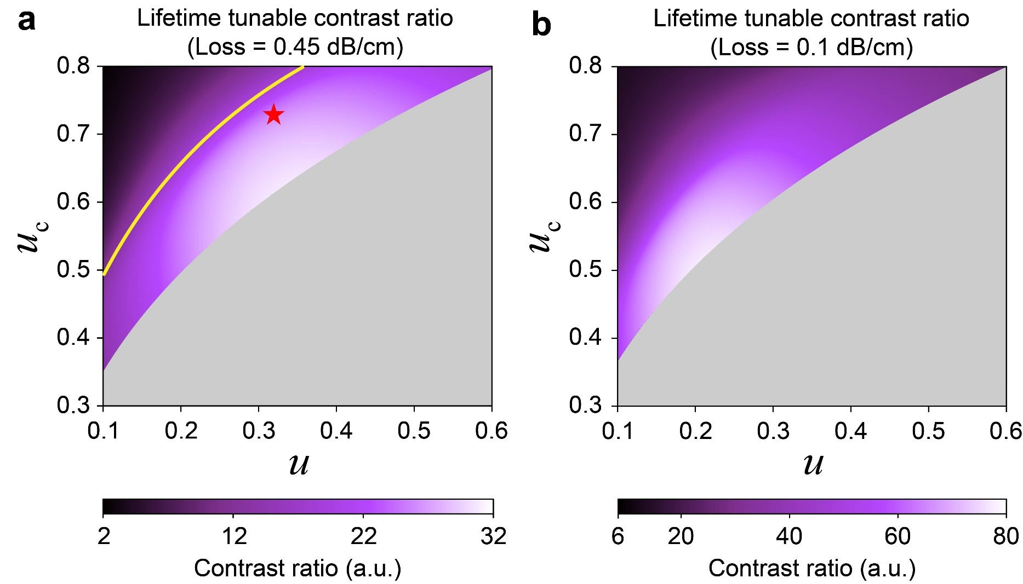
Fig. S12. Scan of photon lifetime tunable contrast ratio $γ_{c}/2γ_{1}$. a Parameters’ scan under the condition of waveguide loss = 0.45 dB/cm. The yellow line is the EPs in the parameter space. Our device is operated at the red star. b Parameters’ scan under the condition of waveguide loss = 0.1 dB/cm.
Moreover, the photon lifetime of the signal resonance when the two rings are aligned is also performed with respect to the system parameters in FIG. S13. Increasing the two coupling strengths can shorten the photon lifetime.
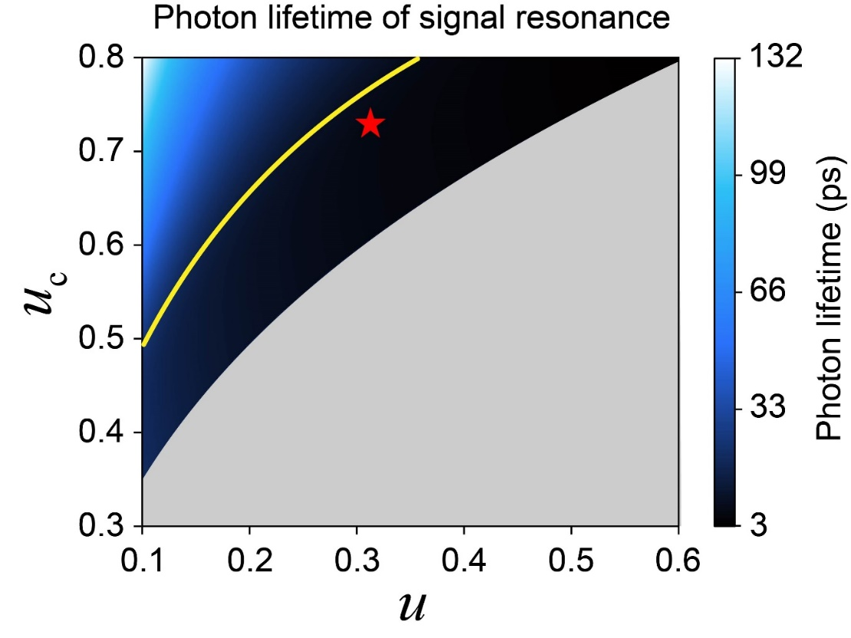
Fig. S13. Scan of photon lifetime of signal resonance. Photon lifetime scan with respect to two coupling coefficients. The yellow line is the EPs in the parameter space. Our device is operated at the red star (6.5 ps).
Last, the critical coupling condition of the pump resonance is shown in Fig. S14. The extinction ratio (ER) of pump resonance is scanned. The white-yellow region represents critical coupling. Our device is operated at the cyan star (ER = 16 dB).
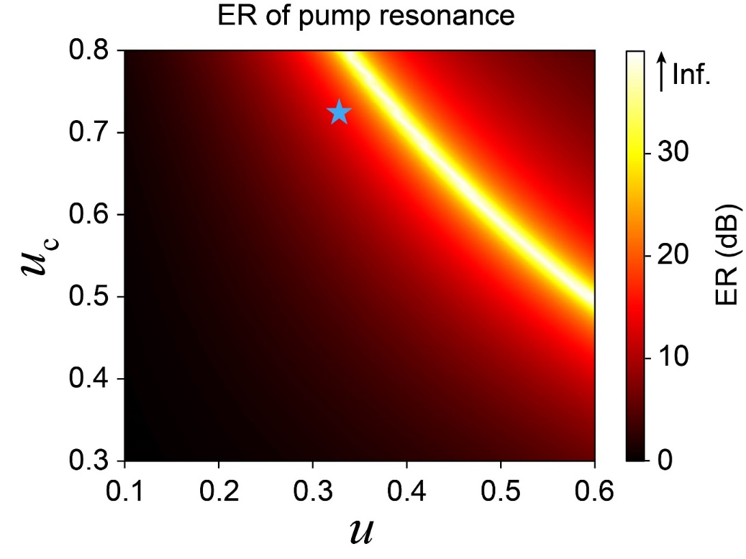
Fig. S14. Scan of extinction ratio of pump resonance. Our device is operated at the cyan star. The color bar is truncated at 40 dB since the ER approaches infinity (Inf.) in the ideal case.
Based on the analysis in this section, it is crucial that the design of the device includes a thorough evaluation of the photon lifetime adjustment range, the operating parameters, and the coupling conditions of the pump resonance. In conclusion, choosing the right device parameters requires a balanced approach tailored to the specific application scenario in order to determine the optimal operating point.

Reference:
- Kim, C. et al. Parity-time symmetry enabled ultra-efficient nonlinear optical signal processing. eLight 4, 6 (2024).
- Peng, B. et al. Parity–time-symmetric whispering-gallery microcavities. Nature Phys. 10, 394–398 (2014).
- Joshi, C. et al. Picosecond-resolution single-photon time lens for temporal mode quantum processing. Optica 9, 364 (2022).

