Table 1 Specifications of PM2.5, PM10, VOCs, CO₂, temperature and humidity sensors used in the BIAB setup
 | Sensors
Specification | PM2.5 & PM10 | VOCs | CO₂ | Temperature & Humidity
Brand | Renke | Taqu | Renke | Renke
Model | RS-PM-*-2 | T29-PICRST15 | RS-CO2*-*-2 | RS-WS-N01-8
Reference | https://www.renkeer.com/product/pm-sensor/ | https://taqu.coowor.com/ | https://www.renkeer.com/product/co2-sensor/ | https://www.renkeer.com/product/modbus-rtu-temperature-sensor/
Power Supply | 10-30V DC | 10-30V DC | 10-30V DC | 10-30V DC
Range | 0-1000ug/m³ | 0~2000 CO₂-ppm-equivalent | 0 ~ 5000 ppm | Humidity: 0%RH~ 80%RH
Temperature:
-40℃~+60℃,
Resolution | 1ug/m³ | Not specified | 1ppm | Humidity:  0.1%RH
Temperature:
0.1℃
Accuracy | ±3%FS (@100μg/m3,25℃, 50%RH) | ± 100, CO₂-ppm-eq | ± (50ppm+ 3%FS) @ (25℃,400~5000ppm) | Humidity:  ±3%RH (60%RH,25℃)
Temperature:
±0.5℃ (25℃)
Response time | ≤90s | Not specified | 2s | Humidity:  ≤8s(1m/s wind speed )
Temperature:
≤25s(1m/s wind speed )
Output signal | RS485/0-5v/0-10v/4-20mA | RS485 | RS485/0-5V/0-10V/4-20mA | RS485

Table 3 Experimental setup of each filtration case
Case | Setup | Type of Filtration | Targeted Pollutant
1 | 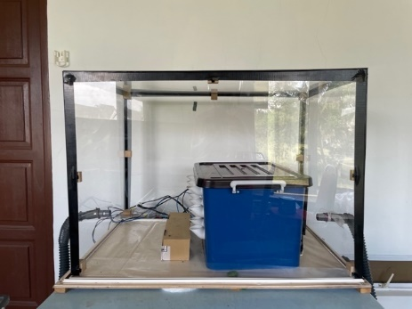 | No filter | Baseline Case
2 | 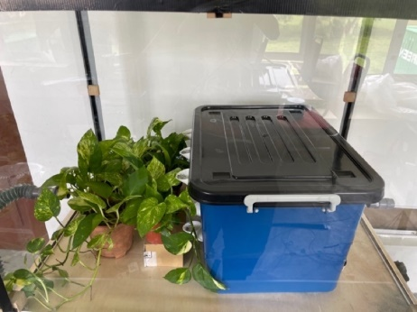 | Botanical Plant (Golden Pothos) | Volatile Organic Compounds (VOCs)
3 | 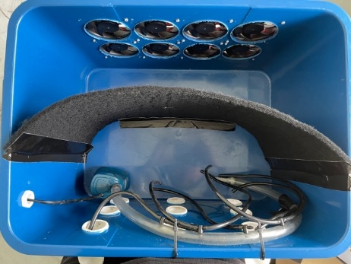 | - Botanical Plant (Golden Pothos)  - Primary Carbon Filter | - Volatile Organic Compounds (VOCs)  - Particulate Matter (PM 2.5 and 10)
4 | 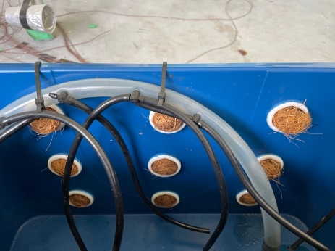 | - Botanical Plant (Golden Pothos)  - Primary Carbon Filter  - Coconut Husk | - Volatile Organic Compounds (VOCs)  - Particulate Matter (PM 2.5 and 10)  - Particulate Matter (PM 2.5 and 10)
5 | 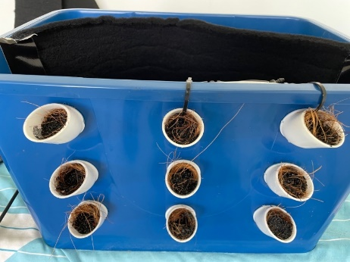 | - Botanical Plant (Golden Pothos)  - Primary Carbon Filter  - Coconut Husk  - Granular Activated Carbon | - Volatile Organic Compounds (VOCs)  - Particulate Matter (PM 2.5 and 10)  - Particulate Matter (PM 2.5 and 10)  - Volatile Organic Compounds (VOCs)

