Additional file 1

Table S1; Numbers of OTUs, phylotypes and high quality sequences in equine GI samples (n=265) from EGS (n=31), CTRL (n=54) and CoG (n=48) horses.

 |  | n | OTUs | Phylotypes | Sequences
CTRL | Stomach | 10 | 3416 | 979 | 98,8105
CTRL | Ileum | 17 | 4280 | 1168 | 1,602,418
CTRL | Caecum | 13 | 3388 | 803 | 673,960
CTRL | Colon | 14 | 3267 | 763 | 1,003,297
CTRL | Faeces | 13 | 3700 | 952 | 953,890
EGS | Stomach | 32 | 5842 | 1448 | 2,530,483
EGS | Ileum | 26 | 5371 | 1294 | 1,243,588
EGS | Caecum | 29 | 8038 | 1908 | 2,536,764
EGS | Colon | 24 | 6519 | 1527 | 1,747,884
EGS | Faeces | 39 | 8033 | 1827 | 3,643,478
CoG | Faeces | 48 | 6700 | 1617 | 6,666,542
TOTAL |  | 265 | 13,204 | 2816 | 23,590,409

Figure S1. Rarefaction curve of phylotype richness for individual GI samples (n=265) showing adequate coverage.
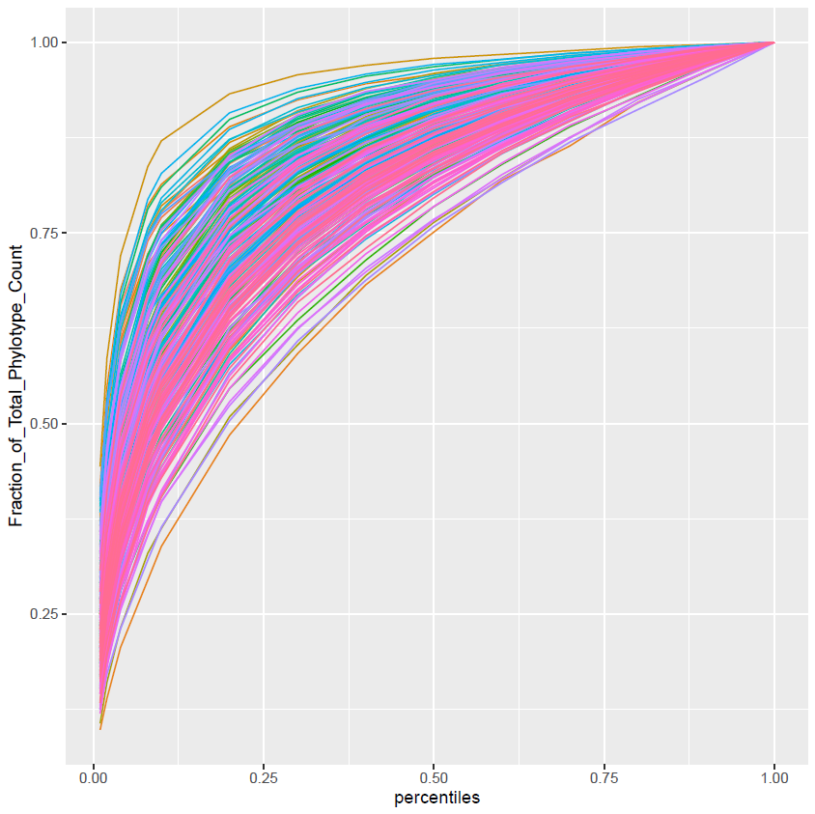

Table S2; Number and % of phylotypes (assignments were available for 2460/2816 phylotypes) and key phylotypes (assignments were available for 35/56 key phylotypes) assigned to each of the 20 FUNGuild growth morphologies. Some phylotypes and key phylotypes were assigned to multiple growth morphologies.

Growth morphology | Number of phylotypes in entire database | % of phylotypes in entire database | Number of key phylotypes | % of key phylotypes
Microfungus | 803 | 32.7 | 13 | 37.1
NULL | 743 | 30.2 | 11 | 31.4
Agaricoid | 361 | 14.7 | 4 | 11.4
Yeast | 234 | 9.5 | 6 | 17.1
Tremelloid | 91 | 3.7 | 2 | 5.7
Facultative yeast | 90 | 3.7 | 3 | 8.6
Corticioid | 77 | 3.1
Thallus | 64 | 2.6
Gasteroid | 57 | 2.3 | 2 | 5.7
Polyporoid | 30 | 1.2
Secotioid | 25 | 1.0 | 2 | 5.7
Clavarioid | 18 | 0.7
Dark Septate Endophyte | 16 | 0.7
Pezizoid | 14 | 0.6
Dark Septate Microfungus | 10 | 0.4
Boletoid | 9 | 0.4
Xylarioid | 3 | 0.1
Phalloid | 2 | 0.1
Cordyceptoid | 2 | 0.1
Hydnoid | 1 | 0.0

Table S3; Number and % of phylotypes (assignments were available for 2460/2816 phylotypes) and key phylotypes (assignments were available for 35/56 key phylotypes) assigned to each of the 3 FUNGuild trophic modes. Some phylotypes and key phylotypes were assigned to multiple trophic modes.

Trophic Mode | Number of phylotypes in entire database | % of phylotypes in entire database | Number of key phylotypes | % of key phylotypes
Saprotroph | 1849 | 75.3 | 32 | 91.4
Pathotroph | 860 | 35.0 | 12 | 34.3
Symbiotroph | 637 | 25.9 | 10 | 28.6

Table S4; Number and % of phylotypes (assignments were available for 2460/2816 phylotypes) and key phylotypes (assignments were available for 35/56 key phylotypes) assigned to each of 26 ecological guilds. Some phylotypes and key phylotypes were assigned to multiple ecological guilds.

Guild | Number of phylotypes in entire database | % of phylotypes in entire database | Number of key phylotypes | % of key phylotypes
Undefined Saprotroph | 1354 | 55.1 | 25 | 71.4
Plant Pathogen | 570 | 23.2 | 5 | 14.3
Wood Saprotroph | 410 | 16.7 | 4 | 11.4
Endophyte | 314 | 12.8 | 6 | 17.1
Animal Pathogen | 291 | 11.8 | 5 | 14.3
Fungal Parasite | 252 | 10.3 | 8 | 22.8
Ectomycorrhizal | 218 | 8.9 | 2 | 5.7
Soil Saprotroph | 183 | 7.4 | 4 | 11.4
Dung Saprotroph | 168 | 6.8 | 7 | 20.0
Plant Saprotroph | 137 | 5.6 | 3 | 8.6
Lichen Parasite | 81 | 3.3 | 0 | 0.0
Litter Saprotroph | 81 | 3.3 | 1 | 2.9
Lichenized | 69 | 2.8 | 0 | 0.0
Leaf Saprotroph | 42 | 1.7 | 1 | 2.9
Bryophyte Parasite | 36 | 1.5 | 1 | 2.9
Epiphyte | 32 | 1.3 | 0 | 0.0
Ericoid Mycorrhizal | 30 | 1.2 | 0 | 0.0
Animal Endosymbiont | 24 | 1.0 | 0 | 0.0
Clavicipitaceous Endophyte | 16 | 0.7 | 0 | 0.0
NULL | 10 | 0.4 | 0 | 0.0
Plant parasite | 9 | 0.4 | 1 | 2.9
Arbuscular Mycorrhizal | 6 | 0.2 | 0 | 0.0
Algal Parasite | 4 | 0.2 | 0 | 0.0
Orchid Mycorrhizal | 4 | 0.2 | 0 | 0.0
Animal Parasite | 2 | 0.1 | 0 | 0.0
Undefined Symbiotroph | 1 | 0.0 | 0 | 0.0

Figure S2: Taxonomy plots showing relative abundance of taxa at (A) order and (B) family levels. Data are filtered at 0.05% abundance threshold.
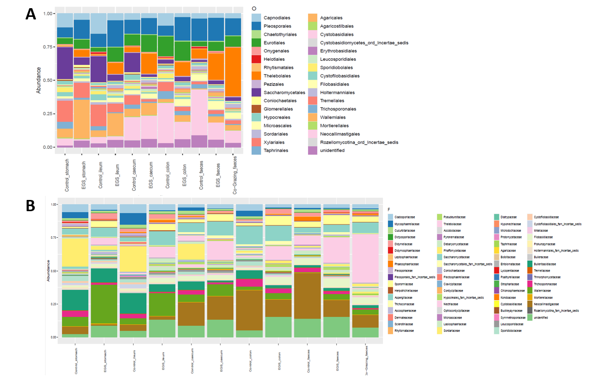
Table S5; Statistical comparison of indices of alpha-diversity across all 5 GI sites (overall) and between paired GI sites. Data pooled for all horses; ANOVA, P values. Significant differences in bold, letter indicates higher value (Ca=caecum; F=faeces).

 | Overall |  | Stomach | Ileum | Caecum | Colon
Chao1 | 0.0164 | Ileum | 0.788
Chao1 | 0.0164 | Caecum | 0.0669 | 0.0325 (Ca)
Chao1 | 0.0164 | Colon | 0.366 | 0.229 | 0.354
Chao1 | 0.0164 | Faeces | 0.0102 (F) | 0.00307 (F) | 0.954 | 0.18
Inverse Simpson | 0.151 | Ileum | 0.385
Inverse Simpson | 0.151 | Caecum | 0.0364 (Ca) | 0.241
Inverse Simpson | 0.151 | Colon | 0.234 | 0.903 | 0.235
Inverse Simpson | 0.151 | Faeces | 0.666 | 0.413 | 0.0287 (Ca) | 0.399

Table S6; Weighted UniFrac distance analysis identified significant inter-site dissimilarity in mycobiota structure in EGS and CTRL horses, at phylotype level. P values, statistically different comparisons in bold.

 |  | Stomach | Ileum | Caecum | Colon
EGS | Ileum | 0.721
EGS | Caecum | 0.1 | 0.652
EGS | Colon | 0.027 | 0.247 | 0.826
EGS | Faeces | 0.001 | 0.01 | 0.75 | 0.394
CTRL | Ileum | 0.996
CTRL | Caecum | 0.572 | 0.794
CTRL | Colon | 0.244 | 0.344 | 0.924
CTRL | Faeces | 0.334 | 0.138 | 0.407 | 0.793

Table S7; Inter-group weighted UniFrac distance analysis at different GI sites, at phylotype level (P values). Statistically significant dissimilarity is indicated in bold.

 |  | Phylotypes
EGS versus CTRL | Overall | 0.023
EGS versus CTRL | Stomach | 0.001
EGS versus CTRL | Ileum | 0.364
EGS versus CTRL | Caecum | 0.442
EGS versus CTRL | Colon | 0.115
EGS versus CTRL | Faeces | 0.146
EGS versus CoG | Faeces | 0.008
CoG versus CTRL | Faeces | 0.006

Table S8; Numbers of differentially abundant (increased, decreased and total) taxa, at phylum, class, order, family, genus and phylotype levels. Comparisons are EGS vs CTRL, EGS vs CoG and CoG vs CTRL groups, overall (data pooled for all sites) and for 5 paired GI site comparisons.

 |  | EGS vs CTRL |  |  |  |  |  | EGS vs CoG | CoG vs CTRL
 |  | Overall | Stomach | Ileum | Caecum | Colon | Faeces | Faeces | Faeces
Phylum | Increased | 9 | 3 | 4 | 1 | 6 | 1 | 6 | 1
Phylum | Decreased | 2 | 1 | 1 | 0 | 0 | 1 | 3 | 2
Phylum | Total | 11 | 4 | 5 | 1 | 6 | 2 | 9 | 3
Class | Increased | 25 | 4 | 8 | 10 | 15 | 8 | 13 | 5
Class | Decreased | 5 | 4 | 8 | 3 | 1 | 2 | 9 | 2
Class | Total | 30 | 8 | 16 | 13 | 16 | 10 | 22 | 7
Order | Increased | 56 | 15 | 16 | 38 | 39 | 25 | 45 | 11
Order | Decreased | 24 | 14 | 32 | 3 | 2 | 5 | 9 | 10
Order | Total | 80 | 29 | 48 | 41 | 41 | 30 | 54 | 21
Family | Increased | 137 | 27 | 23 | 102 | 89 | 78 | 112 | 23
Family | Decreased | 38 | 32 | 55 | 10 | 12 | 14 | 16 | 17
Family | Total | 175 | 59 | 78 | 112 | 101 | 92 | 128 | 40
Genus | Increased | 310 | 68 | 50 | 208 | 161 | 147 | 212 | 51
Genus | Decreased | 91 | 76 | 106 | 29 | 28 | 36 | 42 | 26
Genus | Total | 401 | 144 | 156 | 237 | 189 | 183 | 254 | 77
Phylotypes | Increased | 560 | 122 | 108 | 305 | 243 | 229 | 365 | 85
Phylotypes | Decreased | 186 | 139 | 160 | 54 | 43 | 82 | 91 | 82
Phylotypes | Total | 746 | 261 | 268 | 359 | 286 | 311 | 456 | 167

