Supplementary information
Droplet microrobotic structures for compartmentalized biochemistry and organoid engineering
Jin Li¹, William David Jamieson², Yigang Shen^{3,1,7}, Matthew Colborne², Hongdi Wang^{1,8}, Tianqi Wang⁵, Wen Xu¹, David Regan¹, Aisling Stewart⁶, Silvia Holler⁹, Marinella Pinelli⁹, Xianfeng Chen⁸, Martin Hanczyc⁹, Bo Hou⁶, Yasir Ahmed Syed⁴, Xu Hou⁷, Oliver Karen Castell², Stephen Mann⁴ and David Anthony Barrow¹

Corresponding authors
1. Cardiff School of Engineering, Cardiff University, Cardiff CF24 3AA, the United Kingdom
2. Cardiff School of Pharmacy and Pharmaceutical Sciences, Cardiff University, Cardiff CF10 3NB, the United Kingdom
3. College of Engineering, Zhejiang Normal University, Jinhua 321004, China
4. Max Planck-Bristol Centre for Minimal Biology, School of Chemistry, University of Bristol, Bristol BS8 1TS, the United Kingdom.
5. Neuroscience and Mental Health Innovation Institute, Cardiff School of Biosciences, Cardiff University, Cardiff CF24 4HQ, the United Kingdom
6. Cardiff School of Physics and Astronomy, Cardiff University, Cardiff CF24 3AA, the United Kingdom
7. College of Chemistry and Chemical Engineering, Xiamen University, Xiamen 361005, China
8. School of Engineering, University of Edinburgh, Edinburgh EH9 3JL, the United Kingdom
9. Department of Cellular, Computational and Integrative Biology, University of Trento, Trento 38121, Italy

Table of contents
Fig S1. 3D-printed microfluidic thermal tweezer devices using different fabrication methods.
Fig S2. Trajectories of DMSs assembly described in Fig 2c.
Fig S3. Sequential movement of a droplet in a microfluidic thermal tweezer device with four electrodes.
Fig S4. Clockwise rotation of a 2-unit DMS.
Fig S5. DMS can grab new unit and build a closed circuit of droplet networks by sequential rotation and movement.
Fig S6. The assembly and disassembly of a DMS unit incorporating magnetic microparticles through magnetic-thermofluidic operations.
Fig S7. Example image visualization demonstrating how machine learning algorithms detect droplet movement for the analysis of DMS locomotion.
Fig S8. Droplet speed is influenced by droplet size, the heating electrode temperature, and fluidic structures when a droplet moves within a microfluidic thermal tweezer device.
Fig S9. Simulation results of the relationship between hydrodynamic force exerted to the droplet and the droplet’s distance from the centre of the heating microelectrode.
Fig S10. Temperature profile above the centre of a heating microelectrode in a mineral oil-filled thermal tweezer device under 1 A current input.
Fig S11. The excitation and emission spectrum of IVTT expressed YPet.
Fig S12. No YFP production was observed due to the absence of α-HL preventing the transport of Mg²⁺ from the MgCl₂ buffer droplet to the Mg²⁺-deficient IVTT droplet containing the YPet plasmid at 37 $℃$.
Fig S13. E-Phys measurement of a linear, 5-unit DMS without any membrane protein pore reconstituted on the DMS’s membranes.
Fig S14. A two-unit DMS was assembled and then repeatedly guided into and out of a 3D-printed C-shaped block within a microfluidic thermal tweezer device.
Fig S15. MscL channels did not gate in the DIB membrane when the DMS was not constrained by a solid structure within conventional thermofluidic fields.
Fig S16. Deformation of the DMS by the solid structure did not cause ionic leakage across the DIB membrane in conventional thermofluidic fields.
Fig S17. Methods for the formation, growth, differentiation, and neuron activity characterisation of human brain organoids used in our experiment.
Fig S18. Confocal fluorescence microscopy images of human brain organoids (52 d) after cultured in both hydrophobic and hydrophilic 3D-printed devices.
Fig S19. Fluorescence images (grey scale) of an organoid containing DMS movement in response to the microelectrode heating.
Fig S20. TEM images and EDX data of the InP/ZnS QDs.
Fig S21. Confocal fluorescence microscopy images of sectioned brain organoids showing QDs uptake.
Fig S22. TEM images of the doxorubicin-loaded lipid-coated nanoparticles used in this work.
Fig S23. LPC concentration-assisted DMS complex merger as a control experiment for Fig 5h.
Fig S24. 2D monolayer cell viability at different LPC concentrations in culture medium.
Fig S25. Confocal fluorescence microscopy images of sectioned brain organoids showing the uptake of doxorubicin-loaded lipid-coated nanoparticles.
Fig S26. Stable formation of a DMS complex consisting of an organoid-containing DMS and three doxorubicin-loaded lipid-coated nanoparticles containing DMSs.
Fig S27. A. Performance evaluation of different types of tweezer devices for droplet manipulation. B. Their respective energy efficiencies.
Table S1. Reagents and components within S30 IVTT system.

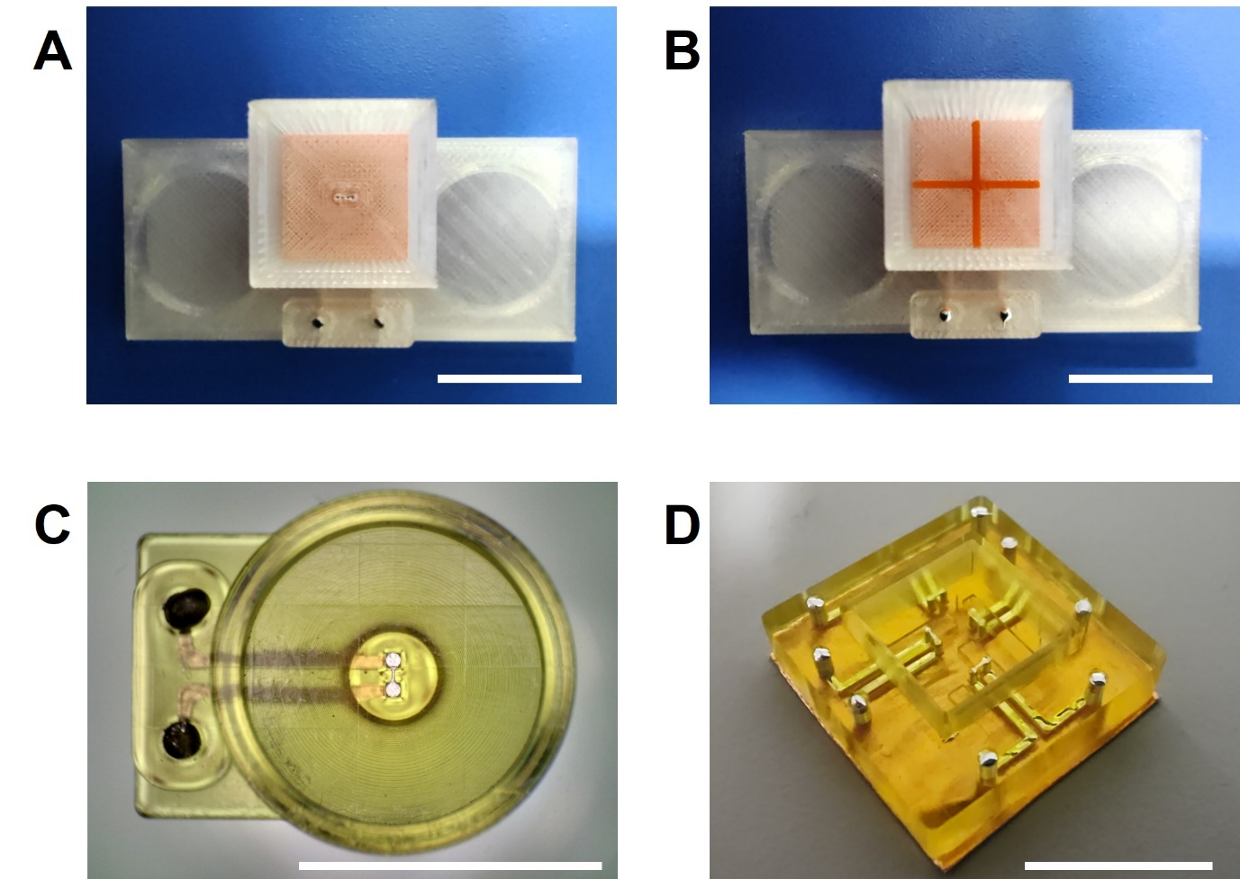
Fig S1. 3D-printed microfluidic thermal tweezer devices using different fabrication methods. A, B. 3D-printed hydrophobic thermal tweezer devices made from Ultimaker PLA transparent filaments and fabricated via fused filament printing on an Ultimaker S5 printer. A. The device features a central square pool containing a single embedded microelectrode, formed by injecting liquid metal into 3D-printed fluidic ducts. B. The same device as in A, now with an additional cross-shaped fluidic structure (made from Ultimaker PLA orange filament) to compartmentalise the pool. C, D. 3D-printed hydrophilic thermal tweezer devices made from BMF HTL resin and fabricated via digital laser processing on a BMF S230 printer. C. The device features a central circular pool with one embedded microelectrode formed by liquid metal injection. D. A hydrophilic thermal tweezer device incorporating four microelectrodes. Scale bars denote 1 cm.

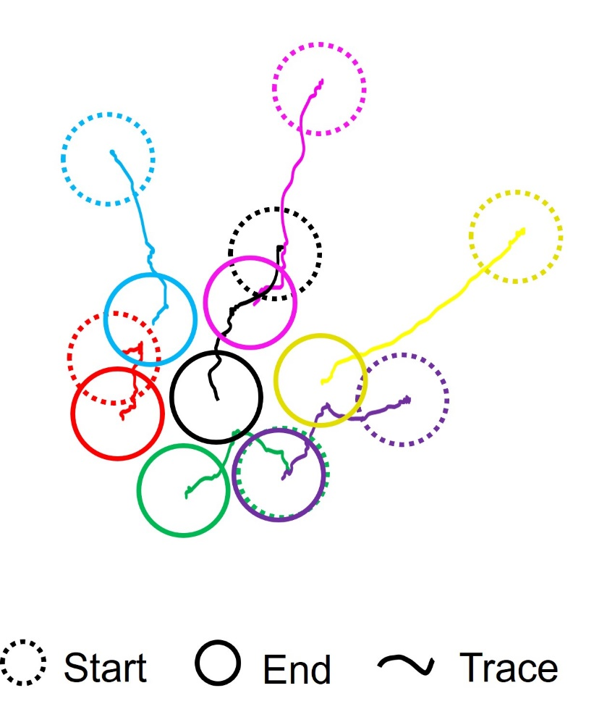
Fig S2. Trajectories of DMSs assembly described in Fig 2c.

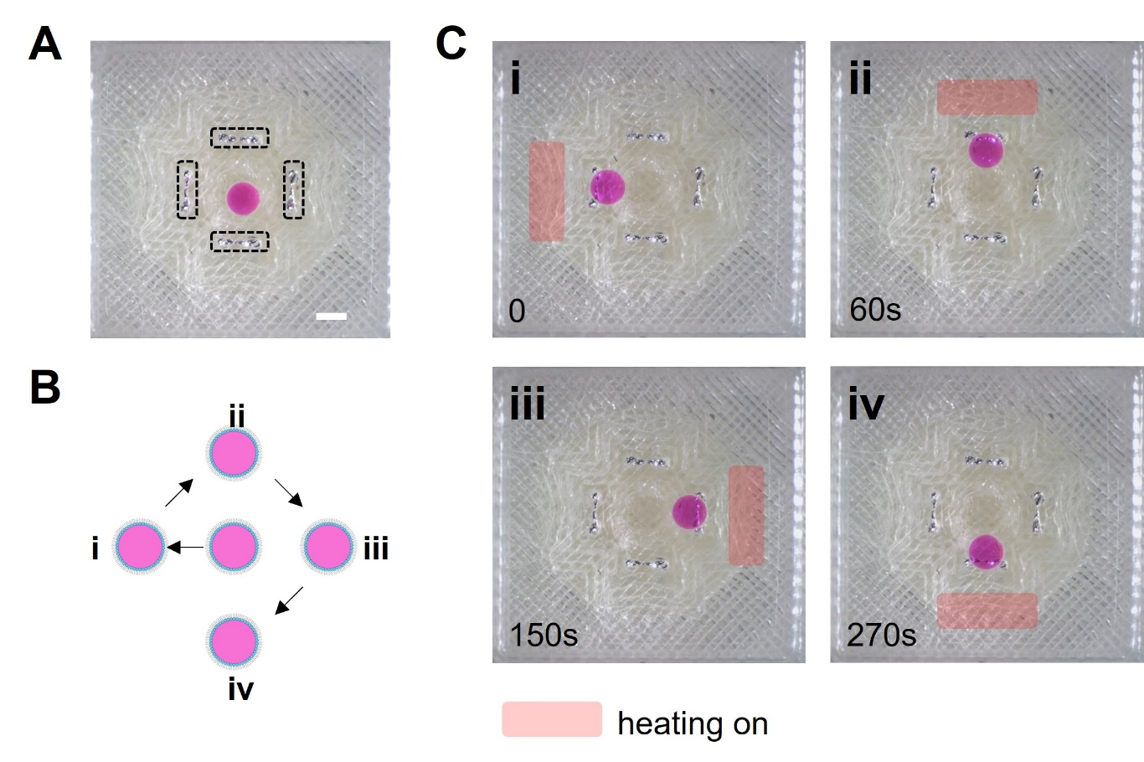
Fig S3. Sequential movement of a droplet in a microfluidic thermal tweezer device with four electrodes. A. The droplet was initially placed at the centre of the four microelectrodes (indicated by dotted black rectangles). The scale bar denotes 1 mm. B. Schematic drawing of the droplet’s movement. C. i-iv Sequential clockwise movements (as Fig S3 B) of the droplet to different locations corresponding to the respective heating operations of the microelectrode (highlighted by red bar).

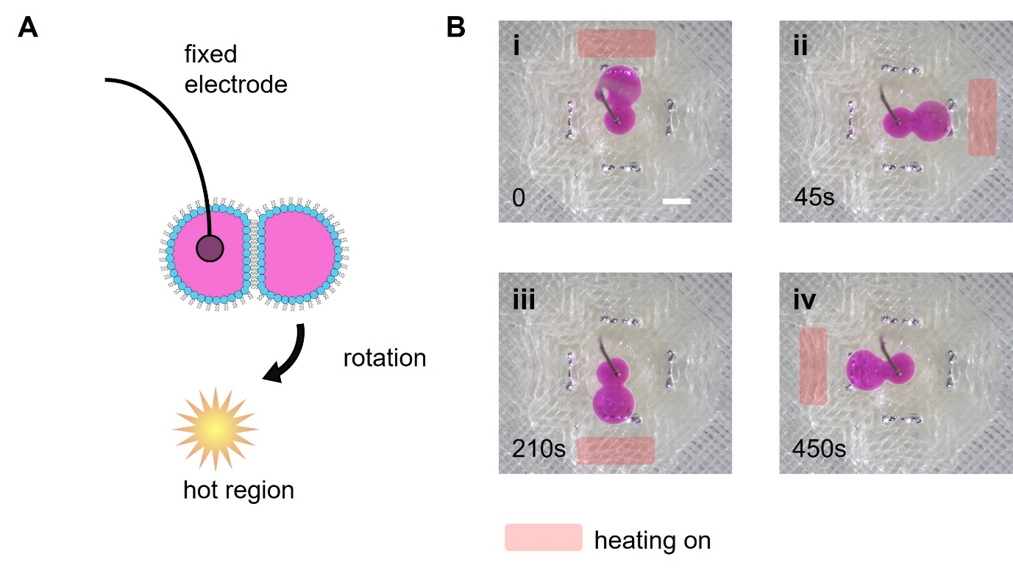
Fig S4. Clockwise rotation of a 2-unit DMS. A. Schematics of the experiment setup. The left droplet of the DMS was anchored in place by a fixed wire electrode coated with agarose at one end. B. i-iv Sequential clockwise rotation of the DMS in different directions, corresponding to the heating microelectrode (highlighted by red bar). The scale bar denotes 1 mm.

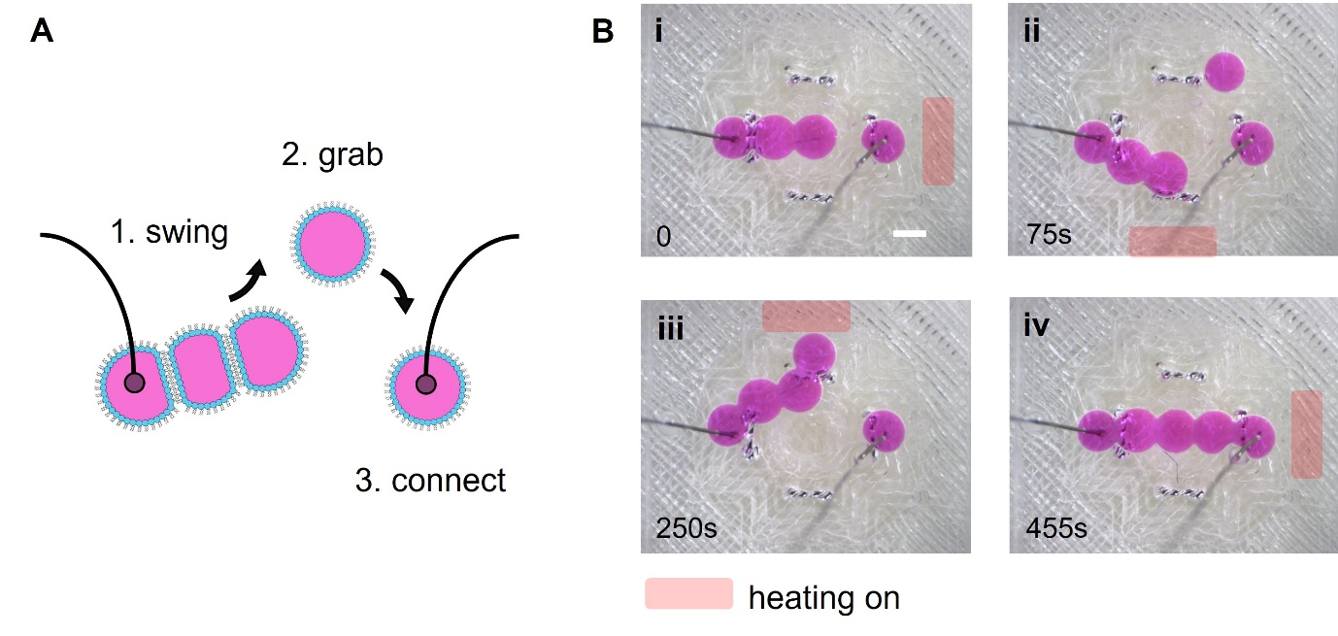
Fig S5. DMS can grab new unit and build a closed circuit of droplet networks by sequential rotation and movement. A. Schematic of the experiment setup. The leftmost and rightmost droplet were anchored in place by fixed wire electrodes coated with agarose. B. i. The 3-unit DMS could not initially reach the rightmost droplet. ii. The 3-unit DMS rotated toward the bottom heating microelectrode (highlighted by red bar). Another droplet was placed near the top microelectrode, but due to the distance and thus resulting weak local thermal convection, it did not move to the bottom microelectrode. iii. The 3-unit DMS then rotated to the top heating microelectrode, capturing the single droplet and forming a 4-unit DMS. iv. The newly formed 4-unit DMS rotated to the right microelectrode, acquiring another droplet to become a 5-unit DMS and completing a closed-circuit droplet network with the two wire electrodes. The light red rectangles indicate the heating operations of the corresponding microelectrodes. Scale bar denotes 1 mm.

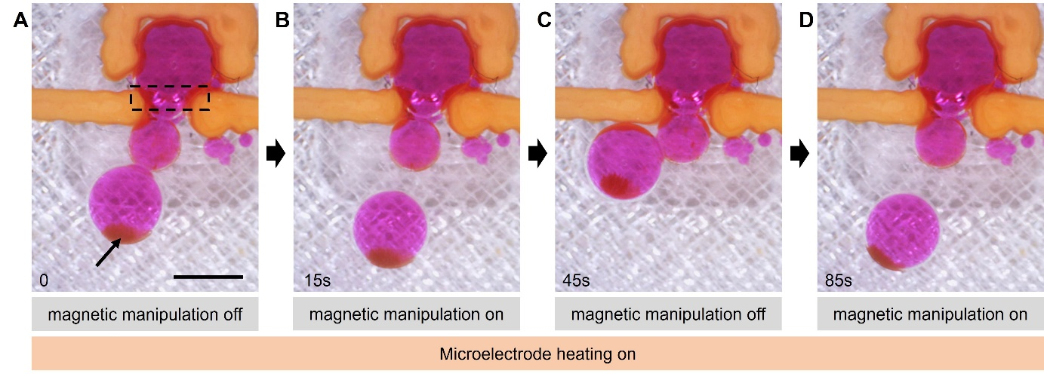
Fig S6. The assembly and disassembly of a DMS unit incorporating magnetic microparticles through magnetic-thermofluidic operations. A. One unit of the multi-unit DMS contained magnetic particles (brownish region, indicated by the black arrow). The DMS was trapped in the middle by a 3D-printed gate structure. The microelectrode (dotted black circle) was heating during the experiment. B. Upon the approaching of an external magnet, the unit containing magnetic particles detached from the DMS and moved toward the magnet. C. Once the external magnet was removed, the unit moved back toward the heating electrode and formed a new bilayer connection. D. This process can be repeated to reconfigure the DMS structure and components. Scale bar denotes 1 mm.

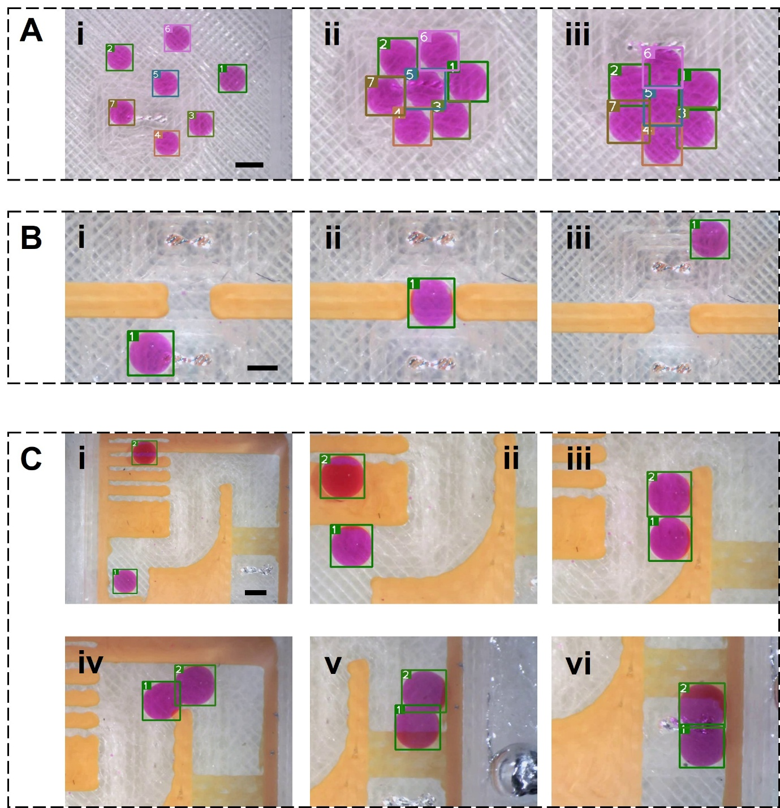
Fig S7. Example image visualization demonstrating how machine learning algorithms detect droplet movement for the analysis of DMS locomotion. The algorithm uses rectangular bounding boxes around the droplets to label each droplet with a unique number and track its position. A. The algorithm can recognise, label and track multiple DMS movements as shown in Fig 2c. B. The algorithm can detect the droplet deformation as shown in Fig 2d. For example, in B-i and iii, the droplet remains spherical, so a square bounding box is used for detection. In contrast, in B-ii the droplet is squeezed into an oval shape while passing through a gate, so a rectangle bounding box is applied. C. The algorithm can also analyse complex movements of multi-unit DMS as shown in Fig 2e, incorporating the features described in in A and B. Scale bars denote 1 mm.

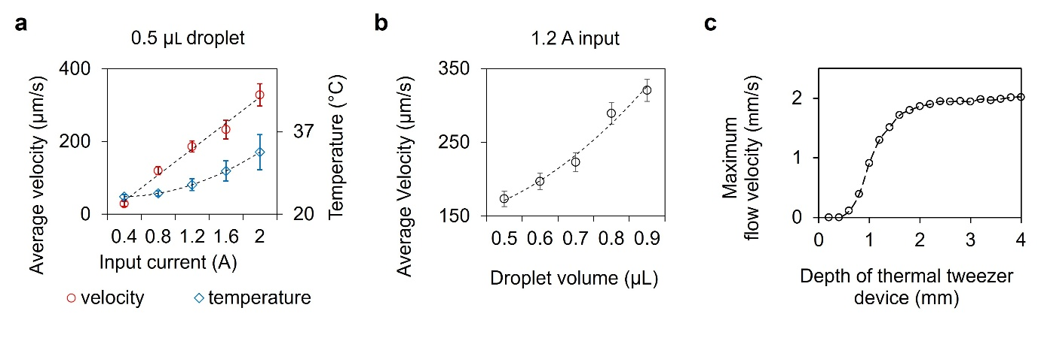
Fig S8. Droplet speed is influenced by droplet size, the heating electrode temperature, and fluidic structures when a droplet moves within a microfluidic thermal tweezer device. a. The average velocity of a 0.5 µL aqueous droplet was controlled by the heating microelectrode temperature inside the thermal tweezer microfluidic device shown in Fig 2b. The microelectrode temperature was regulated by varying the current input. b. When the input current was set to 1.2 A, droplet velocity was influenced by droplet size. The microfluidic devices used in a and b have a depth of 4 mm. c. Simulated results showing the approximate maximum velocity of convective flow in a mineral oil carrier phase for thermal tweezer microfluidic devices with different pool depths.

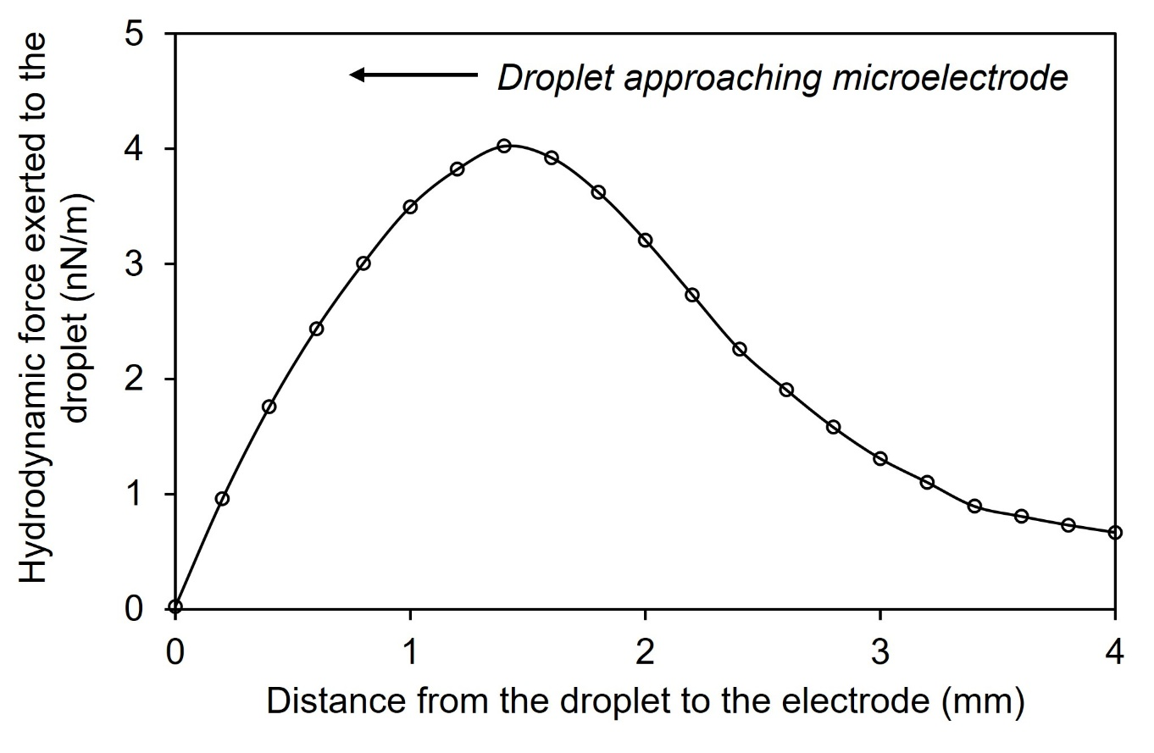
Fig S9. Simulation results of the relationship between hydrodynamic force exerted to the droplet and its distance from the centre of the heating microelectrode. The plot shows the approximate hydrodynamic force applied to a 1 mm droplet by thermal convection generated by a single microelectrode with an input current of 1.5 A.

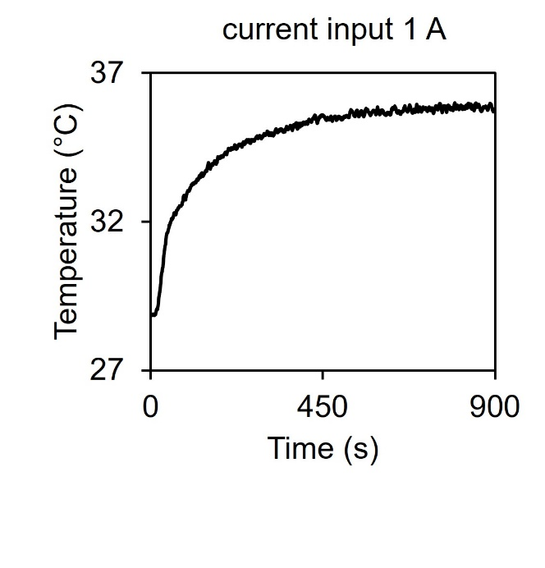
Fig S10. Temperature profile above the centre of a heating microelectrode in a mineral oil-filled thermal tweezer device under a 1 A current input. The temperature was measured using an infrared fibre optic thermometer.

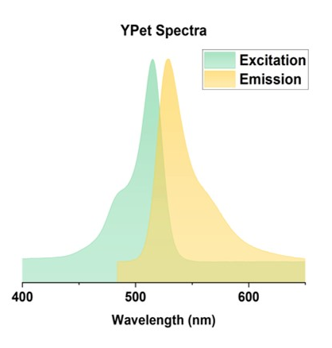
Fig S11. The excitation and emission spectrum of IVTT expressed YPet.

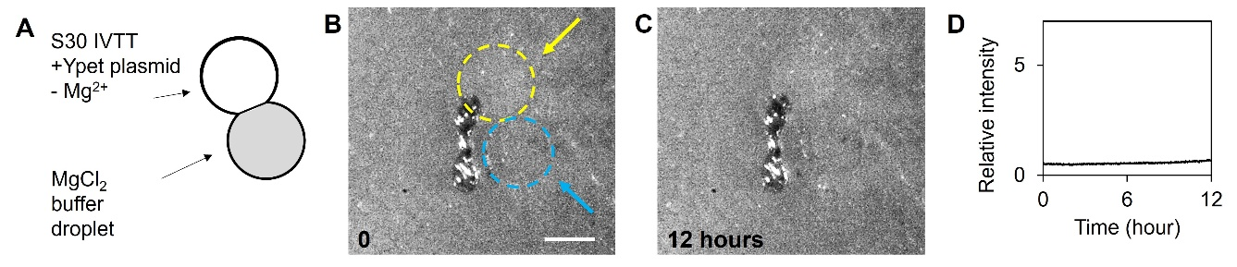
Fig S12. No YFP production was observed due to the absence of α-HL preventing the transport of Mg²⁺ from the MgCl₂ buffer droplet to the Mg²⁺-deficient IVTT droplet containing the YPet plasmid at 37 $℃$. This is a control group for the experiment described in Fig 3e. A. Schematic of the droplet setup. B. Experiment image of DIBs at time 0. The yellow circle and arrow indicate the S30 IVTT droplet containing the Ypet plasmid with Mg²⁺ deficiency. The blue circle and blue arrow indicate the MgCl₂ buffer droplet. The scale bar denotes 1 mm. C. After heating the DIBs described in B at 37 $℃$ for 12 hours, no YFP protein was produced due to Mg²⁺ deficiency. D. Graph showing the relative fluorescence intensity of the S30 IVTT droplet in B and C.

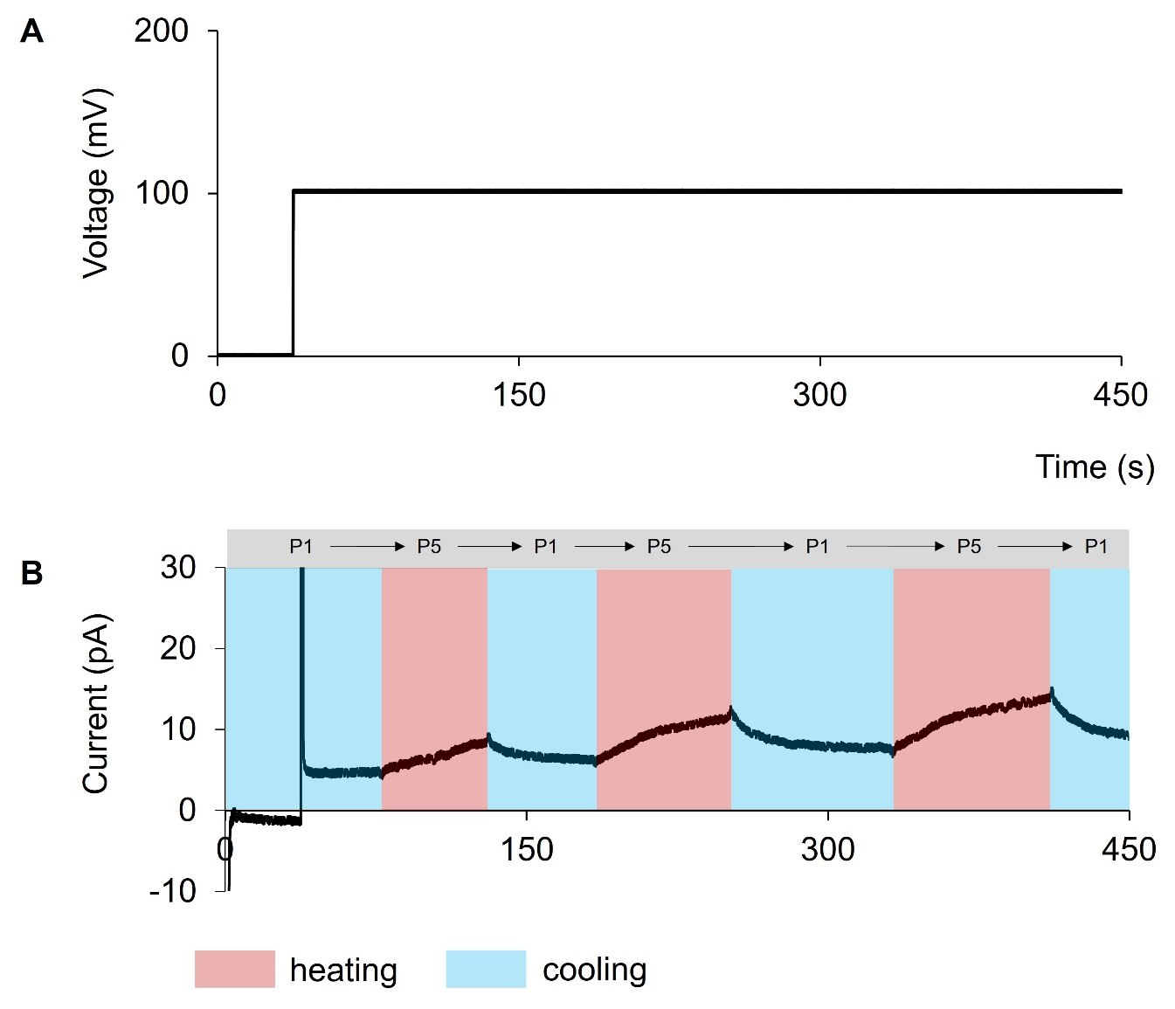
Fig S13. E-Phys measurement of a linear, 5-unit DMS without any membrane protein pore reconstituted on the DMS’s membranes. This serves as the control group for Fig 4c. A. The bias voltage applied to the 5-unit DMS. B. The corresponding current recorded from the DMS during the heating and cooling cycles.

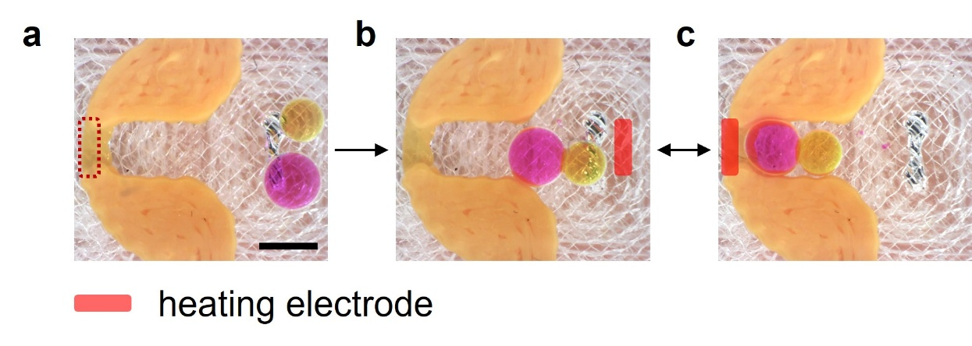
Fig S14. A two-unit DMS was assembled and then repeatedly guided into and out of a 3D-printed C-shaped block within a microfluidic thermal tweezer device. a. Experimental setup. Two aqueous droplets (pink: sulforhodamine B, and yellow: 5,6-carboxyfluorescein) were introduced into an oil bath inside a thermal tweezer device. The device contains a C-shaped block (orange PLA) and two microelectrodes; the microelectrode on the right is highlighted by a red dotted rectangle. Scale bar denotes 1 mm. b. The 2-unit DMS parked at the right-side heating microelectrode without changing shape. c. The DMS was guided into the C-shaped block when only the left-side microelectrode was heated.

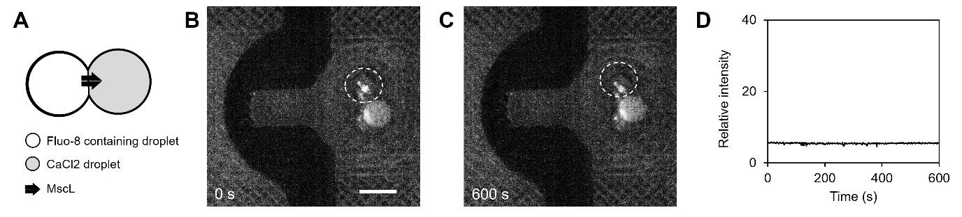
Fig S15. MscL channels did not gate in the DIB membrane when the DMS was not constrained by a solid structure within conventional thermofluidic fields. This is a control group experiment for Fig 5. A. Schematic diagram of the setup. B&C. Experimental images captured at time = 0 s and time = 600 s, respectively. White circles indicate the CaCl₂ droplet. D. Fluorescence signal of the Fluo-8-containing droplet under these conditions. Scale bar denotes 1 mm.

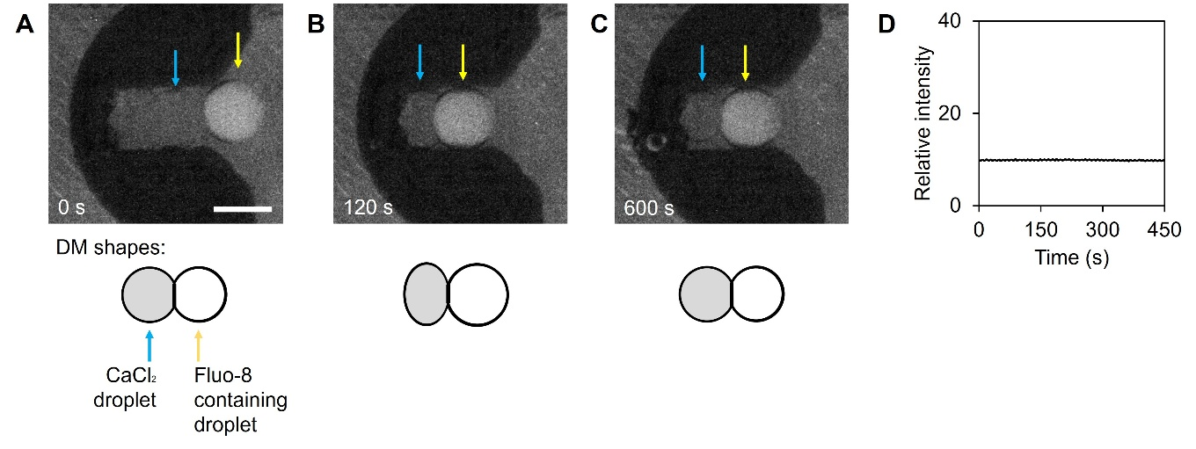
Fig S16. Deformation of the DMS by the solid structure did not cause ionic leakage across the DIB membrane in conventional thermofluidic fields. This is a control group experiment of Fig 5. A-C. Experimental images taken at time = 0 s, 120 s, and 600 s, respectively, showing the shapes of droplets constrained within the C-shaped block. D. Fluorescence signal of the Fluo-8-containing droplet in this setup. Scale bar denotes 1 mm.

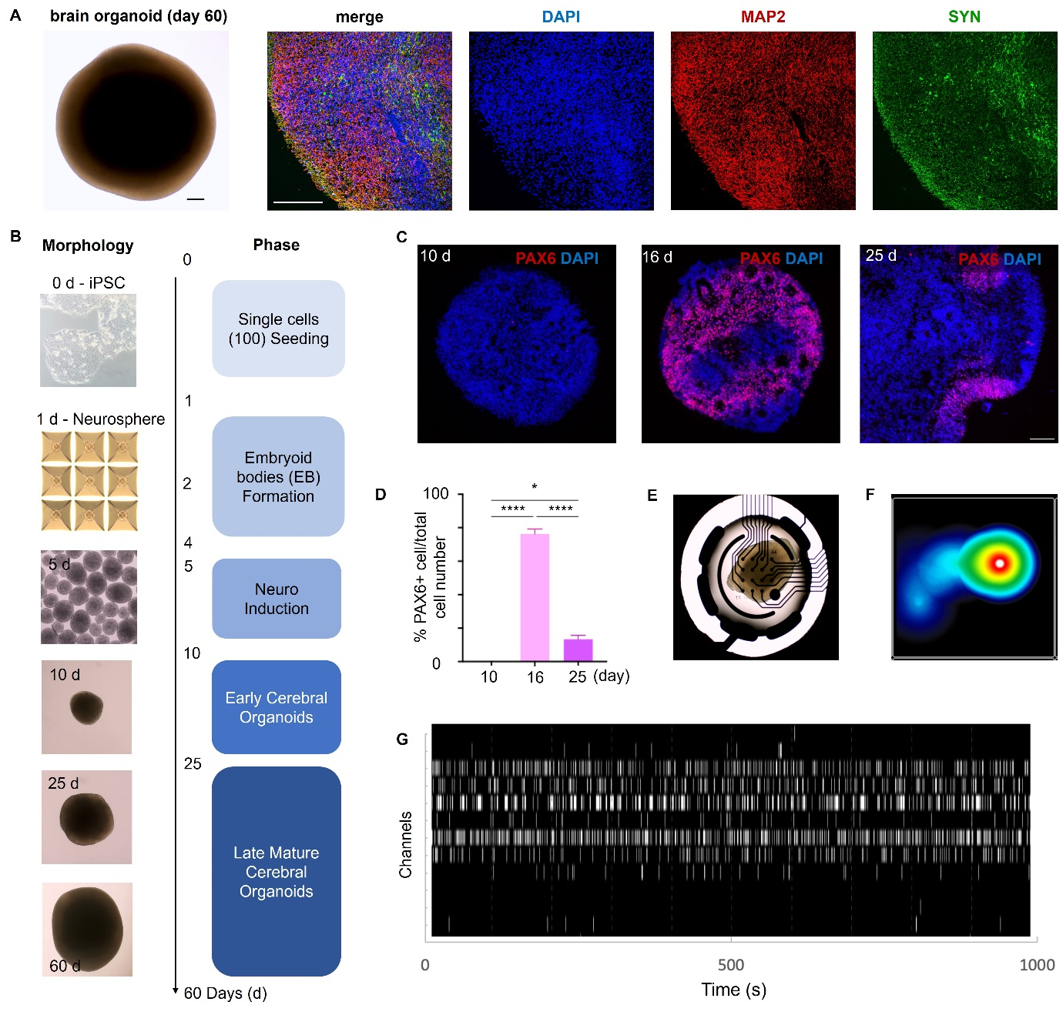
Fig S17. Methods for the formation, growth, differentiation, and neuron activity characterisation of human brain organoids used in our experiment. A. Bright field (left) and confocal fluorescence imaging of matured human brain organoid expressing MAP2 and SYN markers. Scale bars denote 200 µm. B. Schematic representation of the human cerebral organoid (CO) generation method. Single cells (1x10⁵ cells/mL) were seeded on a 24-AggrewellTM plate (0d). From day 1 to 3 (EB formation Phase), hiPSCs self-assembled into spheres in EB formation medium supplemented with 10 µM ROCK inhibitor (Y-27632). The neuro-induction stage spanned days 4 to 10 in Neuron Induction Medium (NIM), enriched with hFGF2 and Y-27632 from days 4 to 7, and followed by plain NIM from day 7 to 10. From day 10 onward, COs matured in Organoids Medium supplemented with growth factors (hBDNF, GDNF and FGF2). Beginning with the neuron-induction stage, COs were maintained in 24-well low-attachment plates on an orbital shaker in 37 ℃ and 5% CO₂. Images in B are representative brightfield views of human iPSCs, self-assembled embryoid bodies (in AggrewellTM plates, and different stages of CO development. C. Representative confocal immunofluorescence images of sliced hiPSCs-derived COs at 10 d, 16 d and 25 d, showing the neuronal development and proliferation marker PAX6 (in red). Nuclei (DAPI) are shown in blue. D. Graph showing the percentage of PAX6+ cells relative to the total cell number of nuclei at 10 d, 16 d and 25 d (n=3 different COs, with 3 complete sections analysed per CO). E. COs placed on 16-electrode plates for MEA recordings. F. Activity map depicting the firing rate of one well containing COs. G. Day 60 human iPSC-derived COs showing burst activity in MEA recordings. Each white mark represents a detected spike.

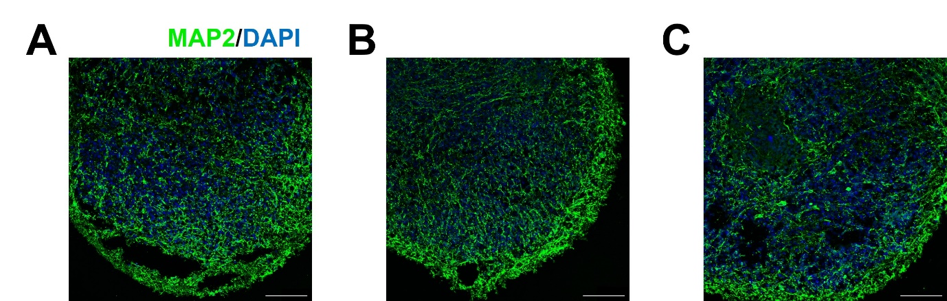
Fig S18. Confocal fluorescence microscopy images of human brain organoids (52 days) cultured in both the hydrophobic and the hydrophilic 3D-printed devices. Scale bars denote 100 µm. N = 3 for each group. A. Organoid cultured in a hydrophobic 3D-printed device. B. Organoid cultured in hydrophilic a 3D-printed device, with the bottom of the device coated with a layer of low-adhesion agarose to minimise cells spreading on the device surface. C. Control group –organoid cultured in a well-plate as described in Fig S17. The culture medium and waste of the device in (A) and (B) were managed by an automated ElveSys perfusion system and sensors with customised fluidic circuits, requiring no manual operation. The culture medium in (C) was manually exchanged every two days. Maintenance of the characteristics of the organoid during culture was verified by immunofluorescence staining for microtubule-associated protein 2 (MAP2), a marker of mature neurone development, and comparing with controls cultured on low-attachment plates over the same period. MAP2 expression was preserved in the organoids cultured in the 3D-printed microfluidic devices with expression levels comparable to those of the control group.

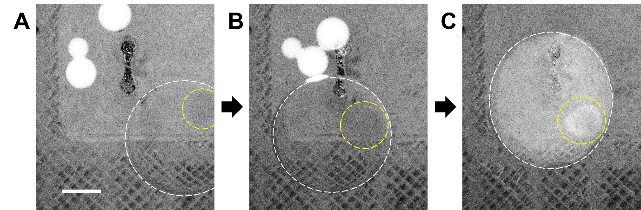
Fig S19. Fluorescence images (grey scale) of an organoid containing DMS movement in response to the microelectrode heating. The DMS is outlined by a white dotted circle, and the organoid is outlined by a yellow dotted circle. The smaller brighter DMSs contained 5 mg/mL QDs, as described in Fig 6 e-g. Scale bar denotes 1 mm.

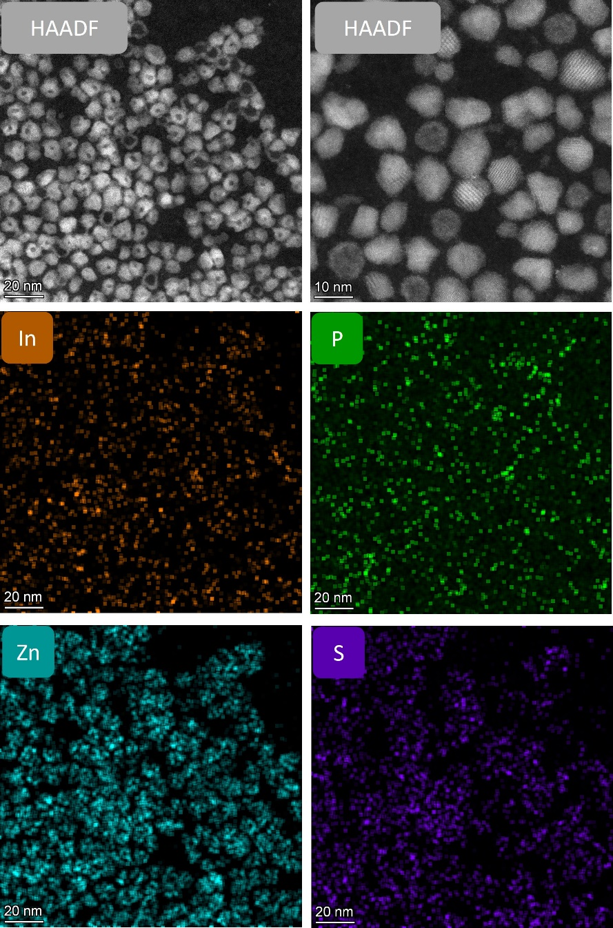
Fig S20. TEM images and EDX data of the InP/ZnS QDs.

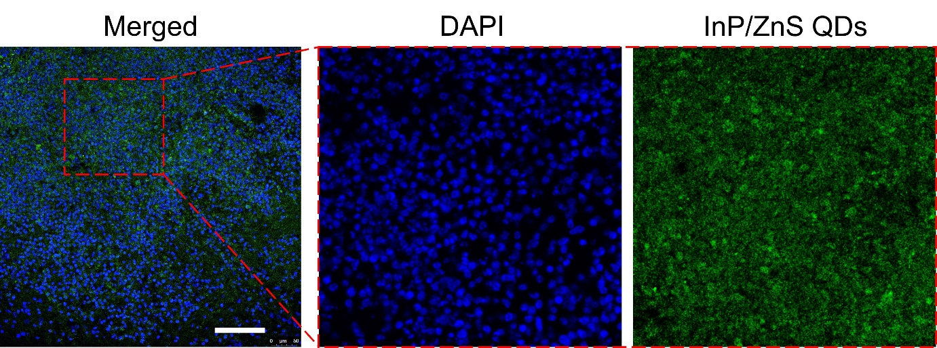
Fig S21. Confocal fluorescence microscopy images of sectioned brain organoids showing QDs uptake. These images correspond to the enlarged example described in Fig 6 e-g. Scale bar denotes 50 µm.

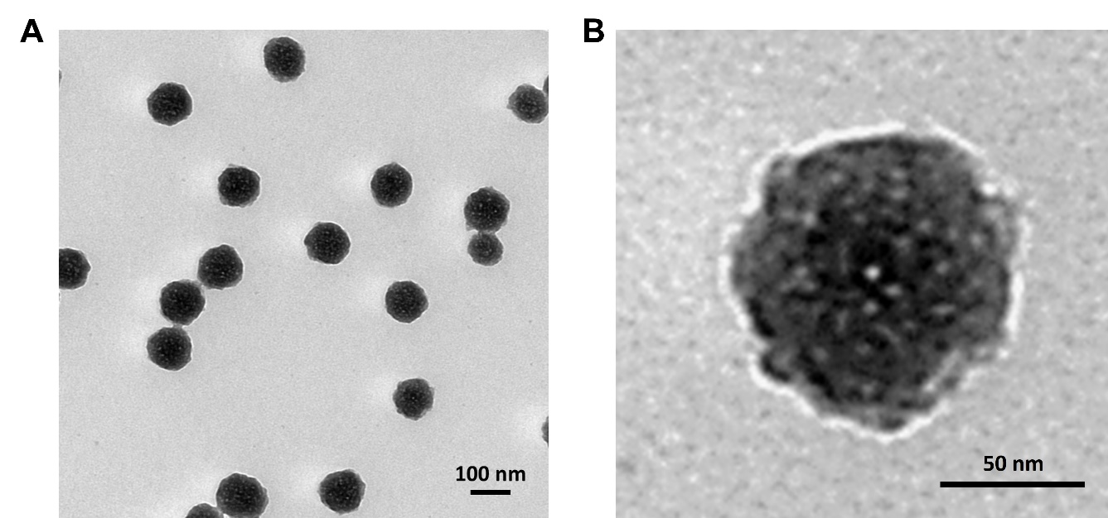
Fig S22. TEM images of the doxorubicin-loaded lipid-coated nanoparticles used in this work. A. Multiple nanoparticles. B. Single nanoparticle

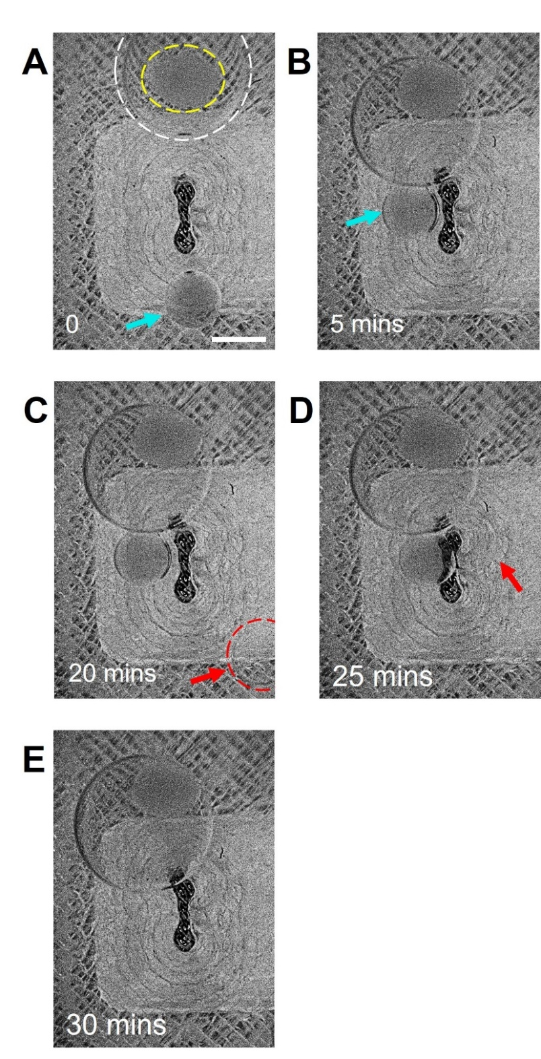
Fig S23. LPC concentration-assisted DMS complex merger as a control experiment for Fig 6h. A. An organoid (outlined with the yellow dotted circle) containing DMS (outlined by the white dotted circle), and a doxorubicin-loaded lipid nanoparticles containing DMS (indicated by the blue arrow) were deposited in a thermal tweezer device. B. When a current was applied to the heating microelectrode, the two DMS moved to it and formed stable DMS complex. C. A third DMS (indicated by the red dotted circle and red arrow) containing 100 µL LPC was introduced into the device. D. The LPC-containing DMS moved to the DMS complex. E. All three DMSs merged. Scale bar denotes 1 mm.

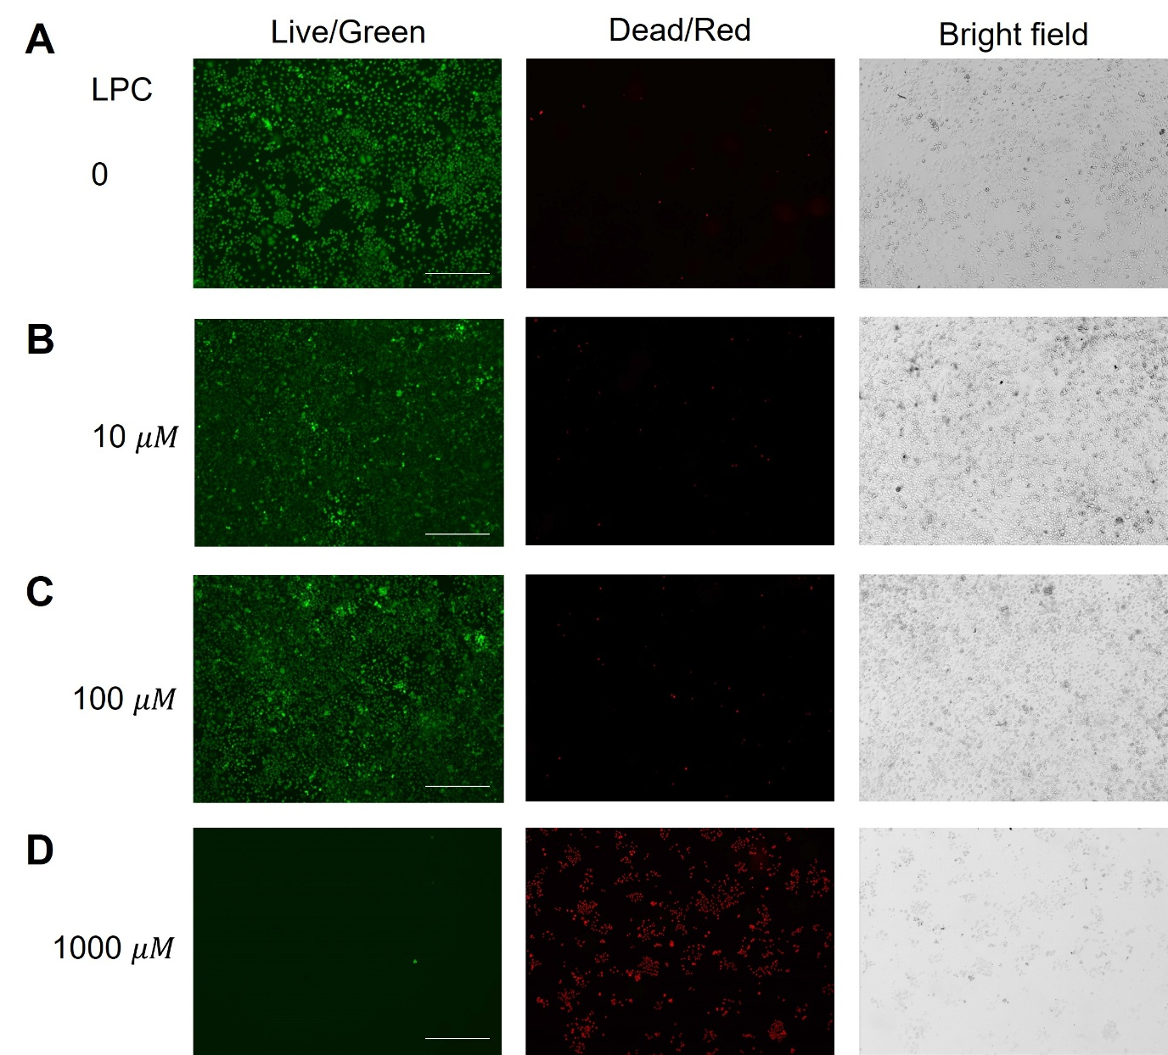
Fig S24. 2D monolayer cell viability at different LPC concentrations in culture medium. Live cells were treated with LPC concentrations of up to 100 µM, and their viability was measured using a live/dead cell staining assay. At an LPC concentration of 1000 µM, significant cell death was observed 30 minutes after the addition of LPC. Scale bars denote 500 µm.

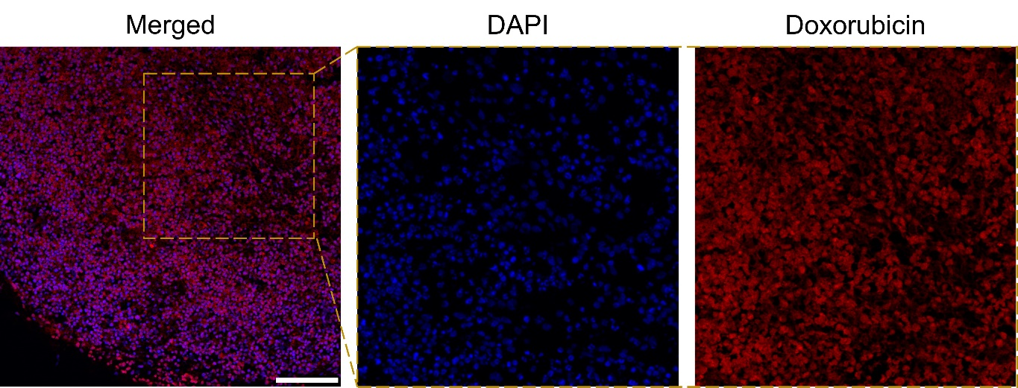
Fig S25. Confocal fluorescence microscopy images of sectioned brain organoids showing the uptake of doxorubicin-loaded lipid-coated nanoparticles. These images correspond to the enlarged example described in Fig 6i. Scale bar denotes 50 µm.

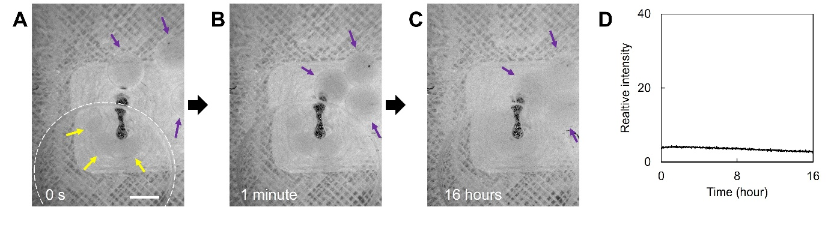
Stable formation of a DMS complex consisting of an organoid-containing DMS and three doxorubicin-loaded lipid-coated nanoparticles containing DMSs. This is a control group for Fig 6h, performed in the absence of LPC-containing DMSs. A. A DMS containing three organoids (highlighted by yellow arrows and outlined by the white dotted circle) and three doxorubicin-loaded, lipid-coated nanoparticles containing DMSs (indicated by purple arrows) were placed in a thermal tweezer device. B. Upon applying current to the heating microelectrode, all DMSs moved toward the microelectrode and formed a stable complex. C. This complex remained stable after 16 hours under continuous heating. D. The fluorescence signal on the organoids remained as a straight baseline, unlike in Fig 6h, indicating no doxorubicin release from the DMSs.

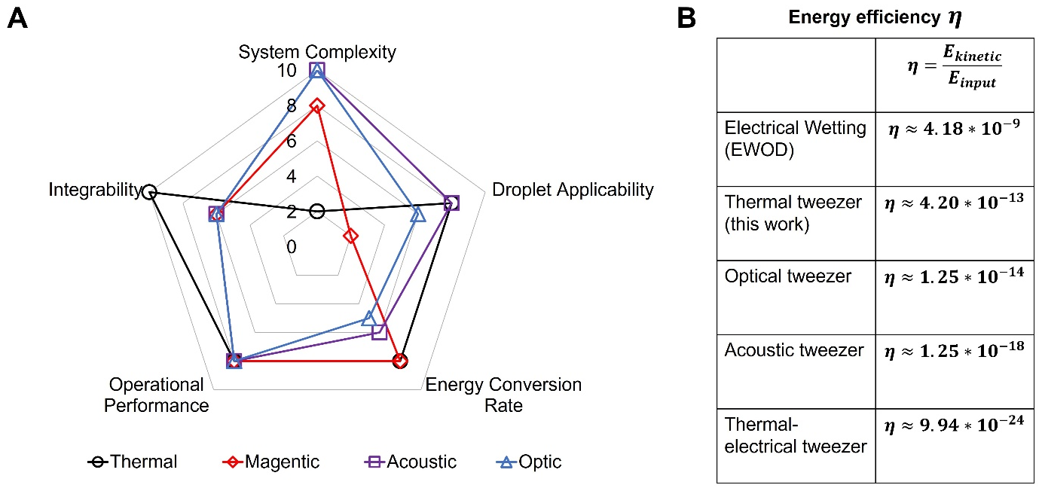
Fig S27. A. Performance evaluation of different types of tweezer devices for droplet manipulation. B, Their respective energy efficiencies. These data were obtained from following literatures covering acoustic tweezers [1, 2], EWOD [3], optical tweezers [4, 5], and thermal electrical tweezers [6]. Compared to magnetic [7], acoustic [8], optical [9], and electrowetting [10], thermal tweezers are non-material-specific, stable, integrable, and provide sufficient force—making them suitable for a wide range of applications from micrometer to millimeter scale with a relatively low technical barrier. Optical tweezers rely on optical gradient forces generated by laser beams to trap and manipulate microscopic particles, requiring complex equipment and specialized training. Acoustic tweezers also generate fluidic flows to move droplets, but the mechanical energy in the liquid introduces heat as a secondary effect, which can interfere with droplet control. Electrowetting and magnetic tweezers are highly material-dependent, limiting their versatility in various biochemistry and tissue engineering experiments. Each droplet-handling technique thus has its own ideal application scenarios. For researchers in synthetic biology, thermal tweezers could stand out for their unique and powerful capabilities, enabling those with a general biological background to quickly master the technique. Furthermore, thermofluidic engineering supports autonomous, thermophilic navigation of cell-sized vesicles and coacervates via thermotaxis [11, 12]. Although not specifically investigated in this work, thermophoresis could potentially be applied to droplet microrobots to control the distribution of smaller components within the liquid compartments.

Table S1. Reagents and components within S30 IVTT system.

Sample name | Units | Starting Concentration | Final Concentration
Cell Extract from E.coli SHuffle T7 | X | 3X | 0.9
Maltose | mM | 100 | 10.8
Amino Acid mix | mM | 13.4 | 2.4
Energy solution | X | 14 | 0.9
Plasmid DNA | nM | 50 | 9
PEG 8000 | %w/v | 16.67 | 1.8
Mg²⁺ glutamate | mM | 200 | Adjusted based on the experimental values
Nuclease free water |  |  | up to final volume

1. Ding, Xiaoyun, et al. "On-chip manipulation of single microparticles, cells, and organisms using surface acoustic waves." Proceedings of the National Academy of Sciences 109.28 (2012): 11105-11109.
2. Tian, Zhenhua, et al. "Wave number–spiral acoustic tweezers for dynamic and reconfigurable manipulation of particles and cells." Science advances 5.5 (2019): eaau6062.
3. Wu, Xingyue, et al. "Research progress of electrode shapes in EWOD-based digital microfluidics." RSC advances 13.25 (2023): 16815-16827.
4. Bolognesi, Guido, et al. "Sculpting and fusing biomimetic vesicle networks using optical tweezers." Nature communications 9.1 (2018): 1882.
5. Zhu, Yuchen, et al. "Optofluidic tweezers: efficient and versatile micro/nano-manipulation tools." Micromachines 14.7 (2023): 1326.
6. Zhang, Kailiang, et al. "Efficient particle and droplet manipulation utilizing the combined thermal buoyancy convection and temperature-enhanced rotating induced-charge electroosmotic flow." Analytica chimica acta 1096 (2020): 108-119.
7. Jiang, Shaojun, et al. "Magnetic Janus origami robot for cross-scale droplet omni-manipulation." Nature Communications 14.1 (2023): 5455.
8. Ozcelik, Adem, et al. "Acoustic tweezers for the life sciences." Nature methods 15.12 (2018): 1021-1028.
9. Erben, Elena, et al. "Opto-fluidically multiplexed assembly and micro-robotics." Light: Science & Applications 13.1 (2024): 59.
10. Teng, Peicheng, et al. "Recent progress of electrowetting for droplet manipulation: from wetting to superwetting systems." Materials Chemistry Frontiers 4.1 (2020): 140-154.
11. Talbot, Emma L., et al. "Thermophoretic migration of vesicles depends on mean temperature and head group chemistry." Nature communications 8.1 (2017): 15351.
12. Kim, Youngsun, and Yuebing Zheng. "Thermophilic Behavior of Heat-Dissociative Coacervate Droplets." Nano Letters 24.50 (2024): 15964-15972.

