Supplementary Materials for

Multimodal Metagenomic Analysis of Bronchoalveolar Lavage Fluid Enables Differential Diagnosis Between Lung Cancer and Pulmonary Infections
Dongsheng Han et al.

This file includes:

Supplementary Text
Figs. S1 to S18
Tables S1 to S3

Other Supplementary Materials for this manuscript include the following:

Data S1 to S3

Supplementary Text

Fig. S1. The steps of the model-building process. Step 1: We used the normalization method included with DESeq2 for batch effect correction and employed both DESeq2 and Lefse as differential analysis methods to identify distinct features in each data type. Step 2: After obtaining all candidate features, we calculated the frequency of features in the training set for each classifier capable of performing feature selection, across different data types. We conducted 1,000 iterations to tally the frequency of each feature's occurrence. Subsequently, we selected the optimal combination of features through sequential forward selection. Step 3: LASSO, SVM, XGBoost, and Random Forest—4 different classifiers and 54 ensemble models of each two classifiers—were used to construct models in the training set for six types of models. Statistical analysis was then performed to identify the optimal classifier/model. Step 4: Finally, we selected the optimal classifier and Model VI for combined rule-in and rule-out predictions, filtering for more accurate diagnostic outcomes.

Fig. S2. Microorganisms found in NC samples and their relative abundance in DNA mNGS data. The boxplot displays the log10-transformed relative abundance of microorganisms. Red (where relative abundance is higher in background samples than in BAL and frequencies were higher than 50% and relative abundances in NCs were higher than 0.1%) and blue (only frequencies were higher than 50% and relative abundances in NCs were higher than 0.1%) labels indicate taxa considered possible contaminant. The differential microorganisms identified in Figure 2 do not correspond entirely to these microorganisms, indicating the reliability of the lung disease-specific microorganisms we have discovered.

Fig. S3. Microorganisms found in NC samples and their relative abundance in DNA mNGS data. The boxplot displays the log10-transformed relative abundance of microorganisms. Red (where relative abundance is higher in background samples than in BAL and frequencies were higher than 50% and relative abundances in NCs were higher than 0.1%) and blue (only frequencies were higher than 50% and relative abundances in NCs were higher than 0.1%) labels indicate taxa considered possible contaminant.

Fig. S4. The alpha (α) diversity measurements of DNA mNGS Data (A) and RNA mNGS Data (B) (Richness/Observed species, ACE, Chao1, Shannon, Simpson and Evenness index) for microbial communities in Pulmonary Infection and Lung Cancer individuals in training cohort. The alpha diversity measurements of DNA mNGS Data (C) and RNA mNGS Data (D) (Richness/Observed species, ACE, Chao1, Shannon, Simpson and Evenness index) for microbial communities in Bacterial Infection, Fungal Infection, Pulmonary Tuberculosis and Lung Cancer individuals. P-values were obtained using Wilcoxon rank-sum test (two-sided). For the boxplots, the central line indicates the median. The lower and upper hinges indicate the first and third quartiles. The lower and upper whiskers extend from the hinge to the smallest and largest values no further than 1.5 * inter-quartile range from the hinge.

Fig. S5. Microbial and bacteriophage composition analyses in BALF RNA mNGS data. A. PCoA based on Bray–Curtis dissimilarity index of microbial and bacteriophage composition in comparing lung cancer and pulmonary infection (single-variable PERMANOVA, P value). PCoA1, principal component 1; PCoA2, principal component 2. B. PCoA based on Bray–Curtis dissimilarity index of microbial and bacteriophage composition in comparing lung cancer and infection subgroups (single-variable PERMANOVA, P value). C. Bubble plot displaying Lefse analysis results and the relative abundance of microorganisms consistently differentially enriched across various pulmonary disease groups. The size of each bubble corresponds to the median relative abundance of statistically significant findings. A red dashed line delineates positive (on the right) and negative (on the left) fold changes. Bubbles indicate statistical significance (adjusted p-value < 0.05). Distinct bubble colors denote different pulmonary diseases, matching the labels atop the bubble graph, illustrating the enrichment of specific species within each pulmonary disease group.

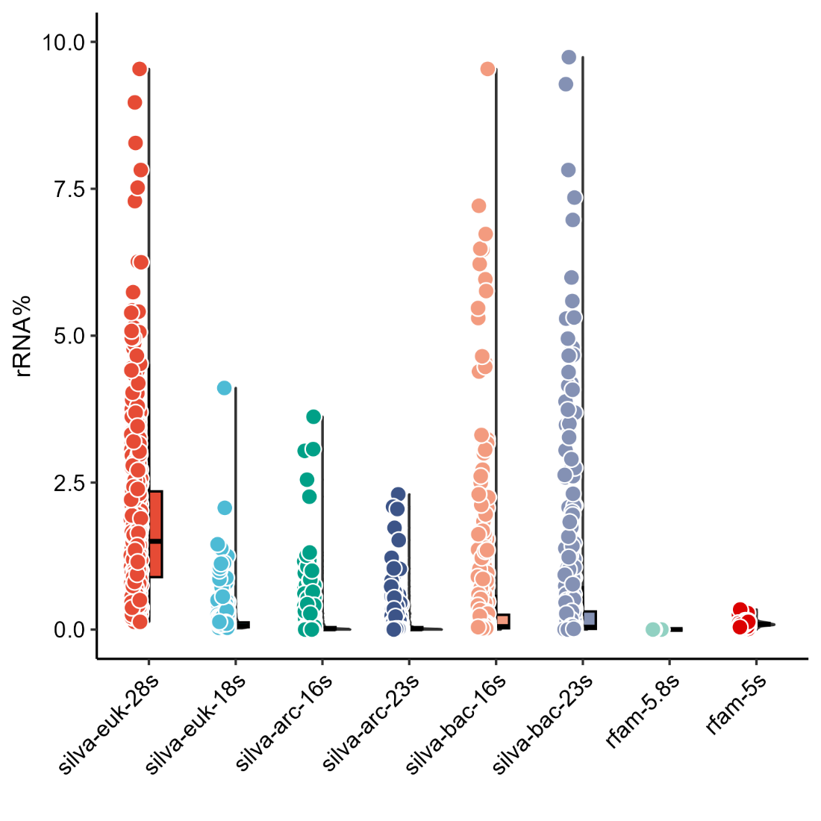
Fig. S6. Ribosomal RNA rate of mNGS RNA data.
Fig. S7. Host transcriptomic response (A-D) and transposable elements (E-H) of BAL in patients among Lung Cancer, Pulmonary Infection (A) bacterial Infection (B), Fungal Infection (C) and Pulmonary Tuberculosis (D). Volcano plots illustrating the differences in gene expression (integrating foldchanges and probabilities) among patients belongs to different groups. Blue dots represent significantly over-expressed genes (p-value < 0.05) in Cancer groups. Horizontal dotted lines indicate the foldchange were 1.5 times either higher or lower. Red dots show significantly overexpressed genes (foldchanges were 1.5 times higher comparing with control groups) in infection group and other sub-groups.

Fig. S8. Heatmap of 42 significantly differential expressed genes encoding cytokines, their receptors and interferon stimulated (A) and 29 significantly differential expressed transposable elements (TE) (B). (Left) Heatmap of DEGs encoding cytokines, their receptors and ISG or TE on average of each group. Plus (+) indicate significant DEGs up regulated in this group. Minus (-) indicate significant DEGs down regulated in this group (p-value < 0.05). (Right) Heatmap of DEGs encoding cytokines, their receptors and ISG or TE of each sample. Gene were classified by ISG, Chemokines, Interleukins, Cytokines and Cytokines receptors. Red triangle represents gene were regulated with same trend in each comparison of Lung Cancer with Pulmonary Infection, Bacterial Infection, Fungal Infection and Pulmonary Tuberculosis.

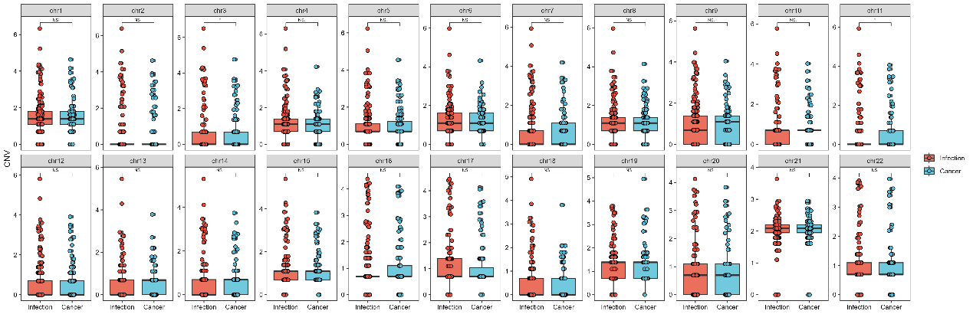
Fig. S9. CNV numbers on each chromosome called by CNVkit between Lung cancer and Pulmonary infection group. Paired Wilcoxon rank sum test was used for continuous variables. *, **, *** represent significance between two groups and N.S. represents no significance between two groups.

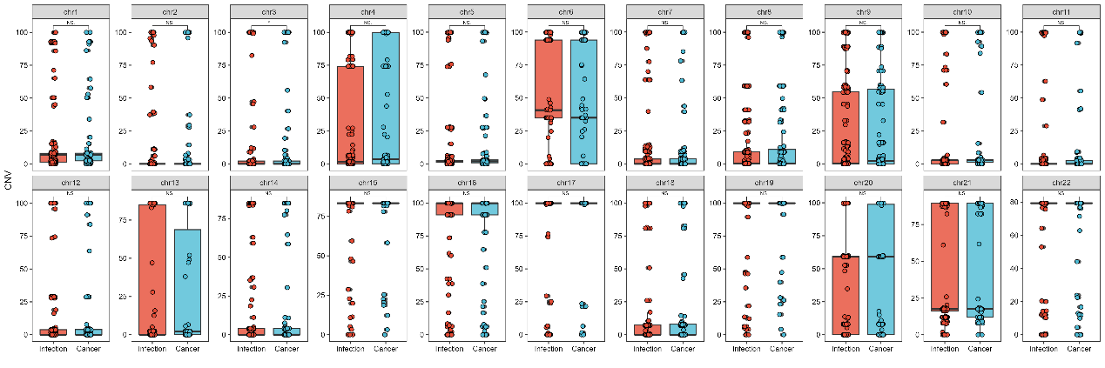
Fig. S10. CNV percentage on each chromosome called by CNVkit between Lung Cancer and Pulmonary Infection group. Paired Wilcoxon rank sum test was used for continuous variables. *, **, *** represent significance between two groups and N.S. represents no significance between two groups.

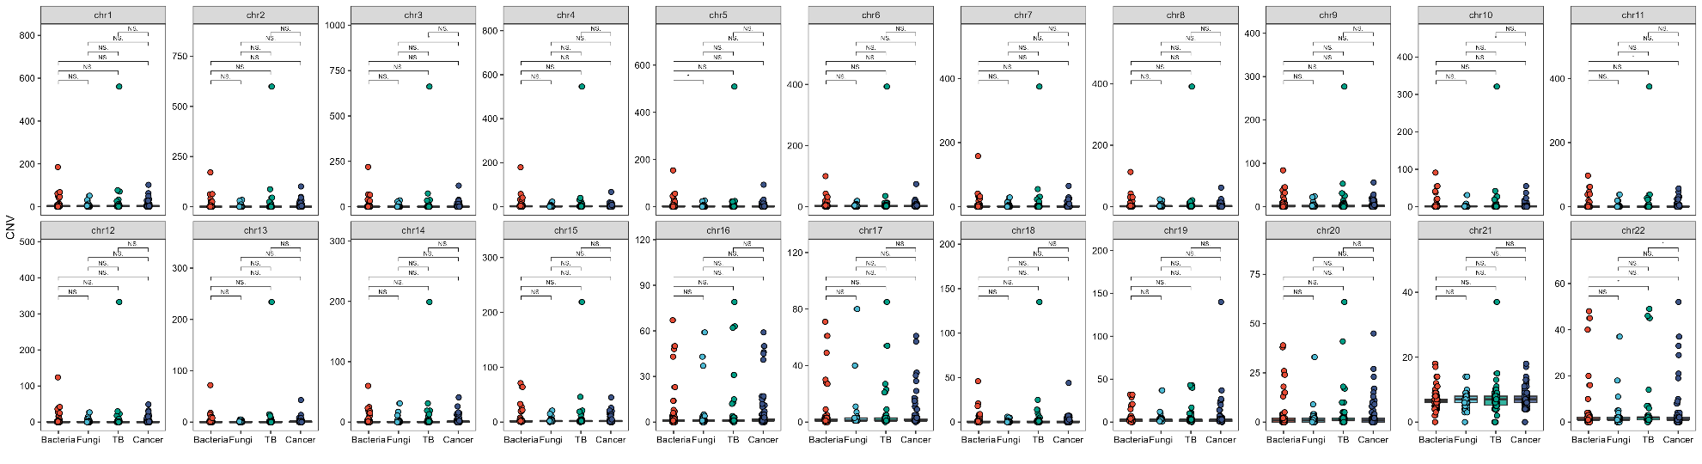
Fig. S11. CNV numbers on each chromosome called by CNVkit among Lung Cancer, Bacterial Infection, Fungal Infection and Pulmonary Tuberculosis. Paired Wilcoxon rank sum test was used for continuous variables of each two-group comparison. *, **, *** represent significance between two groups and N.S. represents no significance between two groups.

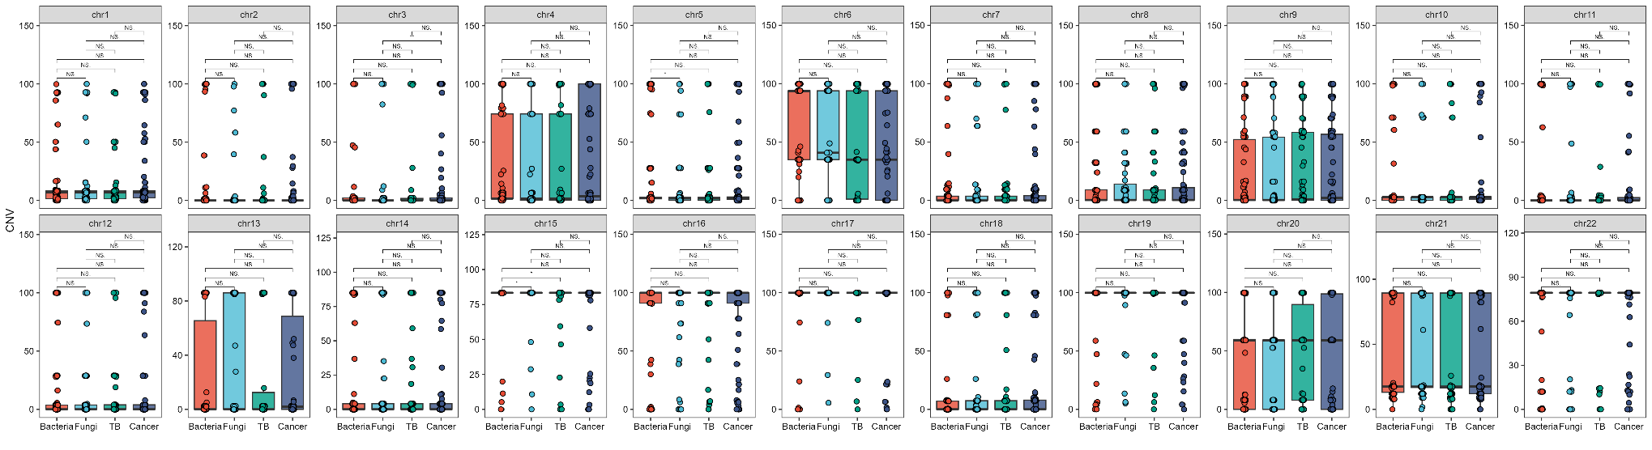
Fig. S12. CNV percentage on each chromosome called by CNVkit among Lung Cancer, Bacterial Infection, Fungal Infection and Pulmonary Tuberculosis. Paired Wilcoxon rank sum test was used for continuous variables of each two-group comparison. *, **, *** represent significance between two groups and N.S. represents no significance between two groups.
Fig. S13. A. The ichorCNA Tumor Fraction values between Lung Cancer and Pulmonary Infection group. Paired Wilcoxon rank sum test was used for continuous variables. B. The ichorCNA Tumor Fraction values among Lung Cancer, Bacterial Infection, Fungal Infection and Pulmonary Tuberculosis. Paired Wilcoxon rank sum test was used for continuous variables of each two-group comparison. C. The ESTIMATE values between Lung Cancer and Pulmonary Infection. Paired Wilcoxon rank sum test was used for continuous variables. Paired Wilcoxon rank sum test was used for continuous variables. *, **, *** represent significance between two groups and N.S. represents no significance between two groups. D. The ESTIMATE values among Lung Cancer, Bacterial Infection, Fungal Infection and Pulmonary Tuberculosis. Paired Wilcoxon rank sum test was used for continuous variables of each two-group comparison. *, **, *** represent significance between two groups and N.S. represents no significance between two groups.

Fig. S14. A total of 58 prediction models (4 individual machine learning models: LASSO, Random Forest, XGboost and Support Vector Machine and 54 ensemble models) via Model I further calculated AUC of each model across all comparisons in validation datasets. Red label indicated the model with highest average AUC of all comparison.

Fig. S15. A total of 58 prediction models (4 individual machine learning models: LASSO, Random Forest, XGboost and Support Vector Machine and 54 ensemble models) via Model II further calculated AUC of each model across all comparisons in validation datasets. Red label indicated the model with highest average AUC of all comparison.

Fig. S16. A total of 58 prediction models (4 individual machine learning models: LASSO, Random Forest, XGboost and Support Vector Machine and 54 ensemble models) via Model III further calculated AUC of each model across all comparisons in validation datasets. Red label indicated the model with highest average AUC of all comparison.

Fig. S17. A total of 58 prediction models (4 individual machine learning models: LASSO, Random Forest, XGboost and Support Vector Machine and 54 ensemble models) via Model IV further calculated AUC of each model across all comparisons in validation datasets. Red label indicated the model with highest average AUC of all comparison.

Fig. S18. A total of 58 prediction models (4 individual machine learning models: LASSO, Random Forest, XGboost and Support Vector Machine and 54 ensemble models) via Model V further calculated AUC of each model across all comparisons in validation datasets. Red label indicated the model with highest average AUC of all comparison.

Group | Euk-28s | Euk-18s | Arc-16s | Arc-23s | Bac-16s | Bac-23s | rfam-5.8s | rfam-5s | Euk-ribosome | Total
Bacterial infection | 1.64[1.01, 2.92] | 0.08[0.05, 0.15] | 0.05[0, 0.17] | 0.03[0, 0.12] | 0.29[0.05, 1.24] | 0.32[0.03, 1.33] | 0[0, 0] | 0.1[0.08, 0.11] | 1.83[1.12, 3.01] | 3.21[1.92, 5.85]
Fungal infection | 1.32[0.58, 2.16] | 0.07[0.04, 0.14] | 0[0, 0.01] | 0[0, 0.01] | 0.03[0.02, 0.09] | 0.01[0, 0.08] | 0[0, 0] | 0.08[0.07, 0.11] | 1.48[0.75, 2.32] | 1.75[1.12, 2.73]
Lung cancer | 1.84[1.06, 2.6] | 0.06[0.04, 0.11] | 0.01[0, 0.03] | 0.01[0, 0.04] | 0.06[0.02, 0.25] | 0.05[0.01, 0.29] | 0[0, 0] | 0.09[0.07, 0.11] | 1.95[1.3, 2.66] | 2.65[1.72, 4.05]
Pulmonary tuberculosis | 1.29[1.06, 2.6] | 0.05[0.04, 0.11] | 0[0, 0.03] | 0[0, 0.03] | 0.03[0.02, 0.23] | 0.02[0.01, 0.26] | 0[0, 0] | 0.09[0.07, 0.11] | 1.37[1.3, 2.66] | 1.63[1.72, 4.05]
Total | 1.53[0.89, 2.45] | 0.06[0.04, 0.12] | 0.01[0, 0.04] | 0.01[0, 0.04] | 0.06[0.02, 0.27] | 0.04[0.01, 0.35] | 0[0, 0] | 0.09[0.07, 0.11] | 1.66[1.01, 2.62] | 2.3[1.38, 3.98]

Table S1. Ribosomal RNA rate (%) of different pulmonary disease groups
Group | Mapping reads (M reads) | Host rate (%)
Bacterial infection | 18.82[14.98, 22.48] | 98.1[96.94, 98.54]
Fungal infection | 20.34[16.71, 24.84] | 98.4[97.74, 98.74]
Lung cancer | 18.89[15.48, 23.77] | 98.22[96.67, 98.63]
Pulmonary tuberculosis | 19.36[16.73, 23.35] | 98.43[97.76, 98.74]
Total | 19.23[15.95, 23.66] | 98.22[97.46, 98.66]

Table S2. Host rate (%) and mapping reads of different pulmonary disease groups in DNA mNGS data

Groups | Model | Ensemble Learning | Dataset | AUC | 95% CI | Sensitivity | Specificity
Lung Cancer  vs Pulmonary Infection | Model1 | 0.1*Lasso+0.9*SVM | Train set | 0.645 | [0.577, 0.713] | 0.609 | 0.614
Lung Cancer  vs Pulmonary Infection | Model2 | 0.3*RF+0.7*XGBoost | Train set | 0.772 | [0.713, 0.831] | 0.736 | 0.706
Lung Cancer  vs Pulmonary Infection | Model3 | 0.3*Lasso+0.7*RF | Train set | 0.911 | [0.876, 0.946] | 0.816 | 0.853
Lung Cancer  vs Pulmonary Infection | Model4 | 0.2*Lasso+0.8*SVM | Train set | 0.591 | [0.513, 0.669] | 0.517 | 0.731
Lung Cancer  vs Pulmonary Infection | Model5 | 0.9*Lasso+0.1*XGBoost | Train set | 0.526 | [0.444, 0.609] | 0.425 | 0.782
Lung Cancer  vs Pulmonary Infection | Model6 | 0.3*Lasso+0.7*RF | Train set | 0.937 | [0.91, 0.964] | 0.92 | 0.812
Lung Cancer  vs Pulmonary Infection | Model1 | 0.1*Lasso+0.9*SVM | Validation set | 0.743 | [0.659, 0.827] | 0.472 | 0.866
Lung Cancer  vs Pulmonary Infection | Model2 | 0.3*RF+0.7*XGBoost | Validation set | 0.595 | [0.488, 0.702] | 0.889 | 0.354
Lung Cancer  vs Pulmonary Infection | Model3 | 0.3*Lasso+0.7*RF | Validation set | 0.845 | [0.77, 0.92] | 0.667 | 0.89
Lung Cancer  vs Pulmonary Infection | Model4 | 0.2*Lasso+0.8*SVM | Validation set | 0.604 | [0.497, 0.712] | 0.806 | 0.451
Lung Cancer  vs Pulmonary Infection | Model5 | 0.9*Lasso+0.1*XGBoost | Validation set | 0.54 | [0.44, 0.641] | 0.361 | 0.756
Lung Cancer  vs Pulmonary Infection | Model6 | 0.3*Lasso+0.7*RF | Validation set | 0.847 | [0.776, 0.918] | 0.944 | 0.61
Lung Cancer  vs Bacterial Infection | Model1 | 0.1*Lasso+0.9*SVM | Train set | 0.729 | [0.649, 0.808] | 0.816 | 0.65
Lung Cancer  vs Bacterial Infection | Model2 | 0.3*RF+0.7*XGBoost | Train set | 0.753 | [0.678, 0.828] | 0.759 | 0.688
Lung Cancer  vs Bacterial Infection | Model3 | 0.3*Lasso+0.7*RF | Train set | 0.922 | [0.883, 0.962] | 0.885 | 0.85
Lung Cancer  vs Bacterial Infection | Model4 | 0.2*Lasso+0.8*SVM | Train set | 0.589 | [0.503, 0.676] | 0.563 | 0.637
Lung Cancer  vs Bacterial Infection | Model5 | 0.9*Lasso+0.1*XGBoost | Train set | 0.537 | [0.448, 0.626] | 0.46 | 0.713
Lung Cancer  vs Bacterial Infection | Model6 | 0.3*Lasso+0.7*RF | Train set | 0.925 | [0.886, 0.963] | 0.828 | 0.887
Lung Cancer  vs Bacterial Infection | Model1 | 0.1*Lasso+0.9*SVM | Validation set | 0.801 | [0.696, 0.906] | 0.889 | 0.676
Lung Cancer  vs Bacterial Infection | Model2 | 0.3*RF+0.7*XGBoost | Validation set | 0.766 | [0.658, 0.874] | 0.639 | 0.765
Lung Cancer  vs Bacterial Infection | Model3 | 0.3*Lasso+0.7*RF | Validation set | 0.85 | [0.762, 0.937] | 0.667 | 0.882
Lung Cancer  vs Bacterial Infection | Model4 | 0.2*Lasso+0.8*SVM | Validation set | 0.572 | [0.434, 0.71] | 0.611 | 0.647
Lung Cancer  vs Bacterial Infection | Model5 | 0.9*Lasso+0.1*XGBoost | Validation set | 0.551 | [0.469, 0.633] | 0.194 | 0.912
Lung Cancer  vs Bacterial Infection | Model6 | 0.3*Lasso+0.7*RF | Validation set | 0.847 | [0.756, 0.938] | 0.806 | 0.824
Lung Cancer  vs Fungal Infection | Model1 | 0.1*Lasso+0.9*SVM | Train set | 0.701 | [0.614, 0.788] | 0.598 | 0.732
Lung Cancer  vs Fungal Infection | Model2 | 0.3*RF+0.7*XGBoost | Train set | 0.788 | [0.713, 0.864] | 0.908 | 0.536
Lung Cancer  vs Fungal Infection | Model3 | 0.3*Lasso+0.7*RF | Train set | 0.987 | [0.976, 0.999] | 0.989 | 0.893
Lung Cancer  vs Fungal Infection | Model4 | 0.2*Lasso+0.8*SVM | Train set | 0.559 | [0.464, 0.654] | 0.517 | 0.661
Lung Cancer  vs Fungal Infection | Model5 | 0.9*Lasso+0.1*XGBoost | Train set | 0.554 | [0.455, 0.653] | 0.632 | 0.589
Lung Cancer  vs Fungal Infection | Model6 | 0.3*Lasso+0.7*RF | Train set | 0.996 | [0.99, 1] | 0.989 | 0.964
Lung Cancer  vs Fungal Infection | Model1 | 0.1*Lasso+0.9*SVM | Validation set | 0.851 | [0.761, 0.942] | 0.917 | 0.609
Lung Cancer  vs Fungal Infection | Model2 | 0.3*RF+0.7*XGBoost | Validation set | 0.775 | [0.658, 0.893] | 0.694 | 0.87
Lung Cancer  vs Fungal Infection | Model3 | 0.3*Lasso+0.7*RF | Validation set | 0.86 | [0.764, 0.956] | 0.778 | 0.826
Lung Cancer  vs Fungal Infection | Model4 | 0.2*Lasso+0.8*SVM | Validation set | 0.638 | [0.488, 0.787] | 0.5 | 0.783
Lung Cancer  vs Fungal Infection | Model5 | 0.9*Lasso+0.1*XGBoost | Validation set | 0.592 | [0.464, 0.72] | 0.167 | 1
Lung Cancer  vs Fungal Infection | Model6 | 0.3*Lasso+0.7*RF | Validation set | 0.872 | [0.78, 0.964] | 0.944 | 0.696
Lung Cancer  vs Tuberculosis | Model1 | 0.1*Lasso+0.9*SVM | Train set | 0.713 | [0.629, 0.798] | 0.977 | 0.426
Lung Cancer  vs Tuberculosis | Model2 | 0.3*RF+0.7*XGBoost | Train set | 0.75 | [0.664, 0.835] | 0.851 | 0.59
Lung Cancer  vs Tuberculosis | Model3 | 0.3*Lasso+0.7*RF | Train set | 0.951 | [0.921, 0.981] | 0.874 | 0.918
Lung Cancer  vs Tuberculosis | Model4 | 0.2*Lasso+0.8*SVM | Train set | 0.711 | [0.628, 0.794] | 0.575 | 0.82
Lung Cancer  vs Tuberculosis | Model5 | 0.9*Lasso+0.1*XGBoost | Train set | 0.521 | [0.418, 0.624] | 0.828 | 0.377
Lung Cancer  vs Tuberculosis | Model6 | 0.3*Lasso+0.7*RF | Train set | 0.961 | [0.935, 0.986] | 0.897 | 0.918
Lung Cancer  vs Tuberculosis | Model1 | 0.1*Lasso+0.9*SVM | Validation set | 0.716 | [0.6, 0.833] | 0.972 | 0.36
Lung Cancer  vs Tuberculosis | Model2 | 0.3*RF+0.7*XGBoost | Validation set | 0.626 | [0.483, 0.769] | 0.639 | 0.68
Lung Cancer  vs Tuberculosis | Model3 | 0.3*Lasso+0.7*RF | Validation set | 0.914 | [0.846, 0.983] | 0.944 | 0.72
Lung Cancer  vs Tuberculosis | Model4 | 0.2*Lasso+0.8*SVM | Validation set | 0.521 | [0.371, 0.671] | 0.417 | 0.76
Lung Cancer  vs Tuberculosis | Model5 | 0.9*Lasso+0.1*XGBoost | Validation set | 0.557 | [0.433, 0.68] | 0.417 | 0.72
Lung Cancer  vs Tuberculosis | Model6 | 0.3*Lasso+0.7*RF | Validation set | 0.909 | [0.838, 0.979] | 0.917 | 0.76

Table S3. Performance of different models to classify lung cancer and infection

Data S1. (separate file)
Microbiological results and malignancy diagnosis by cytology/flow cytometry/Pathological results of pulmonary disease patients.

Data S2. (separate file)
Features of Model I-VI among all classifiers.

Data S3. (separate file)
Microbiological results and diagnosis of Negative Control patients.

