Table 1: Baseline characteristics

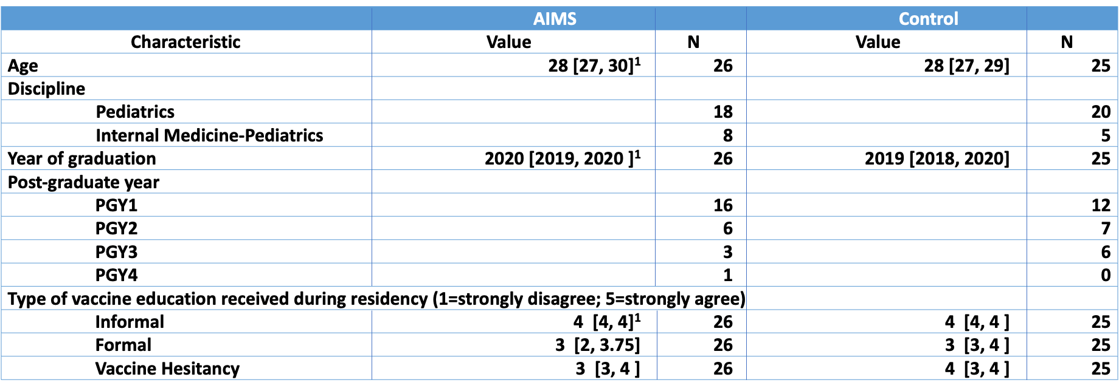

Table 1 caption: baseline characteristics of enrolled residents.
PGY: postgraduate year
¹Values are median [interquartile range]

