Supplementary Information

Kidney Tumoroid Characterisation by Spatial Mass Spectrometry with Same-Section Multiplex Immunofluorescence Uncovers Tumour Microenvironment Lipid Signatures Associated with Aggressive Tumour Phenotypes

Supplementary Table S1 Kidney cancer cases used in generation of patient-derived tumoroids. Abbreviations: ISUP - International Society of Urological Pathology, ccRCC - clear cell renal cell carcinoma, pRCC - papillary renal cell carcinoma and ChRCC - chromophobe renal cell carcinoma, NA – not applicable.
Case ID | Sex | Age | Histology | ISUP Grade | T Stage | Leibovich
SR1040-512 | Male | 59 | ccRCC | G4 | pT3b | 8
SR1040-519 | Female | 78 | pRCC | G2 | pT1b | 2
SR1040-520 | Female | 79 | ccRCC | G4 | pT3a | 9
SR1040-561 | Female | 74 | ccRCC | G3 | pT3a | 5
SR1040-602 | Male | 76 | ccRCC | G3 | pT3b | 6
SR1040-610 | Male | 73 | ChRCC | NA | pT3a | NA
SR1040-621 | Female | 59 | ccRCC | G2 | pT3a | 5
SR1040-622 | Female | 79 | ccRCC | G2 | pT3a | 4

Supplementary Figures

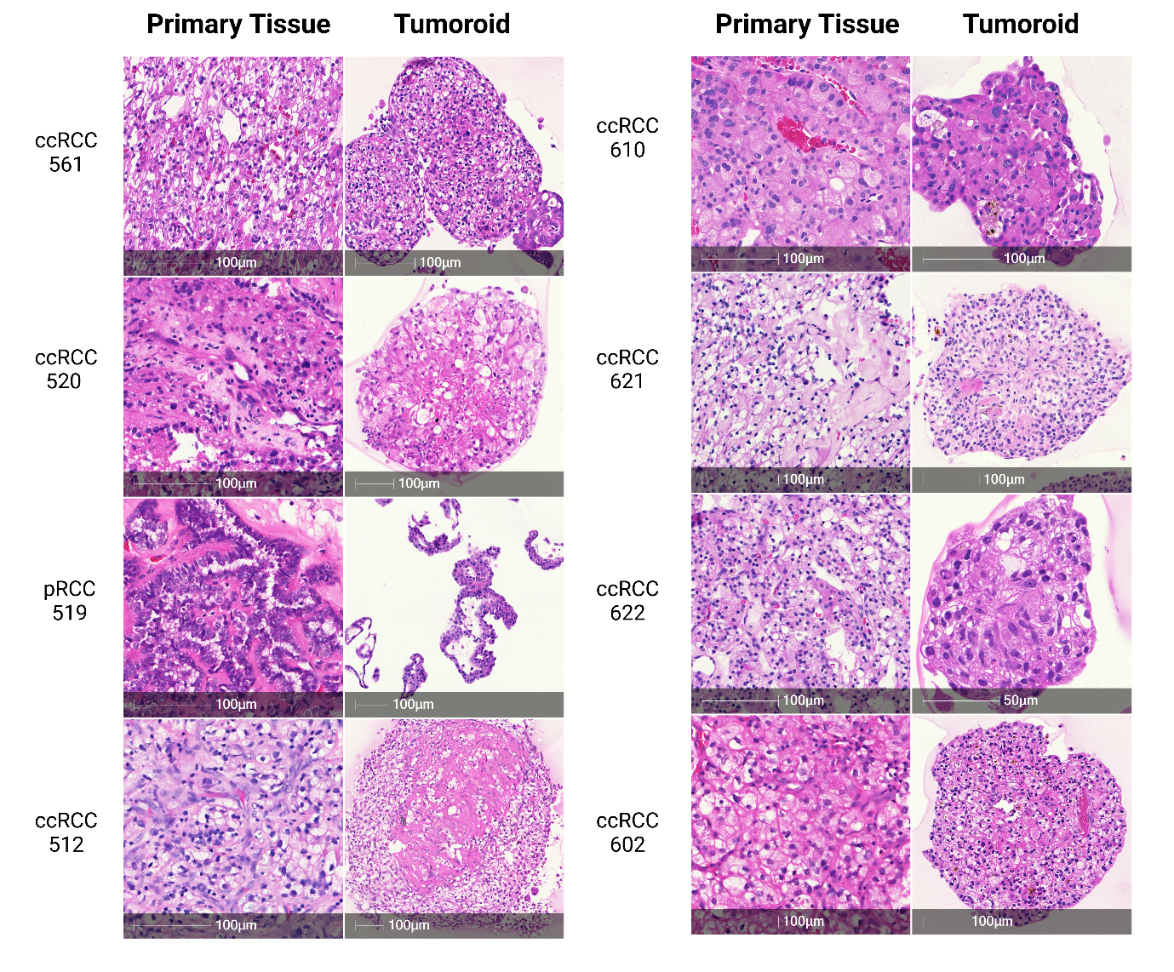
Figure S1 Examples of successful tumoroid formation. H&E images of FFPE sections of patient tissue and tumoroids (n=4 shown).

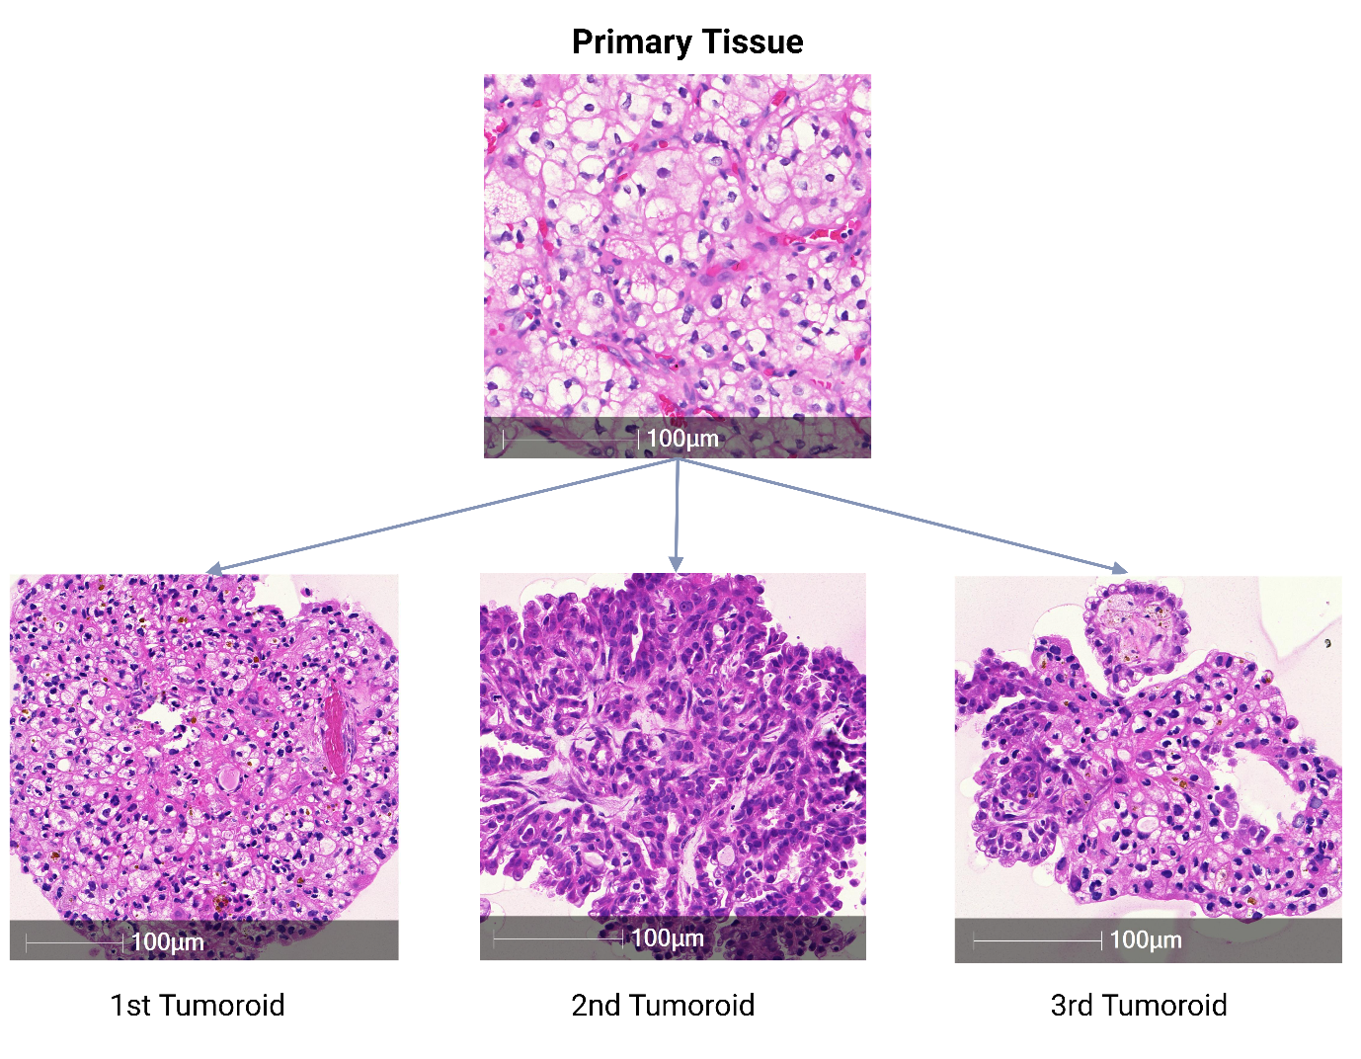
Figure S2 H&E images of multiple tumoroids from the same parent tissue. Histological analysis of n=1 FFPE section, shows intra-heterogeneity of tumoroids derived from the same patient.

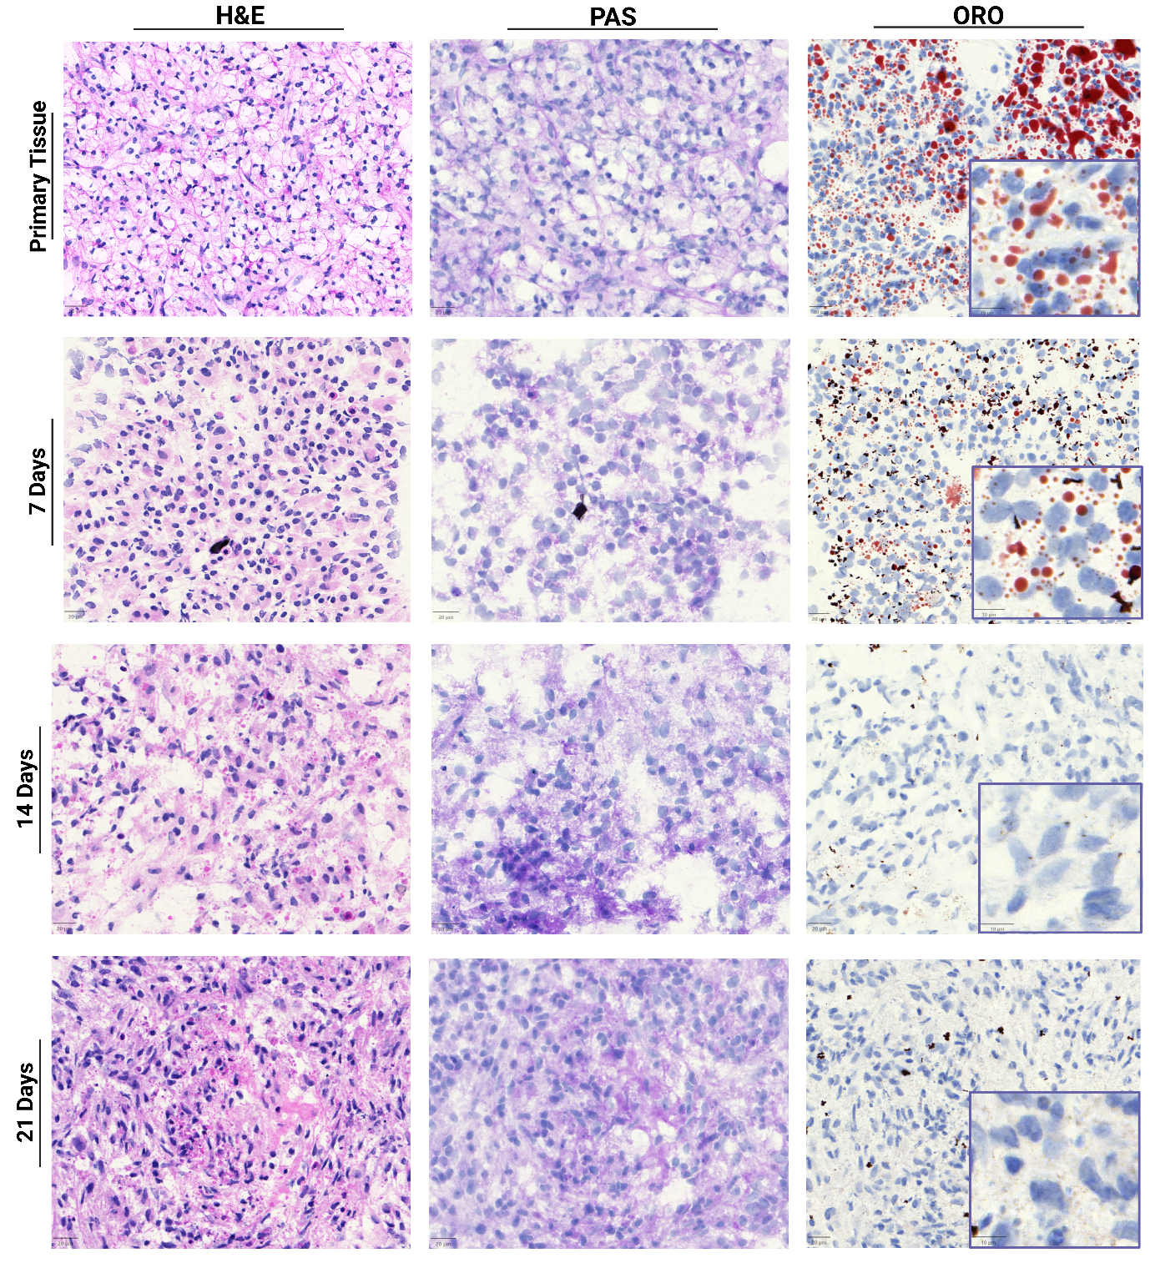
Figure S3 H&E, PAS and ORO Histochemical staining of tumoroids harvested at Day 7, 14 and 21. Neutral lipid and glycogen accumulation in patient-derived ccRCC tumour tissue and cultured tumoroids. Cultured tumoroids presented a time dependent accumulation of glycogen and depletion of neutral lipids.

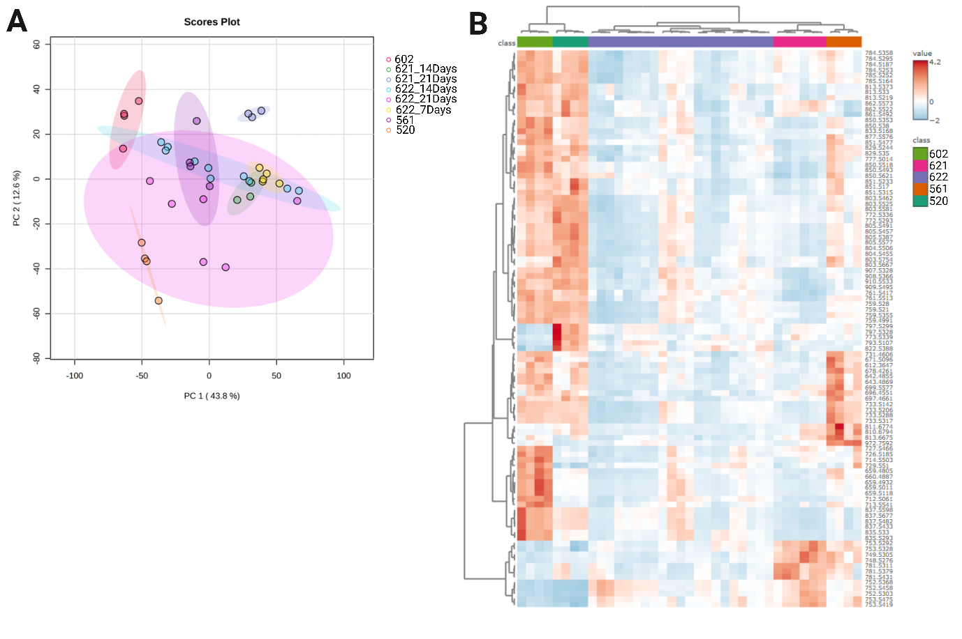
Figure S4 Metabolic and lipidomic heterogeneity in ccRCC patient-derived tumoroids. (A) PCA scores plot of lipidomic analysis of ccRCC tumoroids derived from five patients showing intra-cases heterogeneity with culture time in cases 621 and 622. (B) Heatmap of lipidomic heterogeneity among tumoroid cases (data presented individually for each ROI).

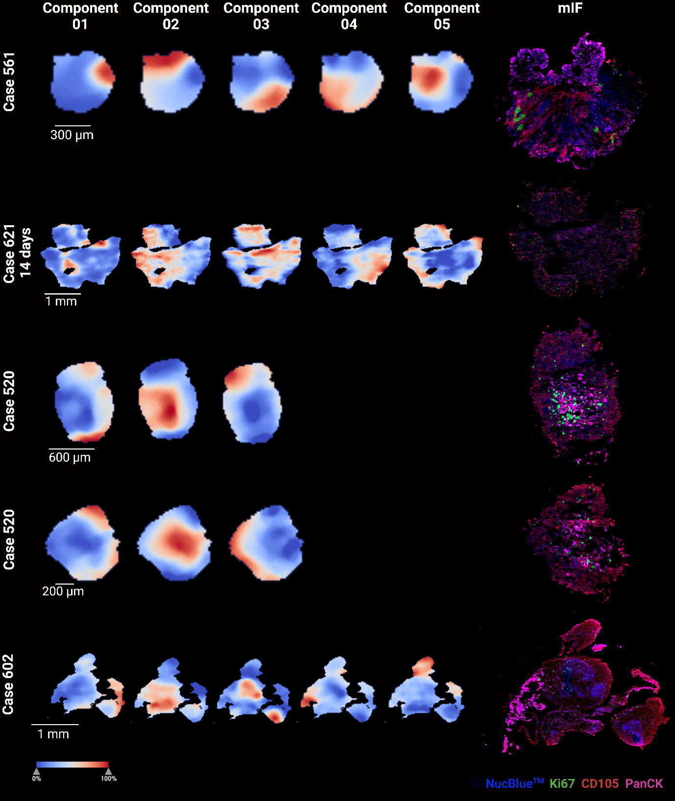
Figure S5 Metabolite and lipid-driven pLSA analysis of tumoroids. pLSA of cases 561, 621, 520 and 602 and their corresponding immunofluorescence (mIF) images showing cells positive for Ki67 (green marker), CD105 (red marker) and PanCK (pink marker). NucBlue™ - nuclear marker.
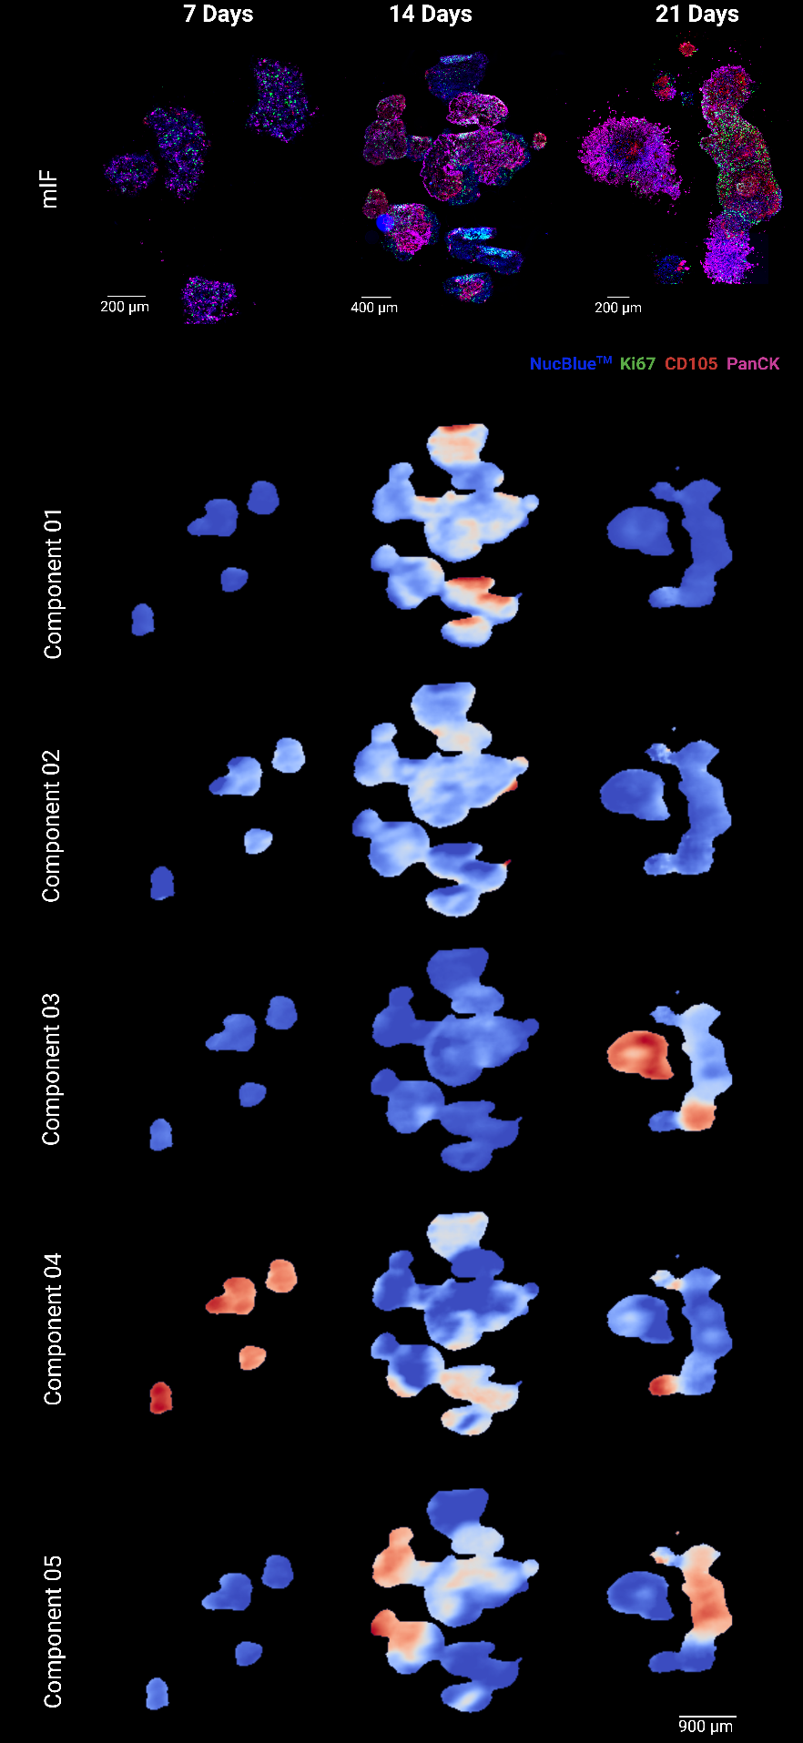
Figure S6 Metabolite and lipid-driven pLSA analysis of tumoroids from case 622. Tumoroids collected at 7, 14 and 21 days of culture and their corresponding immunofluorescence (mIF) images showing cells positive for Ki67 (green marker), CD105 (red marker) and PanCK (pink marker). NucBlue™ - nuclear marker.

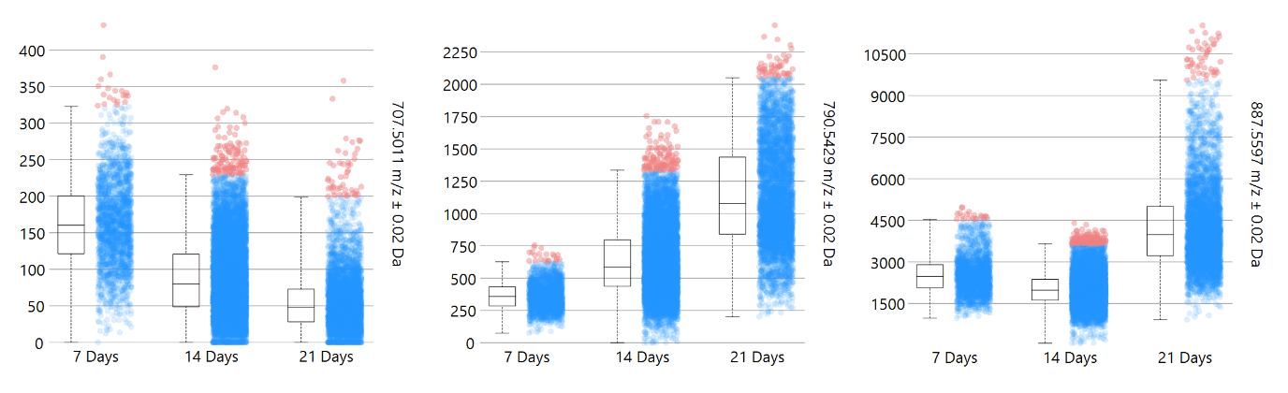
Figure S7 Expression levels of representative lipids in tumoroids of case 622 cultured over a period of 7 to 21 days.

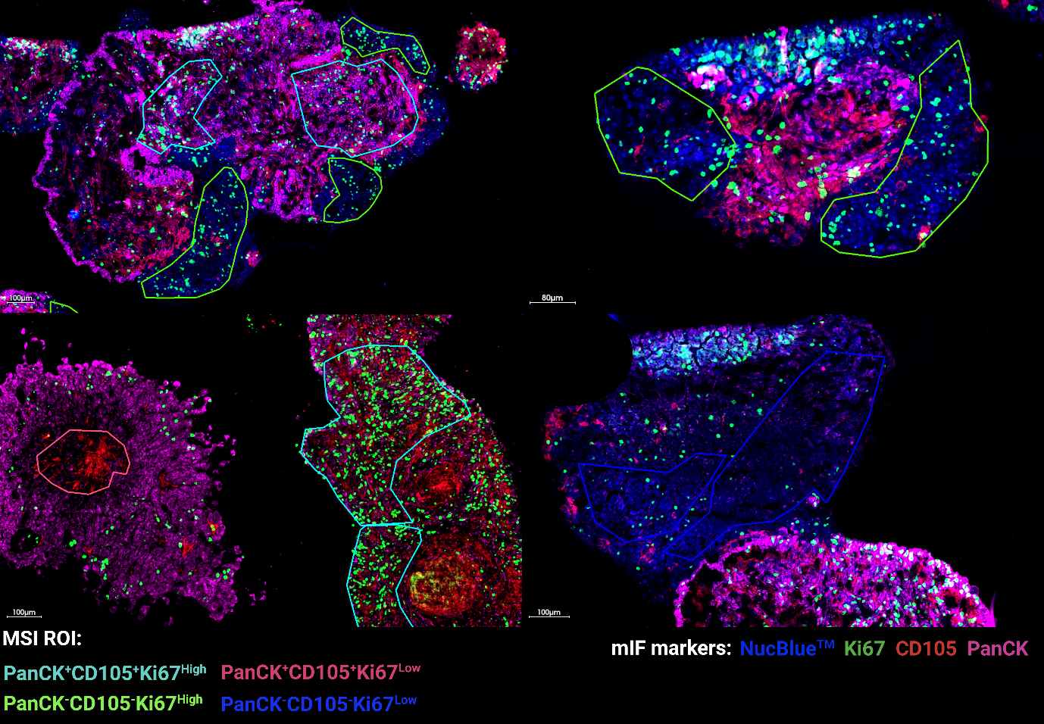
Figure S8 Representative regions of interest selected for guiding metabolomics data analysis based on the expression of protein markers CD105 (endothelial cells, red marker), Pan-cytokeratin (PanCK, pink marker) and Ki67 (proliferation, green marker). Data corresponds to case 622. mIF performed on the same section post-DESI-MSI analysis.

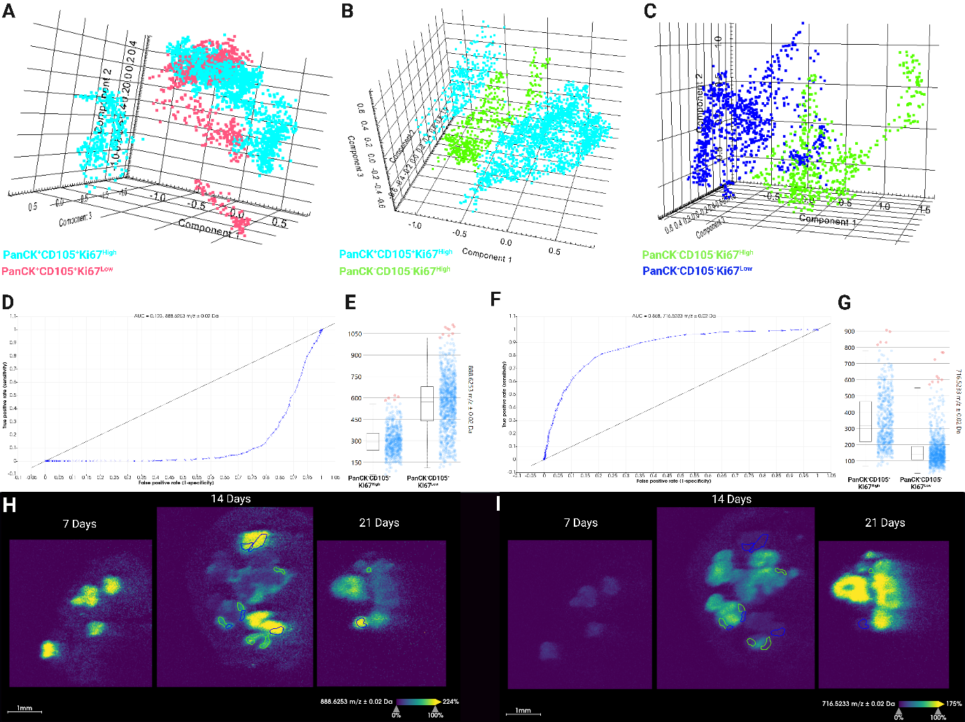
Figure S9 Lipidomic differences between selected regions of interest based on the expression of protein markers CD105, Pan-cytokeratin (PanCK, epithelial cells) and Ki67 (proliferation) in case 622. (A- C) PCA scores plot of lipidomic analysis of ccRCC tumoroids visualising differences of lipid profile based on the expression of PanK, CD105 and Ki67. (D, F) Example AUC-ROC plot for m/z 888.6253 and 716.5233. (E) Ion intensity box plot of m/z 888.6253 and (H) ion image. (G) Ion intensity box plot of m/z 716.5233 and (I) ion image.
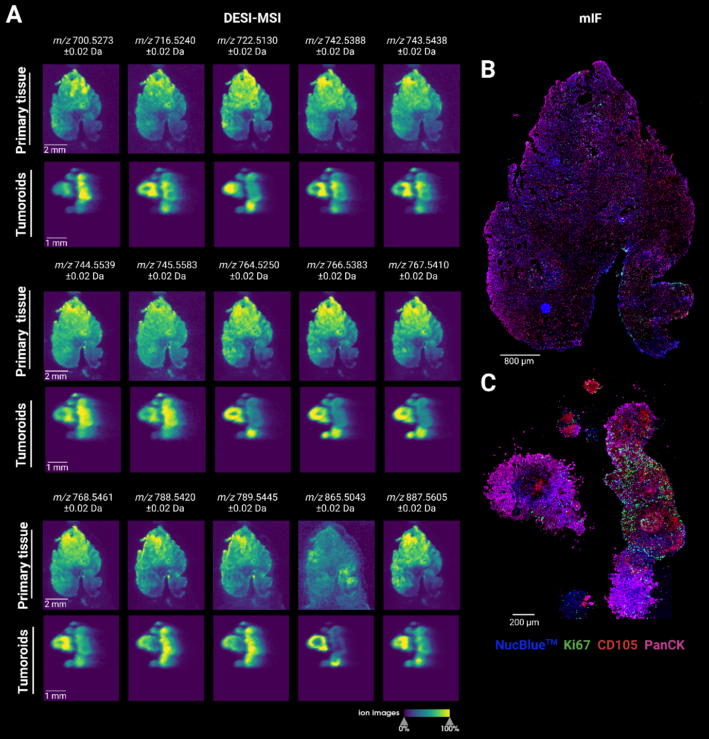
Figure S10 DESI-MSI and mIF analysis of primary tissue and derived tumoroids. (A) DESI-MS ion images of lipids identified in regions of di-differentiation and higher PanCK expression in case 622 patient tissue and its respective derived tumoroids. mIF images of (B) patient tissue and (C) tumoroids. CD105 (endothelial cells, red marker), Pan-cytokeratin (PanCK, pink) and Ki67 (proliferation, green).

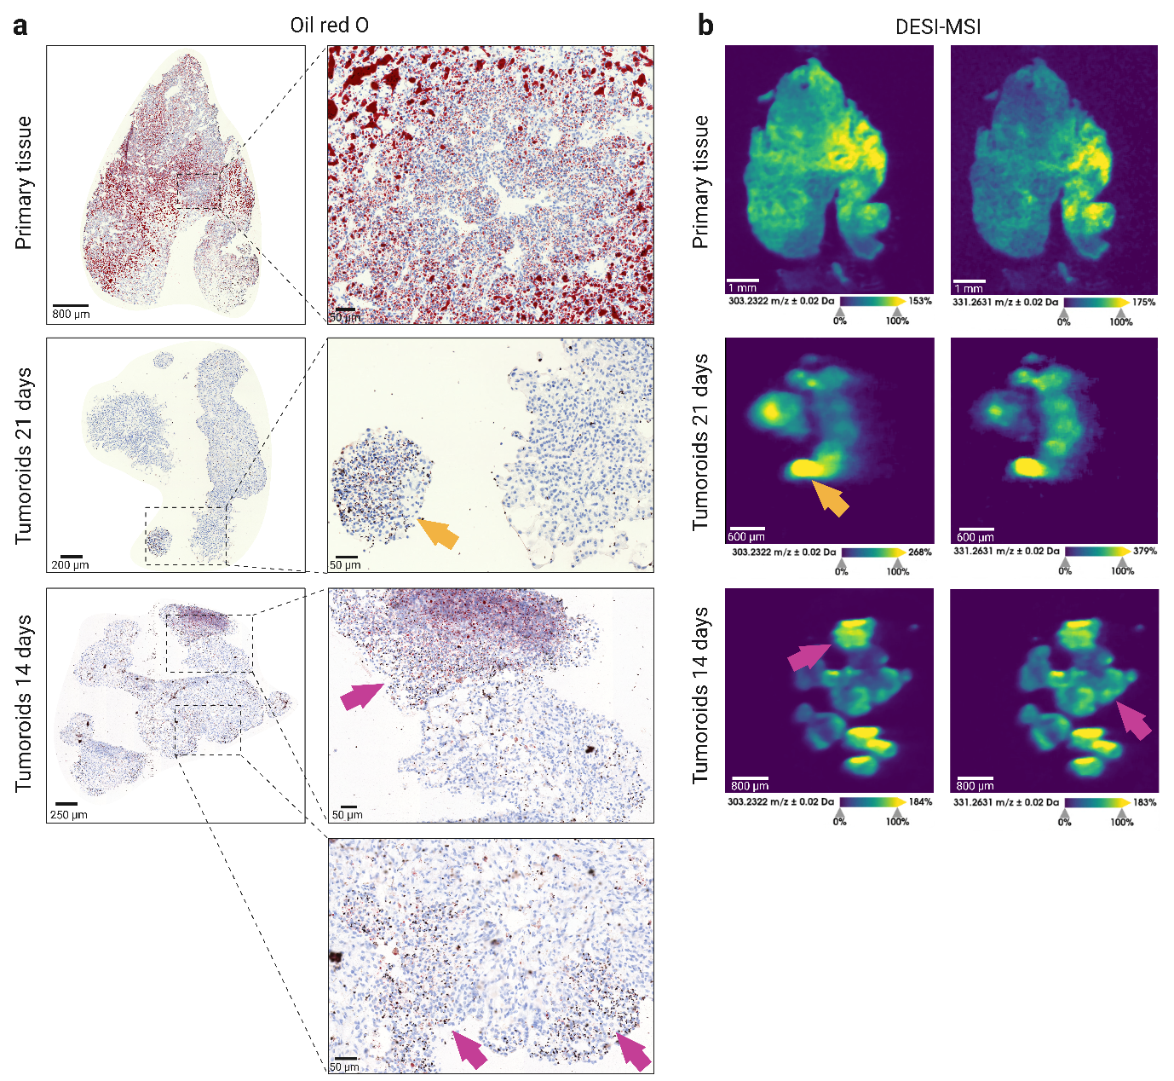
Figure S11 ORO Histochemical analysis and Fatty acid analysis of primary tissue and tumoroids at 14 and 21 days. Fatty acid abundance, particularly long-chain fatty acids, correlating with reduced LDs.

Table S2 Molecules identified in CD105⁺ regions in tumoroids of case 561 and 622
m/z | Matched m/z | ppm error | Ion | Molecule | Class | Case 561 | Case 622
124.007 | 124.0074 | -3.226 | [M-H]- | Taurine | Small metabolites | Yes | No
218.1027 | 218.1034 | -3.209 | [M-H]- | Pantothenic acid | Small metabolites | Yes | In 14 days
237.0912 | 237.0915 | -1.265 | [M-H]- | 15(R)-hydroperoxy-EPE (HEPES) | - | Yes | -
722.5125 | 722.5130 | -0.692 | [M-H]- | PE P-(16:0/20:4)* | PE | Yes | Yes
746.5154 | 746.513 | 3.215 | [M-H]- | PE O-38:7 | PE | Yes | Yes
773.5337 | 773.5338 | -0.129 | [M-H]- | PG 36:2 | PG | Yes | Yes
774.5392 | 774.5443 | -6.585 | [M-H]- | PE O-40:7 | PE | Yes | Yes
775.5445 | 775.5495 | -6.447 | [M-H]- | PG 36:1 | PG | Yes | Yes
776.5518 | 776.5447 | 9.143 | [M-H]- | PS 35:0 | PS | Yes | Yes
790.5411 | 790.5392 | 2.403 | [M-H]- | PE 40:6 | PE | Yes | Yes
792.5502 | 792.5549 | -5.930 | [M-H]- | PE 40:5 | PE | Yes | Yes
795.5414 | 795.5393 | 2.640 | [M-H]- | PI O-32:0 | PI | Yes | Not seen
796.5258 | 796.5265 | -0.879 | [M+Cl]- | PS O-35:1 | PS | Yes | No
817.5074 | 817.5025 | 5.994 | [M-H]- | PG 40:8 | PG | Yes | No
817.5214 | 817.5236 | -2.691 | [M-H]- | PI O-34:3 | PI | Yes | Not seen
819.5184 | 819.5182 | 0.244 | [M-H]- | PG 40:7 | PG | Yes | No
820.5269 | 820.5265 | 0.487 | [M+Cl]- | PS O-37:3 | PS | Yes | No
838.5609 | 838.5604 | 0.596 | [M-H]- | PS 40:4 | PS | Yes | Yes
841.5049 | 841.5025 | 2.852 | [M-H]- | PG 42:10 | PG | Yes | No
842.512 | 842.5108 | 1.424 | [M+Cl]- | PE 40:6;O | PE | Yes | No
843.5191 | 843.5182 | 1.067 | [M-H]- | PG 42:9 | PG | Yes | No
845.5334 | 845.5338 | -0.473 | [M-H]- | PG 42:8 | PG | Yes | No
865.5043 | 865.5025 | 2.080 | [M-H]- | PG 44:12 | PG | Yes | No
867.5181 | 867.516 | 2.421 | [M+Cl]- | PI O-35:3 | PI | Yes | No
*Confirmed by MS/MS experiment

Table S3 Molecules identified in PanCK⁺ regions in tumoroids of case 561 and 622.
m/z | Matched m/z | ppm error | Ion | Molecule | Class | Case 561 | Case 622
700.5273 | 700.529 | -1.998 | [M-H]- | PE O-34:2 | PE | Yes | Yes
716.5239 | 716.524 | 0.419 | [M-H]- | PE 34:1 | PE | Yes | Yes
722.5125 | 722.5130 | -0.692 | [M-H]- | PE P-(16:0/20:4)* | PE | Yes | Yes
742.5388 | 742.539 | -0.539 | [M-H]- | PE 36:2* | PE | Yes | Yes
743.5438 | 743.541 | 3.228 | [M-2H]2- | CL 74:2 | CL | Yes | Yes
744.5539 | 744.555 | -1.343 | [M-H]- | PE 36:1 | PE | Yes | Yes
745.5583 | 745.557 | 1.610 | [M-2H]2- | CL 74:0 | CL | Yes | Yes
764.525 | 764.524 | 1.831 | [M-H]- | PE 38:5 | PE | Yes | Yes
766.5383 | 766.539 | -1.174 | [M-H]- | PE 38:4 | PE | Yes | Yes
767.541 | 767.541 | -0.521 | [M-2H]2- | CL 78:6 | CL | Yes | Yes
768.5461 | 768.549 | -4.164 | [M-2H]2- | CL 78:5 | CL | Yes | Yes
788.542 | 788.545 | -3.424 | [M-H]- | PS 36:1 | PS | Yes | Yes
789.5445 | 789.544 | 0.633 | [M-H]- | PA 43:6 | PA | Yes | Yes
865.5043 | 865.5025 | 2.080 | [M-H]- | PG 44:12 | PG | Yes | Yes
887.5605 | 887.566 | -5.633 | [M-H]- | PI (18:0/20:3)* | PI | Yes | Yes
*Confirmed by MS/MS experiment

Table S4 Molecules identified in PanCK⁻CD105⁻ regions in tumoroids of case 561 and 622.
m/z | Matched m/z | ppm error | Ion | Molecule | Class | Case  561 | Case 622
705.4925 | 705.4865 | 8.505 | [M-H]- | PA O-38:6 | PA | Yes | Not seen
707.5013 | 707.5021 | -1.131 | [M-H]- | PA O-38:5 | PA | Yes | Yes
748.5275 | 748.5287 | -1.603 | [M-H]- | PE O-38:6 | PE | Yes | Yes
749.5304 | 749.5338 | -4.536 | [M-H]- | PG 34:0 | PG | Yes | Yes
750.5426 | 750.5443 | -2.265 | [M-H]- | PE O-38:5 | PE | Yes | Yes
752.5217 | 752.5236 | -2.525 | [M-H]- | PE 37:4 | PE | Yes | Not seen
810.5301 | 810.5291 | 1.234 | [M-H]- | PS 38:4 | PS | Yes | Yes
866.595 | 866.5917 | 3.808 | [M-H]- | PS 42:4 | PS | Yes | Not seen
885.5495 | 885.5499 | -0.452 | [M-H]- | PI (18:0/20:4)* | PI | Yes | Yes
886.553 | 886.5604 | -8.347 | [M-H]- | PS 44:8 | PS | Yes | Yes
889.6189 | 889.6175 | 1.574 | [M-H]- | PI O-39:2 | PI | Yes | Yes
891.6393 | 891.6332 | 6.841 | [M-H]- | PI O-39:1 | PI | Yes | Yes
*Confirmed by MS/MS experiment

Table S5 ROC analysis results – molecules capable of distinguishing regions of PanCK-CD105-Ki67+ and PanCK-CD105-Ki67-
m/z | Matched m/z | ppm error | Ion | Molecule | Class | AUC | Phenotype
700.5264 | 700.5287 | 3.283 | [M-H]- | PE O-34:2 | PE | 0.875 | PanCK-CD105-Ki67+
718.5344 | 718.5392 | 6.680 | [M-H]- | PE 34:0 | PE | 0.856 | PanCK-CD105-Ki67+
716.5233 | 716.5236 | 0.419 | [M-H]- | PE 34:1 | PE | 0.868 | PanCK-CD105-Ki67+
746.5172 | 746.513 | -5.626 | [M-H]- | PE O-38:7 | PE | 0.857 | PanCK-CD105-Ki67+
744.5538 | 744.5549 | 1.477 | [M-H]- | PE 36:1 | PE | 0.851 | PanCK-CD105-Ki67+
744.5538 | 744.5493 | -6.044 | [M-2H]2- | CL 74:1 | CL | 0.851 | PanCK-CD105-Ki67+
890.6348 | 890.6397 | 5.502 | [M-H]- | SHexCer 42:1;O2 | SHexCer | 0.143 | PanCK-CD105-Ki67-
890.6383 | - | - | - | - | - | 0.147 | PanCK-CD105-Ki67-
862.608 | 862.6084 | 0.464 | [M-H]- | SHexCer 40:1;O2 | SHexCer | 0.118 | PanCK-CD105-Ki67-
888.6253 | 888.624 | -1.463 | [M-H]- | SHexCer 42:2;O2 | SHexCer | 0.123 | PanCK-CD105-Ki67-
888.6253 | 888.6255 | 0.225 | [M+Cl]- | PE 44:3 | PE | 0.123 | PanCK-CD105-Ki67-
889.627 | - | - | - | - | - | 0.149 | PanCK-CD105-Ki67-
860.5952 | 860.5942 | -1.162 | [M+Cl]- | PC 39:3 | PC | 0.135 | PanCK-CD105-Ki67-
860.5952 | 860.5942 | -1.162 | [M+Cl]- | PE 42:3 | PE | 0.135 | PanCK-CD105-Ki67-
897.5412 | 897.5499 | 9.693 | [M-H]- | PI 39:5 | PI | 0.135 | PanCK-CD105-Ki67-
860.5759 | - | - | - | - | - | 0.142 | PanCK-CD105-Ki67-

Table S6 ROC analysis results – molecules capable of distinguishing regions of PanCK+CD105+Ki67+ and PanCK-CD105-Ki67+
m/z | Matched m/z | ppm error | Ion | Molecule | Class | AUC | Phenotype
777.5562 | 777.5571 | 1.157 | [M+Cl]- | PA O-40:2 | PA | 0.851 | PanCK+CD105+Ki67+
718.5344 | 718.5392 | 6.680 | [M-H]- | PE 34:0 | PE | 0.853 | PanCK+CD105+Ki67+
747.5169 | 747.5182 | 1.739 | [M-H]- | PG 34:1 | PG | 0.853 | PanCK+CD105+Ki67+
687.5414 | - | - | - | - | - | 0.858 | PanCK+CD105+Ki67+
835.5316 | 835.5342 | 3.112 | [M-H]- | PI 34:1 | PI | 0.858 | PanCK+CD105+Ki67+
717.5253 | 717.5258 | 0.697 | [M-2H]2- | CL 70:0 | CL | 0.862 | PanCK+CD105+Ki67+
716.5233 | 716.5236 | 0.419 | [M-H]- | PE 34:1 | PE | 0.869 | PanCK+CD105+Ki67+
746.5172 | 746.513 | -5.626 | [M-H]- | PE O-38:7 | PE | 0.872 | PanCK+CD105+Ki67+
776.5515 | 776.5447 | -8.757 | [M-H]- | PS 35:0 | PS | 0.875 | PanCK+CD105+Ki67+
776.5515 | 776.5449 | -8.499 | [M+Cl]- | HexCer 36:2;O3 | HexCer | 0.875 | PanCK+CD105+Ki67+
746.5575 | - | - | - | - | - | 0.878 | PanCK+CD105+Ki67+
770.5681 | 770.5705 | 3.115 | [M-H]- | PE 38:2 | PE | 0.893 | PanCK+CD105+Ki67+
770.5613 | - | - | - | - | - | 0.894 | PanCK+CD105+Ki67+
745.556 | 745.5571 | 1.475 | [M-2H]2- | CL 74:0 | CL | 0.896 | PanCK+CD105+Ki67+
743.5414 | 743.5414 | 0.000 | [M-2H]2- | CL 74:2 | CL | 0.897 | PanCK+CD105+Ki67+
772.5319 | 772.5287 | -4.142 | [M-H]- | PE O-40:8 | PE | 0.902 | PanCK+CD105+Ki67+
772.5319 | 742.5336 | -6.330 | [M-2H]2- | CL 74:3 | CL | 0.902 | PanCK+CD105+Ki67+
744.5538 | 744.5549 | 1.477 | [M-H]- | PE 36:1 | PE | 0.911 | PanCK+CD105+Ki67+
775.5455 | 775.5495 | 5.158 | [M-H]- | PG 36:1 | PG | 0.915 | PanCK+CD105+Ki67+
742.5383 | 742.5392 | 1.212 | [M-H]- | PE 36:2 | PE | 0.917 | PanCK+CD105+Ki67+
774.5389 | 774.5443 | 6.972 | [M-H]- | PE O-40:7 | PE | 0.924 | PanCK+CD105+Ki67+
843.5177 | 843.5182 | 0.593 | [M-H]- | PG 42:9 | PG | 0.027 | PanCK-CD105-Ki67+
845.5343 | 845.5338 | -0.591 | [M-H]- | PG 42:8 | PG | 0.032 | PanCK-CD105-Ki67+
871.5421 | 871.5473 | 5.966 | [M+Cl]- | PI O-35:1 | PI | 0.032 | PanCK-CD105-Ki67+
844.5217 | - | - | - | - | - | 0.036 | PanCK-CD105-Ki67+
841.5032 | 841.5025 | -0.832 | [M-H]- | PG 42:10 | PG | 0.047 | PanCK-CD105-Ki67+
869.5303 | 869.5338 | 4.025 | [M-H]- | PG 44:10 | PG | 0.048 | PanCK-CD105-Ki67+
869.5303 | 869.5316 | 1.495 | [M+Cl]- | PI O-35:2 | PI | 0.048 | PanCK-CD105-Ki67+
846.5322 | 846.5291 | -3.662 | [M-H]- | PS 41:7 | PS | 0.051 | PanCK-CD105-Ki67+
842.5094 | 842.5108 | 1.662 | [M+Cl]- | PE 40:6;O | PE | 0.054 | PanCK-CD105-Ki67+
870.5345 | - | - | - | - | - | 0.059 | PanCK-CD105-Ki67+
844.5347 | - | - | - | - | - | 0.061 | PanCK-CD105-Ki67+
846.5396 | - | - | - | - | - | 0.064 | PanCK-CD105-Ki67+
872.5455 | - | - | - | - | - | 0.078 | PanCK-CD105-Ki67+
868.5201 | - | - | - | - | - | 0.102 | PanCK-CD105-Ki67+
867.5161 | 867.516 | -0.115 | [M+Cl]- | PI O-35:3 | PI | 0.105 | PanCK-CD105-Ki67+
762.5421 | - | - | - | - | - | 0.114 | PanCK-CD105-Ki67+
817.5054 | 817.5025 | -3.547 | [M-H]- | PG 40:8 | PG | 0.115 | PanCK-CD105-Ki67+
818.6267 | 818.6281 | 1.710 | [M-H]- | PS O-39:0 | PS | 0.115 | PanCK-CD105-Ki67+
762.5356 | 762.5291 | -8.524 | [M-H]- | PS 34:0 | PS | 0.120 | PanCK-CD105-Ki67+
762.5356 | 762.5292 | -8.393 | [M+Cl]- | HexCer 35:2;O3 | HexCer | 0.120 | PanCK-CD105-Ki67+
763.5463 | 763.5495 | 4.191 | [M-H]- | PG 35:0 | PG | 0.125 | PanCK-CD105-Ki67+
847.5427 | 847.5495 | 8.023 | [M-H]- | PG 42:7 | PG | 0.131 | PanCK-CD105-Ki67+
818.5098 | 818.5108 | 1.222 | [M+Cl]- | PE 38:4;O | PE | 0.135 | PanCK-CD105-Ki67+
763.5377 | - | - | - | - | - | 0.136 | PanCK-CD105-Ki67+
890.6348 | 890.6397 | 5.502 | [M-H]- | SHexCer 42:1;O2 | Cer | 0.139 | PanCK-CD105-Ki67+
890.6383 | - | - | - | - | - | 0.140 | PanCK-CD105-Ki67+
810.5297 | 810.5291 | -0.740 | [M-H]- | PS 38:4 | PS | 0.145 | PanCK-CD105-Ki67+
819.6301 | - | - | - | - | - | 0.145 | PanCK-CD105-Ki67+
779.5441 | - | - | - | - | - | 0.147 | PanCK-CD105-Ki67+
891.6290 | 891.6332 | 4.710 | [M-H]- | PI O-39:1 | PI | 0.150 | PanCK-CD105-Ki67+

Supplementary Method Information
Table SM1 Summary of antibody dilutions
Antibody | Supplier | Dilution
Hoechst33342 | Fisher scientific | 1:100
Ki67 | Agilent | 1:200
CD45 | Abcam | 1:500
Cleaved caspase 3 | Cell Signaling | 1:500
CD20 | Agilent | 1:50
CD3 | Agilent | 1:50
Vimentin | Cell Signaling | 1:400
P53 | Agilent | 1:50
CD68 | Abcam | 1:3000
CD56 | Cell Signaling | 1:500
CD11b | Abcam | 1:1000
ICOS | Abcam | 1:500
MCK (AE1/AE3) | Agilent | 1:100
Cytokeratin (Wide spectrum) | Agilent | 1:100

