FigS1. Knockdown of CDK10 promotes the proliferation and metastasis of gastric cancer cell in vitro and vivo. a) Knockdown of CDK10 in MKN45 assessed by WB; b＆c) MTS and colony formation assays was used to analyze proliferation of MKN45 cells after CDK10- knockdown; d) Wound-healing assays were used to assess the impact of CDK10-konckdown on the cell migration ability; f) Transwell invasion assays were used to evaluate the cell invasion ability; g) HE staining of the lung metastases were counted in CDK10-konckdown and vector groups.

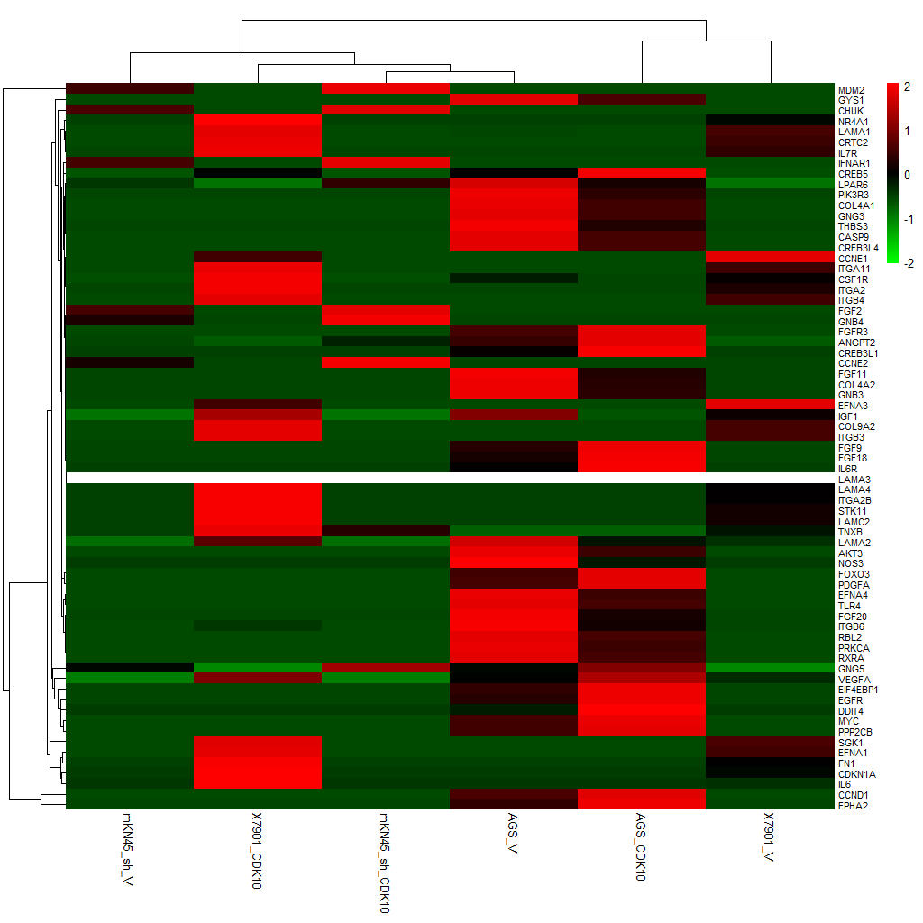
FigS2. RNA-seq sequencing by comparing lncRNA-C5ORF42-5-overexpressed cells with the control.

