Supplementary information

Article title: Humoral immune abnormalities in transient childhood neutropenia: Insights from a 10-Year cohort study in a tertiary center
Emmanuele Schorn¹, Maarja Soomann¹, Seraina Prader¹, Jana Pachlopnik Schmid¹, Johannes Trück¹
¹ Division of Immunology and the Children’s Research Center, University Children's Hospital Zurich, University of Zurich, Zurich, Switzerland
Correspondence: Johannes Trück, MD, DPhil, Division of Immunology and Children’s Research Center, University Children’s Hospital Zurich, Lenggstrasse 30, 8008 Zürich, Switzerland (johannes.trueck@kispi.uzh.ch).

Tables
Table S1: Definitions with corresponding explanations.
Term | Definition/Explanation
Autoimmune neutropenia (AIN) | Isolated neutropenia lasting more than 6 weeks with positive neutrophil-specific autoantibodies and no other identifiable cause(1)
Idiopathic neutropenia (IN) | IN was defined as neutropenia lasting more than 6 weeks, with either negative or no autoantibody testing and no other identifiable cause(2)
Inclusion criteria | 1) age 0 to 6 years, 2) transient neutropenia lasting for at least 6 weeks
Exclusion criteria | 1) an identifiable cause to their neutropenia other than autoimmunity (e.g., constitutional neutropenia, alloimmune neutropenia, neutropenia associated with myeloproliferative disorders, neutropenia related to acquired bone marrow failure, medication-induced neutropenia, and infection-associated neutropenia), 2) remission before 4 months of age
Late-onset neutropenia | Discovery of neutropenia after 36 months of age
Long-lasting neutropenia | Persistence of neutropenia for more than 36 months
Moderate humoral abnormalities | IgG deficiency and/or insufficient vaccine antibodies
Mild humoral abnormalities | IgA and/or IgM deficiency, IgG subclass deficiency, and/or abnormalities in B-cell differentiation, without moderate abnormalities
Severe infection | Documented infection requiring hospitalization
Mild infection | Documented infection not requiring hospitalization

Table S2: Search terms for patients with neutropenia.
Search terms
PD Neutropenia AIN
AIN
autoimmune neutropenia
Autoimmun Neutropenie
Autoimmunneutropenie
Autoimmun-Neutropenie
Neutropenie autoimmune
Neutropenie, autoimmune
neutropenie
autoimmune
immun
auto

Table S3: Neutropenia categories for sequential filtering process as seen in the flow diagram (Figure 1).
Neutropenia Group | Definition
No neutropenia
Denied general consent
> 6 years | Older than 6 years at onset of neutropenia
Not assessed | Not assessed for neutropenia at Children’s Hospital of Zurich
< 6 weeks neutropenia duration | Neutropenia duration less than 6 weeks
Infection associated neutropenia | Tuberculosis, HIV, CMV, Hepatitis B, several bacterial and viral infections
Constitutional Neutropenia | Severe congenital neutropenias, cyclic neutropenia, associated with various extra hematological signs, associated with congenital bone marrow failure, associated to metabolic disorders and nutritional deficiency as proposed by Fioredda et al (1)
Secondary autoimmune neutropenia | Neutropenia is secondary to another condition rather than being a primary disorder and is associated with other underlying conditions such as autoimmune diseases, malignancies, immunodeficiencies, viral infections, or drug reactions. It is more prevalent in adults and is often seen in conjunction with diseases like rheumatoid arthritis, Felty syndrome, systemic lupus erythematosus, scleroderma, large granular lymphocytic leukemia, chronic lymphocytic leukemia, Waldenström macroglobulinemia, Hodgkin lymphoma and thymoma (3)
Alloimmune Neutropenia | Neutropenia due to alloimmunization against neutrophil-specific antigens (4), autoantibodies are often detected in mother and child. Resolution of neutropenia in first 4 months after birth
Table S4: RStudio packages and corresponding citations.
RStudio packages | Citation
readxl | Wickham H, Bryan J (2023). _readxl: Read Excel Files_. R package version 1.4.3, <https://CRAN.R-project.org/package=readxl>.
dplyr | Wickham H, François R, Henry L, Müller K, Vaughan D (2023). _dplyr: A Grammar of Data Manipulation_. R package version 1.1.4, <https://CRAN.R-project.org/package=dplyr>.
lubridate | Garrett Grolemund, Hadley Wickham (2011). Dates and Times Made Easy with lubridate. Journal of Statistical Software, 40(3), 1-25. URL https://www.jstatsoft.org/v40/i03/.
ggplot2 | H. Wickham. ggplot2: Elegant Graphics for Data Analysis. Springer-Verlag New York, 2016.
tidyr | Wickham H, Vaughan D, Girlich M (2024). _tidyr: Tidy Messy Data_. R package version 1.3.1, <https://CRAN.R-project.org/package=tidyr>.
scales | Wickham H, Pedersen T, Seidel D (2023). _scales: Scale Functions for Visualization_. R package version 1.3.0, <https://CRAN.R-project.org/package=scales>.
hmisc | Harrell Jr F (2024). _Hmisc: Harrell Miscellaneous_. R package version 5.1-3, <https://CRAN.R-project.org/package=Hmisc>.
writexl | Ooms J (2024). _writexl: Export Data Frames to Excel 'xlsx' Format_. R package version 1.5.0, <https://CRAN.R-project.org/package=writexl>.
survival | Therneau T (2024). _A Package for Survival Analysis in R_. R package version 3.7-0, <https://CRAN.R-project.org/package=survival>.  Terry M. Therneau, Patricia M. Grambsch (2000). _Modeling Survival Data: Extending the Cox Model_. Springer, New York. ISBN 0-387-98784-3.
survminer | Kassambara A, Kosinski M, Biecek P (2021). _survminer: Drawing Survival Curves using 'ggplot2'_. R package version 0.4.9, <https://CRAN.R-project.org/package=survminer>.
ggpubr | Kassambara A (2023). _ggpubr: 'ggplot2' Based Publication Ready Plots_. R package version 0.6.0, <https://CRAN.R-project.org/package=ggpubr>.
broom | Robinson D, Hayes A, Couch S (2024). _broom: Convert Statistical Objects into Tidy Tibbles_. R package version 1.0.6, <https://CRAN.R-project.org/package=broom>.
boot | Angelo Canty and Brian Ripley (2022). boot: Bootstrap R (S-Plus) Functions. R package version 1.3-28.1.  Davison, A. C. & Hinkley, D. V. (1997) Bootstrap Methods and Their Applications. Cambridge University Press, Cambridge. ISBN 0-521-57391-2

Table S5: Total number of infections among all patients before and during neutropenia, categorized by infection type.
Type of infection | before neutropenia | during neutropenia
Respiratory infection treated with antibiotics | 2 | 21
Respiratory infection without antibiotic treatment | 8 | 17
Urinary tract infection | 6 | 8
Enteritis | 2 | 8
Pneumonia | 2 | 6
Fever with hospitalization and intravenous antibiotics | 1 | 6
Acute otitis media | 2 | 3
Sepsis | 3 | 2
Periorbital cellulitis / infraorbital phlegmon / preseptal cellulitis | 2 | 2
Stomatitis | 0 | 2
Line infection | 0 | 2
Late onset sepsis | 3 | 1
Conjunctivitis with intravenous antibiotics | 1 | 1
Wound infection | 0 | 1
Erysipelas | 0 | 1
Mastitis | 0 | 1
Paronychia | 0 | 1
Omphalitis | 0 | 1
Phlegmon | 0 | 1
Furunculosis | 0 | 1
Epstein-Barr Virus infection | 0 | 1
Lymphadenitis | 6 | 0
Cytomegalovirus infection | 2 | 0
Dacrocystitis | 1 | 0
Mastoiditis | 1 | 0
Abscess | 1 | 0
Retropharyngeal abscess | 1 | 0
Perianal abscess | 1 | 0
Early onset sepsis | 1 | 0
Sum | 46 | 87

Table S6: Demographic, clinical and diagnostic characteristics stratified by immunological testing.
 | Immunological testing  (n=68) | No immunological testing (n=24) | p-value
 | Number  (%) | Number  (%)
Autoimmune Neutropenia | 45  (66) | 13  (54) | 0.423
Idiopathic Neutropenia | 23  (34) | 11  (46)
Sex (male) | 38  (56) | 19  (79) | 0.076
Preterm | 15  (22) | 7  (29) | 0.531
Extremely preterm (<28 weeks) | 5  (7) | 3  (12.5)
Very preterm (28-31 weeks) | 3  (4) | 1  (4)
Moderate to late preterm (32-36 weeks) | 7  (10) | 3  (13)
Born at term | 43  (63) | 12  (50)
Unknown gestational age | 10  (15) | 5  (21)
Context of initial diagnosis of neutropenia
Incidental finding* | 28  (41) | 16  (67) | 0.094
Mild infection# | 17  (25) | 4  (17)
Severe infection$ | 23  (34) | 4  (17)
 | Median  (Range) | Median  (Range)
Age at onset (months) | 7.8  (0-36.9) | 5.67  (0.7-12.8) | 0.233
Age at remission (months) | 24.2  (4.1-68.8) | 16.3  (6.2-46.7) | 0.122
Duration of neutropenia (months)€ | 15.6  (1.3-50.1) | 10.2  (2.8-37.1)
*full blood count (FBC) performed for reasons unrelated to infection; #FBC due to infection, not hospitalized; $FBC due to infection, hospitalized; €in those who achieved remission

Table S7: Demographic, clinical and diagnostic characteristics by presence of humoral immune system abnormalities.
 | Any Abnormality (n=52) | No Abnormality (n=16) | p-value
 | Number  (%) | Number  (%)
Autoimmune Neutropenia | 29  (56) | 16  (100) | 0.003
Idiopathic Neutropenia | 23  (44) | 0  (0)
Sex (male) | 31  (60) | 7  (44) | 0.407
Preterm | 14  (27) | 1  (6) | 0.189
Extremely preterm (<28 weeks) | 5  (9.6) | 0  (0)
Very preterm (28-31 weeks) | 3  (5.8) | 0  (0)
Moderate to late preterm (32-36 weeks) | 6  (11.5) | 1  (6)
Born at term | 31  (60) | 12  (75)
Unknown gestational age | 7  (14) | 3  (19)
Context of initial diagnosis of neutropenia
Incidental finding* | 26  (50) | 2  (13) | 0.023
Mild infection# | 11  (21) | 6  (38)
Severe infection$ | 15  (29) | 8  (50)
 | Median  (Range) | Median  (Range)
Age at onset (months) | 6.2  (0-36.9) | 12.0  (5.3-34.2) | <0.001
Age at remission (months) | 19.9  (4.1-68.8) | 45.2  (18.5-62.9) | <0.001
Duration of neutropenia (months)€ | 12.1  (1.3-50.1) | 28.5  (13.2-40.4)
*full blood count (FBC) performed for reasons unrelated to infection; #FBC due to infection, not hospitalized; $FBC due to infection, hospitalized; €in those who achieved remission

Table S8: Demographic, clinical and diagnostic characteristics of autoimmune and idiopathic neutropenia patients.
 | Autoimmune Neutropenia  (n=58) |  | Idiopathic Neutropenia  (n=34) |  | p-value
 | Number | (%) | Number | (%)
Sex (male) | 34 | (41) | 23 | (68) | 0.523
Preterm | 10 | (17) | 12 | (35) | 0.130
Extremely preterm (<28 weeks) | 4 | (7) | 4 | (12)
Very preterm (28-31 weeks) | 0 | (0) | 4 | (12)
Moderate to late preterm (32-36 weeks) | 6 | (10) | 4 | (12)
Born at term | 37 | (64) | 18 | (53)
Unknown gestational age | 11 | (19) | 4 | (12)
Context of initial diagnosis of neutropenia |  |  |  |  | 0.002
Incidental finding* | 20 | (35) | 24 | (71)
Mild infection# | 15 | (26) | 6 | (18)
Severe infection$ | 23 | (40) | 4 | (12)
 | Median | (Range) | Median | (Range)
Age at onset (months) | 9.0 | (0.7-36.9) | 4.3 | (0-27.3) | 0.001
Age at remission (months) | 29.2 | (6.1-68.8) | 16.3 | (4.1-47.2) | 0.005
Duration of neutropenia (months)€ | 17.4 | (1.3-50.1) | 9.6 | (2.8-46.0)
*full blood count (FBC) performed for reasons unrelated to infection; #FBC due to infection, not hospitalized; $FBC due to infection, hospitalized; €in those who achieved remission

Table S9: Demographic, clinical and diagnostic characteristics of idiopathic neutropenia patients with and without autoantibody testing.
 | IN Patients tested  (n=21) |  | IN Patients not tested  (n=13) |  | p-value
 | Number | (%) | Number | (%)
Sex (male) | 15 | (71) | 8 | (62) | 0.709
Preterm | 8 | (38) | 4 | (31) | 1.000
Extremely preterm (<28 weeks) | 2 | (10) | 2 | (15)
Very preterm (28-31 weeks) | 3 | (14) | 1 | (8)
Moderate to late moderate preterm (32-36 weeks) | 3 | (14) | 1 | (8)
Born at term | 11 | (52) | 7 | (54)
Unknown gestational age | 2 | (10) | 2 | (15)
Context of the initial diagnosis of neutropenia |  |  |  |  | 0.539
Incidental finding* | 14 | (67) | 10 | (77)
Mild infection# | 5 | (24) | 1 | (8)
Severe infection$ | 2 | (10) | 2 | (15)
 | Median | (Range) | Median | (Range)
Age at onset (months) | 3.38 | (0-27.3) | 5.3 | (1.2-11.7) | 0.625
Age at remission (months) | 15.8 | (4.1-41.1) | 16.4 | (6.2-47.2) | 0.550
Duration of neutropenia (months) | 8.79 | (2.8-32.6) | 10.2 | (4.2-46)
*full blood count (FBC) performed for reasons unrelated to infection; #FBC due to infection, not hospitalized; $FBC due to infection, hospitalized; €in those who achieved remission; IN, idiopathic neutropenia

Table S10: Immunological abnormalities by diagnostic test in the autoimmune neutropenia and idiopathic neutropenia groups.
 | Autoimmune Neutropenia  (n=58) |  | Idiopathic Neutropenia  (n=34)
Diagnostics | No. Tested | No. with positive test / abnormalities (%)* | No. Tested | No. with positive test / abnormalities (%)*
Autoantibody-testing | 58 | 58 (100) | 21 | 0 (0)
GIFT | 58 | 57 (98) | 18 | 0 (0)
GAT | 58 | 31 (54) | 18 | 0 (0)
ELISA (MAIGA) | 55 | 35 (64) | 17 | 0 (0)
Genetic testing | 11 | 0 (0) | 8 | 0 (0)
Bone marrow examination | 9 | 1 (0) | 1 | 0 (0)
Antibody testing#
IgG | 46 | 7 (15) | 22 | 7 (32)
IgA and/or IgM | 46 | 18 (39) | 22 | 18 (82)
IgG subclasses | 14 | 3 (21) | 5 | 3 (60)
Vaccine antibodies | 46 | 11 (24) | 22 | 7 (32)
Flow cytometry
Total B, T, and NK cell count | 48 | 4 (8) | 22 | 0 (0)
T-cell subpopulation | 48 | 6 (13) | 21 | 1 (5)
B-cell subpopulation | 41 | 16 (39) | 20 | 8 (40)
*percentage of patients with abnormalities of all patients tested with the respective test; #only decreased levels were considered abnormal; GIFT, granulocyte immunofluorescence test; GAT, granulocyte agglutination test; ELISA, enzyme-linked immunosorbent assay; MAIGA, monoclonal antibody immobilization of granulocyte-specific antigens; No., number

Table S11: Demographic, clinical and diagnostic characteristics of patients with minimum absolute neutrophil count values ≥0.25 × 10⁹/L and <0.25 × 10⁹/L.
 | Minimum ANC  <0.25 × 10⁹/L  (n=53) |  | Minimum ANC  ≥ 0.25 × 10⁹/L  (n=39) |  | p-value
 | Number | (%) | Number | (%)
Autoimmune Neutropenia | 44 | (83) | 14 | (36) | <0.001
Idiopathic Neutropenia | 9 | (17) | 25 | (64)
Sex (male) | 31 | (59) | 26 | (67) | 0.561
Preterm | 11 | (21) | 11 | (28) | 0.690
Extremely preterm (<28 weeks) | 4 | (8) | 4 | (10)
Very preterm (28-31 weeks) | 0 | (0) | 4 | (10)
Moderate to late preterm (32-36 weeks) | 7 | (13) | 3 | (8)
Born at term | 32 | (60) | 23 | (59)
Unknown gestational age | 10 | (19) | 5 | (13)
Context of the initial diagnosis of neutropenia |  |  |  |  | 0.007
Incidental finding* | 19 | (36) | 25 | (64)
Mild infection# | 12 | (23) | 9 | (23)
Severe infection$ | 22 | (42) | 5 | (13)
 | Median | (Range) | Median | (Range)
Age at onset (months) | 9.5 | (0.7-36.9) | 2.9 | (0-27.3) | <0.001
Age at remission (months) | 30.4 | (6.1-68.8) | 14.9 | (4.1-60.9) | <0.001
Duration of neutropenia (months)€ | 18.3 | (1.3-46.6) | 9.2 | (2.5-50.1)
*full blood count (FBC) performed for reasons unrelated to infection; #FBC due to infection, not hospitalized; $FBC due to infection, hospitalized; €in those who achieved remission; ANC, absolute neutrophil count

Figures

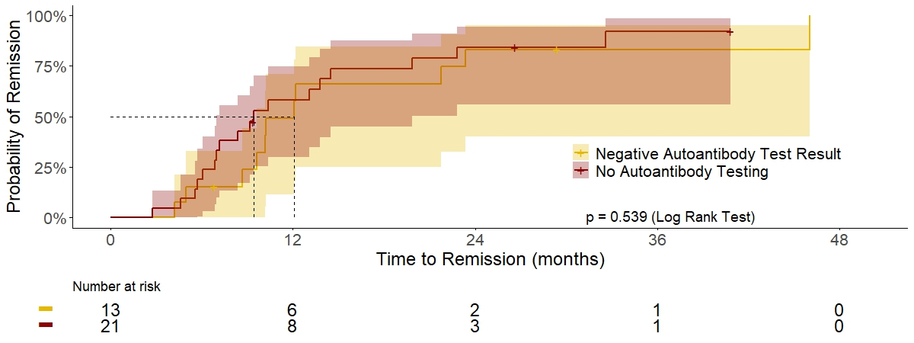
Figure S1: Time to remission of neutropenia. Probability of remission including 95% confidence interval is shown for idiopathic neutropenia patients with and without neutrophil-specific autoantibody testing. Dashed lines indicate the median time to remission in the two subgroups.

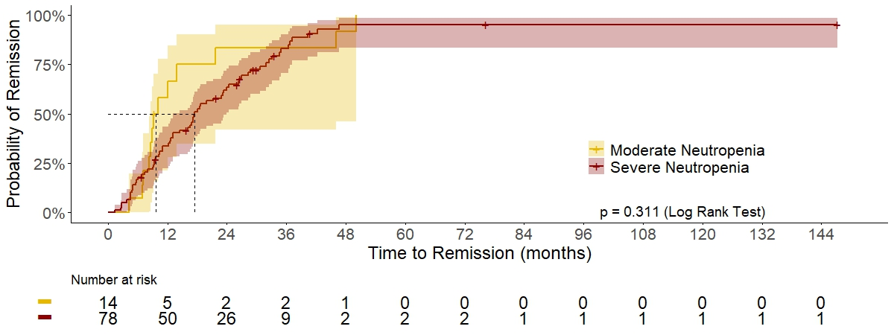
Figure S2: Time to remission of neutropenia. Probability of remission including 95% confidence interval is shown for patients with moderate (minimum absolute neutrophil count (ANC) 0.5-1 × 10⁹/L) and severe neutropenia (minimum ANC < 0.5 × 10⁹/L). Dashed lines indicate the median time to remission in the two subgroups.

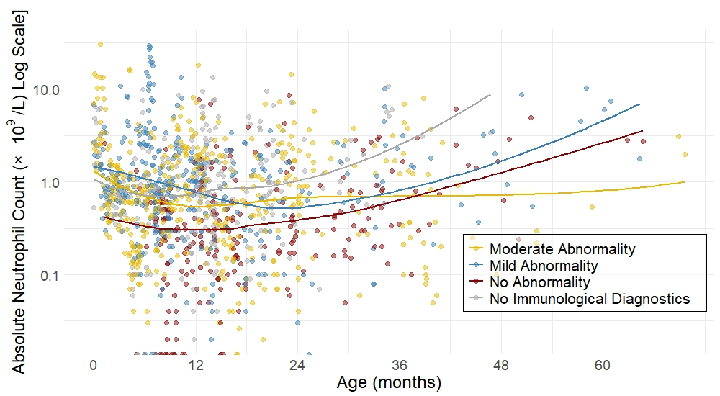
Figure S3: Absolute neutrophil count values up to 3 months after remission of neutropenia. The different subgroups moderate, mild, and no humoral abnormalities, as well as the group of patients without additional immunological diagnostics are indicated with different colors. A smooth curve shows the general course the absolute neutrophil count.

References
1. Fioredda F, Onofrillo D, Farruggia P, Barone A, Veltroni M, Notarangelo LD, et al. Diagnosis and management of neutropenia in children: The approach of the Study Group on Neutropenia and Marrow Failure Syndromes of the Pediatric Italian Hemato-Oncology Association (Associazione Italiana Emato-Oncologia Pediatrica - AIEOP). Pediatr Blood Cancer. 2022 Jun;69(6):e29599.
2. Farruggia P, Fioredda F, Puccio G, Onofrillo D, Russo G, Barone A, et al. Idiopathic neutropenia of infancy: Data from the Italian Neutropenia Registry. Am J Hematol. 2019 Feb;94(2):216–22.
3. Fioredda F, Dufour C, Höglund P, Papadaki HA, Palmblad J. Autoimmune Neutropenias: Update on Clinical and Biological Features in Children and Adults. HemaSphere [Internet]. 2023 Jan [cited 2024 Apr 30];7(1). Available from: https://www.ncbi.nlm.nih.gov/pmc/articles/PMC9771305/
4. Farruggia P, Dufour C. Diagnosis and management of primary autoimmune neutropenia in children: insights for clinicians. Ther Adv Hematol. 2015 Feb;6(1):15–24.

