Supplementary information

A biosynthetic survey of biocontrol fungi

Ana Calheiros de Carvalho¹, Naiara Hurtado-Lopez¹, Carolina Cano Prieto¹, Miriam von Bargen¹, Luis Caleb Damas-Ramos¹, , Agustina Undabarrena¹, Daniela Rago¹, Ling Chen¹, Adrian Enrique Gadar Lopez¹, Sidharth Jayachandran¹, Luisa Maria Trejo Alarcon², Xiaowei Li¹, Dushica Arsovska¹, Linda Ahonen¹, Vijayalakshmi Kandasamy¹,` Line Sondt-Marcussenv¹, Mariana Arango Saavedra¹, Iason Karyofyllis¹, Kealan Peter Exley¹, Charissa de Bekker³, Jay Keasling^{1,4,5,6,7} and Pablo Cruz-Morales¹.

¹Novo Nordisk Foundation Center for Biosustainability, Technical University of Denmark, Kongens Lyngby, Denmark.
²Industrial Genomics Laboratory, FEMSA Biotechnology Center, School of Engineering and Sciences, Tecnológico de Monterrey, Monterrey, Mexico.
³Microbiology, Department of Biology, Utrecht University, Utrecht, The Netherlands
⁴Biological Systems and Engineering Division, Lawrence Berkeley National Laboratory, Berkeley, California, USA.
⁵Joint BioEnergy Institute, Lawrence Berkeley National Laboratory, Emeryville, California, USA.
⁶Department of Chemical and Biomolecular Engineering, University of California, Berkeley, California, USA.
⁷Department of Bioengineering, University of California, Berkeley, California, USA.
Correspondence keasling@berkeley.edu and pcruzm@biosustain.dtu.dk

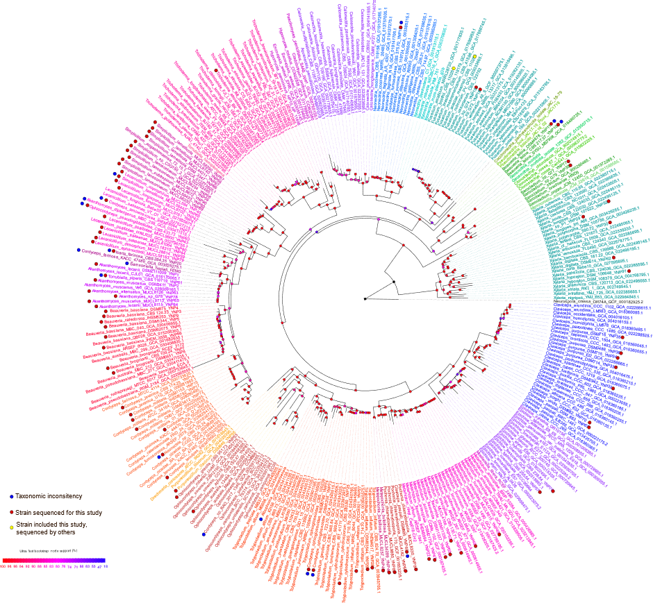
Figure S1: Phylogenetic analysis of 89 strains within the Hypocreales clade using 81 conserved orthologous protein families from a dataset of 320 genomes. The dataset included members of the genus Xylaria (Xylariales, Sordariomycetes), and a Neurospora crassa strain (Sordariales, Sordariomycetes) as outgroups.

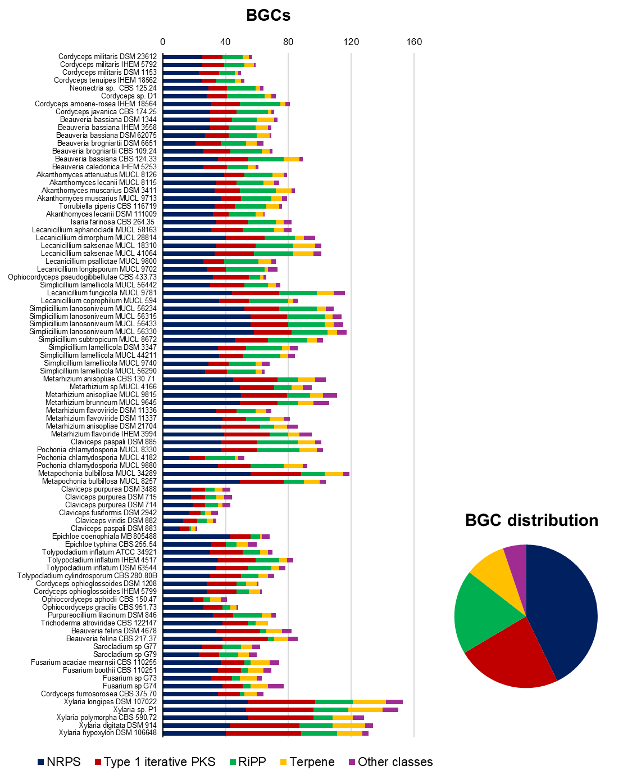
Figure S2: Distribution of BGCs among the strains analyzed in this study. Colors bars represent the major BGCs classes: NRPSs (blue), type 1 iterative PKSs (red), RiPPs (green), terpenes (yellow), and other classes (purple).

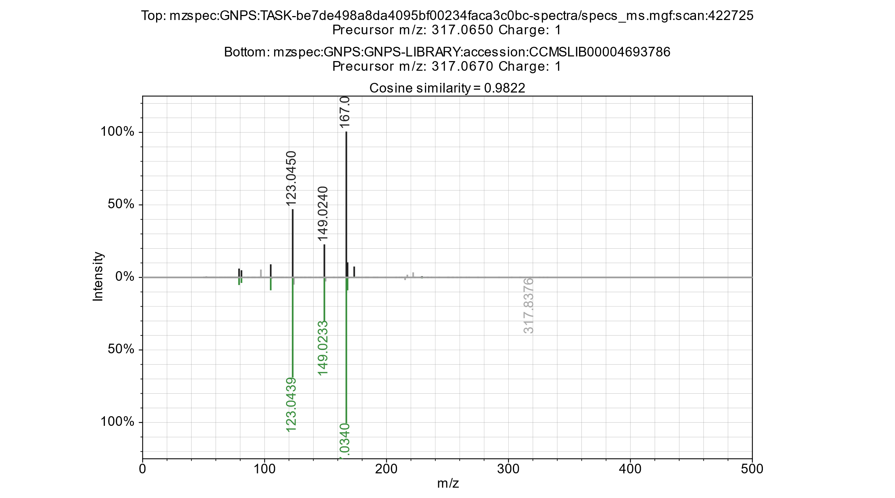
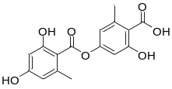
Figure S3: Mirror plot of experimental MS/MS spectra (upper, black) and GNPS reference spectra (lower, green) for lecanoric acid annotation.

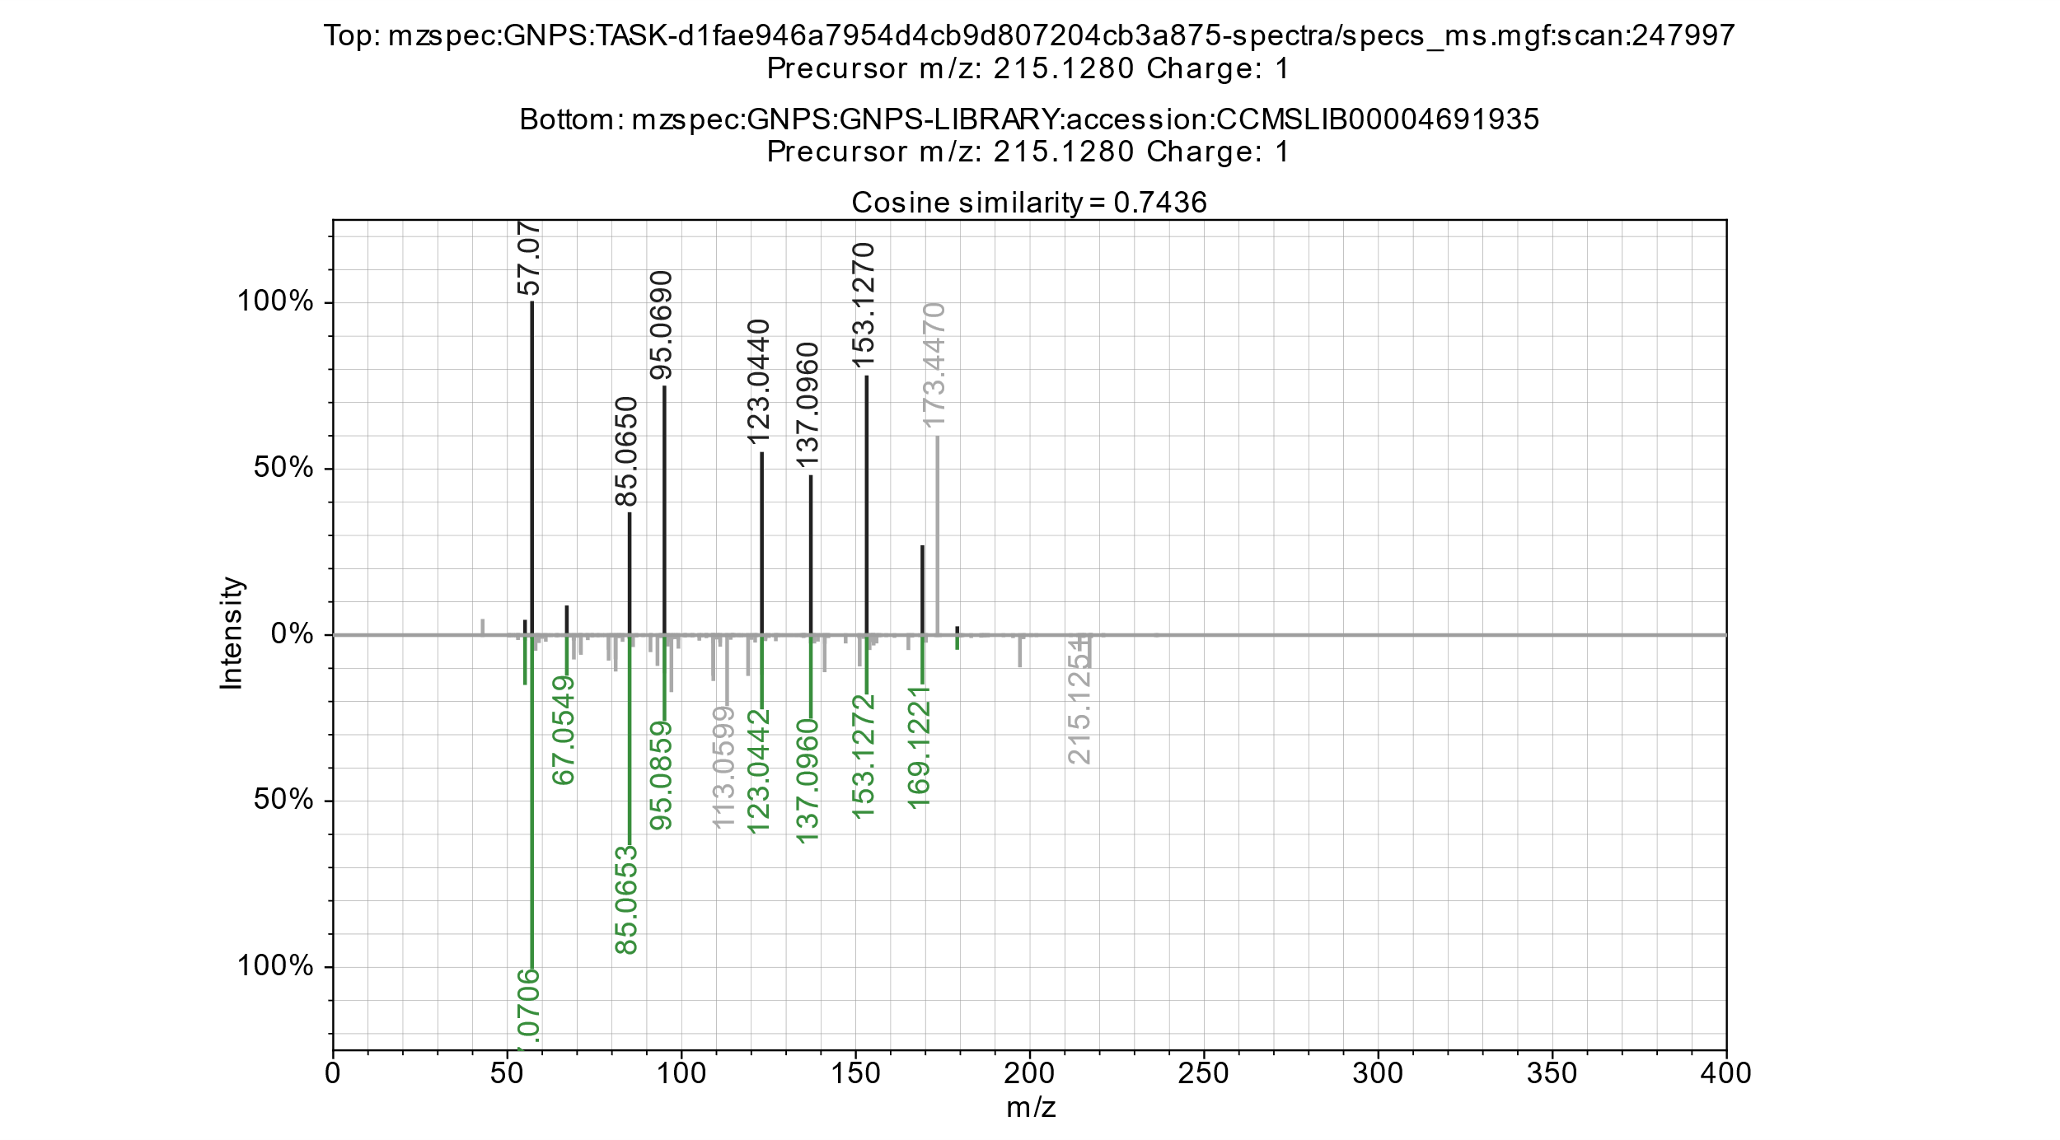
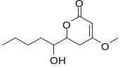
Figure S4: Mirror plot of experimental MS/MS spectra (upper, black) and GNPS reference spectra (lower, green) for pestalotin annotation.

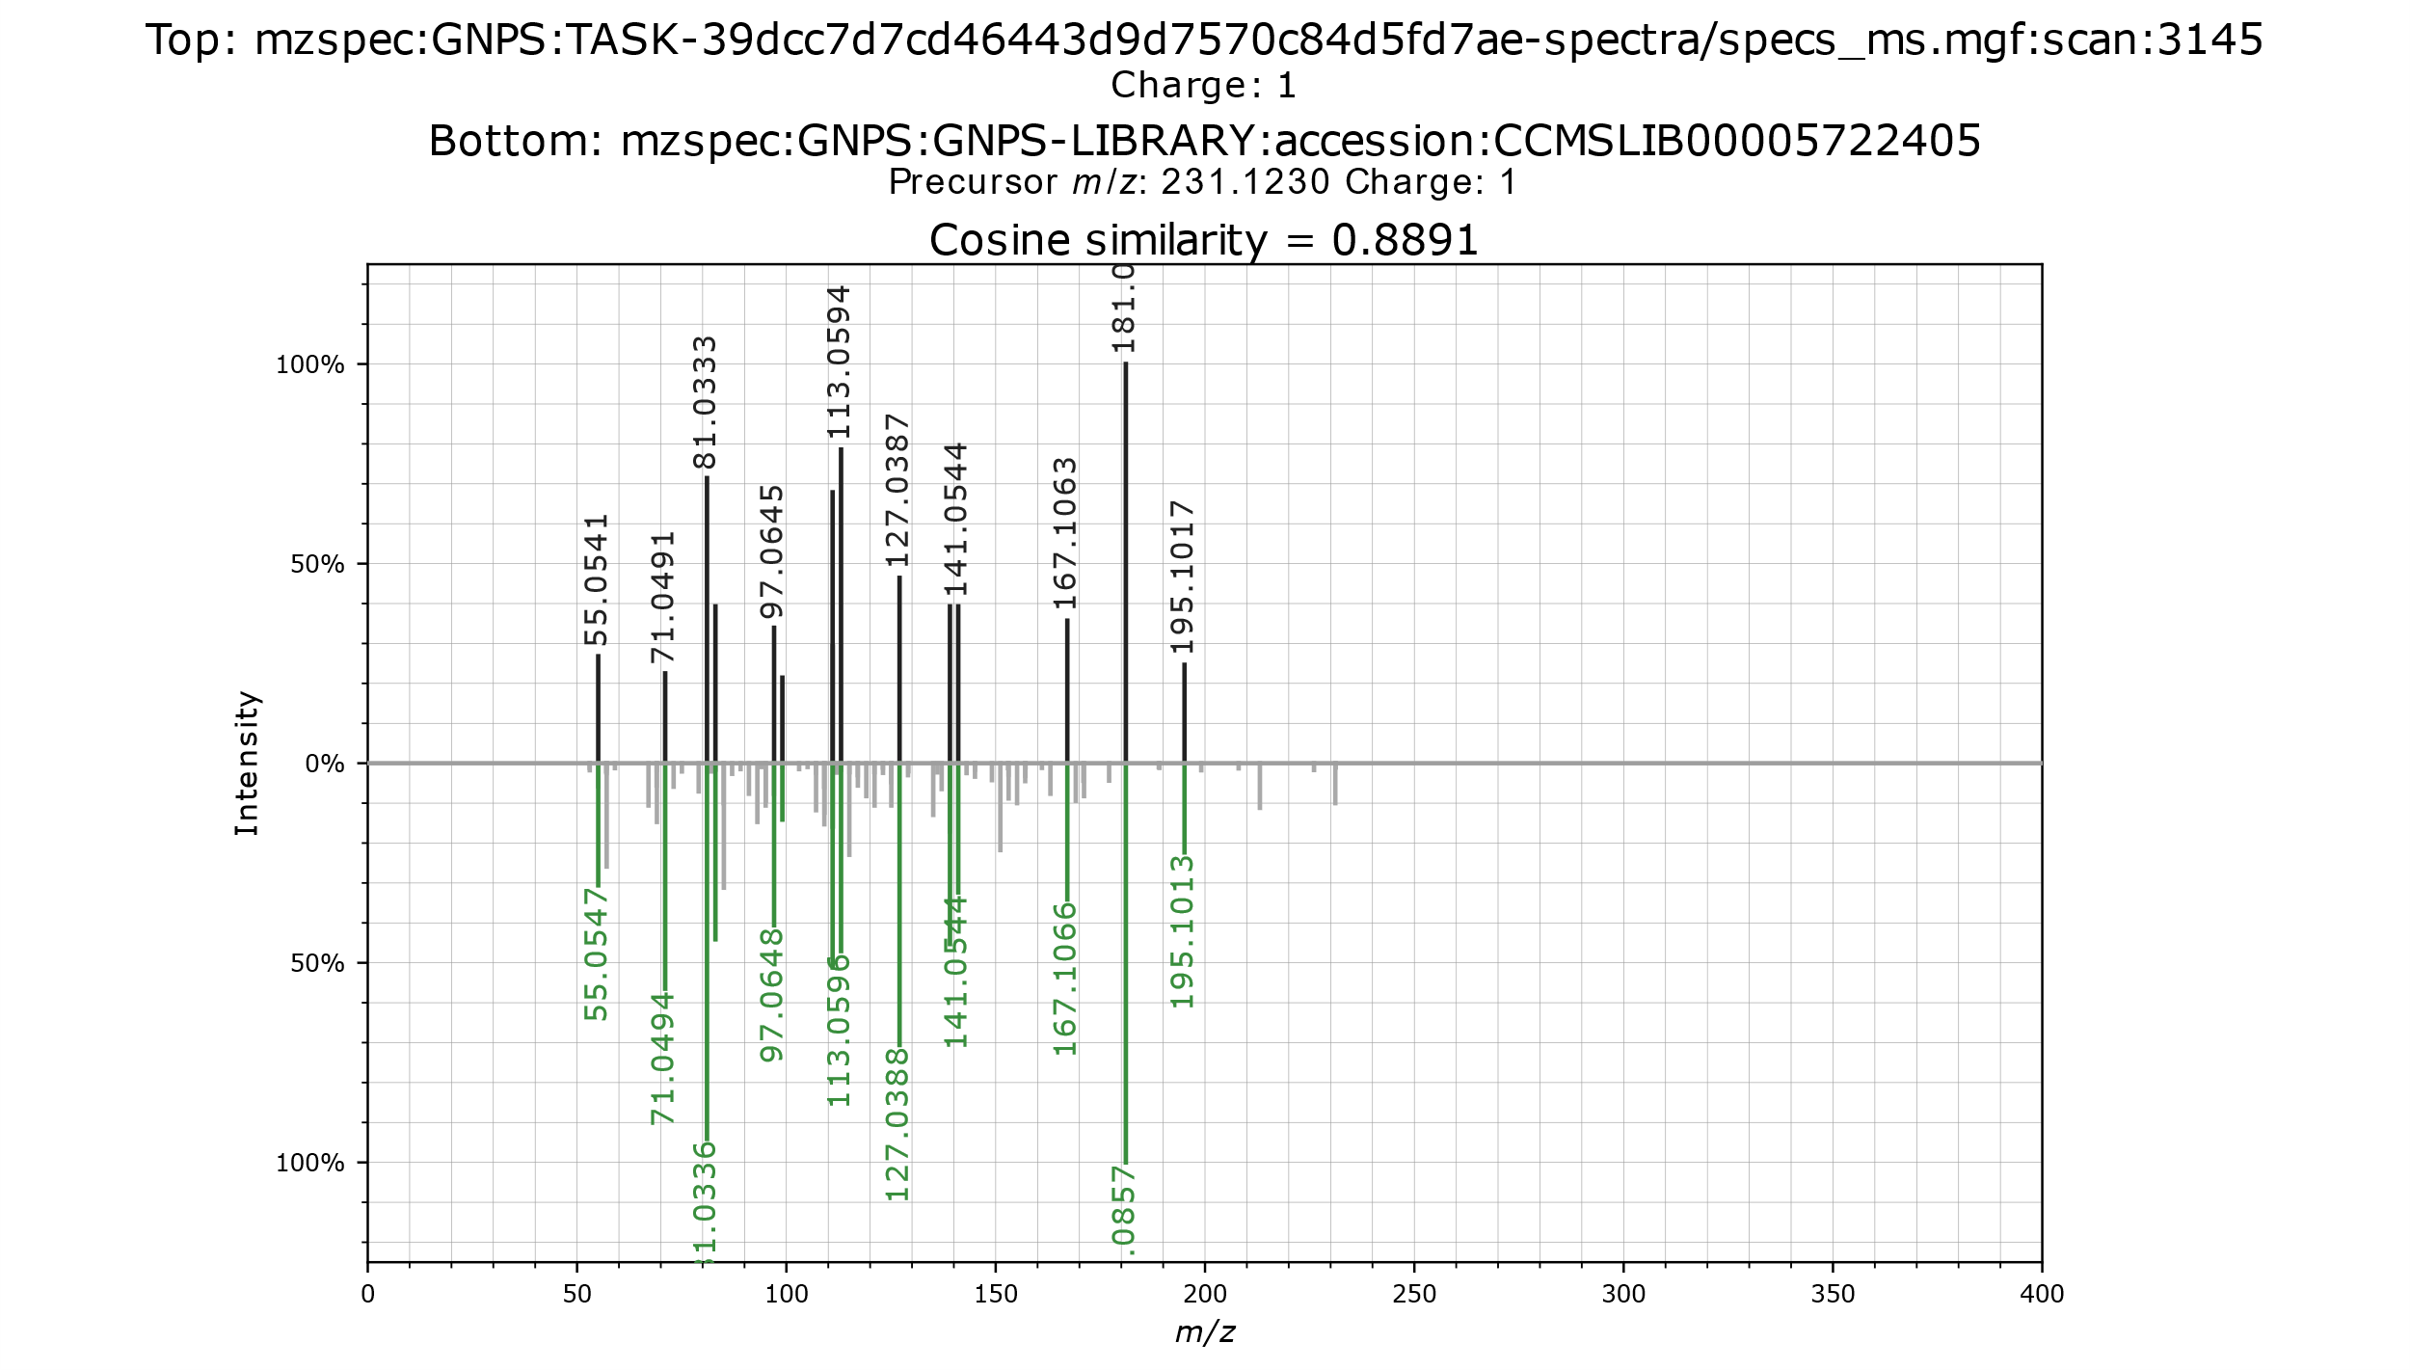
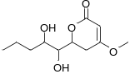
Figure S5: Mirror plot of experimental MS/MS spectra (upper, black) and GNPS reference spectra (lower, green) for 7-hydroxypestalotin annotation.

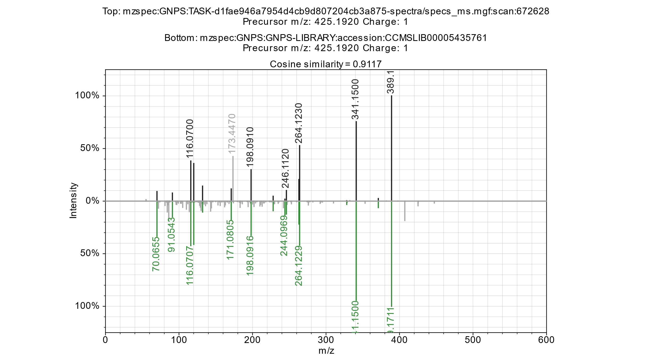
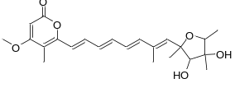
Figure S6: Mirror plot of experimental MS/MS spectra (upper, black) and GNPS reference spectra (lower, green) for citreoviridin annotation.

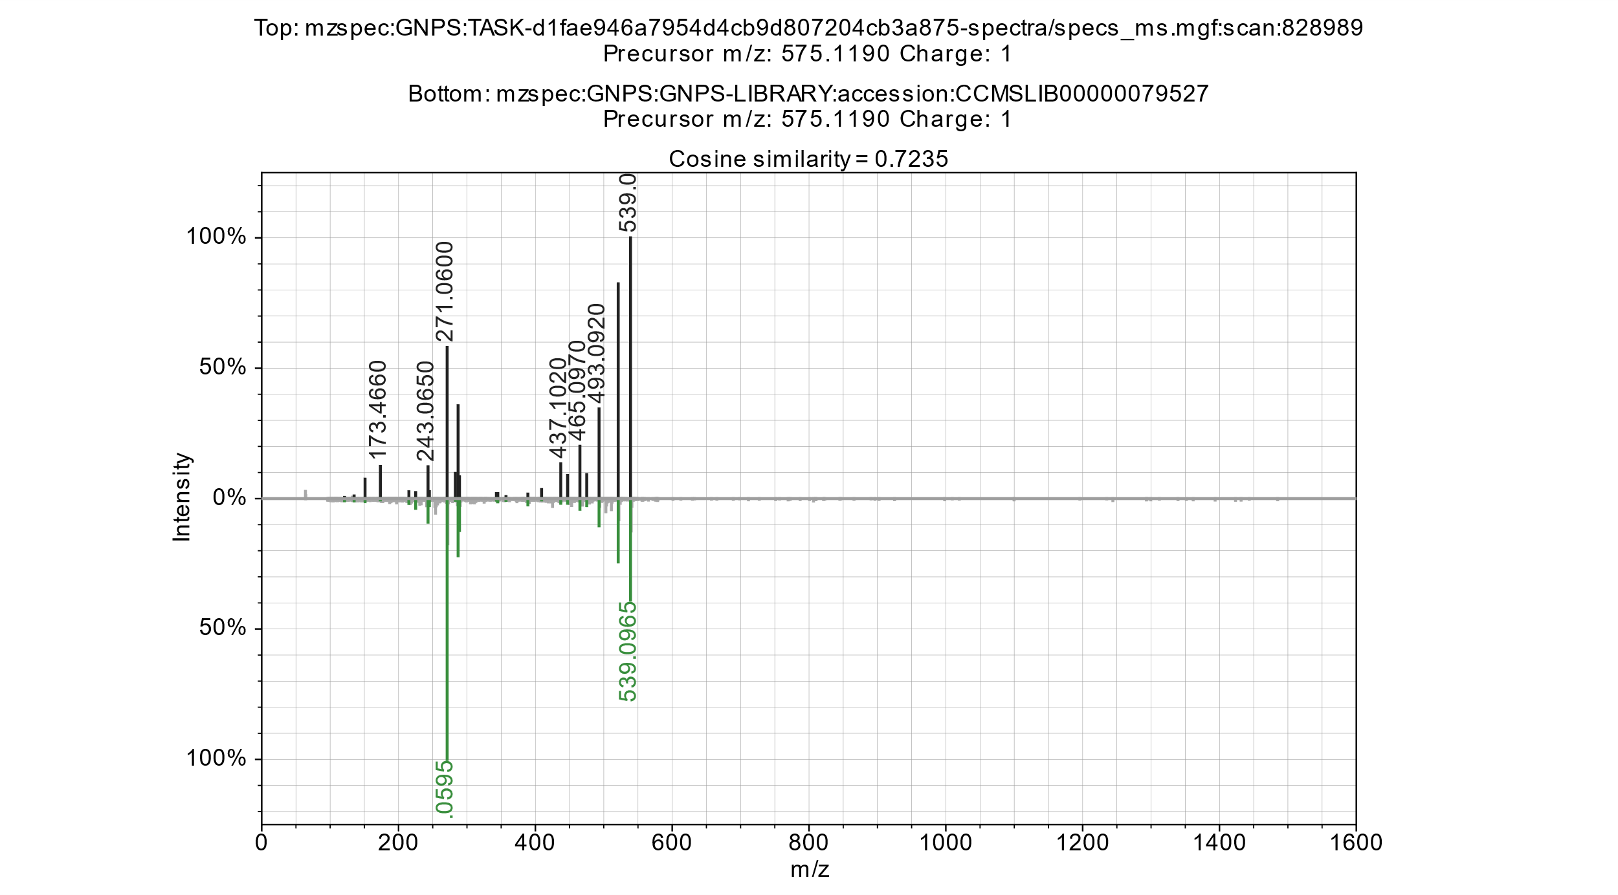
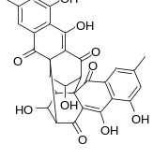
Figure S7: The mirror plot of experimental MS/MS spectra (upper, black) and GNPS reference spectra (lower, green) for rugulosin annotation.

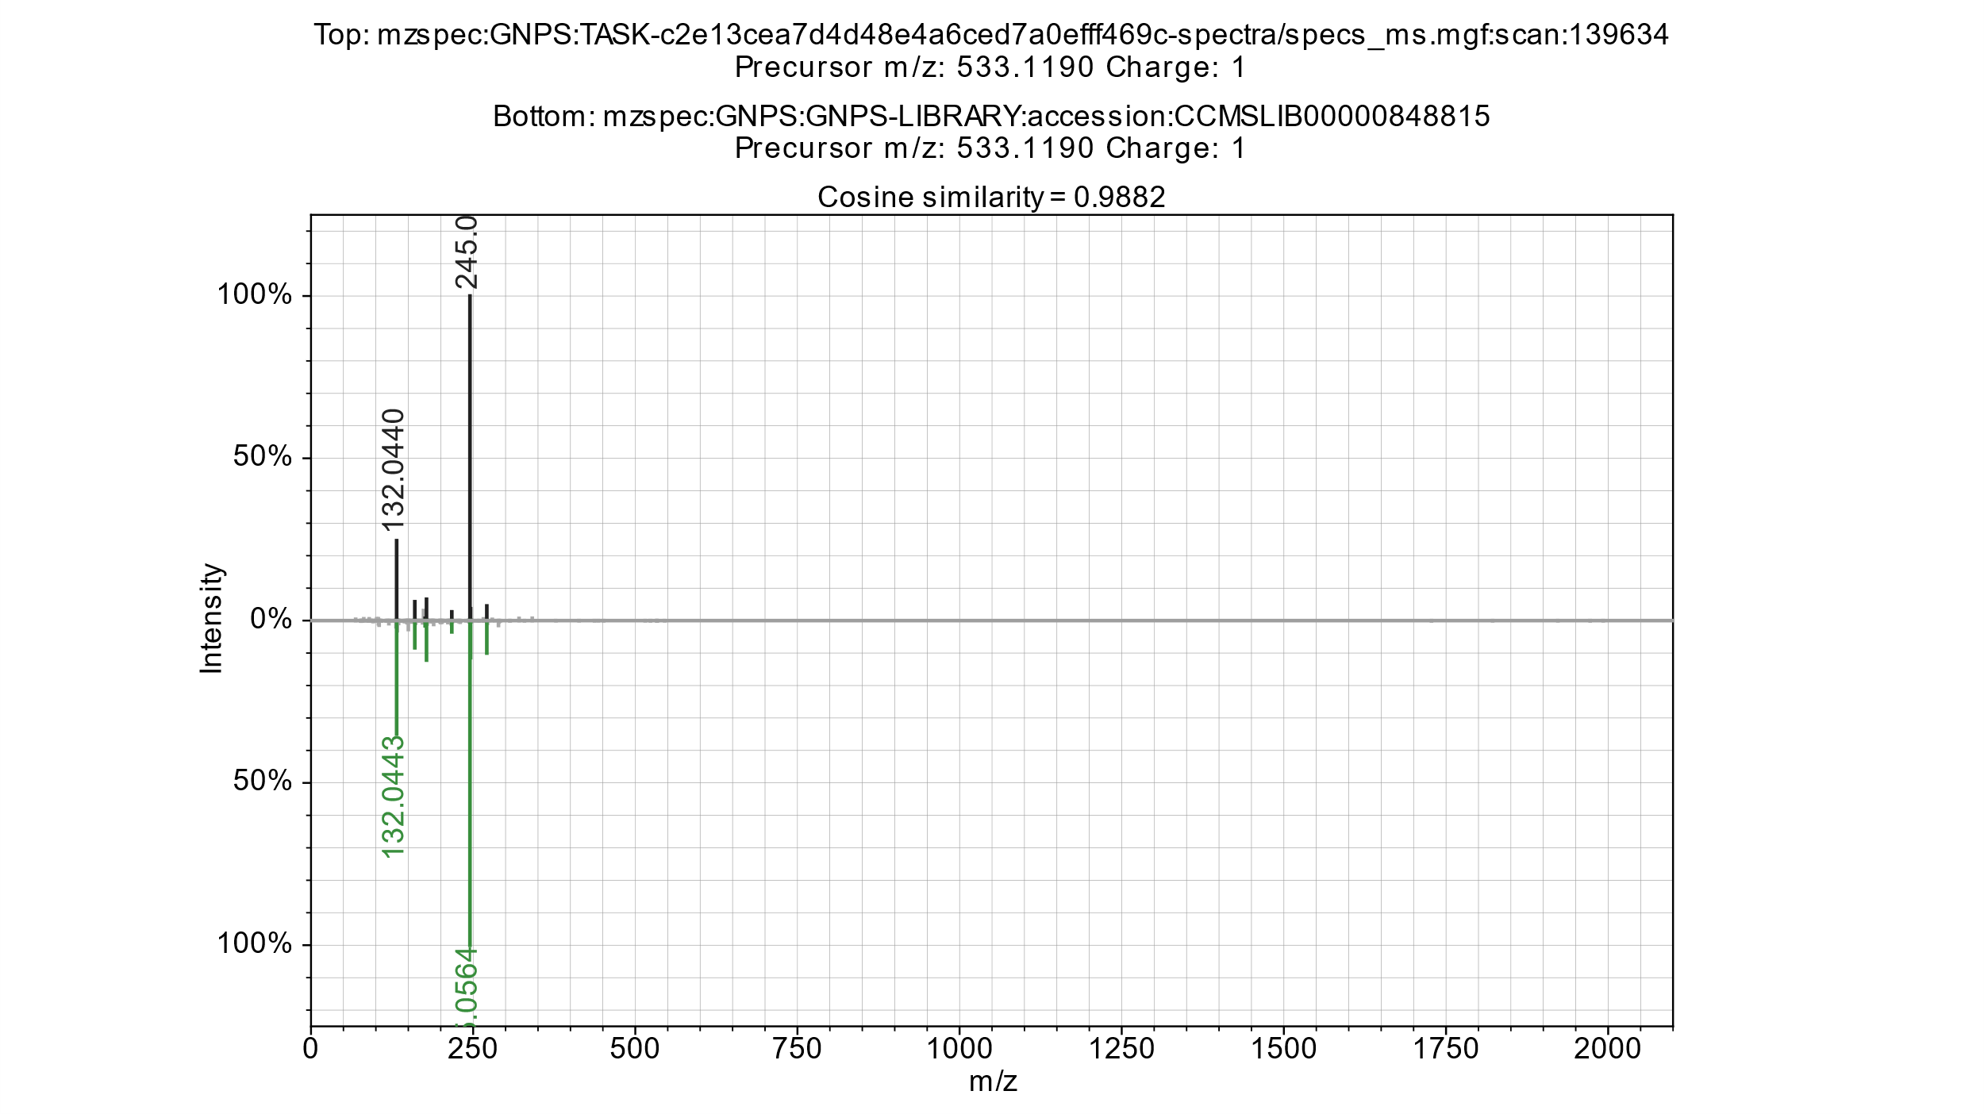
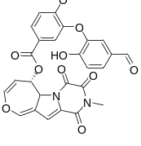
Figure S8: Mirror plot of experimental MS/MS spectra (upper, black) and GNPS reference spectra (lower, green) for dethiosecoemestrin annotation.

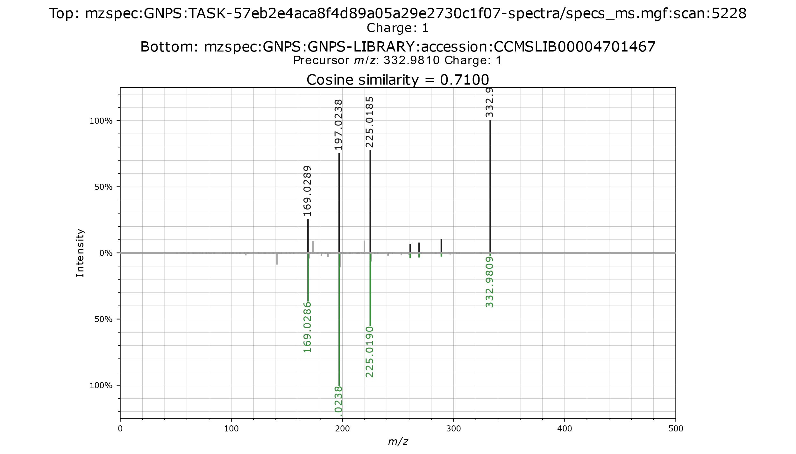
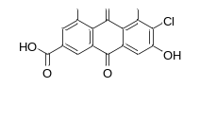
Figure S9: Mirror plot of experimental MS/MS spectra (upper, black) and GNPS reference spectra (lower, green) for 6-chloro-4,5,7-trihydroxy-9,10-dioxoanthracene-2-carboxylic acid annotation.

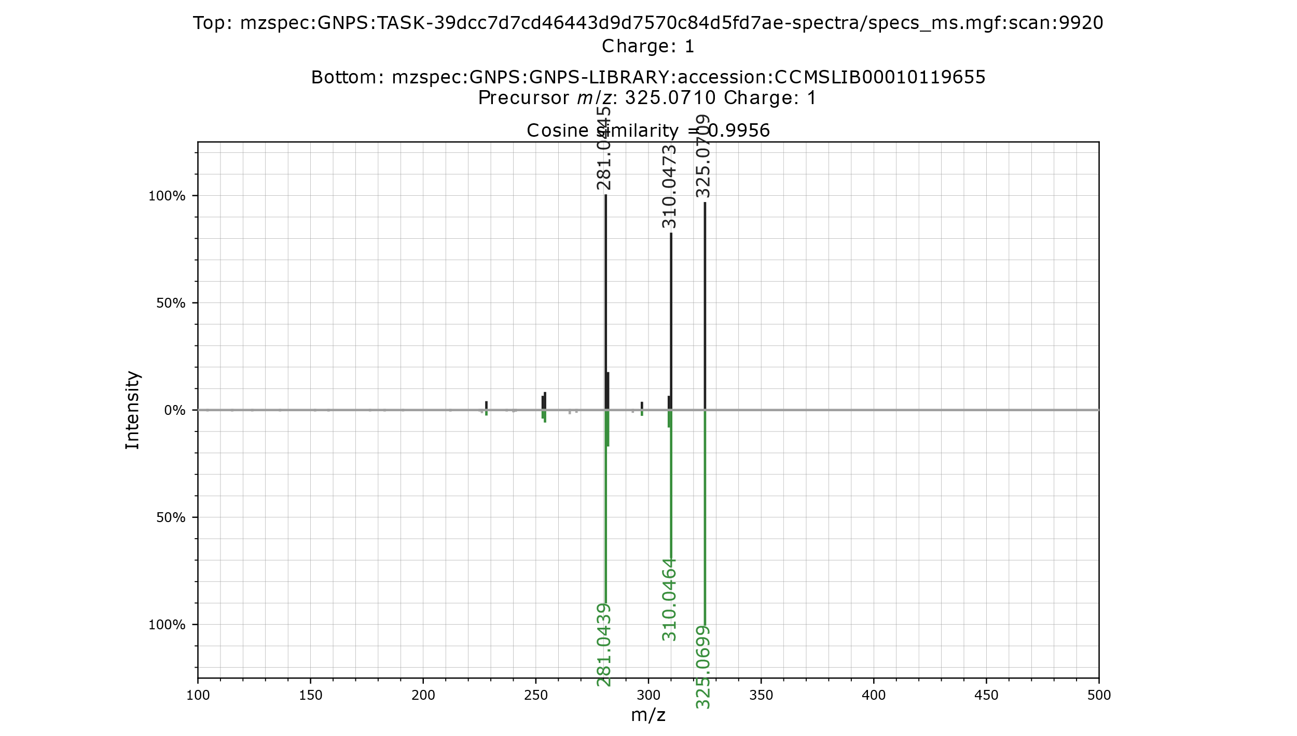
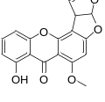
Figure S10: Mirror plot of experimental MS/MS spectra (upper, black) and GNPS reference spectra (lower, green) for sterigmatocystin annotation.

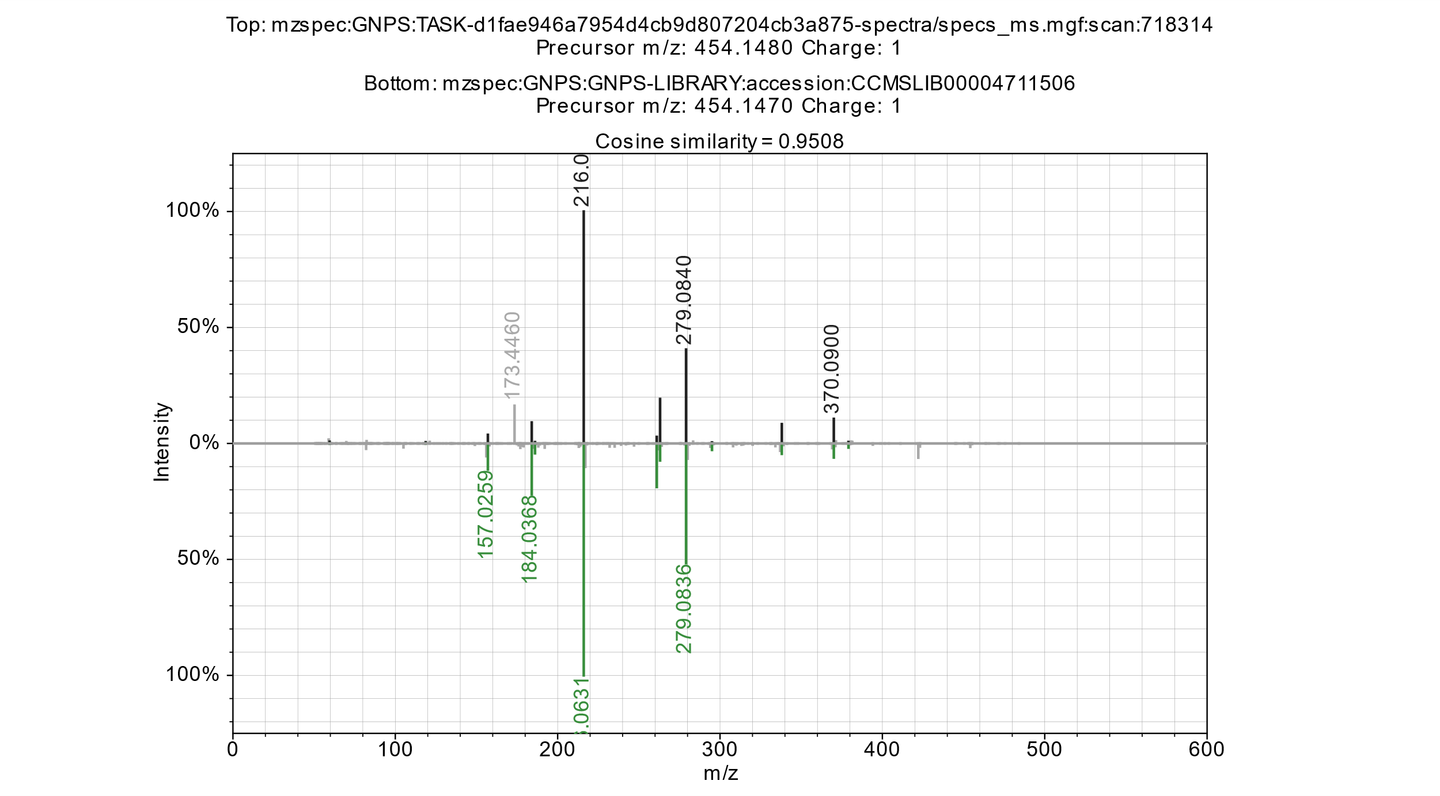
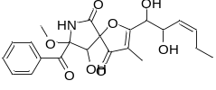
Figure S11: Mirror plot of experimental MS/MS spectra (upper, black) and GNPS reference spectra (lower, green) for pseurotin A annotation.

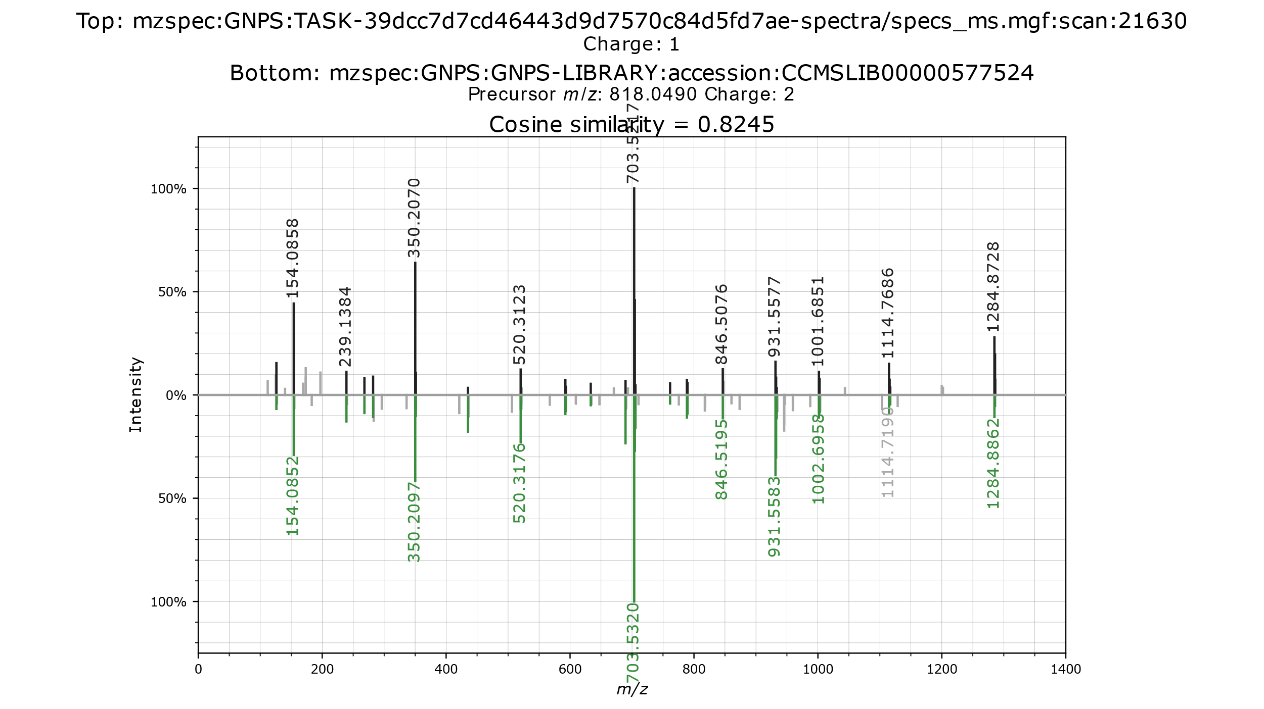
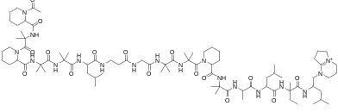
Figure S12: Mirror plot of experimental MS/MS spectra (upper, black) and GNPS reference spectra (lower, green) for efrapeptin F annotation.

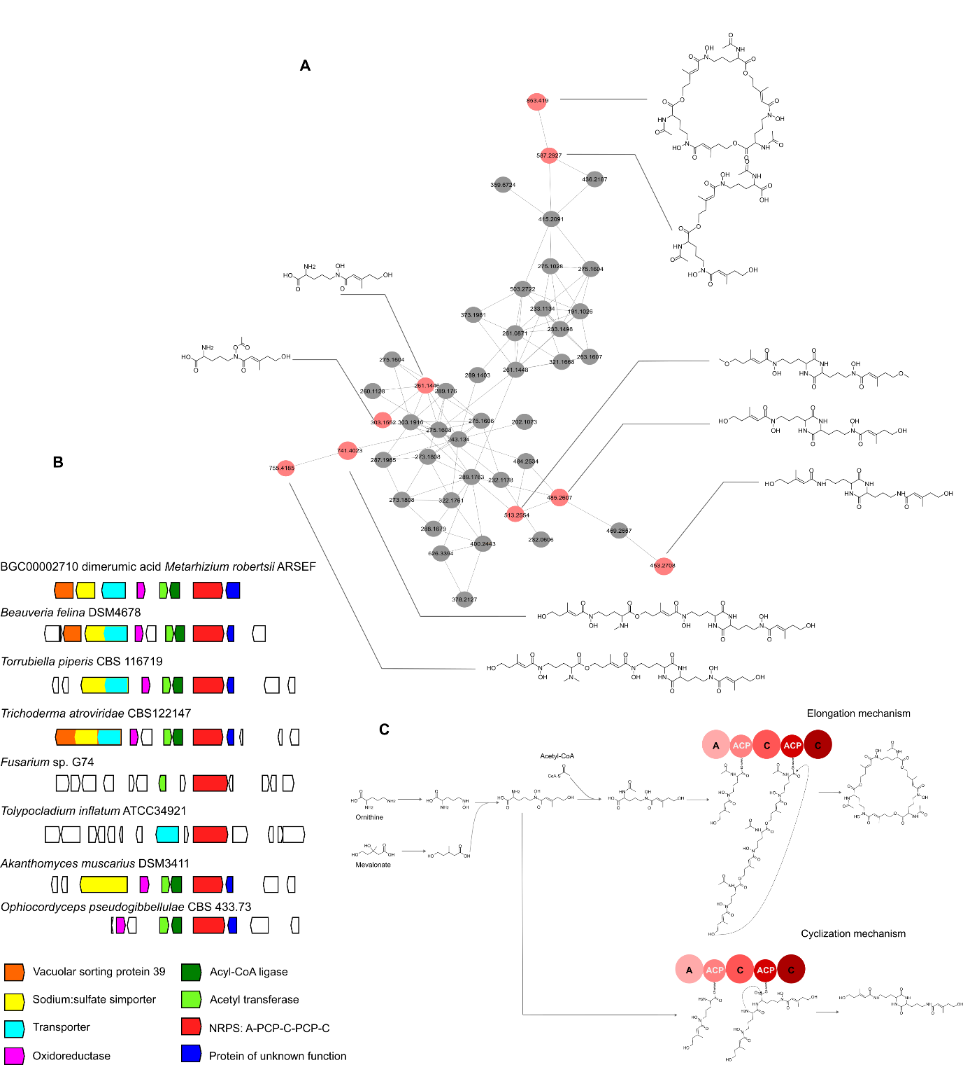
Figure S 13: Molecular network and biosynthetic mechanisms for hydroxy acetyl ornithine-derived siderophores. A. Molecular network for hydroxy acetyl ornithine-derived metabolites. B. biosynthetic gene cluster found in selected genomes. C. conserved biosynthetic mechanism for this family of compounds highlighting

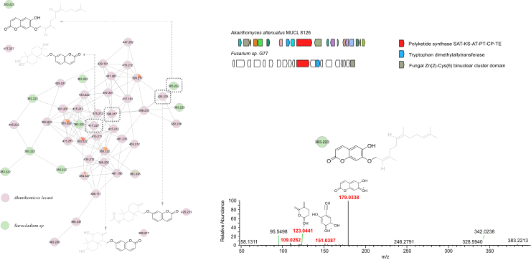
Figure S14: Molecular network for an unannotated molecular family. The network was generated with GNPS. The compounds class for the four highlighted compounds was predicted to be coumarins or terpene lactones using Sirius v5.8.3. The fragmentation spectra for m/z 383.2213 is presented as well as the proposed fragments. The corresponding structure was predicted by Sirius v5.8.3 with a confidence level of 86.27%. Ions m/z 415.212 [M+H]⁺, m/z 417.227 [M+H]⁺, m/z 425.233 [M+H]⁺ and m/z 383.223 [M+H]⁺ were predicted to be coumarins linked to a prenyl moiety. These ions were found in spectra from Akanthomyces attenuatus MUCL 8126 and Sarocladium sp. G77 and a fragment corresponding to m/z 179.0339, which is characteristic for coumarin fragments, was detected in the MS/MS-spectra. We used these features to postulate BGC predictions for these molecules, which we reasoned should be orthologous. Our search led to a conserved candidate BGC that included orthologs of tryptophan dimethylallyltransferase, and a PKS linked to coumarin biosynthesis (A. attenuatus BGC YNP 63 - 93.1 and Sarocladium sp BGC YNP77 - 23.1), which we predict are involved in the biosynthesis of the putative prenylated coumarins.

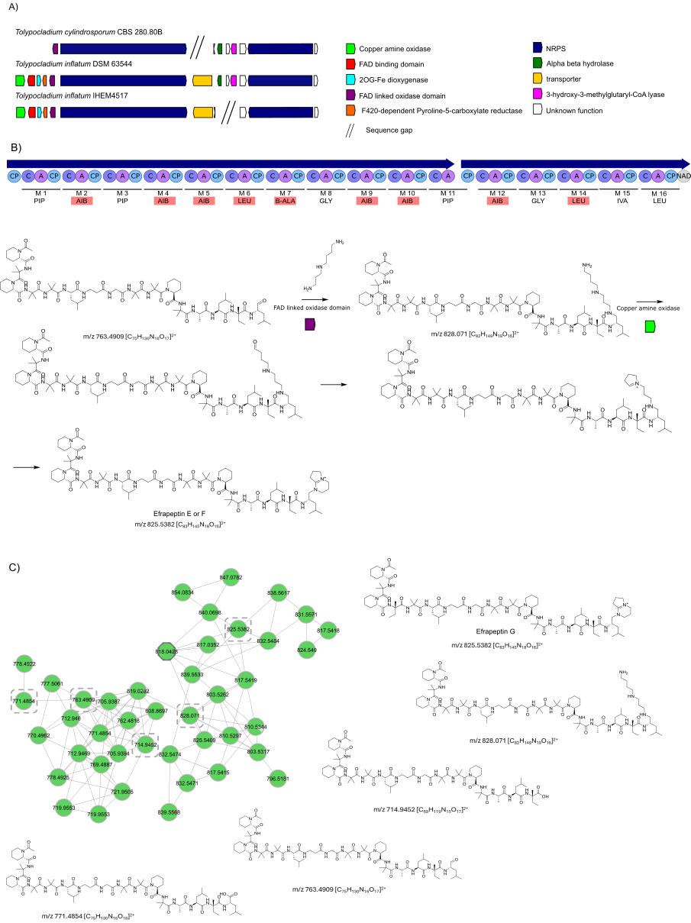
Figure S15: Proposed biosynthetic pathway and BGC for Efrapeptin. A. Comparison of Efrapeptin biosynthetic genes between Tolypocladium strains. B Efrapeptin biosynthetic gene cluster and biosynthetic proposal. The NRPS domain organization shows in light red boxes the predicted amino acid specificities for the A domains that match the structure of efrapeptin. C Molecular network for Efrapeptin and related compounds. The network was generated with GNPS. Pip= piperazine, Aib= amino isobutyric acid, B-ala. beta alanine, IVA =isovaline

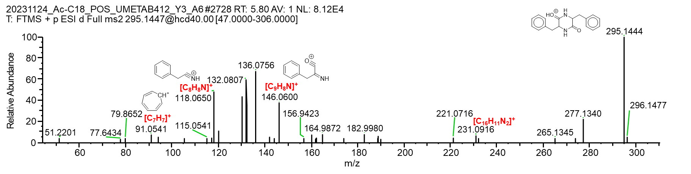
Figure S16: MS/MS spectra of the product obtained from heterologous expression of DseA encoded in g8518 from Akanthomyces muscarius DSM3411 involved in the biosynthesis of dethiosecoemestrin in Saccharomyces cerevisiae. The proposed fragments were generated using CFM-ID

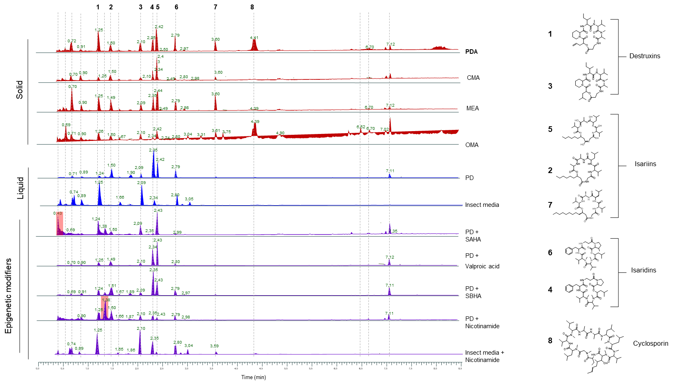
Figure S17: Epigenetic manipulation of NP metabolism from Amphicorda felina. Total Ion Chromatogram (ESI+) for Amphicorda felina DSM4678 extracts after cultivation in different media: solid media (potato dextrose agar, corn meal agar, malt extract agar, and oatmeal agar); liquid media (potato dextrose, potato dextrose + SAHA, potato dextrose + valproic acid, potato dextrose + SBHA, potato dextrose + nicotinamide, and insect media + nicotinamide). Annotated compounds are linked to their respective peaks. We selected Amphicorda felina DSM4678 and Amphicorda felina CBS 217.37 to examine the variation in natural product production under different culture media: Potato Dextrose Agar - PDA, Oatmeal Agar - OMA, Malt Extract Agar MEA, and Insect media (Acheta domesticus) and the addition of epigenetic modifiers (suberoylanilide hydroxamic acid - SAHA, SBHA - Suberohydroxamic acid, Valproic acid and Nicotinamide in Potato Dextrose Broth - PDB). Ther compounds: destruxins, isariins, and isaridins were annotated using GNPS. The induction by epigenetic modifiers mainly caused changes in the production of the annotated compounds. Cyclosporin could be detected only in PDA and OMA. When both strains were cultivated in PDB, PDB + SAHA, PDB + SBH, and PDB + nicotinamide, a peak was observed at a retention time of 1.38 (m/z 387.1807) that did not get annotated by GNPS. Based on peak intensity, the compound was produced most abundantly in PDB + nicotinamide. According to Sirius prediction, the molecular formula is C₂₂H₂₆O₆, and it is classified as a polyketide.
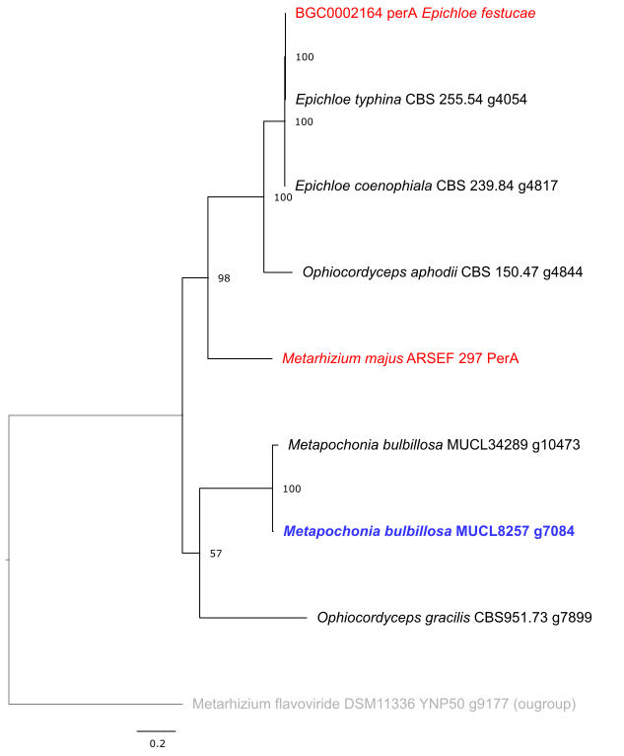
Figure S18: Phylogenetic relationships among peramine synthase orthologs among our strains. The orthologs highlighted in red are known to direct the synthesis of peramine, the ortholog in blue was selected for heterologous expression and confirmed to direct the synthesis of peramine. The sequence in gray encodes for an unrelated dimodular NRPS used as an outgroup,

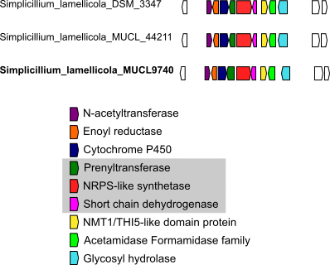
Figure S19: Gene context and annotation of g9547 from Simplicillium lamellicola MUCL 9740. Three orthologous BGCs found among the strains in our collection are shown, the three genes that were heterologously expressed are shown in a grey box.

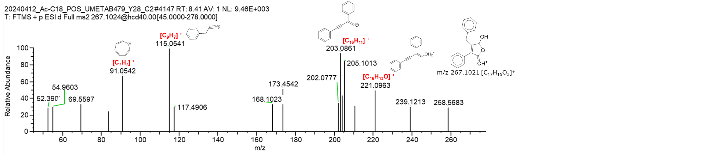
Figure S20: MS/MS spectra of the NRPS encoded in g5810 from Metarhizium anisopliae MUCL 9815 product obtained from heterologous expression in Saccharomyces cerevisiae. The proposed fragments were generated using CFM-ID.
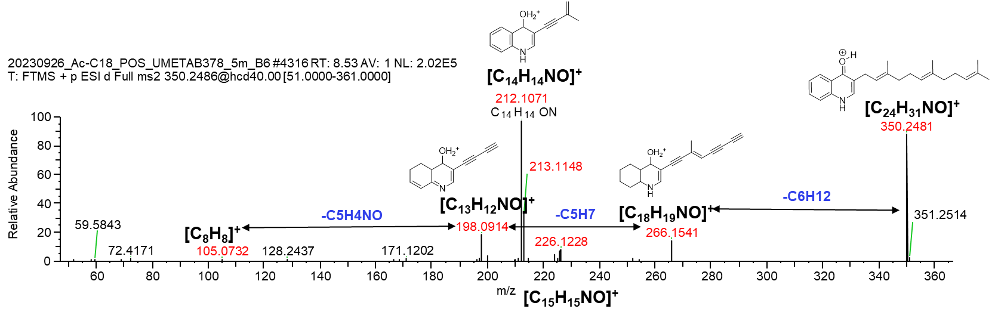
Figure S21: MS/MS spectra of the product obtained from heterologous expression of g9546-48 from Simplicillium lamellicola MUCL 9740 in Saccharomyces cerevisiae. The proposed fragments were generated using CFM-ID.

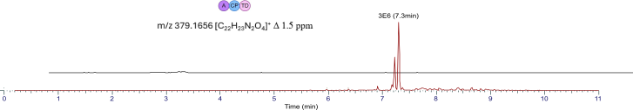
Figure S22: Extracted ion chromatograms obtained from LC-MS analysis of products from heterologous expression in Saccharomyces cerevisiae. Chromatogram corresponds to NRPSs g11, produced by Simplicillium lamellicola MUCL44211.

Plasmid | E. coli Selection Marker | E. coli Origin of Replication | Yeast Origin of Replication | Yeast Auxotrophy Marker | Yeast Replicons | Promoter | Terminator | Insert | Size (bp)
p64U_ g9547 | AmpR | ColE1 | CEN6_AR4 (YCp) | ura3 | ARS + CEN (low copy) | GAL1 | tADH1 | g9547 | 5668
p64U_ g9548 | AmpR | ColE1 | CEN6_AR4 (YCp) | ura3 | ARS + CEN (low copy) | ENO2 | tPRM9 | g9548 | 5943
p64U_ g9546 | AmpR | ColE1 | CEN6_AR4 (YCp) | ura3 | ARS + CEN (low copy) | TDH3 | tCYC1 | g9546 | 5794
p64U_g9546 _g9547_g9548 | AmpR | ColE1 | CEN6_AR4 (YCp) | ura3 | ARS + CEN (low copy) | TDH3 (g9546), GAL1 (g9547), ENO2 (g9548) | tCYC1 (g9546), tADH1 (g9547), tPRM9 (g9548) | g9546, g9547, g9548 | 11.931
pESC- g7094 | AmpR | ColE1, f1 | 2µ | leu2 | 2 µ (high copy) | GAL1/10 | tCYC1 | g7094 | 16.046
pESC- g5810 | AmpR | ColE1, f1 | 2µ | leu2 | 2 µ (high copy) | GAL1/10 | tCYC1 | g5810 | 10.471
pESC- g11 | AmpR | ColE1, f1 | 2µ | leu2 | 2 µ (high copy) | GAL1/10 | tCYC1 | g11 | 12.766
pESC- g8518 | AmpR | ColE1, f1 | 2µ | leu2 | 2 µ (high copy) | GAL1/10 | tCYC1 | g8518 | 12.958

Table S1: Features of the plasmids used for heterologous expression in of NRPSs from Hypocreales in Saccharomyces cerevisiae.

