Table 1: ADME qualified bioactive
S.No. | Bioactive | PCID | Mol._Wt. | Mol._Formula | Structure
1. | 4-Chloro-3,5-dimethoxybenzyl alcohol | 84777014 | 202.63 g/Mol | C₉H₁₁ClO₃ | 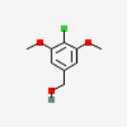
2. | (Z)-5-[(5-Methyl-2-thienyl)methylene]-2(5H)-furanone | 11469583 | 192.24 g/mol | C₁₀H₈O₂S | 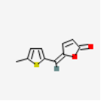
3. | Melosatin B | 188038 | 293.4 g/mol | C₁₉H₁₉NO₂ | 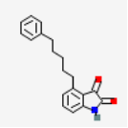
4. | WIN56291 | 129539 | 355.2 g/mol | C₁₆H₁₆Cl₂N₂O₃ | 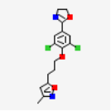
5. | Ketotifen | 3827 | 309.4 g/mol | C₁₉H₁₉NOS | 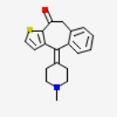
6. | Irenolone | 2754650 | 288.3 g/mol | C₁₉H₁₂O₃ | 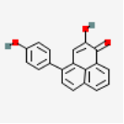
7. | 3-Hydroxy-carbofuran | 27975 | 237.25 g/mol | C₁₂H₁₅NO₄ | 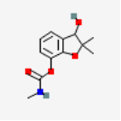
8. | 2-Methoxy-3-(1-methylpropyl)pyrazine | 520098 | 166.22 g/mol | C₉H₁₄N₂O | 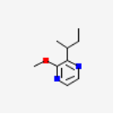
9. | Ethyl N-ethylanthranilate | 61980 | 193.24 g/mol | C₁₁H₁₅NO₂ | 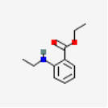
10. | Promacyl | 36733 | 277.36 g/mol | C₁₆H₂₃NO₃ | 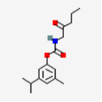
11. | Ruspolinone | 442655 | 249.30 g/mol | C₁₄H₁₉NO₃ | 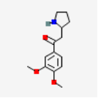
12. | Convolamine | 420422 | 305.4 g/mol | C₁₇H₂₃NO₄ | 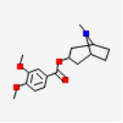
13. | Capsaicin | 1548943 | 305.4 g/mol | C₁₈H₂₇NO₃ | 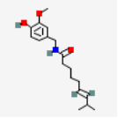
14. | Variotin | 5282176 | 291.4 g/mol | C₁₇H₂₅NO₃ | 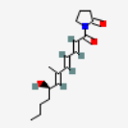
15. | Coixinden B | 9845244 | 234.25 g/mol | C₁₃H₁₄O₄ | 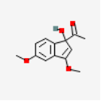
16. | Muricinine | 131750994 | 313.3 g/mol | C₁₈H₁₉NO₄ | 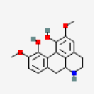
17. | C16 Sphinganine | 656816 | 273.45 g/mol | C₁₆H₃₅NO₂ | 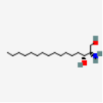
18. | Promazine sulfoxide | 547559 | 300.4 g/mol | C₁₇H₂₀N₂OS | 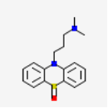
19. | Methyl 2-furoate | 11902 | 126.11 g/mol | C₆H₆O₃ | 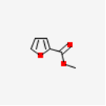
20. | 3,4-Heptanedione | 83671 | 128.17 g/mol | C₇H₁₂O₂ | 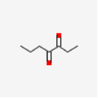
21. | 1-(5-Methyl-3-pyridinyl)-1-decanone | 71347088 | 247.38 g/mol | C₁₆H₂₅NO | 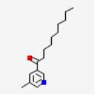
22. | Monomenthyl succinate | 10199004 | 256.34 g/mol | C₁₄H₂₄O₄ | 