Supplementary files

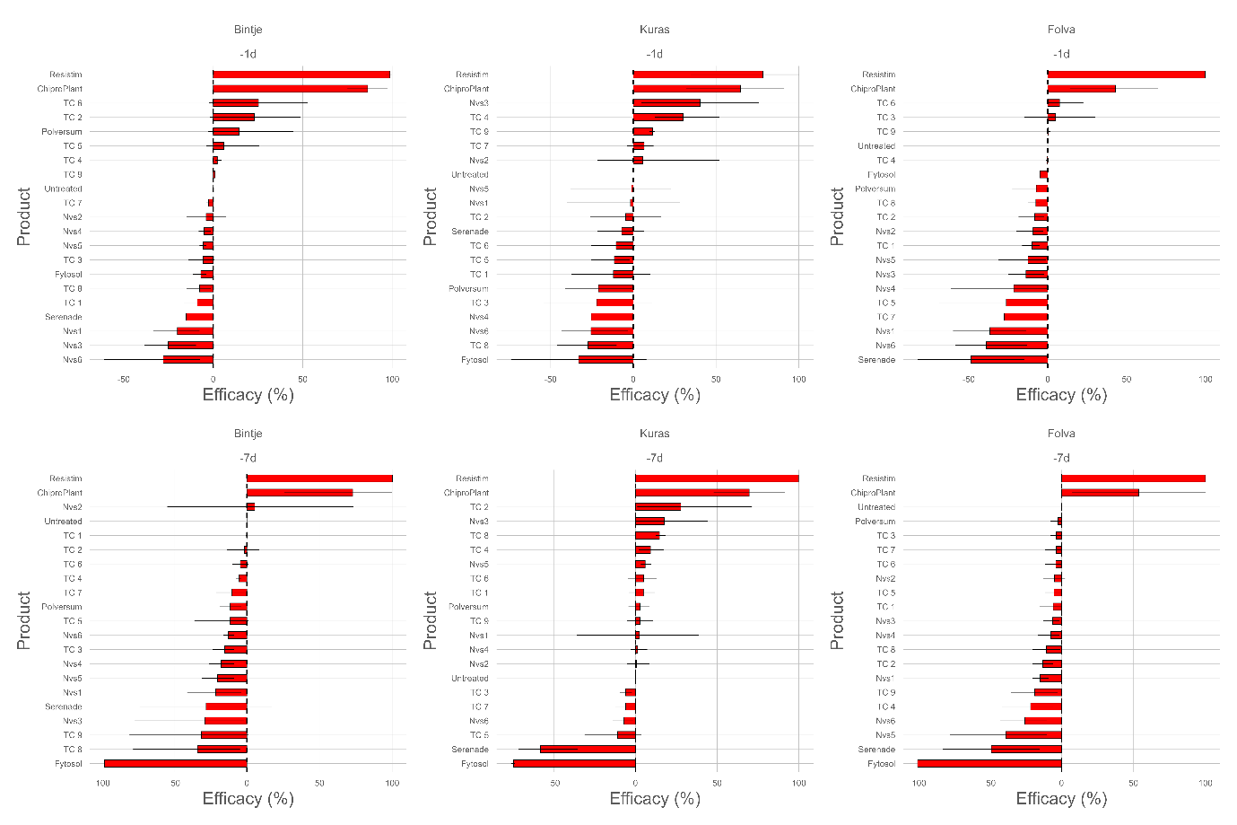
S1. Efficacy of biological control agents (BCAs) and plant resistance inducers (PRIs) for controlling late blight (Phytophthora infestans) on detached leaves of cvs. Kuras, Folva and Bintje. The dashed line represents the untreated control (no effect). Horizontal red bars are the 95% confidence intervals (based on bootstrapping).

S2. Chemical fungicides and their dosages used in the field trials
Country | Product | Active ingredient | Dosage, l/ha
Estonia | Revus Top | 250 g/l mandipropamid + 250 g/l difenoconazole | 0,6
Denmark | Ranman Top | 160 g/l cyazofamid | 0,5
Finland | Revus  Infinito  Shirlan  Ranman Top | 250 g/l mandipropamid  62,5 g/l fluopicolide + 625 g/l propamocarb-hydrochloride  500 g/l fluazinam  160 g/l cyazofamid | 0,6  1,6  0,4  0,5
Germany | Revus Top | 250 g/l mandipropamid + 250 g/l difenoconazole | 0,6
Scotland | Ranman Top  Zorvec Endavia  Infinito  Axidor  Prescos | 160 g/l cyazofamid  30 g/l oxathiapiprolin + 70 g/l benthiavalicarb),  62,5 g/l fluopicolide + 625 g/l propamocarb)  50 g/l cymoxanil + 400 g/l propamocarb  300 g/l ametoctradin + 225 g/l dimethomorph | 0,5  0,4  1,6  2,1  0,8

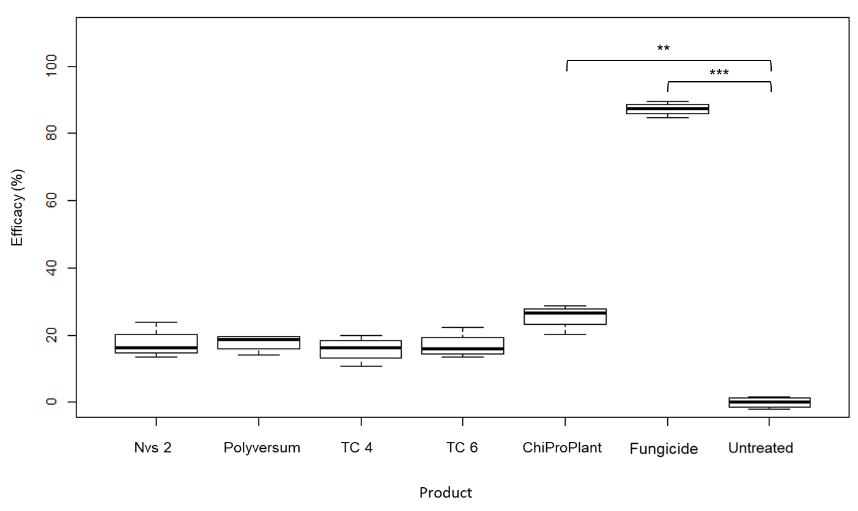
S3. Efficacy of biocontrol products against late blight on potato plants grown under field conditions in Germany (cv. Kuras). Efficacy of the product is expressed as percentage of rAUDPC relative to rAUDPC of the untreated control. Asterisks indicate statistically significant differences (*p < 0.05, **p < 0.01, ***p < 0.001).

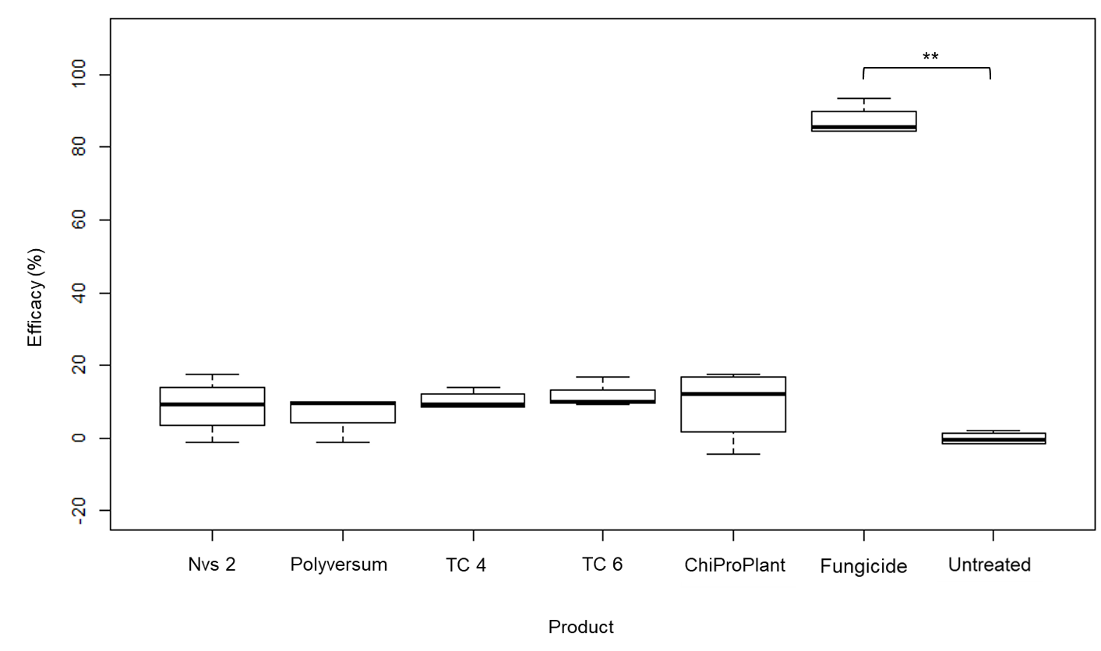
S4. Efficacy of biocontrol products against late blight under field conditions in Denmark on cv. Kuras. Efficacy of the product is expressed as percentage of rAUDPC relative to rAUDPC of the untreated control. Asterisks indicate statistically significant differences (*p < 0.05, **p < 0.01, ***p < 0.001).

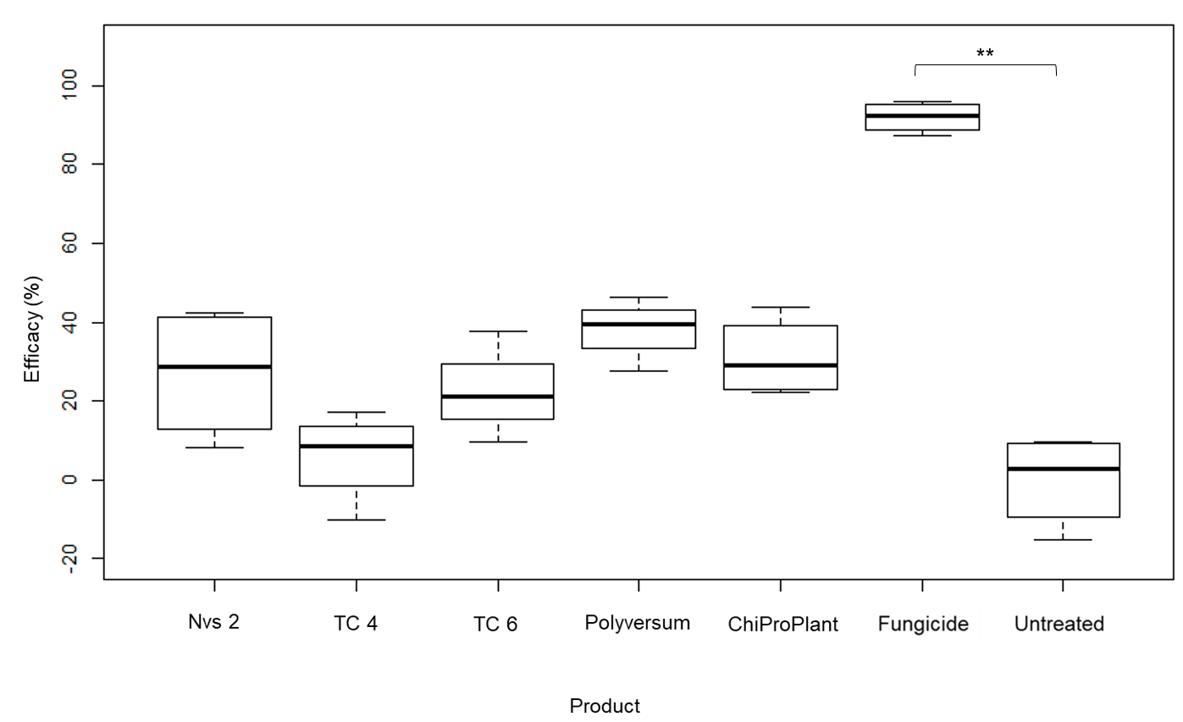
S4. Efficacy of biocontrol products against late blight under field conditions in Scotland on cv. Maris Piper. Efficacy of the product is expressed as percentage of rAUDPC relative to rAUDPC of the untreated control. Asterisks indicate statistically significant differences (*p < 0.05, **p < 0.01, ***p < 0.001).

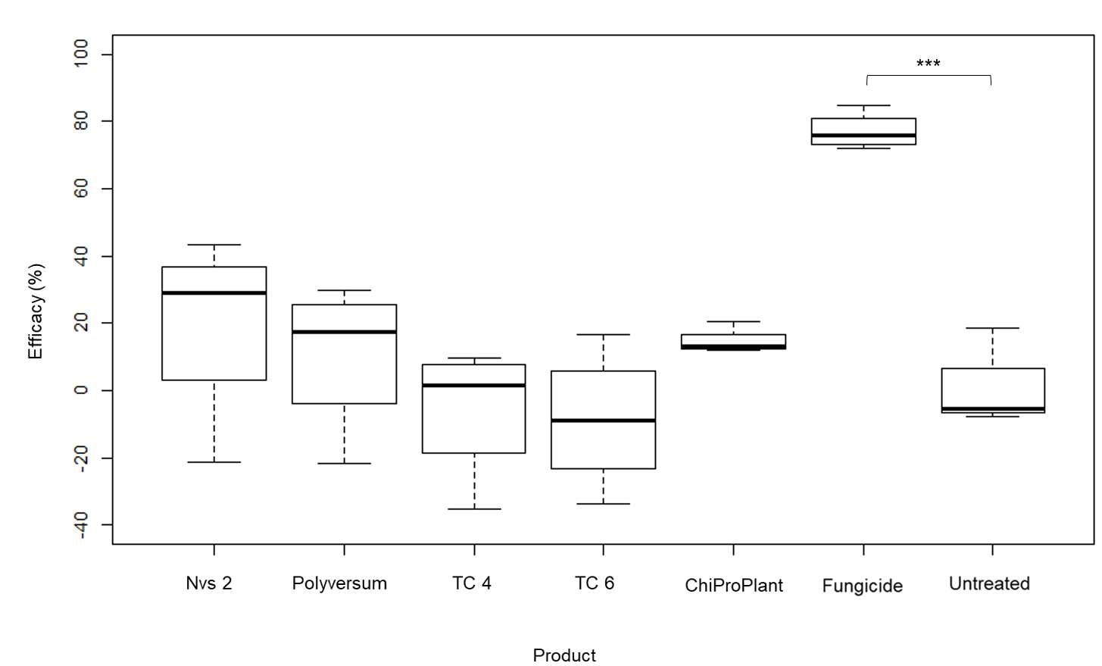
S5. Efficacy of biocontrol products against late blight under field conditions in Scotland on cv. Gatsby. Efficacy of the product is expressed as percentage of rAUDPC relative to rAUDPC of the untreated control. Asterisks indicate statistically significant differences (*p < 0.05, **p < 0.01, ***p < 0.001).

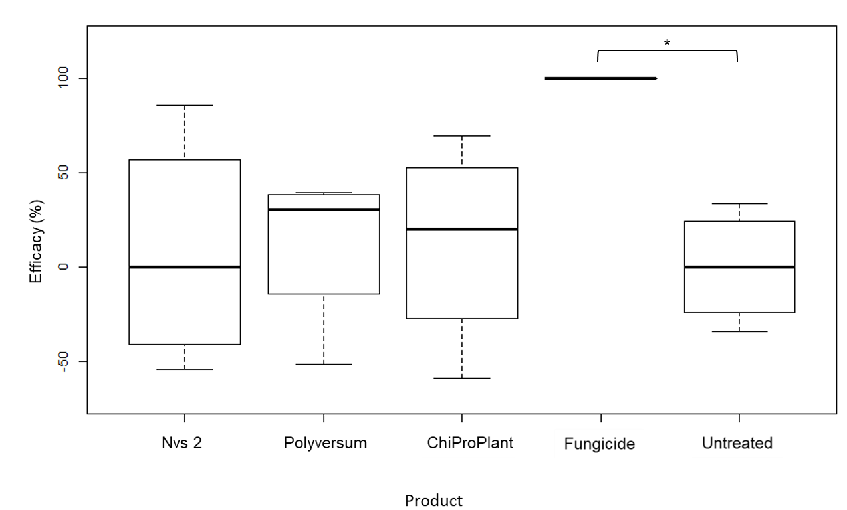
S6. Efficacy of biocontrol products against late blight under field conditions in Finland on cv. Kuras. Efficacy of the product is expressed as percentage of rAUDPC relative to rAUDPC of the untreated control. Asterisks indicate statistically significant differences (*p < 0.05, **p < 0.01, ***p < 0.001).

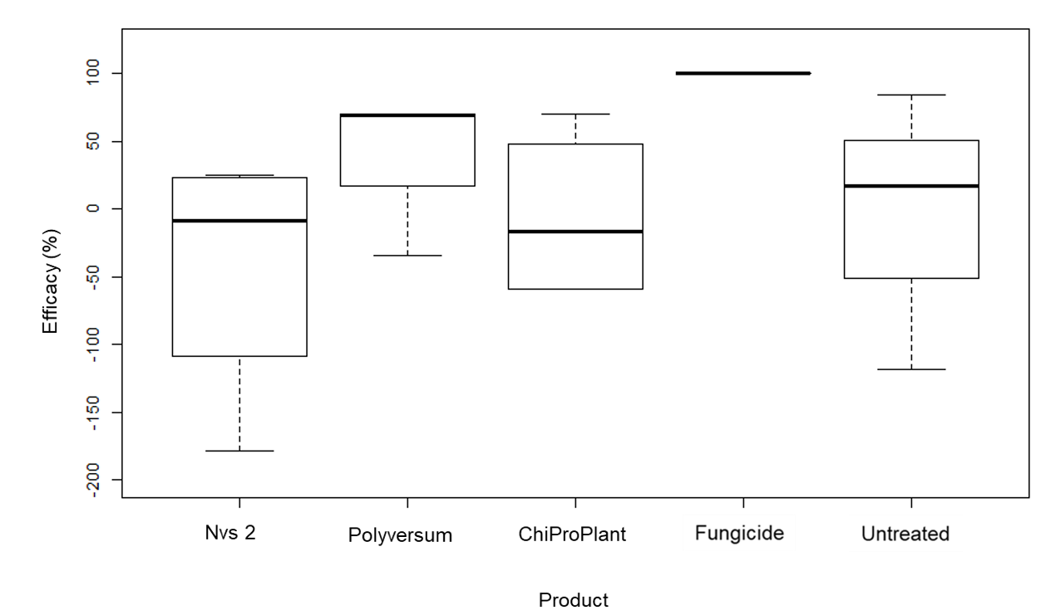
S7. Efficacy of biocontrol products against late blight under field conditions in Finland on cv. Mungo. Efficacy of the product is expressed as percentage of rAUDPC relative to rAUDPC of the untreated control. All differences between the treatments are statistically not significant (p < 0.05).

