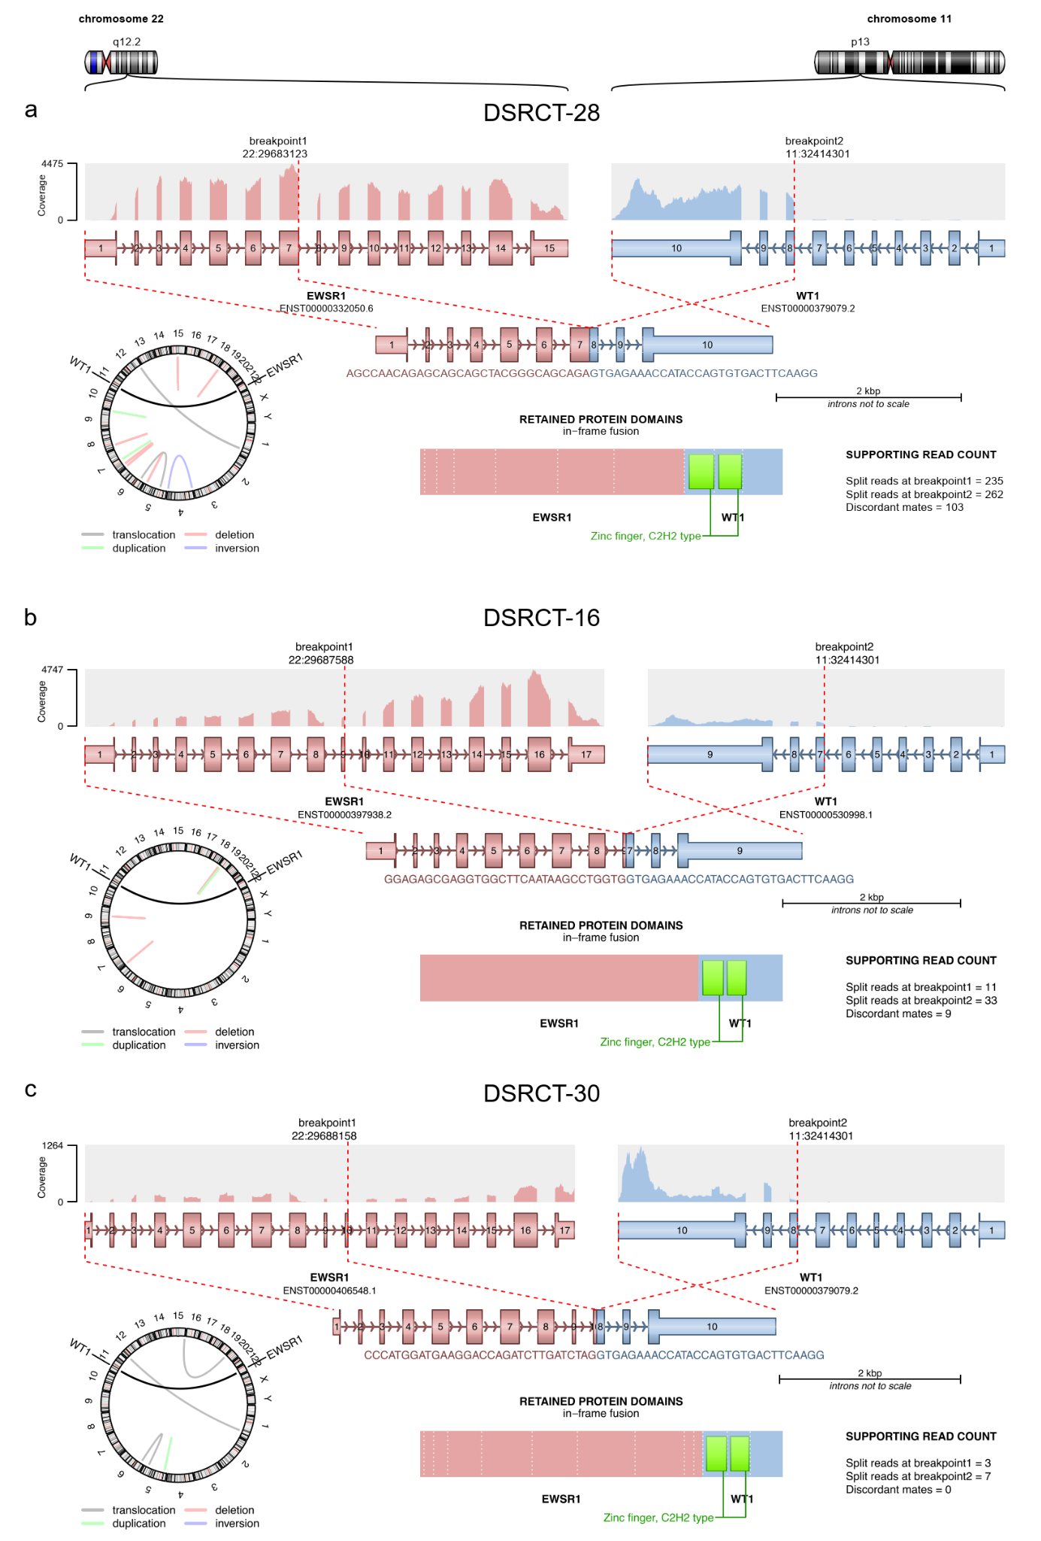

Supplementary Figure 1. Schematic representation of the three EWSR1::WT1 fusion transcripts. (a) In 25 of 27 cases (92.6%), the most common EWSR1::WT1 fusion with breakpoints in exons 7-8 was detected. Patient DSRCT-28 is shown as an example. (b) Patient DSRCT-16 had an EWSR1::WT1 fusion with breakpoints in exons 9-8. (c) Patient DSRCT-30 had an EWSR1::WT1 fusion with breakpoints in exons 10-8. Exon numbers are provided for the canonical EWSR1 (ENST00000397938.7) and WT1 (ENST00000452863.10) transcripts.
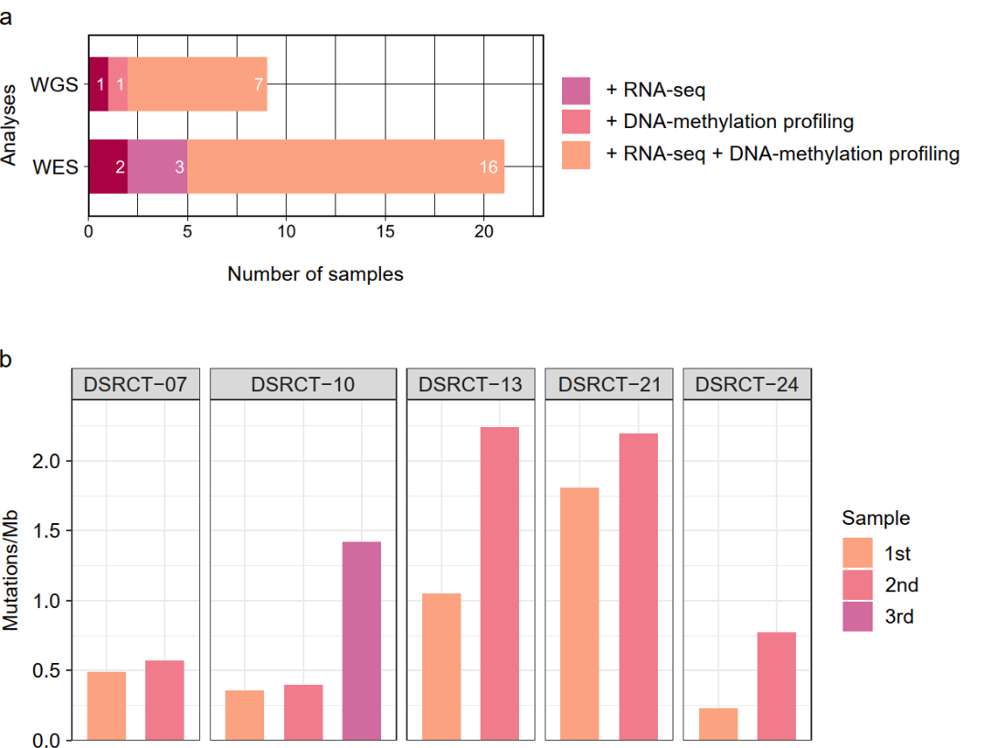
Supplementary Figure 2. (a) Number of samples analyzed by whole-exome sequencing (WES), whole-genome sequencing (WGS), RNA sequencing (RNA-seq), and DNA methylation profiling. (b) Increasing somatic mutation rates in four patients with sequential tumor samples. Mb, megabase.

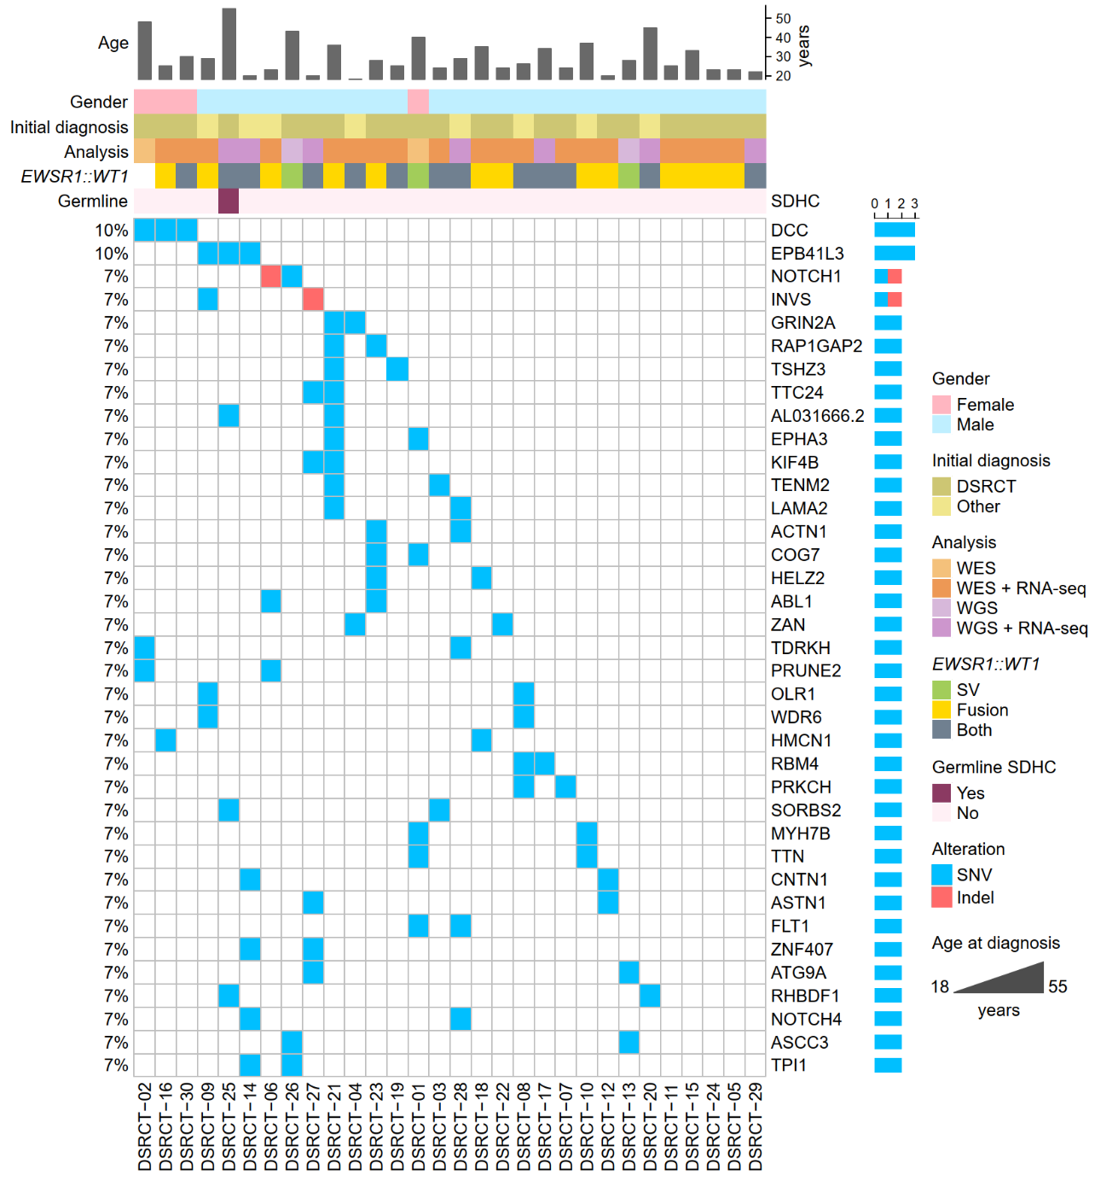
Supplementary Figure 3. Landscape of recurrent somatic SNVs and indels. The EWSR1::WT1 fusion in patient DSRCT-02 was detected by fluorescence in situ hybridization in nearly all tumor cells. SV, structural variant.
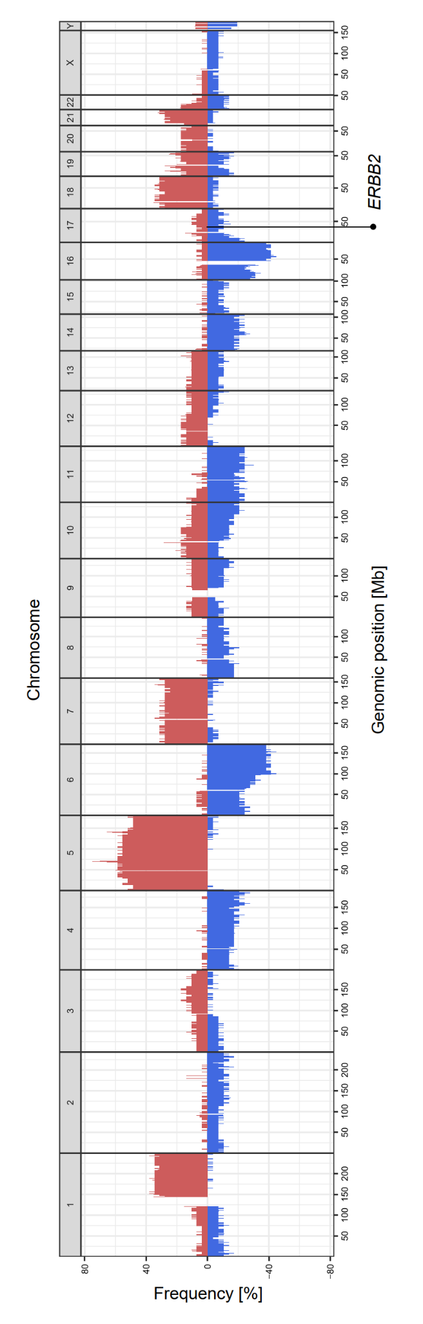
Supplementary Figure 4. Average somatic DNA copy number profile across 29 DSRCT cases. Chromosomes are represented along the vertical axis, and frequencies of genomic gains (red) and losses (blue) are represented along the horizontal axis. The position of the ERBB2 gene on chromosome 17q12 is indicated. Mb, megabase.
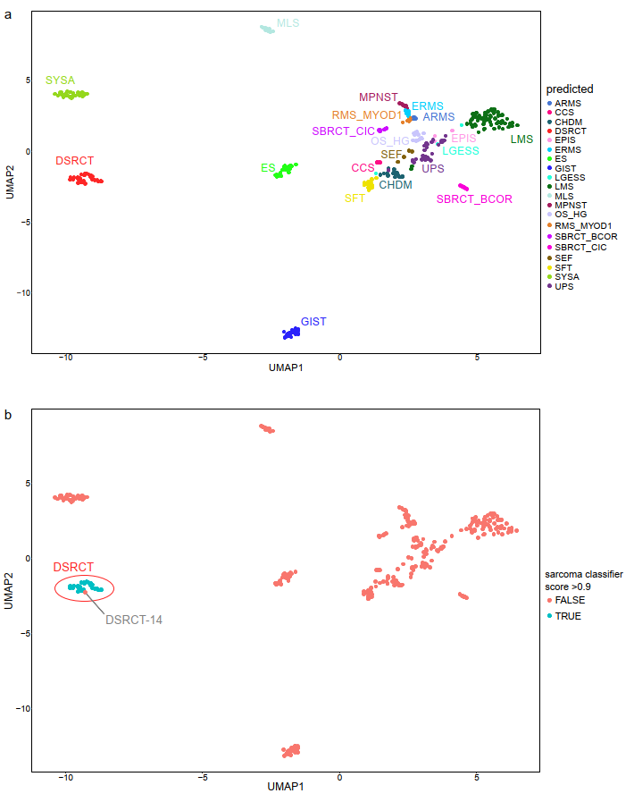
Supplementary Figure 5. (a) UMAP analysis using the 5,000 most variable CpG sites of the DNA methylation profiles of 30 DSRCT samples from 25 patients and other sarcoma samples (n = 305). Inclusion criteria for non-DSRCT samples were a sarcoma classifier score ≥ 0.9 and more than three samples per entity. (b) Same UMAP as in (a) with coloring according to whether the sarcoma classifier score for DSRCT was ≥ 0.9 (green) or < 0.9 (red). ARMS, alveolar rhabdomyosarcoma; CCS, clear cell sarcoma; CHDM, chordoma; DSRCT, desmoplastic small round cell tumor; EPIS, epithelioid sarcoma; LGESS, low-grade endometrial stromal sarcoma; ES, Ewing sarcoma; ERMS, embryonal rhabdomyosarcoma; GIST, gastrointestinal stromal tumor; LMS, leiomyosarcoma; MLS, myxoid liposarcoma; MPNST, malignant peripheral nerve sheath tumor; OS_HG, high-grade osteosarcoma; RMS_MYOD1, MYOD1-mutant spindle cell/sclerosing rhabdomyosarcoma; SBRCT_BCOR, small blue round cell tumor with BCOR alteration; SBRCT_CIC, small blue round cell tumor with CIC alteration; SEF, sclerosing epithelioid sarcoma; SFT, solitary fibrous tumor; SYSA, synovial sarcoma; UPS, undifferentiated pleomorphic sarcoma.
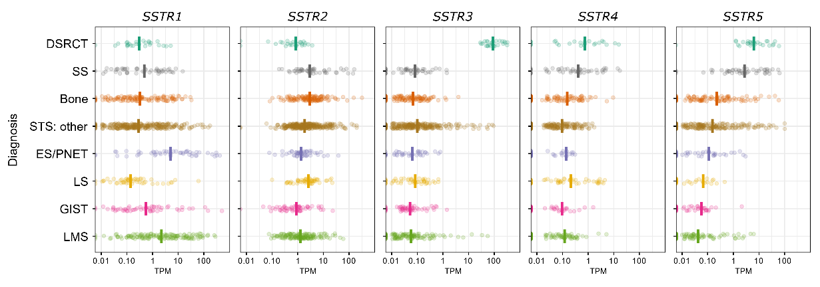
Supplementary Figure 6. SSTR1, SSTR2, SSTR3, SSTR4, and SSTR5 mRNA expression in DSRCT compared to other sarcomas enrolled in MASTER. The vertical lines indicate median expression. GIST, gastrointestinal stromal tumor; LMS, leiomyosarcoma; LS, liposarcoma; PNET, primitive neuroectodermal tumor; SS, synovial sarcoma; STS, soft-tissue sarcoma; TPM, transcripts per kilobase million.

Supplementary Table 3. Recommendations according to intervention baskets
Basket | n | %
Tyrosine kinase | 48 | 44.9
DNA damage repair | 13 | 12,1
Immunotherapy | 12 | 11.2
Other | 12 | 11.2
Theranostics | 11 | 10.3
PI3K-AKT-mTOR | 6 | 5.6
Antibody-drug conjugate | 2 | 1.9
Cell cycle | 2 | 1.9
RAF-MEK-ERK | 1 | 0.9

Supplementary Table 4. Clinical trials recommended based on molecular profiling
Patient | Molecular tumor board | ClinicalTrials.gov identifier(s)
DSRCT-07 | 2 | NCT02987959, NCT02576444
DSRCT-12 | 1 | NCT02568267
DSRCT-13 | 3 | NCT03127215, NCT04503278
DSRCT-15 | 1 | NCT01976741
DSRCT-16 | 1 | NCT01976741, NCT01189643, NCT02460224, NCT01968109
DSRCT-17 | 1 | NCT03127215, NCT02419417
DSRCT-18 | 1 | NCT02607813
DSRCT-20 | 1 | NCT03517956, NCT03102320
DSRCT-21 | 1 | NCT02419417
DSRCT-22 | 1 | NCT03517956
DSRCT-23 | 1 | NCT04503278
DSRCT-24 | 2 | NCT04503278
DSRCT-25 | 1 | NCT04503278
DSRCT-26 | 1 | NCT03127215
DSRCT-28 | 1 | NCT04503278
DSRCT-29 | 1 | NCT04503278
DSRCT-30 | 1 | NCT04551521
Supplementary Table 5. SNVs and resulting treatment recommendations
Patient | Gene | Mutation | Allele frequency | Inhibitor class (inhibitor)
DSRCT-01 | FLT1 | c.427C>T, p.P142S | 0.07 | Multikinase (pazopanib)
DSRCT-01 | EPHA3 | c.1339C>G, p.R447G | 0.31 | Multikinase (dasatinib)
DSRCT-05 | FGFR4 | c.1907G>T, p.G636V | 0.17 | Multikinase (pazopanib)
DSRCT-09 | MTOR | c.6644C>A, p.S2215Y | 0.40 | mTORC1 (everolimus)

Supplementary Table 6. SBS signatures and resulting treatment recommendations
Patient | Molecular tumor board | Signature^{A} | Inhibitor class | Additional biomarker(s)
DSRCT-10 | 3 | SBS3 | PARP | None
DSRCT-13 | 1  2 | SBS3  SBS3 | PARP  PARP^{B} | None  None
DSRCT-13 | 3 | SBS3 | PARP^{B} | SNV in CDK12
DSRCT-14 | 1 | SBS8 | PARP | Increased SLFN11 expression
DSRCT-17 | 1 | SBS3  SBS8 | PARP^{B} | Gain and increased expression of PARP1, increased PARP2 expression, deletions of ATM and PALB2
DSRCT-19 | 1 | SBS2 | Immune checkpoint | None
DSRCT-21 | 1 | SBS3 | PARP | Deletions of FANCA, BAP1, WDR48, and TOP2B
DSRCT-26 | 1 | SBS3 | PARP^{B} | None
DSRCT-27 | 1 | SBS3  SBS8 | PARP | Increased SLFN11 expression
A: Designation according to Human Cancer Signatures v3.4 (https://cancer.sanger.ac.uk/signatures).
B: As part of the TOP-ART trial NCT03127215.

Supplementary Table 7. CNVs and resulting treatment recommendations
Patient | Gene(s) | Expression | TCN | Ploidy | Alteration | Inhibitor class (inhibitor)
DSRCT-03 | PALB2  ERCC4 | Absent  Absent | 3.5  3.5 | 6 | Deletion  Deletion | PARP
DSRCT-07 | PDGFRB | Unknown | 3 | 2 | Duplication | Multikinase (imatinib)
DSRCT-07 | RICTOR | Unknown | 3 | 2 | Duplication | AKT/mTOR
DSRCT-07 | ERCC1 | Unknown | 1 | 2 | Deletion | PARP
DSRCT-13 | MET | Absent | 3 | 2 | Gain | MET (cabozantinib)
DSRCT-16 | BRCA1  FANCE  RAD51 | Low  Low  Low | 1.7  1.8  1.3 | 2 | Deletion  Deletion  Deletion | PARP
DSRCT-17 | CCND1 | High | 3 | 2 | Gain | CDK4/6
DSRCT-18 | PTEN | Low | 2 | 4 | Deletion | mTORC1
DSRCT-25 | PTEN | Low | 3 | 4 | Deletion | mTORC1
TCN, total copy number.

Supplementary Table 8. Cancer predisposition genes evaluated for rare germline alterations
AIP | CREBBP | FANCF | MUTYH | RAD51D | SOS1
AKT1 | CYLD | FANCG | NBN | RB1 | SPINK1
ALK | DDB2 | FANCI | NF1 | RECQL4 | STAT3
ANKRD26 | DDX41 | FANCL | NF2 | RET | STK11
APC | DICER1 | FAS | NRAS | RHBDF2 | SUFU
ATM | DIS3L2 | FH | NSD1 | RMRP | TERC
BAP1 | DKC1 | FLCN | NTHL1 | RPS19 | TERT
BARD1 | DOCK8 | GATA2 | PALB2 | RPS24 | TINF2
BLM | EGFR | GJB2 | PARN | RPS26 | TMEM127
BMPR1A | ELANE | GPC3 | PDGFRA | RTEL1 | TP53
BRCA1 | EPCAM | HFE | PHOX2B | RUNX1 | TRIM37
BRCA2 | ERCC2 | HMBS | PIK3CA | SAMD9 | TSC1
BRIP1 | ERCC3 | HPS1 | PIK3R1 | SBDS | TSC2
BUB1B | ERCC4 | HRAS | PMS2 | SDHA | VHL
CBL | ERCC5 | IDH1 | POLD1 | SDHAF2 | WAS
CDC73 | ETV6 | KIT | POLE | SDHB | WRAP53
CDH1 | EXT1 | KRAS | POLH | SDHC | WRN
CDK4 | EXT2 | MAX | POT1 | SDHD | WT1
CDKN1B | EZH2 | MEN1 | PRKAR1A | SETBP1 | XPA
CDKN1C | FANCA | MET | PRSS1 | SLX4 | XPC
CDKN2A | FANCB | MITF | PTCH1 | SMAD4 | XRCC2
CEBPA | FANCC | MLH1 | PTEN | SMARCA4
CHEK2 | FANCD2 | MSH2 | PTPN11 | SMARCB1
COL7A1 | FANCE | MSH6 | RAD51C | SMARCE1

Supplementary Table 9. Treatment history of patient DSRCT-28
Line | Regimen | Start | Duration (months) | Best response
1 | Cisplatin, 5-fluorouracil, docetaxel | 05/2018 | 4 | PR
2 | Capecitabine | 09/2018 | 5 | NA
3 | Nivolumab | 04/2019 | 5 | SD
4 | Doxorubicin | 09/2019 | 2 | PD
5 | Nab-paclitaxel, carboplatin | 11/2019 | 11 | PR
6 | Nivolumab, ipilimumab | 10/2020 | 1 | PD
7 | Palbociclib, letrozole | 01/2021 | 8 | NA
8 | Gemcitabine | 09/2021 | 3 | PD
9 | Capecitabine | 11/2021 | 4 | PD
10 | Paclitaxel | 03/2022 | 2 | PD
11 | Pazopanib | 06/2022 | 4 | PD
12 | VIDE (without doxorubicin) | 10/2022 | 5 | SD
13 | T-DXd | 04/2023 | 18 | PR
14 | T-DM1 | 11/2024 | 3 | NA
NA, not available; PR, partial response; SD, stable disease; PD, progressive disease; T-DM1, trastuzumab emtansin.

Supplementary Table 10. Response to T-DXd in patient DSRCT-28 as determined by ¹⁸F-FDG-PET/CT
Date of assessment | Response
04/2023 | PR
07/2023 | PR
10/2023 | PR
01/2024 | PR
04/2024 | PR
07/2024 | PR
10/2024 | PD
PR, partial response; PD, progressive disease.

Supplementary Table 11. Treatment history of patient DSRCT-30
Line | Regimen | Start | Duration (months) | Best response
1 | VAIA | 07/2020 | 2 | PR
2 | VIDE | 08/2020 | 4 | PR
3 | Trabectedin | 11/2020 | 9 | PR
4 | Topotecan, cyclophosphamide | 09/2022 | 9 | PD
5 | Irinotecan, temozolomide^{A} | 01/2023 | 9 | PR
6 | T-DXd | 08/2023 | > 10 | PR
A: Until 05/2023.
PR, partial response; SD, stable disease; PD, progressive disease; T-DM1, trastuzumab emtansin.

Supplementary Table 12. Response to T-DXd in patient DSRCT-30 as determined by ¹⁸F-FDG-PET/CT
Date of assessment | Response
11/2023 | PR
01/2024 | PR
04/2024 | SD
07/2024 | SD
PR, partial response; SD, stable disease; PD, progressive disease.

