Characterization of Novel Straboviridae Phages Enhancing Antibiotic Efficacy and Biofilm Inhibition Against MDR Escherichia coli

Md Shamsuzzamn^{1,2}, Shukho Kim^{1,2}, Yoon-Jung Choi^{1,2} and Jungmin Kim^{1,2*}
¹Department of Biomedical Science, School of Medicine, Kyungpook National University, Daegu, Republic of Korea
²Department of Microbiology, School of Medicine, Kyungpook National University, Daegu, Republic of Korea

*Corresponding author: E-mail: minkim@knu.ac.kr; Phone: +82-53-420-4840; Fax: +82-53-427-5664.

Present address: Department of Microbiology, Kyungpook National University School of Medicine ADD. (41944) 680 gukchaebosang-ro, Jung-gu, Daegu, Republic of Korea.

Running title: Characterization of novel phage’s targeting Multidrug-Resistant Escherichia coli

Keywords: Multidrug-Resistant Escherichia coli, phage therapy, genome analysis, phage-antibiotic synergy, biofilm.

Repositories:
The complete genome sequences of phages EC.W1-1 and EC.W15-3 are available in GenBank with the NCBI (https://www.ncbi.nlm.nih.gov/) accession numbers PP170089 and PQ030847, respectively.
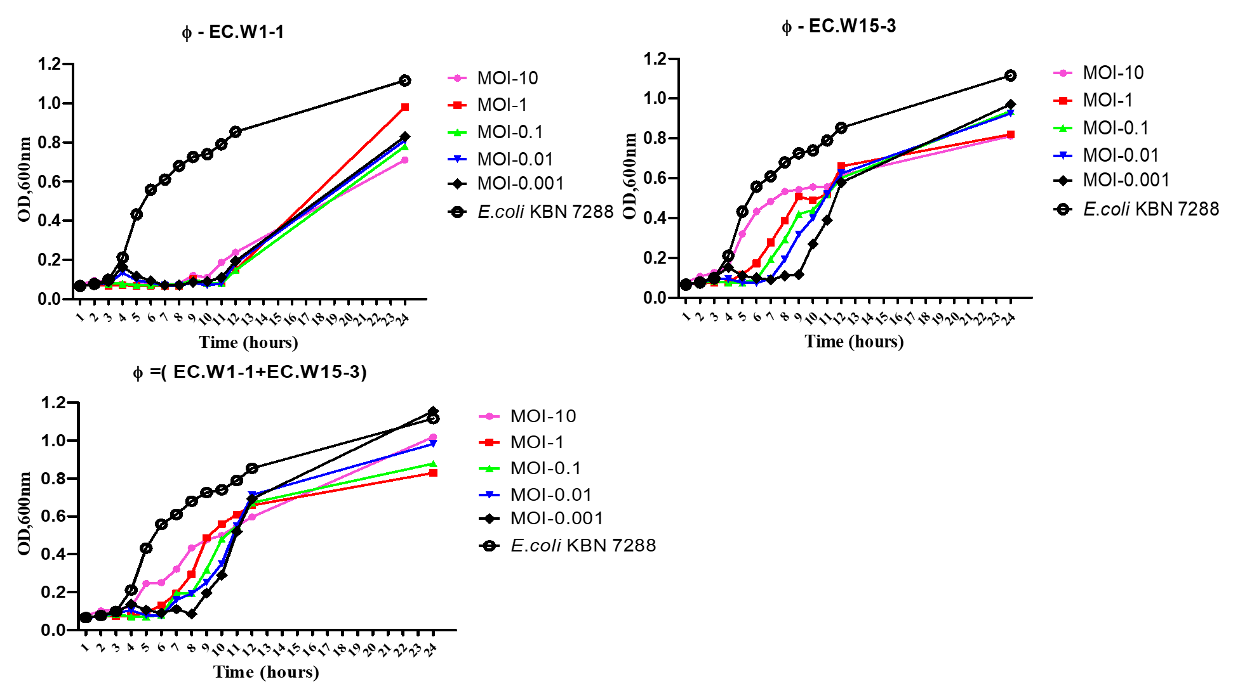
Figure S.1: In vitro Bacterial Lytic Activities of Phage EC.W1-1 and EC.W15-3 at Different Multiplicities of Infection (MOIs) and their Combination. The graph depicts the killing curves of E. coli clinical isolate KBN 7288 (ST131) by phage EC.W1-1 and EC.W15-3 at MOIs of 10, 1, 0.1, 0.01, and 0.001 over a 24-hour period. Each data point represents the mean ± standard deviation (SD) of three independent experiments.24 hours
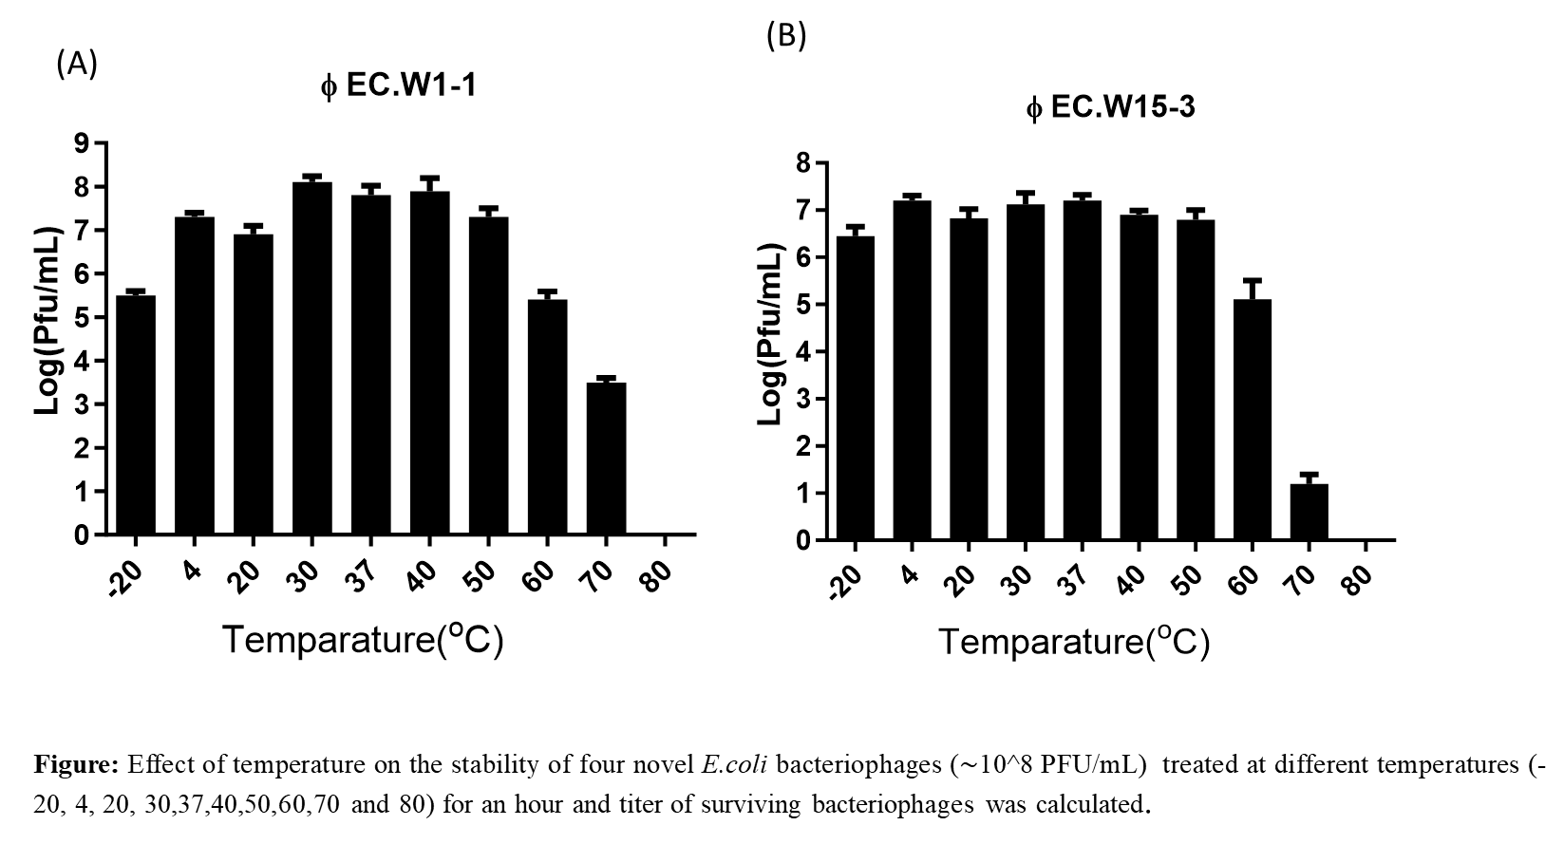

Figure S.2: Effect of temperature on the stability of four novel E.coli bacteriophages (∼10^8 PFU/mL) treated at different temperatures (-20, 4, 20, 30,37,40,50,60,70 and 80) for an hour and titer of surviving bacteriophages was calculated.

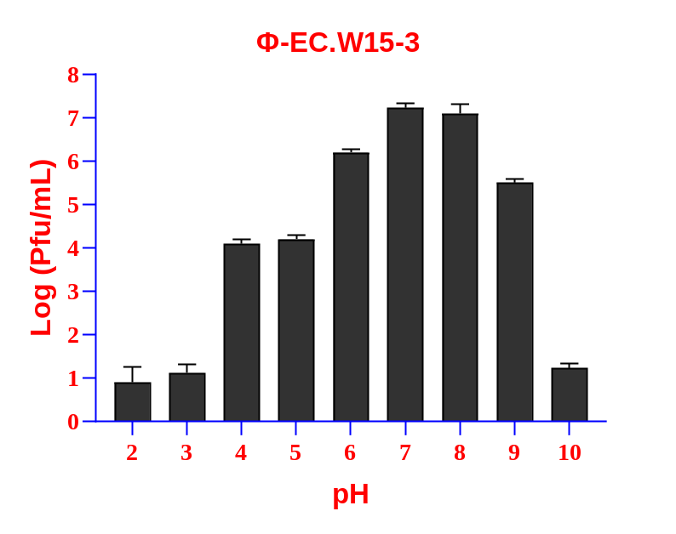
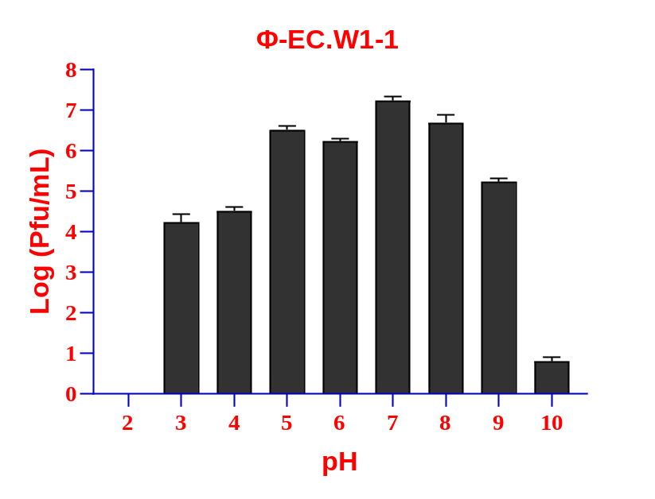
Figure S.3. pH stability of phages, demonstrating their stability over a relatively narrow range of pH values. The phage concentration (∼10^8 PFU/mL) was incubated at pH values ranging from 2 to 10 at 37°C for 4 hours. Values represent means ± standard deviations from the duplication of each treatment

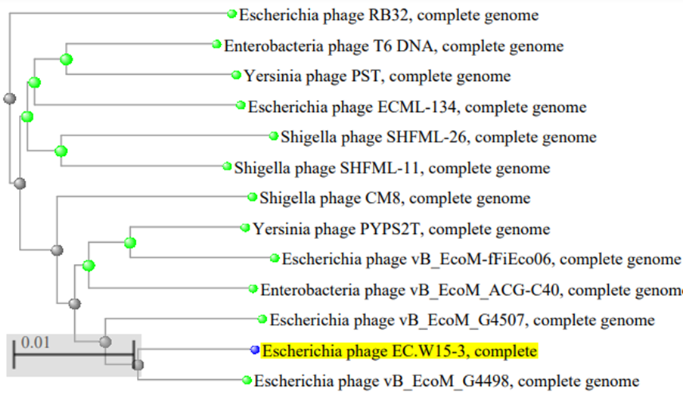
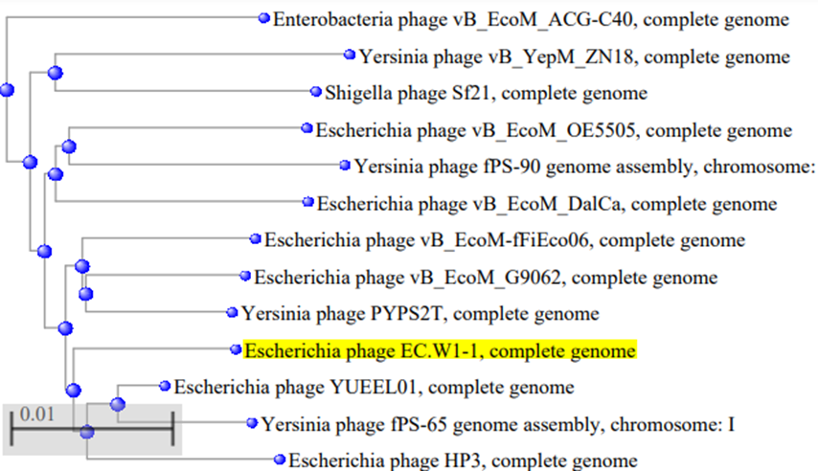

Figure S.4. Phylogenetic tree of selected bacteriophages. The phylogenetic tree was constructed by the Neighbor-Joining method. Reference sequences used in the analysis were obtained from the GenBank database (https://blast.ncbi.nlm.nih.gov/Blast.cgi). The highlighted mark indicates the phage EC.W1-1 and EC.W15-3

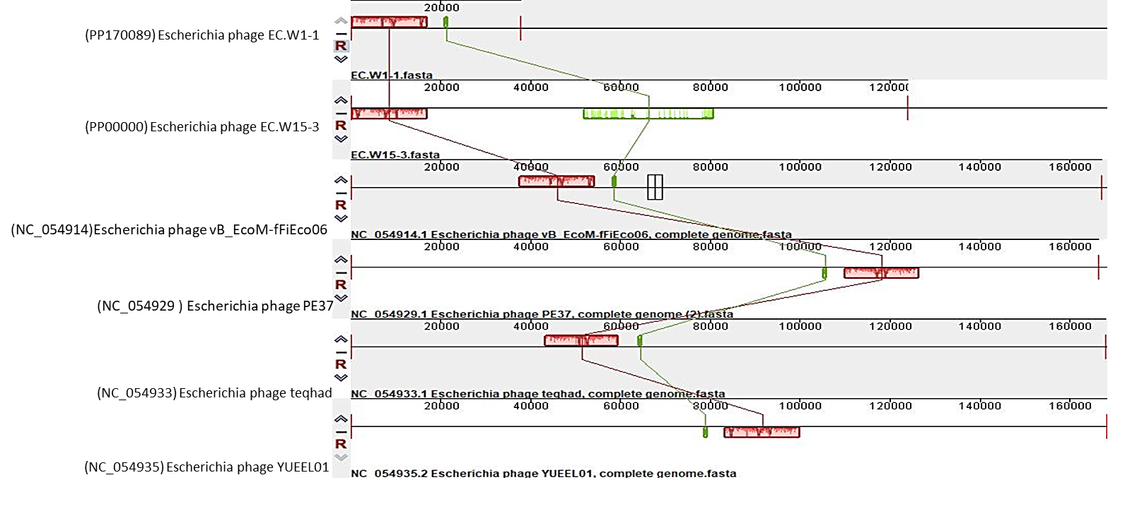
Figure S.5 : This study employed the progressive Mauve algorithm (v2.3.1) to perform multiple alignments of the genomes of 2 novel E. coli bacteriophages and the four closest genomes of E. coli bacteriophages. The objective was to investigate the rearrangement patterns and synteny in these genomes. The genomes were laid out horizontally, with homologous segments represented by colored blocks. The regions outside the blocks lacked homology and were represented by white areas, which were unique to each genome and not aligned.

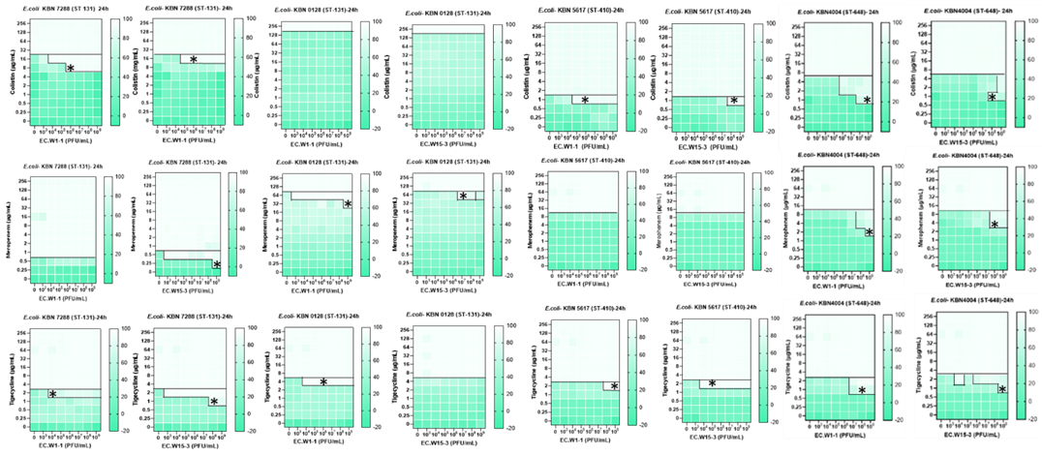
Figure S.6. Reduction in MIC values due to Phage antibiotics combination against different Multidrug resistant sequence Types.
Table S.1: Susceptibility of two novel bacteriophages against various Sequence Types (STs) of. multidrug-resistant E. coli
ST types | % Susceptibility |  | Isolates
ST types | EC.W1-1 | EC.W15-3 | Isolates
ST73 | 100 | 100 | n=1
ST648 | 100 | 25 | n=4
ST2311 | 100 | 0 | n=1
ST405 | 100 | 0 | n=1
ST607 | 0 | 0 | n=1
ST13003 | 100 | 100 | n=1
ST1139 | 0 | 0 | n=1
ST1487 | 0 | 0 | n=1
ST10 | 0 | 0 | n=1
ST7962 | 50 | 0 | n=2
ST131 | 88.88 | 66.66 | n=18
ST410 | 19.23 | 15.38 | n=26
ST206 | 0 | 0 | n=1
ST167 | 100 | 100 | n=1

Table S.2. Genomic information of two novel E. coli bacteriophages
Name of phage | Φ EC.W1-1 | Φ EC.W15-3
Accession number | PP170089 | PQ030847
Class | Caudoviricetes | Caudoviricetes
Family | Straboviridae | Straboviridae
Genus | Tequatrovirus | Tequatrovirus
G+C | 35.61 | 37.27
Genome size (BP) | 37,736 | 123,792
Hypothetical protein | 61 | 59
Crispr | 1 | -
Phage finder | 9 | 78
Integration/excision | 1 | -
Replication/recombination/repair | 1 | 9
Stability/transfer/defense | - | 2
Holin | - | 1
Tail fiber/spike protein | 2 | 1
Lysis inhibitor | 2 | 2
Lysis protein | 3 | -
Putative peptidase | 2 | 1
Internal protein | 2 | -
Endonuclease | 4 | -
Glutaredoxin | 3 | -
Thioredoxin | 9 | 6
Head protein | - | 5
Capsid protein | - | 1
Baseplate protein | - | 4
Genomic similarity | Escherichia phage YUEEL01, complete genome | Escherichia phage teqhad, complete genome
Query Cover /Per. Ident (%) | 98/98.27% | 92/92.65%

