Supporting Information (SI)
Effects of Hemicellulose on Recycling Performance of Paper Based on Sisal fibers

Shaoliu Qin^{1, 2}, Yian Chen^{2,} *, Shenming Tao², Cunzhi Zhang², Xingzhen Qin^{1,} *, Pan Chen^{3,} *, Haisong Qi^{2,}

¹ School of Chemistry and Chemical Engineering, Guangxi University, Nanning, 530004, China.
² State Key Laboratory of Pulp and Paper Engineering, South China University of Technology, Guangzhou, 510641, China.
³ Department of Materials Engineering, Beijing Institute of Technology, Beijing, 100081, China.

Corresponding Author
*E-mail: xzhqin2009@163.com.
*E-mail: chenyian@scut.edu.cn.
*E-mail: panchen@bit.edu.cn

Table S1 The chemical composition of sisal holocellulose fiber
Type | Glucose content (%) | Xylose contentª (%) | Lignin content (%) | Minerals and others (%)
Holocellulose-0 | 76.81 | 10.17 | 7.54 | 5.48
Holocellulose-1 | 76.34 | 10.09 | 7.97 | 5.60
Holocellulose-2 | 76.13 | 10.12 | 7.90 | 5.85
Holocellulose-3 | 76.43 | 9.94 | 7.77 | 5.86
Holocellulose-4 | 76.20 | 10.09 | 7.93 | 5.78
Holocellulose-5 | 78.16 | 9.60 | 6.97 | 5.27
Celulose-0 | 62.39 | 7.91 | 5.81 | 23.89
Celulose-1 | 72.51 | 8.46 | 4.47 | 14.56
Celulose-3 | 59.69 | 7.96 | 4.48 | 27.87
Celulose-5 | 65.29 | 8.14 | 4.46 | 22.11
ª Polyxylose is mainly element in sisal hemicellulose.

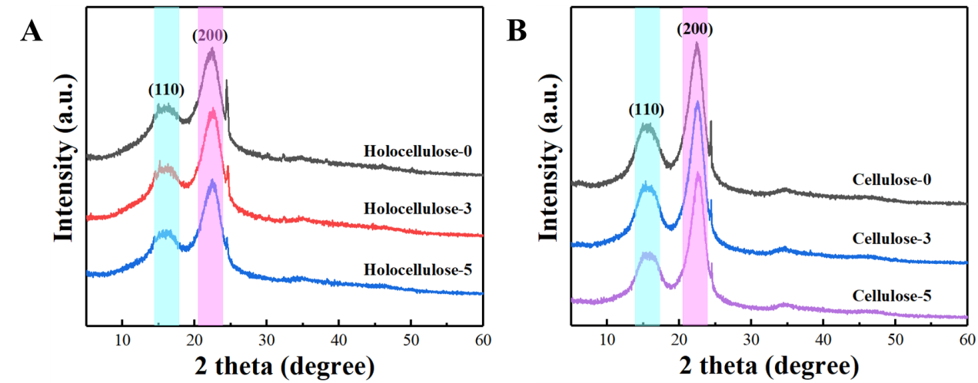
Fig. S1 XRD curves of holocellulose (A) and cellulose (B) papers after different rounds of recycling processes.

