Supplemental Information

Rgnef regulates bone mass through the activation of RhoA and Rac1

Jiae Lee^{1,2,a}, Gong-Rak Lee^{1,2,a}, Minjeong Kwon^{1,2}, Hye In Lee^{1,2}, Taehee Kim^{1,2,3}, Jong Ran Lee¹, Soo Young Lee^{1,2,3} and Woojin Jeong^{1,2,3}*

¹Department of Life Science, Ewha Womans University, Seoul 03760, South Korea
²Multitasking Macrophage Research Center, Ewha Womans University, Seoul 03760, South Korea
³Brain Korea 21 FOUR Program. LIFE Talent Development for Future Response, Ewha Womans University, Seoul 03760, South Korea
ª These authors contributed equally to this work.
*Corresponding author: Woojin Jeong, Ph.D., Science Building C, Room 211, 52 Ewhayeodae-gil, Seodaemun-gu, Seoul 03760, Korea. Tel: +82-2-3277-4495; Fax: +82-2-3277-3760; Email: jeongw@ewha.ac.kr

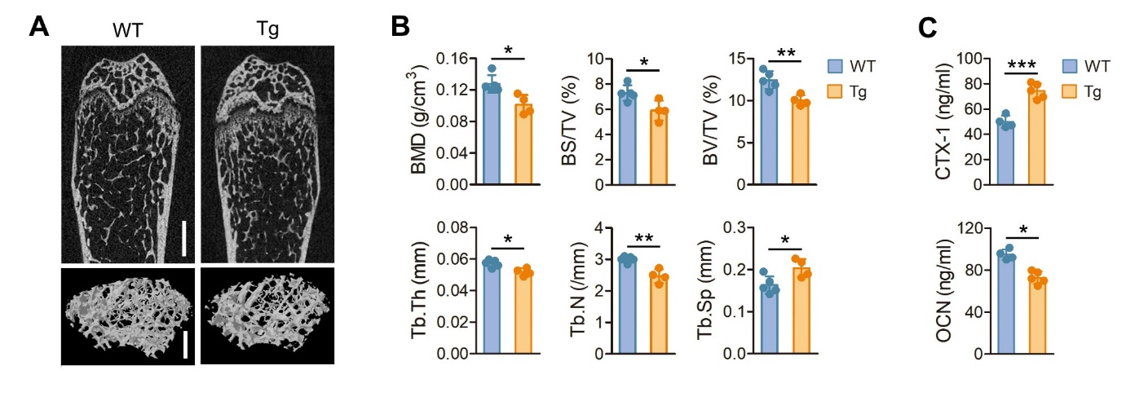

Supplementary Fig. 1. Bone phenotype of Rgnef overexpressing transgenic mice in physiological condition. (A) Representative microcomputed tomography images of femurs from 7-week-old wild-type (n=5) and Rgnef transgenic (Tg) mice (n=4): upper, sagittal; lower, three-dimensional reconstruction. Scale bar, 0.5 mm. (B) Quantitative histomorphometry of trabecular bone: BMD, bone mineral density; BS/TV, bone surface density; BV/TV, bone volume density; Tb.Th, trabecular thickness; Tb.N, trabecular number; Tb.Sp, trabecular spacing. (C) Serum levels of CTX-1 and OCN in wild-type (n=4) and Rgnef Tg mice (n=5). P values less than 0.05 were considered statistically significant: *P< 0.05, **P< 0.01, and ***P< 0.005 between the indicated groups.

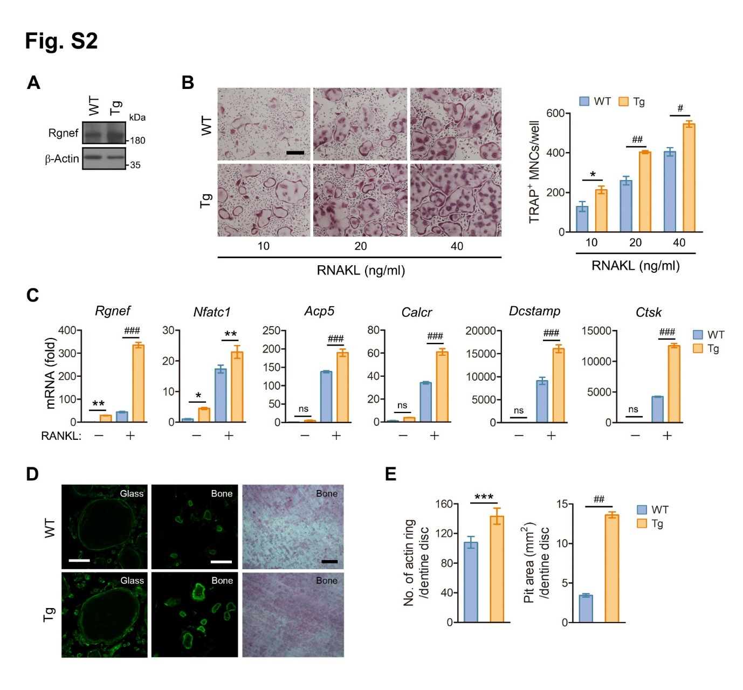

Supplementary Fig. 2. Promotion of osteoclast differentiation, actin ring formation and bone resorption by Rgnef overexpression. (A) The expression of Rgnef protein in BMMs was determined by immunoblotting. (B-E) BMMs were cultured in the presence of MCSF (35 ng/ml) and treated with the indicated concentration of RANKL for 4 days (B) or 20 ng/ml of RANKL for 2 days (C) on plate, 5 days on glass (D, left) or 7 days on dentin (D, middle and right). (B) The cells were fixed, subjected to TRAP staining, and visualized under a light microscope. Scale bar, 100 μm. TRAP-positive multinucleated cells (MNCs) containing more than twenty nuclei were counted. n=3. (C) Relative mRNA levels of Nfatc1 and its target genes were quantified by real-time PCR and presented as fold induction. n=3. (D) The cells were stained with Alexa fluor 488-phalloidin and then photographed under a confocal microscope (left and middle). The cells on dentin were removed and resorption pits were visualized by hematoxylin staining (right). Scale bar, 100 μm. (E) The number of actin ring (n=4) and the area of resorption pit (n=3) were determined from D. P values less than 0.05 were considered statistically significant: *P< 0.05, **P< 0.01, ***P< 0.005, #P< 0.001, ##P< 0.0005, and ###P < 0.0001 between the indicated groups.

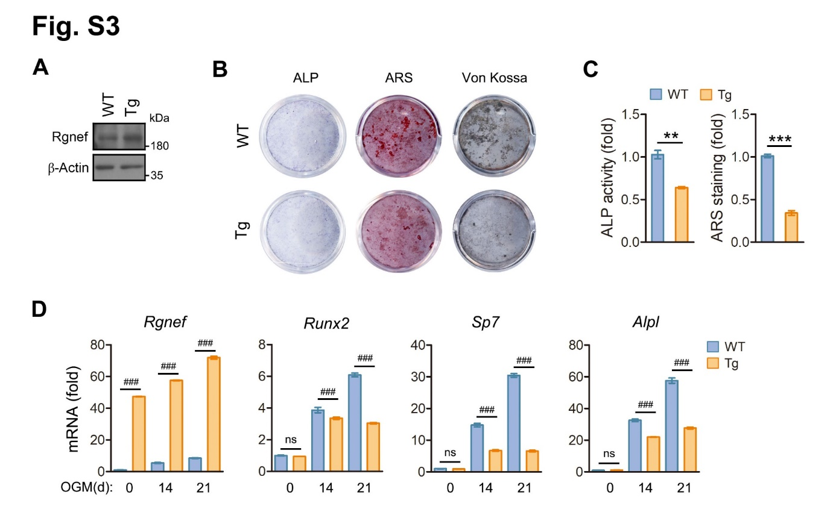

Supplementary Fig. 3. Inhibition of osteoblast differentiation and function by Rgnef overexpression. MSCs were cultured in OGM for 14 days (B and C, ALP), 21 days (B and C, ARS), 24 days (B, Von kossa), and the indicated times (D). (A) The expression of Rgnef in MSCs was determined by immunoblotting. (B) The cells were fixed in 4% paraformaldehyde and stained for ALP, with ARS or Von kossa. (C) Cell lysates were subjected to ALP activity assay, and the amount of ARS bound to cells was measured. n=3. (D) The transcription of osteoblastic genes was quantified by real-time PCR and presented as fold induction. n=3. P values less than 0.05 were considered statistically significant: **P< 0.01, ***P< 0.005, and ###P < 0.0001 between the indicated groups; ns, not significant.

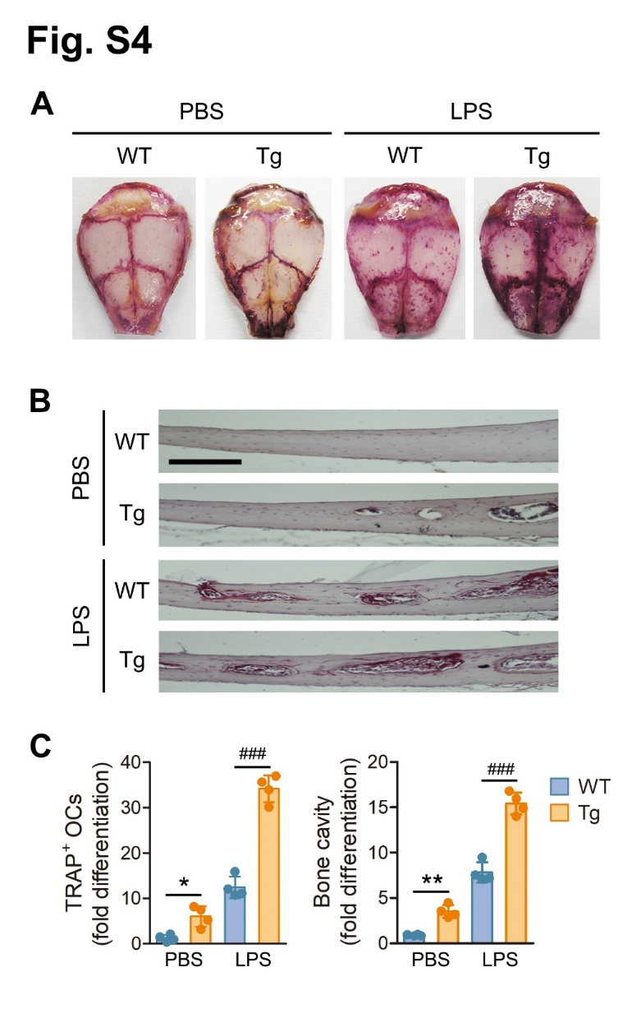

Supplementary Fig. 4. Augmentation of LPS-induced bone destruction by Rgnef overexpression. LPS-injected calvaria was fixed, stained with TRAP and decalcified. (A) Whole images of TRAP-stained calvaria. (B) Section images of calvaria stained with TRAP and hematoxylin. Scale bar: 100 μm. (C) TRAP-positive osteoclasts and bone cavity were quantified and expressed as fold difference. n=4. P values less than 0.05 were considered statistically significant: *P< 0.05, **P< 0.01, and ###P < 0.0001 between the indicated groups.

