SUPPLEMENTAL MATERIALS
TITLE: Associations of Body Shapes with Insulin Resistance and Cardiometabolic Risk in Middle-aged and Elderly Chinese

AUTHORS: Yulin Zhou, Yanan Hou, Jiali Xiang, et al.

Figure legends
Supplemental Figure 1. Feature selection. A: Automated feature selection. It was performed by using the information gain attribute ranking method on the open-source Waikato Environment for Knowledge Analysis platform. Information gain ranking was used to evaluate the worth of each variable (usually the clinical indicator) by measuring the entropy gain to the outcome. The greater the information gain a clinical indicator has, the more important the indicator is in the classification process. The model was built with logistic regression analysis based on the data set. The regression coefficient of each significant variable was regard as the contribution level. B: Entropy gain for each indicator. It illuminates the information gain and ranks the attributes of each variable from the top to the bottom. Three indicators (WHR, WNR and WTR) were chosen to construct body shapes. Abbreviation: WHR, waist-to hip ratio; WTR, waist-to-thigh ratio; WNR, waist-to-neck ratio; NTR, neck-to thigh ratio; NHR, neck-to hip ratio; THR, thigh-to-hip ratio.

Supplemental Figure 1. Feature selection.

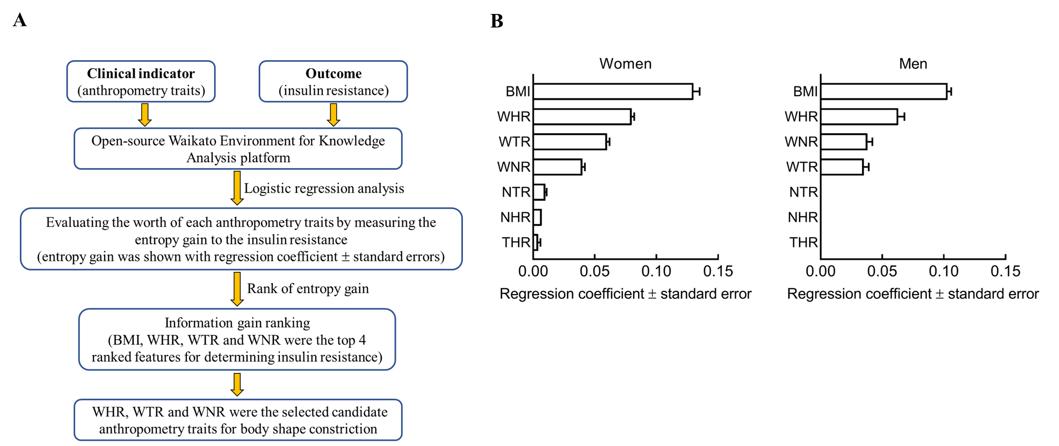

Supplemental Table 1. Predictive values of anthropometric traits.
 | Women |  | Men
 | AUROC | P value | AUROC | P value
Insulin resistance
BMI | 0.740 (0.724-0.756) | / | 0.739 (0.716-0.761) | /
BMI+WHR | 0.747 (0.731-0.763) | 0.0009 | 0.747 (0.725-0.770) | 0.02
BMI+WHR+WTR | 0.756 (0.741-0.772) | <0.0001 | 0.747 (0.725-0.770) | 0.08
BMI+WHR+WTR+WNR | 0.757 (0.742-0.773) | <0.0001 | 0.747 (0.725-0.770) | 0.09
Metabolic syndrome
BMI | 0.743 (0.728-0.759) | / | 0.774 (0.754-0.794) | /
BMI+WHR | 0.787 (0.773-0.802) | <0.0001 | 0.796 (0.776-0.815) | <0.0001
BMI+WHR+WTR | 0.789 (0.775-0.803) | <0.0001 | 0.795 (0.776-0.815) | <0.0001
BMI+WHR+WTR+WNR | 0.787 (0.773-0.801) | <0.0001 | 0.795 (0.776-0.814) | 0.0001
Data are AUROC, 95% confidence intervals. P values were from logistic analysis. Abbreviation: AUROC, area under the receiver operating characteristic (AUROC) curves; BMI, body mass index; WHR, waist-to-hip circumference ratio; WTR, waist-to-thigh circumference ratio; WNR, waist-to-neck circumference ratio.

