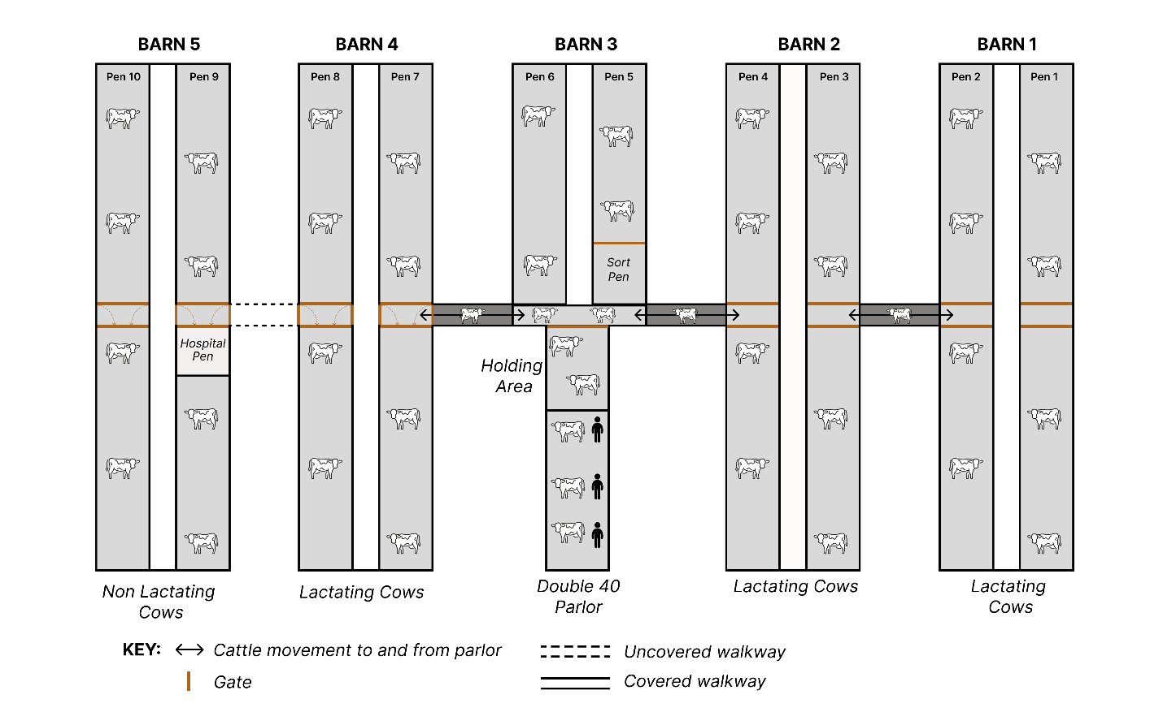
Extended Data Fig. 1. Schematic representation of the dairy farm targeted in our study depicting the distribution and location of the barns, parlor and hospital pen.
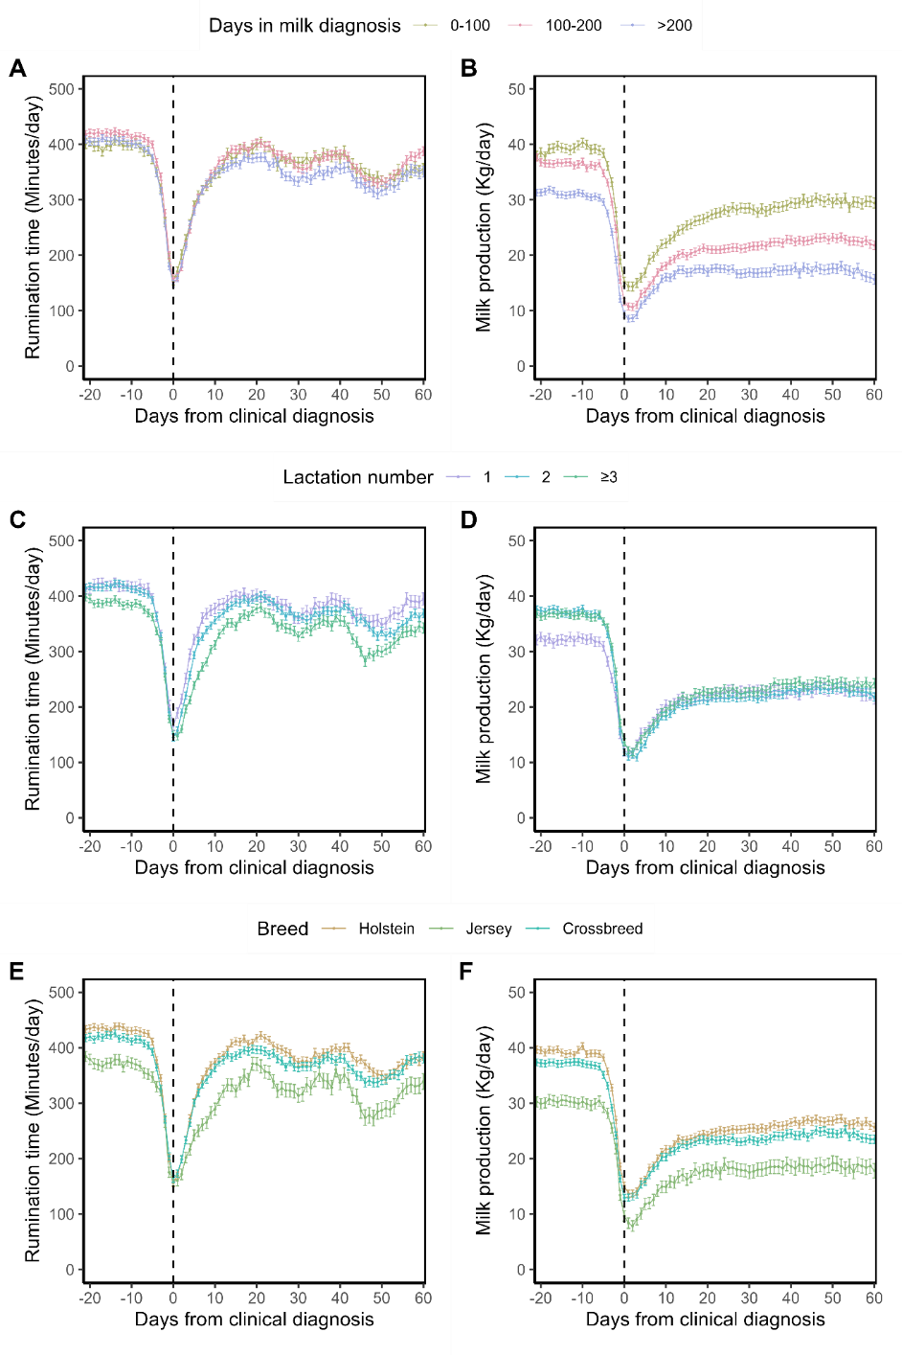
Extended Data Fig. 2. Adjusted means for milk production (Kg/day) and rumination time (Minutes/day) in lactating cows with clinical influenza diagnosis estimated using mixed linear regression by days from clinical diagnosis (n=776). Results are stratified by days in milk (Panels A and B), lactation number (Panels C and D) and breed (Panels E and F). Models accounted for days in milk, lactation number and breed. Models included cow-ID as a random effect and an autoregressive correlation structure. Error bars represent 95% confidence intervals.
Extended Data Table 1. Diagnostic testing via RT-PCR of cows presenting with clinical signs of influenza (n = 41).
ID | DIM | Lact | Breed | Milk (n=41) |  | Nasal swab (n=41) |  | Urine (n=16) |  | Feces (n=16) |  | Serum (n=15) |  | Whole blood (n=15)
 |  |  |  | + | CT | + | CT | + | CT | + | CT | + | CT | + | CT
31544 | 191 | 4 | Holstein | Yes | 9.7 | No | - | - | - | - | - | - | - | - | -
38144 | 163 | 3 | Crossbreed | Yes | 30.0 | No | - | No | - | No | - | - | - | - | -
39180 | 127 | 3 | Holstein | Yes | 19.2 | No | - | - | - | - | - | No | - | No | -
41541 | 268 | 2 | Holstein | Yes | 24.5 | No | - | No | - | No | - | - | - | - | -
42157 | 199 | 2 | Holstein | Yes | 14.4 | Yes | 33.7 | - | - | - | - | - | - | - | -
42475 | 226 | 2 | Holstein | Yes | 17.9 | No | - | - | - | - | - | No | - | No | -
42493 | 116 | 2 | Holstein | No | - | Yes | 36.6 | No | - | No | - | - | - | - | -
42577 | 181 | 2 | Holstein | Yes | 20.0 | No | - | - | - | - | - | No | - | No | -
43206 | 187 | 2 | Holstein | Yes | 14.2 | Yes | 33.1 | No | - | No | - | No | - | No | -
43305 | 150 | 2 | Holstein | Yes | 17.4 | No | - | - | - | - | - | - | - | - | -
43370 | 39 | 2 | Holstein | No | - | No | 39.6 | No | - | No | - | - | - | - | -
44518 | 107 | 2 | Holstein | No | - | No | - | - | - | - | - | Yes | 35.4 | No | -
44553 | 95 | 2 | Holstein | No | - | No | - | - | - | - | - | - | - | - | -
44906 | 81 | 2 | Holstein | No | - | No | - | - | - | - | - | - | - | - | -
46982 | 198 | 1 | Holstein | Yes | 31.8 | No | - | No | - | No | - | - | - | - | -
47385 | 214 | 1 | Holstein | Yes | 19.4 | No | - | - | - | - | - | No | - | No | -
47978 | 219 | 1 | Crossbreed | Yes | 14.8 | No | - | - | - | - | - | - | - | - | -
48083 | 214 | 1 | Crossbreed | Yes | 32.7 | No | - | No | - | No | - | - | - | - | -
48096 | 209 | 1 | Holstein | No | - | No | - | Yes | 32.4 | No | - | - | - | - | -
48971 | 155 | 1 | Holstein | Yes | 26.4 | No | - | Yes | 30.4 | No | - | - | - | - | -
49062 | 95 | 4 | Jersey | Yes | 15.0 | No | - | - | - | - | - | No | - | No | -
49326 | 78 | 4 | Jersey | Yes | 21.3 | No | - | - | - | - | - | - | - | - | -
49466 | 145 | 4 | Jersey | Yes | 28.6 | No | - | No | - | No | - | - | - | - | -
49490 | 230 | 4 | Jersey | Yes | 24.3 | No | - | - | - | - | - | No | - | Yes | 35.2
49603 | 19 | 4 | Jersey | Yes | 23.2 | No | - | No | - | No | - | - | - | - | -
49842 | 57 | 1 | Crossbreed | Yes | 30.1 | No | - | No | - | No | - | - | - | - | -
50447 | 19 | 4 | Jersey | Yes | 16.5 | No | - | - | - | - | - | No | - | No | -
50467 | 85 | 4 | Jersey | Yes | 33.1 | No | - | No | - | No | - | - | - | - | -
84486 | 373 | 2 | Crossbreed | No | - | No | - | No | - | No | - | - | - | - | -
85205 | 119 | 2 | Crossbreed | Yes | 16.7 | No | - | - | - | - | - | No | - | No | -
85922 | 214 | 2 | Crossbreed | Yes | 30.4 | No | - | No | - | No | - | - | - | - | -
85938 | 239 | 2 | Crossbreed | Yes | 21.1 | No | - | - | - | - | - | - | - | - | -
86117 | 160 | 2 | Crossbreed | Yes | 17.6 | No | - | - | - | - | - | No | - | No | -
86317 | 157 | 2 | Crossbreed | Yes | 15.1 | No | - | - | - | - | - | No | - | No | -
87218 | 67 | 2 | Crossbreed | Yes | 19.8 | No | - | - | - | - | - | No | - | No | -
100072 | 109 | 1 | Holstein | Yes | 33.4 | Yes | 39.8 | - | - | - | - | - | - | - | -
100846 | 204 | 1 | Crossbreed | Yes | 15.0 | No | - | - | - | - | - | - | - | - | -
700826 | 158 | 2 | Crossbreed | Yes | 12.7 | Yes | 34.5 | - | - | - | - | No | - | No | -
700828 | 139 | 2 | Holstein | Yes | 18.8 | No | - | No | - | No | - | - | - | - | -
700832 | 223 | 2 | Holstein | Yes | 21.5 | No | - | - | - | - | - | No | - | No | -
7001205 | 45 | 2 | Holstein | Yes | 12.3 | Yes | 32.9 | - | - | - | - | - | - | - | -

Extended Data Table 2. Duration of clinical signs (n=290), days in hospital pen (n=176), days from clinical diagnosis to death (n=53) and herd removal (n=245).
Item | Overall | By days in milk |  |  | By lactation number
Item | Overall | 0-100 | 200-300 | >300 | 1 | 2 | 3≥
Days clinical | n = 290 | n = 87 | n = 113 | n = 90 | n = 61 | n = 139 | n = 90
Mean ± SD | 7.9 ± 9.3 | 6.10 ± 8.5 | 8.4 ± 7.4 | 9.1 ± 11.8 | 6.6 ± 7.5 | 7.86 ± 9.6 | 8.90 ± 9.9
Median (Range) | 6 (0, 64) | 5 (0, 52) | 6 (0, 37) | 6 (0, 64) | 4 (0, 46) | 5 (0, 64) | 7 (0, 62)
Days in hospital | n = 176 | n = 45 | n = 56 | n = 75 | n = 33 | n = 78 | n = 65
Mean ± SD | 5.1 ± 3.8 | 4.0 ± 3.1 | 5.8 ± 4.3 | 5.3 ± 3.6 | 4.0 ± 3.0 | 5.5 ± 4.2 | 5.3 ± 3.5
Median (Range) | 5 (0, 22) | 3 (0, 14) | 5 (0, 22) | 5 (0, 18) | 4 (0, 13) | 5 (0, 22) | 5 (0, 15)
Days to death | n = 53 | n = 21 | n = 20 | n = 12 | n = 9 | n = 17 | n = 27
Mean ± SD | 13.6 ± 15.1 | 12.3 ± 16.8 | 11.9 ± 11.3 | 18.8 ± 17.5 | 11.4 ± 11.6 | 24.9 ± 20.7 | 7.2 ± 4.7
Median (Range) | 7 (0, 66) | 6 (1, 66) | 8 (0, 45) | 10.5 (0, 50) | 7 (0., 33) | 16 (2, 66) | 7 (0, 22)
Days to removal | n = 245 | n = 52 | n = 98 | n = 95 | n = 43 | n = 97 | n = 105
Mean ± SD | 20.6 ± 15.4 | 28.4 ±14.2 | 23.2 ± 13.8 | 13.5 ± 14.8 | 18.0 ± 17.7 | 25.2 ± 13.9 | 17.2 ± 14.8
Median (Range) | 21 (1, 68) | 29.5 (2, 65) | 24.5 (1, 68) | 6 (1, 68) | 9 (1, 68) | 26 (1, 68) | 14 (1, 65)

Extended Data Table 3. Mortality and herd removal during the follow-up period (3/21/2024 to 6/7/2024) for cows that were present in lactating pens during the outbreak (n=3,662).
Item | % (n/total) | Adjusted RR (95%CI)
Mortality
Clinical Influenza
No | 1.3% (37/2,886) | Referent
Yes | 6.8% (53/776) | 6.0 (4.0, 9.1)
Herd removal
Clinical Influenza
No | 8.7% (251/2,886) | Referent
Yes | 31.6% (245/776) | 3.6 (3.2, 4.2)
Adjusted RR (95%CI): Adjusted relative risk and 95% CI estimated from logistic regression models, and controlling for days in milk, lactation number and breed.

Item | CN and SN (n=67) | CN and SP (n=485) | CP and SP (n=85) | Total (n=637)
Neutralizing antibody titers
Mean ± SD | - | 176 ± 283 | 345 ± 377 | 202 ± 304
Median (Range) | - | 64 (8, 2,050) | 256 (16, 2,050) | 128 (8, 2,050)
Days in milk
Dry | 37.3% (25) | 3.5% (17) | 0% (0) | 6.6% (42)
0-100 | 31.3% (21) | 42.3% (205) | 20.0% (17) | 38.1% (243)
101-200 | 6.0% (4) | 31.1% (152) | 40.0% (34) | 29.8% (190)
>200 | 25.4% (17) | 22.9% (111) | 40.0% (34) | 25.4% (162)
Lactation number
1 | 25.4% (17) | 37.3% (183) | 29.4% (25) | 35.3% (225)
2 | 25.4% (17) | 34.8% (169) | 38.8% (33) | 34.4% (219)
3≥ | 49.3% (33) | 27.4% (133) | 31.8% (27) | 30.3% (119)
Breed
Holstein | 28.4% (19) | 39.2% (190) | 30.6% (26) | 36.9% (235)
Jersey | 40.3% (27) | 21.6% (105) | 16.5% (14) | 22.9% (146)
Crossbreed | 31.3% (21) | 39.2% (190) | 52.9% (45) | 40.2% (256)
Extended Data Table 4. Descriptive characteristics of serologic results for 637 animals on site during the outbreak.

