Supplementary Figs and tables

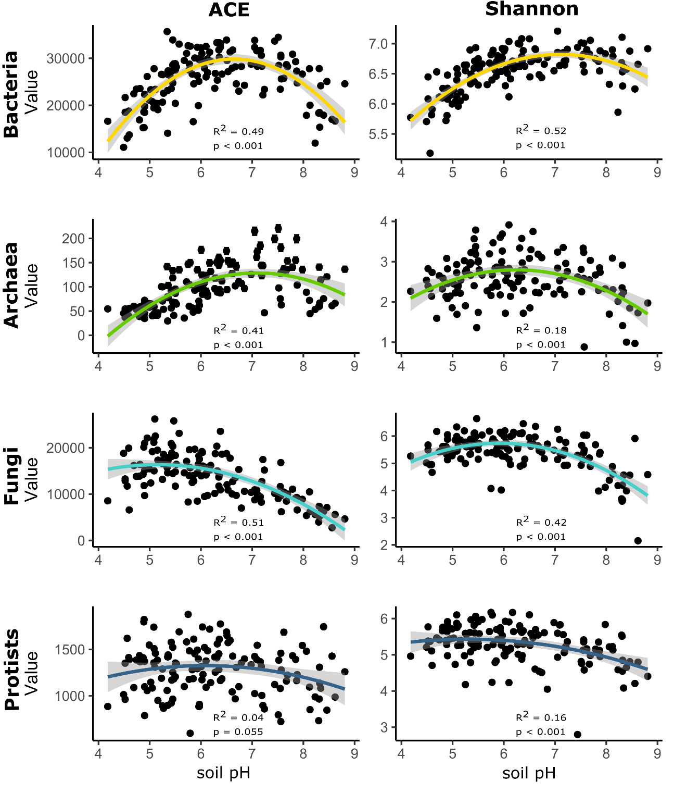

Figure S1: Linear regressions with quadratic terms of soil pH with alpha diversity of the four microbial groups.

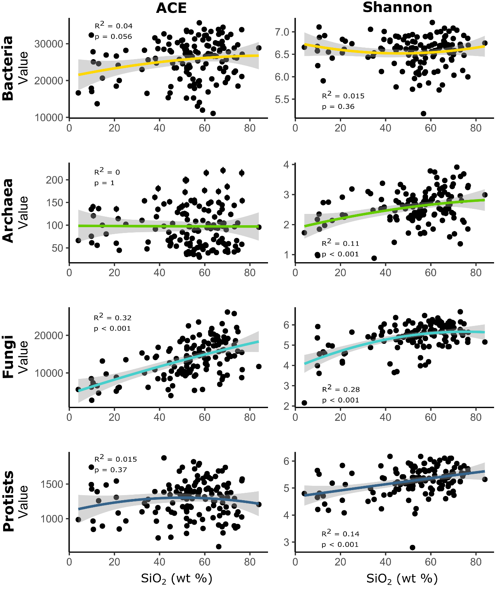

Figure S2: Linear regressions with quadratic terms of silica with alpha diversity of the four microbial groups.

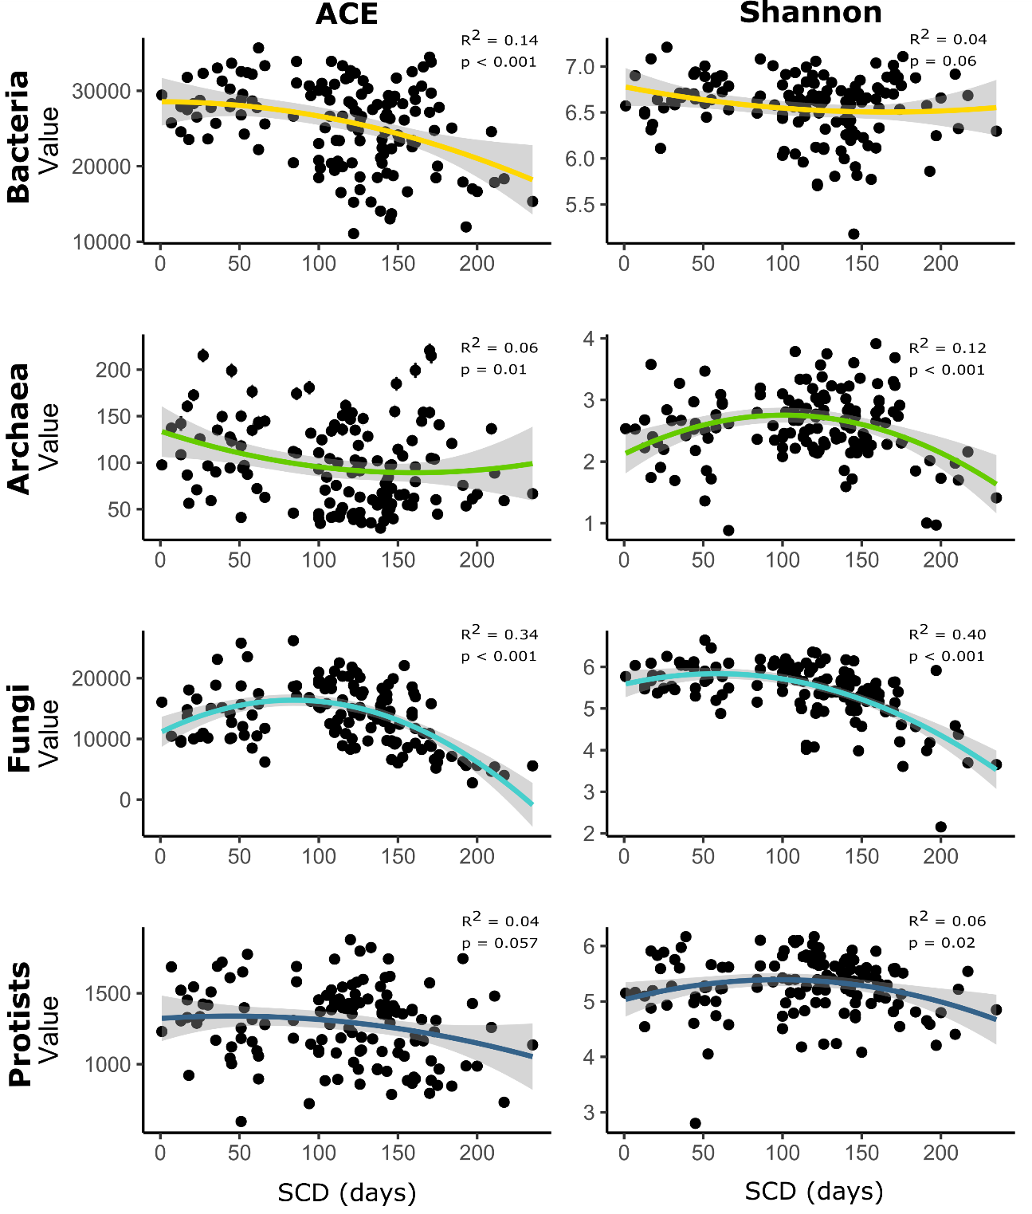

Figure S3: Linear regressions with quadratic terms of snow cover duration (SCD) with alpha diversity of the four microbial groups.

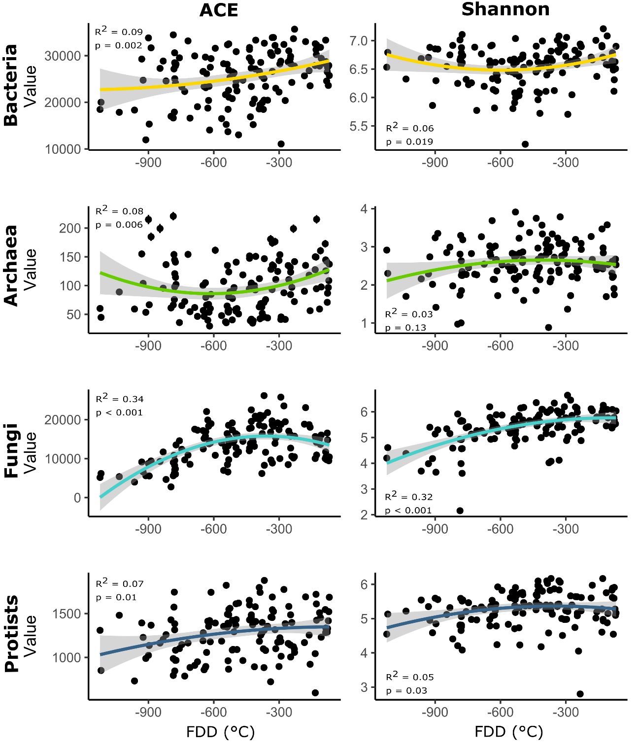

Figure S4: Linear regressions with quadratic terms of freezing degree days (FDD) with alpha diversity of the four microbial groups. More negative values indicate a higher number of days with temperatures below zero and therefore, colder temperatures.

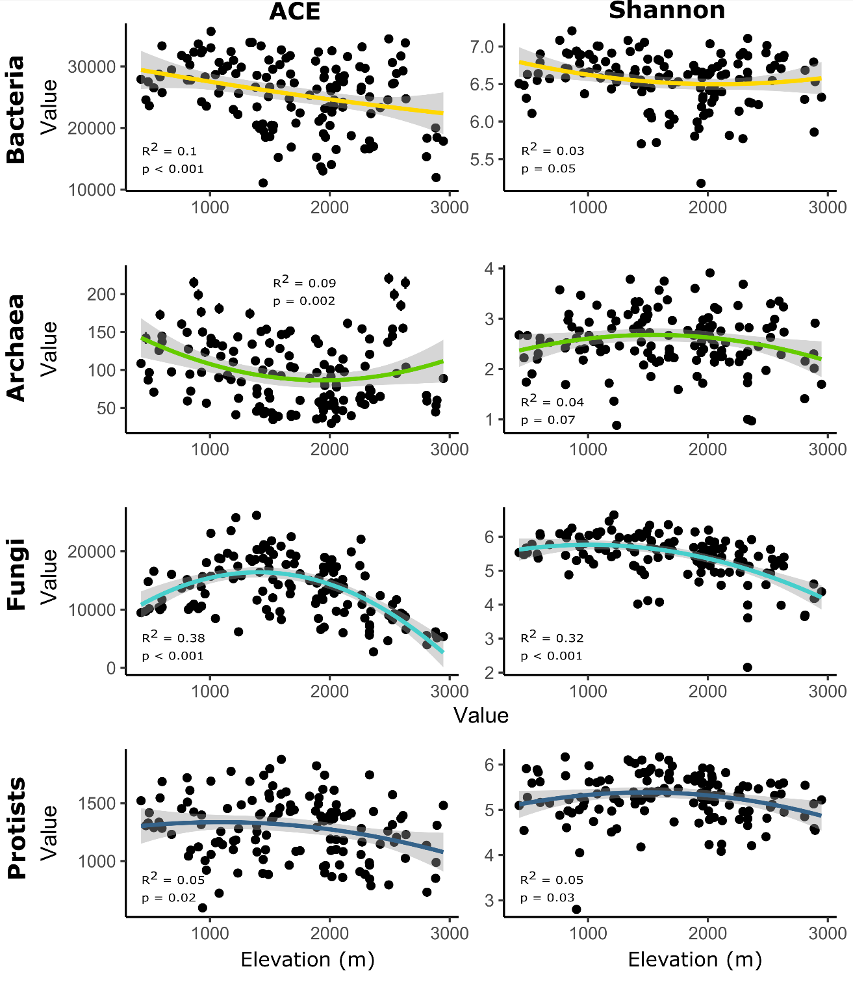
Figure S5: Linear regressions with quadratic terms of elevation with alpha diversity of the four microbial groups.

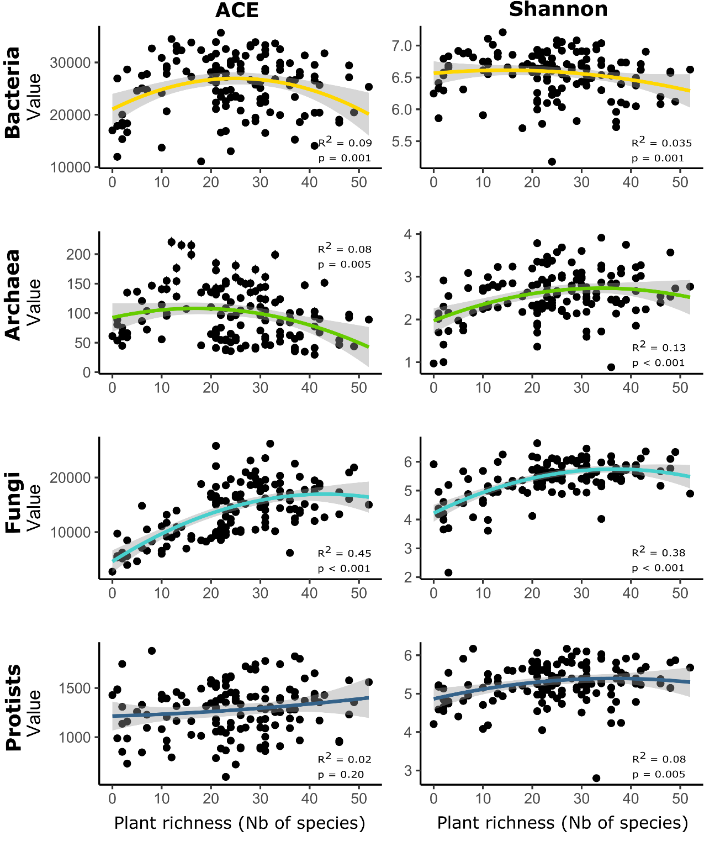
Figure S6: Linear regressions with quadratic terms of plant richness with alpha diversity of the four microbial groups.

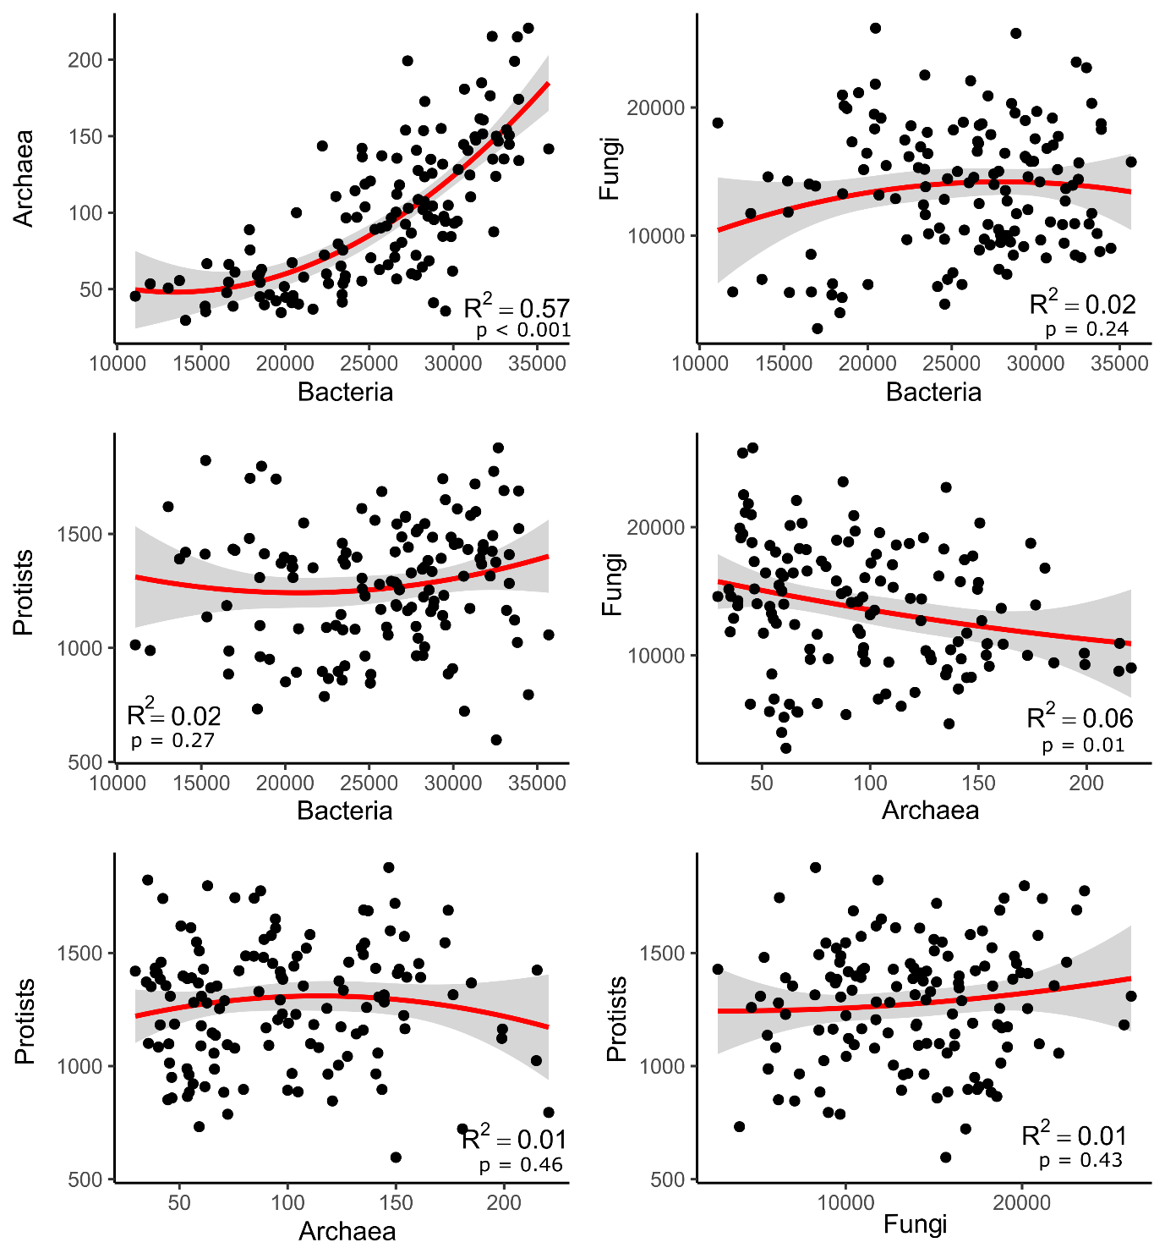
Figure S7: Inter-group ACE correlations with quadratic models illustrating generally weak correlations.

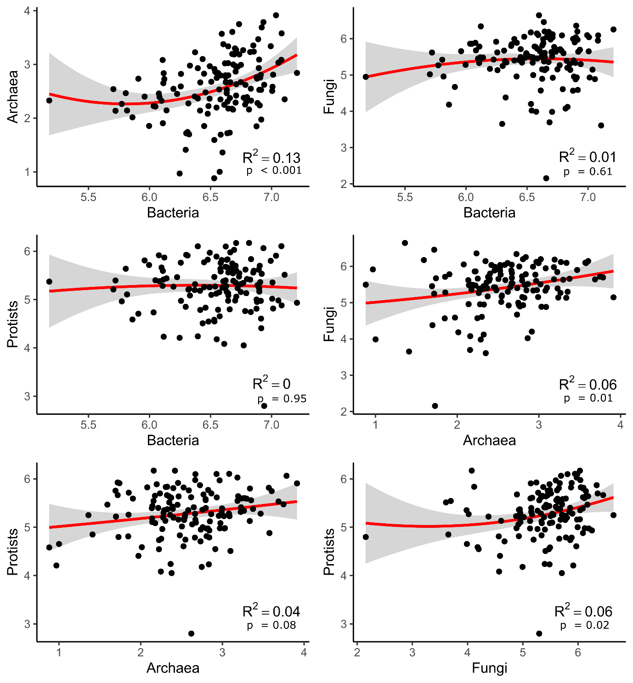
Figure S8: Inter-group Shannon correlations with quadratic models illustrating generally weak correlations.

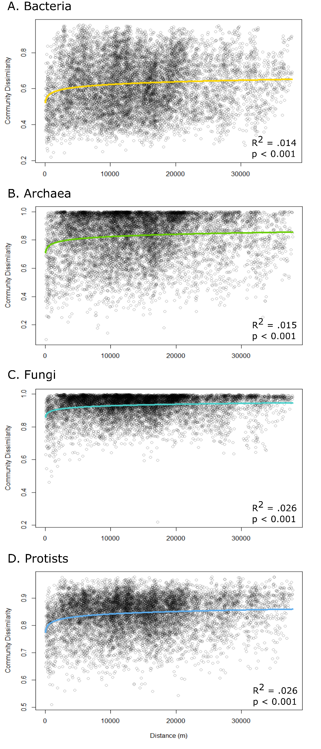
Figure S9: Distance decay curves illustrating the low increase in community dissimilarity with increasing geographic distance but the high spatial turnover.

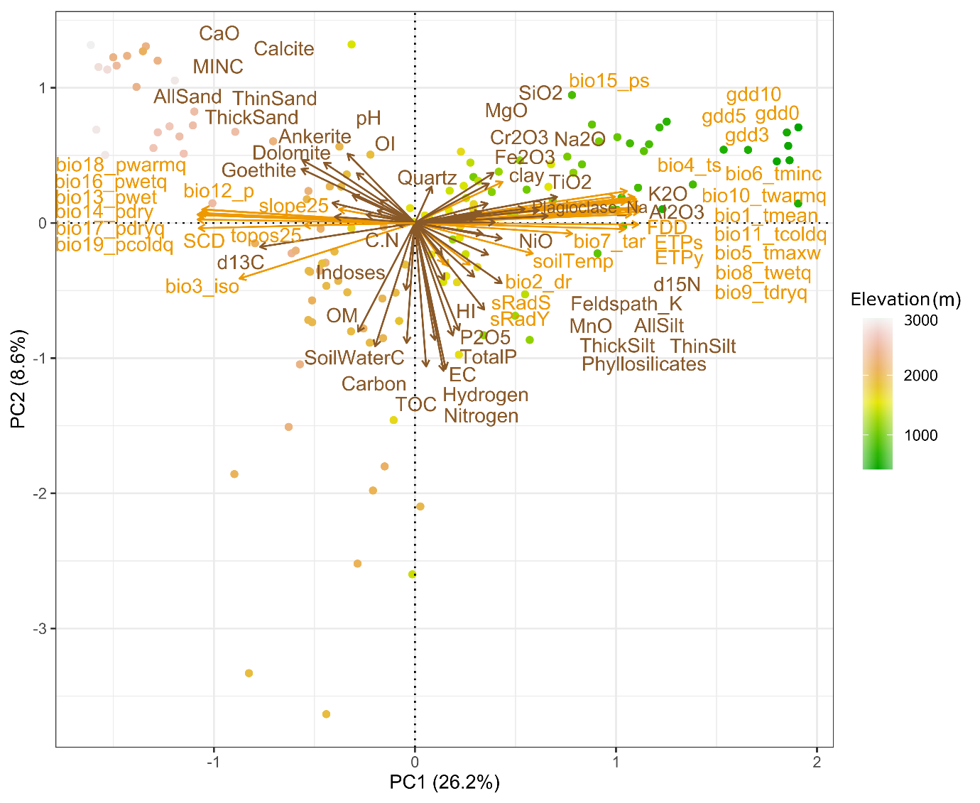-

Figure S10: Principal component analysis (PCA) of the sampled sites based on all the edaphic (brown) and topoclimatic (orange) variables. The length of the arrows indicates the contribution and the angle between arrows illustrate the correlations between variables. The PC scores of each site were later extracted and used to calculate the niche breadth and position of each ASV along the PC axes.

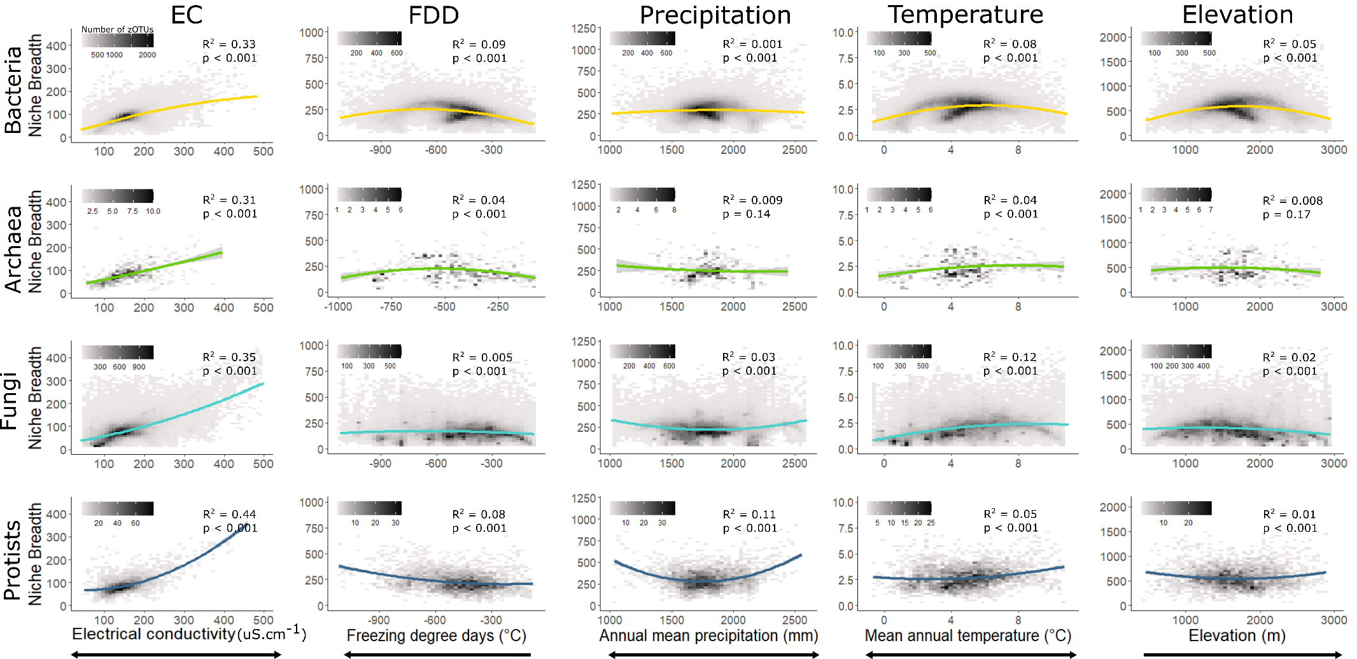
Figure S11: Average niche breadth (range) of each ASV along environmental gradients (niche position) and linear regressions with quadratic terms. The colour gradient indicates the number of zOTU per bin (density). Each bin is constructed in ggplot2 using geom_bin2d. The arrows indicate the directionality of the environmental extreme of the gradients. In most cases within this study area, and especially for climatic variables, only part of the gradient is covered but the direction is still indicated. Mean annual precipitation is based on bio12_p and mean annual temperature is based on bio1_tmean.
Table S1: Summary of edaphic, topoclimatic and biotic variables used in the study, with the full variable names and units.

Abbreviation | Environmental variables
Edaphic factors
Al₂O₃ | Aluminium oxide (wt %)
AllSand | Total sand
AllSilt | Total silt
Ankerite | Ankerite (%)
Calcite | Calcite (%)
CaO | Calcium oxide (wt %)
Carbon | Bulk carbon content (wt %)
Clay | Clay
C:N | Bulk C:N ratio
Cr₂O₃ | Chromium oxide (wt %)
d13C | Carbon stable isotope ratio (per ml vs VPDB)
d15N | Nitrogen stable isotope ratio (per ml vs air-N₂)
Dolomite | Dolomite (%)
EC | Electrical conductivity (1:1 μS/cm)
Fe₂O₃ | Iron oxide (wt %)
Feldspath_K | Feldspath-K (%)
Goethite | Geothite (%)
HI | Hydrogen index (mg hydrocarbons/g TOC)
Hydrogen | Bulk hydrogen content (wt %)
Indoses | Indoses (%)
K₂O | Potassium oxide (wt %)
MINC | Mineral carbon content (wt %)
MgO | Magnesium oxide (wt %)
MnO | Manganese oxide (wt %)
Na₂O | Sodium oxide (wt %)
NiO | Nickel oxide (wt %)
Nitrogen | Bulk nitrogen content (wt %)
OI | Oxygen index (mg CO₂/g TOC)
OM | Organic matter content (wt %)
P₂O₅ | Phosphorus pentoxide (wt %)
pH | Soil pH
Phyllosilicates | Phyllosilicates (%)
Plagioclase_Na | Plagioclase-Na (%)
Quartz | Quartz (%)
SiO₂ | Silicon oxide (wt %)
SoilWaterC | Bulk soil water content (%)
ThickSand | Thick sand
ThickSilt | Thick silt
ThinSand | Thin sand
ThinSilt | Thin silt
TiO₂ | Titanium oxide (wt %)
TOC | Total organic carbon content (wt %)
TotalP | Total phosphorus content (mg /g)
Topoclimatic variables
bio1_tmean | Annual Mean Temperature (°C)
bio2_dr | Mean Diurnal Range (°C)
bio3_iso | Isothermality
bio4_ts | Temperature seasonality (°C)
bio5_tmaxw | Max temperature of warmest month (°C)
bio6_tminc | Min Temperature of Coldest Month (°C)
bio7_tar | Temperature Annual Range (°C)
bio8_twetq | Mean Temperature of Wettest Quarter (°C)
bio9_tdryq | Mean Temperature of Driest Quarter (°C)
bio10_twarmq | Mean Temperature of Warmest Quarter (°C)
bio11_tcoldq | Mean Temperature of Coldest Quarter (°C)
bio12_p | Annual Precipitation (mm)
bio13_pwet | Precipitation of wettest month (mm)
bio14_pdry | Precipitation of driest month (mm)
bio15_ps | Precipitation seasonality
bio16_pwetq | Precipitation of wettest quarter (mm)
bio17_pdryq | Precipitation of driest quarter (mm)
bio18_pwarmq | Precipitation of warmest quarter (mm)
bio19_pcoldq | Precipitation of colder quarter (mm)
gdd0 | Sum of growing degree days above 0°C (°C)
gdd3 | Sum of growing degree days above 3°C (°C)
gdd5 | Sum of growing degree days above 5°C (°C)
gdd10 | Sum of growing degree days above 10°C (°C)
ETPs | Seasonal potential evapotranspiration (mm)
ETPy | Annual potential evapotranspiration (mm)
FDD | Freezing degree days - Sum of temperatures <0°C (°C)
SCD | Snow cover duration (days)
slope25 | Terrain slope (°)
soilTemp | Soil temperature (°C)
sRadS | Seasonal solar radiations (kJ · day⁻¹)
sRadY | Annual solar radiations (kJ · day⁻¹)
topos25 | Topographic position
Biotic variables
ACE_BAC | Bacteria ACE richness
ACE_ARCH | Archaea ACE richness
ACE_FUN | Fungi ACE richness
ACE_PROT | Protists ACE richness
Shannon_BAC | Bacteria Shannon diversity
Shannon_ARCH | Archaea Shannon diversity
Shannon_FUN | Fungi Shannon diversity
Shannon_PROT | Protists Shannon diversity
Plant_richness | Plant richness

Table S2: Differences in microbial alpha diversity. For each column, subscript characters with the same letters (a,b,c,d) indicate no statistically significant difference (p > 0.05) with the Tukey HSD test.
 | ACE (mean ± SD) | Shannon (mean ± SD)
Bacteria | 25609 ± 5550 ª | 6.56 ± 0.34 ª
Archaea | 97.5 ± 45.6 ^{b} | 2.58 ± 0.56 ^{b}
Fungi | 13721 ± 4950 ^{c} | 5.42 ± 0.67 ^{c}
Protists | 1281 ± 266 ^{d} | 5.28 ± 0.52 ^{c}

