Supplemental Materials

TILDA Samples
This study utilized data from TILDA (The Irish Longitudinal Study on Aging), conducted between October 2009 and February 2018, which began with a nationally representative sample of 8,175 individuals and 329 spouses (3,780 male; 4,724 female) aged 50 years and older (range 49-80; M = 62.97, SD = 9.407). Data collection involved home interviews (62% completion rate) and surveys (84% completion rate), gathering comprehensive information about participants' economic circumstances, health, social relationships, employment, demographics, and psychosocial variables. Subsequent wave sample sizes were: W2 = 7206; W3= 6572; W4=5856; and W5=4980.

Listwise cluster results

Table 1: Data represents four clusters across Waves 2-5, showing sample sizes (n) and standardized scores (z) for Communion and Agency dimensions.
Cluster | Wave | n | Communion (z) | Agency (z)
Prototype 1 (Separated) | 2 | 860 | -0.65 | 0.25
 | 3 | 717 | -0.63 | 0.45
 | 4 | 635 | -0.58 | 0.40
 | 5 | 572 | -0.74 | 0.07
Prototype 2 (Neglected) | 2 | 478 | -1.45 | -1.38
 | 3 | 337 | -1.59 | -1.28
 | 4 | 372 | -1.47 | -1.26
 | 5 | 270 | -1.42 | -1.45
Prototype 3 (Muted) | 2 | 829 | 0.39 | -0.68
 | 3 | 743 | 0.22 | -0.76
 | 4 | 606 | 0.30 | -0.71
 | 5 | 540 | 0.57 | -0.50
Prototype 4 (Empowered) | 2 | 1133 | 0.82 | 0.90
 | 3 | 930 | 0.89 | 0.86
 | 4 | 830 | 0.88 | 0.89
 | 5 | 682 | 0.69 | 1.03

Panel 1: Sankey diagrams illustrating change in prototype membership across waves.

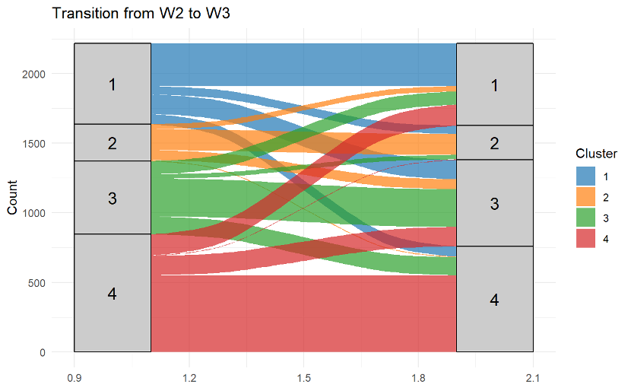
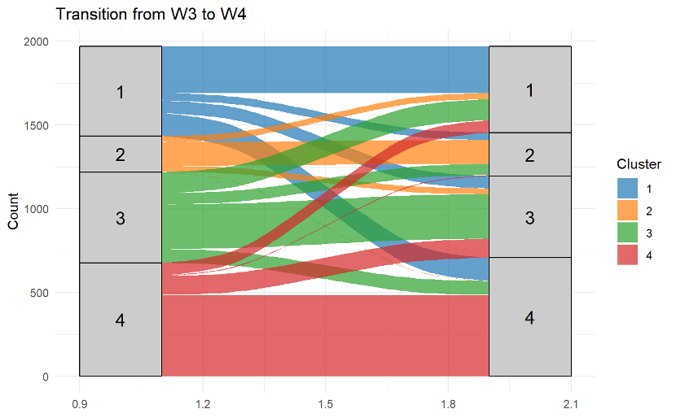

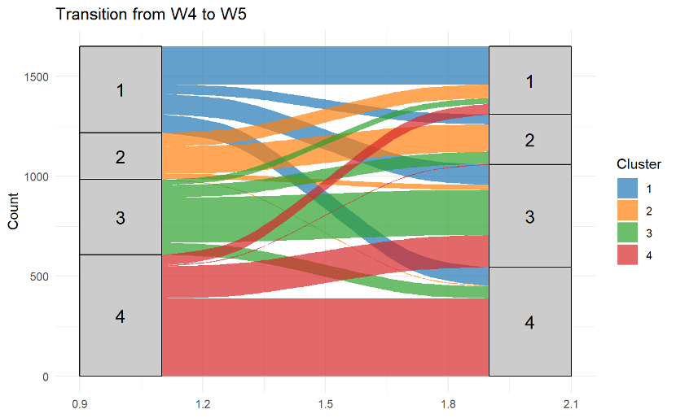

Correlations among variables for each data wave

Wave 2 Correlation Table
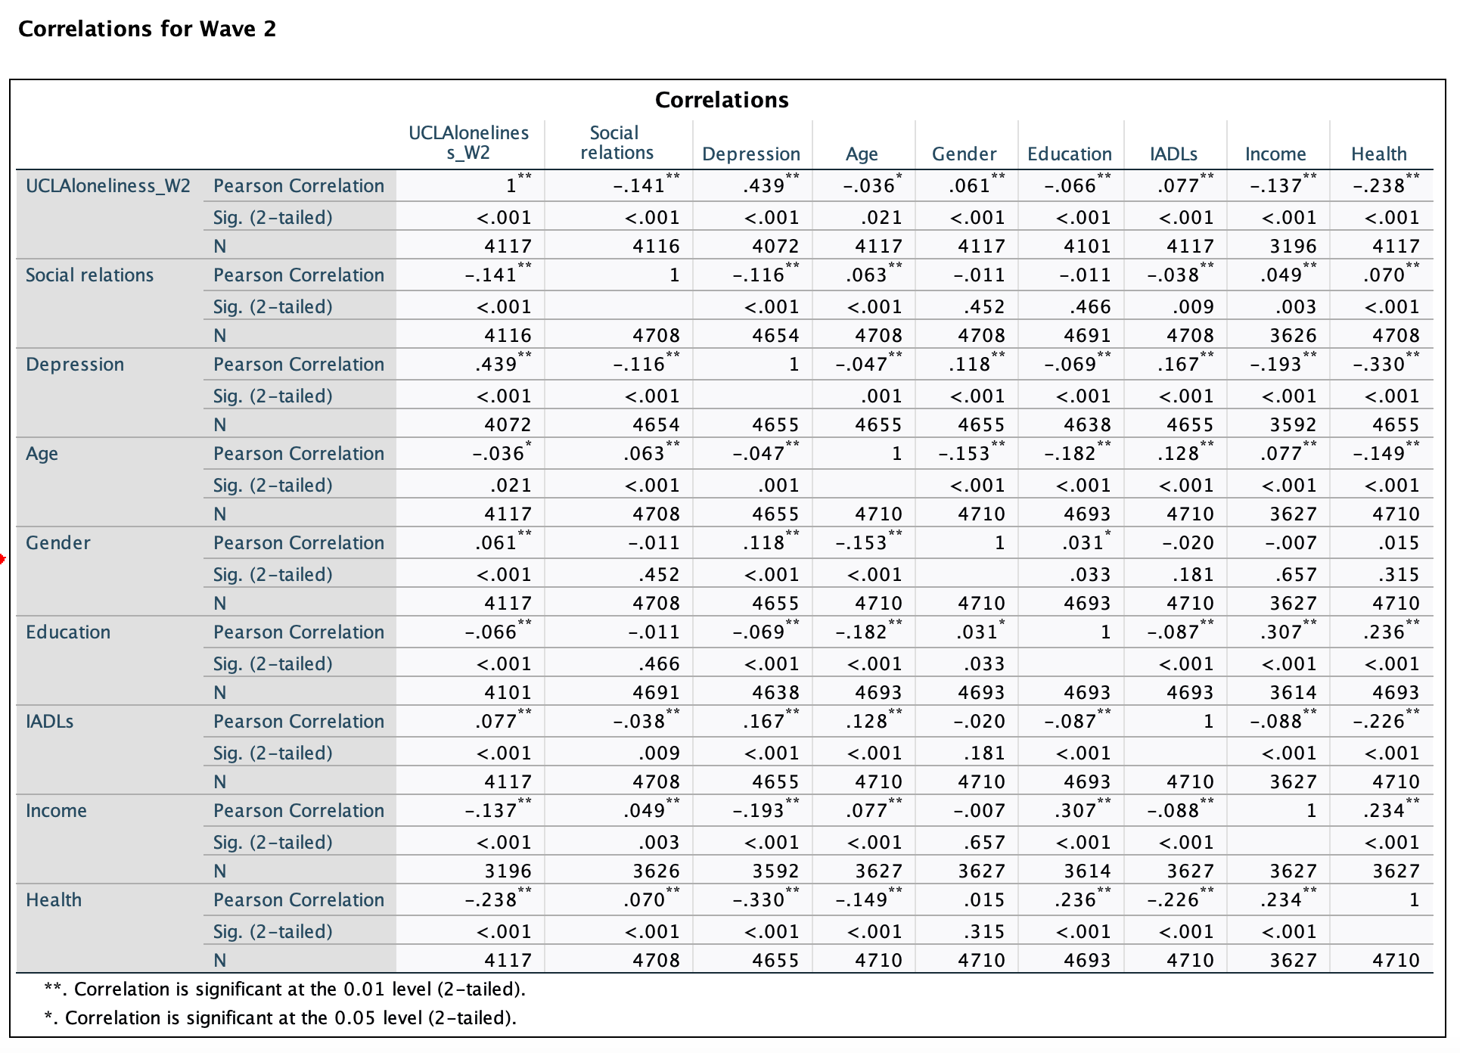
Wave 3 Correlation Table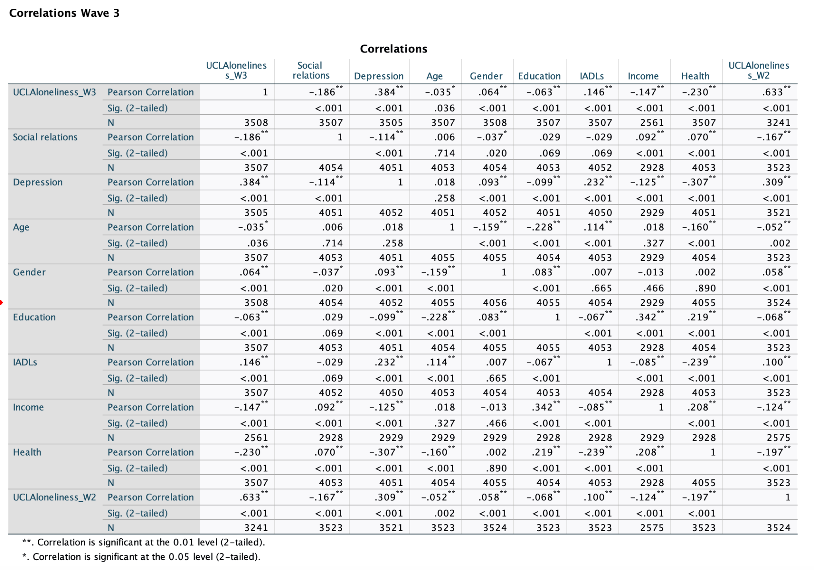

Wave 4 Correlation Table
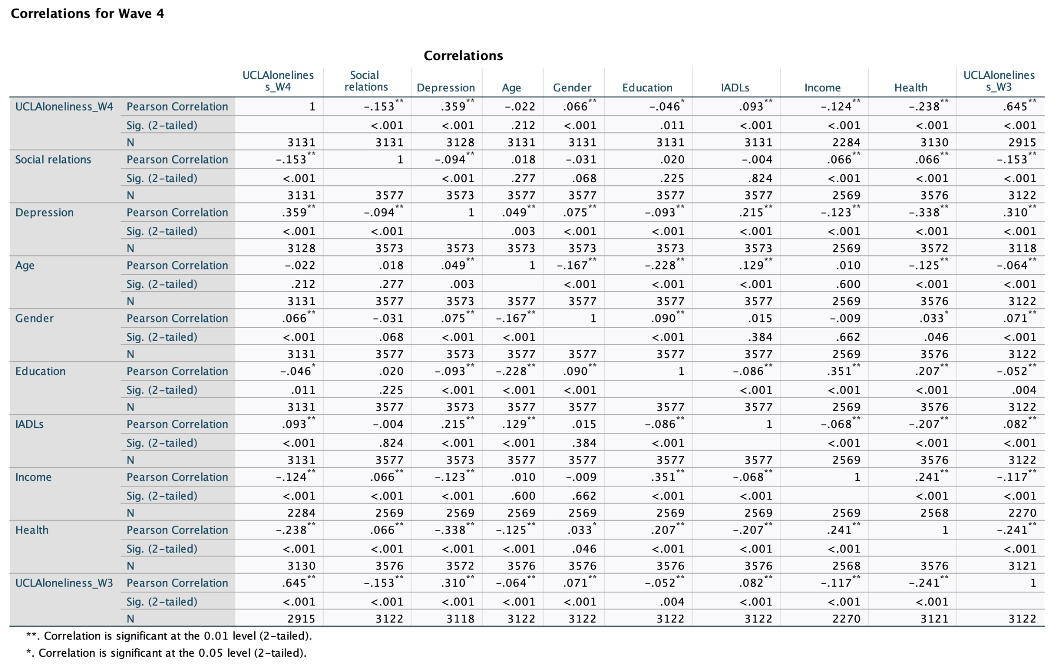

Wave 5 Correlation Table
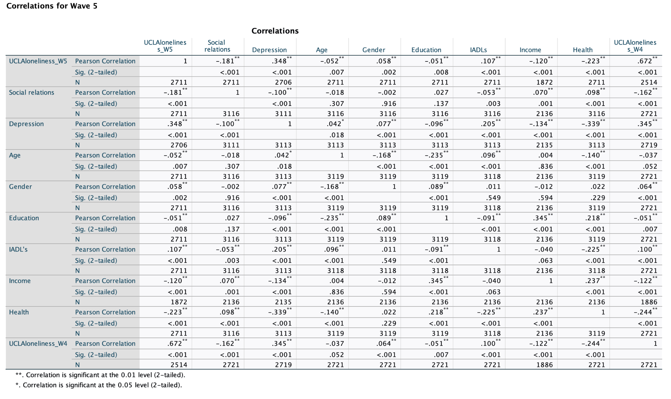

2 Cluster solutions across the 4 waves

Wave 2
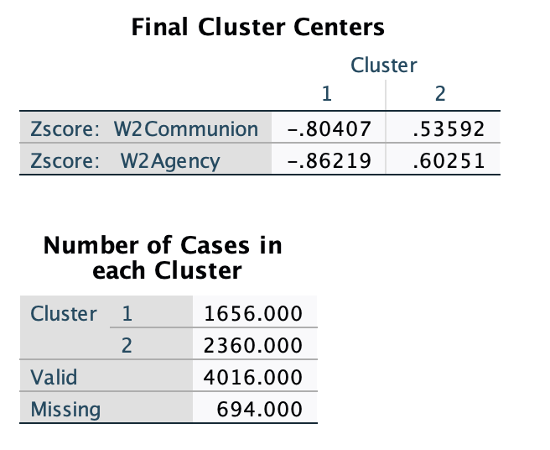

Wave 3
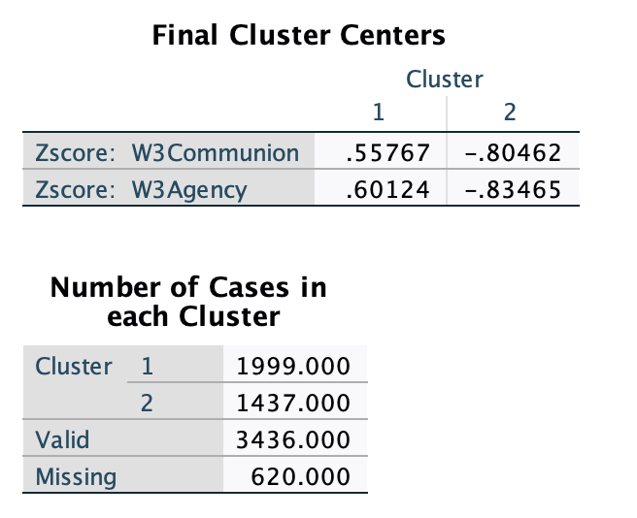

Wave 4
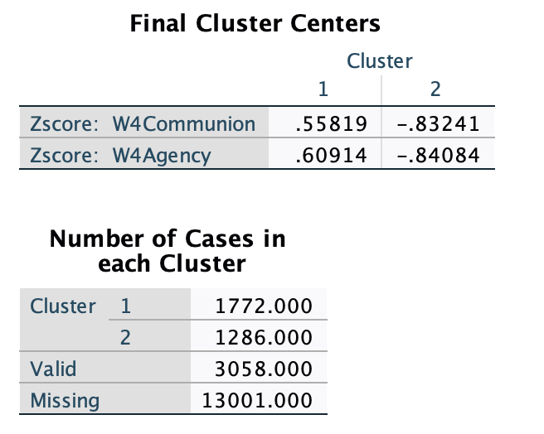

Wave 5
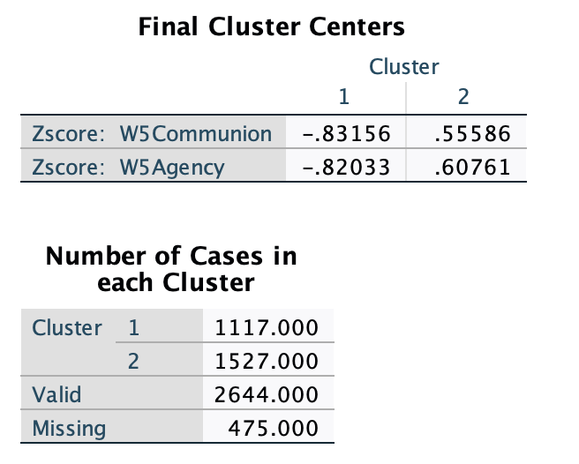

Analyses without covariates (pairwise cluster results)

Overall Wave 2 Effect of Squad on Loneliness Scores (no covariates)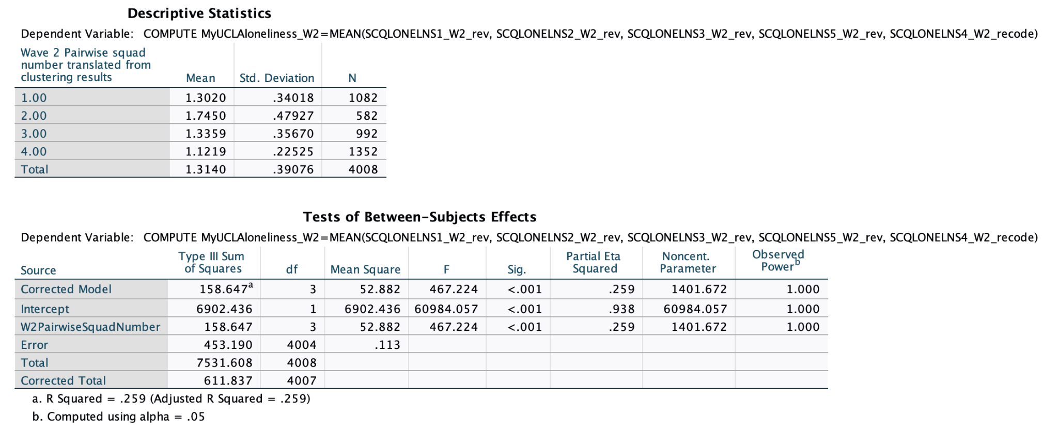

Overall Wave 3 Effect of Squad on Loneliness Scores (no covariates, except for previous
loneliness score)
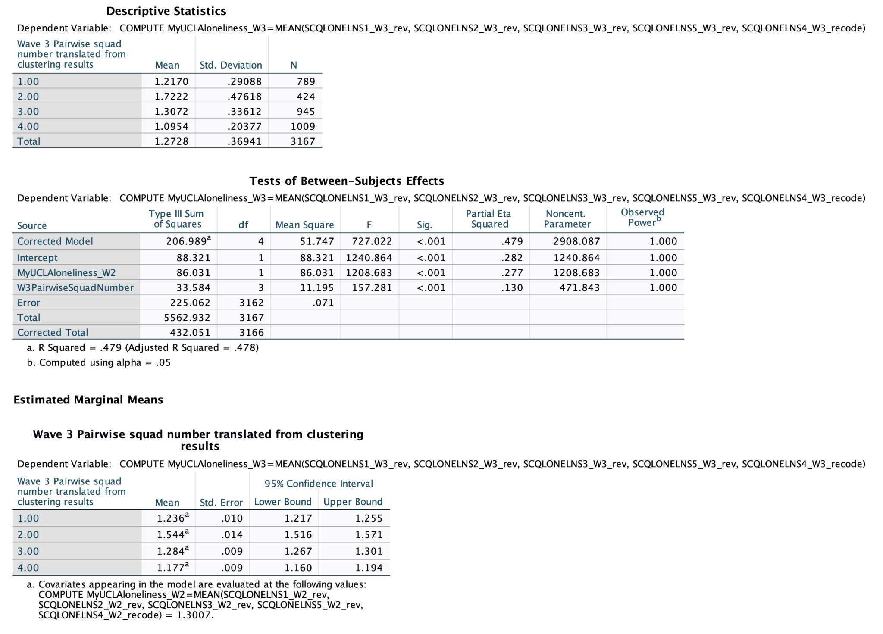

Overall Wave 4 Effect of Squad on Loneliness Scores (no covariates, except for previous
loneliness score)

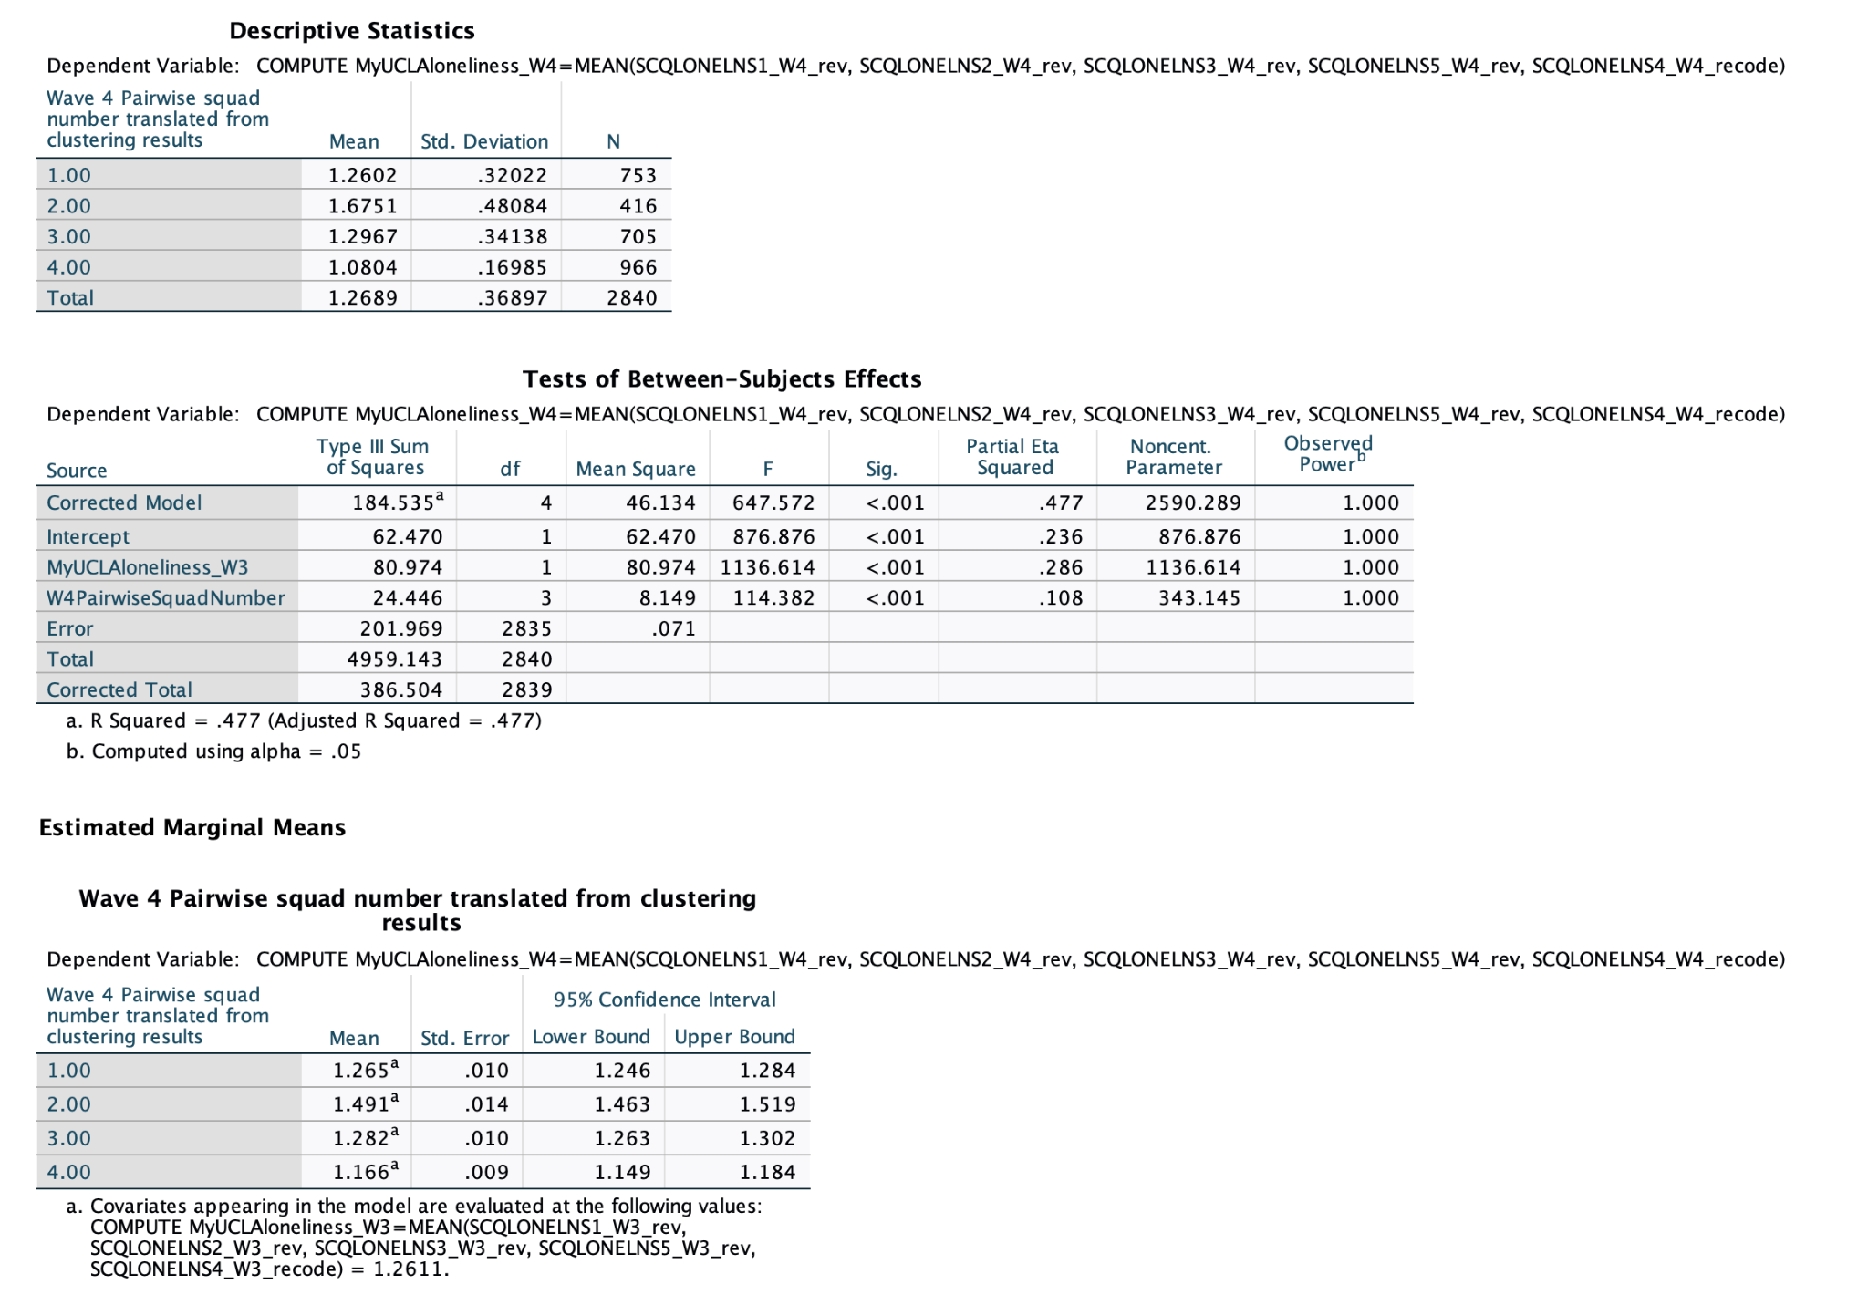

Overall Wave 5 Effect of Squad on Loneliness Scores (no covariates, except for previous
loneliness score)

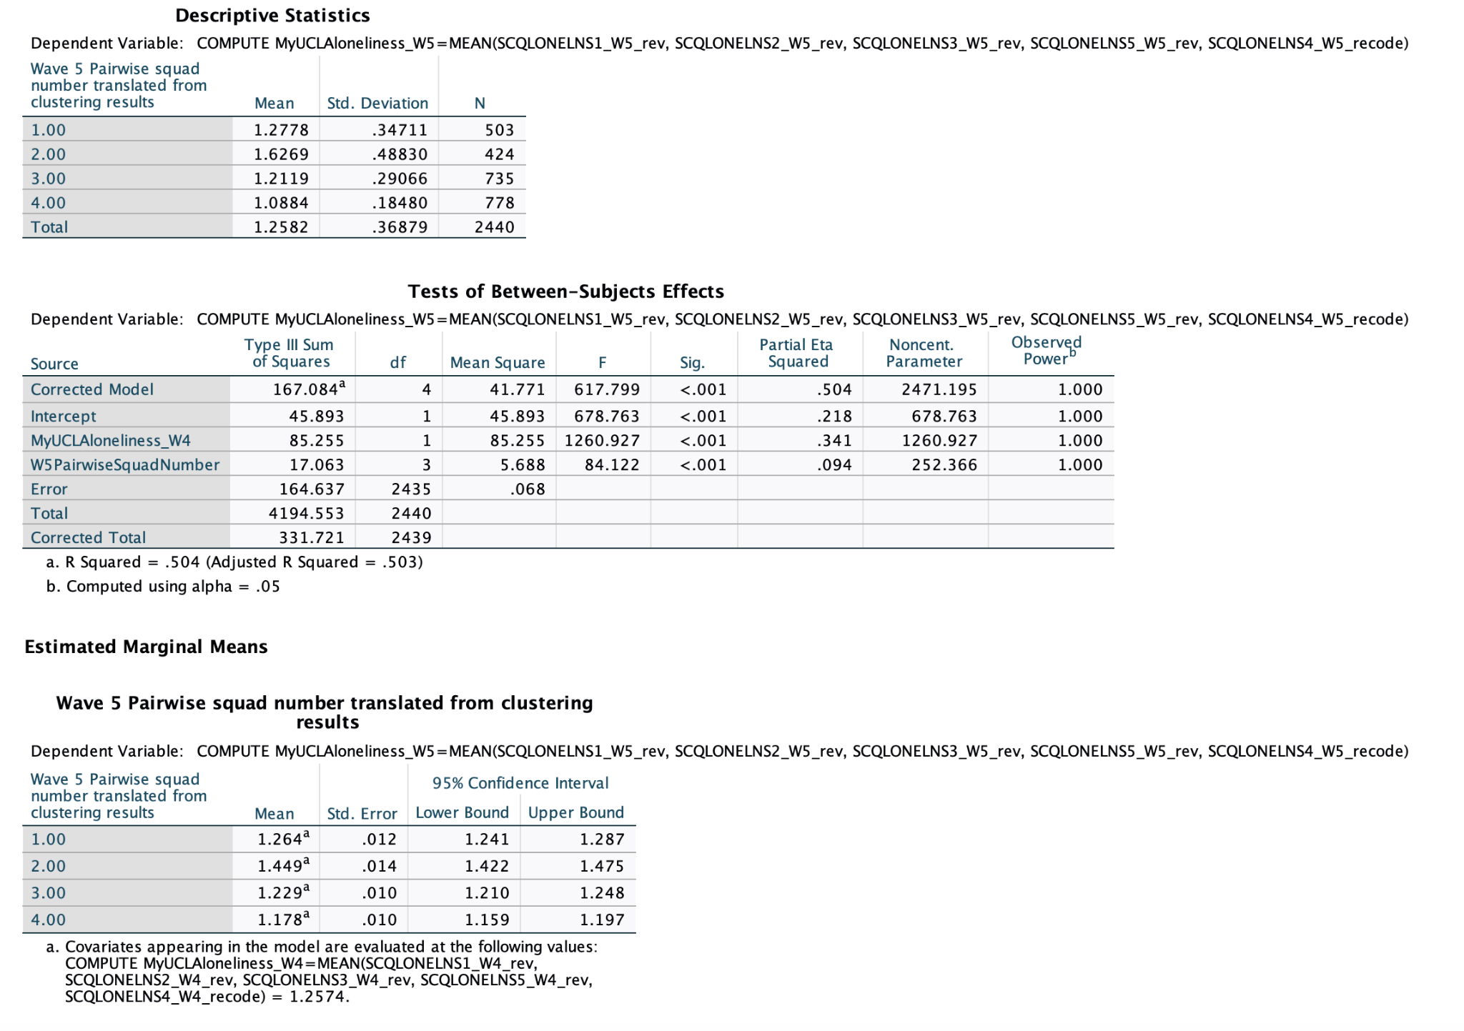

Analysis of Change from Wave 2 to Wave 3 (first set of assumptions; no covariates,
except for previous loneliness score)

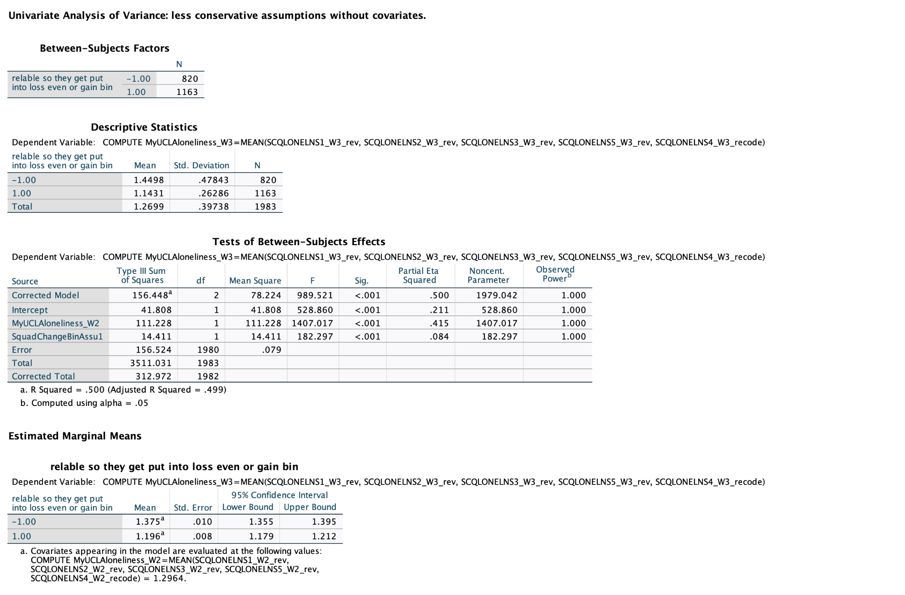

Note: -1 condition refers to individuals who ended up in the more unfavorable cluster or squad; +1 are individuals who ended up in the more favorable squad.

Analysis of Change from Wave 2 to Wave 3 (second set of assumptions; no covariates,
except for previous loneliness score)
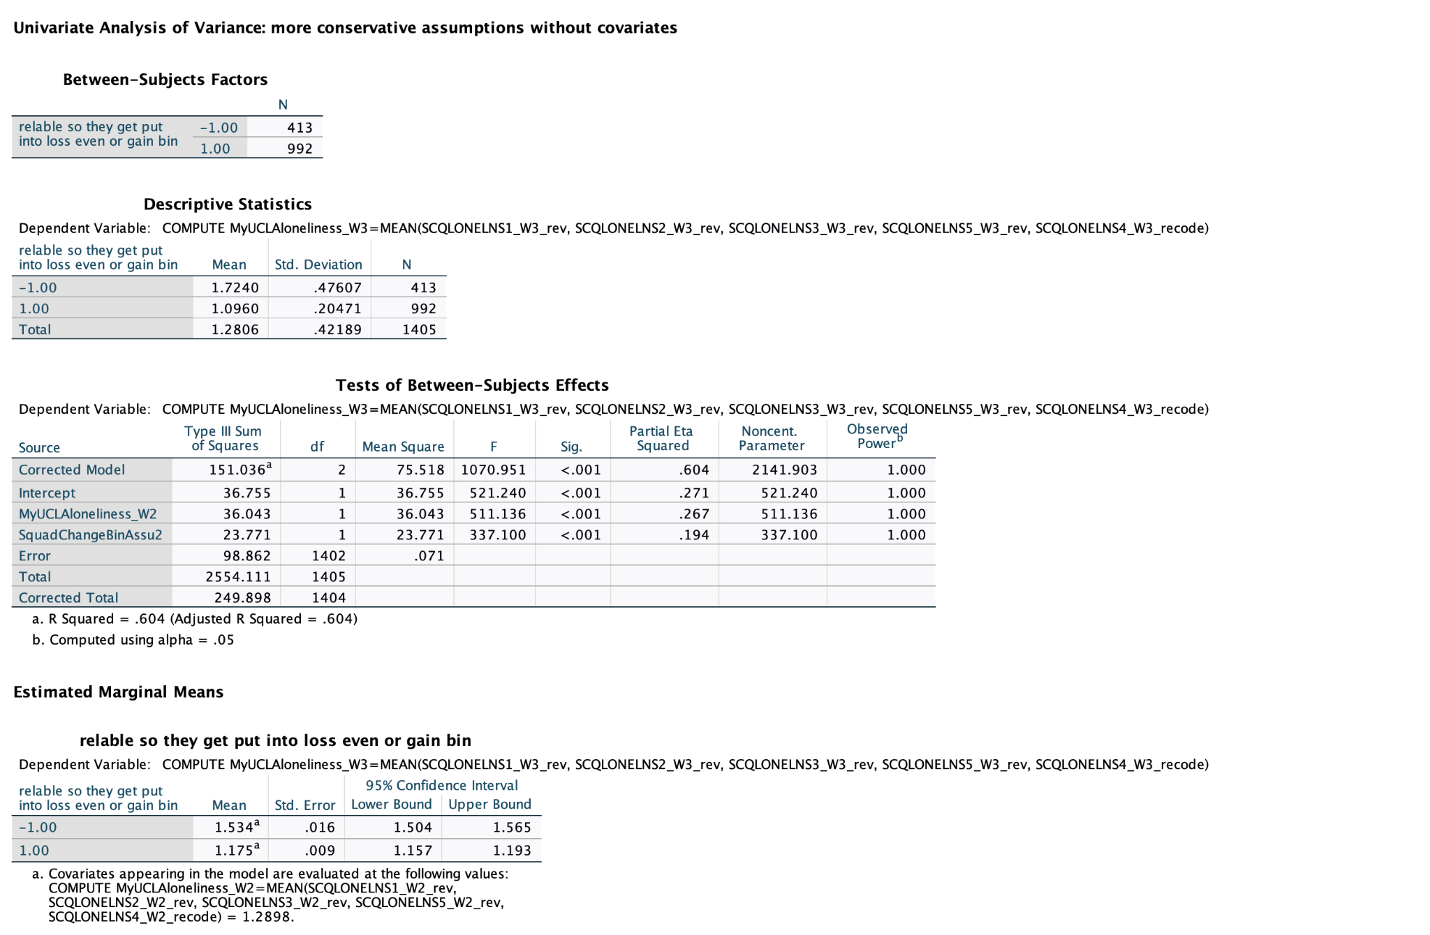

Note: -1 condition refers to individuals who ended up in the more unfavorable cluster or squad; +1 are individuals who ended up in the more favorable squad.

Analysis of Change from Wave 3 to Wave 4 (first set of assumptions; no covariates,
except for previous loneliness score)

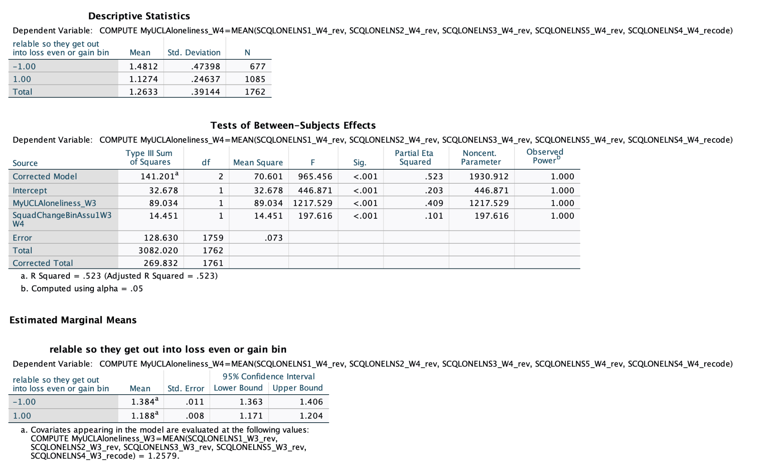

Note: -1 condition refers to individuals who ended up in the more unfavorable cluster or squad; +1 are individuals who ended up in the more favorable squad.

Analysis of Change from Wave 3 to Wave 4 (second set of assumptions; no covariates,
except for previous loneliness score)

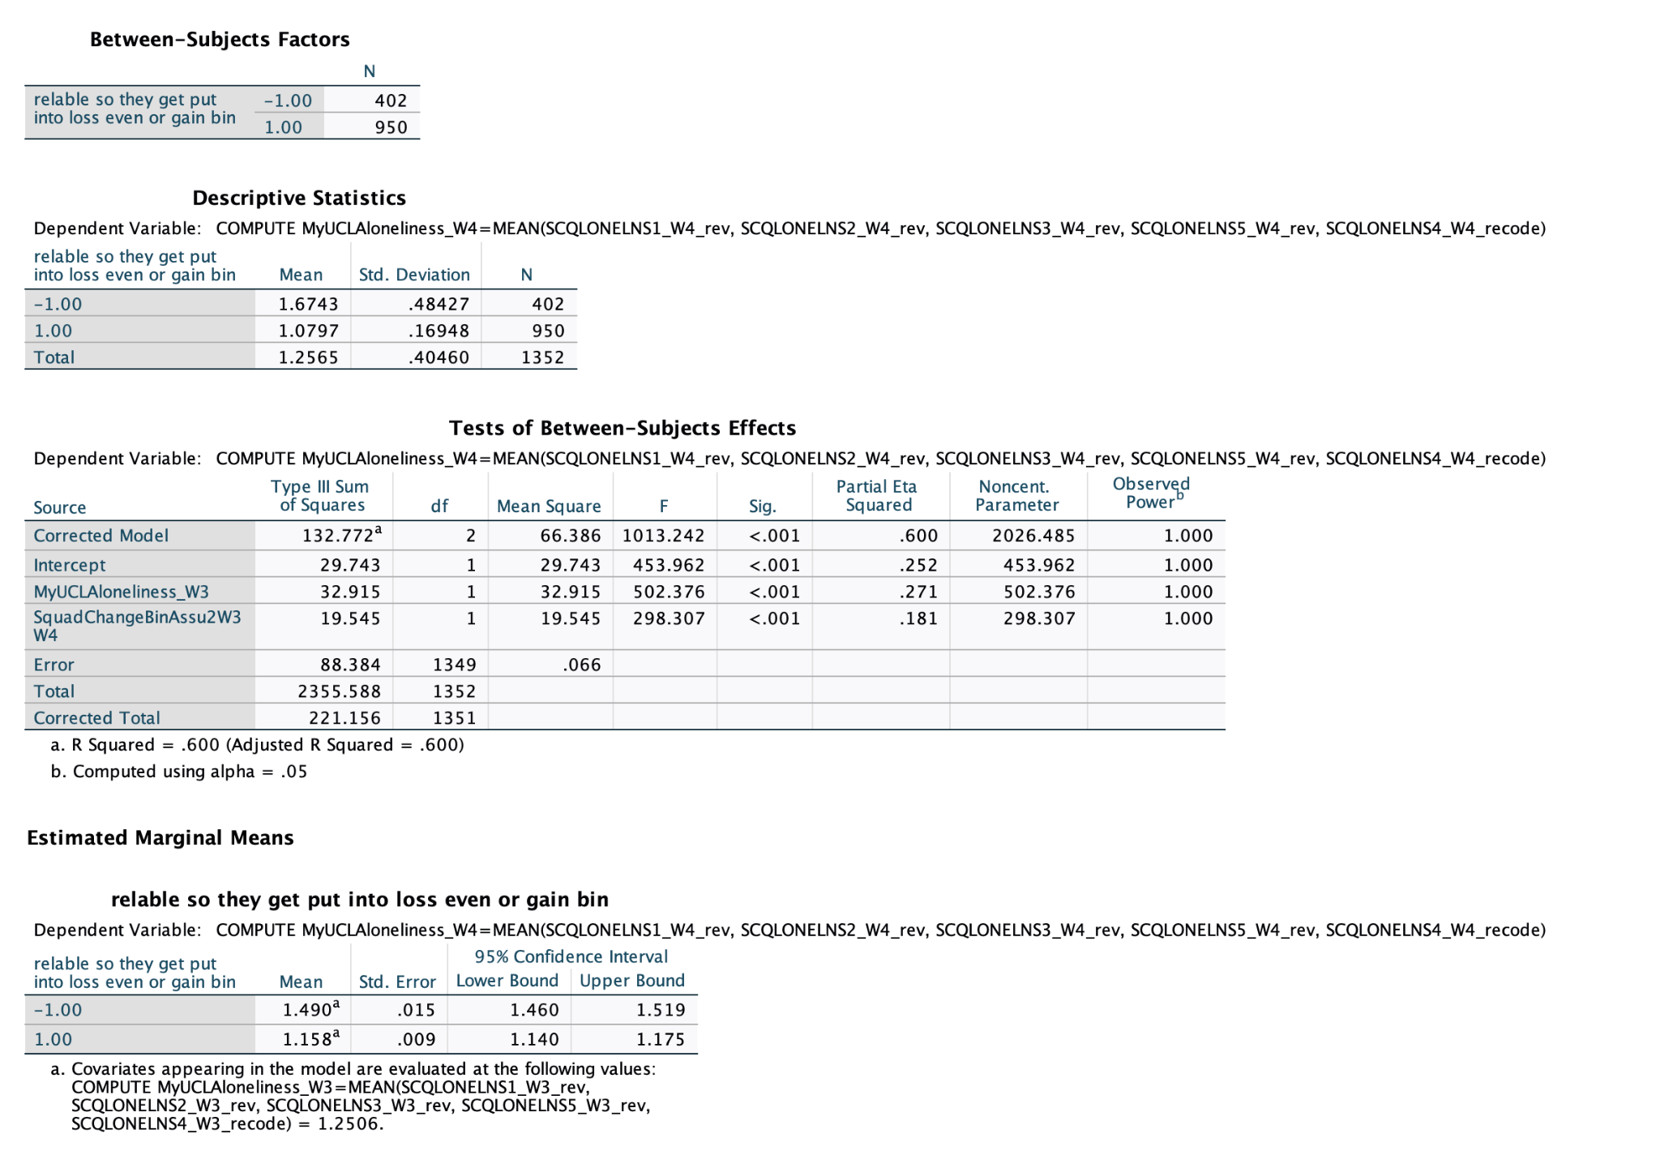

Note: -1 condition refers to individuals who ended up in the more unfavorable cluster or squad; +1 are individuals who ended up in the more favorable squad.

Analysis of Change from Wave 4 to Wave 5 (first set of assumptions; no covariates,
except for previous loneliness score)
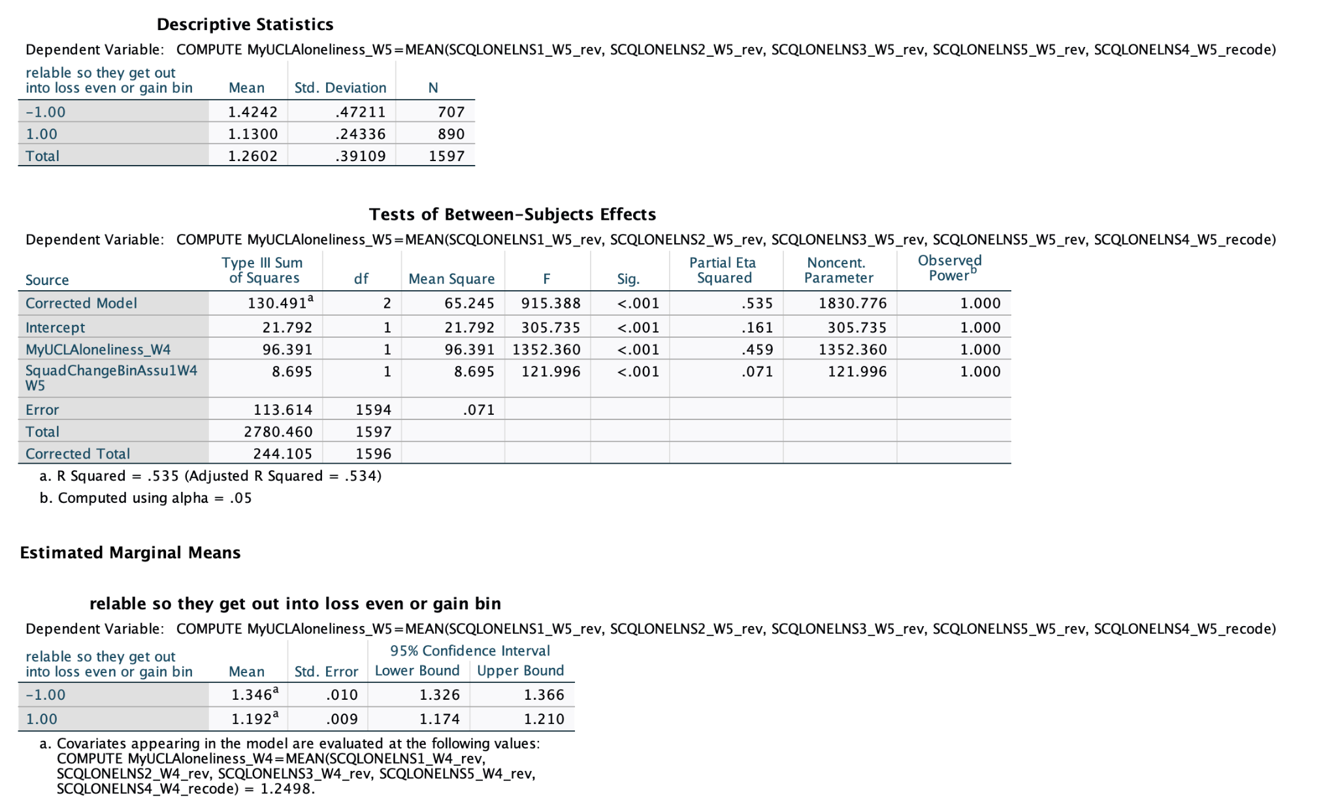

Note: -1 condition refers to individuals who ended up in the more unfavorable cluster or squad; +1 are individuals who ended up in the more favorable squad.

Analysis of Change from Wave 4 to Wave 5 (second set of assumptions; no covariates,
except for previous loneliness score)
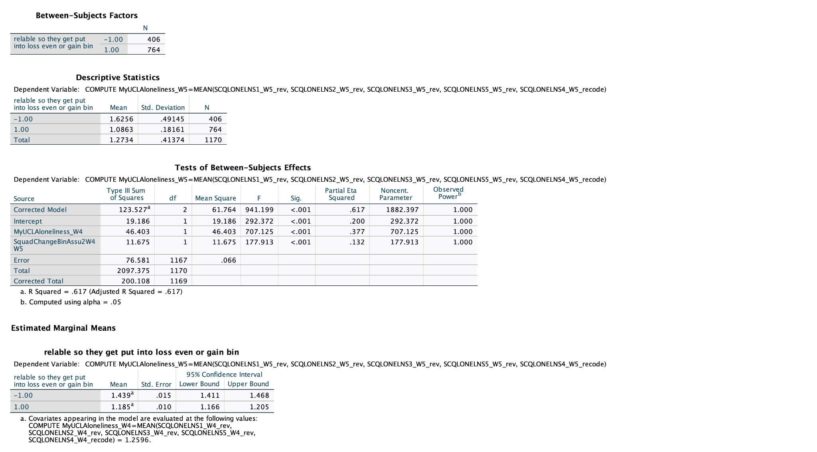

Note: -1 condition refers to individuals who ended up in the more unfavorable cluster or squad; +1 are individuals who ended up in the more favorable squad.

