Panel 1: Clustering results for each wave after re-standardizing criterion variables.

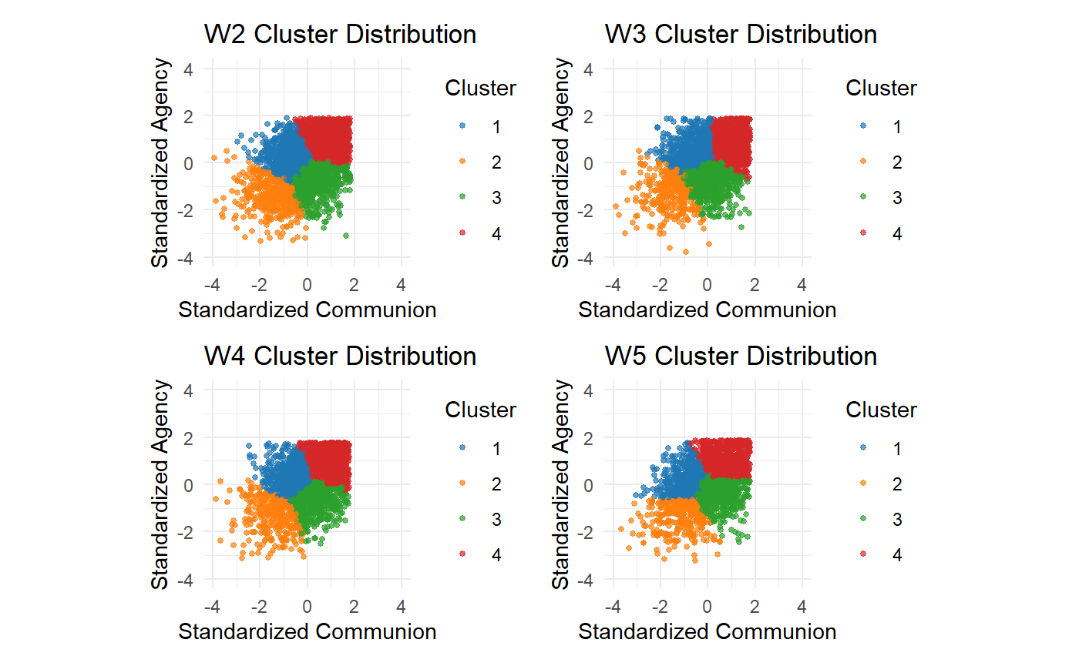
Panel 2: Maps detailing change in prototype membership across different time points.

