Supplements
Education, Occupation and Income Inequalities in Obesity Among Portuguese Women and Men: Evidence from National Health Surveys (2005–2019)
Berta Valente, Milton Severo, Ulf-Göran Gerdtham, Sílvia Fraga, Joana Araújo

Table S1. Weighted prevalence of occupation categories from the Portuguese National Health Surveys (2005-2019)
 | 2005/2006 |  | 2014 |  | 2019
Occupation, N̂ (%) | Women  3,304,423 (50.8%) | Men  3,204,410 (49.2%) | Women  3,223,112 (51.8%) | Men  3,003,929 (48.2%) | Women  3,158,573 (52.0%) | Men  2,914,605 (48.0%)
Unemployed | 672,174 (20%) | 170,933 (5.3%) | 1,238,971 (39%) | 916,584 (31%) | 969,895 (31%) | 597,644 (21%)
Unskilled workers | 474,232 (14%) | 287,391 (9.0%) | 339,270 (11%) | 101,751 (3.5%) | 289,537 (9.3%) | 156,070 (5.5%)
Plant and machine operators, and assembly workers | 136,308 (4.1%) | 396,265 (12%) | 132,538 (4.2%) | 246,884 (8.4%) | 110,614 (3.5%) | 247,853 (8.7%)
Farmers and skilled agricultural and fisheries workers | 173,917 (5.3%) | 170,030 (5.3%) | 34,662 (1.1%) | 87,702 (3.0%) | 34,800 (1.1%) | 57,566 (2.0%)
Laborers, craftsmen, service and sales staff | 892,179 (27%) | 1,128,322 (35%) | 462,553 (15%) | 686,975 (23%) | 705,658 (23%) | 780,716 (27%)
Administrative and similar staff | 400,116 (12%) | 253,898 (7.9%) | 213,782 (6.7%) | 100,338 (3.4%) | 238,051 (7.6%) | 136,278 (4.8%)
Technicians and mid-level professionals | 189,188 (5.7%) | 291,061 (9.1%) | 190,311 (6.0%) | 273,733 (9.3%) | 167,772 (5.4%) | 321,008 (11%)
Professional military | 1,469 (<0.1%) | 14,280 (0.4%) | 1,085 (<0.1%) | 27,273 (0.9%) | 2,306 (<0.1%) | 28,524 (1.0%)
Public administration senior managers, managers and senior managers of companies | 115,385 (3.5%) | 246,834 (7.7%) | 92,027 (2.9%) | 201,978 (6.9%) | 93,036 (3.0%) | 197,357 (6.9%)
Specialists in the intellectual and scientific professions | 249,388 (7.5%) | 243,780 (7.6%) | 463,288 (15%) | 297,517 (10%) | 509,062 (16%) | 325,286 (11%)
Missing | 67 | 1,614 | 54,624 | 63,195 | 37,842 | 66,303

Figure S1. Obesity prevalence by educational level and sex

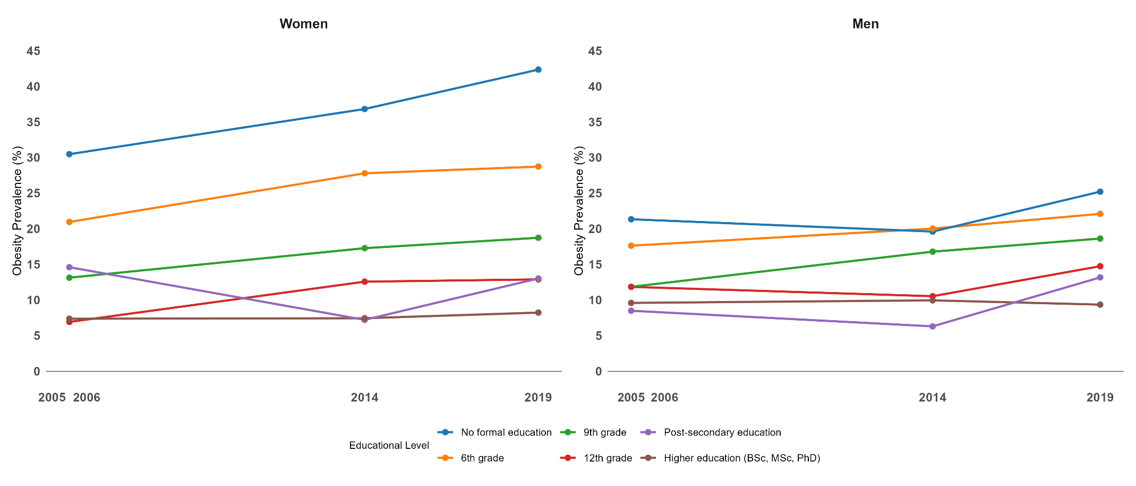

Figure S2. Obesity prevalence by occupational level and sex

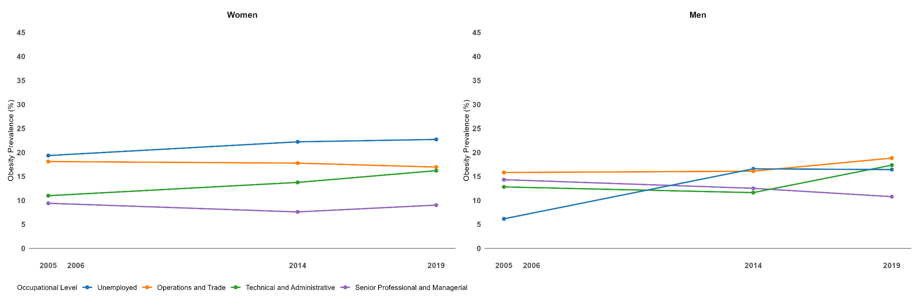

Figure S3. Obesity prevalence by income quintile and sex

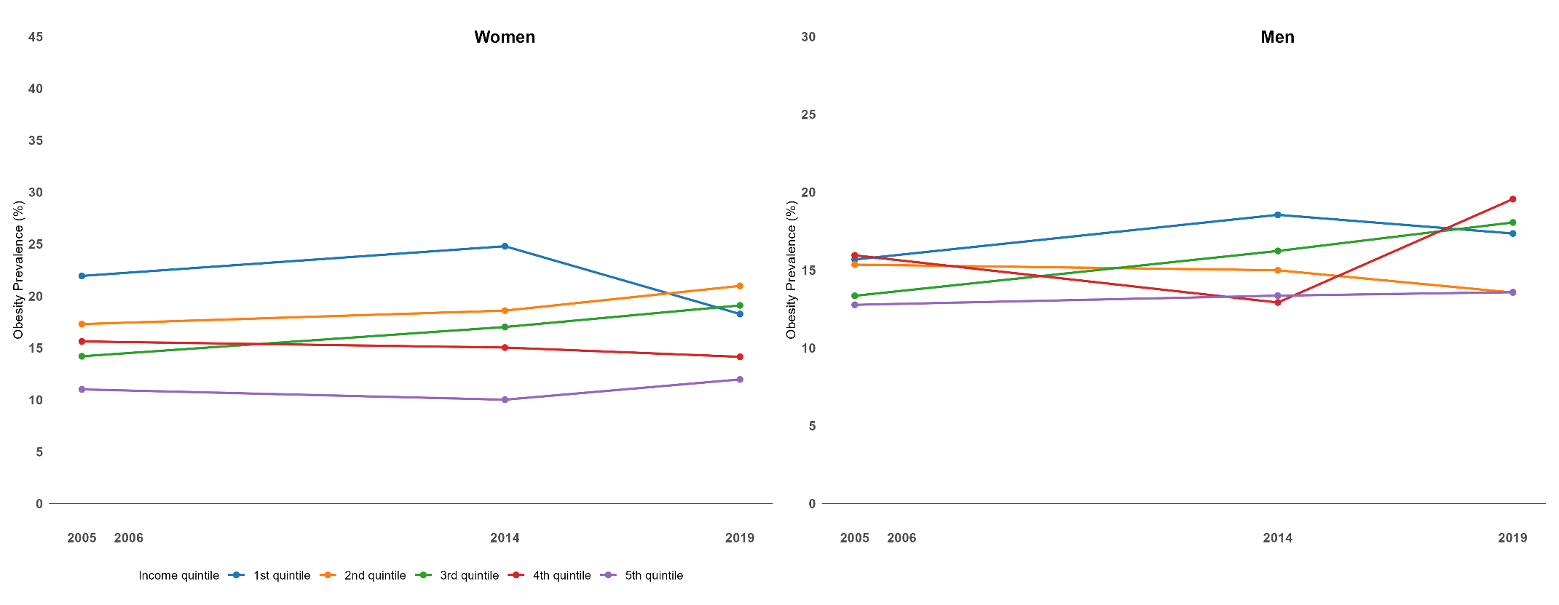

Table S2. Descriptives of RIDIT scores of socioeconomic indicators by sex, age and year
 | Ridit Score Education | p-value | Ridit Score Occupation | p-value | Ridit Score Income | p-value
Sex
Females | 0.54 (0.28) | <0.001 | 0.49 (0.29) | <0.001 | 0.48 (0.28) | <0.001
Males | 0.52 (0.26) | <0.001 | 0.55 (0.26) | <0.001 | 0.53 (0.28) | <0.001
Age
20-34 | 0.53 (0.27) | <0.001 | 0.50 (0.27) | <0.001 | 0.49 (0.28) | <0.001
35-49 | 0.53 (0.27) | <0.001 | 0.58 (0.25) | <0.001 | 0.52 (0.29) | <0.001
50-64 | 0.54 (0.27) | <0.001 | 9,47 (0.27) | <0.001 | 0.50 (0.29) | <0.001
Year
2005 | 0.53 (0.27) | <0.001 | 0.52 (0.28) | <0.001 | 0.49 (0.28) | <0.001
2014 | 0.53 (0.27) | <0.001 | 0.51 (0.28) | <0.001 | 0.51 (0.28) | <0.001
2019 | 0.54 (0.27) | <0.001 | 0.52 (0.28) | <0.001 | 0.51 (0.28) | <0.001

Table S3. Double interactions between sex, year and age and SII and RII
 | Sex |  | Year |  |  | Age
 | Women | Men | 2005 | 2014 | 2019 | 20-34 | 35-49 | 50-64
Slope Index of Inequality (SII)
Education | Ref. | <0.001 | Ref. | 0.108 | 0.060 | Ref. | 0.177 | 0.282
Occupation | Ref. | <0.001 | Ref. | 0.387 | 0.227 | Ref. | <0.001 | 0.002
Income | Ref. | 0.002 | Ref. | 0.225 | 0.742 | Ref. | 0.403 | 0.216
Relative Index of Inequality (RII)
Education | Ref. | <0.001 | Ref. | 0.140 | 0.200 | Ref. | 0.283 | 0.039
Occupation | Ref. | 0.001 | Ref. | 0.119 | 0.388 | Ref. | 0.046 | 0.677
Income | Ref. | <0.001 | Ref. | 0.021 | 0.969 | Ref. | 0.397 | 0.232

Table S4. AIC and BIC for slope index of inequality and relative index of inequality model fit assessment
 | 2005 | 2014 | 2019
Education
BIC
SII | 13226.18 | 9949.885 | 7402.544
RII | 13219.53 | 9948.45 | 7402.163
AIC
SII | 13210.85 | 9935.159 | 7388.445
RII | 13204.20 | 9933.724 | 7388.064
Occupation
BIC
SII | 13482.42 | 10022.72 | 7537.787
RII | 13485.56 | 10030.12 | 7604.711
AIC
SII | 13467.09 | 10008.03 | 7523.708
RII | 13470.23 | 10015.43 | 7590.633
Income
BIC
SII | 13315.94 | 10213.17 | 7642.706
RII | 13315.56 | 10211.75 | 7643.775
AIC
SII | 13300.64 | 10198.44 | 7628.608
RII | 13300.26 | 10197.02 | 7629.677

Table S5. Overall occupation absolute and relative measures of inequality of obesity, stratified by sex and age
Age groups (years) | Occupation
Age groups (years) | Women | Men
Slope Index of Inequality, 95% (CI)
20-34 | -0.08 (-0.12; -0.04) | -0.01 (-0.05; 0.04)
35-49 | -0.18 (-0.22; -0.14) | -0.12 (-0.17; -0.06)
50-64 | -0.15 (-0.20; -0.10) | -0.08 (-0.14; -0.02)
Relative Index of Inequality, 95% (CI)
20-34 | 0.49 (0.32; 0.76) | 0.92 (0.55; 1.53)
35-49 | 0.33 (0.25; 0.43) | 0.51 (0.36; 0.72)
50-64 | 0.54 (0.43; 0.68) | 0.69(0.52; 0.92)
Abbreviations: CI, confidence interval

