Appendix A. Supplementary data

Manuscript Title: VALORIZATION OF WATER HYACINTH BIOMASS: COMPREHENSIVE CHARACTERIZATION AND ACTIVATED CARBONS’ PRODUCTION AND APPLICATION
Authors: Ana Lourenço, Tiago Gomes, Maria Bernardo, Inês Matos, Nuno Lapa, Jorge Gominho
Number of Pages (not including cover page): 9
Number of Tables: 2
Number of Figures: 4

Table S1. Lipophilic extracts composition of water hyacinth biomass (% of the total chromatographic area). Legend: MT (monoterpenes), MTA (monoterpene alcohol), MTK (monoterpene ketone), ST (sesquiterpene), T (terpene), Ar (aromatic), FA (fatty acids), SDA (saturated α,ω-diacids), DA (diterpenic acids), MAG (monoacylglycerol), LCA (long chain alcohol), PHS (phytosterols), NI (not identified compound).

Peak nbr | RT (min) | Compounds | Family | Area (%)
1 | 3.75 | NI | - | 1.4
2 | 3.88 | Propanoic Acid (C4:0) | FA | 0.37
3 | 4.87 | Urea | Others | 4.1
4 | 5.11 | Glycerol | Others | 11.3
5 | 5.36 | 1,2,3 - Butanetriol | SA | 1.3
6 | 5.70 | NI | - | 0.11
7 | 5.83 | Uracil | Others | 1.2
8 | 6.31 | Erythrono-1,4-Lactone | Others | 0.13
9 | 6.62 | Hexanoic acid (C6:0) | FA | 5.3
10 | 7.20 | Alanylthreonine | Others | 0.13
11 | 8.01 | Erythritol | SA | 11.9
12 | 8.10 | Threitol | SA | 1.2
13 | 9.59 | Benzoic acid | Ar | 0.23
14 | 11.31 | Ribitol | SA | 0.28
15 | 11.84 | Benzoic acid | Ar | 0.14
16 | 12.30 | Azelaic acid | SDA | 0.40
17 | 12.87 | NI | - | 0.25
18 | 13.06 | Tetradecanoic acid (C14:0) | FA | 0.40
19 | 13.53 | Adenine | Others | 0.21
20 | 14.72 | Pentadecanoic acid (C15:0) | FA | 0.53
21 | 14.95 | 1-Pentadecanol (C15) | LCA | 0.33
22 | 16.47 | Hexadecanoic acid (C16:0) | FA | 20.6
23 | 17.84 | 9-octadecen-1-ol | LCA | 1.2
24 | 18.10 | Heptadecanoic acid (C17:0) | FA | 0.57
25 | 18.32 | 1-Octadecanol | LCA | 0.37
26 | 18.70 | Phytol | SA | 0.47
27 | 19.26 | 9,12-Octadecadienoic acid (C18:2) | FA | 3.8
28 | 19.39 | 11- cis-Octadecenoic acid (C18:1) | FA | 6.8
29 | 19.50 | 11-trans-Octadecenoic acid (C18:1) | FA | 0.61
30 | 19.86 | Octadecanoic acid (C18:0) | FA | 5.7
31 | 21.64 | n-Tetratriacontane | ALK | 0.27
32 | 23.34 | Eicosanoic acid (C20:0) | FA | 0.38
33 | 26.16 | 1-Palmitoylglycerol (G-C16:0) | MAG | 1.7
34 | 26.76 | Docosanoic acid (C22:0) | FA | 0.56
35 | 28.43 | Tricosanoic acid (C23:0) | FA | 0.44
36 | 29.40 | 1-Stearoylglycerol (G-C18:0) | MAG | 0.66
37 | 30.06 | Tetracosanoic acid (C24:0) | FA | 0.91
38 | 31.56 | 24-hydroxytetracosanoic (C24:0) | HFA | 0.21
39 | 31.65 | Pentacosanoic acid (C25:0) | FA | 0.14
40 | 32.48 | 24-hydroxytetracosanoic (C24:0) | HFA | 0.93
41 | 33.19 | Hexacosanoic acid (C26:0) | FA | 0.26
42 | 34.77 | Cholest-4-en-3-ol | PHS | 1.3
43 | 36.16 | Octacosanoic acid (C28:0) | FA | 0.20
44 | 36.32 | Campesterol | PHS | 0.48
45 | 36.83 | β-Stigmasterol | PHS | 3.9
46 | 37.64 | Stigmasterol-5-ene | PHS | 2.1
47 | 37.76 | Stigmastanol | PHS | 0.32
48 | 38.17 | Stigmasta-4,22-dien-3-one | PHS | 0.22
49 | 48.49 | α-D-Glucopyranoside | Others | 0.26
 |  | Total identified compounds (% of total area) |  | 94.7

Table S2. Identification and quantification of pyrolysis products from the Eichhornia crassipes biomass (water hyacinth) and its Klason lignin (% of the total chromatographic area).

Peak nbr | RT | Compound | Origin | Water hyacinth | Klason  lignin
1 | 5.67 | acetone | c | 3.6 | 0.3
2 | 5.76 | 2-oxo-propanal | c | 3.6 | n.d.
3 | 6.36 | 2-methyl-furan | c | 0.4 | n.d.
#4 | 6.87 | methyl vinyl ketone | c | 0.8 | n.d.
#5 | 6.87 | 2,3-butanedione | c | 0.8 | n.d.
6 | 7.60 | hydroxyacetaldehyde | c | 1.8 | n.d.
7 | 8.23 | acetic acid | c | 3.6 | n.d.
8 | 8.90 | 2-hydroxypropanone (acetol) | c | 2.3 | n.d.
9 | 9.02 | toluene | L | 1.2 | 5.2
10 | 10.54 | 3-hydroxypropanal | c | 1.7 | n.d.
#11 | 11.14 | furan-2-one isomer | c | 0.8 | n.d.
#12 | 11.14 | 3-furaldehyde | c | 0.8 | n.d.
13 | 11.29 | CH₃-CO-CHOH-CHO | c | 1.2 | n.d.
14 | 11.36 | CHO-CH₂-CH₂-CHO | c | 0.4 | n.d.
15 | 11.43 | styrene | L | 0.5 | 1.2
#16 | 11.65 | furfural | c | 1.9 | n.d.
#17 | 11.65 | 2-cyclopenten-1-one | c | 1.9 | n.d.
18 | 12.43 | NI sugar derivative | c | 1.4 | n.d.
19 | 12.69 | NI sugar derivative | c | 0.4 | n.d.
20 | 12.94 | NI sugar derivative | c | 0.4 | n.d.
21 | 13.15 | 3-ethyl-1-pyrroline | Prot | 0.4 | n.d.
22 | 13.26 | 4-cyclopentene-1,3-dione | c | 0.4 | n.d.
23 | 13.46 | dihydro-4-hydroxy-2(3H)-furanone | c | 0.5 | n.d.
24 | 13.59 | NI sugar derivative | c | 0.4 | n.d.
25 | 13.68 | 2-hydroxy-2-cyclopenten-1-one | c | 1.8 | n.d.
26 | 14.19 | 5-methyl-2-furaldehyde | c | 0.9 | n.d.
27 | 14.59 | 3-methyl-2-cyclopenten-1-one | c | 0.5 | n.d.
28 | 14.86 | 2(5H)-furanone | c | 0.5 | n.d.
29 | 15.10 | NI sugar derivative | c | 0.6 | n.d.
30 | 15.23 | 4-hydroxy-5,6-dihydro-(2H)-pyran-2-one | c | 0.8 | n.d.
31 | 15.64 | 2-hydroxy-3-methyl-2-cyclopenten-1-one | c | 1.5 | n.d.
32 | 15.73 | methyl-dihydro-(2H)-pyran-2-one | c | 0.7 | n.d.
33 | 16.08 | phenol | H | 1.1 | 5.8
#34 | 16.62 | 2-(propan-2-one)-tetrahydrofuran | L | 0.5 | n.d.
#35 | 16.62 | guaiacol | G | 0.5 | 2.0
36 | 17.08 | o-cresol | H | 0.4 | 1.0
37 | 17.82 | 4-methylphenol | H | 1.6 | 7.4
38 | 18.72 | 4-methylguaiacol | G | 0.3 | 1.9
39 | 18.83 | 2,5-dimethylphenol (p-xylenol) | L | 0.3 | 1.1
40 | 19.01 | NI sugar derivative | c | 0.4 | n.d.
41 | 19.70 | 3-ethylphenol | H | 0.3 | 2.0
42 | 20.53 | 4-ethylguaiacol | G | 0.4 | 0.6
43 | 20.72 | NI sugar derivative | c | 2.3 | n.d.
44 | 21.34 | 1,4:3,6-dianhydro-α-d-glucopyranose | c | 0.8 | n.d.
#45 | 21.54 | 1,5-anhydro-β-D-arabinofuranose | c | 2.1 | n.d.
#46 | 21.54 | dihydrobenzofuran | L | 2.1 | 2.7
47 | 21.74 | 4-vinylguaiacol | G | 2.2 | 3.5
48 | 22.55 | 5-hydroxymethylfurfural | c | 1.2 | n.d.
49 | 22.82 | syringol | S | 0.1 | 0.2
50 | 23.04 | indole | Prot | 0.6 | 0.3
51 | 24.47 | 1,5-anhydro-β-D-xylofuranose | c | 1.1 | 0.7
52 | 24.54 | 5-methyl-indole | Prot | 0.5 | n.d.
53 | 25.03 | vanillin | G | 0.3 | n.d.
54 | 29.47 | 1,6-anhydro-β-D-glucopyranose (levoglucosan) | c | 9.0 | n.d.
 |  | Total carbohydrates (C) |  | 53.4 | 1.1
 |  | Total lignin (L) |  | 7.1 | 24.4
 |  | Syringyl units (S) |  | 0.1 | 0.2
 |  | Guaiacyl units (G) |  | 3.6 | 8.0
 |  | p-Hydroxyphenyl units (H) |  | 3.4 | 16.2
 |  | other lignin derivatives (L) |  | 4.6 | 10.1
 |  | Proteins |  | 1.5 | 0.3
 |  | S/G ratio |  | 0.025 | 0.028
 |  | C/L ratio |  | 4.8 | 0.03
# - overlapped compounds; RT – retention time (min); NI – not identified compound; c – carbohydrates derivatives; L - lignin derivatives; Prot – protein derivatives; S – syringyl lignin units; G – guaiacyl lignin units; H – p-hydroxyphenyl lignin units; n.d. – not detected.

(a) | (b)
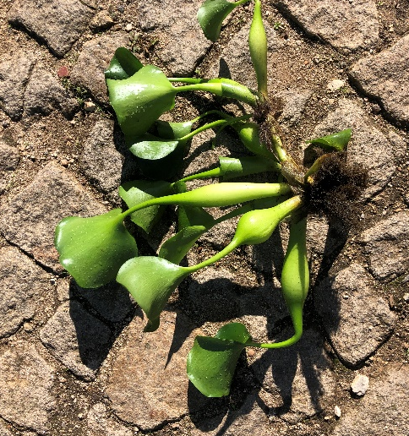 | 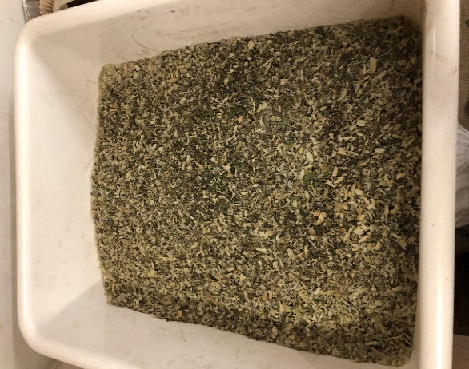

Figure S1. Water hyacinth raw material used in this study (example of an entire plant used in this work) (a) and fraction used for chemical analysis (b).

- TTC
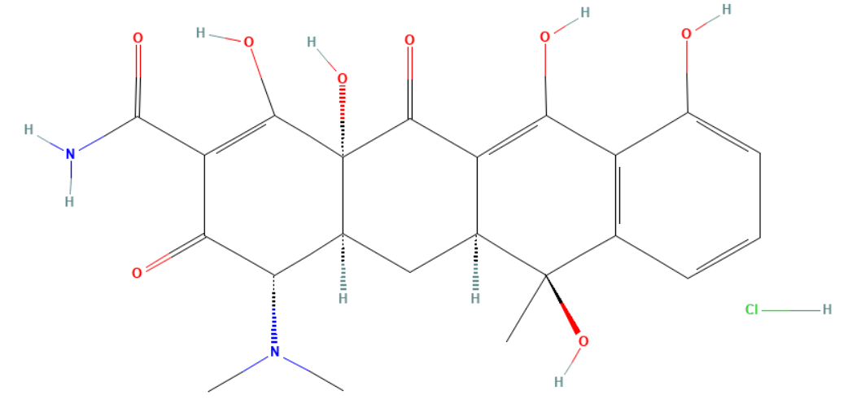
- PAR | - FLX
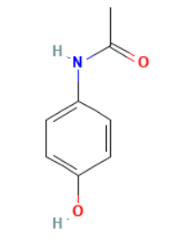 | 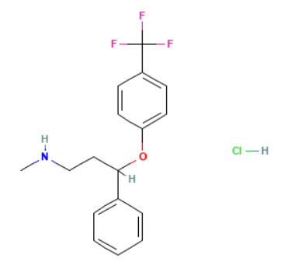

Figure S2. Chemical structure of tetracycline (TTC), paracetamol (PAR), and fluoxetine (FLX).

Figure S3. Pore size distribution from DFT adsorption model for carbon slit-shaped pores.

Figure S4. N₂ adsorption-desorption isotherms at 77 K.

