Title: The Impact of Tranexamic Acid on Spontaneous Intracerebral Hemorrhage: A Systematic Review and Meta-Analysis of RCTs.
Journal: CNS Drugs
Authors:
Mahmoud M. Elhady^{1*}, Eslam Mohammed Rabea², Samah Bahy Mohammed Ebaed³, Manar Adel⁴, Moustafa Z. Elattar⁵, Mahmoud Eleisawy⁶, Ahmed A. Lashin¹, Ahmed A. Elfeky⁷, Mohamed Hesham Gamal⁸, Mohamed Sayed Zaazouee⁹.
Affiliations:
1- Faculty of Medicine, Benha University, Qalubiya, Egypt.
2- Faculty of Medicine, Alexandria University, Alexandria, Egypt.
3- Department of Clinical Pharmacology, Faculty of Medicine, Benha University, Egypt.
4- Faculty of Clinical Pharmacy, Tanta University, Gharbia, Egypt.
5- Anatomy & Embryology Department, Faculty of Medicine, Benha University, Qalubiya, Egypt.
6- Ophthalmology Department, Benha University Hospitals, Qalubiya, Egypt.
7- Faculty of Medicine, Beni Suef University, Beni Suef, Egypt.
8- Faculty of Pharmacy, Tanta University, Gharbia, Egypt.
9- Faculty of Medicine, Al-Azhar University, Assiut, Egypt.
*Corresponding author
Name: Mahmoud M. Elhady
Email: mahmoud160375@fmed.bu.edu.eg

Supplementary Table 1. Search strategies across the four databases.

Database | Strategy | Results
Scopus | TITLE-ABS-KEY ( ( intracerebral OR subarachnoid OR intraparenchymal OR parenchymal OR intraventricular OR intra-axial OR intracranial OR brain OR cerebr* OR stroke* ) AND ( hemorrhag* OR bleed* OR hematoma ) AND ( "Tranexamic acid" OR amca OR amcha OR t-amcha OR "trans-4-(Aminomethyl)cyclohexanecarboxylic Acid" OR cyklokapron OR ugurol OR transamin OR kabi 2161 OR amchafibrin OR anvitoff OR spotof OR exacyl OR lysteda OR evana OR antifibrinolytic ) AND ( random* ) ) | 349
Pubmed | (Intracerebral[Title/Abstract] OR Subarachnoid[Title/Abstract] OR Intraparenchymal[Title/Abstract] OR parenchymal[Title/Abstract] OR Intraventricular[Title/Abstract] OR intra-axial[Title/Abstract] OR Intracranial[Title/Abstract] OR brain[Title/Abstract] OR Cerebr*[Title/Abstract] OR Stroke*[Title/Abstract]) AND (hemorrhag*[Title/Abstract] OR bleed*[Title/Abstract] OR hematoma[Title/Abstract]) AND ("Tranexamic acid"[Title/Abstract] OR AMCA[Title/Abstract] OR AMCHA[Title/Abstract] OR t-AMCHA[Title/Abstract] OR "trans-4-(Aminomethyl)cyclohexanecarboxylic Acid"[Title/Abstract] OR Cyklokapron[Title/Abstract] OR Ugurol[Title/Abstract] OR Transamin[Title/Abstract] OR KABI 2161[Title/Abstract] OR Amchafibrin[Title/Abstract] OR Anvitoff[Title/Abstract] OR Spotof[Title/Abstract] OR Exacyl[Title/Abstract] OR Lysteda[Title/Abstract] OR Evana[Title/Abstract] OR antifibrinolytic[Title/Abstract]) AND (random*[Title/Abstract]) | 211
Cochrane | ((Intracerebral OR Subarachnoid OR Intraparenchymal OR parenchymal OR Intraventricular OR intra-axial OR Intracranial OR brain OR Cerebr* OR Stroke*) AND (hemorrhag* OR bleed* OR hematoma) AND (“Tranexamic acid” OR AMCA OR AMCHA OR t-AMCHA OR “trans-4-(Aminomethyl)cyclohexanecarboxylic Acid” OR Cyklokapron OR Ugurol OR Transamin OR KABI 2161 OR Amchafibrin OR Anvitoff OR Spotof OR Exacyl OR Lysteda OR Evana OR antifibrinolytic) AND (random*)):ti,ab,kw | 352
WOS | TS=((Intracerebral OR Subarachnoid OR Intraparenchymal OR parenchymal OR Intraventricular OR intra-axial OR Intracranial OR brain OR Cerebr* OR Stroke*) AND (hemorrhag* OR bleed* OR hematoma) AND (“Tranexamic acid” OR AMCA OR AMCHA OR t-AMCHA OR “trans-4-(Aminomethyl)cyclohexanecarboxylic Acid” OR Cyklokapron OR Ugurol OR Transamin OR KABI 2161 OR Amchafibrin OR Anvitoff OR Spotof OR Exacyl OR Lysteda OR Evana OR antifibrinolytic) AND (random*)) | 271
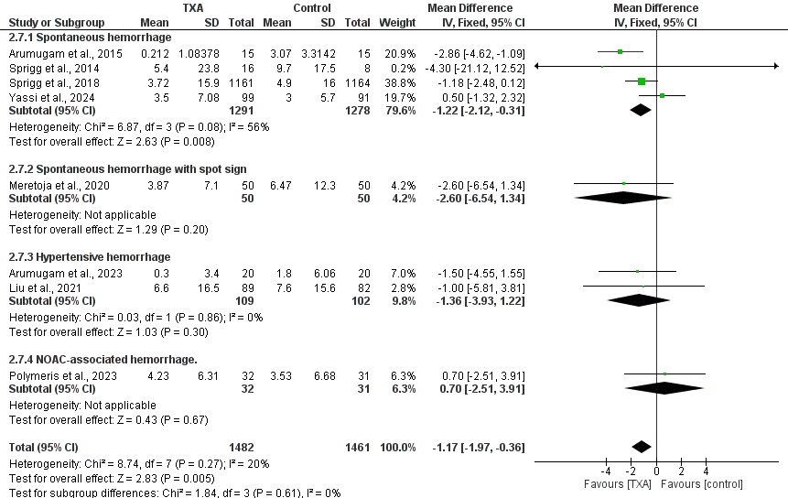
Supplementary Figure 1. Forest plots comparing the absolute change in hematoma volume (mL), measured 24 hours after the event, across different subgroups of studies’ populations.

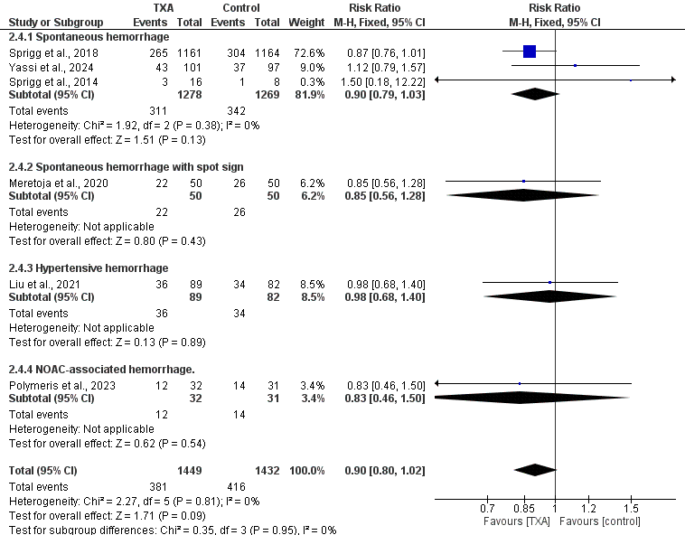
Supplementary Figure 2. Forest plots comparing the odds of hematoma expansion across different subgroups of studies’ populations.

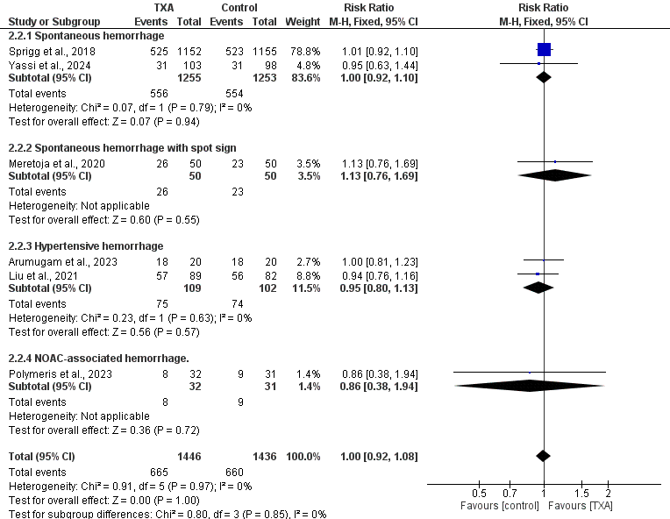
Supplementary Figure 3. Forest plots comparing the odds of patients achieving mRS score 1 to 3 across different subgroups of studies’ populations.

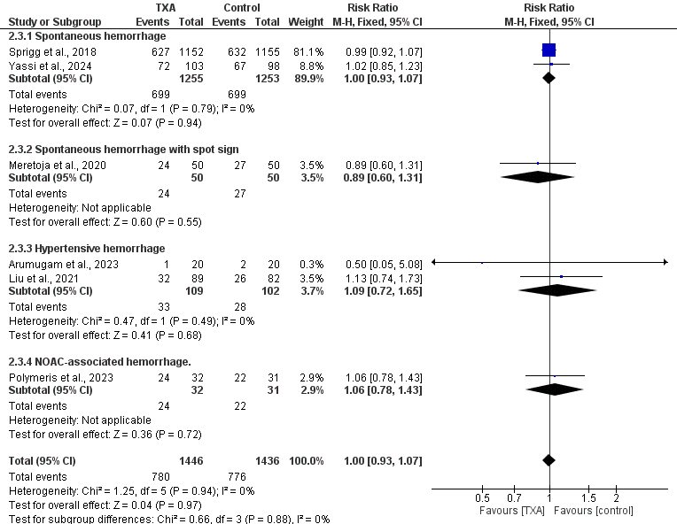
Supplementary Figure 4. Forest plots comparing the odds of patients achieving mRS score 4 to 6 across different subgroups of studies’ populations.

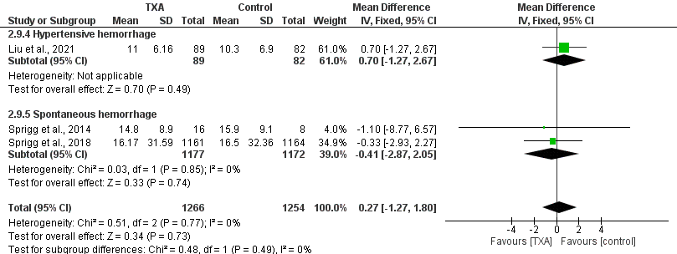
Supplementary Figure 5. Forest plots comparing NIHSS between TXA and placebo groups across different subgroups of studies’ populations.

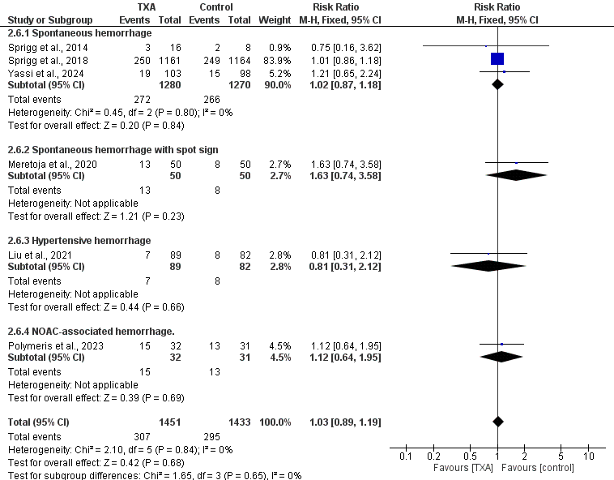
Supplementary Figure 6. Forest plots comparing mortality within 90 days between TXA and placebo groups across different subgroups of studies’ populations.

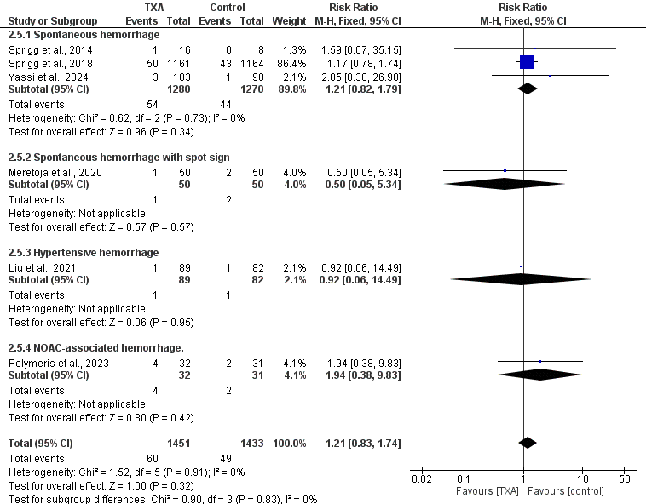
Supplementary Figure 7. Forest plots comparing the odds of major thromboembolic events between TXA and placebo groups across different subgroups of studies’ populations.

