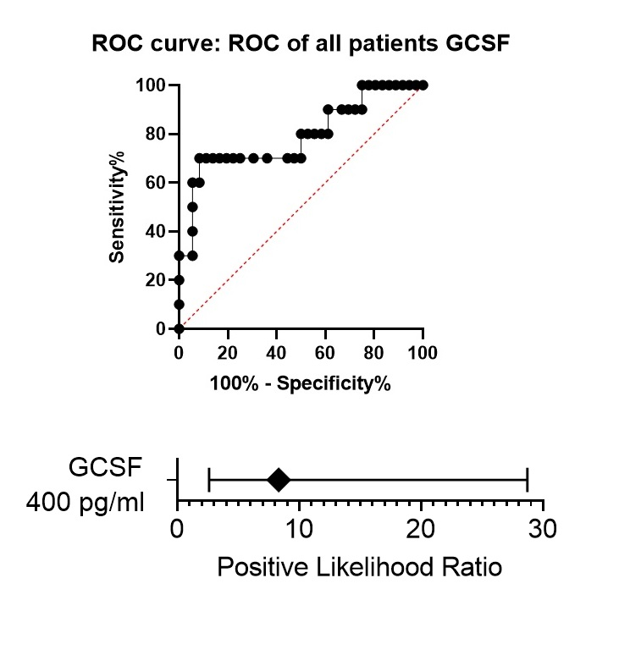
Supplemental figure 1 (related to figure 1). A. A receiver operating characteristic (ROC) curve of G-CSF as a predictor for presence of Gram-negative pathogens in oral cavity in all participants. Concentration of G-CSF in oral rinse higher than 400 pg/ml is a predictor for presence of Gram-negative pathogens in oral cavity in all participants. B. The risk of detection of Gram-negative pathogens in oral cavity is 8.4 times higher in people with concentration of G-CSF in oral rinse higher than 400 pg/ml.

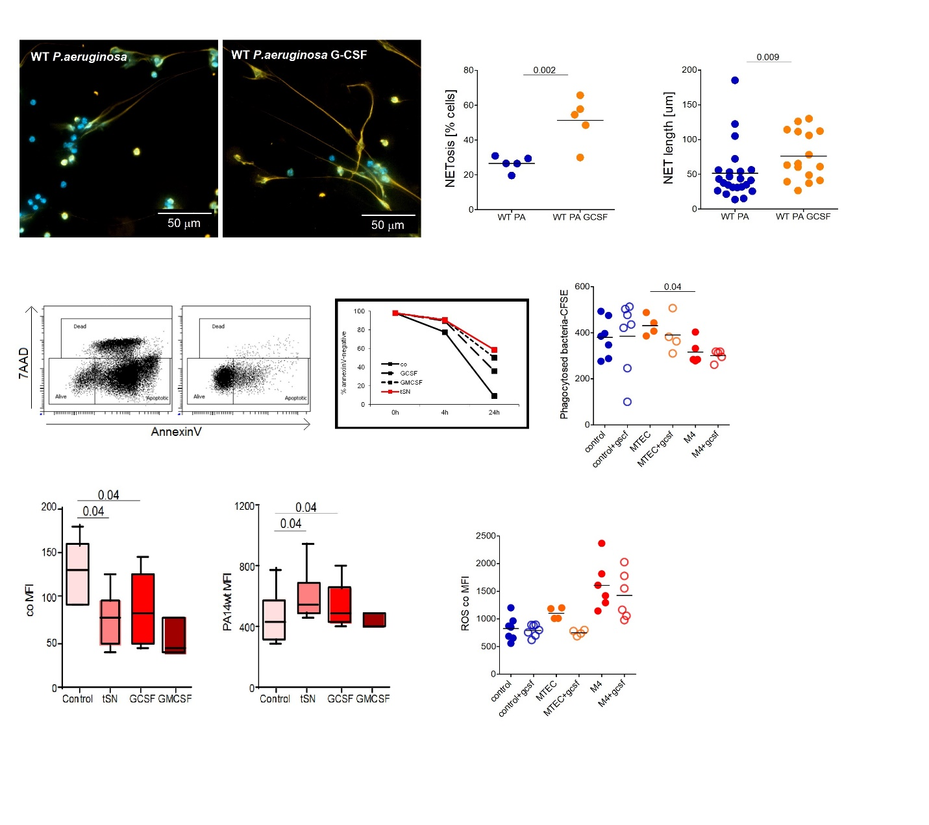
Supplemental figure 2 (related to figure 2). Short treatment of isolated blood neutrophils with G-CSF leads to neutrophil activation against P. aeruginosa. A-C. Enhanced NET formation of murine neutrophils (A exemplified image, B. Total percentage of NET-positive cells, C. NET length). D-E. Prolonged viability of neutrophils by G-CSF (D. exemplified dot-plot, E. Quantification). F. G-CSF possessed no effect on phagocytosis. G-I. Treatment with G-CSF prevented ROS production in steady state (G. human, I. mouse), but potentiated ROS production agains P. aeruginosa (H, human).
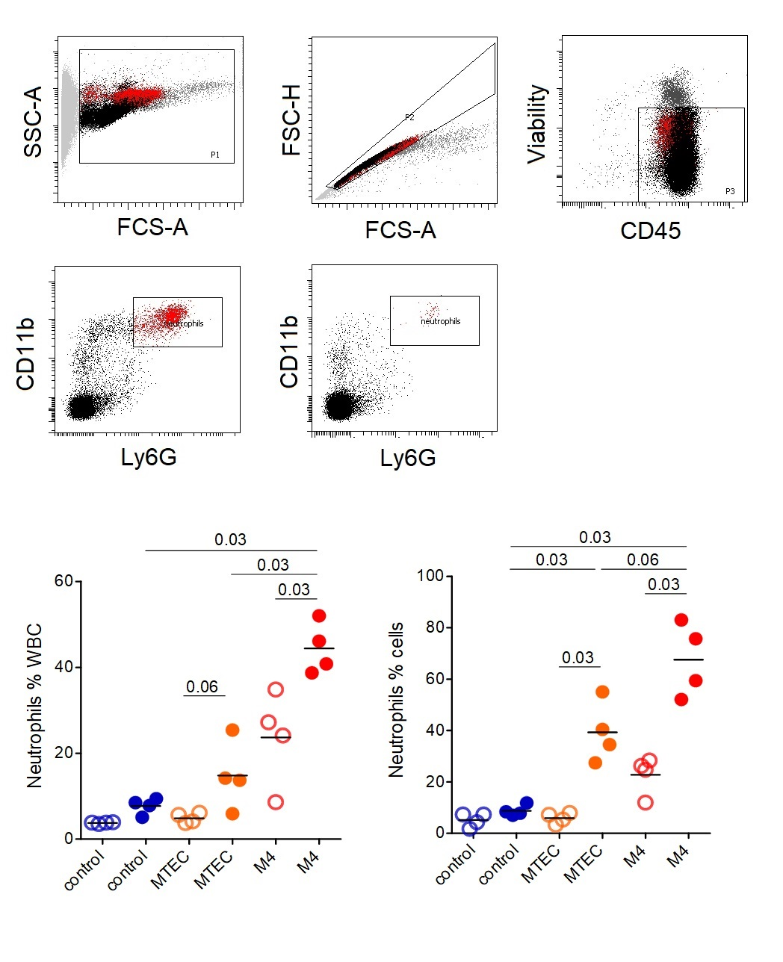
Supplemental figure 3 (related to figure 2). A. Gating strategy for assessment and isolation of tissue (lung) neutrophils. B. ^{G}neutrophils keep the capacity to migrate to the infected lungs.
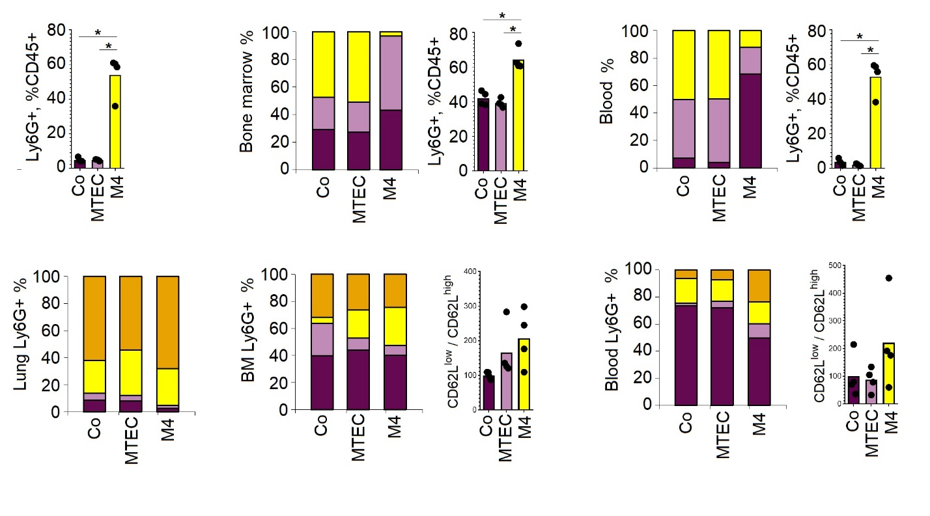
Supplemental figure 4 (related to figures 2 and 4). Elevated neutrophil infiltration and accumulation of CD62L low neutrophils in lung, bone marrow and blood of mice bearing G-MOPC.

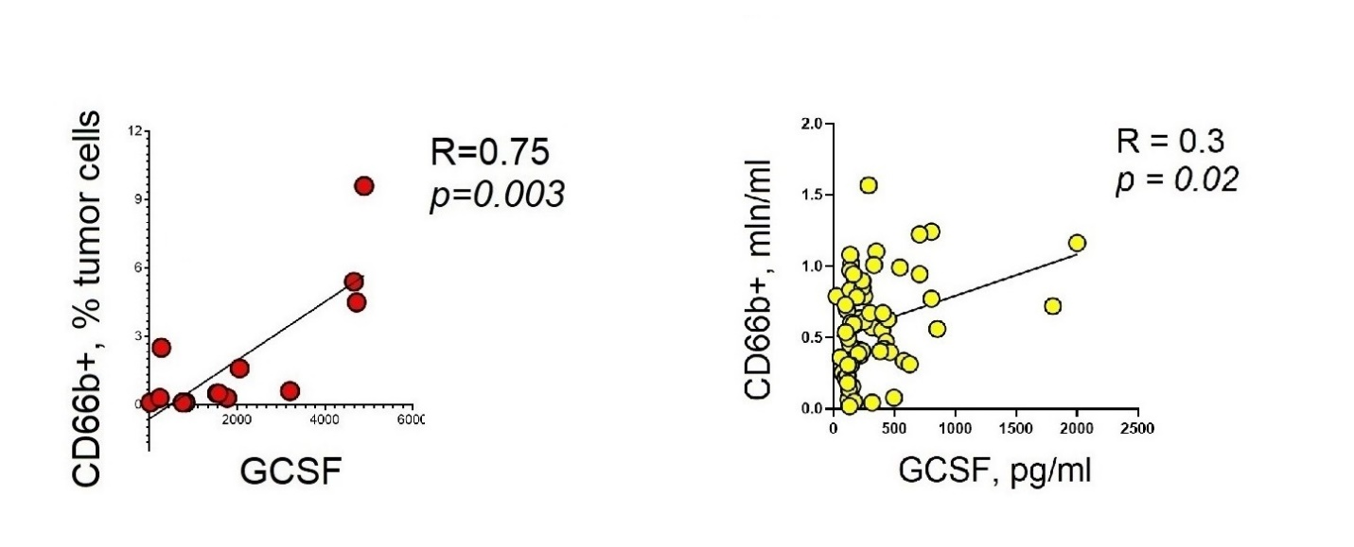
Supplemental figure 5 (related to figure 2). Elevated accumulation of neutrophils in various compartments such as tumor (left) or saliva (right) positively correlates with high G-CSF levels in patients with HNC.

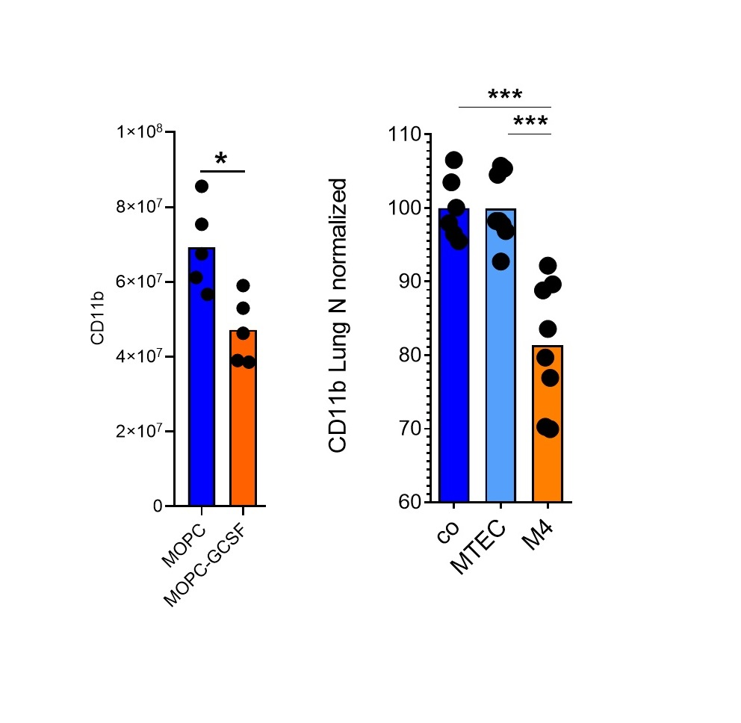
Supplemental figure 6 (related to figure 2). Validation of data from proteomic analysis with flow cytometry. CD1b expression assessed with proteomic analysis (A) and flow sytometry (B) is downregulated in ^{G}neutrophils.

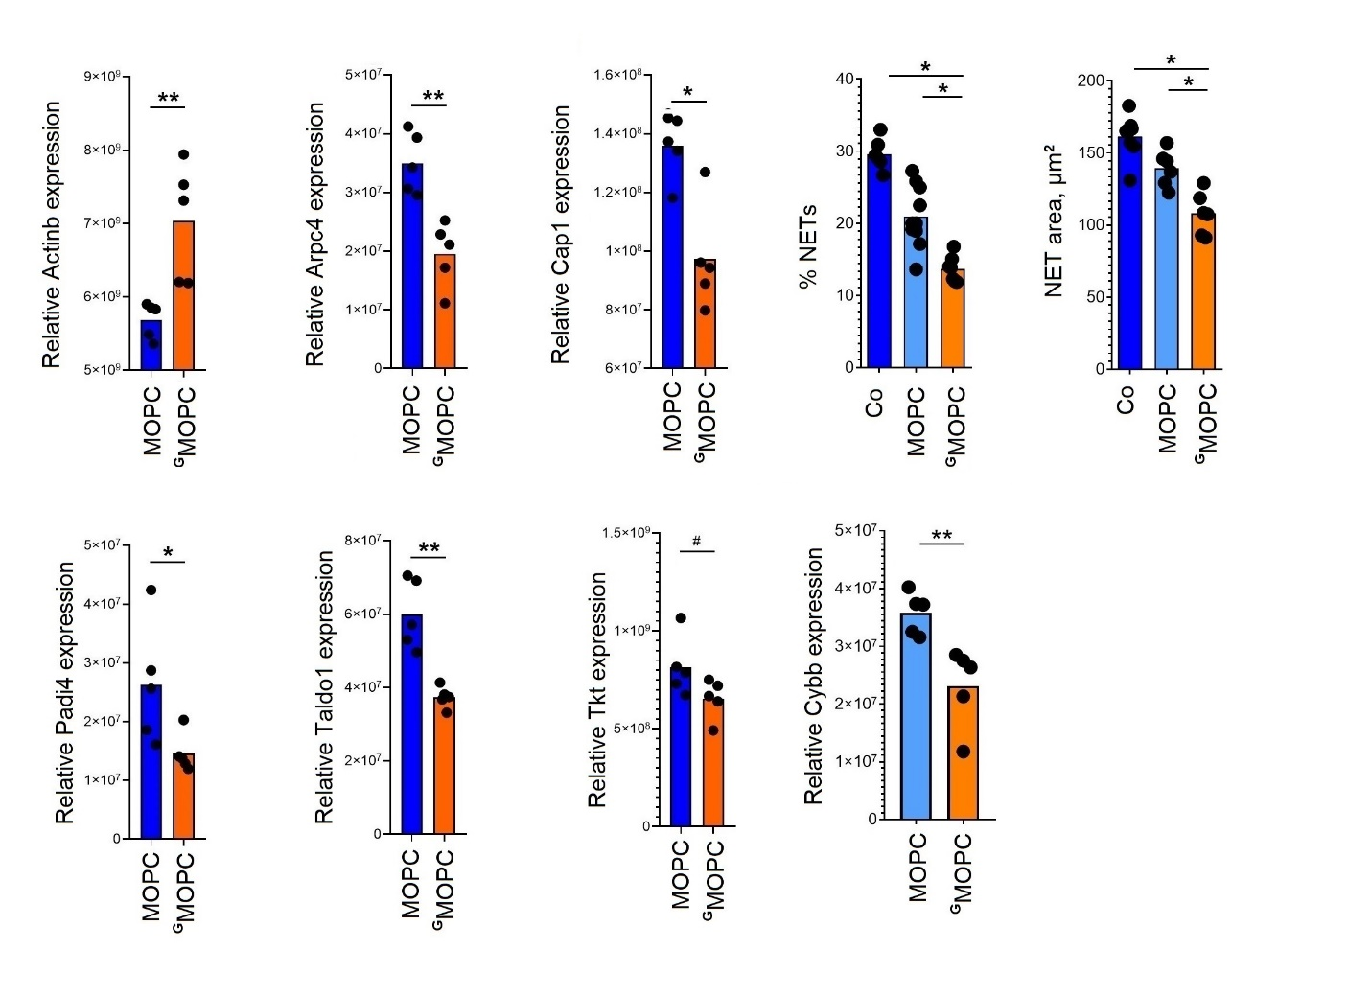
Supplemental figure 7 (related to figure 3). Disregulation in expression of proteins involved in cytoskeleton reorganization, phagocytosis and NET formation. Elevated expression of Actinb (A), downregulated expression of actin-branching proteins Arpc4 (B) and Cap1(C) in ^{G}neutrophils. Decreased percentage of netting cells (D) and lower area covered with NETs (E) in ^{G}neutrophils. Downregulated expression of Padi4 (F), Taldo1(G), Tkt(H) and Cybb(I) in ^{G}neutrophils.

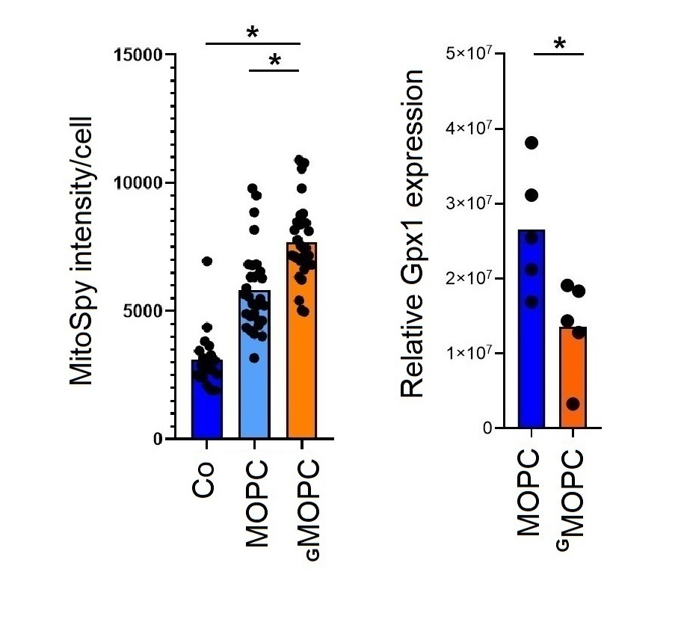
Supplemental figure 8 (related to figure 3). Disregulation in expression of proteins involved in neutrophil tissue toxicity. Elevated mitochondrial activity (A), downregulated expression of Gpx1 (B) in ^{G}neutrophils.

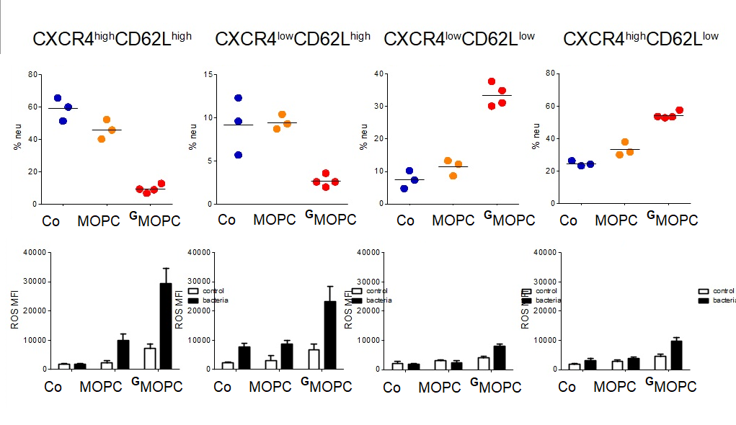
Supplemental figure 9 (related to figure 4). Aged CD62Llow neutrophil subpopulations (CXCR4lowCD62Llow and CXCR4highCD62Llow) are accumulated in lungs of G-MOPC bearing mice (upper line) and are unable to elevate ROS production in response to P. aeruginosa (lower line).
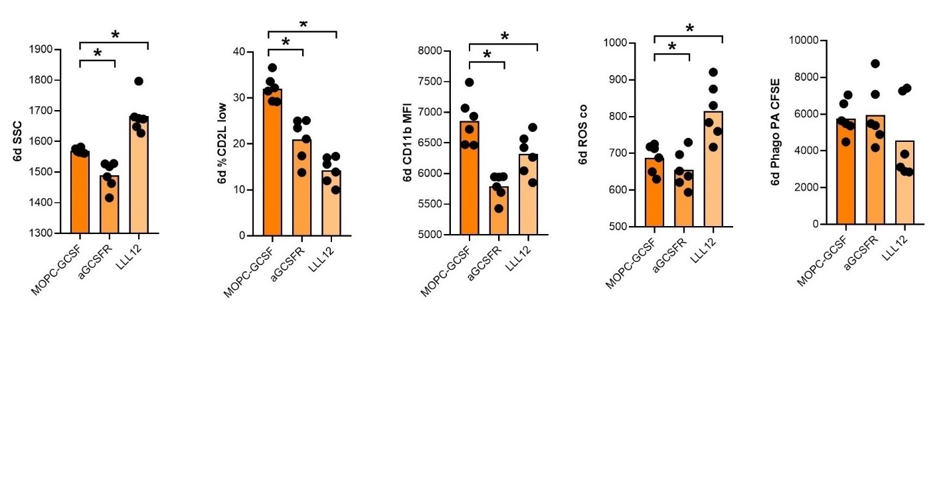
Supplemental figure 10 (related to figure 5). GCSFR antagonism and prevention of STAT3 phosphorylation with LLL12 partially revert the changes in neutrophils induced by tumor-derived GCSF during neutrophil differentiation.

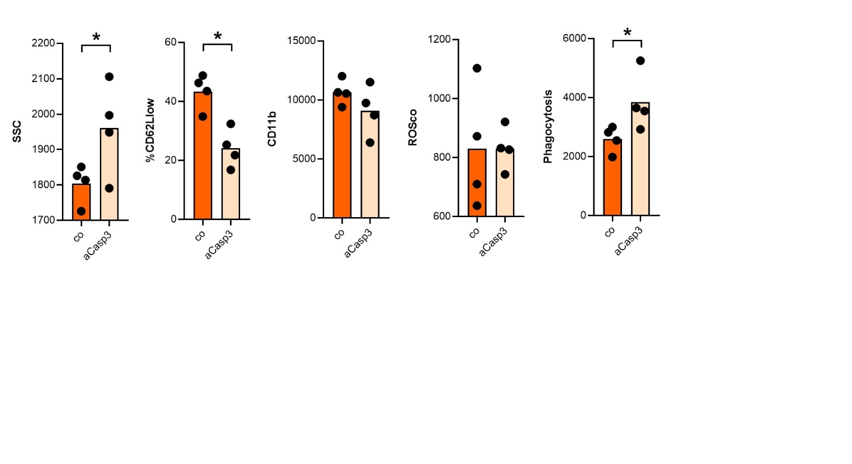
Supplemental figure 11 (related to figure 5). Inhibition of Caspase 3 did not mimic the changes observed in neutrophils after G-CSF exposure.
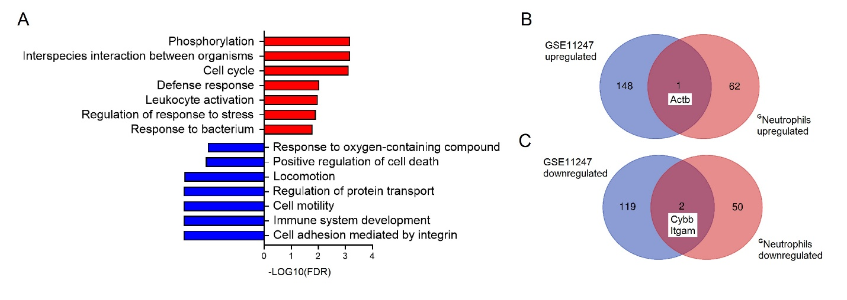
Supplemental figure 12 (related to figure 5). Pathways regulated in CD133+ stem cells treated with G-CSF.

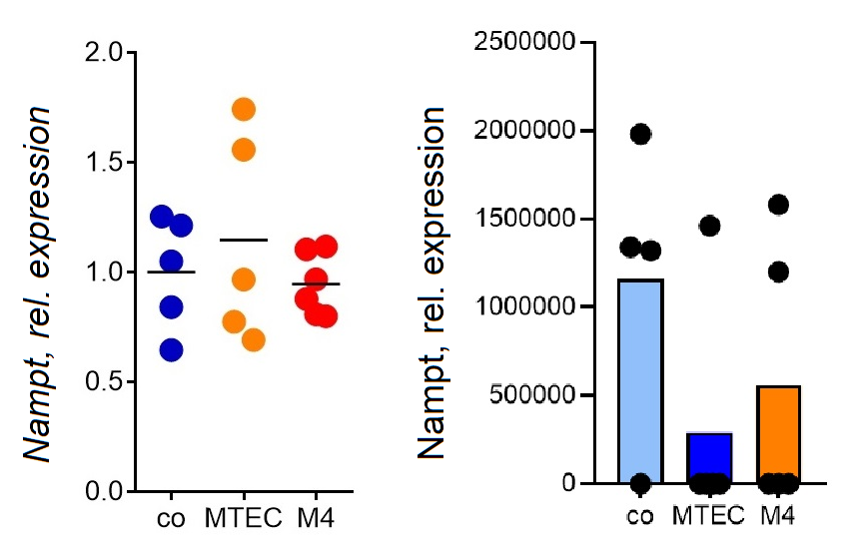
Supplemental figure 13 (related to figure 6). Nampt gene (A) and protein expression is not changed in ^{G}neutrophils.

