Table 1. Quantum Chemical Calculations of Lead Compound and the Standard Compound.
Compounds | Homo |  | Lumo | Eg | I | A | χ | η | δ | ω
Rutin | -0.19703 |  | -0.04211 | 0.15492 | 0.19703 | 0.04211 | 0.11957 | 0.07746 | 12.9098 | 0.09228
Kaempferol | -0.19464 |  | -0.05494 | 0.1397 | 0.19464 | 0.05494 | 0.12479 | 0.06985 | 14.3163 | 0.11147
Quercetin | -0.19392 |  | -0.05648 | 0.13744 | 0.19392 | 0.05648 | 0.1252 | 0.06872 | 14.5518 | 0.11405
Talinumoside I | -0.06609 |  | 0.05151 | 0.1176 | 0.06609 | -0.05151 | 0.00729 | 0.0588 | 17.0068 | 0.00045
Varespladib | -0.07068 |  | 0.05526 | 0.12594 | 0.07068 | -0.05526 | 0.00771 | 0.06297 | 15.8805 | 0.00047
Varespladib Methyl | -0.19388 |  | -0.04717 | 0.14671 | 0.19388 | 0.04717 | 0.12052 | 0.07335 | 13.6323 | 0.09901
Darapladib | -0.21105 |  | -0.06087 | 0.15018 | 0.21105 | 0.06087 | 0.13596 | 0.07509 | 13.3173 | 0.12308
Marimastat | -0.24522 |  | -0.00427 | 0.24095 | 0.24522 | 0.00427 | 0.12475 | 0.12048 | 8.30048 | 0.06458
Ilomastat | -0.19938 |  | -0.01338 | 0.186 | 0.19938 | 0.01338 | 0.10638 | 0.093 | 10.75269 | 0.06084

Table 2. Illustration of the Molecular Orbitals of Lead Compounds and the Standard Compounds.
COMPOUNDS | HOMO | LUMO
Rutin | 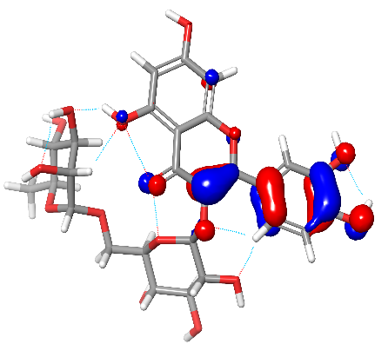 | 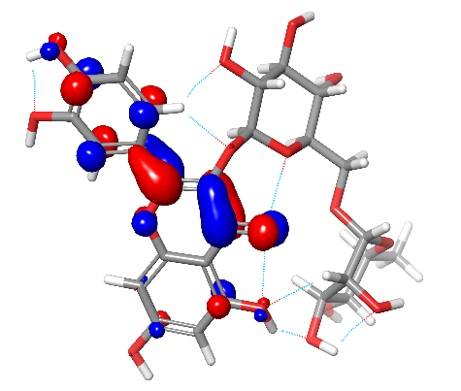
Kaempferol | 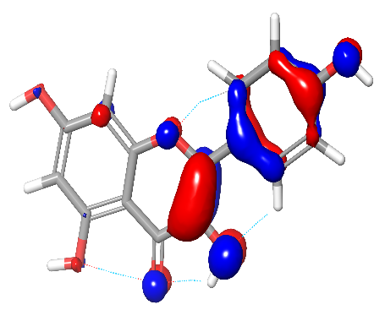 | 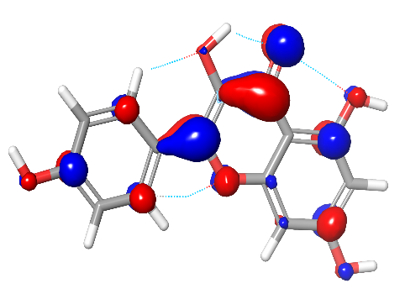
Quercetin | 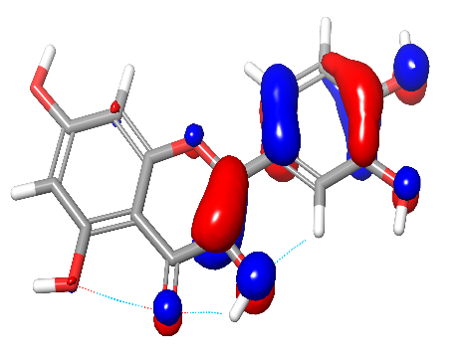 | 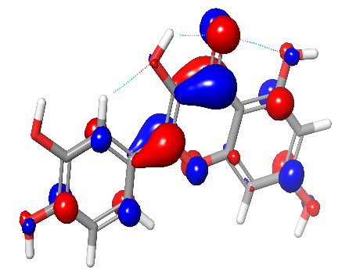
Talinumoside I | 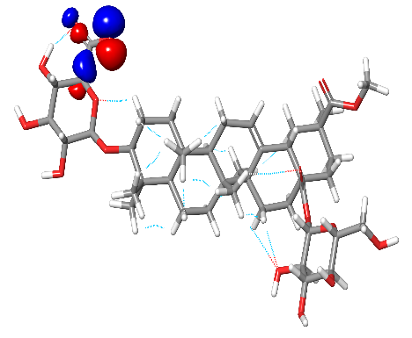 | 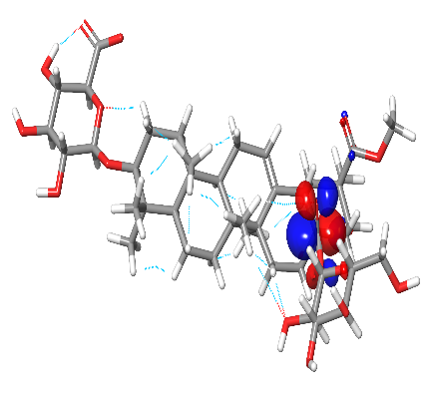
Varespladib | 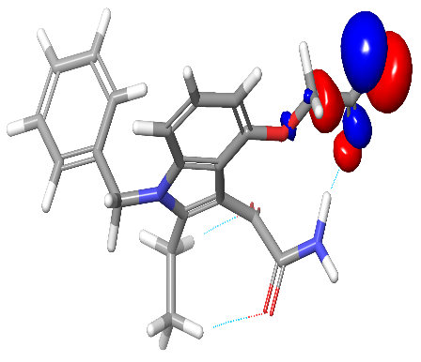 | 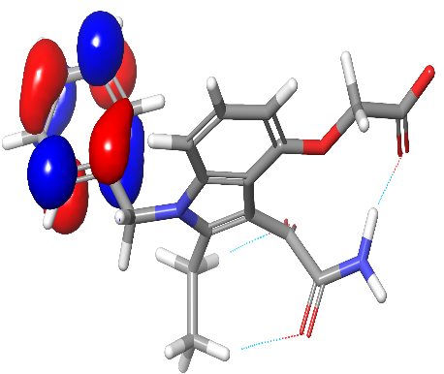
Varespladib Methyl | 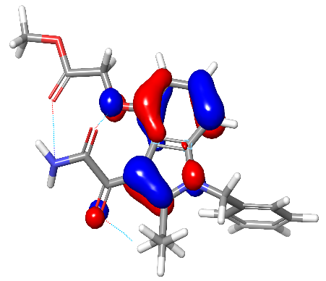 | 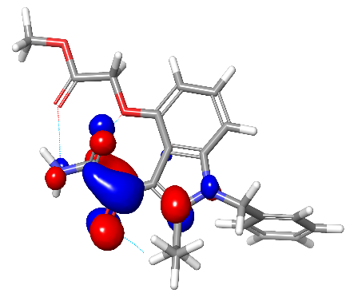
Darapladib | 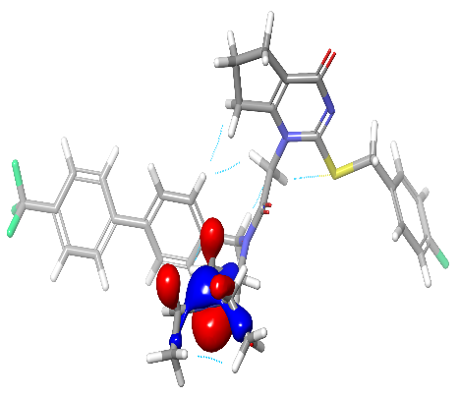 | 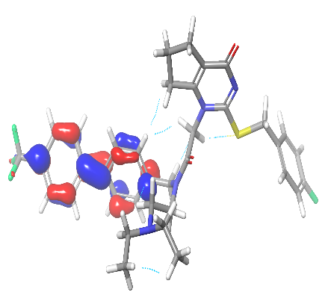
Marimastat | 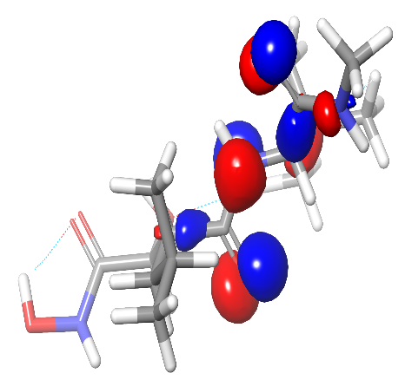 | 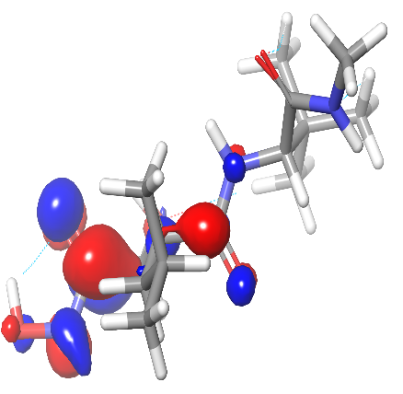
Ilomastat | 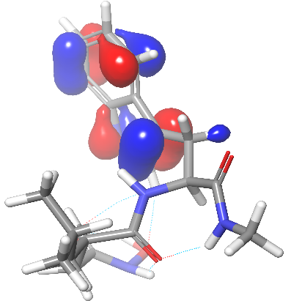 | 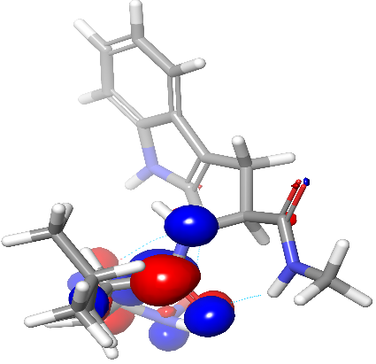

Table 3: Physicochemical Properties of Top-Scoring Compounds
Compounds | Molecular weight(g/mol) | TPSA (Å²) | Log P | Log S | nHA | nHD
Rutin | 610.52 | 269.43 | -1.29 | -3.30 | 16 | 10
Kaempferol | 286.24 | 111.13 | 1.58 | -3.31 | 6 | 4
Quercetin | 302.24 | 131.36 | 1.23 | -3.16 | 7 | 5
Talinumoside I | 838.97 | 259.20 | 1.80 | -6.34 | 16 | 8
Varespladib | 380.39 | 111.62 | 2.18 | -3.80 | 5 | 2
Varespladib Methyl | 394.42 | 100.62 | 2.56 | -4.01 | 5 | 1
Darapladib | 666.77 | 83.74 | 6.89 | -7.75 | 8 | 0
Marimastat | 331.41 | 127.76 | 1.23 | -1.49 | 5 | 5
Ilomastat | 388.46 | 123.32 | 1.80 | -2.26 | 4 | 5

Table 4: Descriptors of Absorption and Distribution
Compounds | GI absorption |  | P-gp substrate |  |  | BBB penetration
Rutin |  | Low |  | Yes |  |  | No
Kaempferol |  | High |  | No |  |  | No
Quercetin |  | High |  | No |  |  | No
Talinumoside I |  | Low |  | Yes |  |  | No
Varespladib |  | High |  | No |  |  | No
Varespladib Methyl |  | High |  | No |  |  | No
Darapladib |  | Low |  | Yes |  |  | No
Marimastat |  | High |  | No |  |  | No
Ilomastat |  | High |  | Yes |  |  | No

Table 5: Descriptors for Pharmacokinetics
Compounds | CYP1A2 inhibitor |  | CYP2C19 inhibitor |  | CYP2C9 inhibitor |  | CYP2D6 inhibitor |  | CYP3A4 inhibitor
Rutin |  | No |  | No |  | No |  | No |  | No
Kaempferol |  | Yes |  | No |  | No |  | Yes |  | Yes
Quercetin |  | Yes |  | No |  | No |  | Yes |  | Yes
Talinumoside I |  | No |  | No |  | No |  | No |  | No
Varespladib |  | No |  | No |  | Yes |  | No |  | No
Varespladib Methyl |  | No |  | Yes |  | Yes |  | No |  | Yes
Darapladib |  | Yes |  | No |  | No |  | Yes |  | Yes
Marimastat |  | No |  | No |  | No |  | No |  | No
Ilomastat |  | No |  | No |  | No |  | No |  | No

Table 6: Excretion and Toxicity Parameters
Compounds | LD50 (mg/kg) |  |  | Hepatotoxicity |  | Carcinogenicity |  | cytotoxicity
Rutin |  | 5000 |  |  | No |  | No |  | No
Kaempferol |  | 3919 |  |  | No |  | No |  | No
Quercetin |  | 159 |  |  | No |  | Yes |  | No
Talinumoside I |  | 3220 |  |  | No |  | No |  | No
Varespladib |  | 78 |  |  | No |  | No |  | Yes
Varespladib Methyl |  | 78 |  |  | No |  | Yes |  | Yes
Darapladib |  | 800 |  |  | No |  | No |  | No
Marimastat |  | 2000 |  |  | No |  | No |  | No
Ilomastat |  | 300 |  |  | Yes |  | Yes |  | No

Table 7: Druglikeness and Bioavailability Score
Compounds | Lipinski rule  Violations |  | Egan rule  Violations |  | Veber rule Bioavailability score Violations
Rutin |  | 3 |  | 1 |  | 1 | 0.17
Kaempferol |  | 0 |  | 0 |  | 0 | 0.55
Quercetin |  | 0 |  | 0 |  | 0 | 0.55
Talinumoside I |  | 3 |  | 1 |  | 1 | 0.11
Varespladib |  | 0 |  | 0 |  | 0 | 0.56
Varespladib Methyl |  | 0 |  | 0 |  | 0 | 0.55
Darapladib |  | 2 |  | 1 |  | 1 | 0.17
Marimastat |  | 0 |  | 0 |  | 1 | 0.55
Ilomastat |  | 0 |  | 0 |  | 1 | 0.55

