NLRP3:
β-actin (NLRP3):
ASC:
β-actin (ASC):
GSDMD:
β-actin (GSDMD):
Caspase1:
β-actin (Caspase1):
Caspase11:
β-actin (Caspase11):
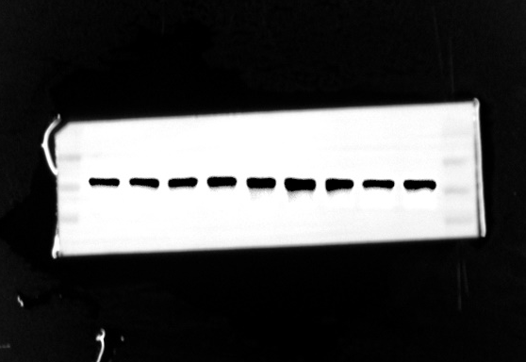
IL-1β:
β-actin (IL-1β)
IL-18:
β-actin (IL-18):
TNF-α:
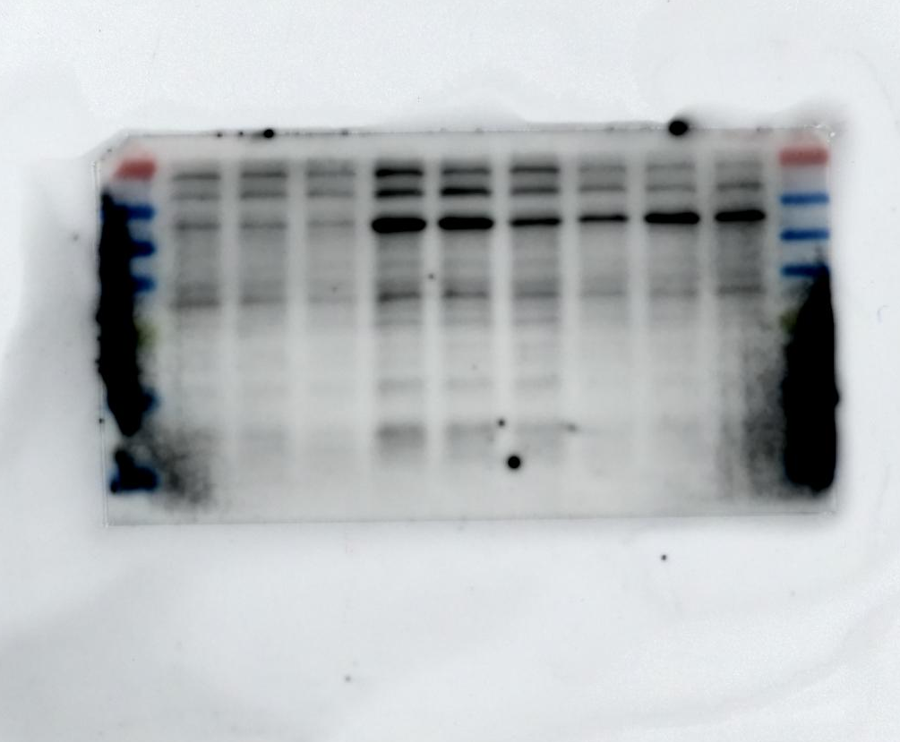
β-actin (TNF-α):
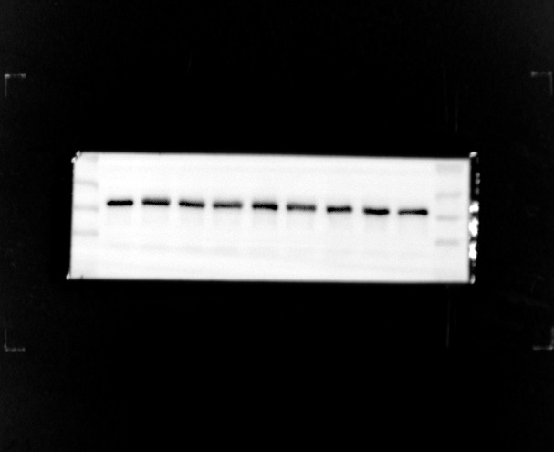
TLR4:
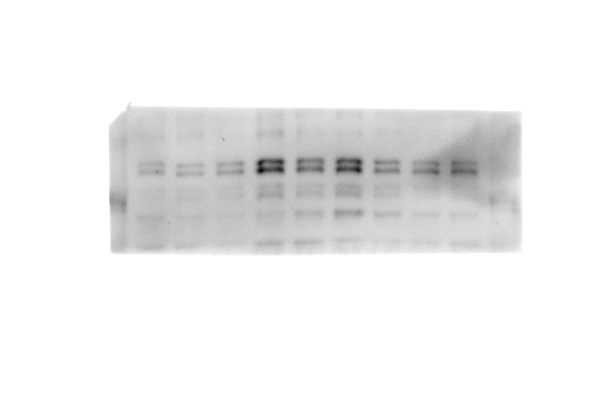
β-actin (TLR4):
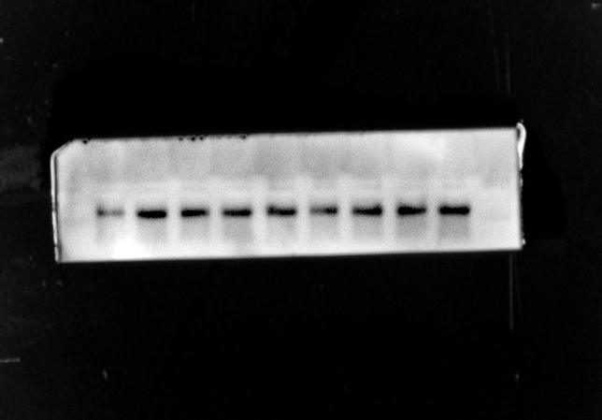
NF-κB P65:
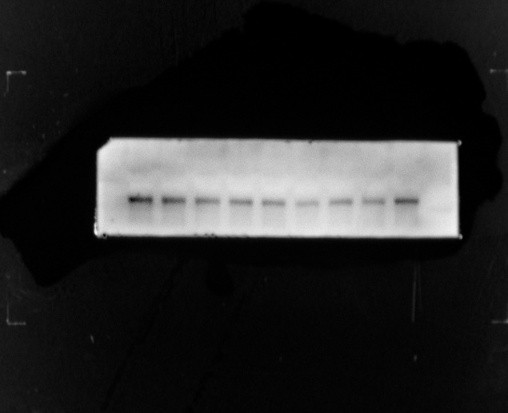
p-NF-κB P65:
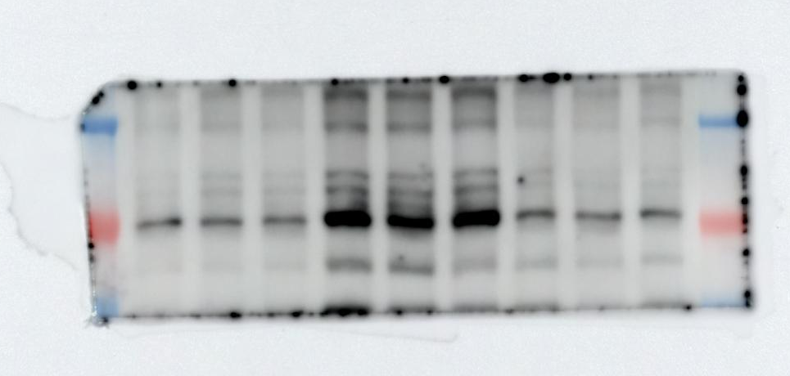
β-actin(p-NF-κB P65):
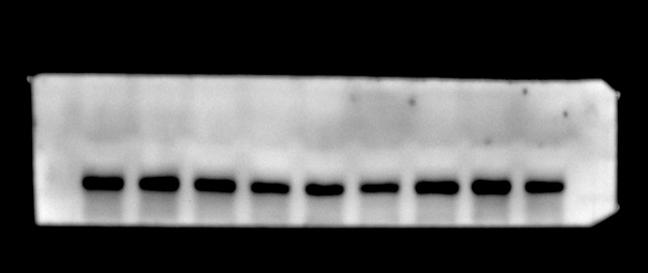
Claudin-5:
β-actin (Claudin-5):
ZO-1:
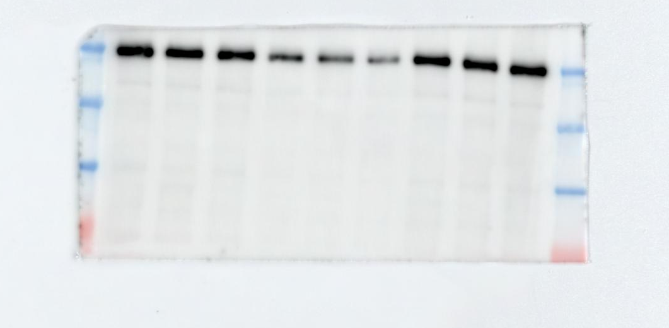
β-actin (ZO-1)
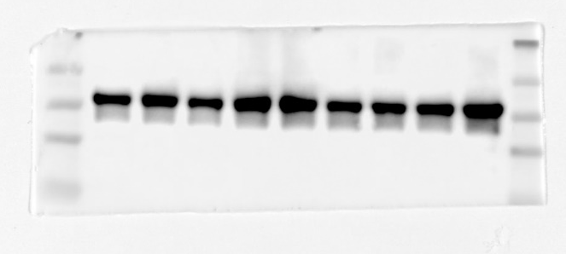
Albumin:
β-actin (Albumin):
LRP-1:
β-actin (LRP-1):
P-gp:
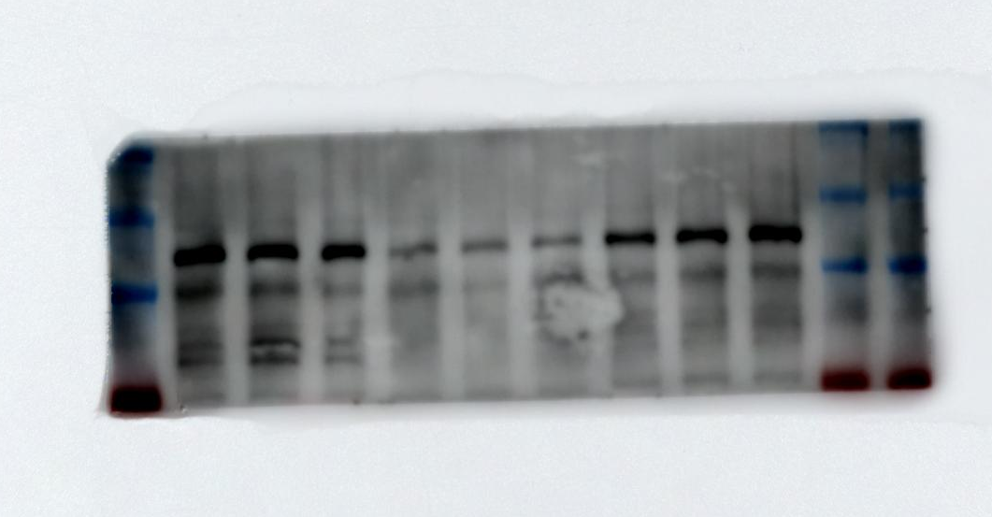
β-actin (P-gp):

