Supplementary information
Mechanistically Interpretable AI for Accelerated Energy Materials Design
Xueyu Hu^{1,4}, Ke Liao^{2,4}, Yucun Zhou^{1,4}, Haoyu Li^{1,4}, Zheyu Luo¹, Nai Shi³, Yong Ding¹, Weining Wang¹, Weilin Zhang¹, Doyeub Kim¹, Chanho Kim¹, Yoojin Ahn¹, Nikhil Govindarajan¹, Zhijun Liu¹*, Meilin Liu¹*
¹School of Materials Science and Engineering, Georgia Institute of Technology; Atlanta, 30332-0245, USA
²School of Artificial Intelligence and Data Science, University of Science and Technology of China; Hefei, 230026, PR China
³Kyushu University Platform of Inter-/Transdisciplinary Energy Research, Kyushu University; Fukuoka, 819-0395, Japan
⁴These authors contributed equally: Xueyu Hu, Ke Liao, Yucun Zhou, Haoyu Li.
*e-mail: meilin.liu@mse.gatech.edu, zhijun.liu@mse.gatech.edu

Table of Contents
Supplementary Notes ……………………………………………………………………………3
Note 1. Candidates Generation ……………………………………………………………3
Note 2. High-throughput Calculation ……………………………………………………3
Note 3. Definition of Hybridization of d-p Bands ………………………………………5
Note 4. Distribution of Computational Descriptors for 6066 Distinct Candidates ………6
Note 5. Material Embedding ………………………………………………………………8
Note 6. Details of the First-Stage Machine Learning Model ……………………………10
Note 7. Generation of Out-of-Distribution Task and Transfer Learning ………………14
Note 8. Standardized Experimental Methodology ………………………………………15
Note 9. Details of the Second-Stage Active Learning Model ……………………………17
Note 10. Shapley Additive ExPlanations (SHAP) Method ……………………………18
Note 11. Understanding the Mechanism Behind Hybridization of d-p Band Values ……19
Note 12. Near-continuous Sampling within Broader Chemical Space …………………20
Note 13. Understanding on the contribution of Nb and Zr as the dopant ………………21
Note 14. Nb-Zr co-doped BaCoO3 as the oxygen electrode ……………………………22
Note 15. Unraveling the ORR mechanism on BCNZ20 …………………………………24
Note 16. Fundamental Properties of BCNZ20 as Oxygen Electrode ……………………25
Note 17. BCNZ20 as an Oxygen Electrode on BZCYYb1711 Symmetrical Cells ……27
Note 18. BCNZ20 as an Oxygen Electrode on PCECs Single Cells ……………………29
Detailed DFT Calculation ………………………………………………………………………31
Supplementary Figures ………………………………………………………………………32
Supplementary Tables …………………………………………………………………………80
Reference ………………………………………………………………………………………92

Supplementary Notes
Note 1. Candidates Generation
To explore the chemical space surrounding state-of-the-art (SOTA) oxygen electrocatalyst – such as La_{0.6}Sr_{0.4}Co_{0.2}Fe_{0.8}O_{3-δ} (LSCF)¹, Ba_{0.5}Sr_{0.5}Co_{0.8}Fe_{0.2}O_{3-δ} (BSCF)², Sm_{0.5}Sr_{0.5}CoO_{3-δ} (SSC)³, BaCo_{0.4}Fe_{0.4}Zr_{0.1}Y_{0.1}O_{3-δ} (BCFZY)⁴, and PrBa_{0.5}Sr_{0.5}Co_{1.5}Fe_{0.5}O_{5+δ} (PBSCF)⁵ – we constructed a comprehensive library of 6,066 unique candidates through systematic sampling of adjacent chemical spaces. This library incorporates variations in A-site elements (Ba, Sr, and PrBa) and B-site active elements (Cr, Mn, Fe, Co, Ni, Cu), resulting in 18 distinct branches. Each branch comprises a pristine cubic perovskite (ABO₃) and 336 ABO₃-derived materials generated by doping with 42 different elements at a resolution of 6.25%. To ensure sufficient electrocatalytic activity, the doping content is restricted to below 50%. High-throughput calculations will be performed on these candidates to generate computational data, which will serve as essential input for the machine leaning model.

Note 2. High-throughput Calculation
High-throughput density functional theory (DFT) calculations were conducted to generate computational descriptors and parameters. These calculations were performed using the Vienna ab initio simulation package (VASP)^{6,7}. The generalized gradient approximation (GGA) with Perdew-Butke-Ernzerhof (PBE) functional was employed to account for exchange-correlation effects in the Kohn-Sham equations⁸. Pseudopotential and U_{eff} values for each element were adopted following the recommendation from Material Project⁹, as detailed in Supplementary Table 1. The energy cutoff and convergence criteria were set as 400 eV and 4×10⁻³ eV, respectively. The RMM-DIIS algorithm and conjugate gradient method were utilized for electronic and ionic optimization, respectively.
Molecular Dynamics-Monte Carlo (MD-MC) simulations were initially performed for each candidate using the Large-scale Atomic/Molecular Massively Parallel Simulator (LAMMPS) and the m3gnet potential^{10,11}, providing insights into the elemental distribution. Subsequently, structural relaxation and static calculations were carried out for each material. The computed energy from static calculation was used to determine the E_{hull} values, cross-referenced with the Material Projects database. Temperature and atmosphere corrections were applied to calculate the E_{hull} values under PCECs operation conditions (T = 600 °C, p(O₂) = 0.21 atm)¹².
Density of states (DOS) calculations were performed for each candidate to extract electronic structure information. The oxygen p-band center (${\overline{O}}_{2p}$) is defined as:
${\overline{O}}_{2p}=\frac{\int_{-∞}^{∞}{E∙D_{O_{2p}}(E)}dE}{\int_{-∞}^{∞}{D_{O_{2p}}(E)}dE}-E_{Fermi}$ (1)
where $E$ is the electron energy, $D_{O_{2p}}(E)$ is the DOS projected onto the oxygen 2p-orbitals, and $E_{Fermi}$ is the Fermi energy. Similarly, the d-band center of the active element M (${\overline{M}}_{3d}$) was defined as:
${\overline{M}}_{3d}=\frac{\int_{-∞}^{∞}{E∙D_{M_{3d}}(E)}dE}{\int_{-∞}^{∞}{D_{M_{3d}}(E)}dE}-E_{Fermi}$ (2)
where $D_{M_{3d}}(E)$ represents the DOS projected onto the 3d-orbitals of M.
The hybridization of the d- and p-bands (H_{dp}) was quantified by the overlap extent of their DOS plots:
$H_{dp}=\int_{-∞}^{+∞}{min⁡(D_{O_{2p}}^{up}\left(E\right),D_{M_{3d}}^{up}\left(E\right))}dE+\int_{-∞}^{+∞}{min⁡(D_{O_{2p}}^{down}\left(E\right),D_{M_{3d}}^{down}\left(E\right))}dE$ (3)
where $D_{O_{2p}}^{up}\left(E\right)$ and $D_{M_{3d}}^{up}\left(E\right)$ are the spin-up DOS projections onto the oxygen 2p- and active element 3d-orbitals, respectively, and $D_{O_{2p}}^{down}\left(E\right)$ and $D_{M_{3d}}^{down}\left(E\right)$ are the spin-down counterparts.
The oxygen vacancy formation energy (E_{V}) was evaluated by removing one oxygen atom and calculating the defective structure, with the vacancy positioned near the dopant to highlight its influence. E_{V} is defined as
$E_{V}=E_{V_{O}^{∙∙}}+\frac{1}{2}E(O_{2})-E_{P}$ (4)
where $E_{V_{O}^{∙∙}}$ is the total energy of the defective bulk with a single oxygen vacancy, $E_{P}$ is the total energy of the pristine bulk, and $E(O_{2})$ is the total energy of an isolated oxygen molecule.
Twelve computational parameters derived from high-throughput calculations, including lattice parameters ($a, b, c, α, β, γ$), volume, free volume, distortion with the formation of oxygen vacancy, space group, point group, symmetry operations.
Scripts for these comprehensive calculations are available at https://github.com/XueyuHu/HighthroughputCalculation/

Note 3. Definition of Hybridization of d-p Bands
The hybridization of d-p bands is conventionally defined in two primary ways. The first definition involves the disparity between the d-band center and the p-band center, quantifying the degree of separation between the d- and p-bands¹³. A smaller difference suggests stronger hybridization, as closer energy levels of the d- and p-orbitals promote state mixing. The second definition is derived from the density of states (DOS), where greater overlap in the DOS indicates stronger hybridization, as more p- and d-states coexist and interact within the same energy range.
The complement these definitions, we introduced a third metric: the distance between the center of the DOS overlap and the Fermi level. This metric represents the energy window between the formed d-p hybridization and the electrons at the Fermi level. Supplementary Fig. 2 presents the Pearson correlation coefficients for these three definitions, revealing their inherent dissimilarity. Consequently, all three definitions were considered during the training of the machine learning model.
In training the second-stage active learning (SSAL) model, we observed that the second definition of H_{dp}, based on DOS overlap, correlates most strongly with electrocatalytic activity. Unless otherwise specified, all references to H_{dp} in this work adhere to the second definition, as expressed in Equation 3.
It is noteworthy that the Local-Orbital Basis Suite Towards Electronic-Structure Reconstruction (LOBSTER) software enables precise quantification of hybridization through crystal orbital Hamilton population (COHP) analysis¹⁴. However, due to the large size of our crystal bulk models, with include 96 B-O bonds, LOBSTER is unsuitable for high-throughput calculations. Instead, it was selectively to a small subset of candidates discussed in Supplementary Note 10.

Note 4. Distribution of Computational Descriptors for 6066 Distinct Candidates
The ${\overline{O}}_{2p}$ values for BaMO₃- and SrMO₃-derived candidates exhibit a consistent trend: Ni > Mn ≈ Fe ≈ Cu > Cr ≈ Co. In contrast, for PrBaM₂O₆-derived candidates, Ni and Co display the highest ${\overline{O}}_{2p}$ values, while Cr, Mn, Fe, and Co share a similar distribution. Notably, BaNiO₃-derived candidates stand out as the most promising for achieving superior charge transfer performance. This is evidenced by the pristine BaNiO₃ achieving a ${\overline{O}}_{2p}$ value of -0.425 eV, while the median ${\overline{O}}_{2p}$ value for BaNiO₃-derived candidates is -0.658 eV.
The ${\overline{M}}_{3d}$ values strongly depend on the type of B-site element, following the order Cr > Mn > Fe ≈ Co ≈ Ni ≈ Cu. Interestingly, when Co serves as the B-site active element, the pristine values are often significantly lower than the median values. This suggests that most doping elements effectively enhance the ${\overline{M}}_{3d}$ values for BaCoO₃-, SrCoO₃-, and PrBaCo₂O₆-derived candidates. Based on the Sabatier principle, the ${\overline{M}}_{3d}$ value should neither be too high nor too low to achieve optimal catalytic activity. Consequently, selecting Mn or Co as B-site active elements may provide superior surface adsorption properties.
The distribution E_{V} values across candidate branches reveals significant variability, with difference of up to 3 eV. This highlights the exceptional tunability of Ev. However, when setting criteria for Ev, it is insufficient to prioritize highly negative values alone. A comprehensive evaluation must account for potential structural changes induced by oxygen vacancies. The E_{hull} values, derived from phase diagrams, complement E_{V} by enabling a more holistic assessment of material stability.
The distribution of H_{dp} values generally follows the order Cu > Co > Cr ≈ Mn ≈ Cu > Fe. Compared to the pristine values, introducing dopants typically reduces H_{dp}, with rare exceptions in candidates derived from SrCoO₃ or PrBaCo₂O₆.
Each of these four descriptors provides unique insights into oxygen electrocatalytic activity, reflecting distinct perspectives and exhibiting diverse distributions. To fully account for their contributions of predictive accuracy, we developed the second-stage active learning (SSAL) model, which integrates all descriptors into a unified framework for comprehensive analysis.

Note 5. Material Embedding
The mere provision of chemical formulas does not enable a machine learning model to fully capture the complex nature of a candidate material. To address this, a comprehensive material embedding process was developed, incorporating three key aspects: chemical fingerprint, physicochemical properties, and structural properties.
1. Chemical Compositions
The fingerprint is constructed based on the chemical composition, including the type and stoichiometry of A-site major, A-site dopant, B-site active, B-site dopant elements. Element types are encoded using a one-hot encoding approach to ensure proper representation.
2. Physicochemical Properties
To describe the constituent elements of each candidate, we enumerated eleven fundamental physicochemical properties: ionic radius, electron affinity, oxidation state, melting point, boiling point, atomic mass, elemental density, ionization energy, electronegativity, calcination index (melting point of the corresponding oxide), and chemical potential of the oxide. These properties were used to derive 132 distinct descriptors through twelve linear combinations designed for the cubic perovskite crystal structure:
(1) Weighted average of the property for A-site elements, based on their fractions.
(2) Weighted average of the property for B-site elements, based on their fractions.
(3) Weighted average of the property for A-site dopant elements, based on their fractions.
(4) Weighted average of the property for B-site dopant elements, based on their fractions.
(5) Weighted average of the property for A-site major elements, based on their fractions.
(6) Weighted average of the property for B-site active elements, based on their fractions.
(7) Sum of (5) and (6).
(8) Ratio of (1) to (2).
(9) Ratio of (5) to (6).
(10) Ratio of (3) to (1).
(11) Ratio of (4) to (2).
(12) Sum of (3) and (4) divided by the sum of (5) and (6).
Physicochemical properties are uniformly represented in the form Property_#, where “Property” denotes the specific physicochemical property and “#” refers to the linear combination method.
3. Structural Properties
The structural properties of perovskite candidates include the traditional tolerance factor (t), the new tolerance factor (τ)¹⁵, the octahedral factor (o), density (ρ), and the oxygen nonstoichiometric number (δ). t is defined as:
$t=\frac{r_{A}+r_{O}}{\sqrt{2}(r_{B}+r_{O})}$ (5)
where $r_{A}$, $r_{B}$, and $r_{O}$ are the weighted average radii of A-site and B-site cations, and the radius of oxygen ions, respectively: $r_{A}= \sum_{i}{r_{A_{i}}*f_{A_{i}}},$ $R_{A}= \sum_{i}{r_{B_{i}}*f_{B_{i}}}$.
τ is defined as:
$τ=\frac{r_{O}}{r_{B}}-n_{A}(n_{A}-\frac{r_{A}/r_{B}}{ln⁡(r_{A}/r_{B})})$ (6)
where $n_{A}$ is the weighted average oxidization state of A-site cations: $n_{A}= \sum_{i}{n_{A_{i}}*f_{A_{i}}}$.
o is defined as:
$o=\frac{r_{B}}{r_{O}}$ (7)
ρ is defined as:
$ρ=\frac{Mr}{{(r_{A}*r_{B})}^{1/2}}$ (8)
where $Mr$ is the relative molecular mass.
δ is defined as:
$δ=\frac{6-n_{A}-n_{B}}{2}$ (9)
where $n_{B}$ is the weighted average oxidization state of B-site cations, which is defined as $n_{B}= \sum_{i}{n_{B_{i}}*f_{B_{i}}}$.
This comprehensive material embedding framework enables the machine learning model to better understand the intricate nature of the candidates, incorporating detailed chemical, physicochemical, and structural features.

Note 6. Details of the First-Stage Machine Learning Model
Following the embedding of material properties for each candidate, a rigorous feature engineering process was employed to prepare input data for the First-Stage Machine Learning (FSML) model. For outlier treatment, the extreme top and bottom 0.5% of feature values across all samples (1% in total) were constrained to their respective 0.5% quantiles. This approach effectively mitigated the impact of distant outliers on model training. Additionally, all features were normalized to ensure compatibility.
The performance of the FSML model was evaluated using root mean square errors (RMSE) and R² metrics, defined as:
$RMSE=\sqrt{\frac{1}{n}\sum_{i=1}^{n}{{(y_{i}-\hat{y_{i}})}^{2}} }$ (10)
$R^{2}=1-\frac{\sum_{i=1}^{n}{{(y_{i}-\hat{y_{i}})}^{2}}}{\sum_{i=1}^{n}{{(y_{i}-\overline{y})}^{2}}}$ (11)
where $y_{i}$ represents the actual value, $\hat{y_{i}}$ is the predicted value, and $\overline{y}$ the mean of the actual values.
The dataset was divided into training and test sets in a 4:1 ratio. Various machine leaning algorithms were tested, with five-fold cross-validation performed with the training set to rigorously evaluate each algorithm. After selecting the best-performing algorithm, XGBoost, model parameters were fine-tuned for optimal performance. The final model’s accuracy and generalizability were assessed using the test set. Details of the machine learning algorithms are provided below.
1. Least Absolute Shrinkage and Selection Operator (LASSO)
LASSO enhances traditional linear regression by incorporating L₁ regularization, enabling feature selection and handling model sparsity. The objective function is:
$\sum_{i=1}^{n}{{(y_{i}-\hat{y_{i}})}^{2}}+λ\sum_{j=1}^{p}{|β_{j}|}$ (12)
where $λ$ controls the penalty strength.
Model Parameter:
- Regularization parameter ($λ$): 0.1.
2. Support Vector Regression (SVR)
SVR, an extension of Support Vector Machine (SVM), constructs a margin around data points, minimizing the error between predicted and actual values while allowing tolerance ($ε$). The objective function is:
$\frac{1}{2}{||w||}^{2}+C\sum{(ξ_{i}+ξ_{i^{+}})}$ (13)
subject to
$\hat{y_{i}}-y_{i}≤ε+ξ_{i}; y_{i}- \hat{y_{i}}≤ε+ξ_{i^{+}}; ξ_{i}, ξ_{i^{+}}≥0$ (14)
SVR can model non-linear relationships using kernel functions.
Model Parameter:
- Kernel: Polynomial
- Degree: 10
- Gamma: Auto
- Epsilon: 0.1
- Shrinking: Enabled
3. Random Forest (RF)
RF is an ensemble learning model that aggregates predictions from multiple decision trees. The prediction is:
$\hat{y}=\frac{1}{T}\sum{f_{t}(x)}$ (15)
where $T$ is the total number of trees, and $f_{t}(x)$ is the prediction of the t-th tree.
Model Parameters:
- Max Depth: 4
- Learning Rate: 0.1
- Number of Estimators: 400
- Max Leaves: 0
- Minimum Child Weight: 20
4. XGBoost (Extreme Gradient Boosting)
XGBoost combines loss functions, regularization terms, and tree complexity. Its objective function is:
$\sum{loss(y_{i}- \hat{y_{i}})}+\sum{Ω(f_{k})}+\sum{Γ(g_{k},h_{k})}$ (16)
where $Γ(g_{k},h_{k})$ represents the regularization term that controlling ensemble complexity.
Model Parameters:
- Max Depth: 4
- Learning Rate: 0.1
- Number of Estimators: 400
- Max Leaves: 0
- Minimum Child Weight: 20
5. ANN (Artificial Neural Network)
Inspired by biological neural networks, ANN consists of interconnected layers of neurons. Each neuron applies non-linear activation function to inputs and transmits the results. The model learns by adjusting weights and biases through backpropagation, enabling the capture of complex patterns.
Model Architecture:
- First layer: 512 neurons, batch normalization, and 50% dropout
- Second layer: 128 neurons, 25% dropout
- Third layer: 64 neurons
- Output layer tailored for the specific task
Dropout layers prevent overfitting, while the architecture balances complexity and performance.

Note 7. Generation of Out-of-Distribution Task and Transfer Learning
To evaluate the generalizability of the First-stage Machine Learning (FSML) model, we generated an out-of-distribution dataset by selecting a completely different A-site element, La, which was absent from the original 6,066 candidates. The selection criteria for B-site elements remained consistent, resulting in the creation of 2022 new LaMO₃-derived candidates. High-throughput calculations were performed on these candidates to obtain their ground truth computational information.
To enhance the FSML model’s generalizability for LaMO₃-derived candidates, a transfer learning approach was employed. The pre-trained FSML model, initially trained on the comprehensive dataset of 6,066 materials, served as the foundation. From the new LaMO₃ dataset, a 2% subset was selected to construct a fine-tuning training set. During this retraining phase, the model’s hyperparameters were carefully optimized:
- Maximum tree depth increased to 5
- Learning rate reduced to 0.01
- Ensemble expanded to 500 trees
This fine-tuning process allowed the FSML model to adapt effectively to the new chemical space, significantly improving its predictive accuracy for LaMO₃-derived candidates. The performance of the refined model was then evaluated by directly comparing its predictions to the ground truths obtained through high-throughput calculations. This comparison served as a benchmark to assess the FSML model’s generalizability in the out-of-distribution task.

Note 8. Standardized Experimental Methodology
In this standardized experimental methodology, SDC symmetrical cells were selected as the evaluation platform, using polarization resistance (R_{p}) values as a direct indicator of ORR performance. SDC (samarium-doped ceria) was chosen for its excellent chemical compatibility with most elements, minimizing the risk of undesired reactions or secondary phase formation¹⁶. Additionally, the SDC substrate, prepared using commercial powders and standardized processes, exhibits outstanding stability, providing a reliable testing platform. Most importantly, as a superior oxygen ion conductor, SDC contributes negligibly to R_{p} within the 600-700 °C operating range. Consequently, the R_{p} values measured under these conditions can be directly attributed to the electrocatalytic activity of the candidate material for ORR.
Supplementary Fig. 6 provides a schematic representation of the standardized experimental methodology. All candidate materials were synthesized using the solid-state reaction (SSR) method. Stoichiometric amounts of metal oxides or metal carbonates (obtained from Aldrich Chemicals) were mixed with zirconia balls and ethanol, followed by ball milling at 400 rpm for 6 hours using a planetary ball mill. The dried precursor powder was then collected, die-pressed into bulk samples, and calcinated at 1100 °C for 5 hours. The calcinated bulk sample were crushed to produce coarse-grained catalyst powder, which was further refined by mixing with zirconia balls and ethanol and subjected to another round of ball milling at 400 rpm for 6 hours.
The refined catalyst powder was mixed with α-terpineol (containing 6 wt.% ethyl cellulose) to create a slurry at a ratio of 0.7:1. This slurry was applied to both sides of the SDC pellets using a screen-printing process. The coated substrates were subsequently calcinated at 950 °C for 2 hours, resulting in sandwich-structured catalyst/SDC/catalyst symmetrical cell, ready for electrochemical impedance spectroscopy (EIS) measurements.
The SDC pellets were fabricated by uniaxial dry pressing of commercially available SDC powder (Fuel Cell Materials, US). Following pressing, the green pellets were sintered at 1450°C for 5 hours, achieving a relative density of approximately 98%.
EIS measurements were conducted using a Solartron 1255 HF frequency response analyzer interfaced with an EG&G PAR potentiostat model 273 A. Measurements were performed with an AC amplitude of 20 mV over a frequency range of 100kHz to 0.01 Hz.

Note 9. Details of the Second-Stage Active Learning Model
Given the resource-intensive and time-consuming nature of experimental evaluations, an active learning strategy was adopted for constructing the Second-Stage Active Learning (SSAL) model. Initially, a dataset comprising 258 experimentally obtained polarization resistance (R_{p}) values and 86 activation energy (E_{a}) measurements was collected. This dataset was divided into training and test sets in a 4:1 ratio, with five-fold cross-validation performed on the training set.
To ensure robustness, 50 random seeds were applied to introduce variability in data shuffling, data point sampling, and model parameter initialization. This process resulted in multiple versions of the first-generation SSAL model, which collectively served as the ensemble models. These ensemble models were used to predict R_{p} and E_{a} values for 6066 candidates. From these predictions, candidates with the highest confidence intervals (top 0.4%) were selected for experimental validation. Subsequently, the experimentally obtained new R_{p} and E_{a} values were incorporated into the dataset, and the model was retrained to generate the next-generation SSAL model. This iterative cycle of model training, evaluation, and data augmentation was repeated over seven rounds. By the end of these iterations, a total of 426 experimentally obtained R_{p} values had been collected, enabling the SSAL model to accurately predict both R_{p} and E_{a}.
As depicted in Supplementary Fig. 7, three progressively advanced architectures were developed for the SSAL model. First, the necessity of incorporating computational information was demonstrated by directly comparing the accuracy of “FF to E” (fundamental features to experimental data) and “FF + FI to E” (fundamental features and functional information to experimental data) architectures. Second, it was shown that FSML-predicted computational information could effectively replace the high-throughput calculation-derived information. This was achieved by comparing the accuracy of “FF + FI to E” and “FF to FI to E” (fundamental features to FSML predicted functional information to experimental data) architectures, demonstrating the feasibility of using SSAL to explore broader chemical spaces.
In practical training and candidate screening procedures, the “FF to FI to E” architecture was consistently applied. This approach bypasses the need for resource-intensive high-throughput calculations, facilitating the exploration of potential candidates.

Note 10. Shapley Additive ExPlanations (SHAP) Method
The SHAP method is a powerful tool for enhancing the interpretability of machine learning models and plays a pivotal role in this study. The core concept of SHAP revolves around quantifying the marginal contributions of individual features to a model’s output, effectively transforming “black-box” models into transparent and interpretable frameworks.
For each prediction in a dataset, SHAP model assigns a numerical value to each feature, representing its contribution to the predicted value. Specifically, SHAP calculates the marginal contribution of each feature by considering how the prediction changes when the feature is added to the model under various feature combinations. The SHAP value for a feature is determined by averaging these contributions across all possible sequences of feature inclusion. This method is particularly versatile as it provides insights into both global and local model behaviors, elucidating the complex relationships between feature values and model predictions.
The Shapley value of a feature $x_{j}$ is computed using the following formula:
(17)
In this equation: represents the complete set of features; $S$ is a subset of features that does not include $x_{j}$; $val(S∪\left\{x_{j}\right\})$ and $val\left(S\right)$ are the model’s predicted outcomes when considering the feature combinations $S∪\left\{x_{j}\right\}$ and $S$, respectively.
By leveraging SHAP, we gain valuable insights into how individual features contribute to model predictions, enabling a deeper understanding of the underlying mechanisms driving the model’s behavior.

Note 11. Understanding the Mechanism Behind Hybridization of d-p Band Values
To investigate the correlation between H_{dp} values and ORR electrocatalytic activity, detailed DFT calculation were performed on 13 BaCoO₃-derived candidates with enhanced energy cutoff (520 eV) and stricter convergence criteria (1×10⁻⁵ eV). Structural optimization was carried out until the force on each atom was reduced to less than 0.02 eV Å⁻¹.
The bulk structures of BaCo_{0.875}M_{0.125}O₃ (M = Bi, Ca, Hf, Mg, Mo, Nb, Sb, Sc, Sn, Ta, W, Y, Zr) were modeled by constructing a supercell with dimensions $2a×2a×2a$, comprising 8 Ba, 7 Co, 1 M, and 24 O atoms. Subsequently, the low-index (001) BO₂-terminated surface, identified as the most active surface for ORR, was cleaved for each candidate. An eight-layer slab structure ($2a×2a×4a$) was constructed, with the bottom four layer fixed. A vacuum layer of 15 Å was introduced to mitigate inter-slab interactions between neighboring cells, and dipole correction was applied to address artificial boundary conditions.
The bonding strength between the outermost cobalt atoms and their adjacent oxygen atoms was quantified using the ICOHP values, calculated with the LOBSTER software. The surface adsorption reaction was described as:
$V_{O, surf}^{∙∙}+O_{2,gas}+q_{ads}e^{'}→*(O_{Ⅰ}^{q_{Ⅰ}}…O_{Ⅱ}^{q_{Ⅱ}})$ (18)
where $V_{O, surf}^{∙∙}$ represents the surface oxygen vacancy, $O_{2,gas}$ denotes the gas-phase oxygen molecule, and $*(O_{Ⅰ}^{q_{Ⅰ}}…O_{Ⅱ}^{q_{Ⅱ}})$ represents the surface superoxide species. The surface oxygen adsorption energy (E_{ads}) was calculated as follows:
$E_{ads}=E_{*(O_{Ⅰ}^{q_{Ⅰ}}…O_{Ⅱ}^{q_{Ⅱ}})}-E_{V_{O, surf}^{∙∙}}-E\left(O_{2,gas}\right)$ (19)
where $E_{*(O_{Ⅰ}^{q_{Ⅰ}}…O_{Ⅱ}^{q_{Ⅱ}})}$ is the total energy of the defective surface with one oxygen molecule adsorbed, $E_{V_{O, surf}^{∙∙}}$ is the total energy of the defective surface, and $E\left(O_{2,gas}\right)$ is the total energy of an isolated oxygen molecule. Bader charge analysis was conducted to quantify the extent of surface electron delocalization, providing additional insights into the role of H_{dp} values in determining ORR electrocatalytic activity.

Note 12. Near-continuous Sampling within Broader Chemical Space
To broaden the application scenarios of the AI-driven Two-Stage Material Screening (TSMS) model, we implemented a dense chemical space sampling strategy. A total of 12 A-site elements (Na, K, Rb, Cs, Mg, Ca, Sr, Ba, La, Pr, Nd, Sm) were selected. Additionally, combinations of rare earth elements (La, Pr, Nd, Sm) with alkaline and alkaline earth metals (Na, K, Rb, Cs, Mg, Ca, Sr, Ba) in a 1:1 ratio were considered. This resulted in 12 single A-site elements and 32 unique dual A-site combinations. For the B-site, 6 active elements (Cr, Mn, Fe, Co, Ni, Cu) and 31 doping elements were chosen were chosen (Al, As, Bi, Ce, Dy, Er, Eu, Ga, Gd, Ge, Hf, Ho, In, Lu, Mo, Nb, Pb, Sb, Sc, Sn, Ta, Tb, Te, Ti, Tm, V, W, Y, Yb, Zn, Zr). Both single doping and co-doping strategies were adopted, ensuring that the ratio of B-site active elements was maintained at ≥ 0.5. Through this approach, a vast library of 6,940,032 distinct candidates were generated, enabling near-continuous sampling of a broader chemical space and enhancing the TSMS model’s versatility for diverse material discovery applications.

Note 13. Understanding on the contribution of Nb and Zr as the dopant
Applying the AI-driven Two-Stage Material Screening (TSMS) tool, we performed a comprehensive three-dimensional evaluation of Nb-doped BaCoO₃ (BCNb) and Zr-doped BaCoO₃ (BCZr), as illustrated in Supplementary Fig. 15. Across a wide doping range (0.0625-0.25), both BCNb and BCZr were predicted to exhibit excellent performance in terms of cost-effectiveness, thermodynamic stability, and electrocatalytic activity. To validate these predictions, BaCo_{1-x}Nb_{x}O_{3-δ} and BaCo_{1-x}Zr_{x}O_{3-δ} (x = 0.0625, 0.125, 0.1875, and 0.25, denoted as BCNb0625, BCNb1250, BCNb1875, BCNb2500, BCZr0625, BCZr1250, BCZr1875, and BCZr2500, respectively) were systematically synthesized. These materials were applied to SDC symmetrical cell substrates for evaluation via EIS. As summarized in Supplementary Fig. 16, the impedance values measured over a temperature range of 700-600 °C strongly corroborate the TSMS predictions, confirming their accuracy across this range (Supplementary Fig. 17).
From the SSAL data mining results (Fig. 3c), BCNb and BCZr were plotted on the H_{dp}-versus-CalcinationIndex_2 chart, revealing distinct trends between the two series (Supplementary Fig. 18). BCNb exhibited higher H_{dp} values, experimentally shown to enhance oxygen molecule adsorption and accelerate ORR kinetics. Conversely, BCZr, characterized by a higher CalcinationIndex_2, resulted in increased specific surface area under standardized synthesis conditions. Individual SHAP analysis further indicated that BCZr has less temperature dependence compared to BCNb (Supplementary Fig. 19), reflected in lower activation energy (E_{a}). Arrhenius analysis of R_{p} versus temperature (Supplementary Fig. 20) yielded E_{a} values of 1.30, 1.02, 1.02, and 1.19 eV for BCNb0625, BCNb1250, BCNb1875, and BCNb2500, respectively, and 1.19, 0.93, 0.96. and 1.09 eV for BCZr0625, BCZr1250, BCZr1875, and BCZr2500.
Additionally, R_{p} data across various temperatures from the SSAL training set were analyzed using the Arrhenius relationship and extracted E_{a} for each candidate. These data were used to train SSAL to predict E_{a}, using three configurations: “FF to E”, “FF + FI to E”, and “FF to FI to E” achieving RMSE of 0.028, 0.016, and 0.019 eV, respectively (Supplementary Table 5). The cumulative error distribution for E_{a} predictions across these configurations is shown in Supplementary Fig. 21. The ultimate configuration (CONFIG 3) achieved an impressive 76.87% accuracy for E_{a} predictions with errors below 0.01 eV. Further SHAP analysis of SSAL predictions for E_{a} identified a broader range of significant features (Supplementary Fig. 22). The analysis revealed that lower δ, lattice parameter c, and IonizationEnergy_4 consistently contribute to reduced E_{a}.

Note 14. Nb-Zr co-doped BaCoO₃ as the oxygen electrode
Experimental investigations enabled precise control of co-doping content, resulting in the synthesis of Nb-Zr co-doped BaCoO₃ (BaCo_{1-x}(NbZr)_{x}O_{3-δ}, x = 0.1, 0.2, and 0.3). These materials were applied to SDC pellets, and their performance was evaluated using EIS. As shown in Supplementary Fig. 24, all three compositions exhibited excellent performance at 600 °C, with polarization resistance values below 0.1 Ω cm², underscoring the success of co-doping strategy. Notably, BaCo_{0.8}(NbZr)_{0.2}O_{3-δ} (BCNZ20) demonstrated the best performance among the BCNZ series, achieving polarization resistance values of 0.0228, 0.0382, 0.0713, 0.1569, and 0.3525 Ω cm², at 700, 650, 600, 550, and 500 °C, respectively, with an activation energy of 0.90 eV.
BCNZ20 was further applied as an oxygen electrode in solid oxide fuel cells (SOFCs), with the configuration of BCNZ20/SDC/YSZ/YSZ-NiO(functional Layer)/YSZ-NiO(supporting Layer), and tested at temperatures ranging from 600 to 700 °C. The open circuit voltages (OCVs) measured at 700, 650, and 600 °C were 1.06, 1.09, and 1.10 V, respectively. Impedance data acquired at OCV (Supplementary Fig. 25a) revealed ohmic resistance (R_{o}) values of 0.156, 0.226, and 0.358 Ω cm², and R_{p} of 0.127, 0.220, and 0.359 Ω cm² at 700, 650, and 600 °C, respectively. In fuel cell (FC) mode, the cell achieved peak power densities (PPDs) of 1.60, 1.15, and 0.69 W cm⁻² at 700, 650, and 600 °C, respectively (Supplementary Fig. 25b). A galvanostatic test conducted in FC mode at 600 °C with a current density of 0.3 A cm⁻² over 400 hours (Supplementary Fig. 25c) demonstrated reasonable stability.
Given the high activation energy for oxygen ion conductivity in YSZ, BCNZ20’s full potential may not be realized at temperatures below 600 °C. To explore its broader applicability, BCNZ20 was applied in PCECs with proton-conducting electrolytes, where it is anticipated to exhibit even superior performance.

Note 15. Unraveling the ORR mechanism on BCNZ20
To investigate the ORR mechanism occurring on BCNZ20, we conducted EIS measurements at 600 °C under various oxygen partial pressures (Supplementary Fig. 28a). Subsequent DRT analysis (Supplementary Fig. 28b) identified two distinct peaks, corresponding to two elementary steps contributing to the overall ORR (Supplementary Fig. 28c). The high-frequency peak, which accounts for the majority part of the total R_{p}, has an n-value of 0.14, indicating that it represents the charge-transfer process. In contrast, the low-frequency peak, with a higher n-value of 0.98, is associated with the oxygen transport process.
Detailed DFT calculations were performed to describe the complete energy profile of ORR on BCNZ20. As depicted in Supplementary Fig. 29, the reaction begins with the surface inherent oxygen vacancy, providing an unsaturated environment for the adjacent cobalt atom. The adsorption of an oxygen molecule occurs, forming superoxide species denoted as $*(O_{Ⅰ}^{q_{Ⅰ}}…O_{Ⅱ}^{q_{Ⅱ}})$,
$V_{O, surf}^{∙∙}+O_{2,gas}+q_{ads}e^{'}→*(O_{Ⅰ}^{q_{Ⅰ}}…O_{Ⅱ}^{q_{Ⅱ}})$ (18)
This process characterized by an adsorption energy of -0.75 eV on the BO₂-terminated (001) BCNZ20 surface. Bader charge analysis reveals charges of $q_{Ⅰ}$= 0.31 e and $q_{Ⅱ}$= 0.41 e, for the oxygen atoms, $O_{Ⅰ}$ and $O_{Ⅱ}$, respectively, as illustrated in Supplementary Fig. 27. This strong adsorption behavior correlates with the high H_{dp} value of BCNZ20 (Supplementary Fig. 18).
The subsequent dissociation step, identified as the rate-determining step, has a low activation energy of 0.57 eV:
$*(O_{Ⅰ}^{q_{Ⅰ}}…O_{Ⅱ}^{q_{Ⅱ}})+q_{diss}e^{'}→*(O_{Ⅰ}^{q_{Ⅰ}^{'}})+O_{Ⅱ, O, surf}^{q_{Ⅱ}^{'}}$ (20)
During this step, the charge transfer increases $q_{Ⅰ}^{'}$ and $q_{Ⅱ}^{'}$ to 0.40 e and 0.78 e, respectively, aligning with DRT analysis. The remaining surface oxygen atom is identified as a peroxide species $*(O_{Ⅰ}^{q_{Ⅰ}^{'}})$. Next, oxygen transport occurs as the $O_{Ⅱ}$ atom moves into the bulk, forming a new surface vacancy ($V_{O, surf}^{∙∙}$):
$O_{Ⅱ, O, surf}^{q_{Ⅱ}^{'}}+V_{O,bulk}^{∙∙}+q_{trans}e^{'}→V_{O, surf}^{∙∙}+O_{O,bulk}^{×}$ (21)
The peroxide species $*(O_{Ⅰ}^{q_{Ⅰ}^{'}})$ subsequently undergoes an incorporation reaction:
$*\left(O_{Ⅰ}^{q_{Ⅰ}^{'}}\right)+V_{O, surf}^{∙∙}+q_{incorp}e^{'}→O_{Ⅰ, O, surf}^{q_{Ⅰ}^{''}}$ (22)
During this process, the Bader charge of $O_{Ⅰ}$ increases from $q_{Ⅰ}^{'}=$ 0.52 e to $q_{Ⅰ}^{''}=$ 0.97 e, with an E_{a} of 0.49 eV. This cycle concludes with the regeneration of a new surface oxygen vacancy, completing the ORR for one oxygen molecule.

Note 16. Fundamental Properties of BCNZ20 as Oxygen Electrode
To evaluate the suitability of BCNZ20 as an oxygen electrode, its physicochemical properties were analyzed across five key dimensions: phase structure, electrical conductivity, oxygen transport properties, chemical compatibility, and thermal expansion coefficient (TEC).
High-resolution transmission electron microscopy (HRTEM) images and selected area electron diffraction (SAED) patterns from the low-index planes (001), (110), and (111) confirmed the cubic perovskite structure of BCNZ20 (Supplementary Figs. 30-32). The measured interatomic spacings of 0.408nm, 0.289 nm, and 0.354 nm along the [001], [110], and [111] directions, respectively, matches well with the Rietveld refinement results from XRD spectra (Supplementary Fig. 33). Energy dispersive X-ray spectroscopy (EDS) mapping demonstrated a uniform distribution of Ba, Co, Nb, Zr, and O within BCNZ20 (Supplementary Fig. 34). In-situ X-ray diffraction (XRD) investigations further validated BCNZ20’s exceptional thermodynamic stability, with the material maintaining a stable cubic perovskite structure (P_{m-3m}) across a broad temperature range (50-700 °C) under dry and wet air (3 vol% H₂O-air) conditions (Supplementary Fig. 35 and Table 8).
A dense strip sample of BCNZ20 was synthesized for electrical conductivity measurements. The green sample was prepared via uniaxial dry pressing of BCNZ20 powder, followed by sintering at 1200 °C. The Archimedes drainage method determined a relative density exceeding 97%, meeting the requirement for conductivity evaluation. Using the four-probe technique and a Keithley-2700 instrument, the electrical conductivity at 600, 550, 500 °C, was 25.94, 24.27, 22.71 S cm⁻¹, respectively. While slightly lower than Ba_{0.5}Sr_{0.5}Co_{0.8}Fe_{0.2}O_{3-δ} (BSCF), BCNZ20 outperformed all other SOTA BaCoO₃-derived materials (Supplementary Fig. 36). This relatively high electrical conductivity highlights BCNZ20’s excellent current collection efficiency, a critical attribute for large-scale applications.
Electrical conductivity relaxation (ECR) measurements were conducted to determine the chemical oxygen surface exchange coefficient (k_{Chem}) and chemical bulk oxygen diffusion coefficient (D_{Chem}) for BCNZ20. By alternating the atmosphere between air and pure oxygen and monitoring changes in conductivity, the oxygen reduction reaction (ORR) and oxygen evolution reaction (OER) processes were simulated (Supplementary Figs. 37a-b). Using a custom MATLAB script, k_{Chem} and D_{Chem} were derived at various temperature (Supplementary Fig. 37c). At 600 °C, BCNZ20 achieved k_{Chem} values of 9.02 E⁻⁴ cm s⁻¹ (ORR) and 2.55 E⁻³ cm s⁻¹ (OER), and D_{Chem} values of 1.10 E⁻⁵ cm² s⁻¹ (ORR) and 1.08 E⁻⁵ cm² s⁻¹ (OER). A comparison with SOTA oxygen electrodes highlighted BCNZ20’s superior oxygen transport properties (Supplementary Figs. 37d-e).
To ensure durability and prevent interdiffusion or secondary phase formation, the chemical compatibility of BCNZ20 with three electrolytes (SDC, BZCYYb1711, and BSCYb172) was investigated. BCNZ20 powder was mechanical mixed with each electrolyte material, and the mixtures were calcinated at 950 °C for 2 hours. XRD analysis of the composite powders (Supplementary Fig. 38) showed that all peaks could be attributed to BCNZ20 or the corresponding electrolyte, confirming excellent chemical compatibility.
BCNZ20’s TEC was evaluated to ensure compatibility with electrolyte materials during thermal cycling. Using a strip samples measured with s NETZSCH DIL402C, BCNZ20 exhibited TEC values of 16.9 E⁻⁶ K⁻¹ below 450 °C, and 19,8 E⁻⁶ K⁻¹ above 450 °C (Supplementary Fig. 39a). These results were consistent with calculations derived from lattice parameters obtained via Rietveld refinement of in-situ XRD data, which yielded TEC values of 14.9 E⁻⁶ K⁻¹ below 450 °C and 19.2 E⁻⁶ K⁻¹ above 450 °C (Supplementary Fig. 39b). The inflection point at ~ 450 °C was attributed to a change in the spin state of cobalt ions. Compared with SOTA oxygen electrodes, BCNZ20 demonstrated a reduced TEC, further underscoring its superior thermal stability (Supplementary Fig. 39c).

Note 17. BCNZ20 as an Oxygen Electrode on BZCYYb1711 Symmetrical Cells
BCNZ20 was applied as an oxygen electrode on BZCYYb1711 pellets, fabricating the BCNZ20/BZCYYb1711/BCNZ20 symmetrical cells. EIS measurements under wet air revealed excellent catalytic activity, with R_{p} values of 0.0456, 0.0891, 0.1711, 0.3450, and 0.7419 Ω cm², at 700, 650, 600, 550, and 500 °C, respectively (Supplementary Fig.40). These values surpass those of all known SOTA oxygen electrodes (Supplementary Fig. 41). At 600 °C, increasing the water partial pressure from 3 vol% to 10 vol% and further to 30 vol% caused a dramatic decrease in R_{p}, from 0.1711 to 0.1330 and then to 0.1071 Ω cm², emphasizing the substantial impact of water partial pressure on R_{p} (Supplementary Fig. 42a). DRT analysis identified two distinct peaks (Supplementary Fig. 42b): the low-frequency peak decreased significantly with increasing water partial pressure, while the high-frequency peak increased slightly due to reduced oxygen partial pressure.
Thermalgravimetric analysis (TGA) of BCNZ20 (Supplementary Fig. 43) revealed a weight loss of 0.58 wt% at 600 °C, indicating a high oxygen vacancy concentration. These vacancies significantly enhance surface hydration, generating extensive protons as evidenced by a 0.04 wt% weight gain when switching from air to wet air. To explore the surface-adsorbed species distribution, BCNZ20 was treated under wet air for 6 hours, followed by XPS analysis, with PrBaCo₂O_{5+δ}, and Ba_{0.9}Co_{0.7}Fe_{0.2}Nb_{0.1}O_{3-δ} used as for comparisons (Supplementary Fig. 44). The O 1s spectra revealed peaks at 528.1, 529.5, 530.7, and 531.9 eV, corresponding to lattice oxygen, oxygen vacancices, hydroxide, and water, respectively. BCNZ20 achieved the highest proportion of hydroxide species (63%), demonstrating its excellent surface hydration properties.
Detailed DFT calculations unraveled the proton-involved ORR (PI-ORR) mechanism on BCNZ20 (Supplementary Fig. 45). While sharing the same adsorption and dissociation processes as conventional ORR (Equation 18 and 20), PI-ORR introduces a distinct pathway facilitated by surface protons (${OH}_{O,surf}^{∙}$) (Supplementary Fig. 46). The first hydrogenation of the peroxide species forms hydroxide $*\left({OH}_{Ⅰ}^{q_{Ⅰ}^{'''}}\right)$,
$*\left(O_{Ⅰ}^{q_{Ⅰ}^{'}}\right)…{OH}_{O,surf}^{∙}+q_{hydro1}e^{'}→*\left({OH}_{Ⅰ}^{q_{Ⅰ}^{'''}}\right)+O_{O,surf}^{×}$ (23)
This step has a low E_{a} of 0.38 eV, significantly lower than the 0.49 eV required for the conventional incorporation reaction (Equation 21). The second hydrogenation reaction leads to the formation and desorption of water, regenerating a clean surface,
$*\left({OH}_{Ⅰ}^{q_{Ⅰ}^{'''}}\right)…{OH}_{O,surf}^{∙}+q_{hydro2}e^{'}→{H_{2}O}_{gas}+O_{O,surf}^{×}$ (24)
With the hydroxide species $*\left({OH}_{Ⅰ}^{q_{Ⅰ}^{'''}}\right)$ already on the surface, the secondary hydration energy remains low at -1.22 eV, facilitating the entire PI-ORR process. These results explain the observed R_{p} reduction in BCNZ20 with increasing water partial pressure, particularly the low-frequency contribution, which reflects improved hydrogenation (Equation 23 and 24).The excellent surface hydration properties of BCNZ20, supported by TGA, XPS, and low hydration energy, enable efficient PI-ORR pathways with low E_{a}, making BCNZ20 highly effective even at lower temperatures.
Long-term stability tests were conducted under 30 vol% water partial pressure at 600 °C. After 500 hours of operation, R_{p} exhibited negligible changes (Supplementary Fig. 47). A comparison of the electrode surface microstructure before and after testing showed no significant difference (Supplementary Fig. 48), confirming the excellent durability of BCNZ20 under these conditions.

Note 18. BCNZ20 as an Oxygen Electrode on PCECs Single Cells
For the fabrication of PCEC single cells, we utilized the recently developed BaSn_{0.1}Ce_{0.7}Yb_{0.2}O_{3-δ} (BSCYb172) electrolyte, chosen for its excellent stability and high protonic conductivity¹⁷. In fuel cell mode, the fuel electrode was supplied with 3%H₂O-97%H₂, while the oxygen electrode was exposed to either ambient air or pure O₂. Supplementary Table 10 summarizes the open circuit voltages (OCVs), ohmic resistances (R_{o}), and R_{p} measured at 600, 550, 500, 450 and 400 °C under both atmospheres. Operation under pure O₂ resulted in a slight increase in OCV, a modest reduction in R_{o}, and a significant (~ 30%) decrease in R_{p} compared to operation in air (Supplementary Fig. 49). At 600 °C under pure O₂, impedance spectra revealed R_{o} and R_{p} values of 0.069 Ω cm² and 0.050 Ω cm², respectively, underscoring the superior conductivity of BSCYb172 electrolyte and the exceptional electrocatalytic activity of the BCNZ20 electrode. Figure 5b presents the performing results under pure O₂, with corresponding performance under air included for comparison. Peak power densities (PPDs) of 2.07, 1.63, 1.00, 0.62 and 0.35 W cm⁻² were achieved at 600, 550, 500, 450, and 400 °C, respectively (Supplementary Fig. 50), highlighting the excellent performance of this PCEC configuration. It is worth noting that our PCEC single cells fabrication process demonstrates excellect consistency. As shown in Supplementary Fig. 51, three independent trials using the same BCNZ20/BSCYb172/BSCYb172-NiO configuration exhibited similar performance, with variations in PPDs, R_{o}, and R_{p} all within 5%.

Detailed DFT Calculation
Detailed DFT calculations were performed to depict the energy profiles of ORR and PI-ORR. All spin-polarized calculations were performed with density functional theory (DFT) method using the Vienna ab initio simulation package (VASP)^{6,7}. The projector augment wave (PAW) method was applied with Pr([Kr]5s²5p⁶6s²) Ba([Kr]5s²5p⁶6s²), Nb([Ar]4p⁶4d⁴5s¹), Zr([Ar]4s²4p⁶4d²5s²), Co([Ne]3d⁷4s²), O([He]2s²2p⁴), and H(1s¹) to solve the interaction between ionic core electrons and valence electrons. The generalized gradient approximation (GGA) with Perdew-Butke-Ernzerhof (PBE) functional was used to take the exchange correlations into consideration in the Kohn-Sham equations⁸. GGA+U with U_{eff} = 3.3 eV was used in the calculations to describe the correlated electrons of the Co 3d-orbital ¹⁸. The energy cutoff and convergence criteria were set as 520 eV and 10⁻⁷ eV, respectively. The structures were relaxed until the force on each atom less than 0.02 eV Å⁻¹. The RMM-DIIS algorithm and the conjugate gradient were used during the electronic and ionic optimization, respectively.
For BCNZ20, a supercell ($2a×2a×2a$) of BaCo_{0.75}Nb_{0.125}Zr_{0.125}O₃ containing 8 Ba, 6 Co, 1 Nb, 1 Zr and 24 O atoms was constructed. The most active low-index (001) BO₂-terminated surface was cleaved¹⁹, and all the possible BO₂-terminated (001) surfaces were evaluated, with the most energetically favorable one selected for further analysis. Pathways ORR and PI-ORR were simulated utilizing the climbing image nudged elastic band (CI-NEB) method²⁰, with three to five intermediate images, minimizing forces to below 0.02 eV Å⁻¹. Microkinetic analysis, based on transition state theory, was performed to validate the calculations²¹. Bader charge analysis provided insights into charge transfer, while all elementary steps of ORR were systematically explored to identify the most favorable pathways¹⁹.

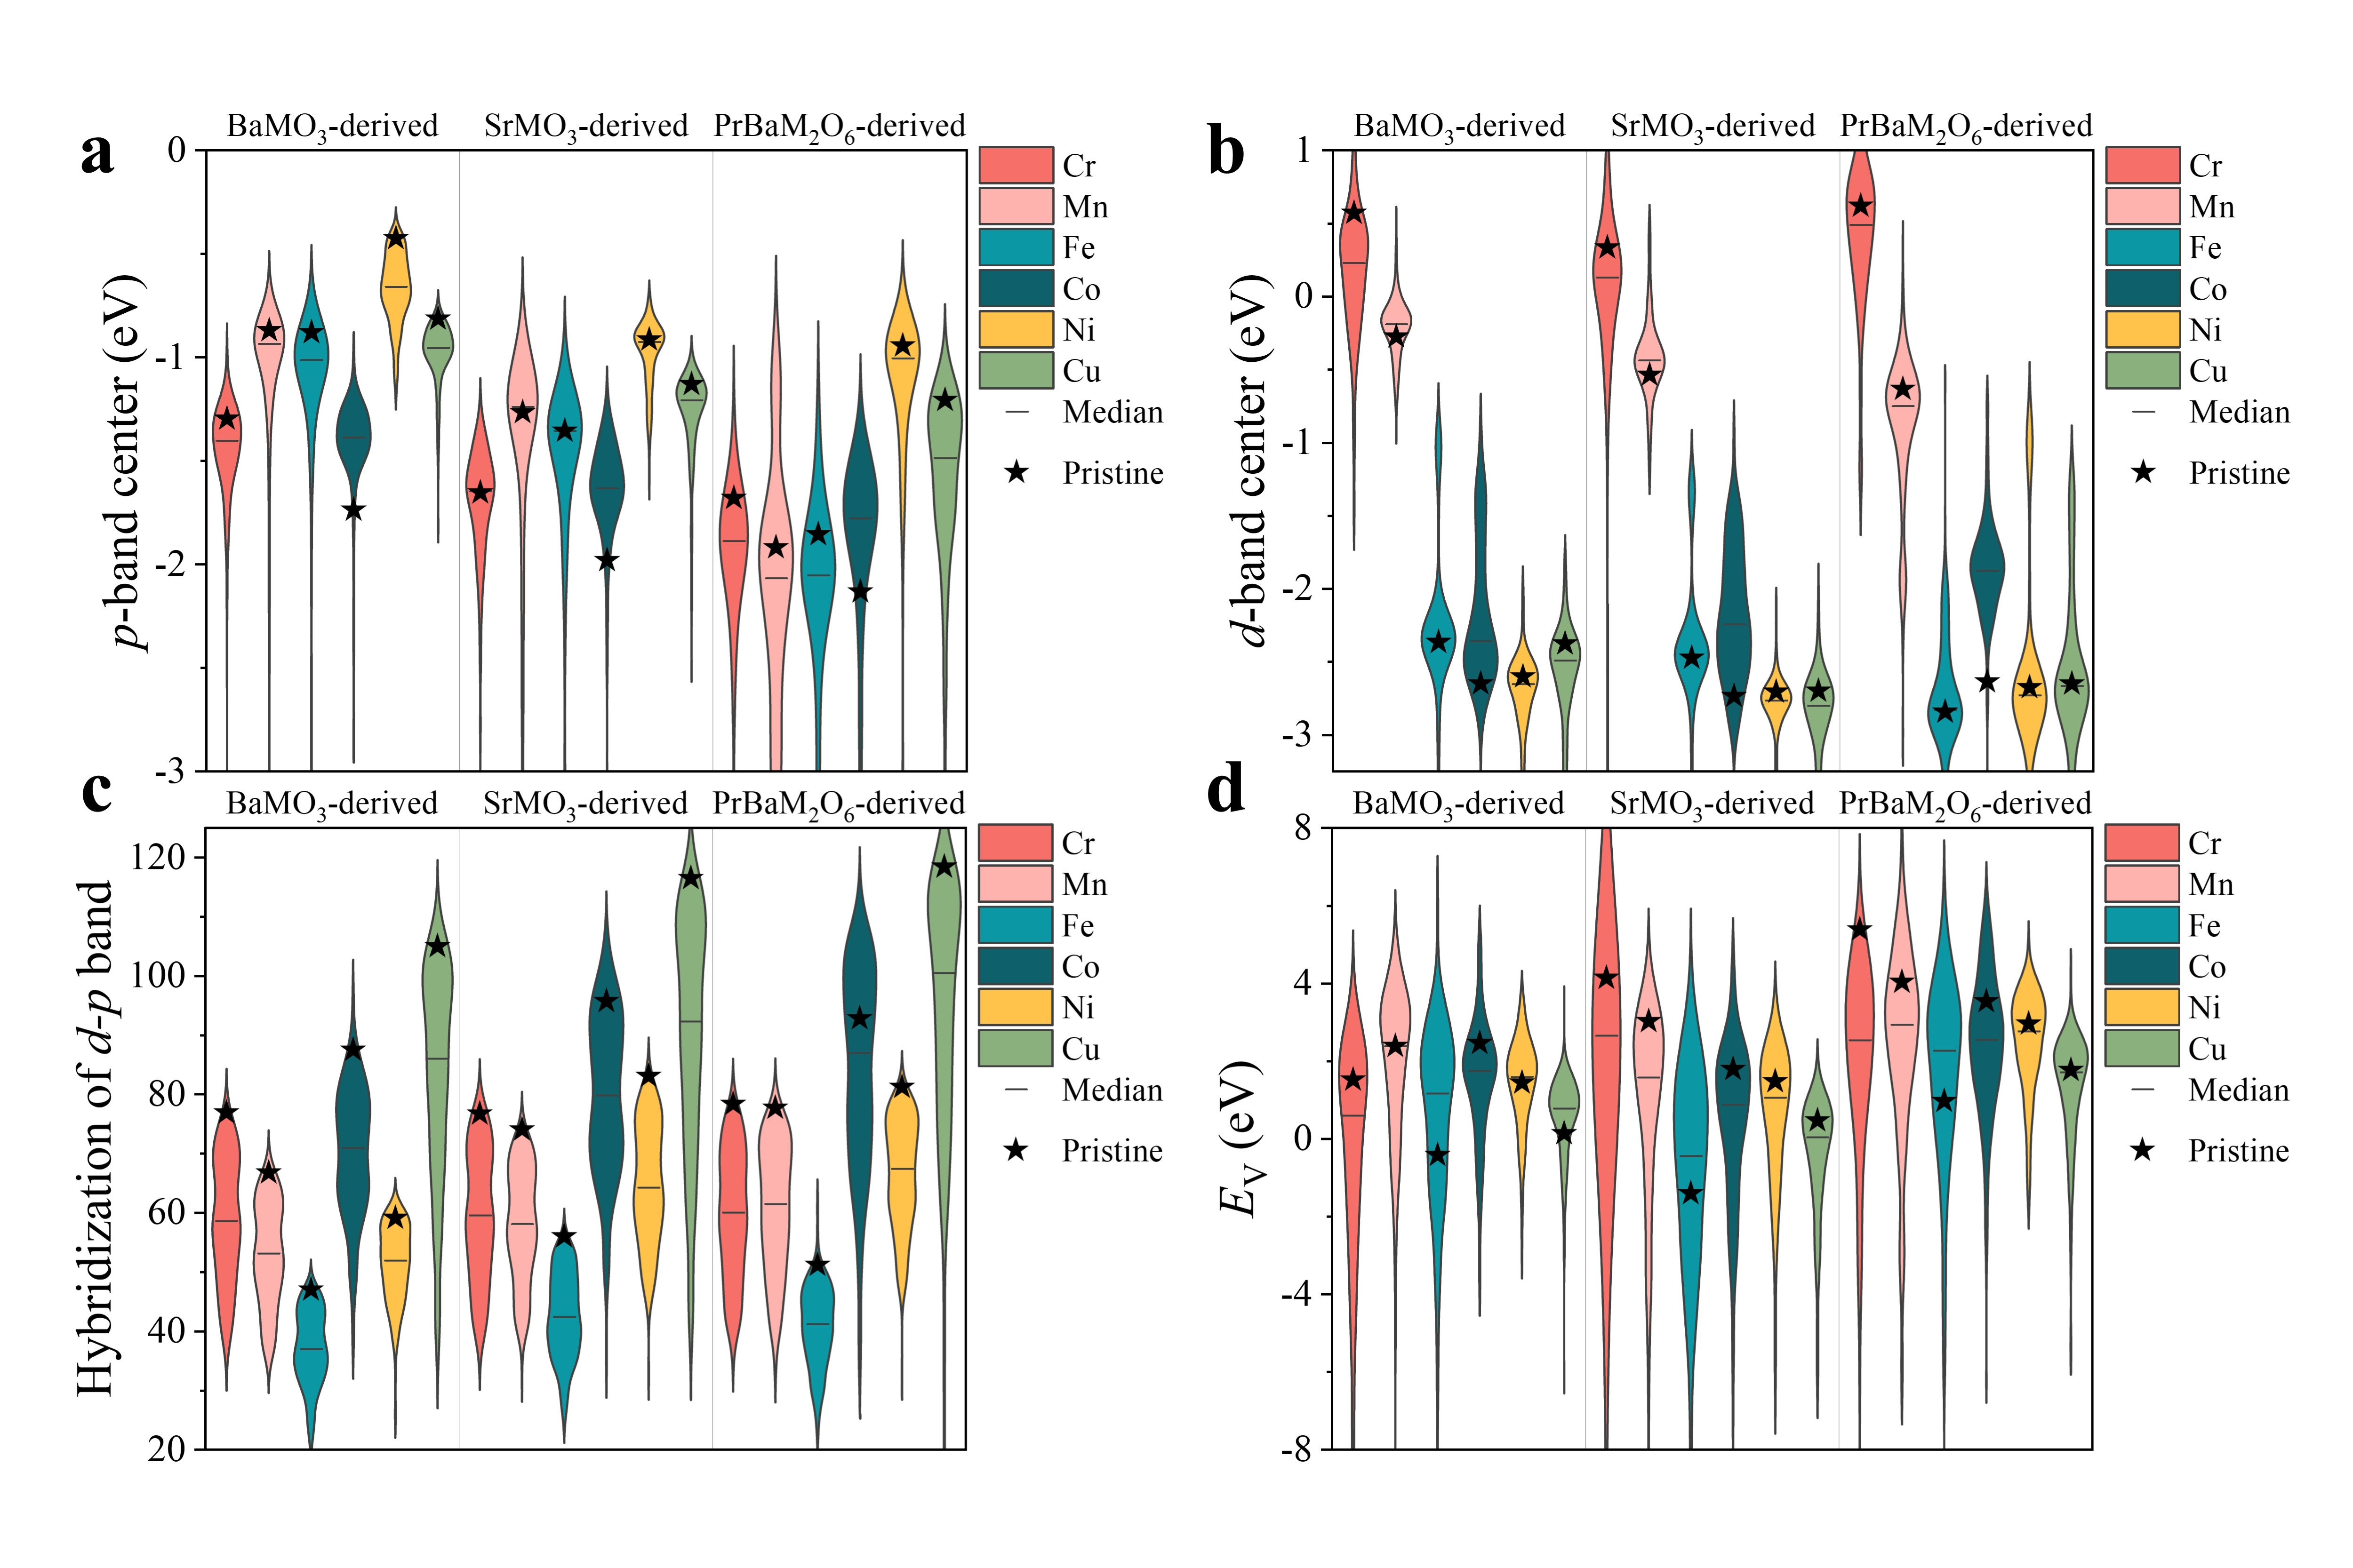
Figure 1. Violin plots showing the distribution of (a) ${\overline{O}}_{2p}$, (b) ${\overline{M}}_{3d}$, (c) H_{dp}, and (d) E_{V}, values across all 18 branches of perovskite candidates, with median and undoped pristine values highlighted for each branch.

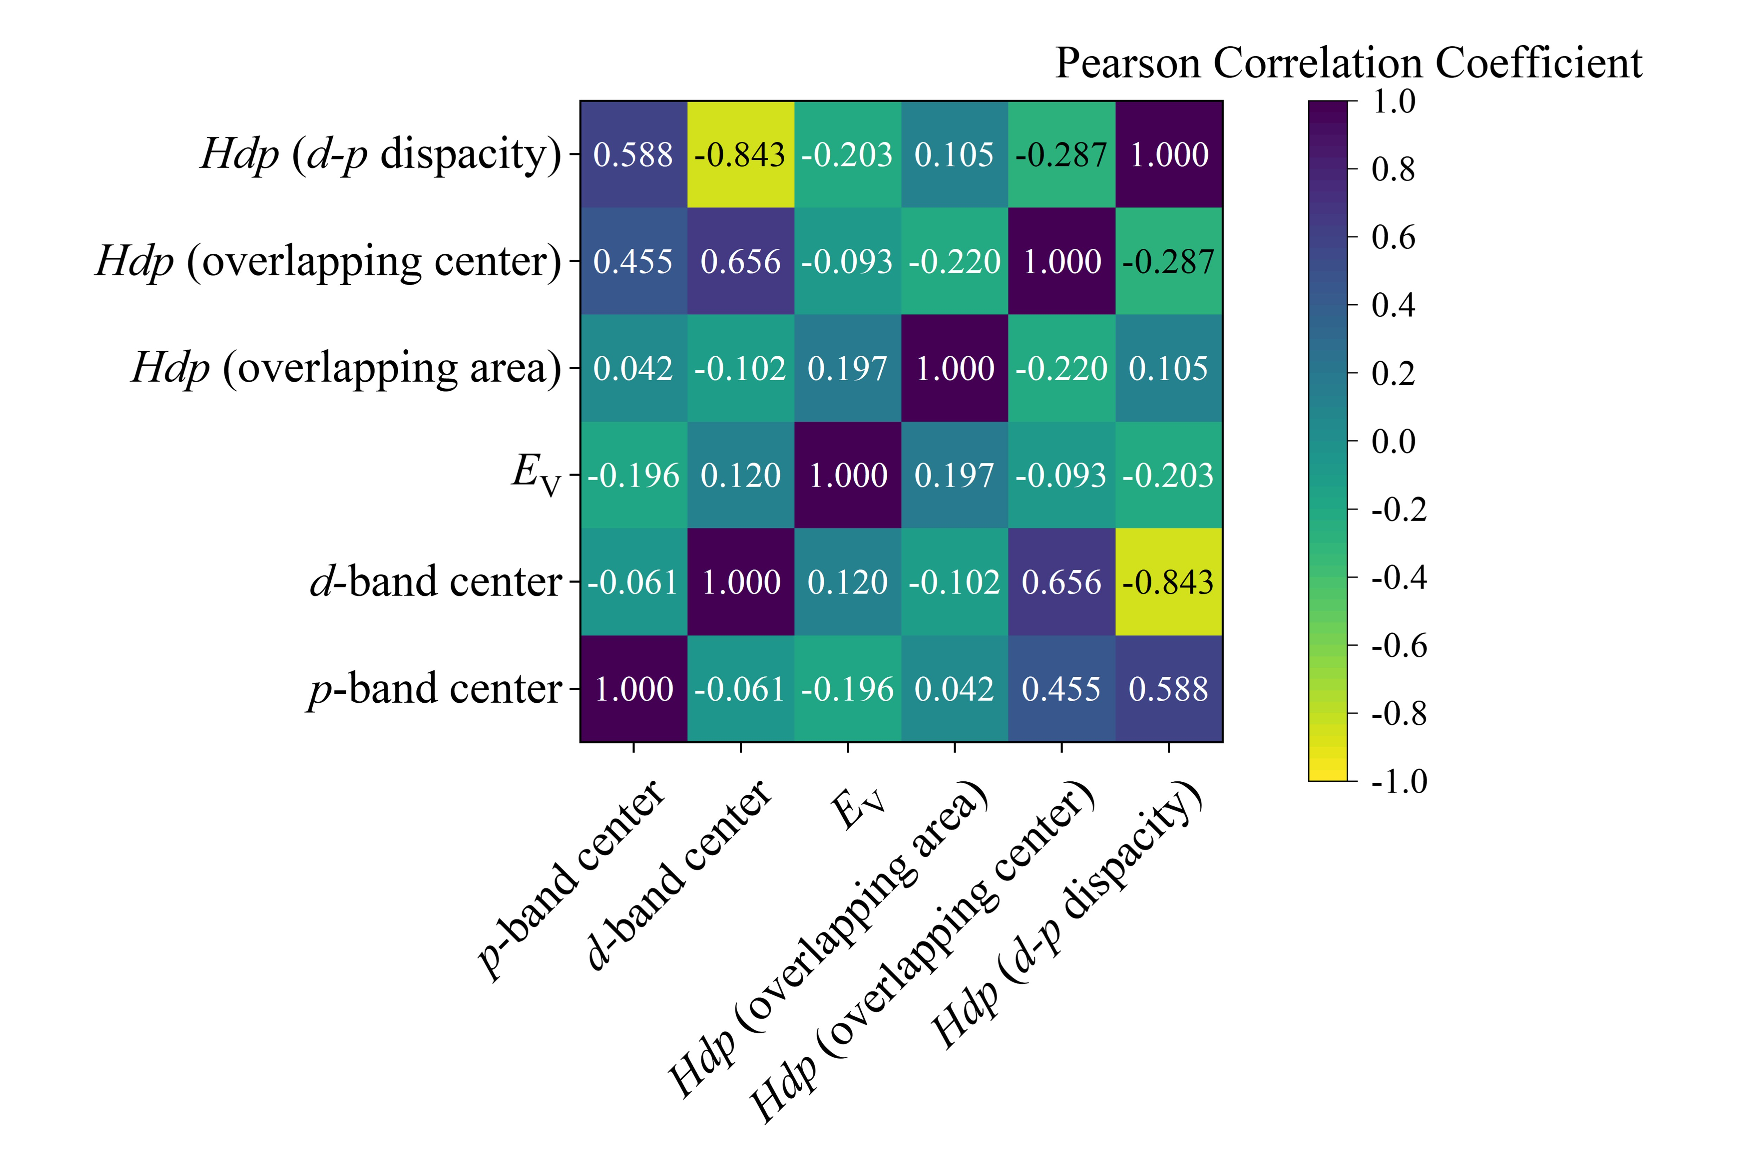
Figure 2. Pearson correlation coefficient among oxygen electrocatalytic activity performance descriptors.
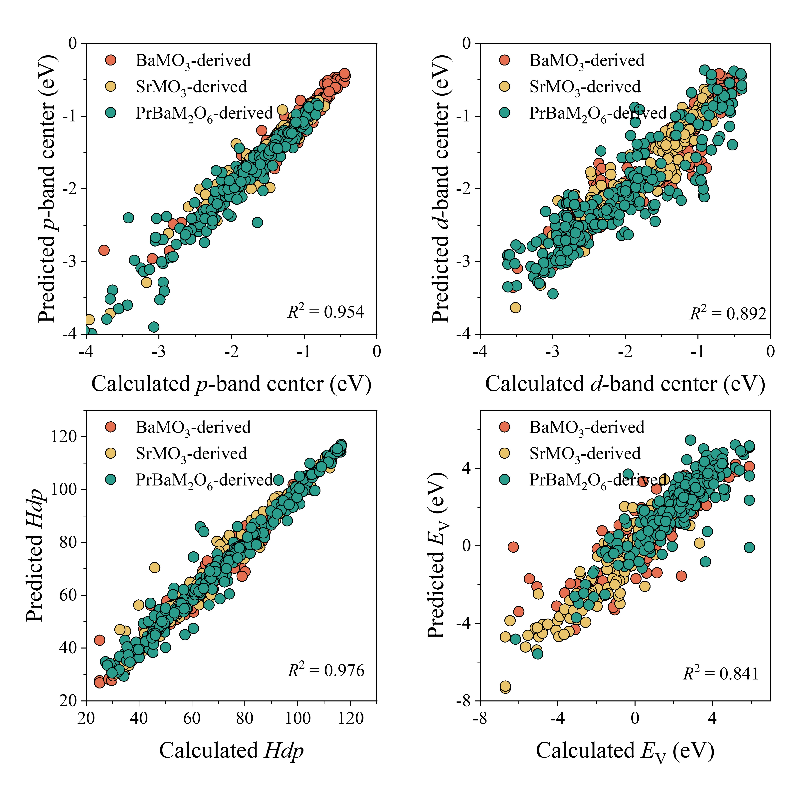
Figure 3. Parity plots for (a) ${\overline{O}}_{2p}$, (b) ${\overline{M}}_{3d}$, (c) H_{dp}, and (d) E_{V}, predicted using the FSML model.
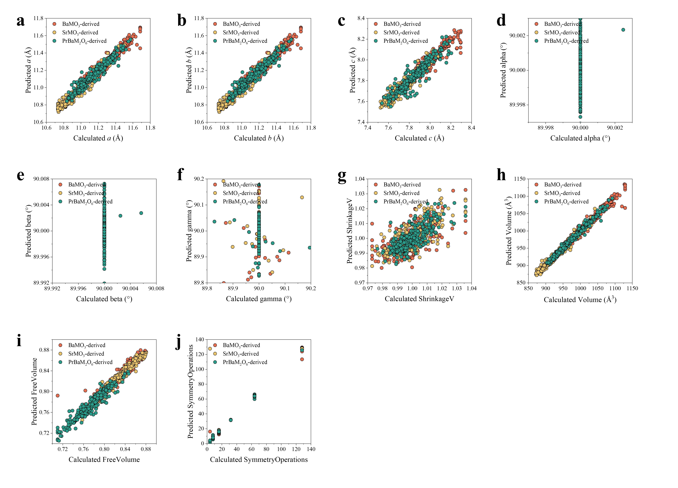
Figure 4. Parity plots for (a) a, (b) b, (c) c, (d) alpha, (e) beta, (f) gamma, (g) volume, (h) shrinkage caused by vacancy formation, (i) free volume, and (j) symmetry operations, predicted using the FSML model.
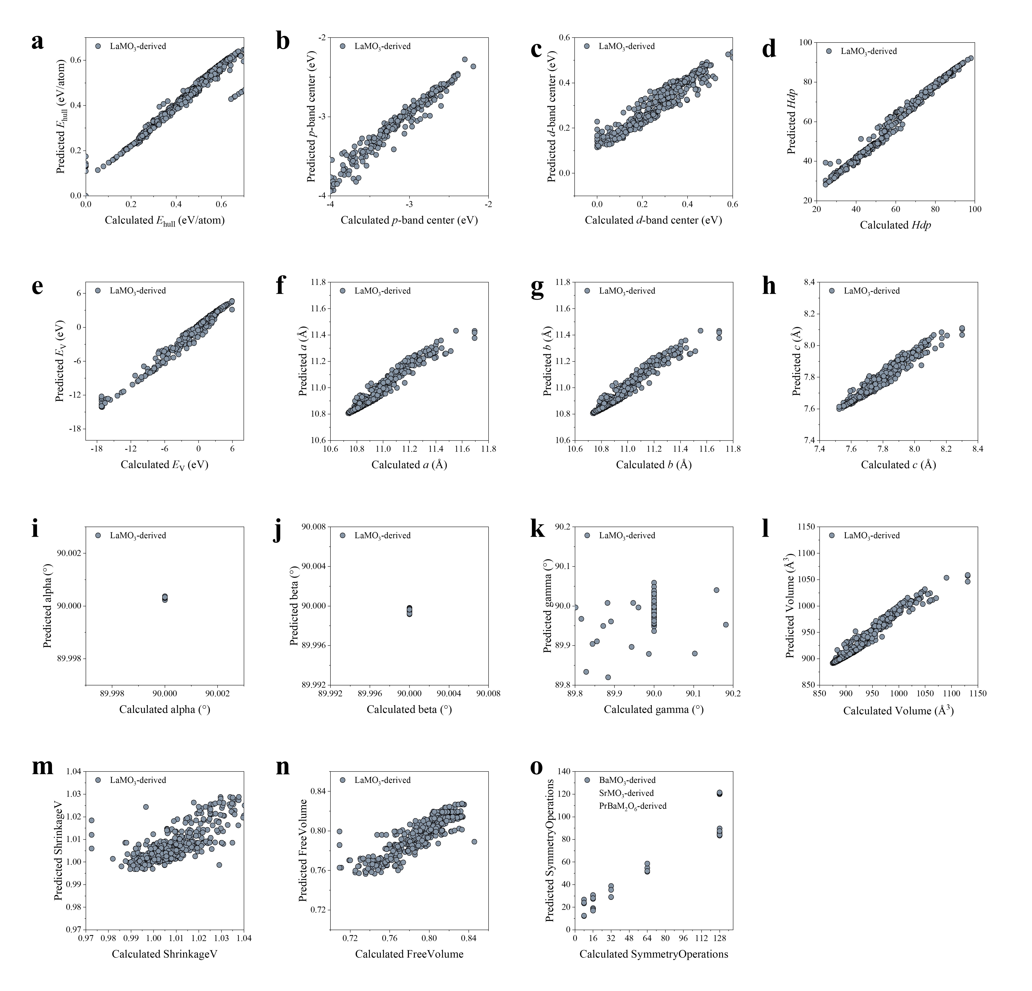
Figure 5. Parity plots for (a) E_{hull}, (b) ${\overline{O}}_{2p}$, (c) ${\overline{M}}_{3d}$, (d) H_{dp}, (e) E_{V} (f) a, (g) b, (h) c, (i) alpha, (j) beta, (k) gamma, (l) volume, (m) shrinkage caused by vacancy formation, (n) free volume, and (o) symmetry operations, for the out-of-distribution task predicted using the FSML model.
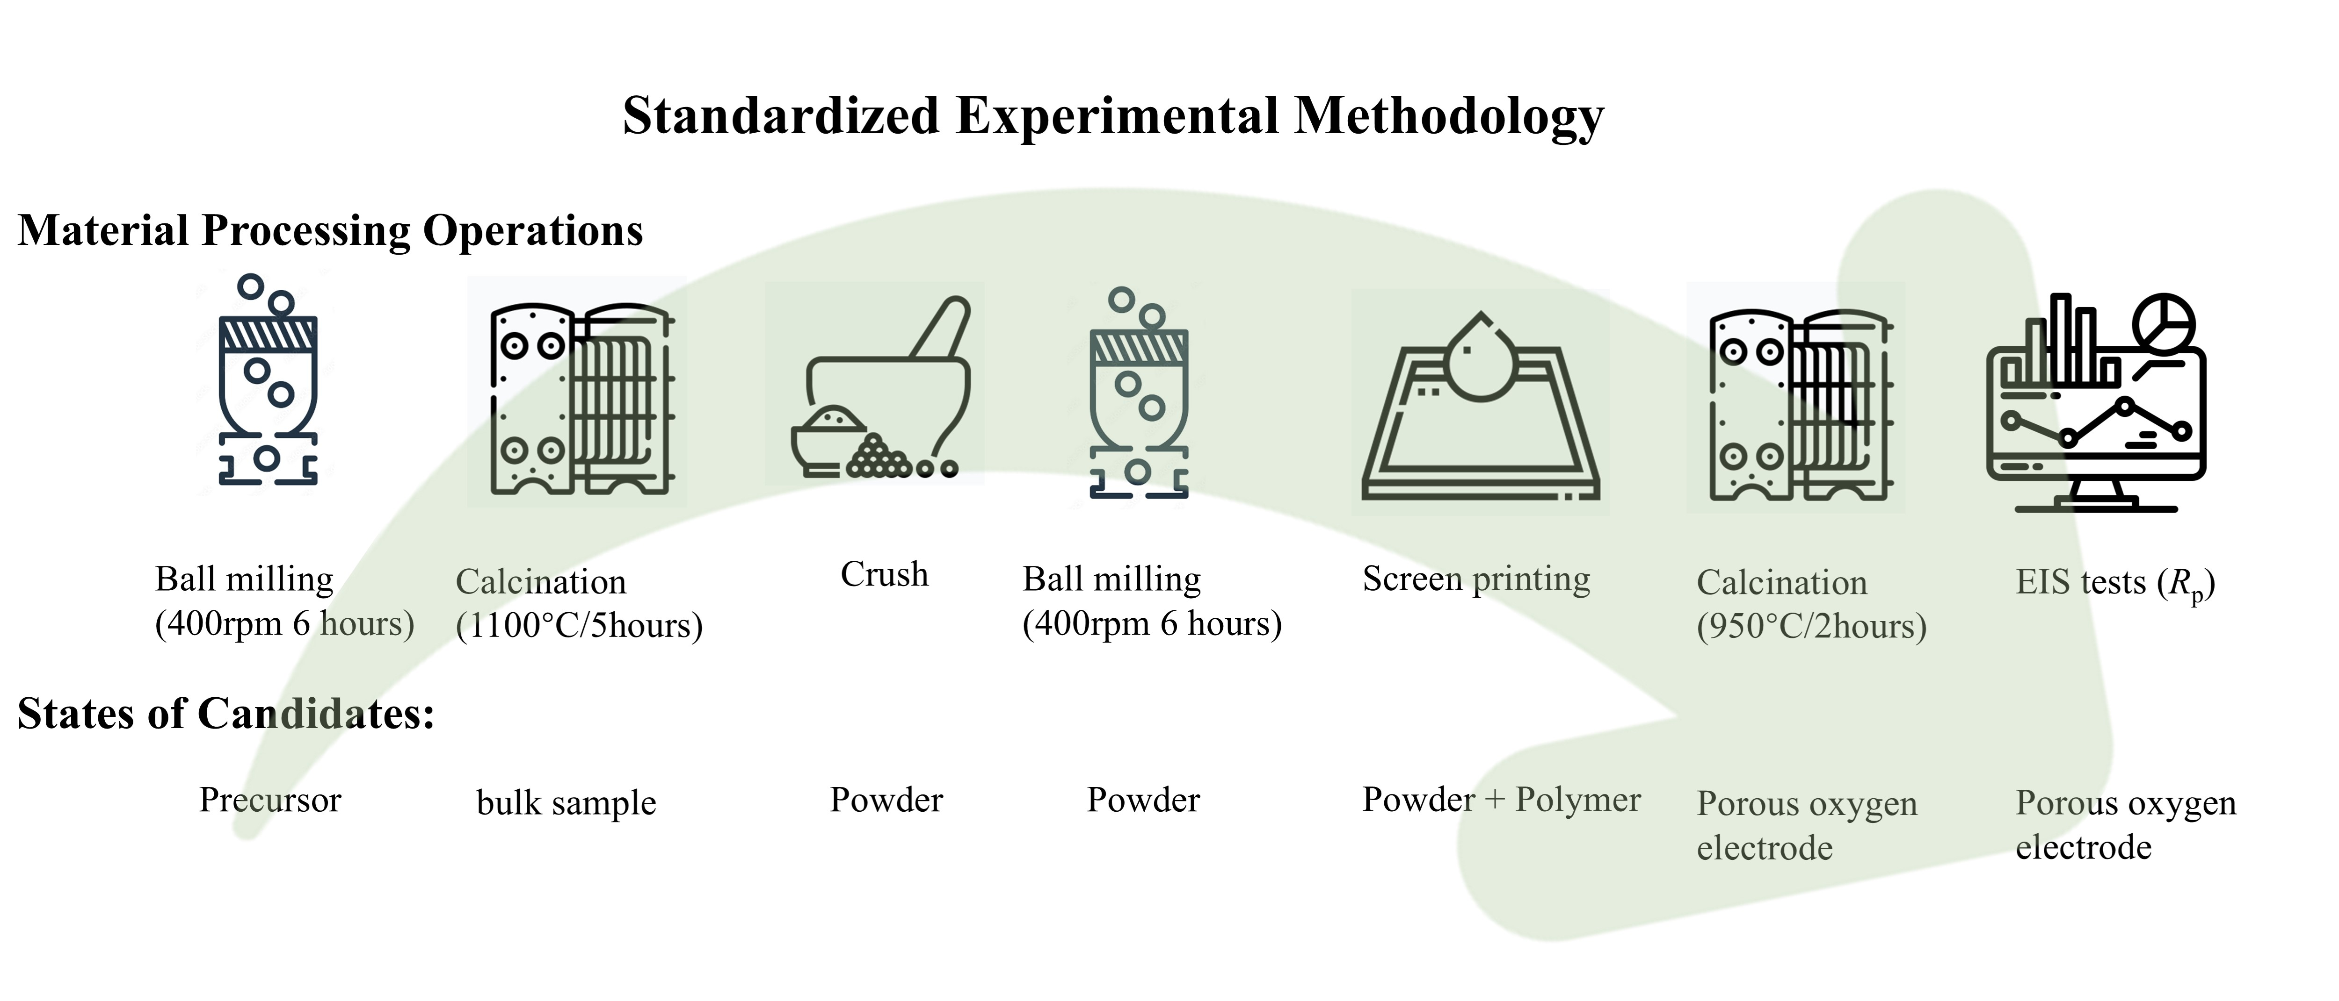
Figure 6. Schematic representation of the standardized experimental methodology.
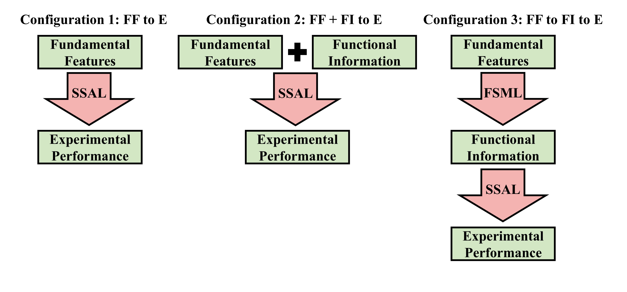
Figure 7. Schematic representation of the three configurations used in applying the SSAL model.
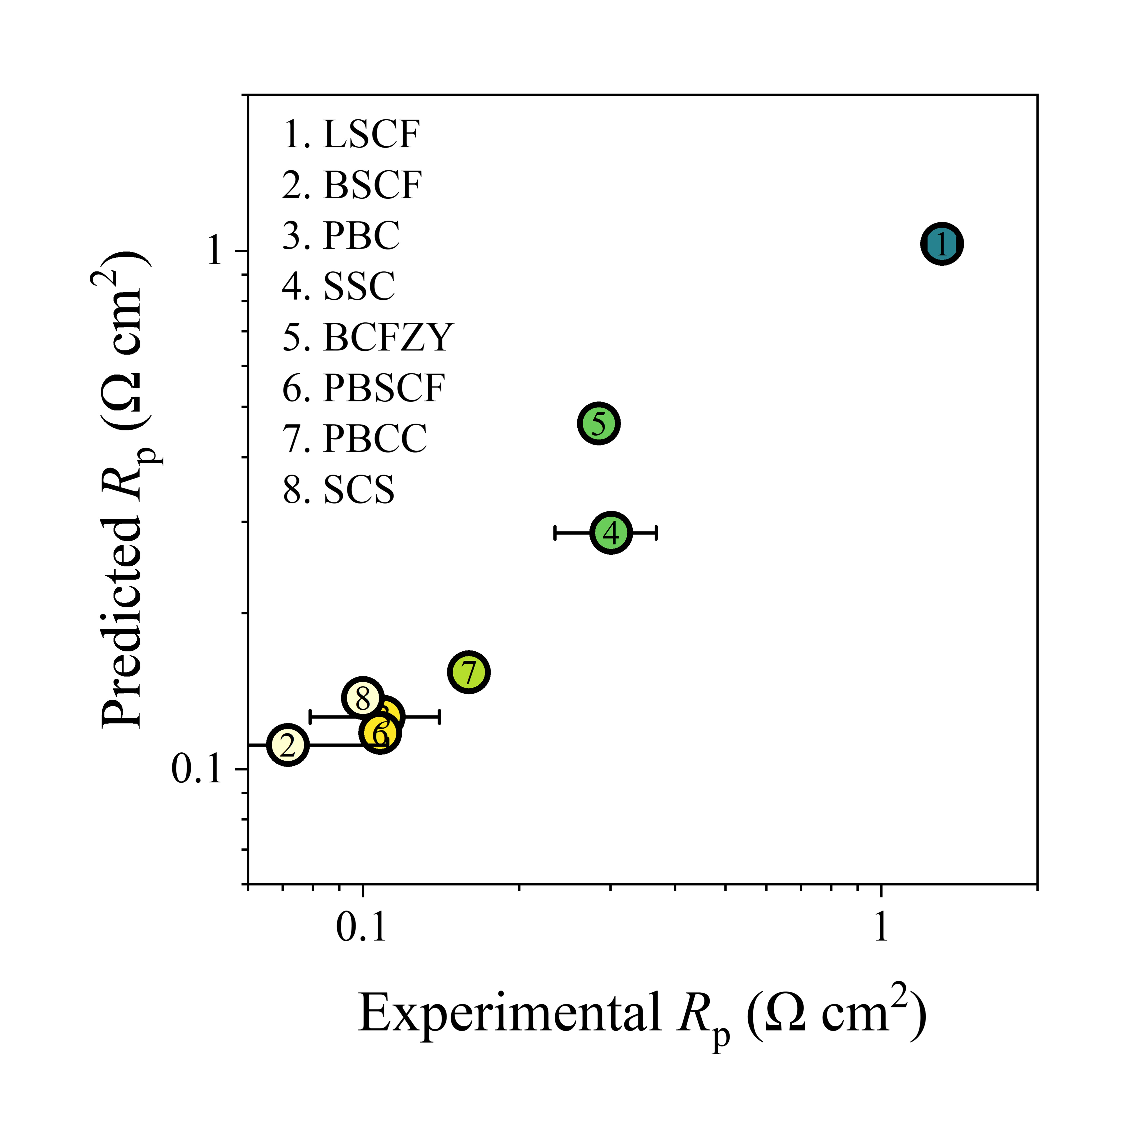
Figure 8. Parity plots for R_{p} of SOTA oxygen electrocatalysts predicted using the SSAL model.
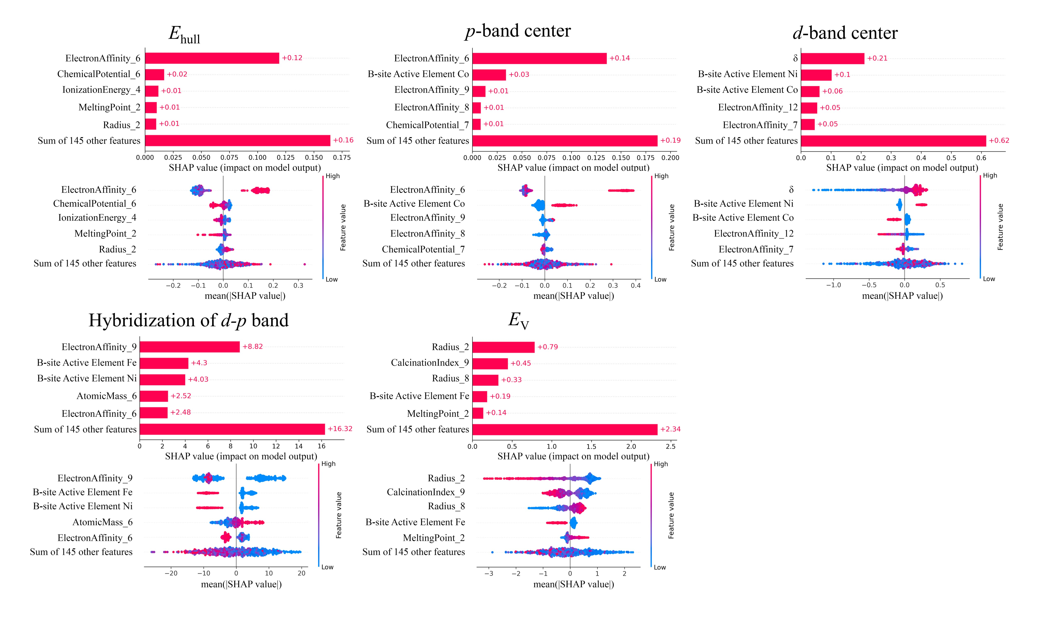
Figure 9. SHAP feature importance plot and beeswarm plot for E_{hull}, ${\overline{O}}_{2p}$, ${\overline{M}}_{3d}$, H_{dp}, and E_{V} prediction using the FSML model.
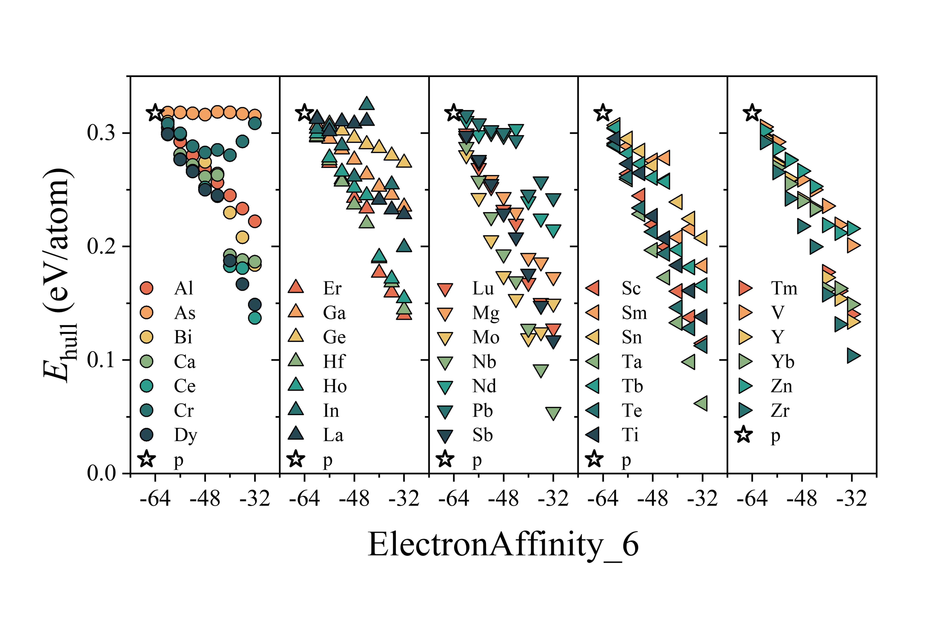
Figure 10. Distribution of E_{hull} as a function of ElectronAffinity_6 for BaCoO₃-derived candidates.
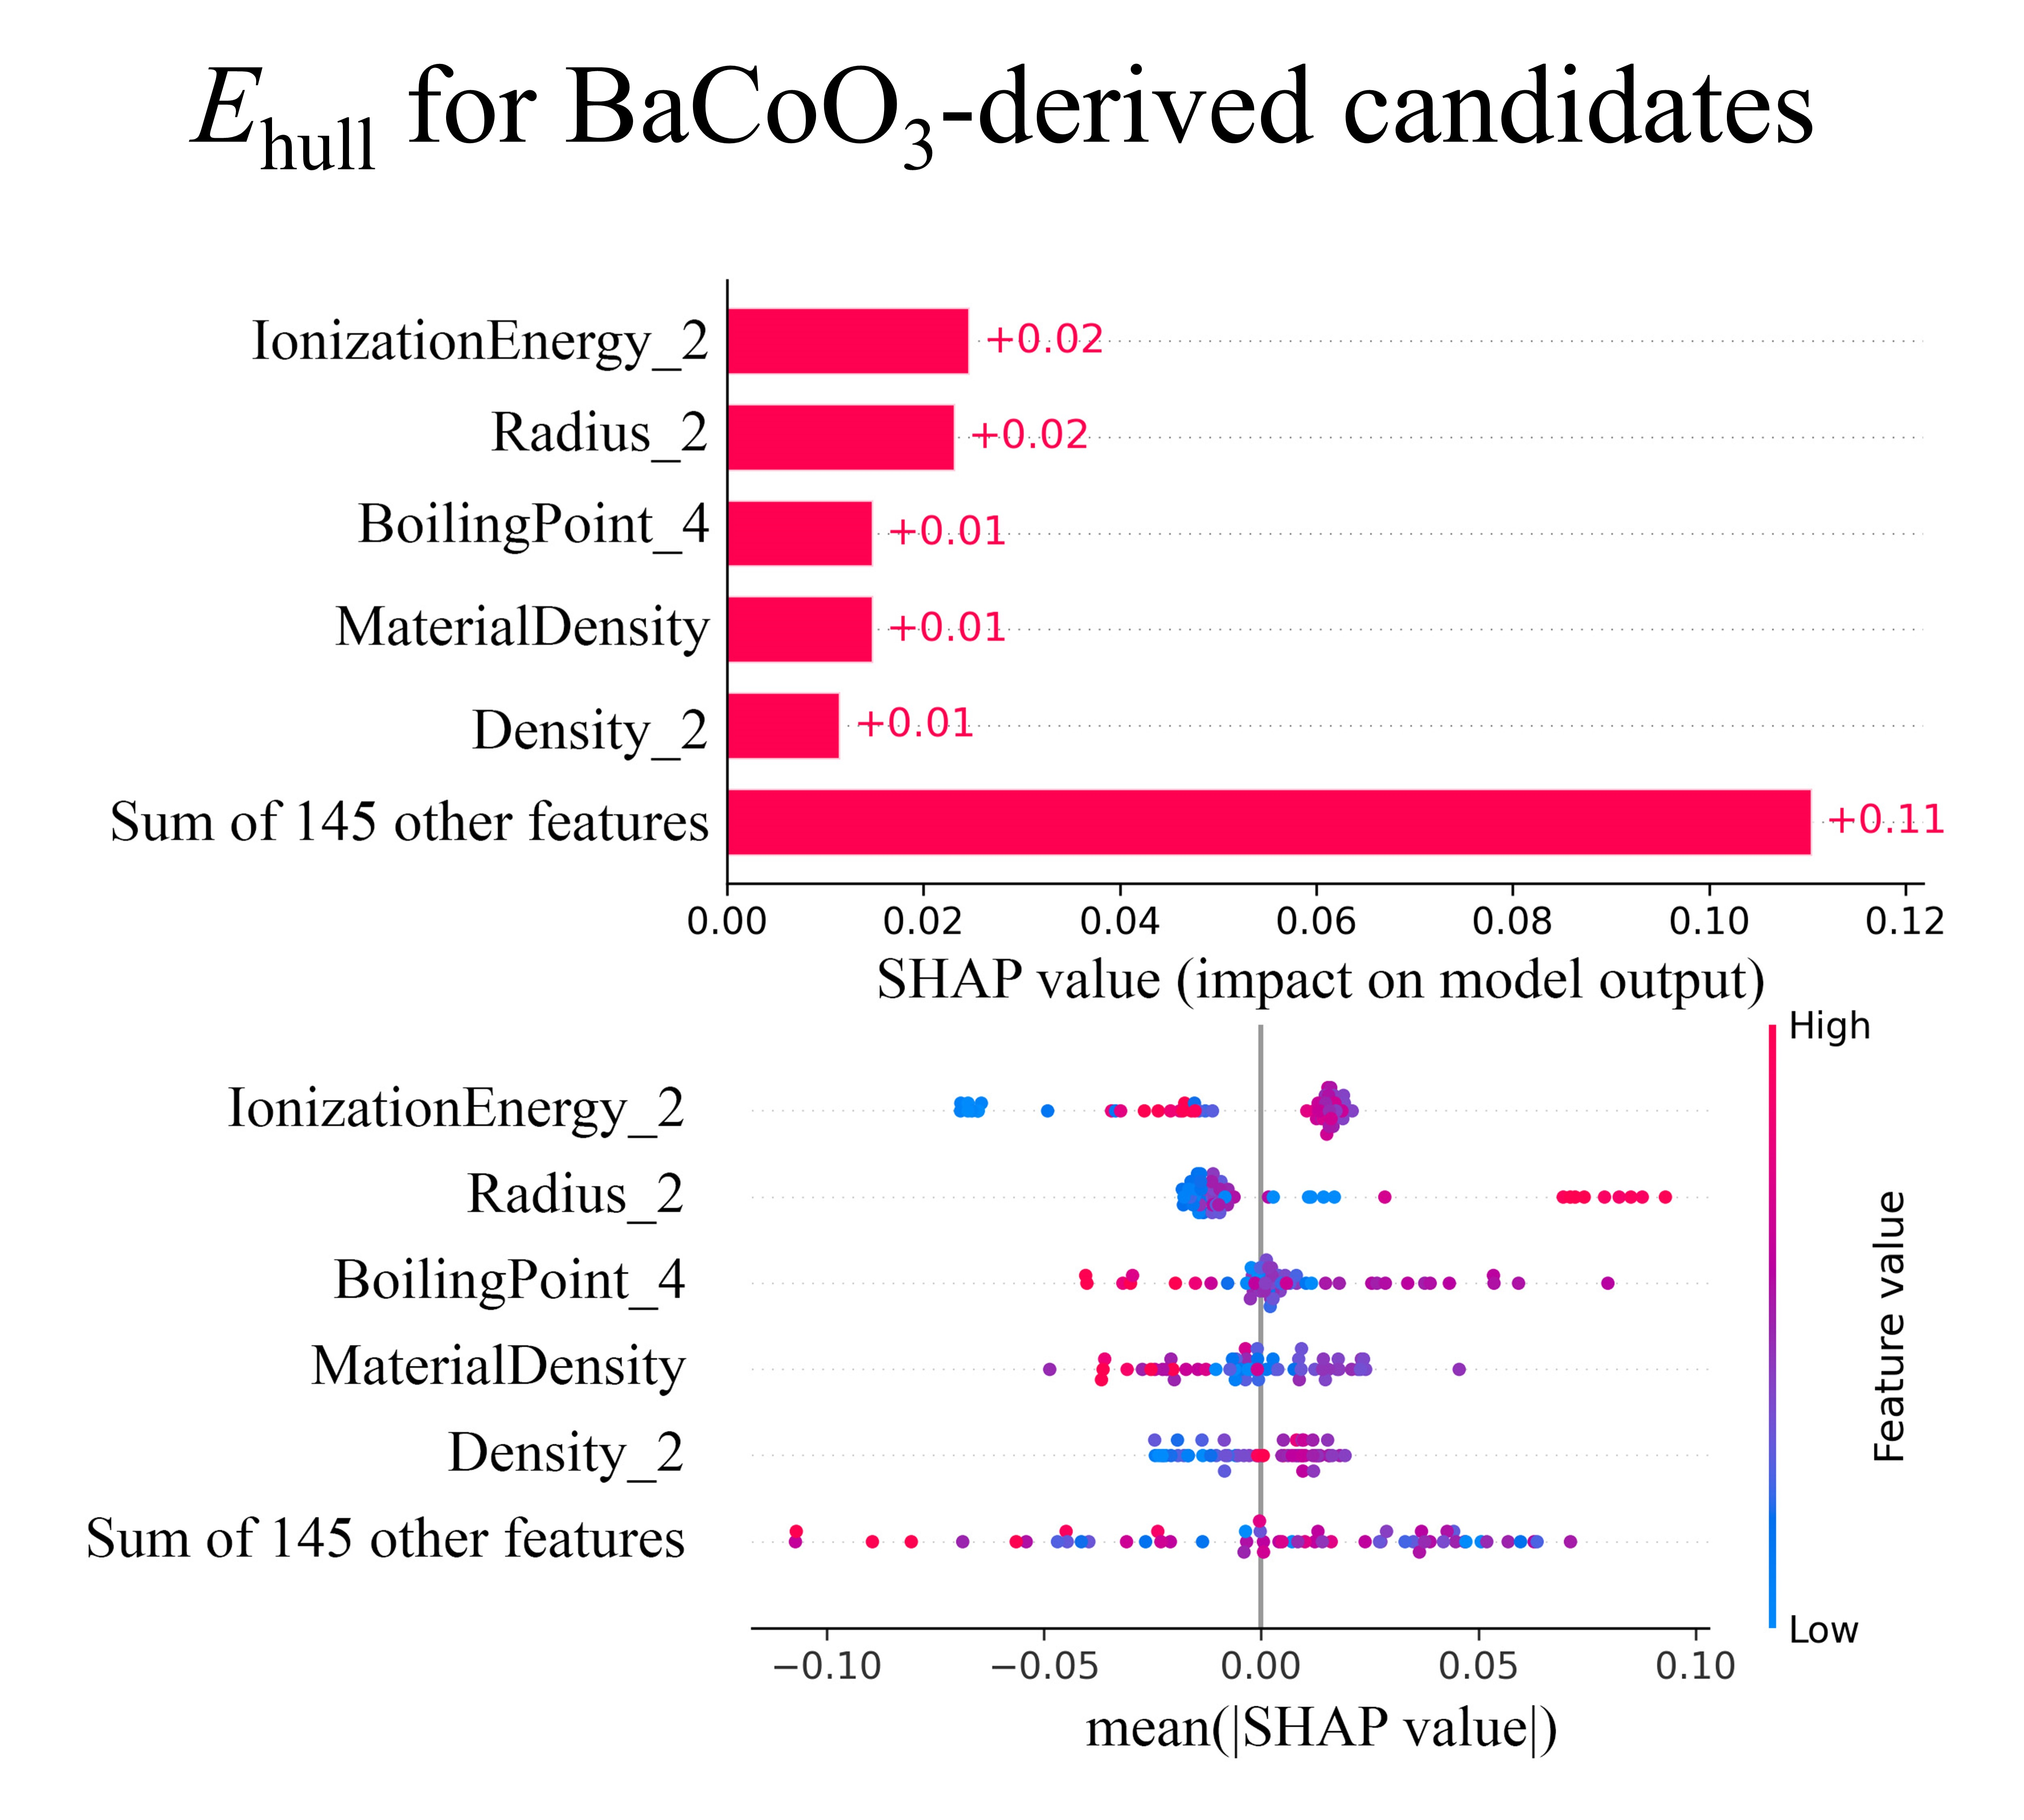
Figure 11. SHAP feature importance plot and beeswarm plot for E_{hull} prediction of BaCoO₃-derived candidates using the FSML model.
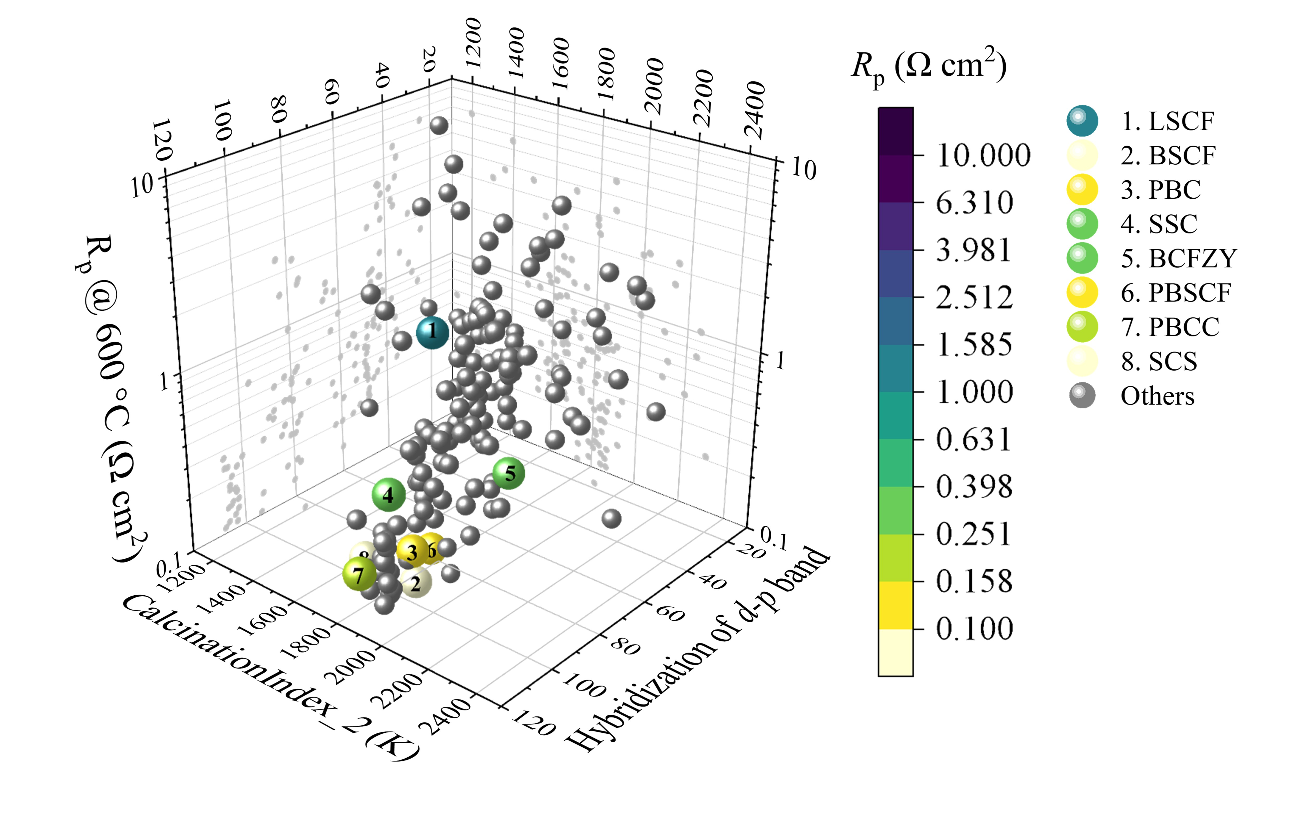
Figure 12. Distribution of R_{p} at 600 °C as a function of CalcinationIndex_2 and H_{dp} for all SOTA oxygen electrocatalysts.
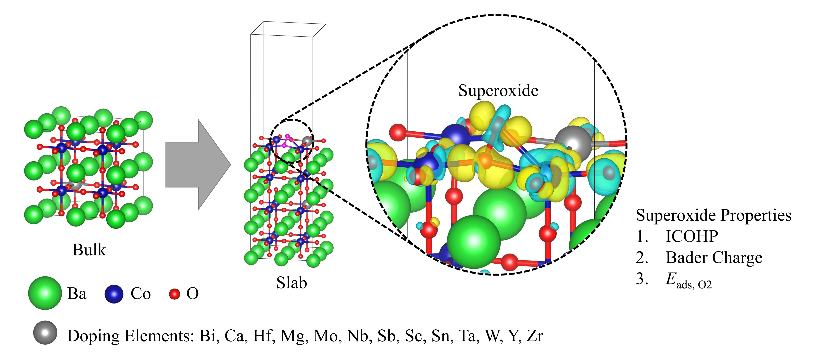
Figure 13. Depiction of the surface structures of the BO₂-terminated (001) surface of BaCoO₃-derived materials with superoxide species adsorbed.
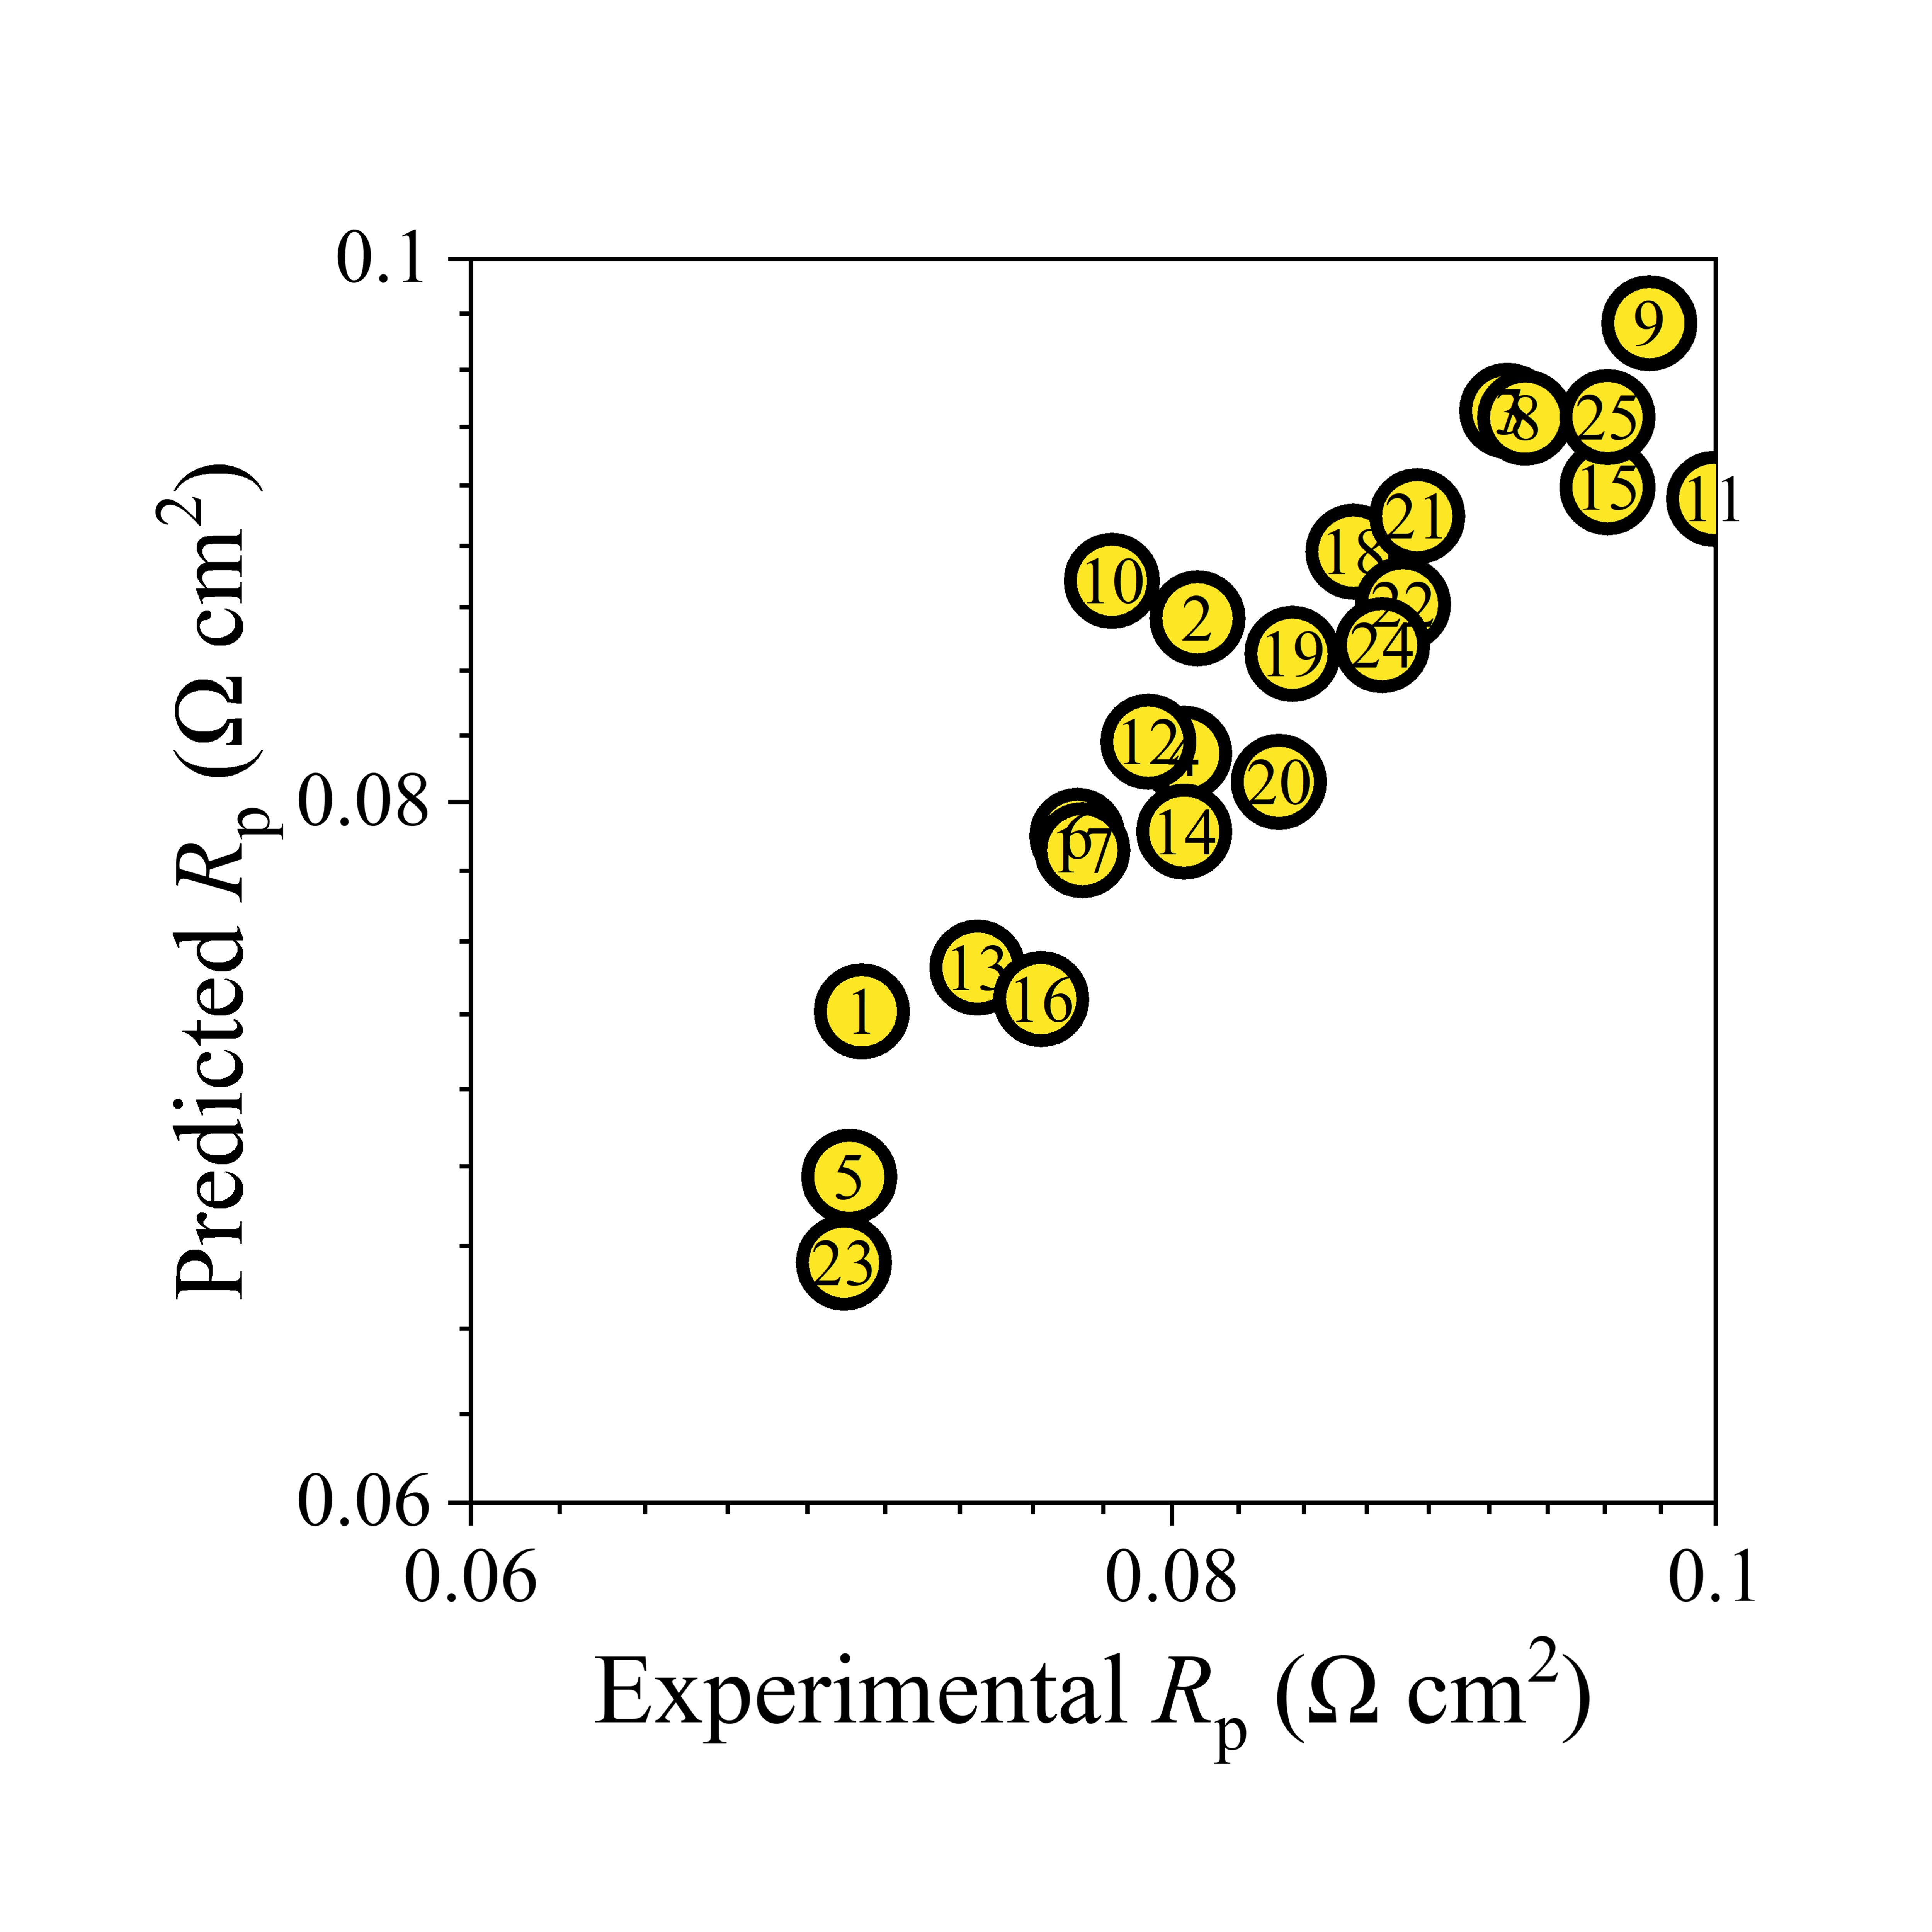
Figure 14. Parity plots for R_{p} of candidates located in the promising region predicted using the TSMS model.
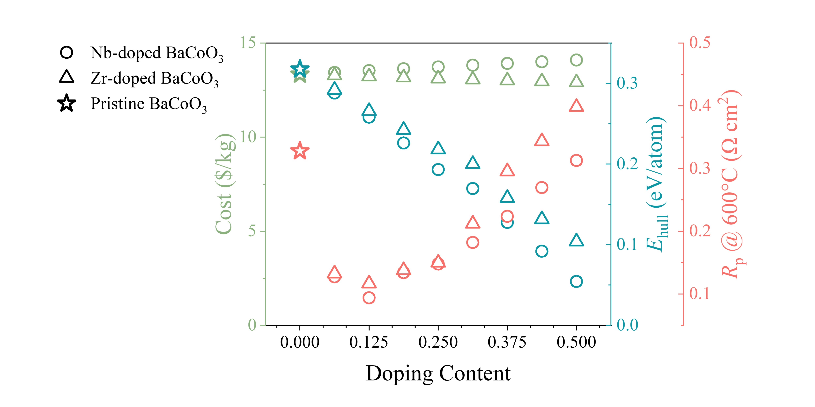
Figure 15. Three-dimensional evaluation of Nb-doped BaCoO₃ and Zr-doped BaCoO₃ in terms of thermodynamic stability, cost-effectiveness, and electrocatalytic activity.
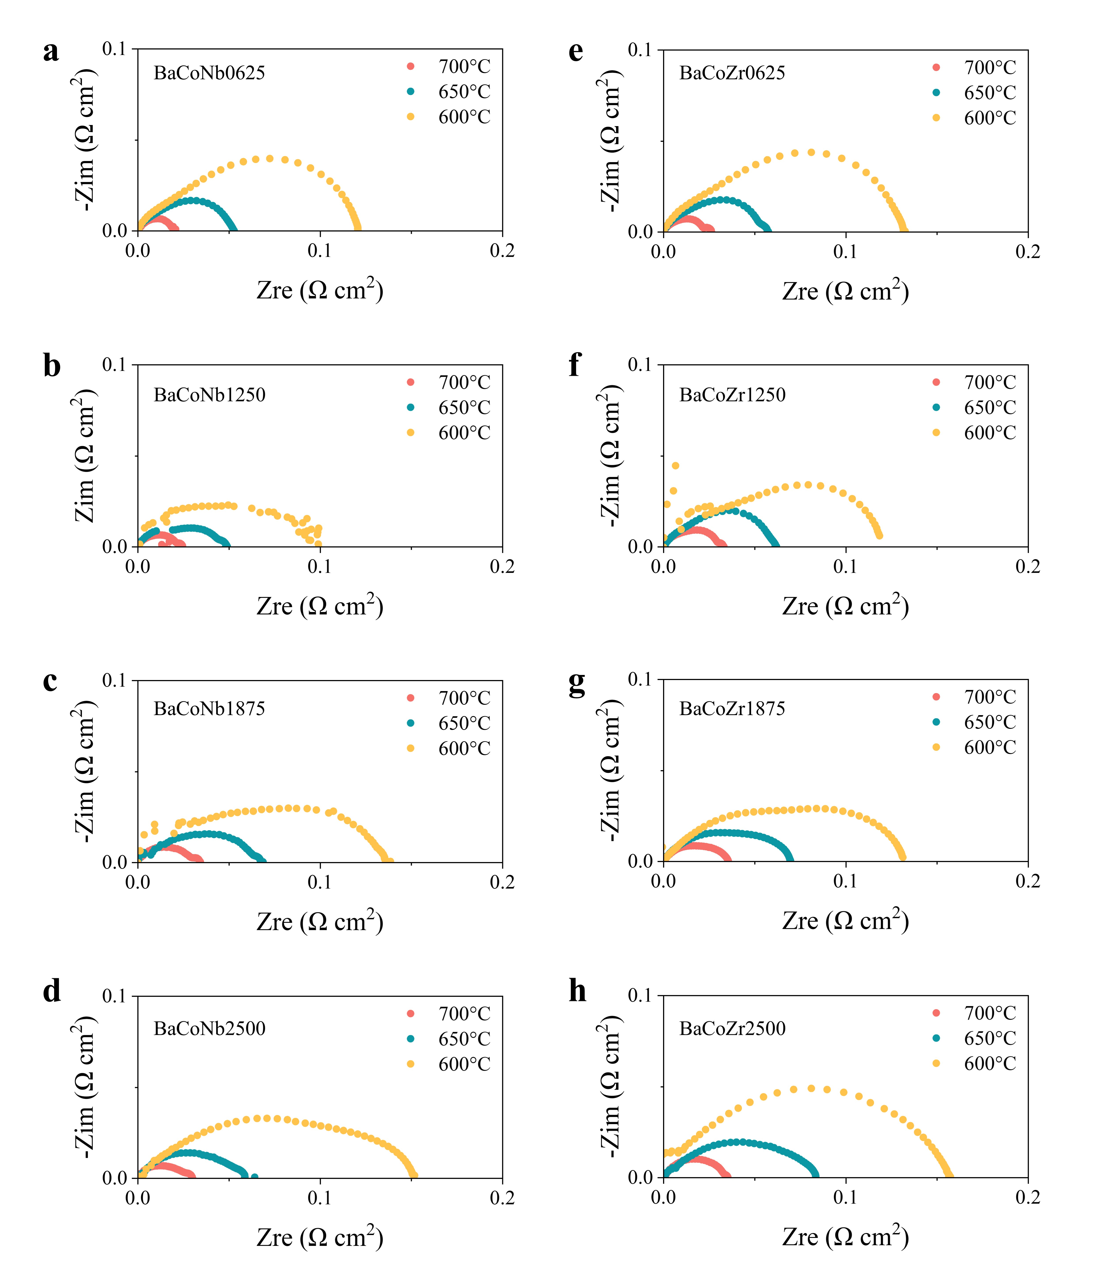
Figure 16. Summary of EIS results for SDC symmetrical cells with (a-d) Nb-doped BaCoO_{3-δ} and (e-h) Zr-doped BaCoO_{3-δ} as oxygen electrode across temperature from 700 °C to 600 °C.
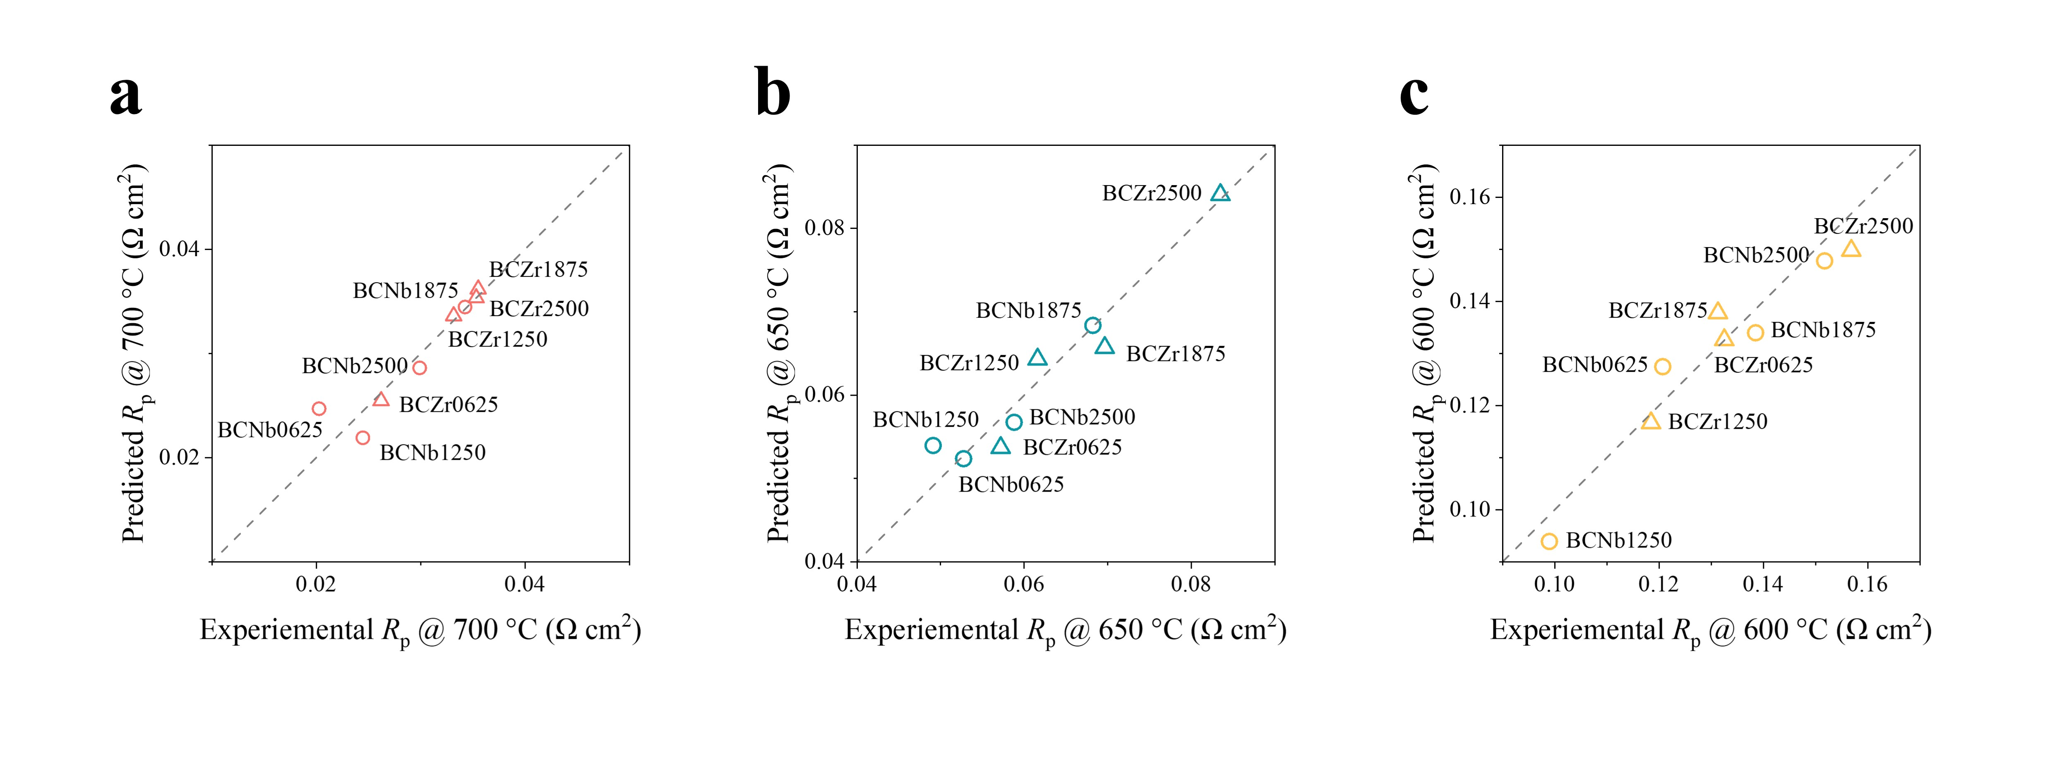
Figure 17. Parity plots for R_{p} at (a) 700, (b) 650, and (c) 600°C, for Nb-doped BaCoO_{3-δ} and Zr-doped BaCoO_{3-δ} predicted using the TSMS model.
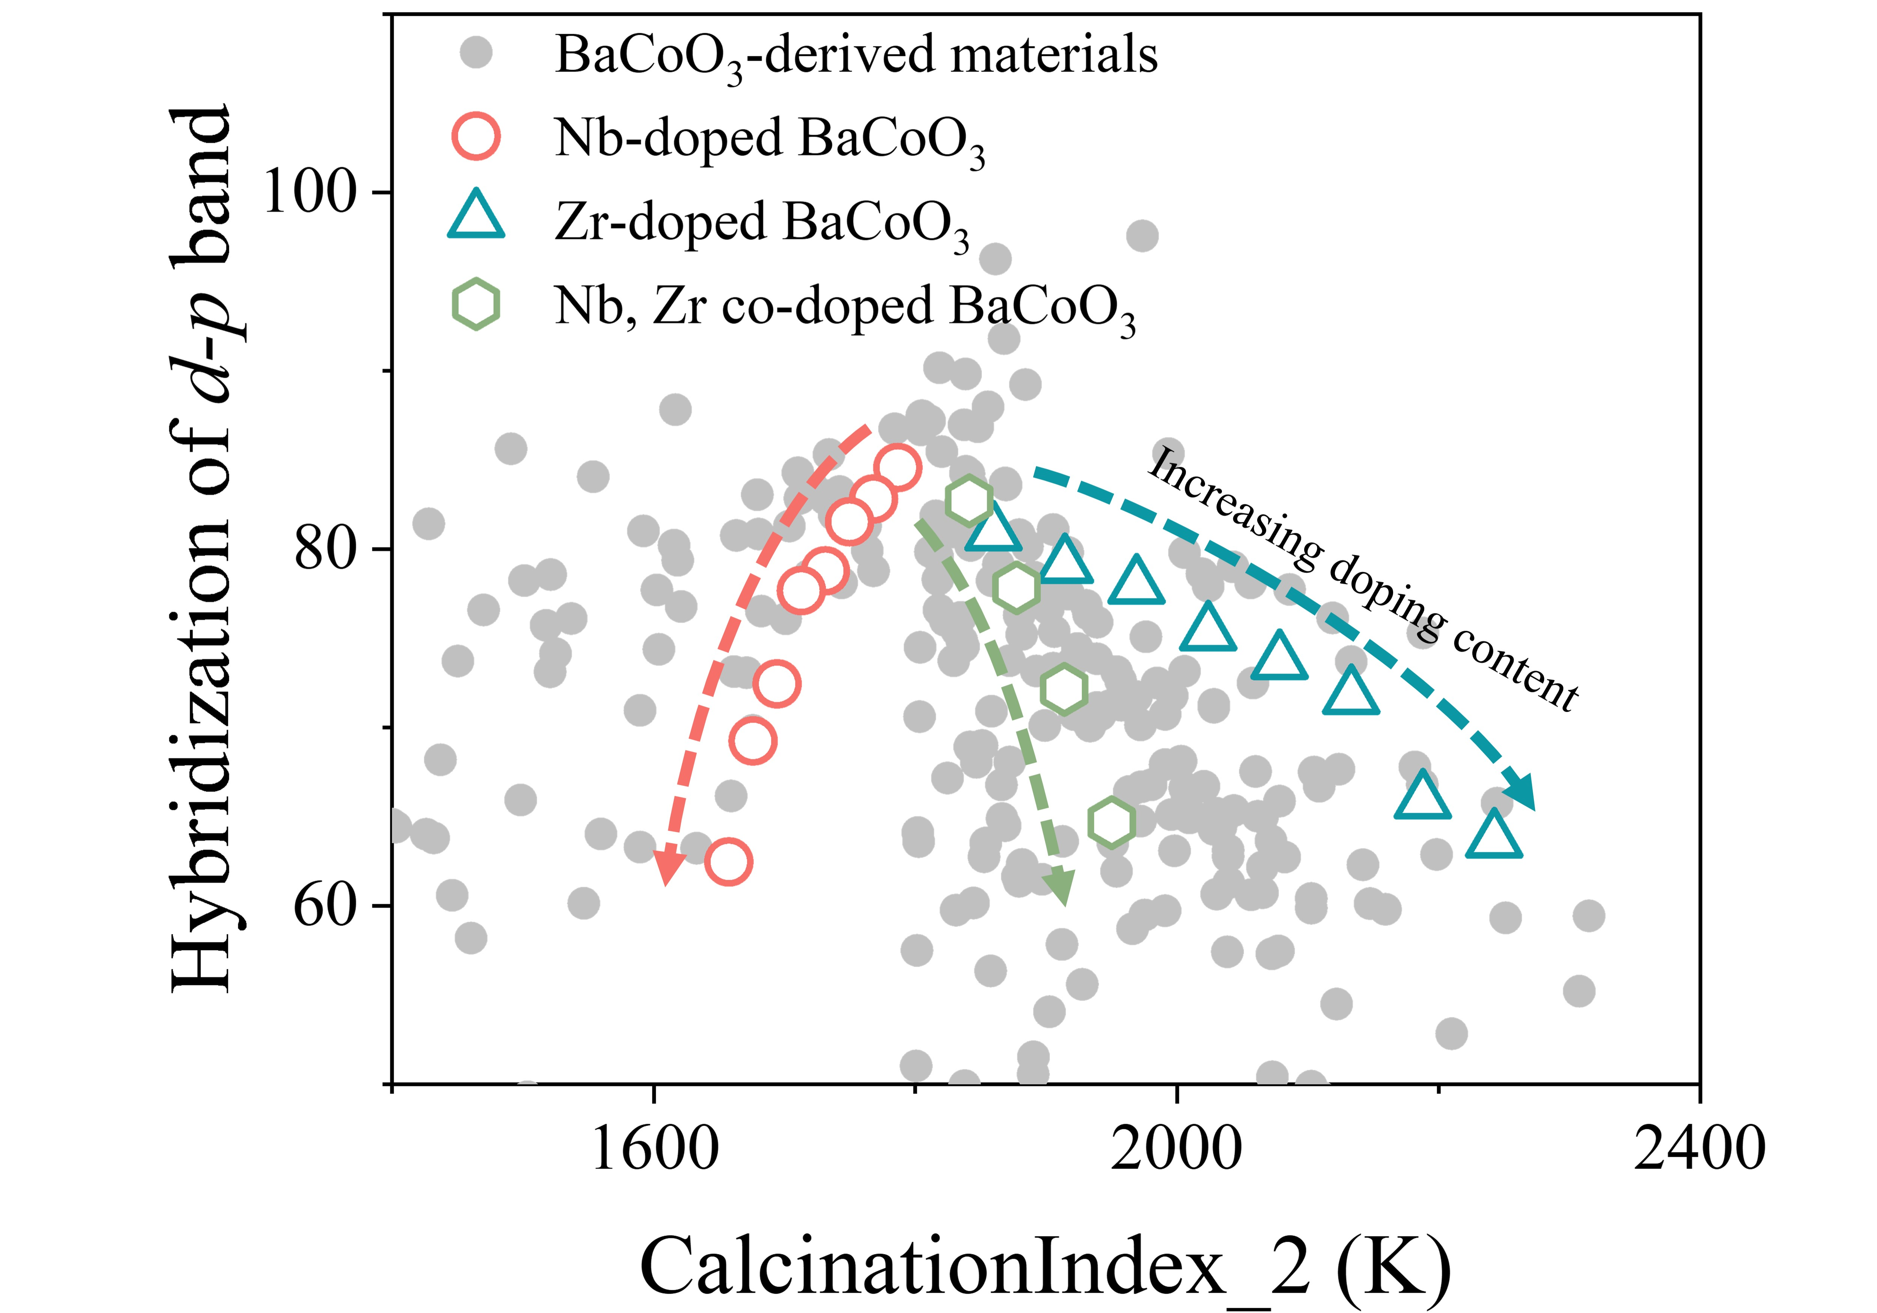
Figure 18. Two-dimensional evaluation of Nb-doped BaCoO₃, Zr-doped BaCoO₃, and Nb-Zr co-doped BaCoO₃ in terms of H_{dp} and CalcinationIndex_2, with arrows indicating the direction of increasing doping content.
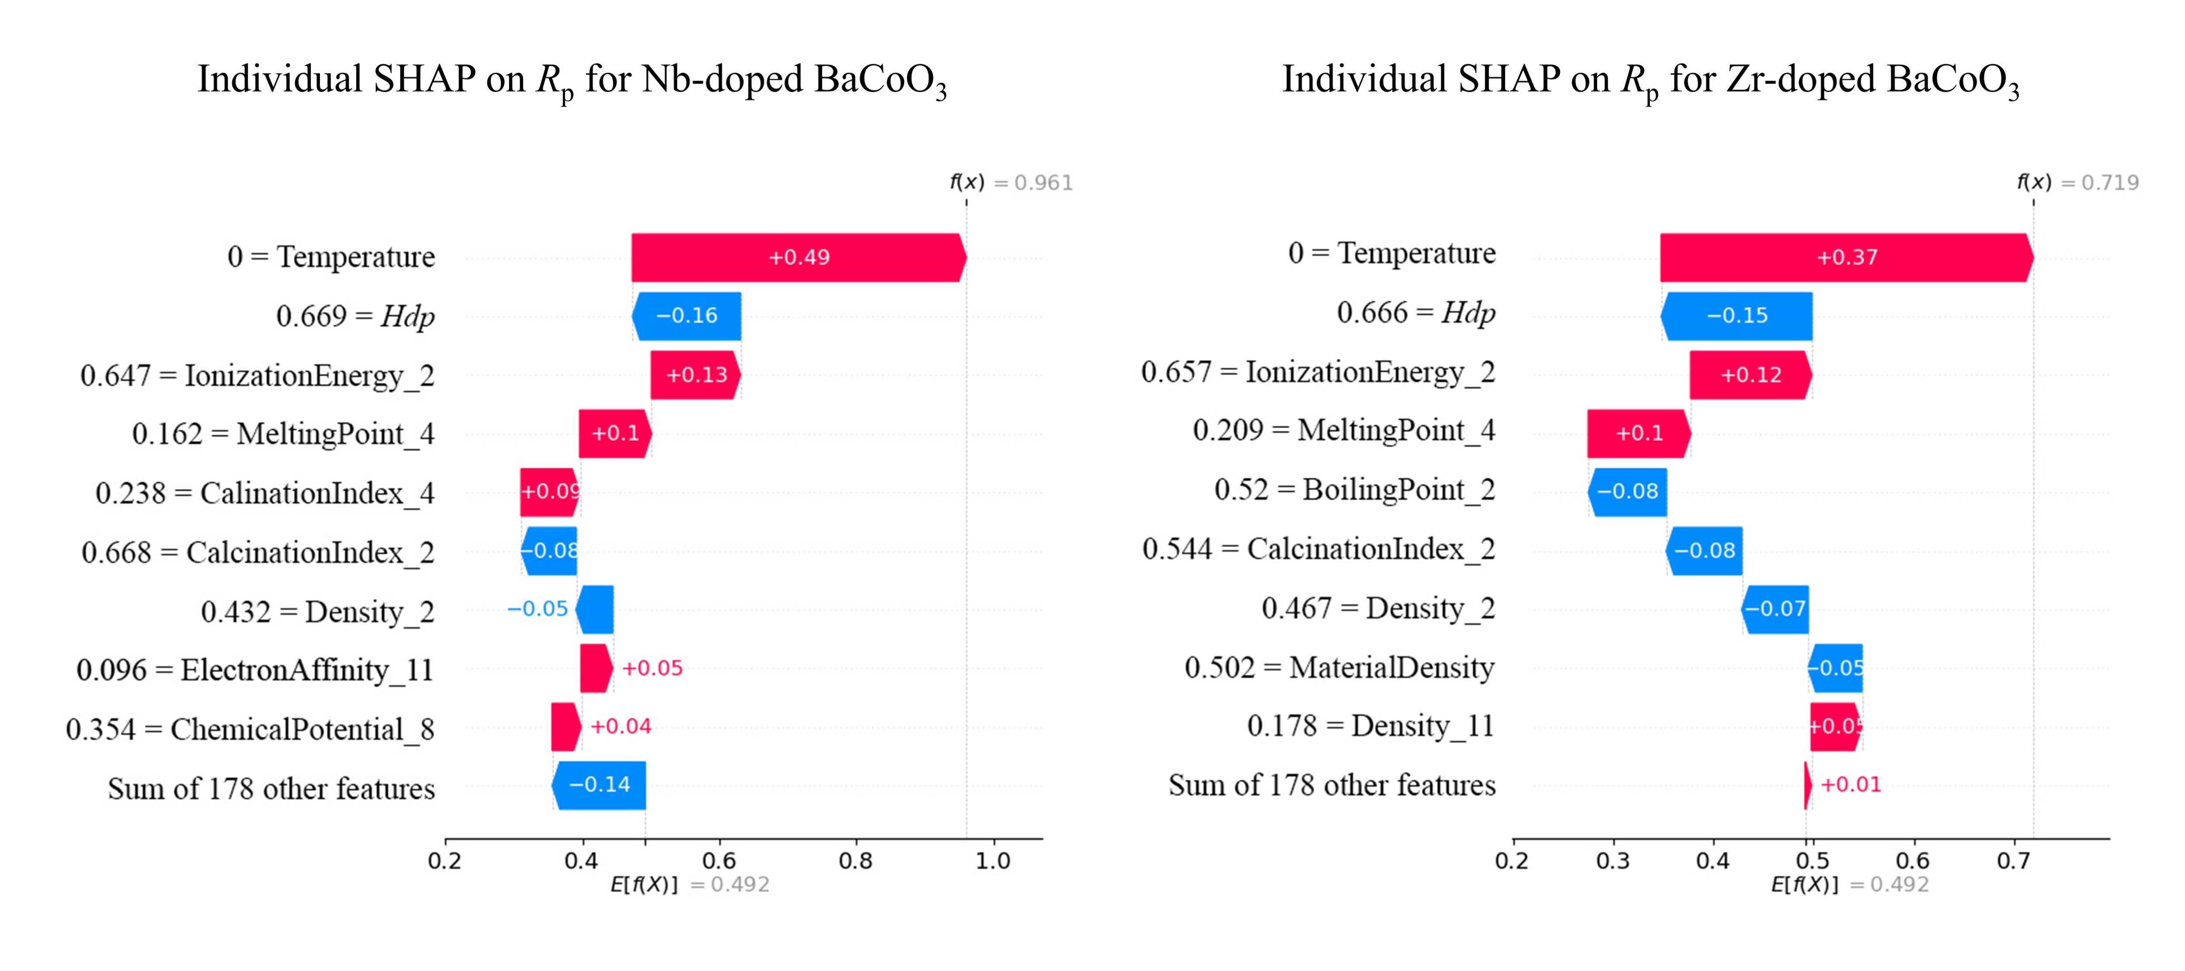
Figure 19. SHAP feature importance plot for R_{p} prediction of Nb-doped and Zr-doped BaCoO₃ candidates using the TSMS model.
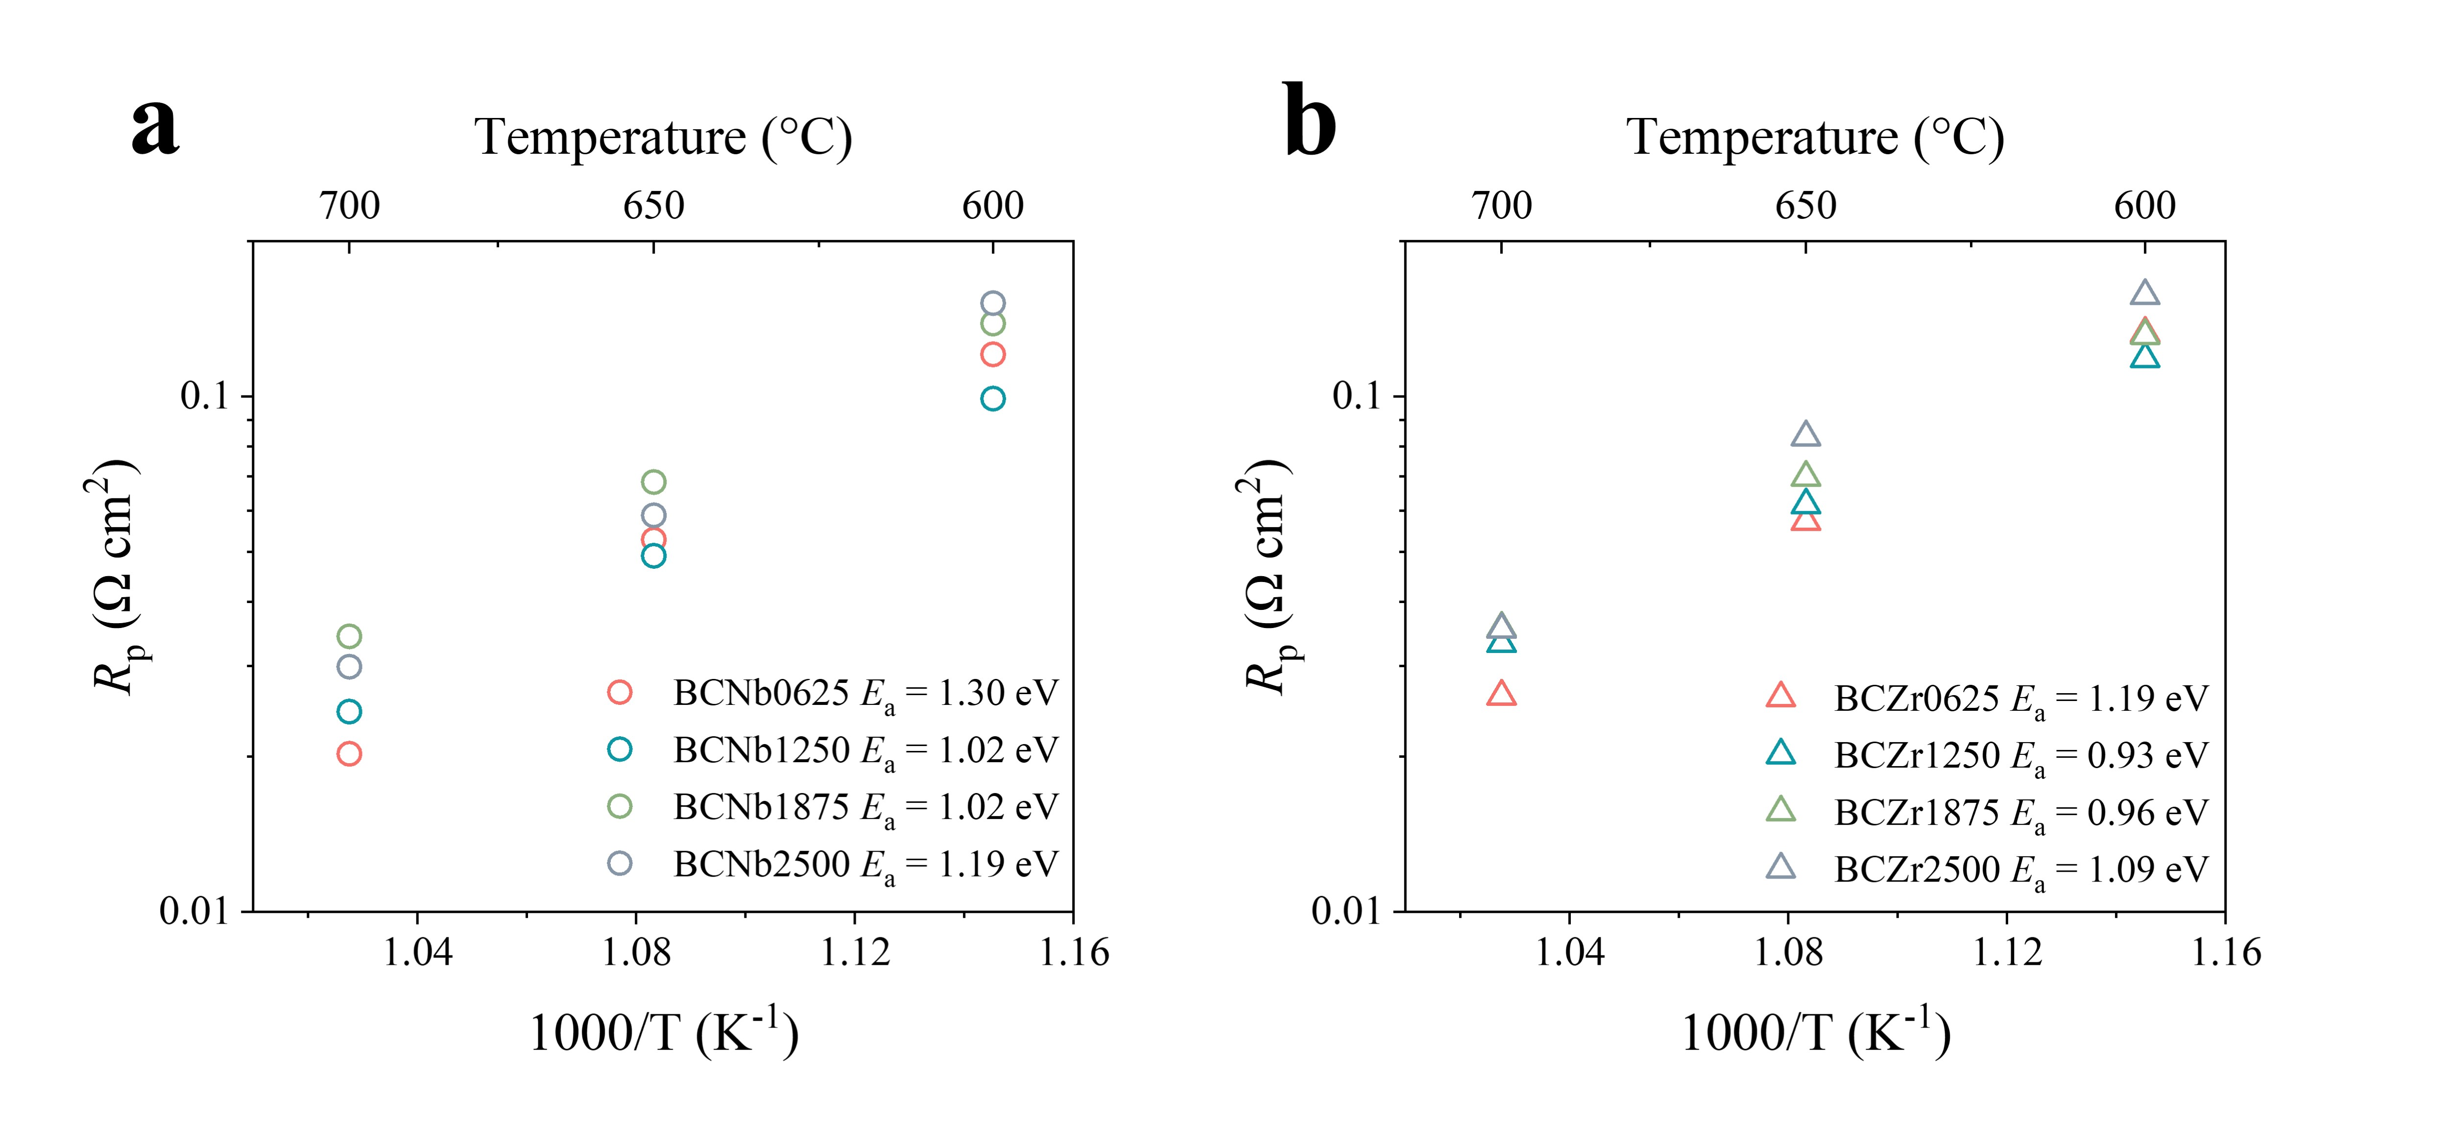
Figure 20. Experimentally obtained R_{p} values for Nb-doped BaCoO₃ and Zr-doped BaCoO₃ candidates plotted in Arrhenius format.
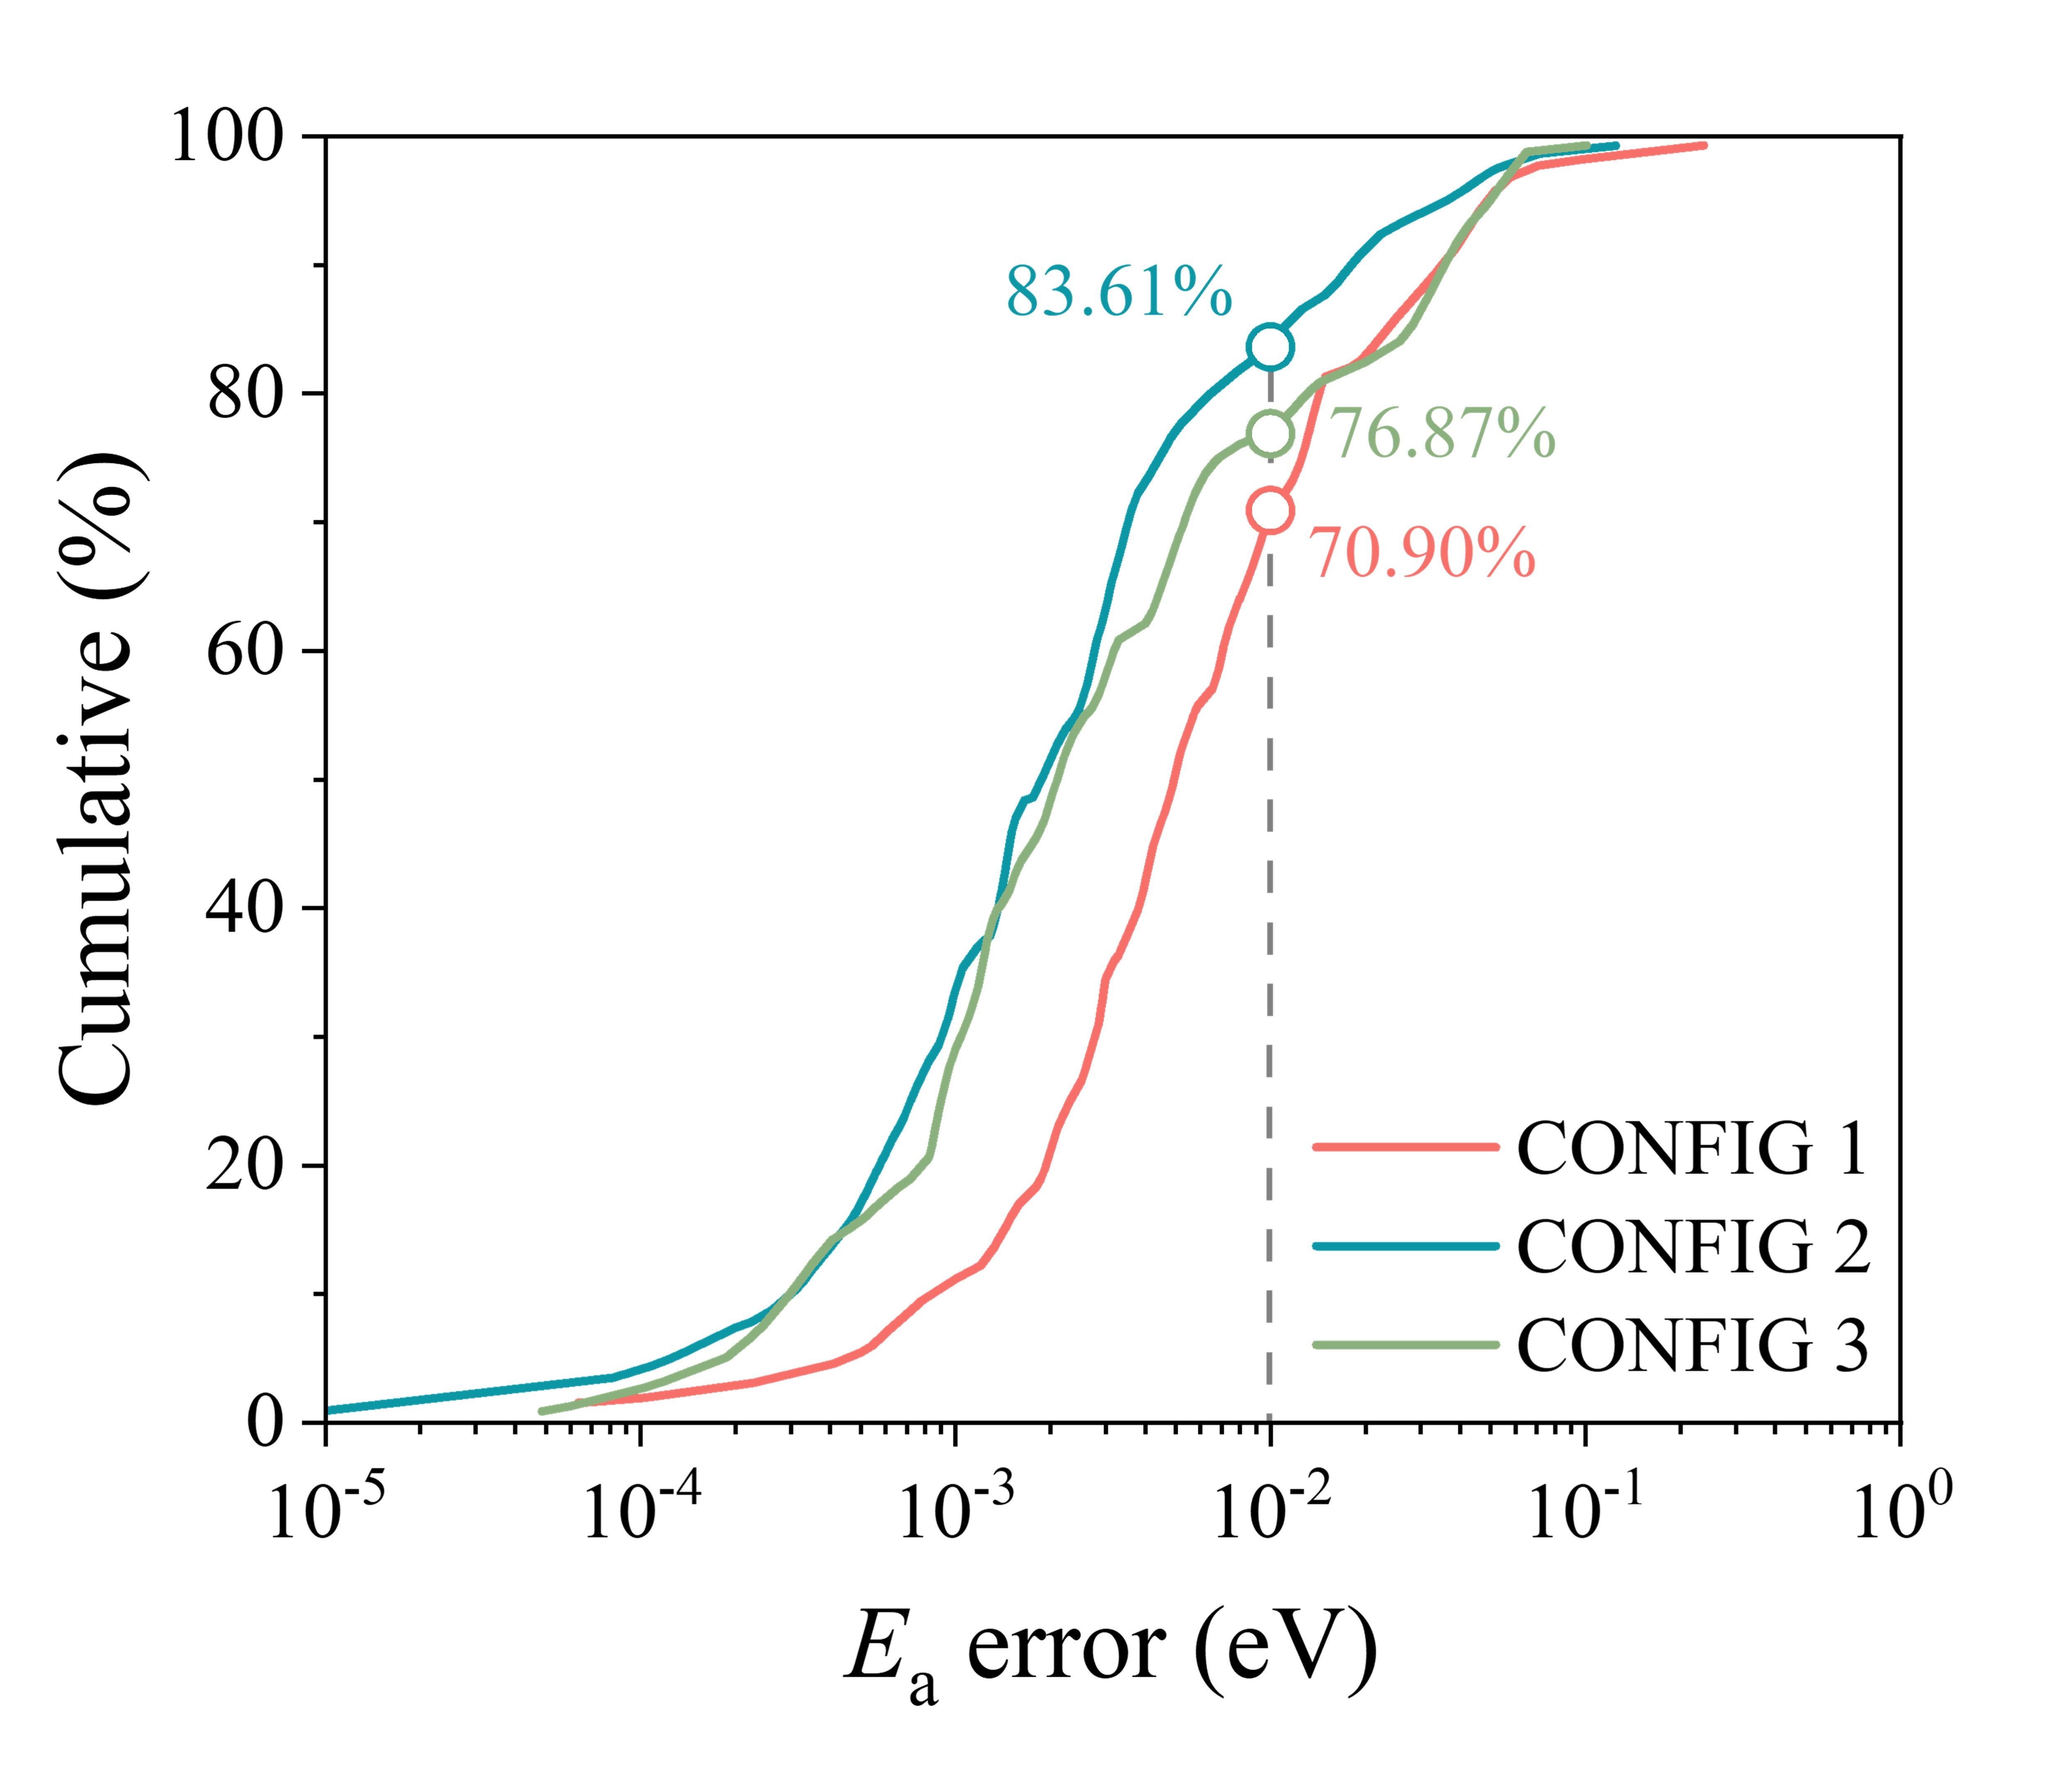
Figure 21. Cumulative error distribution comparison for E_{a} predictions across three SSAL model configurations.
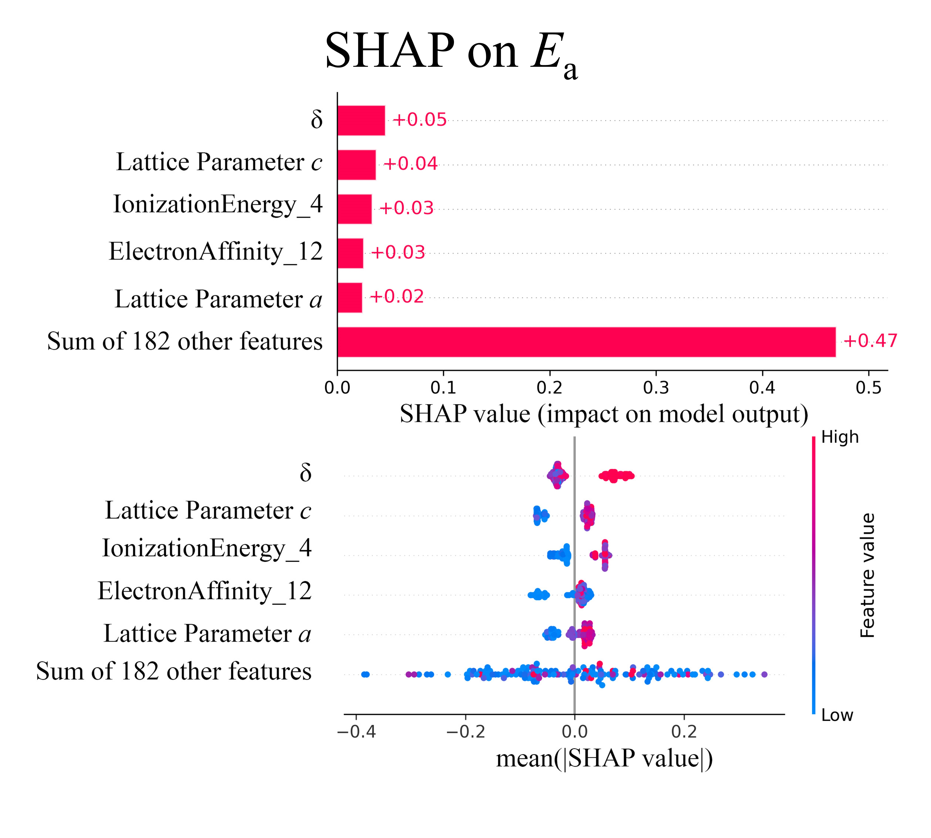
Figure 22. SHAP feature importance plot and beeswarm plot for E_{a} prediction using the SSAL model.
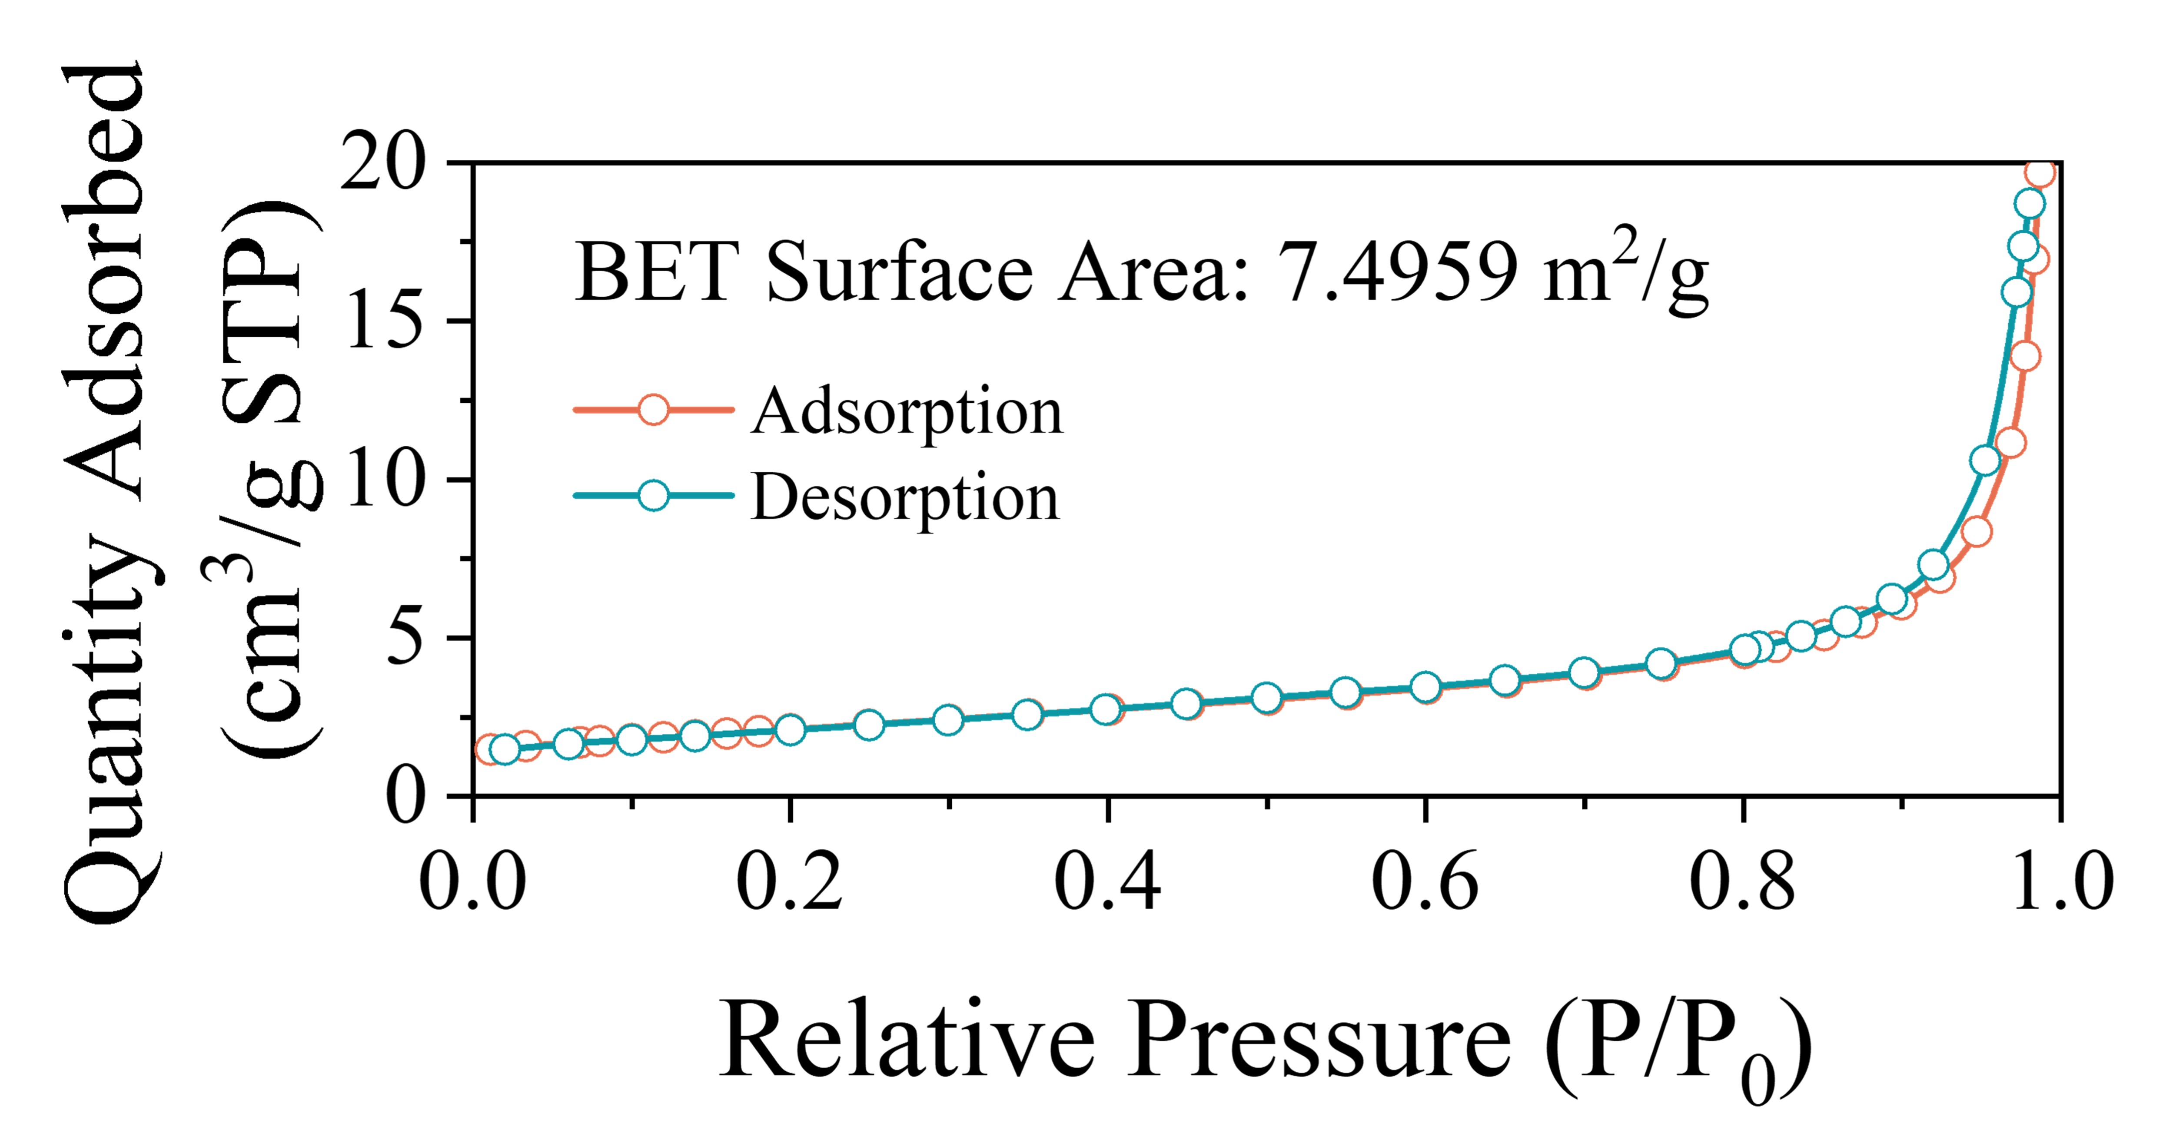
Figure 23. BET analysis results - adsorption and desorption isotherms of BCNZ20.
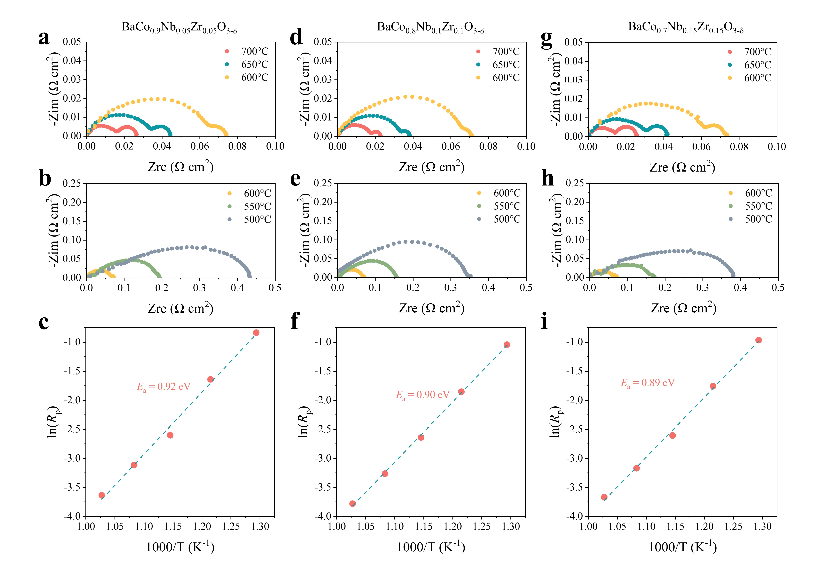
Figure 24. Summary of EIS results for SDC symmetrical cells with (a-c) BCNZ10, (d-f) BCNZ20, and (g-i) BCNZ30 across temperature from 700°C to 500°C, along with the activation energy derived from Arrhenius relationship.
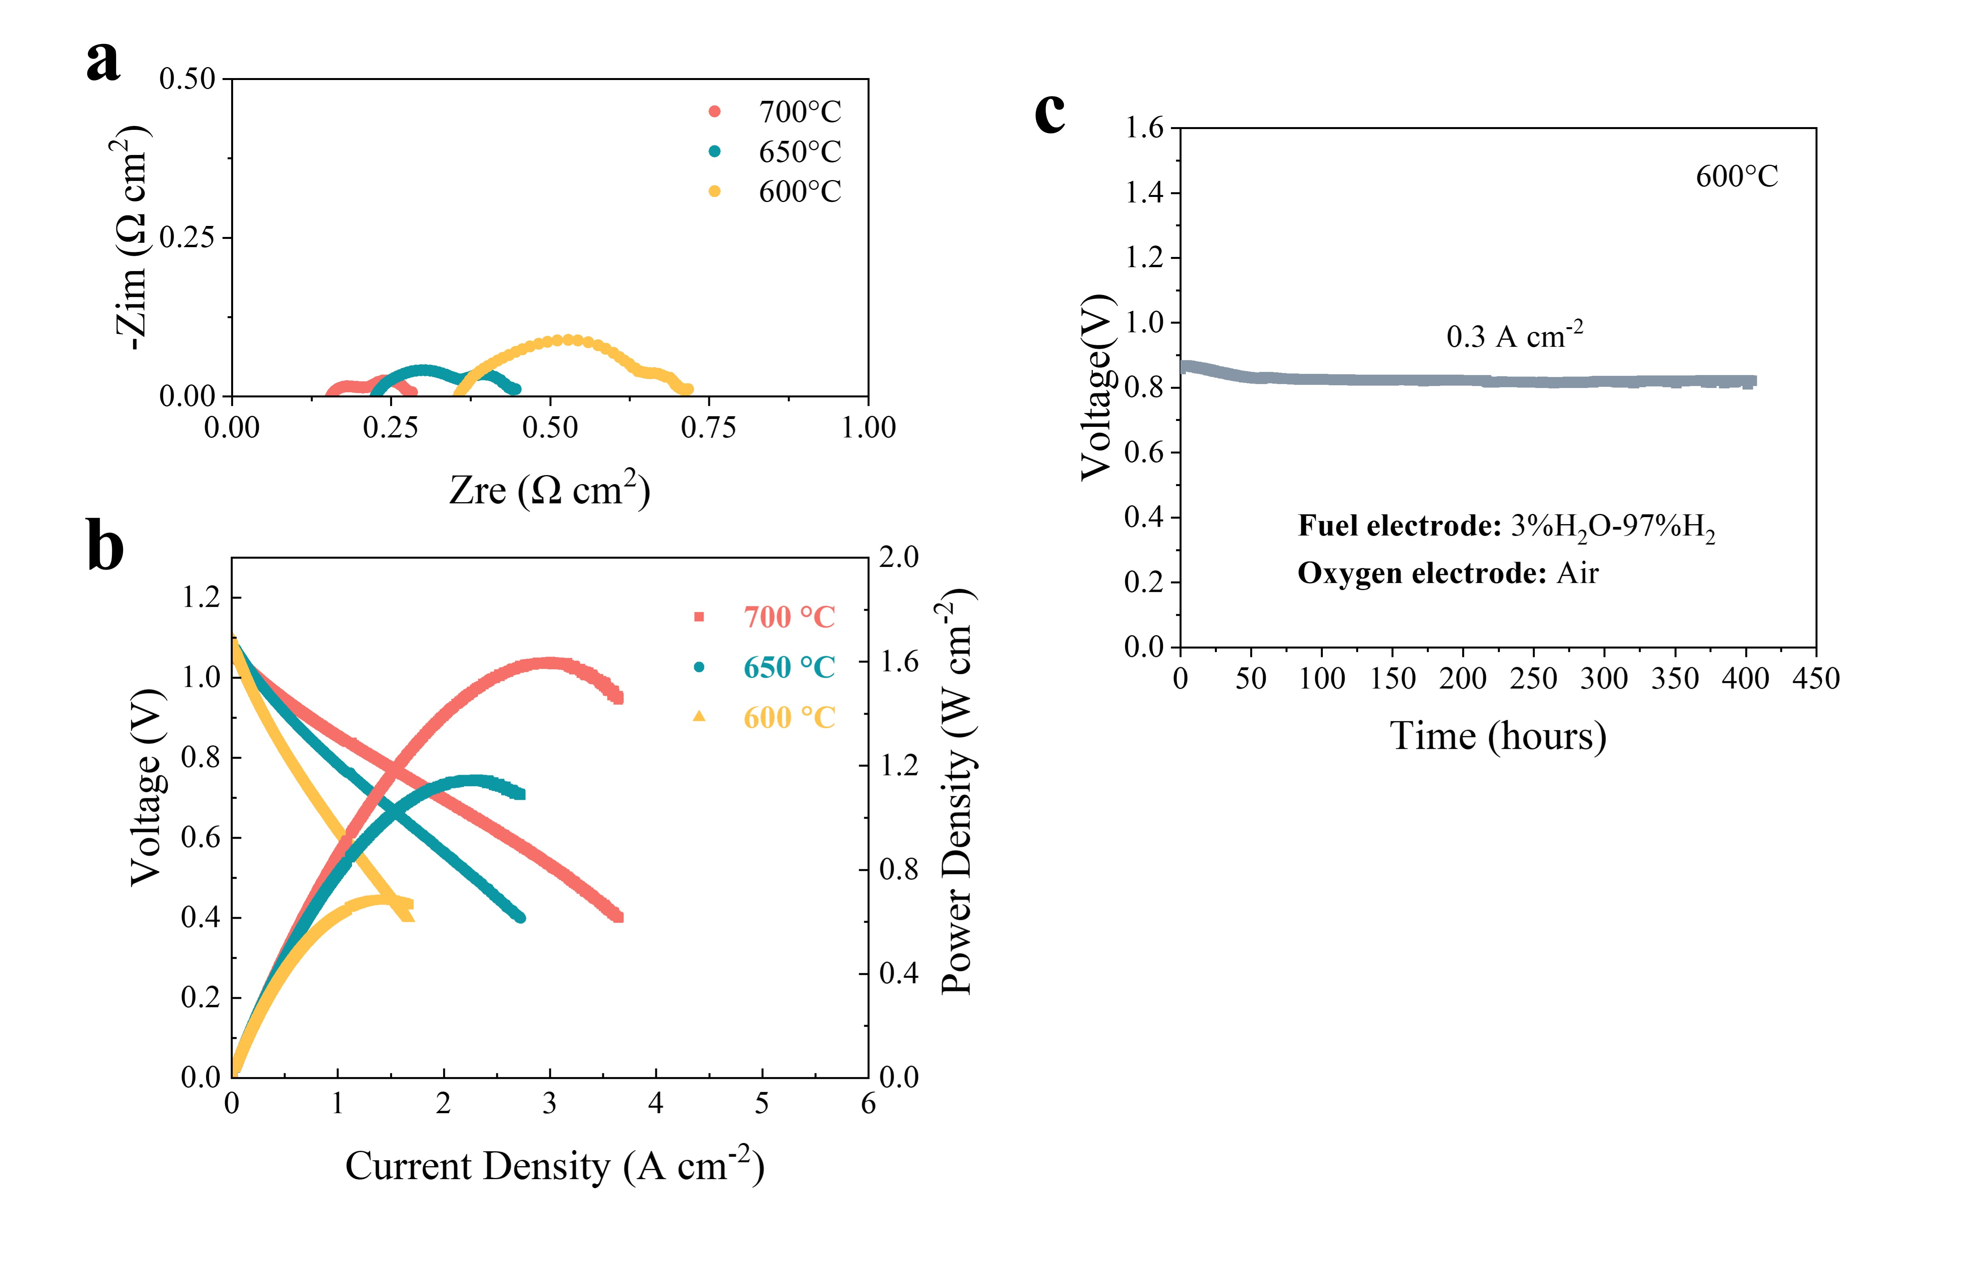
Figure 25. (a) Electrochemical impedance spectroscopy (EIS) plots and (b) Typical I-V-P curves for a BCNZ20/SDC/YSZ/YSZ-NiO single cell measured at 700-600 °C. (c) Long-term galvanostatic tests of a BCNZ20/SDC/YSZ/YSZ-NiO single cell at 600 °C under fuel cell mode with a current density of 0.3 A cm⁻².
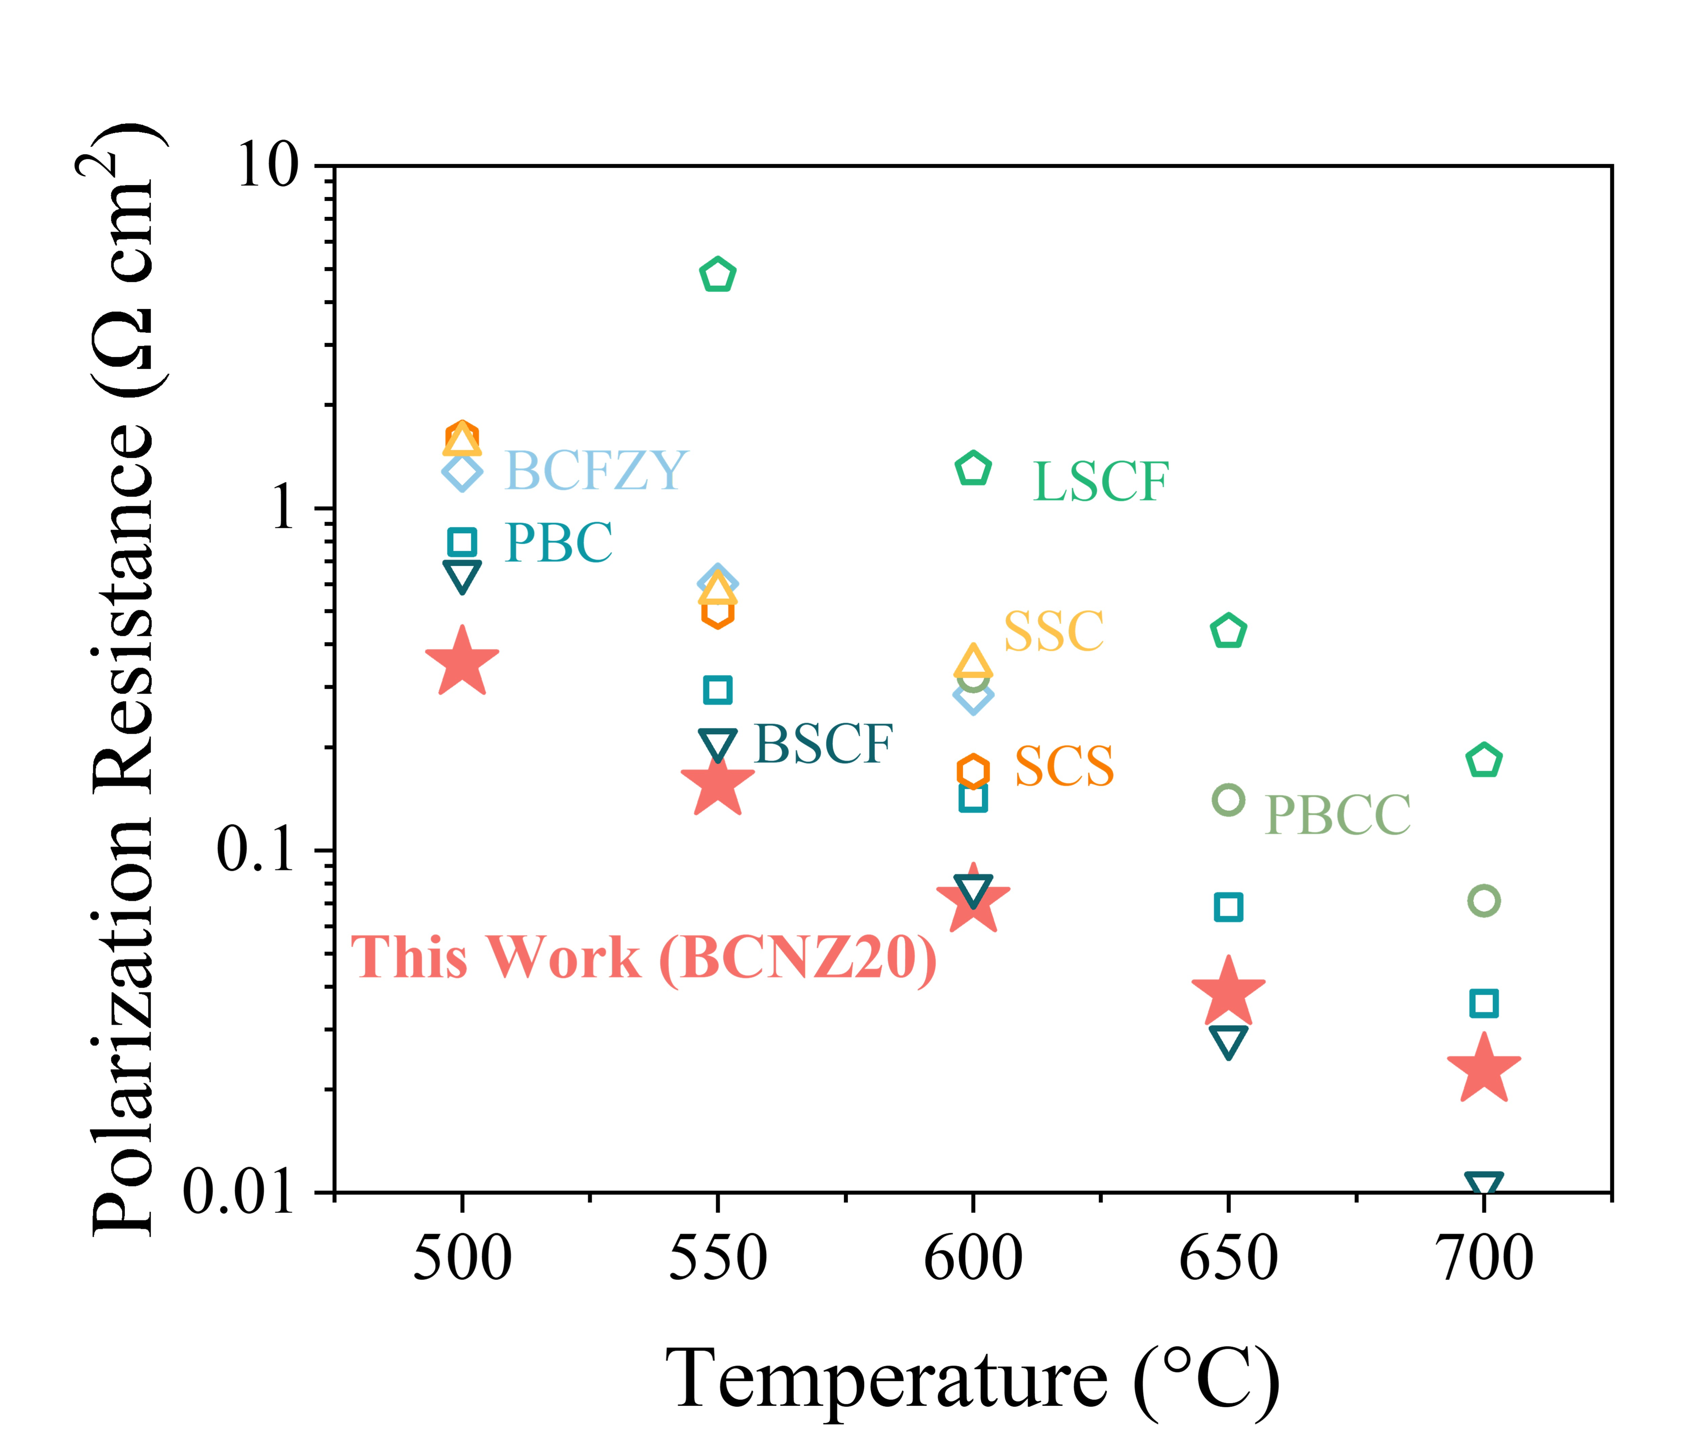
Figure 26. Comparative analysis of R_{p} for SDC symmetrical cells at 700–500 °C, highlighting SOTA oxygen electrodes: La_{0.6}Sr_{0.4}Co_{0.2}Fe_{0.8}O_{3-δ} (LSCF)¹, Ba_{0.5}Sr_{0.5}Co_{0.8}Fe_{0.2}O_{3-δ} (BSCF)², Sm_{0.5}Sr_{0.5}CoO_{3-δ} (SSC)³, BaCo_{0.4}Fe_{0.4}Zr_{0.1}Y_{0.1}O_{3-δ} (BCFZY)⁴, and PrBaCo₂O_{5+δ} (PBC)²², PrBa_{0.8}Ca_{0.2}Co₂O_{5+δ} (PBCC)²³, SrCo_{0.8125}Sb_{0.1875}O_{3-δ} (SCS)²⁴.
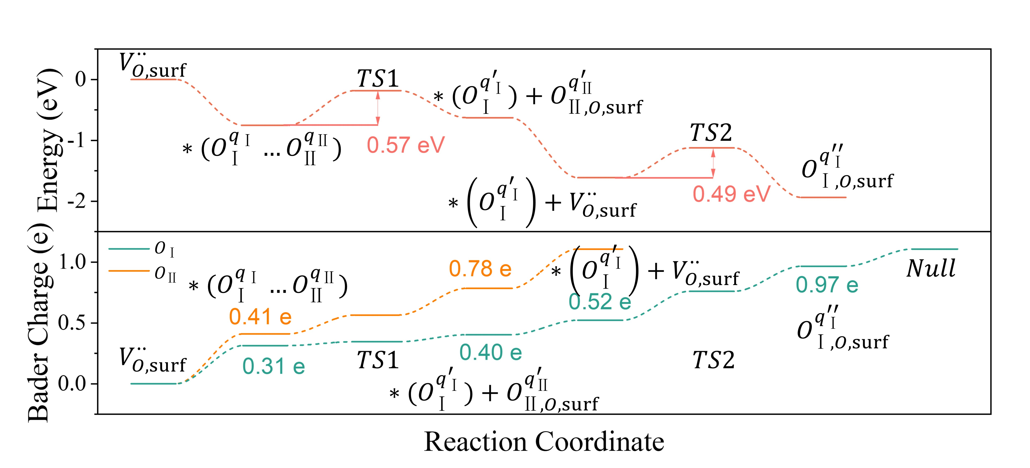
Figure 27. Energy profiles and Bader charge variations for oxygen atoms $O_{Ⅰ}$ and $O_{Ⅱ}$ during ORR on the BO₂-terminated (001) surface of BCNZ20.
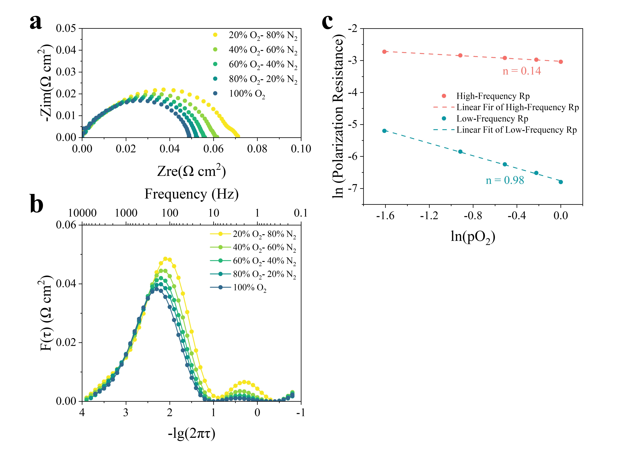
Figure 28. (a) EIS results for BCNZ20/SDC/BCNZ20 symmetrical cells at 600°C under various oxygen partial pressure. (b) DRT analysis of the results in (a). (c) Linear fitting of high- and low- frequency R_{p} values as functions of oxygen partial pressure.
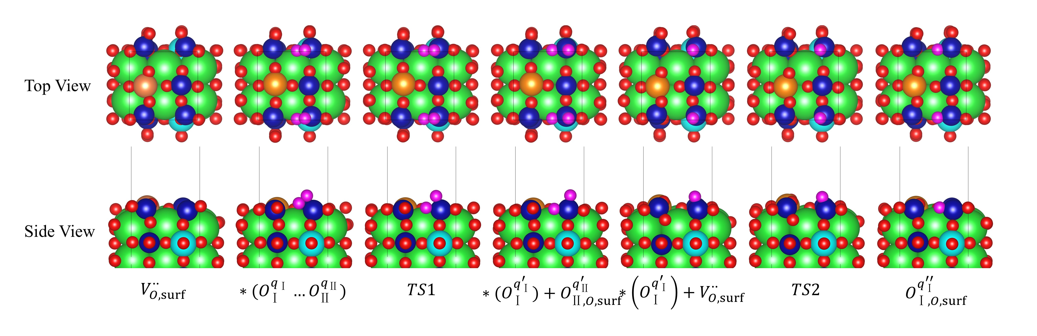
Figure 29. Top and side views of configurations during ORR on the BO₂-terminated (001) surface of BCNZ20.
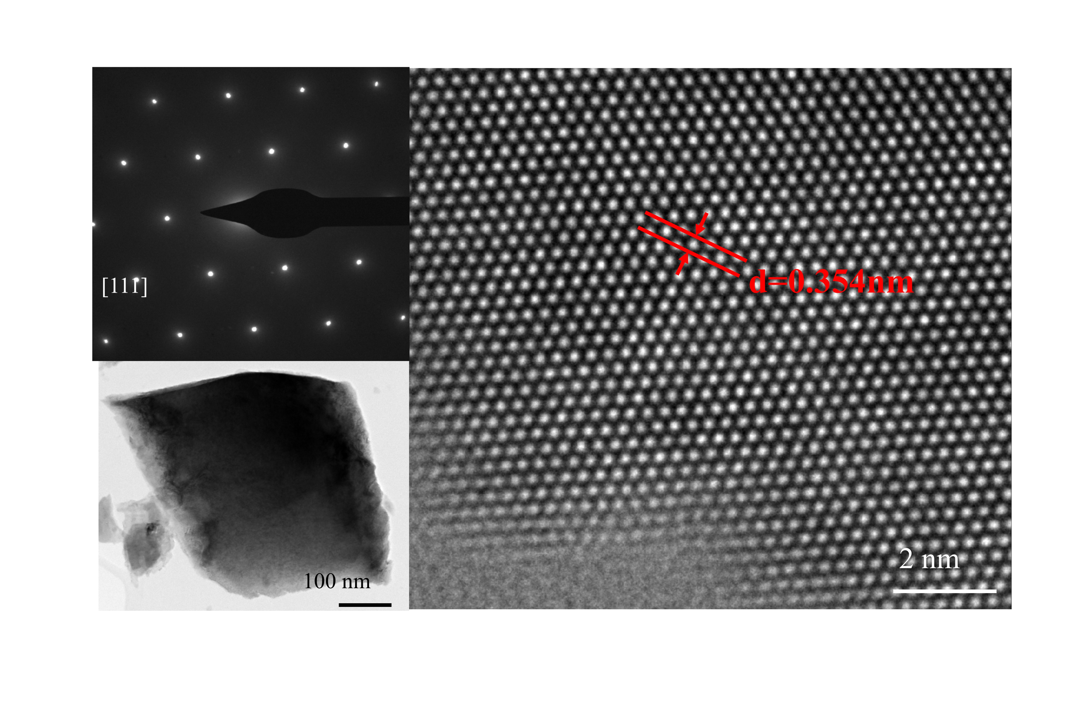
Figure 30. SAED pattern of BCNZ20 powder, captured along the [111] zone axis, aligned parallel to the electron beam.
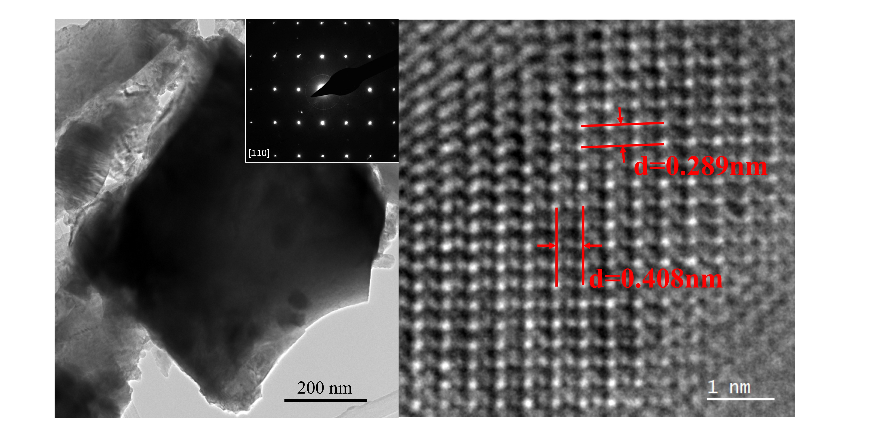
Figure 31. SAED pattern of BCNZ20 powder, captured along the [110] zone axis, aligned parallel to the electron beam.
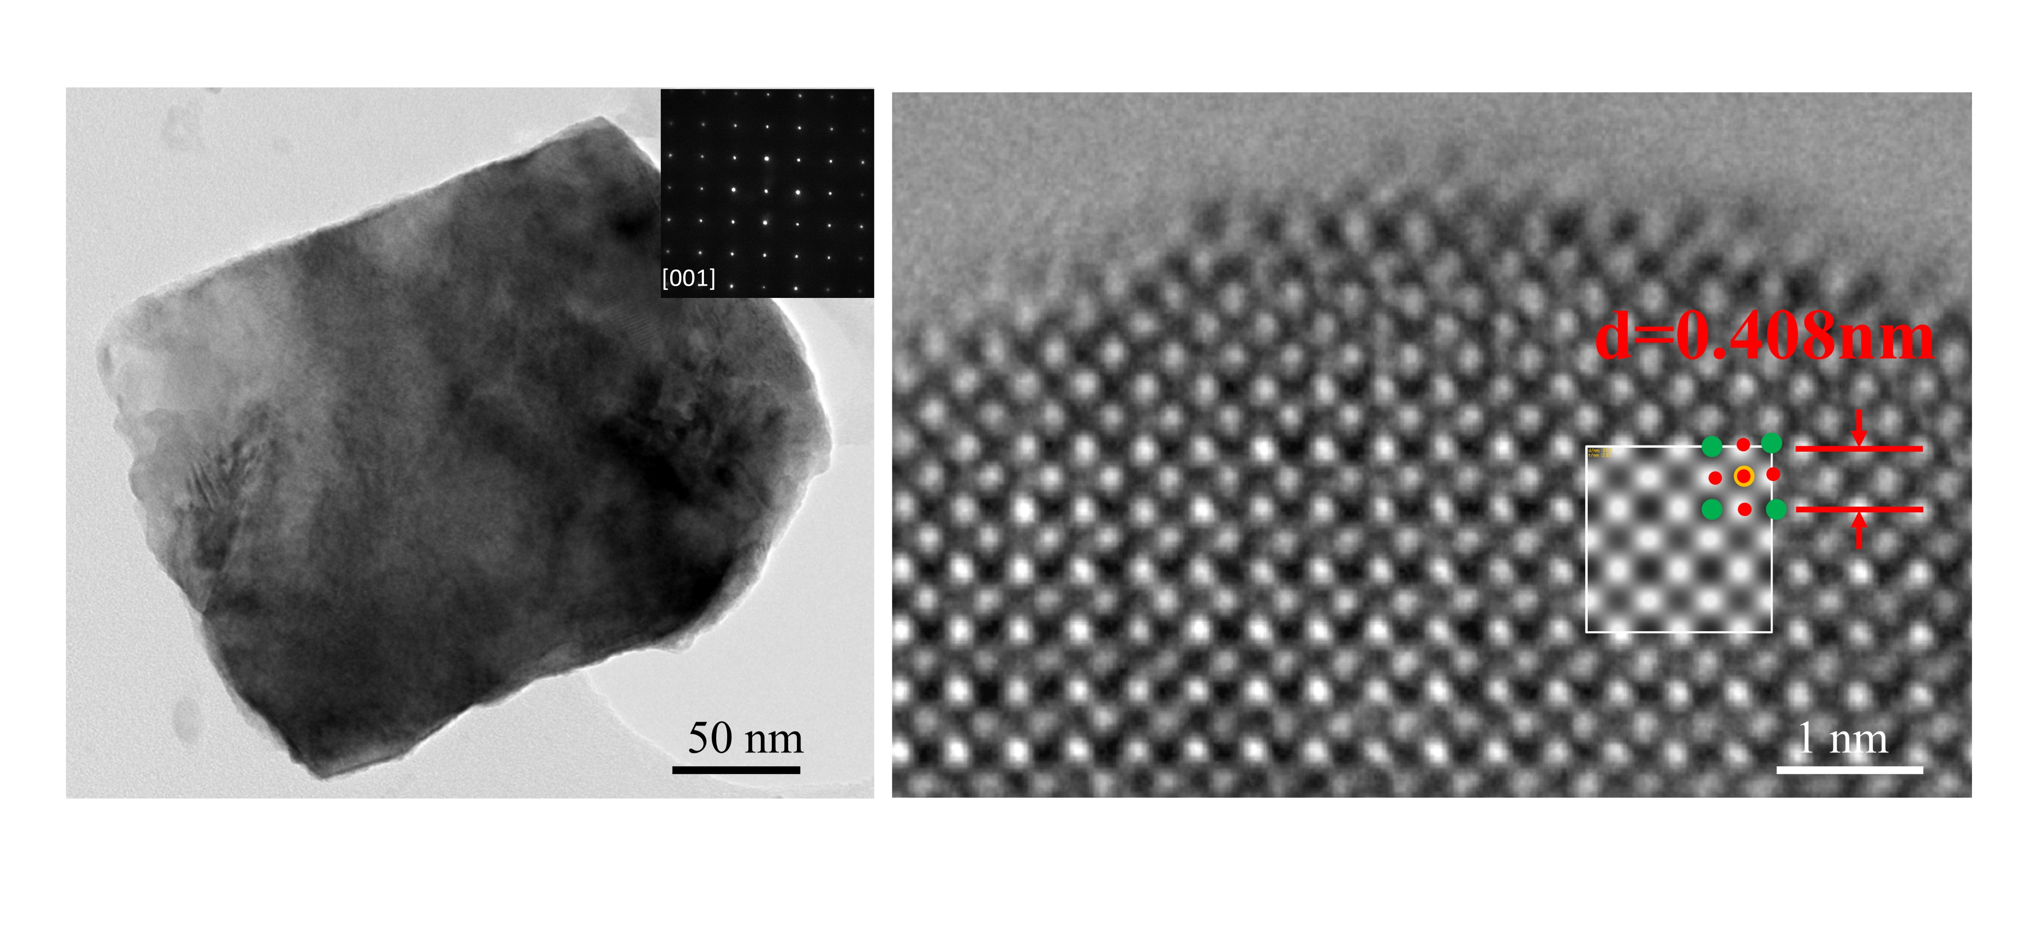
Figure 32. SAED pattern of BCNZ20 powder, captured along the [001] zone axis, aligned parallel to the electron beam.
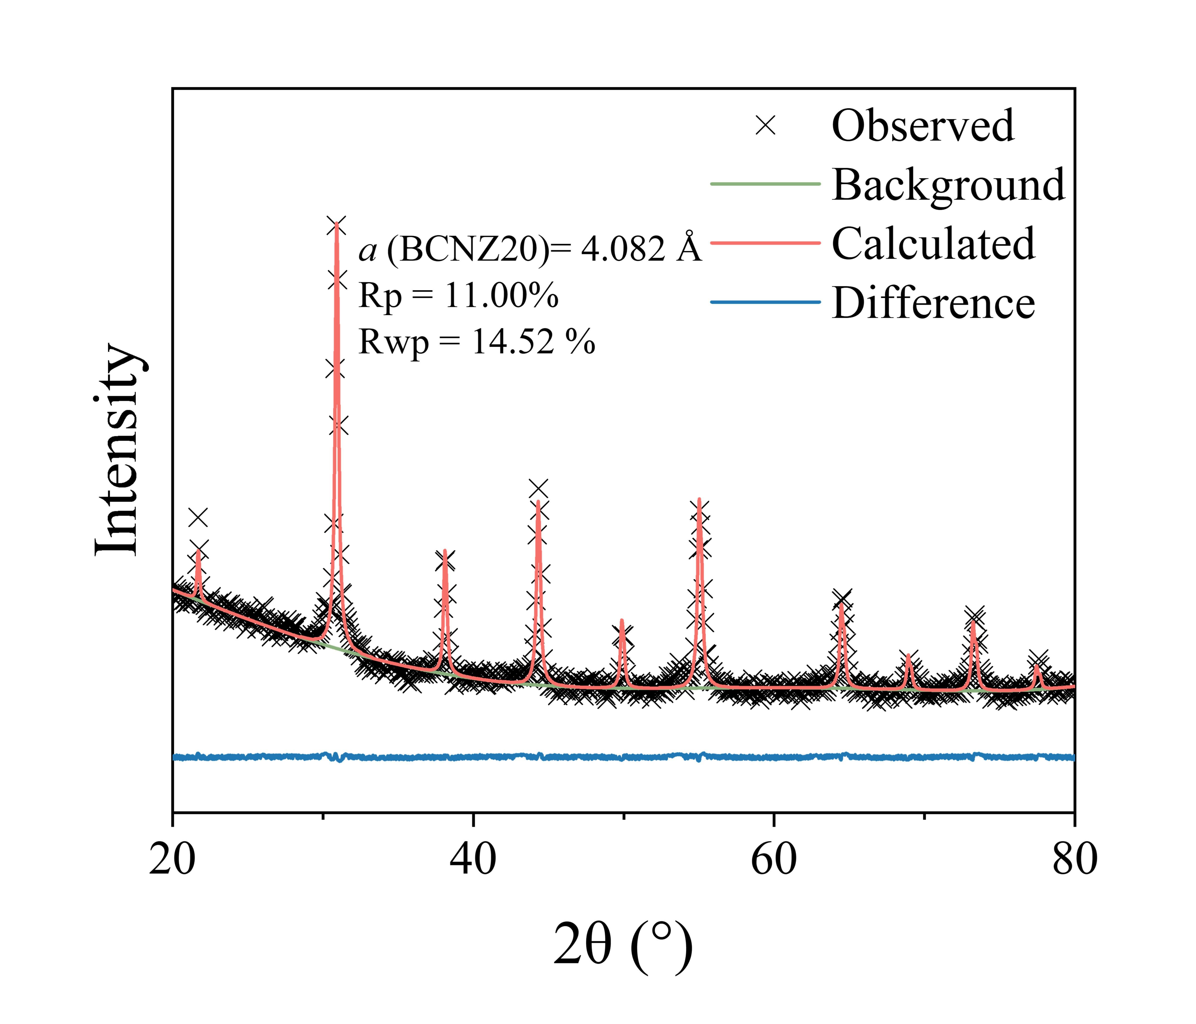
Figure 33. Rietveld refinement results of XRD patterns for BCNZ20.
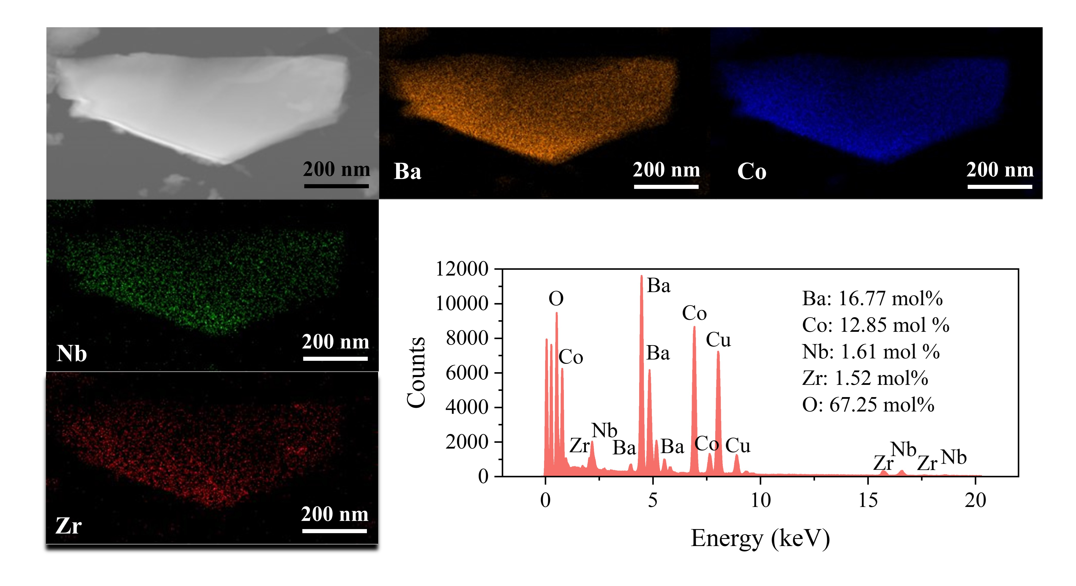
Figure 34. TEM image of BCNZ20 powder with corresponding EDS mapping and spectra.
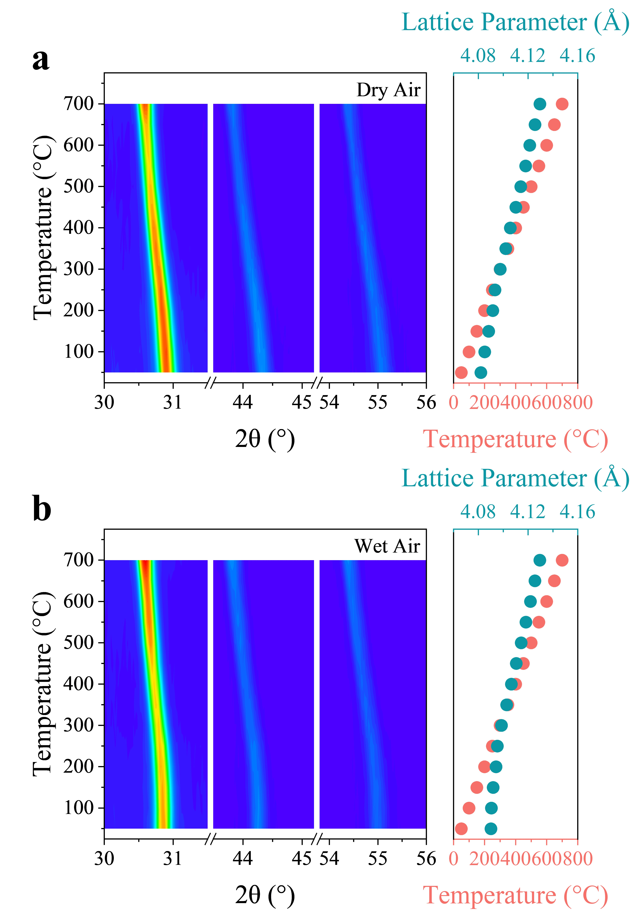
Figure 35. Contour plots of in-situ XRD patterns for BCNZ20 in (a) air and (b) wet air, with lattice parameters provided at different temperature.
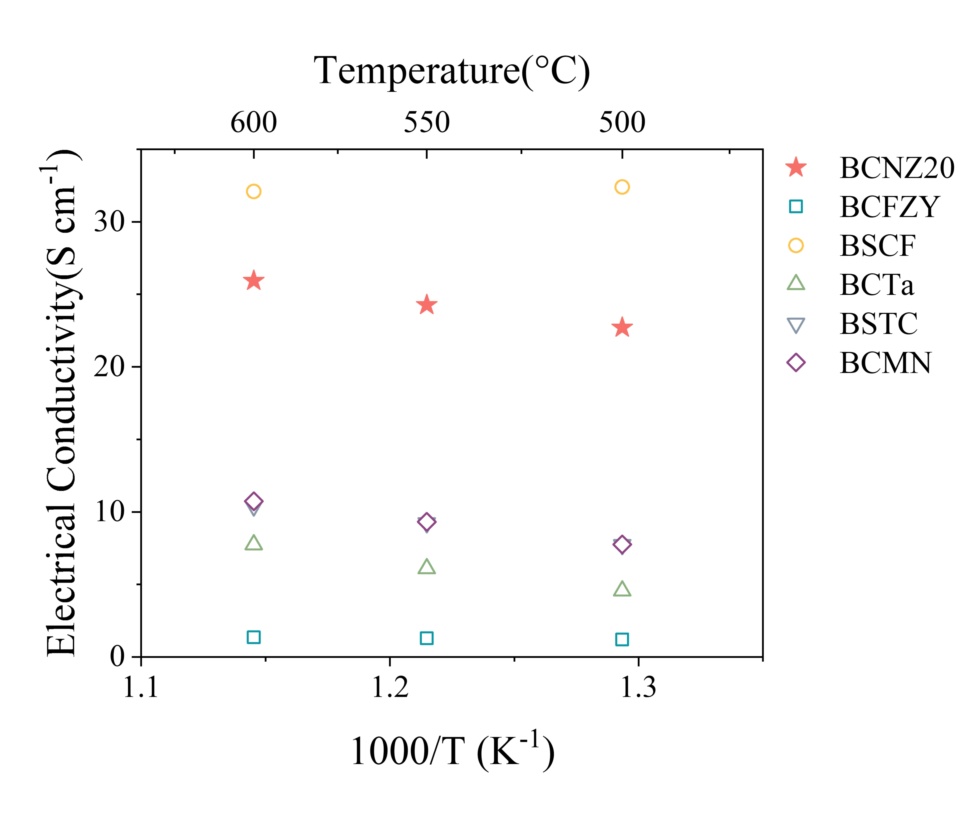
Figure 36. Comparison of the electrical conductivity between BCNZ20 and the SOTA materials: BaCo_{0.4}Fe_{0.4}Zr_{0.1}Y_{0.1}O_{3-δ} (BCFZY)⁴, Ba_{0.5}Sr_{0.5}Co_{0.8}Fe_{0.2}O_{3-δ} (BSCF)², BaCo_{0.8}Ta_{0.2}O_{3-δ} (BCTa)²⁵, BaSc_{0.1}Ta_{0.1}Co_{0.8}O_{3-δ} (BSTC)²⁶, Ba₂Co_{1.5}Mo_{0.25}Nb_{0.25}O_{6-δ} (BCNM)²⁷.
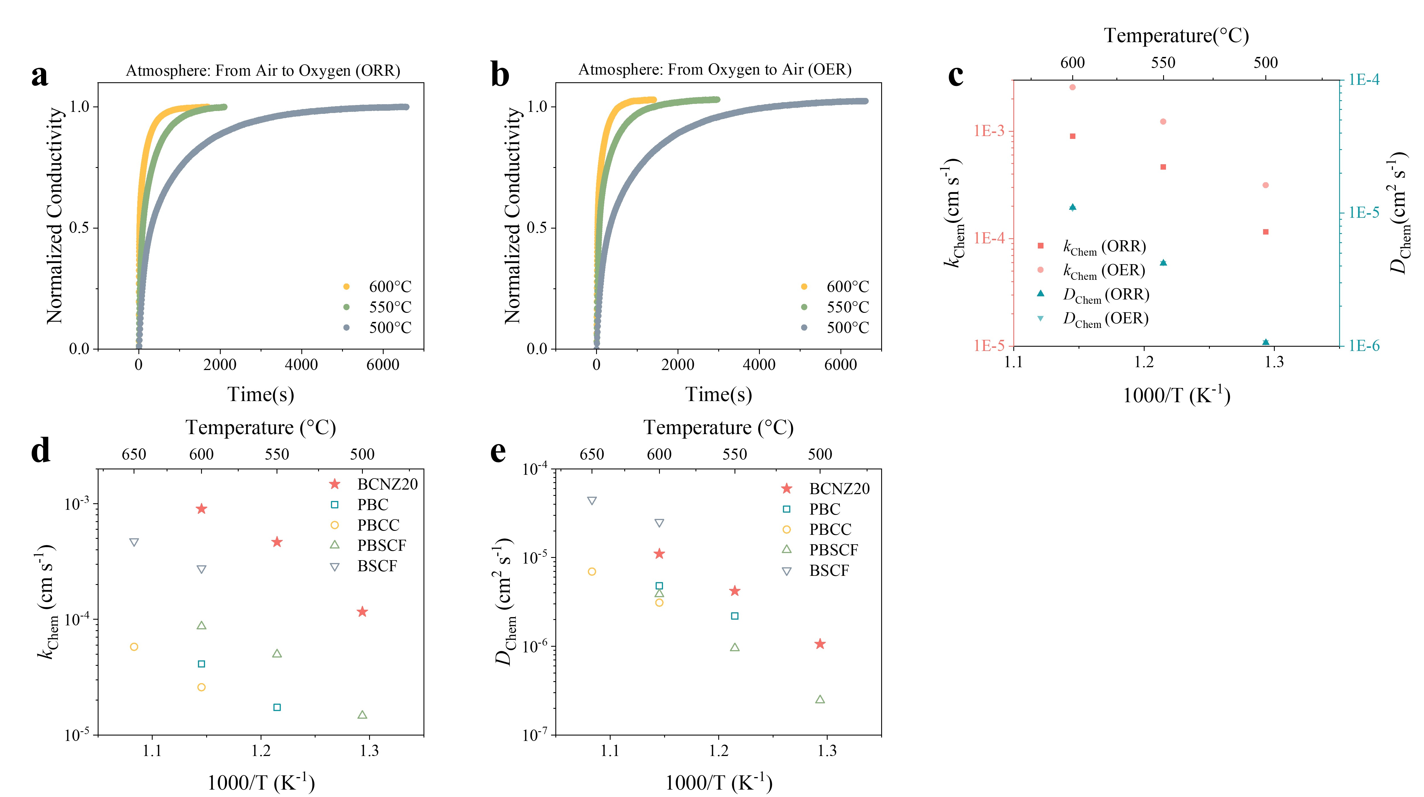
Figure 37. (a, b) Normalized conductivity curves for BCNZ20 measured during ECR experiments at 500-600 °C. (c) k_{Chem}, and D_{Chem} evaluated under elevated and reduced oxygen partial pressures. (d, e) Comparison of the k_{Chem}, and D_{Chem} between BCNZ20 and SOTA materials: PrBaCo₂O_{5+δ} (PBC)²², PrBa_{0.8}Ca_{0.2}Co₂O_{5+δ} (PBCC)²³, PrBa_{0.5}Sr_{0.5}Co_{1.5}Fe_{0.5}O_{5+δ} (PBSCF)⁵, Ba_{0.5}Sr_{0.5}Co_{0.8}Fe_{0.2}O_{3-δ} (BSCF)².
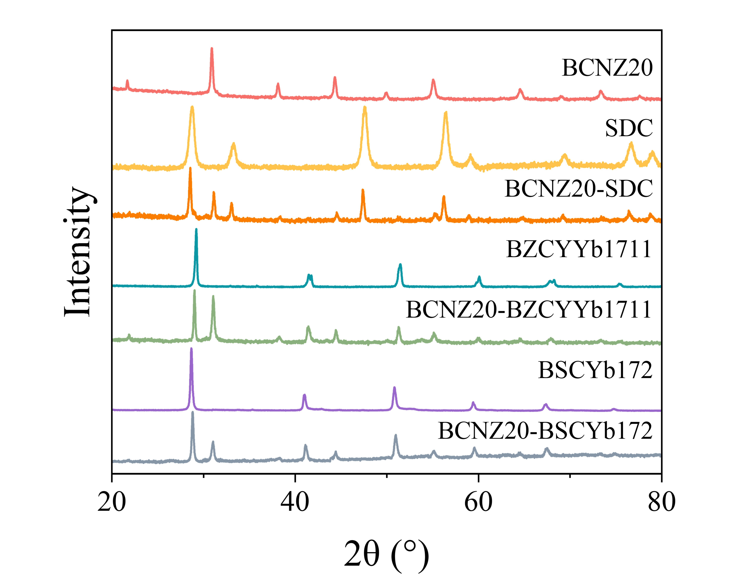
Figure 38. XRD patterns demonstrating the chemical compatibility of BCNZ20 with SDC, BZCYYb1711, and BSCYb172 electrolytes.
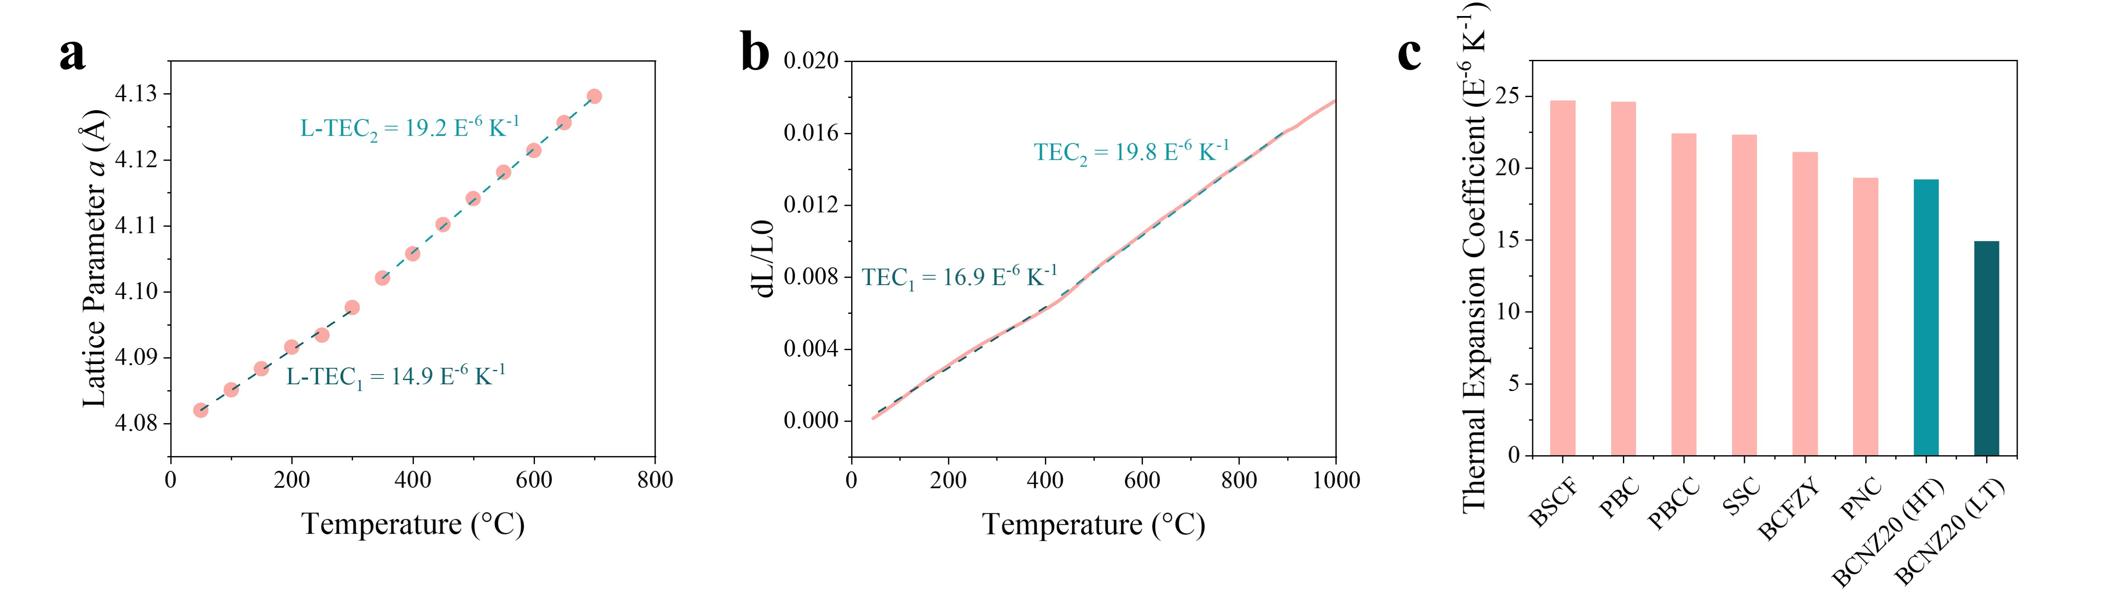
Figure 39. Lattice expansion curves for BCNZ20 from in-situ XRD measurements and thermal expansion curves from strip samples Comparison of TEC between BCNZ20 and the SOTA materials: Ba_{0.5}Sr_{0.5}Co_{0.8}Fe_{0.2}O_{3-δ} (BSCF)², PrBaCo₂O_{5+δ} (PBC)²², PrBa_{0.8}Ca_{0.2}Co₂O_{5+δ} (PBCC)²³, Sm_{0.5}Sr_{0.5}CoO_{3-δ} (SSC)³, BaCo_{0.4}Fe_{0.4}Zr_{0.1}Y_{0.1}O_{3-δ} (BCFZY)⁴, PrNi_{0.5}Co_{0.5}O_{3-δ} (PNC)²⁸.
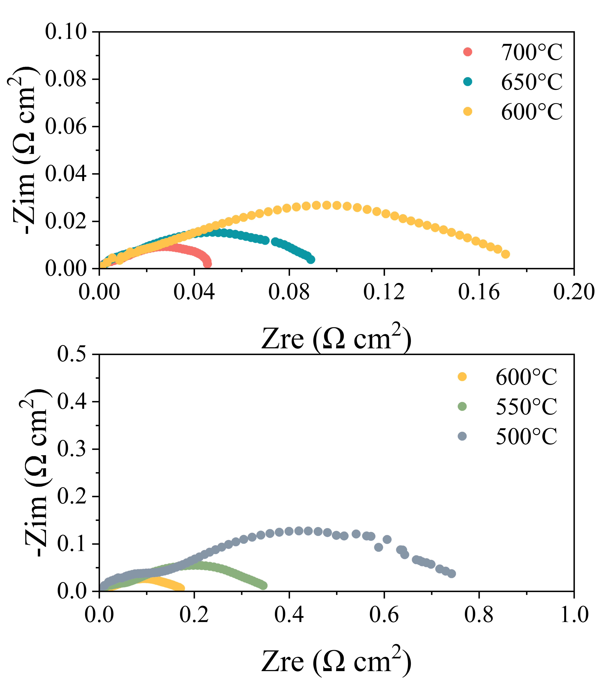
Figure 40. EIS results for BNCZ20/BZCYYb1711/BCNZ20 symmetrical cells from 700°C to 500°C.
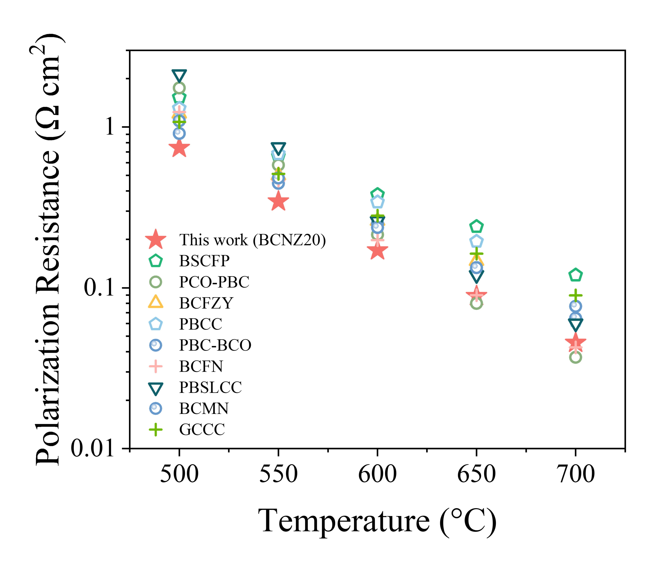
Figure 41. Comparative analysis of R_{p} for BZCYYb1711 symmetrical cells at 700–500 °C, highlighting SOTA oxygen electrodes: Ba_{0.5}Sr_{0.5}(Co_{0.8}Fe_{0.2})_{0.95}P_{0.05}O_{3-δ} (BSCFP)²⁹, Pr_{0.1}Ce_{0.9}O_{2-δ}-PrBaCo₂O_{5+δ} (PCO-PBC)³⁰, BaCo_{0.4}Fe_{0.4}Zr_{0.1}Y_{0.1}O_{3-δ} (BCFZY)³¹, PrBa_{0.8}Ca_{0.2}Co₂O_{5+δ} (PBCC)²³, PrBaCo₂O_{5+δ}-BaCoO_{3-δ} (PBC-BCO)³², Ba_{0.9}Co_{0.7}Fe_{0.2}Nb_{0.1}O_{3-δ} (BCFN)³³, Pr_{0.2}Ba_{0.2}Sr_{0.2}La_{0.2}Ca_{0.2}CoO_{3-δ} (PBSLCC)³⁴, Ba₂Co_{1.5}Mo_{0.25}Nb_{0.25}O_{6-δ} (BCMN)³⁵, Gd_{0.3}Ca_{2.7}Co_{3.82}Cu_{0.18}O_{9-δ} (GCCC)³⁶.
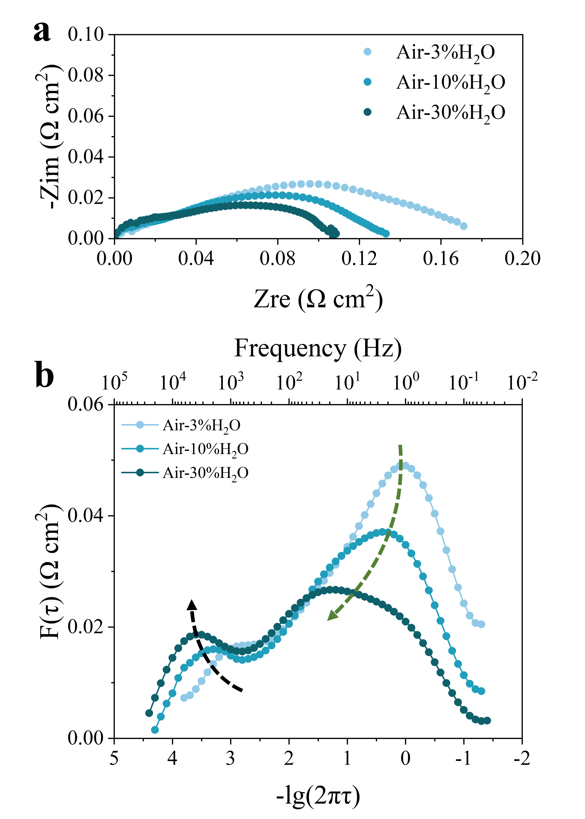
Figure 42. (a) EIS results for BCNZ20/BZCYYb1711/BCNZ20 symmetrical cells at 600 °C under various water vapor pressures. (b) DRT analysis of the EIS results in (a), focusing on the identification of each elementary step.
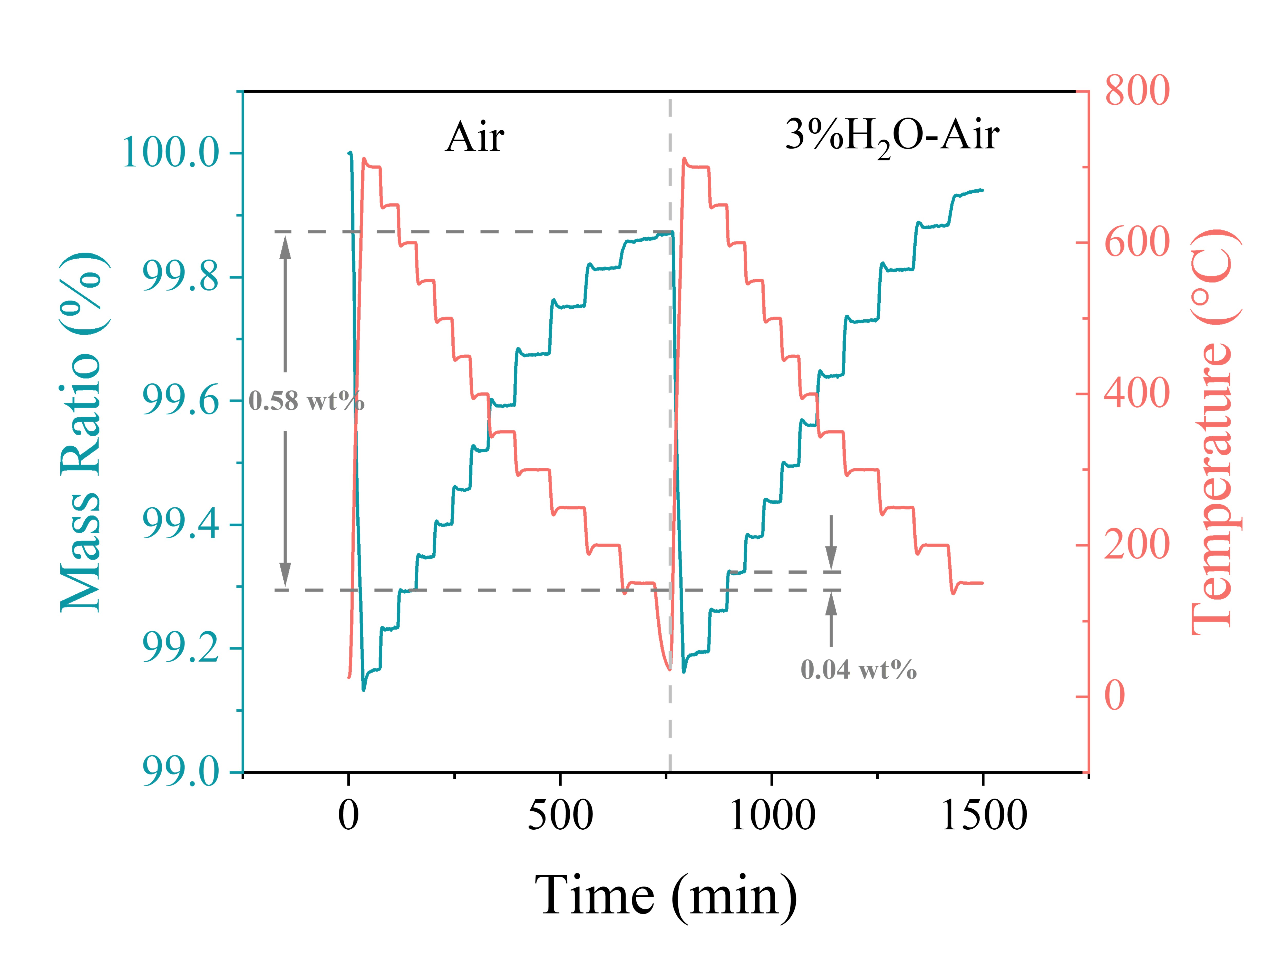
Figure 43. Programmed thermogravimetric analysis of BCNZ20.
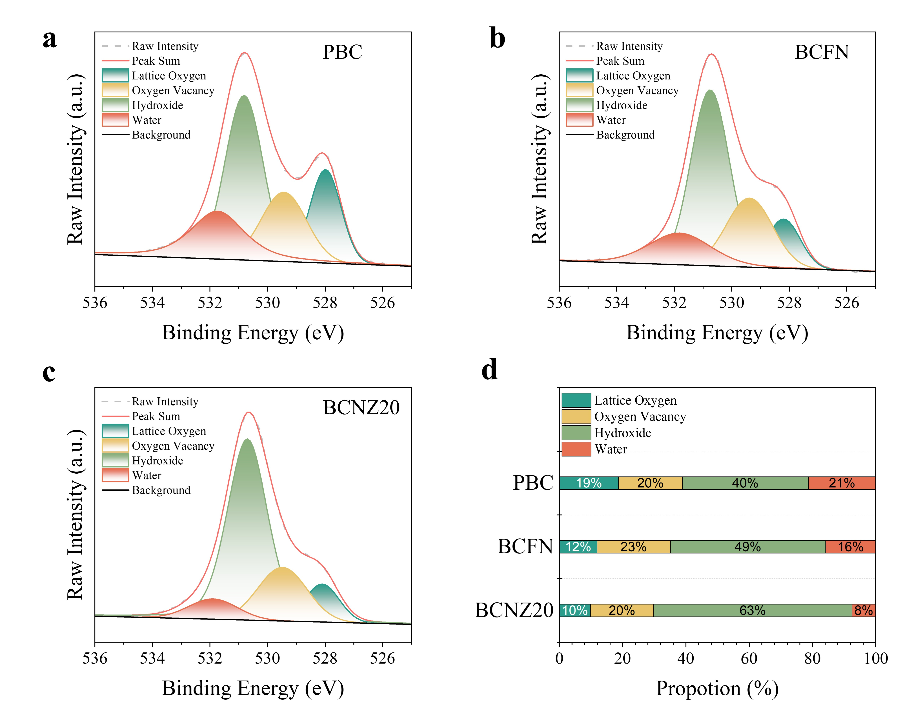
Figure 44. XPS analysis of surface O 1s spectra for (a) PBC, (b) BCFN, and (c) BCNZ20 powders, which underwent a 24-hour pretreatment in wet air immediately prior to the XPS analysis. (d) Comparative analysis of each surface oxygen-related species among PBC, BCFN, and BCNZ20.
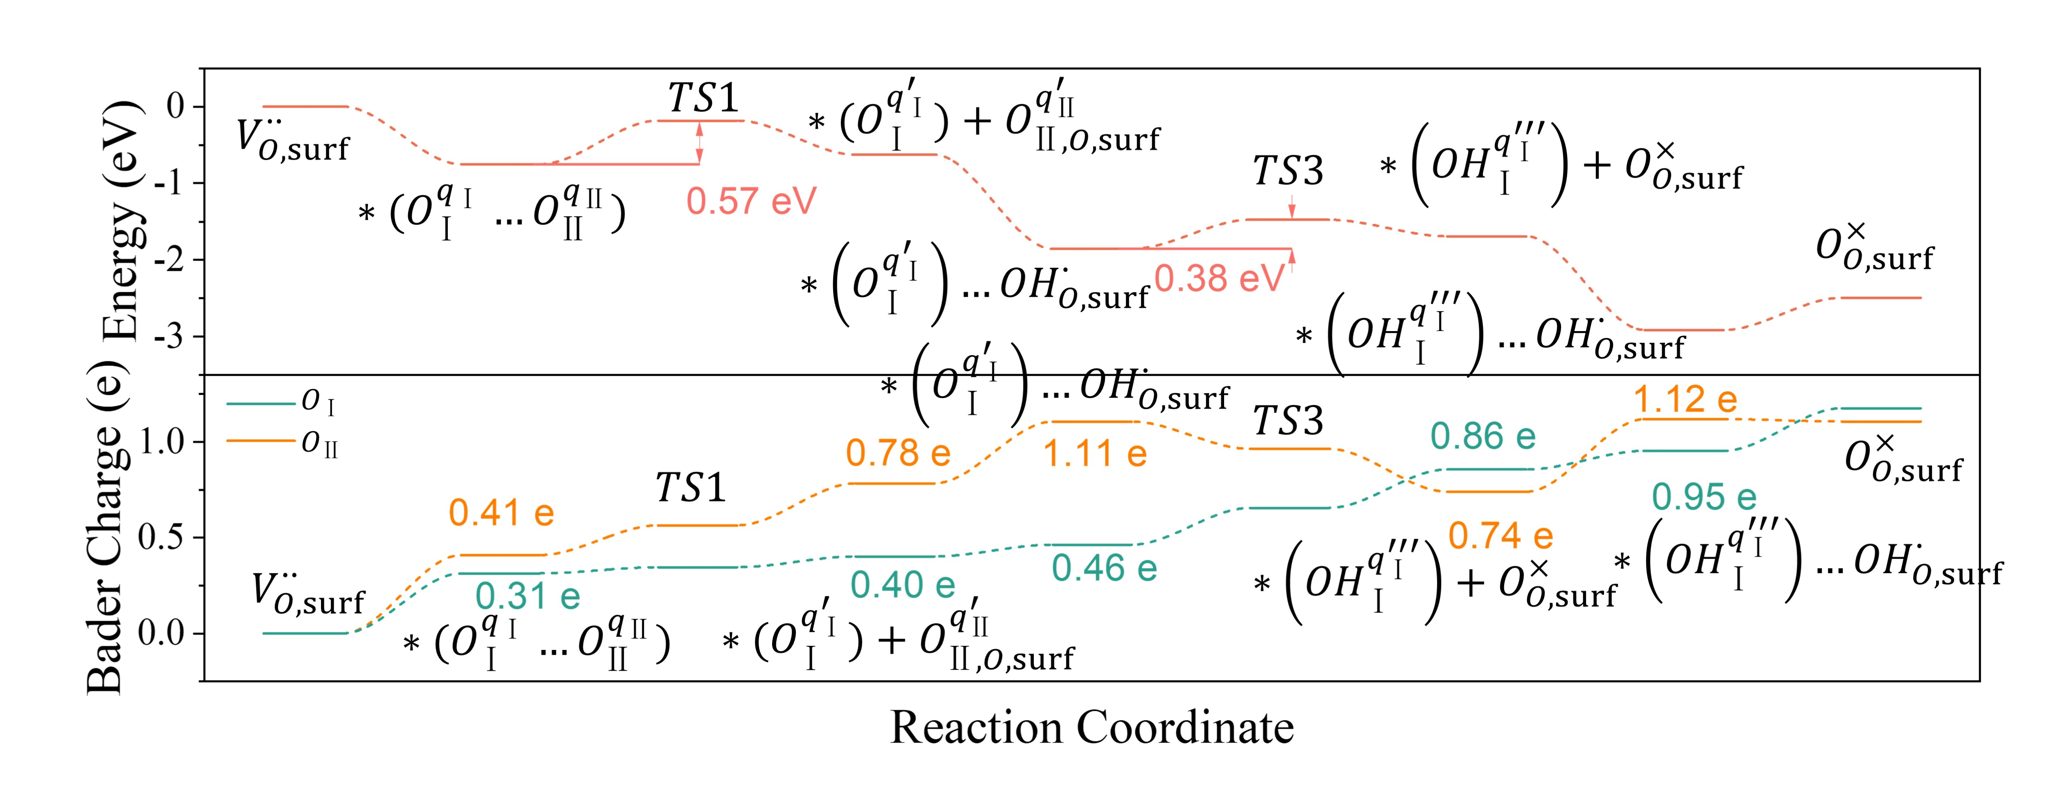
Figure 45. Energy profiles and Bader charge variations during PI-ORR on the BO₂-terminated (001) surface of BCNZ20.
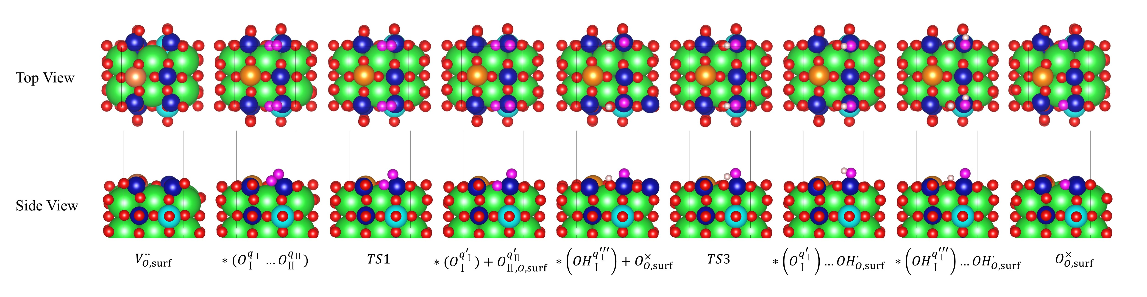
Figure 46. Top and side views of the configurations during PI-ORR on the BO₂-terminated (001) surface of BCNZ20.
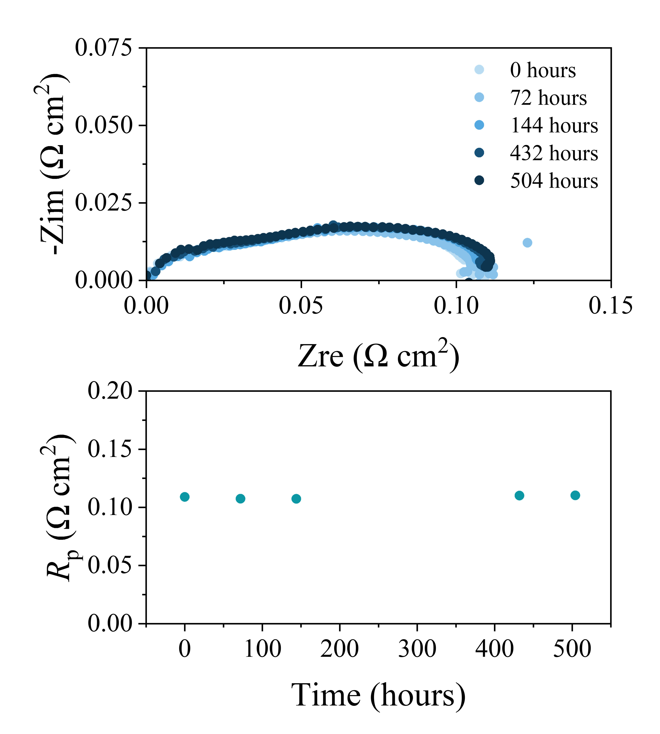
Figure 47. Long-term durability test of the BCNZ20/BZCYYb1711/BCNZ20 symmetrical cell at 600°C under 30% water humidity.
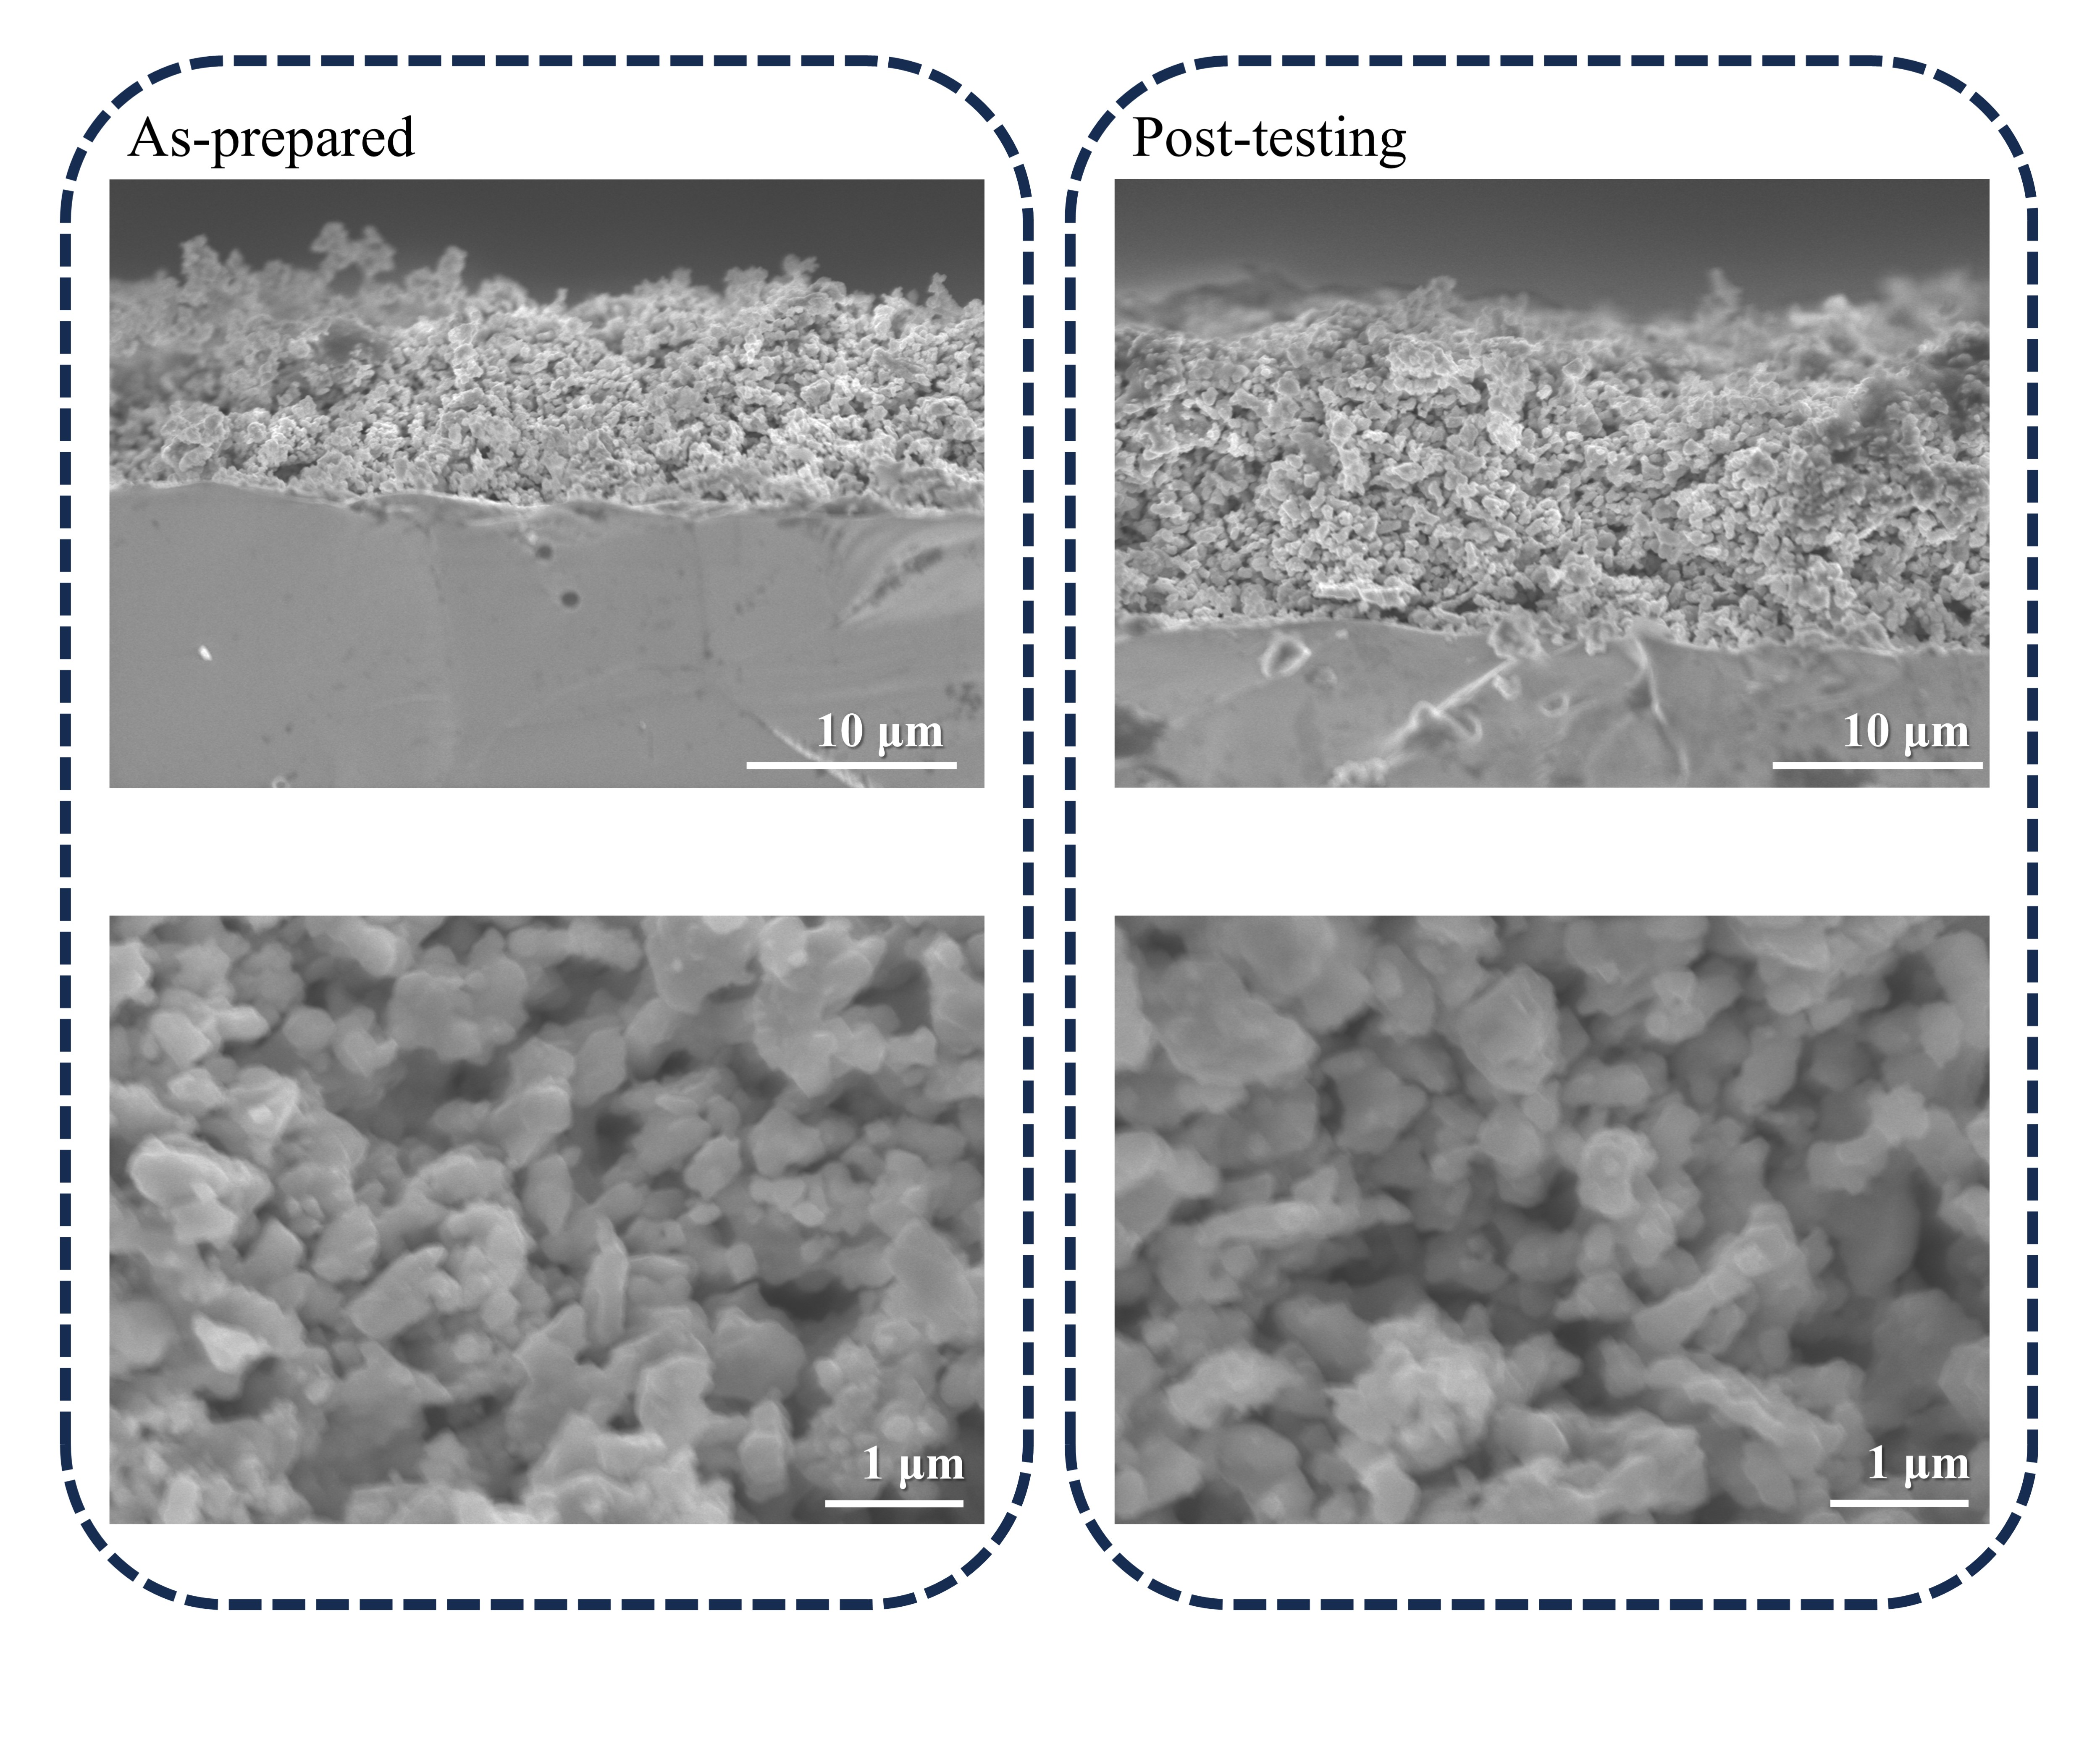
Figure 48. Cross-sectional SEM images of BCNZ20/BZCYYb1711/BCNZ20 symmetrical cells before and after durability test shown in Supplementary Fig. 47.
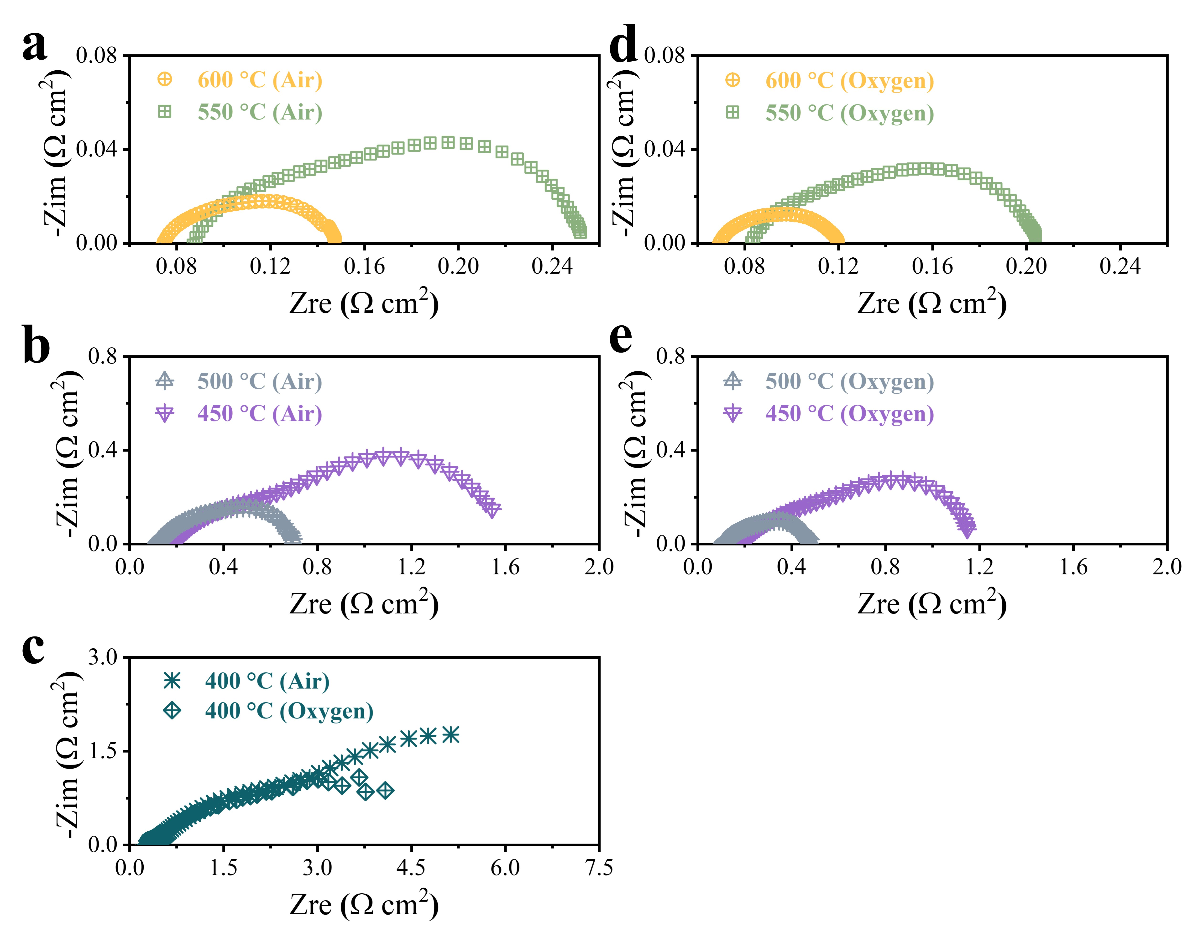
Figure 49. EIS results for single cells at OCV under 600-400 °C with oxygen electrode fed by (a-c) air and (c-e) oxygen.
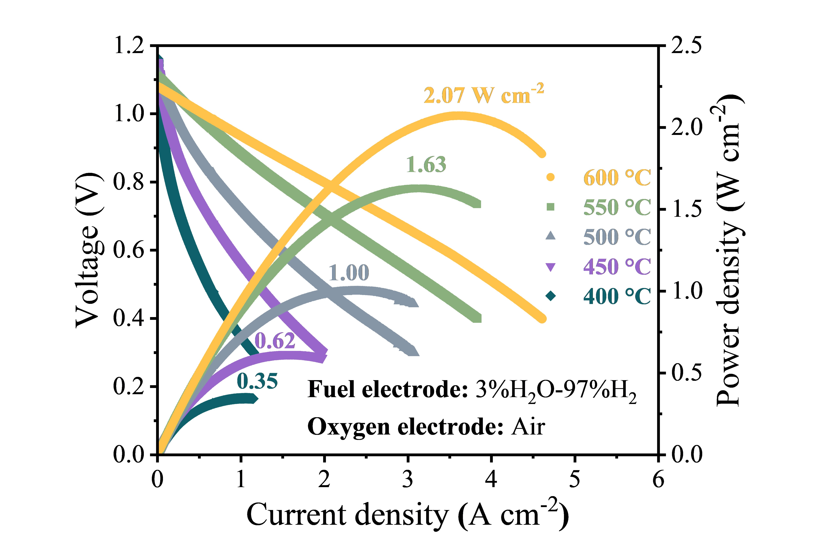
Figure 50. Typical I-V-P curves measured at 600-400 °C in fuel cell mode with oxygen electrode fed by air.
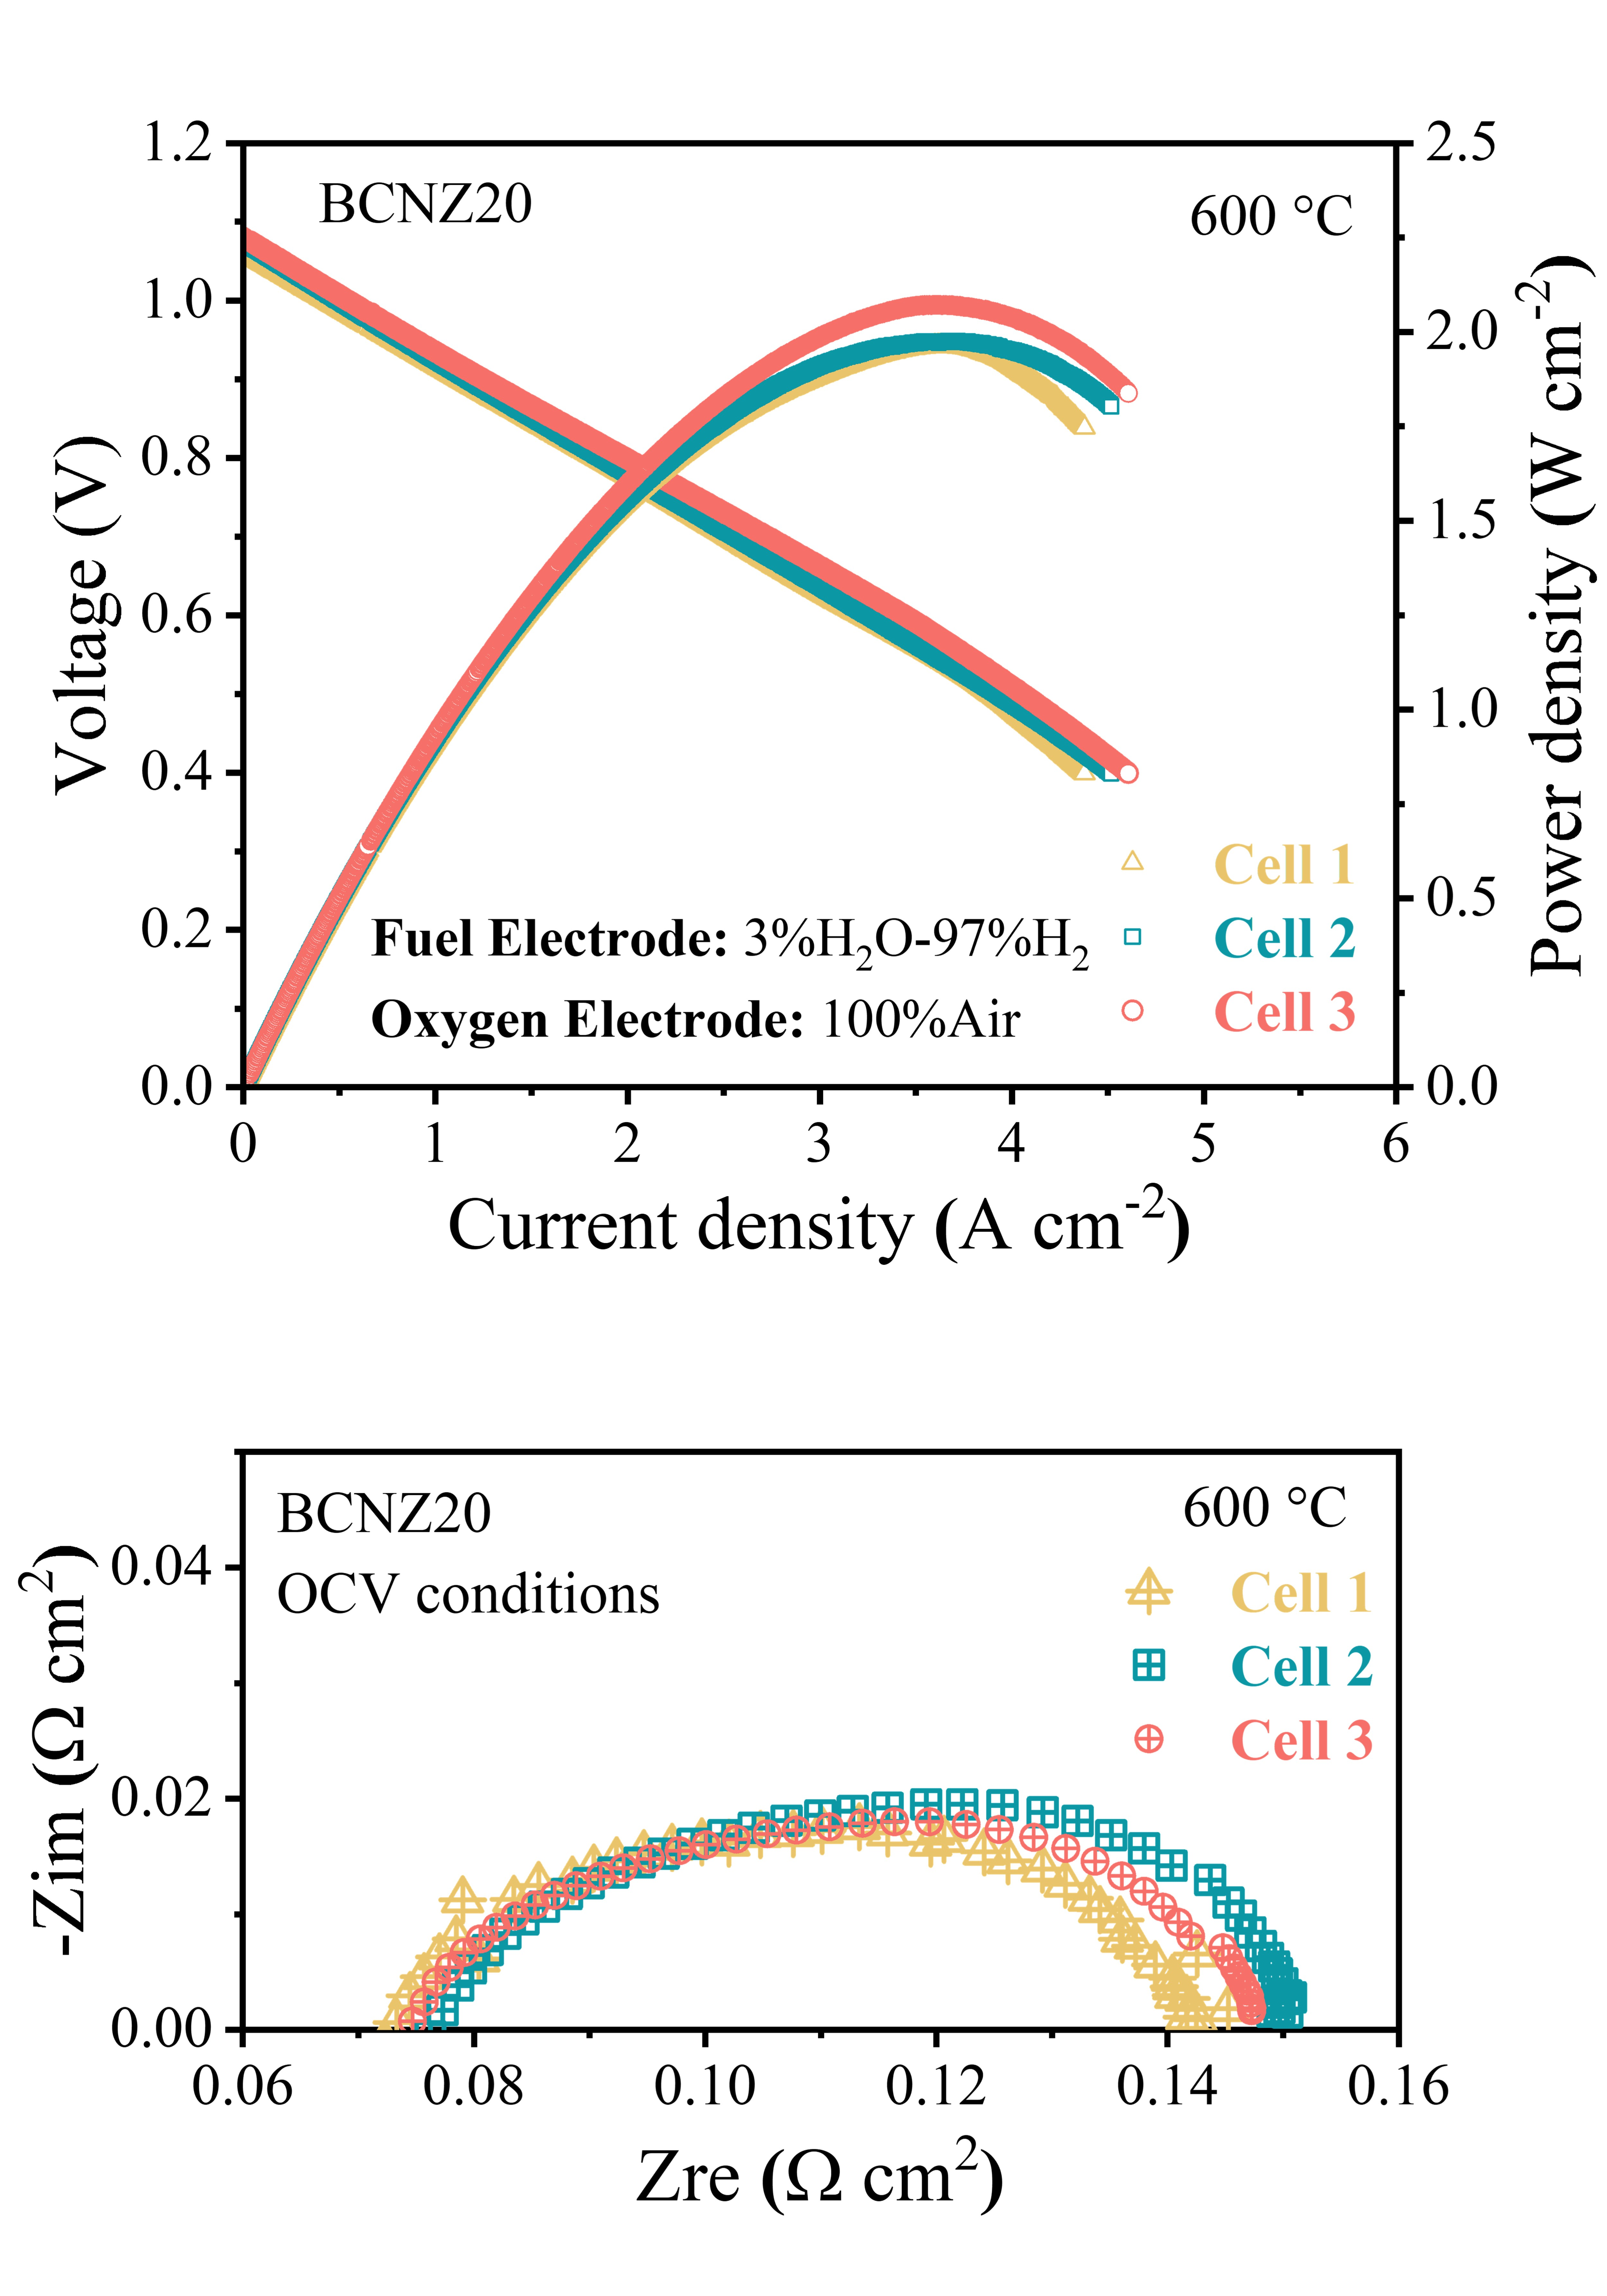
Figure 51. Consistency evaluation of the fabricated PCECs single cells with the same configuration. Typical I-V-P curves and corresponding EIS results under OCV conditions at 600 °C in fuel cell mode with oxygen electrodes fed by air, obtained from three independent trails.
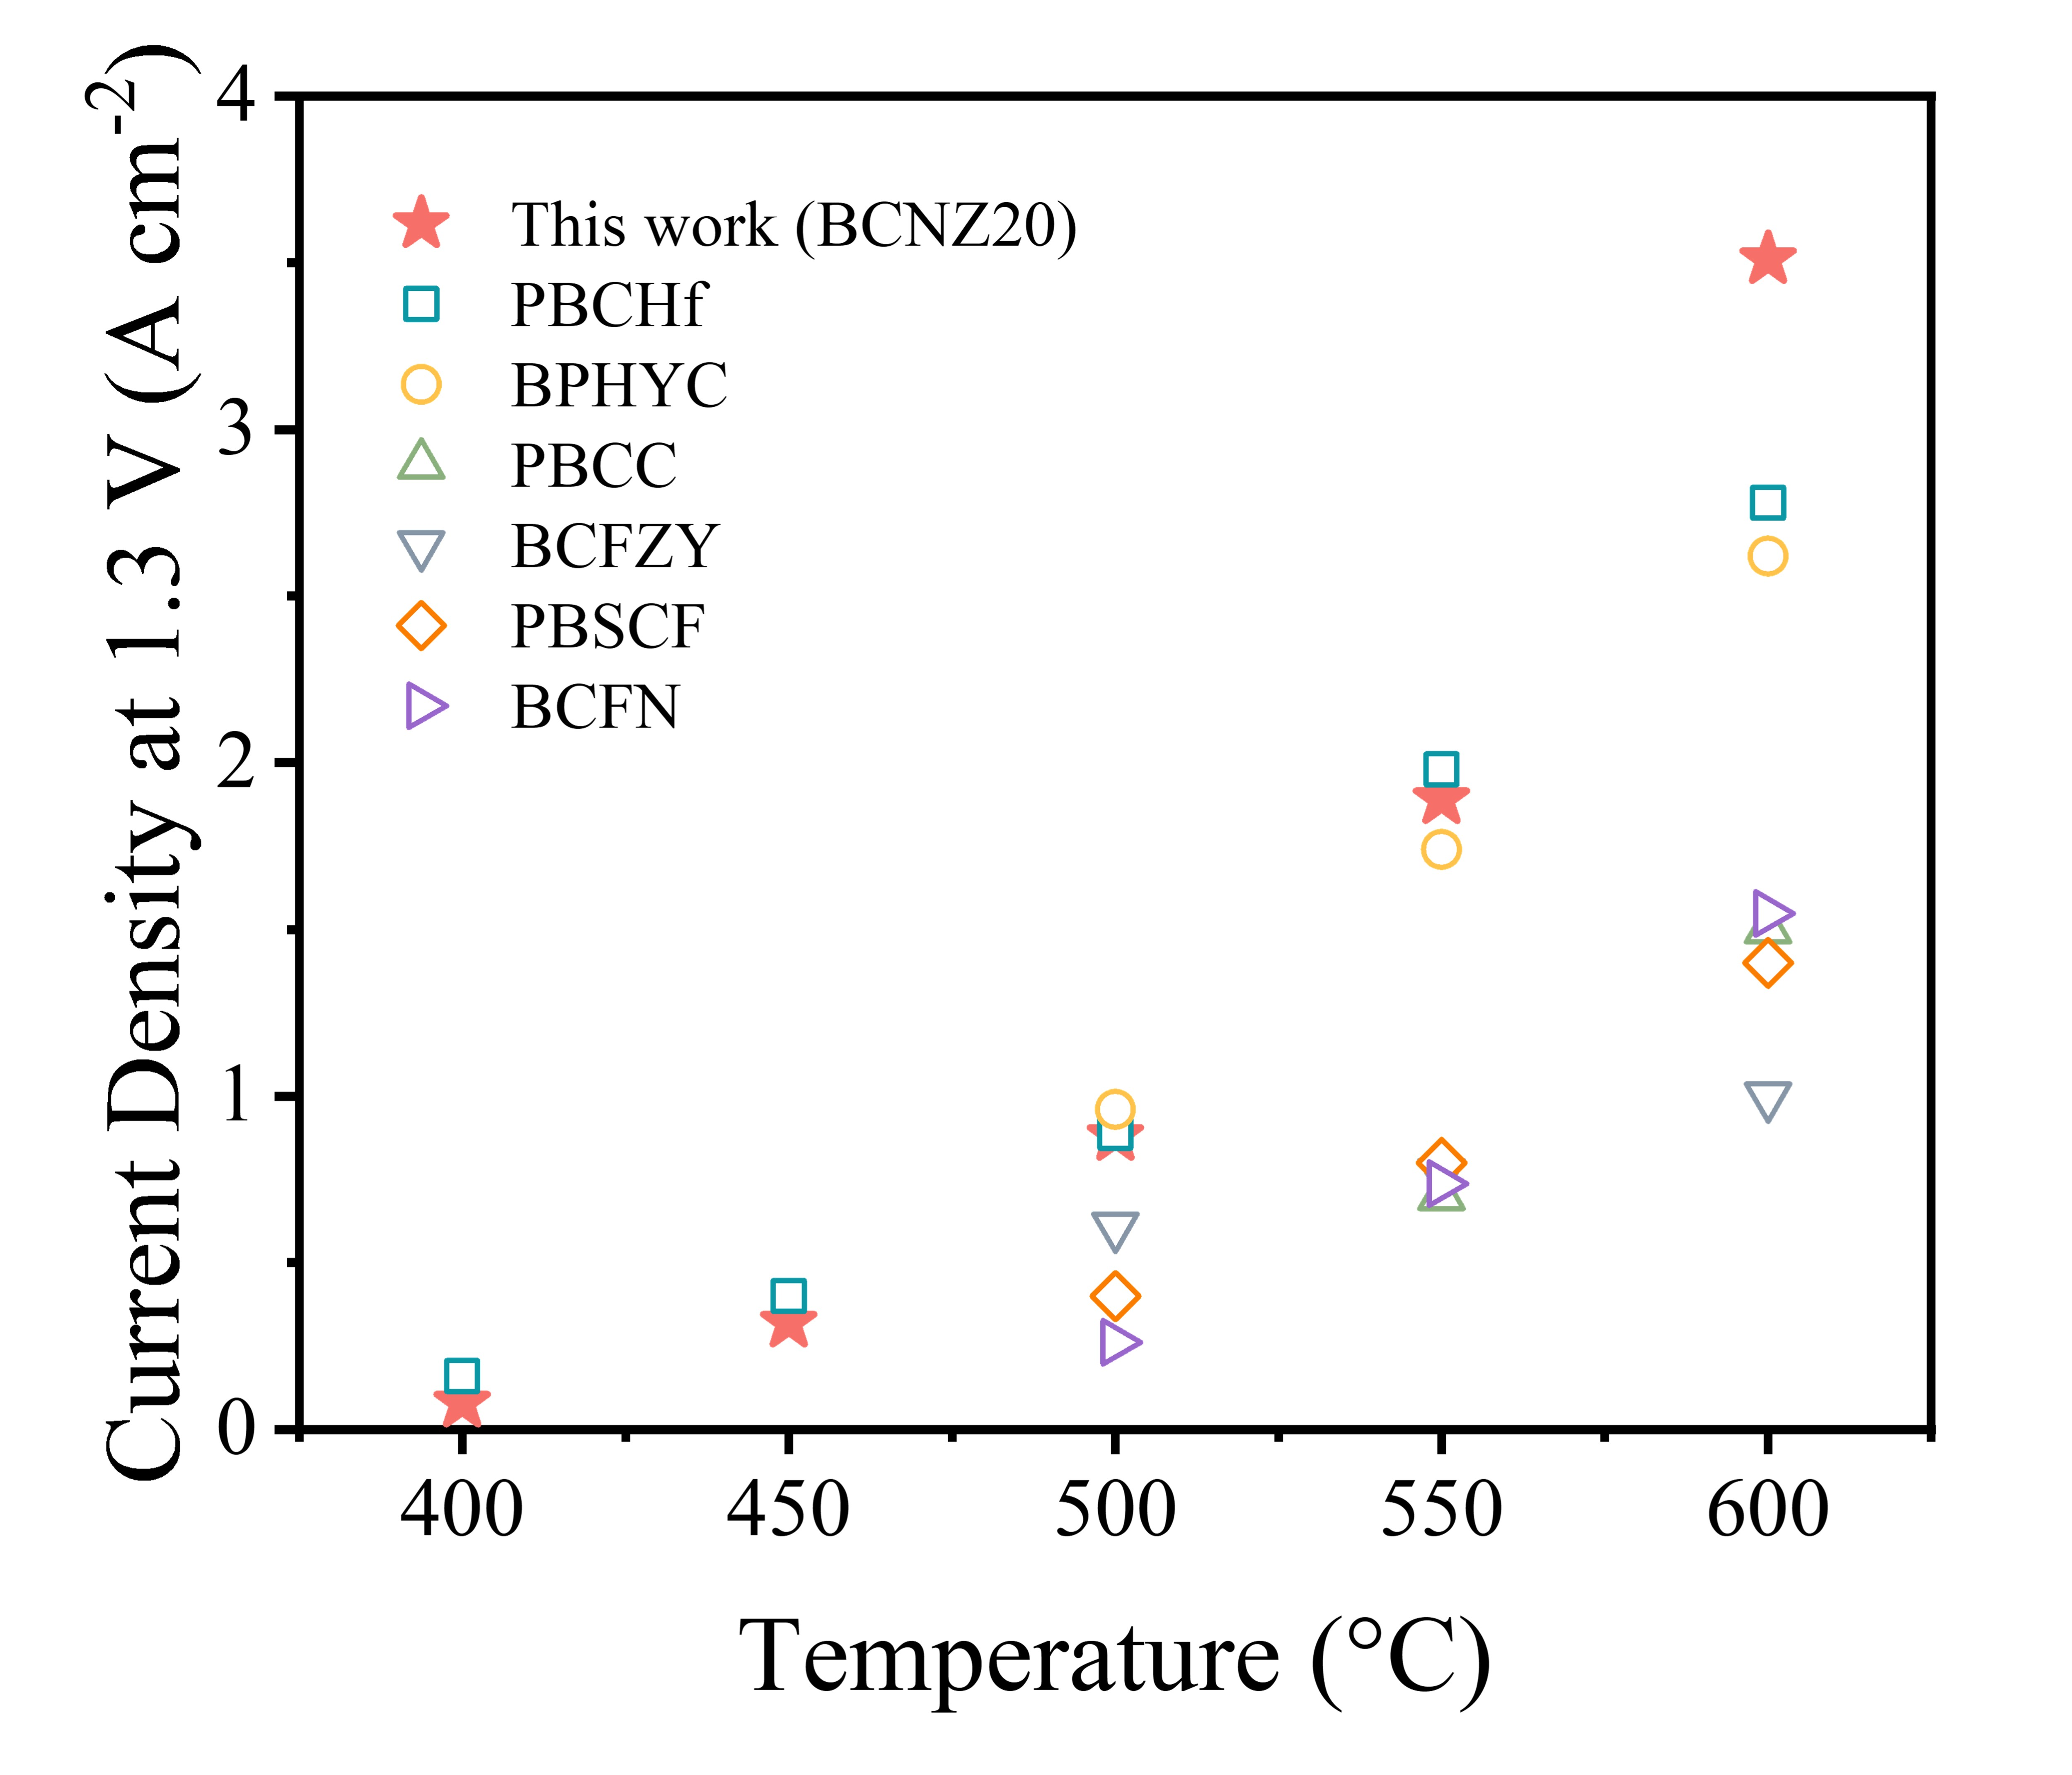
Figure 52. Comparative analysis of current densities at 1.3 V for PCECs at 600–400 °C, highlighting SOTA oxygen electrodes: PrBaCo_{1.9}Hf_{0.1}O_{5+δ} (PBCHf)¹², Ba_{0.1}Pr_{0.9}Hf_{0.1}Y_{0.1}Co_{0.8}O_{3-δ} (BPHYC)³⁷, PrBa_{0.8}Ca_{0.2}Co₂O_{5+δ} (PBCC)²³, BaCo_{0.4}Fe_{0.4}Zr_{0.1}Y_{0.1}O_{3-δ} (BCFZY)⁴, PrBa_{0.5}Sr_{0.5}Co_{1.5}Fe_{0.5}O_{5+δ} (PBSCF)⁵, Ba_{0.9}Co_{0.7}Fe_{0.2}Nb_{0.1}O_{3-δ} (BCFN)³³.
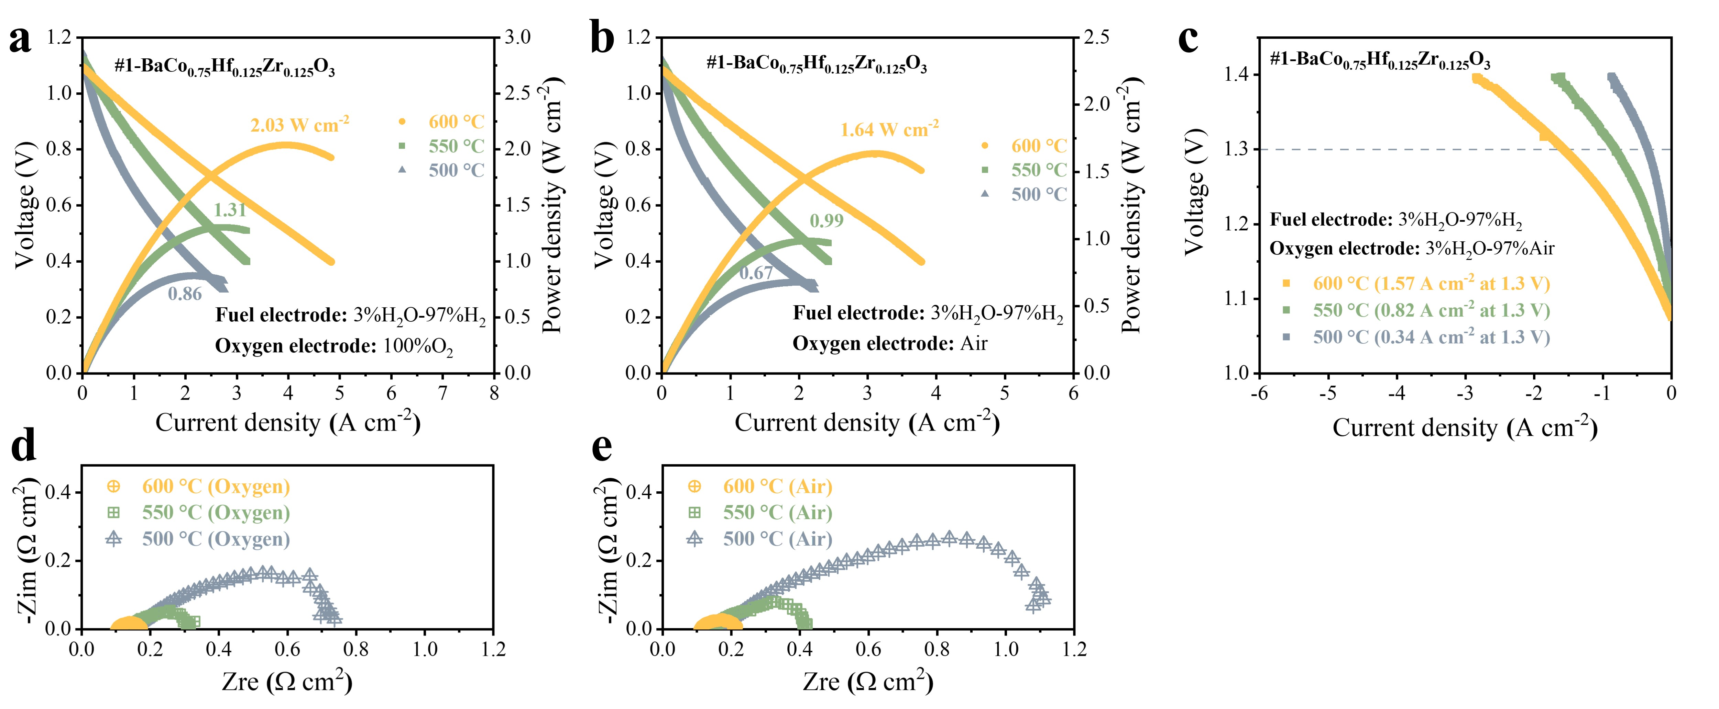
Figure 53. Electrochemical performance of PCEC single cells using BaCo_{0.75}Hf_{0.125}Zr_{0.125}O₃ (No.1 in Fig. 4c) as the oxygen electrode. (a, b) Typical I-V-P curves measured in fuel cell mode at 600-500 °C with oxygen electrode fed by oxygen (a) and air (b). (c) Typical I-V curves measured in electrolysis cell mode at 600-500 °C. (d, e) EIS results for single cells at OCV under 600-500 °C with oxygen electrode fed by oxygen (d) and air (e).
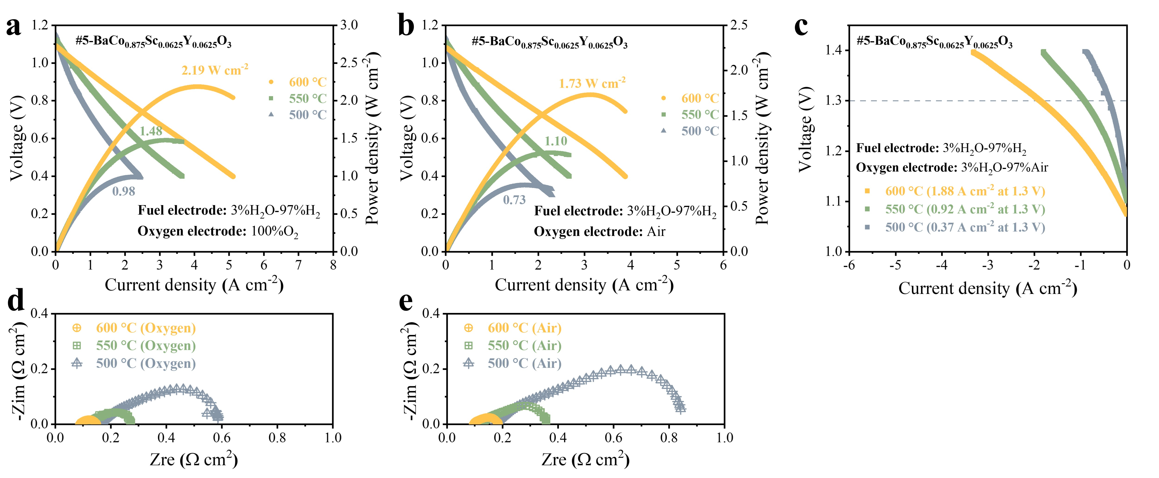
Figure 54. Electrochemical performance of PCEC single cells using BaCo_{0.875}Sc_{0.0625}Y_{0.0625}O₃ (No.5 in Fig. 4c) as the oxygen electrode. (a, b) Typical I-V-P curves measured in fuel cell mode at 600-500 °C with oxygen electrode fed by oxygen (a) and air (b). (c) Typical I-V curves measured in electrolysis cell mode at 600-500 °C. (d, e) EIS results for single cells at OCV under 600-500 °C with oxygen electrode fed by oxygen (d) and air (e).
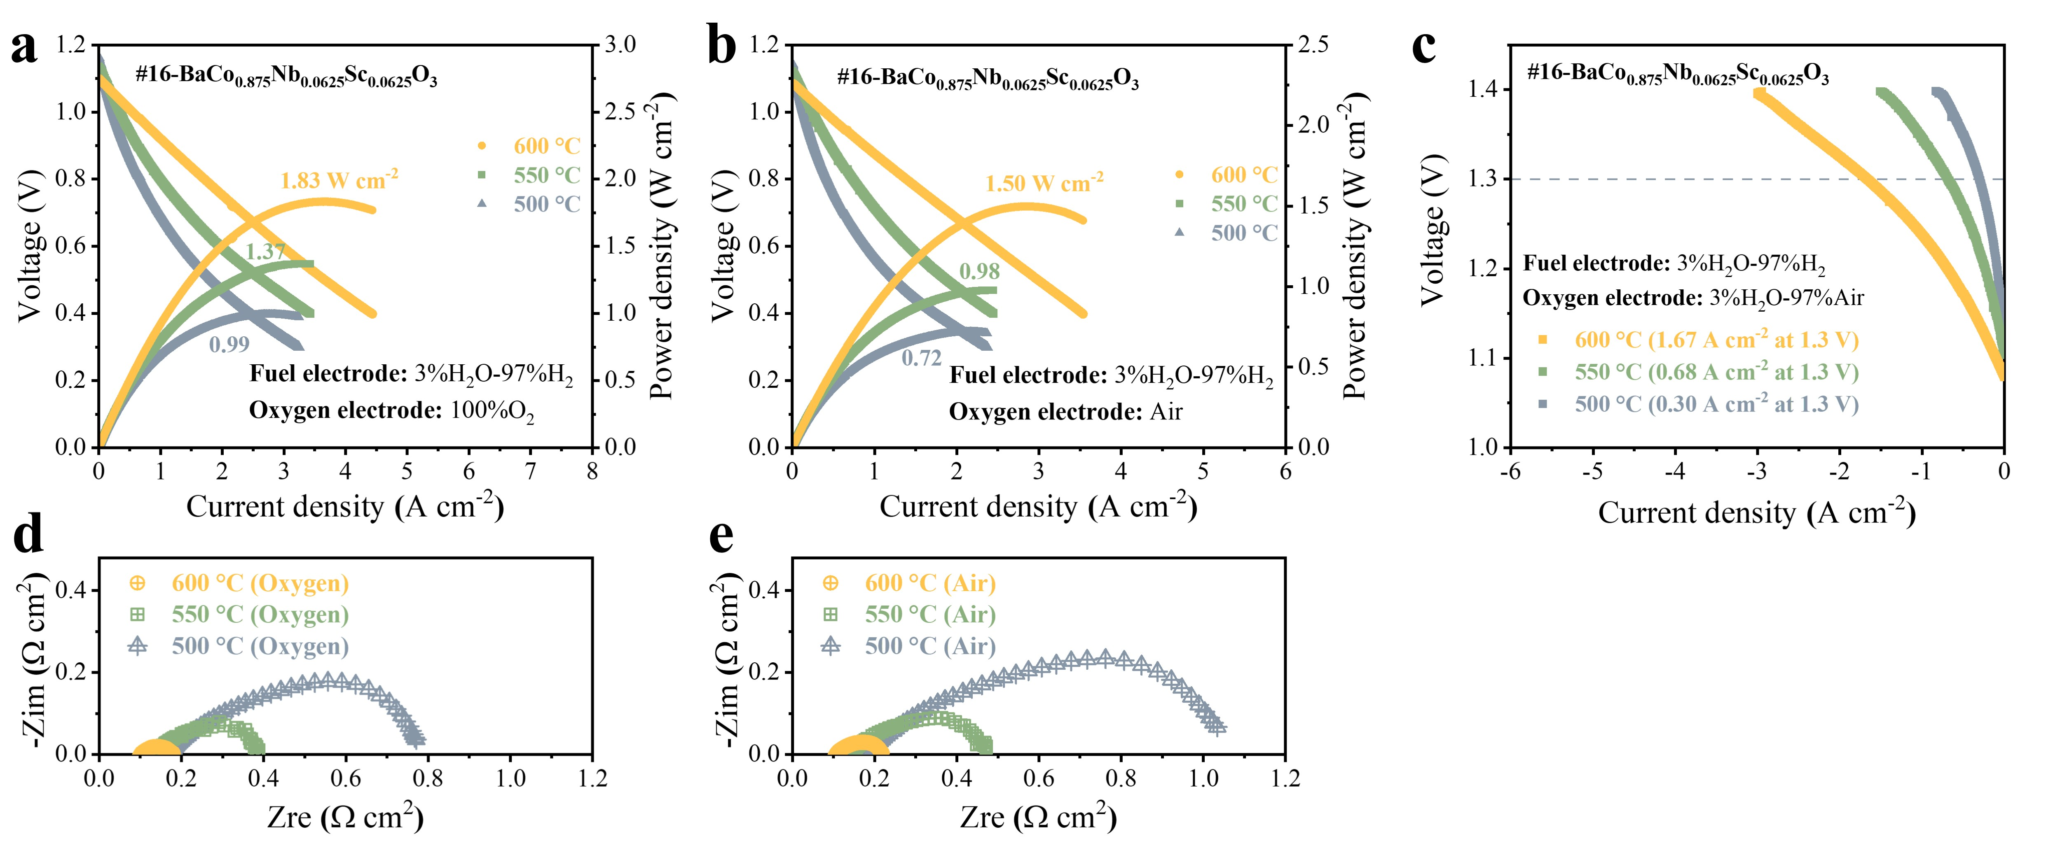
Figure 55. Electrochemical performance of PCEC single cells using BaCo_{0.875}Nb_{0.0625}Sc_{0.0625}O₃ (No.16 in Fig. 4c) as the oxygen electrode. (a, b) Typical I-V-P curves measured in fuel cell mode at 600-500 °C with oxygen electrode fed by oxygen (a) and air (b). (c) Typical I-V curves measured in electrolysis cell mode at 600-500 °C. (d, e) EIS results for single cells at OCV under 600-500 °C with oxygen electrode fed by oxygen (d) and air (e).
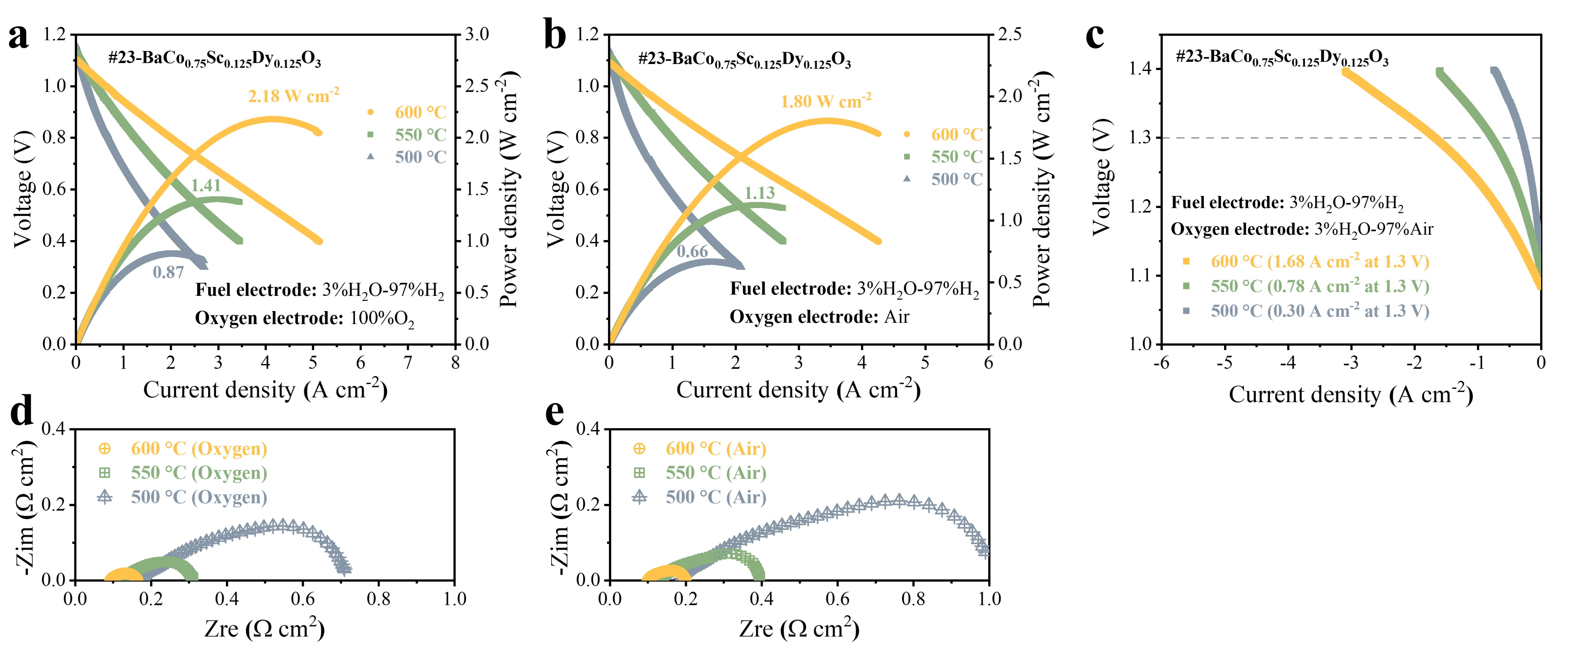
Figure 56. Electrochemical performance of PCEC single cells using BaCo_{0.75}Sc_{0.125}Dy_{0.125}O₃ (No.23 in Fig. 4c) as the oxygen electrode. (a, b) Typical I-V-P curves measured in fuel cell mode at 600-500 °C with oxygen electrode fed by oxygen (a) and air (b). (c) Typical I-V curves measured in electrolysis cell mode at 600-500 °C. (d, e) EIS results for single cells at OCV under 600-500 °C with oxygen electrode fed by oxygen (d) and air (e).
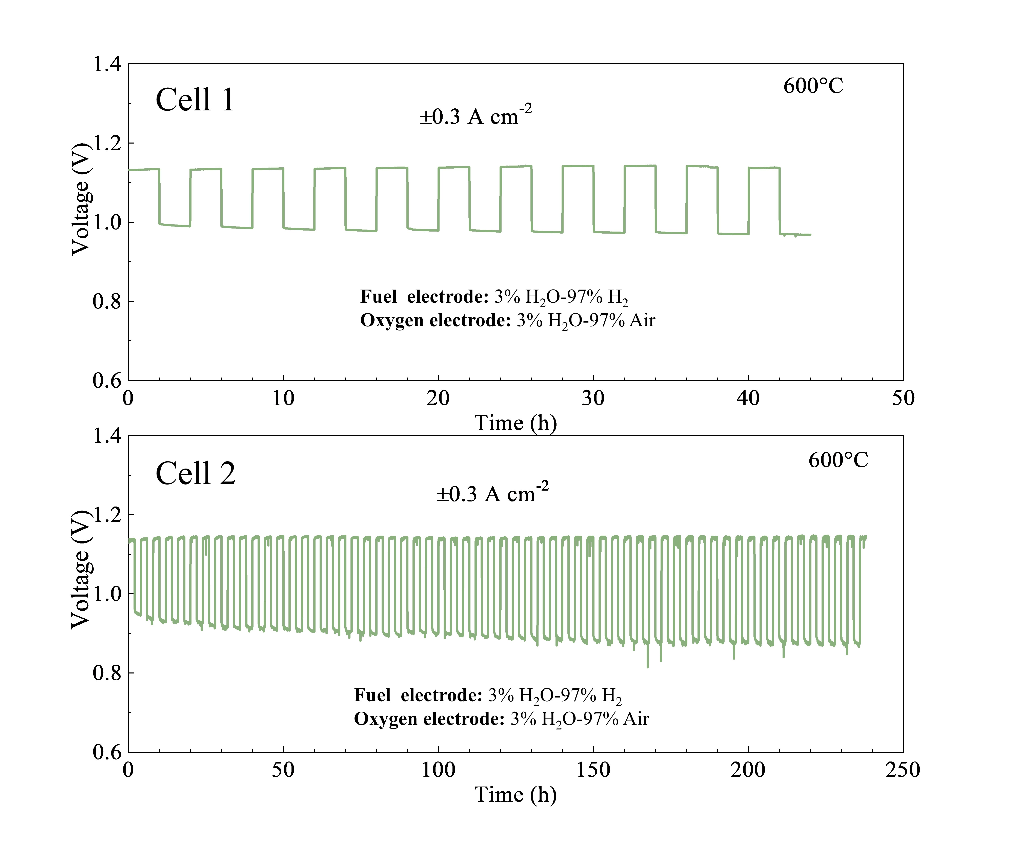
Figure 57. Long-term reversible operation durability of the BCNZ20/BSCYb172/Ni-BSCYb172 single cell: Cell voltage variations over time with alternating fuel cell and electrolysis modes every 2 hours, under 3% water vapor pressure present in the oxygen electrode.
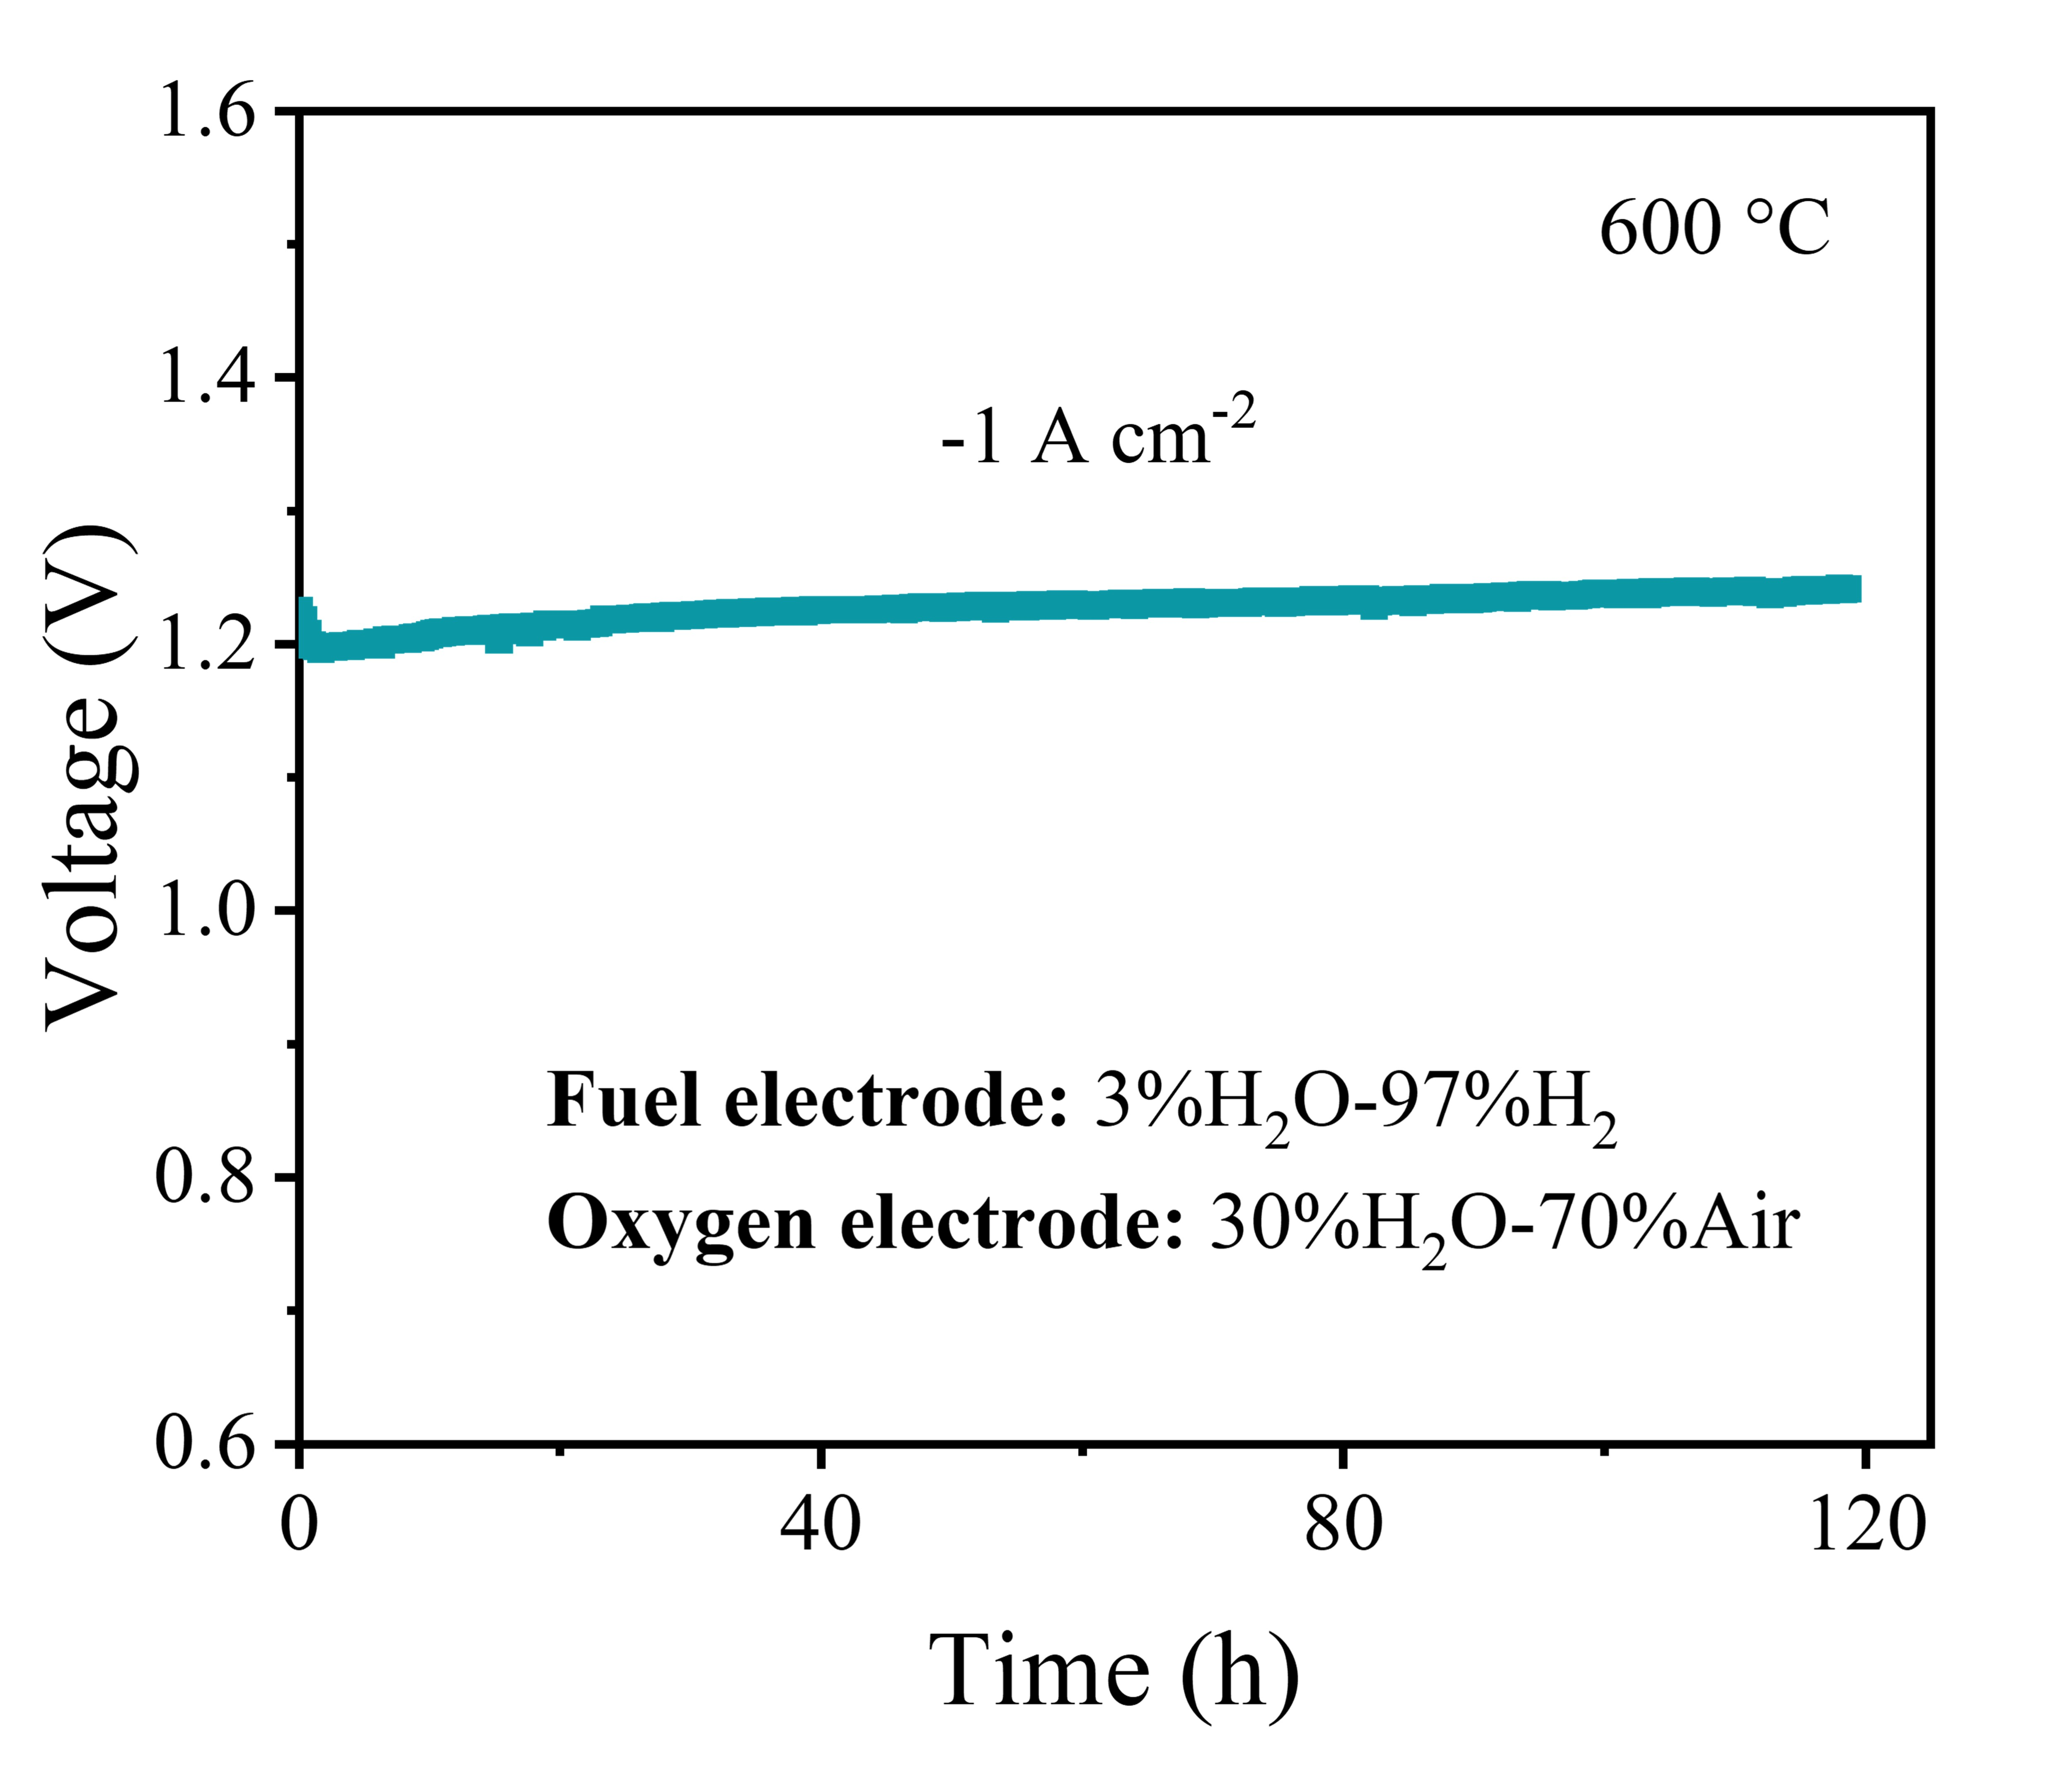
Figure 58. Long-term galvanostatic tests of the BCNZ20/BSCYb172/Ni-BSCYb172 single cell at 600 °C in electrolysis cell mode under a current density of -1 A cm⁻².
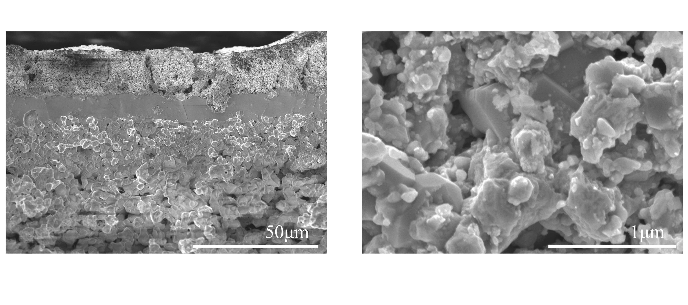
Figure 59. Cross-sectional SEM image showing the architecture of the BCNZ20/BSCYb172/Ni-BSCYb172 single cell after long-term testing.

Table 1. Pseudopotentials and U_{eff} values used in the high-throughput computations
Element | Pseudopotential | U_{eff} (eV)
Ba | Ba_sv 06Sep2000 | 0
Sr | Sr_sv 07Sep2000 | 0
Pr | Pr_3 07Sep2000 | 0
Cr | Cr_pv 02Aug2007 | 3.7
Mn | Mn_pv 02Aug2007 | 3.9
Fe | Fe_pv 02Aug2007 | 5.3
Co | Co 02Aug2007 | 3.32
Ni | Ni_pv 06Sep2000 | 6.2
Cu | Cu_pv 06Sep2000 | 0
Al | Al 04Jan2001 | 0
As | As 22Sep2009 | 0
Bi | Bi 08Apr2002 | 0
Ca | Ca_sv 06Sep2000 | 0
Ce | Ce 23Dec2003 | 0
Dy | Dy_3 06Sep2000 | 0
Er | Er_3 06Sep2000 | 0
Eu | Eu_3 20Oct2008 | 0
Ga | Ga_d 06Jul2010 | 0
Gd | Gd_3 06Sep2000 | 0
Ge | Ge_d 03Jul2007 | 0
Hf | Hf_pv 06Sep2000 | 0
Ho | Ho_3 06Sep2000 | 0
In | In 08Apr2002 | 0
La | La 06Sep2000 | 0
Lu | Lu_3 06Sep2000 | 0
Mg | Mg_pv 13Apr2007 | 0
Mo | Mo_pv 04Feb2005 | 4.38
Nb | Nb_pv 08Apr2002 | 0
Nd | Nd_3 06Sep2000 | 0
Pb | Pb 08Apr2002 | 0
Sb | Sb 06Sep2000 | 0
Sc | Sc_sv 07Sep2000 | 0
Sm | Sm_3 07Sep2000 | 0
Sn | Sn_d 06Sep2000 | 0
Ta | Ta_pv 07Sep2000 | 0
Tb | Tb_3 06Sep2000 | 0
Te | Te 08Apr2002 | 0
Ti | Ti_pv 07Sep2000 | 0
Tm | Tm_3 20Jan2003 | 0
V | V_pv 07Sep2000 | 3.25
W | W 08Apr2002 | 0
Y | Y_sv 25May2007 | 0
Yb | Yb_2 06Sep2000 | 0
Zn | Zn 06Sep2000 | 0
Zr | Zr_sv 04Jan2005 | 0
O | O 08Apr2002 | 0

Table 2. Root mean squared error (RMSE) for various algorithms used in the FSML model for predicting computational descriptors on the test set
Algorithm | RMSE (RMSE with normalized data) on the test set
 | E_{hull} (eV/atom) | p-band center (eV) | d-band center (eV) | Hybridization of d-p band | E_{V} (eV)
LASSO | 0.17321 (0.22884) | 0.20579 (0.16667) | 0.28679 (0.22847) | 0.43176 (0.14018) | 0.69216 (0.17187)
SVR | 0.17499 (0.23119) | 0.20426 (0.16544) | 0.29198 (0.23262) | 0.43927 (0.14262) | 0.69075 (0.17152)
RF | 0.17187 (0.22707) | 0.31659 (0.25642) | 0.26892 (0.21424) | 0.40780 (0.13240) | 0.77827 (0.19326)
ANN | 0.02565 (0.03393) | 0.04594 (0.03715) | 0.09471 (0.07498) | 0.14349 (0.04658) | 0.28190 (0.07000)
XGBoost | 0.02087 (0.02757) | 0.04604 (0.03728) | 0.08143 (0.06489) | 0.12243 (0.03975) | 0.27970 (0.06943)
XGBoost on out-of-distribution task | 0.03439 (0.04765) | 0.19723 (0.091488) | 0.09220 (0.09793) | 0.61945 (0.08538) | 0.72398 (0.13315)

Table 3. Comparison of RMSE and mean absolute error (MAE) in predicting E_{hull} and E_{form} between the FSML model and several SOTA models
Model | E_{hull} (RMSE) | E_{hull} (MAE) | E_{form} (RMSE) | E_{form} (MAE) | Ref
FSML (XGBoost) | 20.87 | 11.63 | 20.65 | 11.39 | This work
Ye’s Model |  |  |  | 20~34 | ³⁸
Schmidt’s Model |  | 121 |  |  | ³⁹
Li’s Model | 29.4 | 16.0 |  |  | ⁴⁰
Chen’s Model |  |  |  | 28 | ⁴¹
Cheng’s Model |  |  |  | 16.07~31.66 | ⁴²
Jonathan’s Model |  | 41 |  |  | ⁴³
Unit: meV/atom

Table 4. Summary of MAE for the FSML model in predicting computational parameters on the test set and out-of-distribution tasks
Computational Parameter | MAE on test set | MAE on out-of-distribution tasks
Lattice Parameter a | 0.0293 Å | 0.0383 Å
Lattice Parameter b | 0.0294 Å | 0.0384 Å
Lattice Parameter c | 0.0310 Å | 0.0362 Å
Lattice Parameter α | 0.0021° | 0.0036°
Lattice Parameter β | 0.0023° | 0.0037°
Lattice Parameter γ | 0.0626° | 0.0672°
Volume | 5.2367 Å³ | 8.6898 Å³
Shrinkage | 0.0059 | 0.0069
Free Volume | 0.0052 | 0.0066
Symmetry Operations | 0.4651 | 5.8154

Table 5. RMSE for different configurations of the SSAL model in predicting experimental metrics (R_{p} and E_{a}), compared with several SOTA models
Model | RMSE of log (R_{p}) (Ω cm²) | RMSE of E_{a} (eV) | Ref
XGBoost (FF to E) | 0.110 | 0.028 | This work
XGBoost (FF + FI to E) | 0.015 | 0.016 | This work
XGBoost (FF to FI to E) | 0.020 | 0.019 | This work
Zhai’s Model | 0.336 |  | ⁴⁴
Ryan’s Model | 0.590 |  | ⁴⁵

Table 6. Three-dimensional evaluation of SOTA catalysts in terms of cost, electrocatalytic activity, and thermodynamic stability: La_{0.6}Sr_{0.4}Co_{0.2}Fe_{0.8}O_{3-δ} (LSCF), Ba_{0.5}Sr_{0.5}Co_{0.8}Fe_{0.2}O_{3-δ} (BSCF), Sm_{0.5}Sr_{0.5}CoO_{3-δ} (SSC), BaCo_{0.4}Fe_{0.4}Zr_{0.1}Y_{0.1}O_{3-δ} (BCFZY), and PrBa_{0.5}Sr_{0.5}Co_{1.5}Fe_{0.5}O_{5+δ} (PBSCF)
State-of-the-art catalysts | Cost ($/kg) | R_{p} @ 600 °C (Ω cm²) | E_{hull} (eV/atom) | Ref
LSCF | 138.02 | 1.302, 1.406, 1.223 | 0.4946 | ^{32,46,47}
BSCF | 8.87 | 0.078,0.108, 0.029 | 0.3992 | ^{2,48,49}
PBC | 163.90 | 0.142, 0.081, 0.1062 | 0.1669 | ^{22,50,51}
SSC | 110.12 | 0.348,0.254, | 0.1833 | ^{3,52}
BCFZY | 23.95 | 0.285 | 0.3476 | ⁴
PBSCF | 170.98 | 0.108 | 0.2615 | ⁵³

Table 7. Summary of novel promising candidates identified by the TSMS model, including their predicted E_{hull} and R_{p}, validated through standardized experiments
No. | Candidate | Predicted E_{hull} (eV/atom) | Predicted R_{p} @ 600°C (Ω cm2) | Experimental R_{p} @ 600°C (Ω cm2)
1 | BaCo_{0.75}Hf_{0.125}Zr_{0.125}O₃ | 0.1291 | 0.07341 | 0.070
2 | BaCo_{0.5}Hf_{0.25}Zr_{0.25}O₃ | 0.0859 | 0.08627 | 0.081
3 | BaCo_{0.875}Mo_{0.0625}Nb_{0.0625}O₃ | 0.1784 | 0.08160 | 0.080
4 | BaCo_{0.75}Mo_{0.125}Nb_{0.125}O₃ | 0.1220 | 0.09392 | 0.092
5 | BaCo_{0.875}Sc_{0.0625}Y_{0.0625}O₃ | 0.1912 | 0.07890 | 0.077
6 | BaCo_{0.75}Sc_{0.125}Y_{0.125}O₃ | 0.1814 | 0.06859 | 0.070
7 | BaCo_{0.75}Hf_{0.125}Dy_{0.125}O₃ | 0.1802 | 0.09396 | 0.092
8 | BaCo_{0.75}Ta_{0.1875}Y_{0.0625}O₃ | 0.1147 | 0.09368 | 0.092
9 | BaCo_{0.625}Nb_{0.1875}Ta_{0.1875}O₃ | 0.0908 | 0.09740 | 0.097
10 | BaCo_{0.75}Ta_{0.125}Sn_{0.125}O₃ | 0.1802 | 0.08762 | 0.078
11 | BaCo_{0.875}Sc_{0.0625}Hf_{0.0625}O₃ | 0.1912 | 0.09061 | 0.100
12 | BaCo_{0.875}Nb_{0.0625}Zr_{0.0625}O₃ | 0.1900 | 0.08201 | 0.079
13 | BaCo_{0.75}Nb_{0.125}Zr_{0.125}O₃ | 0.1291 | 0.07147 | 0.074
14 | BaCo_{0.625}Sc_{0.1875}Y_{0.1875}O₃ | 0.1003 | 0.07903 | 0.080
15 | BaCo_{0.75}W_{0.125}Dy_{0.125}O₃ | 0.1566 | 0.09104 | 0.096
16 | BaCo_{0.875}Nb_{0.0625}Sc_{0.0625}O₃ | 0.1901 | 0.07844 | 0.078
17 | BaCo_{0.75}Nb_{0.125}Sc_{0.125}O₃ | 0.1638 | 0.07379 | 0.076
18 | BaCo_{0.875}Mo_{0.0625}Y_{0.0625}O₃ | 0.1937 | 0.08867 | 0.086
19 | BaCo_{0.75}Mo_{0.125}Y_{0.125}O₃ | 0.1638 | 0.08502 | 0.084
20 | BaCo_{0.75}Sb_{0.125}Y_{0.125}O₃ | 0.1847 | 0.08067 | 0.084
21 | BaCo_{0.75}Ho_{0.125}W_{0.125}O₃ | 0.1517 | 0.08997 | 0.088
22 | BaCo_{0.75}Dy_{0.125}Nb_{0.125}O₃ | 0.1638 | 0.08677 | 0.088
23 | BaCo_{0.75}Sc_{0.125}Dy_{0.125}O₃ | 0.1649 | 0.06621 | 0.070
24 | BaCo_{0.75}Sb_{0.125}Zr_{0.125}O₃ | 0.1802 | 0.08532 | 0.087
25 | BaCo_{0.75}Sb_{0.125}Dy_{0.125}O₃ | 0.1847 | 0.09371 | 0.096

Table 8. Summary of Rietveld refinement results from high-temperature XRD under air and wet air conditions
Air |  |  |  | Wet Air
Temperature (°C) | R_{wp} (%) | R_{p} (%) | a (Å) | Temperature (°C) | R_{wp} (%) | R_{p} (%) | a (Å)
50 | 14.52 | 11 | 4.082 | 50 | 16.33 | 12.32 | 4.0901
100 | 15.28 | 11.56 | 4.0851 | 100 | 16.73 | 12.72 | 4.0905
150 | 15.86 | 11.86 | 4.0883 | 150 | 16.98 | 12.96 | 4.0919
200 | 15.87 | 12.06 | 4.0916 | 200 | 16.8 | 12.76 | 4.0942
250 | 15.23 | 11.64 | 4.0934 | 250 | 16.46 | 12.5 | 4.0953
300 | 15.81 | 12.07 | 4.0976 | 300 | 16.59 | 12.24 | 4.0986
350 | 15.69 | 11.75 | 4.10206 | 350 | 17.23 | 12.76 | 4.1028
400 | 16.25 | 12.31 | 4.10573 | 400 | 16.59 | 12.2 | 4.1066
450 | 16.21 | 12.2 | 4.11017 | 450 | 16.78 | 12.57 | 4.1105
500 | 16.54 | 12.47 | 4.11411 | 500 | 16.03 | 11.72 | 4.11447
550 | 16.22 | 11.91 | 4.1181 | 550 | 15.63 | 11.72 | 4.11826
600 | 17.22 | 12.79 | 4.1214 | 600 | 16.13 | 12.16 | 4.12196
650 | 16.58 | 12.13 | 4.12562 | 650 | 15.25 | 11.28 | 4.12555
700 | 15.38 | 11.34 | 4.1296 | 700 | 16.26 | 12.17 | 4.12954

Table 9. Summary of the current landscape of identified promising PCECs with their electrochemical performance under fuel cell mode
Configuration | Atmosphere | Peak Power Density (W cm²) |  |  |  |  | Ref
Configuration | Atmosphere | 600°C | 550°C | 500°C | 450°C | 400°C | Ref
BCNZ20/BSCYb172(5.8 μm)/BSCYb172-NiO | Oxygen||3%H₂O-97%H₂ | 2.68 | 2.24 | 1.35 | 0.80 | 0.41 | This work
BCNZ20/BSCYb172(5.8 μm)/BSCYb172-NiO | Air||3%H₂O-97%H₂ | 2.07 | 1.63 | 1.00 | 0.62 | 0.35 | This work
PBCHf/BSCYb172(7 μm)/BSCYb172-NiO | Air||3%H₂O-97%H₂ | 1.49 | 1.29 | 0.93 | 0.6 |  | ¹²
BPHYC/BSCYb172(10 μm)/BSCYb172-NiO | Oxygen||3%H₂O-97%H₂ |  |  | 1.05 |  |  | ³⁷
BPHYC/BSCYb172(10 μm)/BSCYb172-NiO | Air||3%H₂O-97%H₂ | 1.57 | 1.21 | 0.82 | 0.52 |  | ³⁷
BCZY63+BCFZY/BZCYYb1711(26.4 μm)/BZCYYb-NiO | Air||H₂ | 0.64 | 0.53 | 0.45 |  |  | ⁴
PBSCF/PBSCF(PLD film)/BZCYYb4411(12.2 μm)/BZCYYb4411-NiO | Air||3%H₂O-97%H₂ | 1.085 | 0.822 | 0.593 | 0.372 |  | ⁵⁴
BSC+PBSCF/BZCYYb1711(3 μm)/BZCYYb1711-NiO | Oxygen||3%H₂O-97%H₂ |  | 1.47 | 0.98 | 0.78 |  | ⁵⁵
BSC+PBSCF/BZCYYb1711(3 μm)/BZCYYb1711-NiO | Air||3%H₂O-97%H₂ |  | 1.22 | 0.83 | 0.55 |  | ⁵⁵
BFZ/BZCYYb1711(3.7 μm)/BZCYYb1711-NiO | Air||3%H₂O-97%H₂ | 1.28 | 0.95 | 0.67 |  |  | ⁵⁶
PNC/BZCYYb1711(16 μm)/BZCYYb1711-NiO | Oxygen||3%H₂O-97%H₂ | 1.6 | 1.25 | 0.90 |  |  | ⁵⁷

Table 10. Summary of open circuit voltages (OCVs), ohmic resistances (R_{o}), and polarization resistances (R_{p}) measured under air and oxygen atmospheres at temperatures from 600 to 400 °C
 | Atmosphere
 | Air||3%H2O-97%H2 |  |  | Oxygen||3%H2O-97%H2
Temperature  (°C) | OCV (V) | R_{o} (Ω cm2) | R_{p} (Ω cm2) | OCV (V) | R_{o} (Ω cm2) | R_{p} (Ω cm2)
600 | 1.08 | 0.075 | 0.072 | 1.09 | 0.069 | 0.050
550 | 1.11 | 0.087 | 0.165 | 1.13 | 0.083 | 0.121
500 | 1.12 | 0.116 | 0.579 | 1.14 | 0.105 | 0.373
450 | 1.15 | 0.177 | 1.366 | 1.17 | 0.176 | 0.972
400 | 1.16 | 0.299 | - | 1.18 | 0.276 | -

Reference
1 Skinner, S. J. Recent advances in Perovskite-type materials for solid oxide fuel cell cathodes. Int J Inorg Mater 3, 113-121 (2001). https://doi.org/Doi 10.1016/S1466-6049(01)00004-6
2 Shao, Z. P. & Haile, S. M. A high-performance cathode for the next generation of solid-oxide fuel cells. Nature 431, 170-173 (2004). https://doi.org/10.1038/nature02863
3 Xia, C. R., Rauch, W., Chen, F. L. & Liu, M. L. Sm0.5Sr0.5CoO3 cathodes for low-temperature SOFCs. Solid State Ionics 149, 11-19 (2002). https://doi.org/10.1016/S0167-2738(02)00131-5
4 Duan, C. C. et al. Readily processed protonic ceramic fuel cells with high performance at low temperatures. Science 349, 1321-1326 (2015). https://doi.org/10.1126/science.aab3987
5 Choi, S., Davenport, T. C. & Haile, S. M. Protonic ceramic electrochemical cells for hydrogen production and electricity generation: exceptional reversibility, stability, and demonstrated faradaic efficiency. Energ Environ Sci 12, 206-215 (2019). https://doi.org/10.1039/c8ee02865f
6 Blochl, P. E. Projector Augmented-Wave Method. Phys Rev B 50, 17953-17979 (1994). https://doi.org/DOI 10.1103/PhysRevB.50.17953
7 Kresse, G. & Furthmuller, J. Efficiency of ab-initio total energy calculations for metals and semiconductors using a plane-wave basis set. Comp Mater Sci 6, 15-50 (1996). https://doi.org/Doi 10.1016/0927-0256(96)00008-0
8 Perdew, J. P., Burke, K. & Ernzerhof, M. Generalized gradient approximation made simple. Phys Rev Lett 77, 3865-3868 (1996). https://doi.org/DOI 10.1103/PhysRevLett.77.3865
9 Jain, A. et al. Commentary: The Materials Project: A materials genome approach to accelerating materials innovation. Apl Mater 1 (2013). https://doi.org/10.1063/1.4812323
10 Chen, C. & Ong, S. P. A universal graph deep learning interatomic potential for the periodic table. Nat Comput Sci 2, 718-+ (2022). https://doi.org/10.1038/s43588-022-00349-3
11 Somjit, V. & Yildiz, B. Atomic and Electronic Structure of the Al₂O₃/Al Interface during Oxide Propagation Probed by Ab Initio Grand Canonical Monte Carlo. Acs Appl Mater Inter 14, 42613-42627 (2022). https://doi.org/10.1021/acsami.2c08706
12 Hu, X. Y. et al. Data-driven discovery of electrode materials for protonic ceramic cells. Energ Environ Sci (2024). https://doi.org/10.1039/d4ee03762f
13 Peng, J. Y. et al. Design principles for transition metal nitride stability and ammonia generation in acid. Joule 7, 150-167 (2023). https://doi.org/10.1016/j.joule.2022.11.011
14 Nelson, R. et al. LOBSTER: Local orbital projections, atomic charges, and chemical-bonding analysis fromprojector-augmented-wave-baseddensity-functional theory. J Comput Chem 41, 1931-1940 (2020). https://doi.org/10.1002/jcc.26353
15 Bartel, C. J. et al. New tolerance factor to predict the stability of perovskite oxides and halides. Sci Adv 5 (2019). https://doi.org/10.1126/sciadv.aav0693
16 Zhang, Y. et al. Recent Progress on Advanced Materials for Solid-Oxide Fuel Cells Operating Below 500 °C. Adv Mater 29 (2017). https://doi.org/10.1002/adma.201700132
17 Luo, Z. Y. et al. Harnessing High-Throughput Computational Methods to Accelerate the Discovery of Optimal Proton Conductors for High-Performance and Durable Protonic Ceramic Electrochemical Cells. Adv Mater 36 (2024). https://doi.org/10.1002/adma.202311159
18 Hu, X. Y. et al. Antimony-doped strontium cobalt oxide as promising cathode for low-temperature solid oxide fuel cell with excellent carbon dioxide tolerance. Appl Catal B-Environ 286 (2021). https://doi.org/10.1016/j.apcatb.2021.119901
19 Cao, Y. P., Gadre, M. J., Ngo, A. T., Adler, S. B. & Morgan, D. D. Factors controlling surface oxygen exchange in oxides. Nat Commun 10 (2019). https://doi.org/10.1038/s41467-019-08674-4
20 Henkelman, G., Uberuaga, B. P. & Jonsson, H. A climbing image nudged elastic band method for finding saddle points and minimum energy paths. J Chem Phys 113, 9901-9904 (2000). https://doi.org/10.1063/1.1329672
21 Zhang, W. L. et al. A Solid Oxide Fuel Cell Runs on Hydrocarbon Fuels with Exceptional Durability and Power Output. Adv Energy Mater 12 (2022). https://doi.org/10.1002/aenm.202202928
22 Wan, Y. H., Xing, Y. L., Li, Y. H., Huan, D. M. & Xia, C. R. Thermal cycling durability improved by doping fluorine to PrBaCo₂O_{5+δ} as oxygen reduction reaction electrocatalyst in intermediate-temperature solid oxide fuel cells. J Power Sources 402, 363-372 (2018). https://doi.org/10.1016/j.jpowsour.2018.09.065
23 Zhou, Y. C. et al. An Active and Robust Air Electrode for Reversible Protonic Ceramic Electrochemical Cells. Acs Energy Lett 6, 1511-1520 (2021). https://doi.org/10.1021/acsenergylett.1c00432
24 Hu, X. et al. Antimony-doped strontium cobalt oxide as promising cathode for low-temperature solid oxide fuel cell with excellent carbon dioxide tolerance. Applied Catalysis B: Environmental 286, 119901 (2021).
25 Kim, J. H. et al. An universal oxygen electrode for reversible solid oxide electrochemical cells at reduced temperatures. Energ Environ Sci 16, 3803-3814 (2023). https://doi.org/10.1039/d2ee04108a
26 Kim, D. et al. On the Role of Bimetal-Doped BaCoO₃ Perovskites as Highly Active Oxygen Electrodes of Protonic Ceramic Electrochemical Cells. Adv Energy Mater 14 (2024). https://doi.org/10.1002/aenm.202304059
27 He, F. et al. Catalytic Self-Assembled Air Electrode for Highly Active and Durable Reversible Protonic Ceramic Electrochemical Cells. Adv Funct Mater 32 (2022). https://doi.org/10.1002/adfm.202206756
28 Ding, H. P. et al. Self-sustainable protonic ceramic electrochemical cells using a triple conducting electrode for hydrogen and power production. Nat Commun 11 (2020). https://doi.org/10.1038/s41467-020-15677-z
29 Liu, Z. et al. Robust bifunctional phosphorus-doped perovskite oxygen electrode for reversible proton ceramic electrochemical cells. Chem Eng J 450, 137787 (2022).
30 Pei, K. et al. Constructing an active and stable oxygen electrode surface for reversible protonic ceramic electrochemical cells. Applied Catalysis B: Environmental 330, 122601 (2023).
31 Duan, C. et al. Highly efficient reversible protonic ceramic electrochemical cells for power generation and fuel production. Nat Energy 4, 230-240 (2019).
32 Niu, Y. et al. Highly active and durable air electrodes for reversible protonic ceramic electrochemical cells enabled by an efficient bifunctional catalyst. Adv Energy Mater 12, 2103783 (2022).
33 Pei, K. et al. Surface restructuring of a perovskite-type air electrode for reversible protonic ceramic electrochemical cells. Nat Commun 13, 2207 (2022).
34 He, F. et al. An Efficient High‐Entropy Perovskite‐Type Air Electrode for Reversible Oxygen Reduction and Water Splitting in Protonic Ceramic Cells. Adv Mater 35, 2209469 (2023).
35 He, F. et al. Catalytic self‐assembled air electrode for highly active and durable reversible protonic ceramic electrochemical cells. Adv Funct Mater 32, 2206756 (2022).
36 Saqib, M. et al. Transition from perovskite to misfit-layered structure materials: a highly oxygen deficient and stable oxygen electrode catalyst. Energ Environ Sci 14, 2472-2484 (2021).
37 Luo, Z. et al. Harnessing High‐Throughput Computational Methods to Accelerate the Discovery of Optimal Proton Conductors for High‐Performance and Durable Protonic Ceramic Electrochemical Cells. Adv Mater, 2311159 (2024).
38 Ye, W. K., Chen, C., Wang, Z. B., Chu, I. H. & Ong, S. P. Deep neural networks for accurate predictions of crystal stability. Nat Commun 9 (2018). https://doi.org/10.1038/s41467-018-06322-x
39 Schmidt, J. et al. Predicting the Thermodynamic Stability of Solids Combining Density Functional Theory and Machine Learning. Chem Mater 29, 5090-5103 (2017). https://doi.org/10.1021/acs.chemmater.7b00156
40 Li, W., Jacobs, R. & Morgan, D. Predicting the thermodynamic stability of perovskite oxides using machine learning models. Comp Mater Sci 150, 454-463 (2018). https://doi.org/10.1016/j.commatsci.2018.04.033
41 Chen, C., Ye, W. K., Zuo, Y. X., Zheng, C. & Ong, S. P. Graph Networks as a Universal Machine Learning Framework for Molecules and Crystals. Chem Mater 31, 3564-3572 (2019). https://doi.org/10.1021/acs.chemmater.9b01294
42 Cheng, G. J., Gong, X. G. & Yin, W. J. Crystal structure prediction by combining graph network and optimization algorithm. Nat Commun 13 (2022). https://doi.org/10.1038/s41467-022-29241-4
43 Schmidt, J., Pettersson, L., Verdozzi, C., Botti, S. & Marques, M. A. L. Crystal graph attention networks for the prediction of stable materials. Sci Adv 7 (2021). https://doi.org/10.1126/sciadv.abi7948
44 Zhai, S. et al. A combined ionic Lewis acid descriptor and machine-learning approach to prediction of efficient oxygen reduction electrodes for ceramic fuel cells. Nat Energy 7, 866-875 (2022). https://doi.org/10.1038/s41560-022-01098-3
45 Jacobs, R., Liu, J., Abernathy, H. & Morgan, D. Machine Learning Design of Perovskite Catalytic Properties. Adv Energy Mater 14 (2024). https://doi.org/10.1002/aenm.202303684
46 Ali, S. A. M., Anwar, M., Raduwan, N. F., Muchtar, A. & Somalu, M. R. Optical, mechanical and electrical properties of LSCF-SDC composite cathode prepared by sol-gel assisted rotary evaporation technique. J Sol-Gel Sci Techn 86, 493-504 (2018). https://doi.org/10.1007/s10971-018-4636-8
47 Liu, M. F. et al. Enhanced performance of LSCF cathode through surface modification. Int J Hydrogen Energ 37, 8613-8620 (2012). https://doi.org/10.1016/j.ijhydene.2012.02.139
48 Li, M. R. et al. A niobium and tantalum co-doped perovskite cathode for solid oxide fuel cells operating below 500 °C. Nat Commun 8 (2017). https://doi.org/10.1038/ncomms13990
49 Liu, Q. L., Khor, K. A. & Chan, S. H. High-performance low-temperature solid oxide fuel cell with novel BSCF cathode. J Power Sources 161, 123-128 (2006). https://doi.org/10.1016/j.jpowsour.2006.03.095
50 Wang, Y., Zhang, H., Chen, F. L. & Xia, C. R. Electrochemical characteristics of nano-structured PrBaCo₂O_{5+δ} cathodes fabricated with ion impregnation process. J Power Sources 203, 34-41 (2012). https://doi.org/10.1016/j.jpowsour.2011.11.069
51 Gu, H. X. et al. Enhancing the oxygen reduction activity of PrBaCo₂O_{5+δ} double perovskite cathode by tailoring the calcination temperatures. Int J Hydrogen Energ 45, 25996-26004 (2020). https://doi.org/10.1016/j.ijhydene.2019.12.171
52 Zhang, H., Zhao, F., Chen, F. L. & Xia, C. R. Nano-structured Sm_{0.5}Sr_{0.5}CoO_{3-δ} electrodes for intermediate-temperature SOFCs with zirconia electrolytes. Solid State Ionics 192, 591-594 (2011). https://doi.org/10.1016/j.ssi.2010.05.024
53 Park, S., Choi, S., Shin, J. & Kim, G. A collaborative study of sintering and composite effects for a PrBa_{0.5}Sr_{0.5}Co_{1.5}Fe_{0.5}O_{5+δ} IT-SOFC cathode. Rsc Adv 4, 1775-1781 (2014). https://doi.org/10.1039/c3ra45296d
54 Choi, S. et al. Exceptional power density and stability at intermediate temperatures in protonic ceramic fuel cells. Nat Energy 3, 202-210 (2018). https://doi.org/10.1038/s41560-017-0085-9
55 Liu, F. et al. Lowering the operating temperature of protonic ceramic electrochemical cells to & lt;450?degrees C. Nat Energy (2023). https://doi.org/10.1038/s41560-023-01350-4
56 Wang, Z. et al. Rational design of perovskite ferrites as high-performance proton-conducting fuel cell cathodes. Nat Catal 5, 777-787 (2022). https://doi.org/10.1038/s41929-022-00829-9
57 Bian, W. J. et al. Revitalizing interface in protonic ceramic cells by acid etch. Nature 604, 479-+ (2022). https://doi.org/10.1038/s41586-022-04457-y

