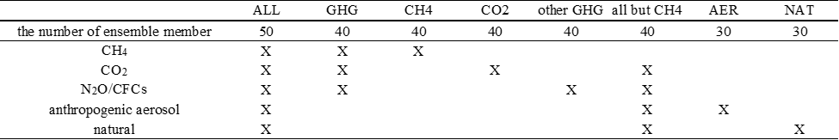
Extended Data Table 1 | The number of ensemble members and specification of the forcings in different simulations.

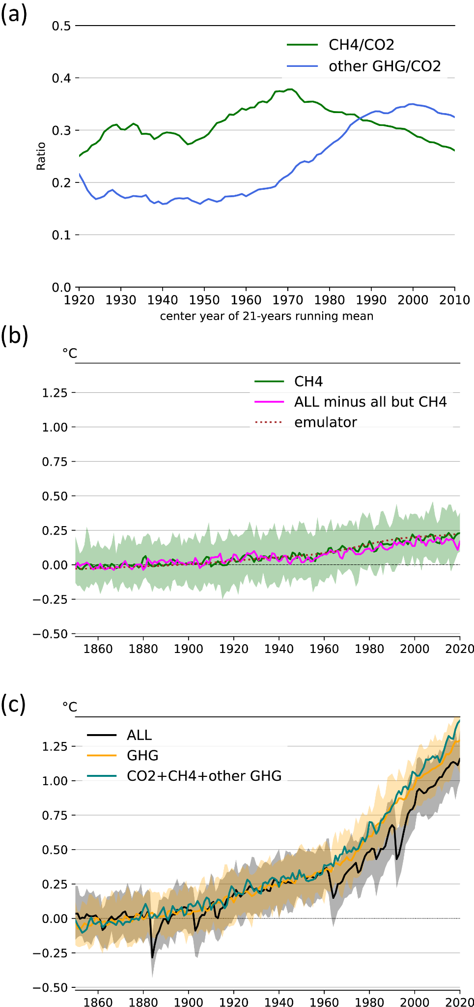
Extended Data Fig. 1 | Quantification CH4 contribution to global warming. (a) Time series of ratios of 21-years running mean CH4 global mean SAT anomaly to that of CO2 (green line). Time series of ratios of 21-years running mean global mean SAT anomaly of other GHGs simulation to that of CO2 (blue line). Year value on the X axis is the median of the years used to calculate the 21-years running mean. (b)Time series of global mean SAT anomaly for ensemble mean CH4 (green solid line), ALL minus all but CH4 (solid pink line), and best estimate of methane concentration contribution using two-layer emulator in AR6 (dotted brown line). Colored shades represent 5-95 percentile of ensemble members for each scenario. (c)Time series of global mean SAT anomaly for ensemble mean ALL (black solid line), GHG (orange solid line), and the sum of CO2, CH4 and other GHG ensemble mean (teal solid line). Colored shades represent 5-95 percentile of ensemble members for each scenario.

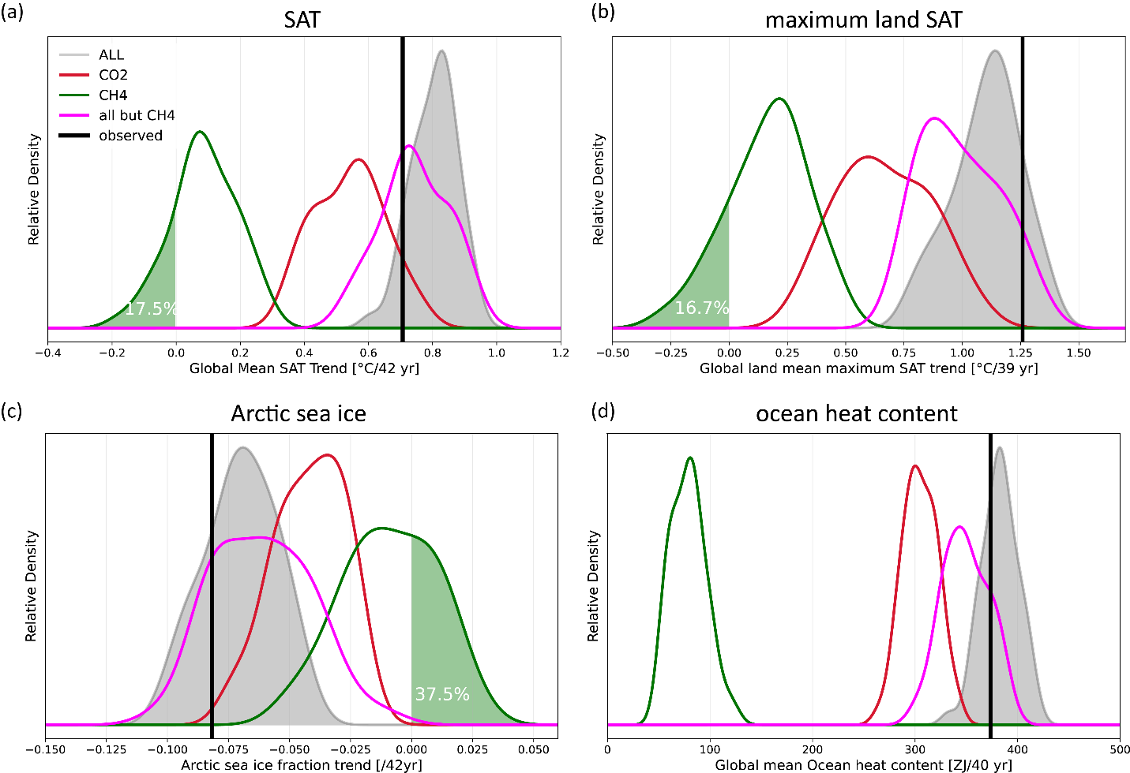
Extended Data Fig. 2 | Probability distribution function of trends in regional climate change indices. Normalized probability distribution function (PDF) for observations, and each experiment for (a) global mean SAT (1979-2020), (b) global mean maximum near surface temperature (1979-2017), (c) Arctic mean sea ice fraction (1979-2020), and (d) global mean ocean heat content (1979-2018) trend. The white text on the light green shade represents the proportion of CH4 ensemble members with the trend of 0 or below.

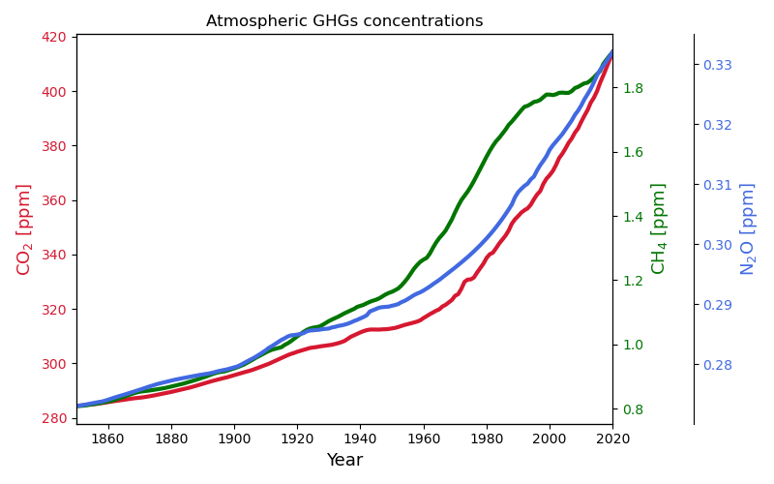
Extended Data Fig. 3 | Temporal evolution of atmospheric GHGs concentration. Time series of atmospheric CO₂, CH₄, and N₂O concentrations prescribed in ALL and each single forcing experiments.

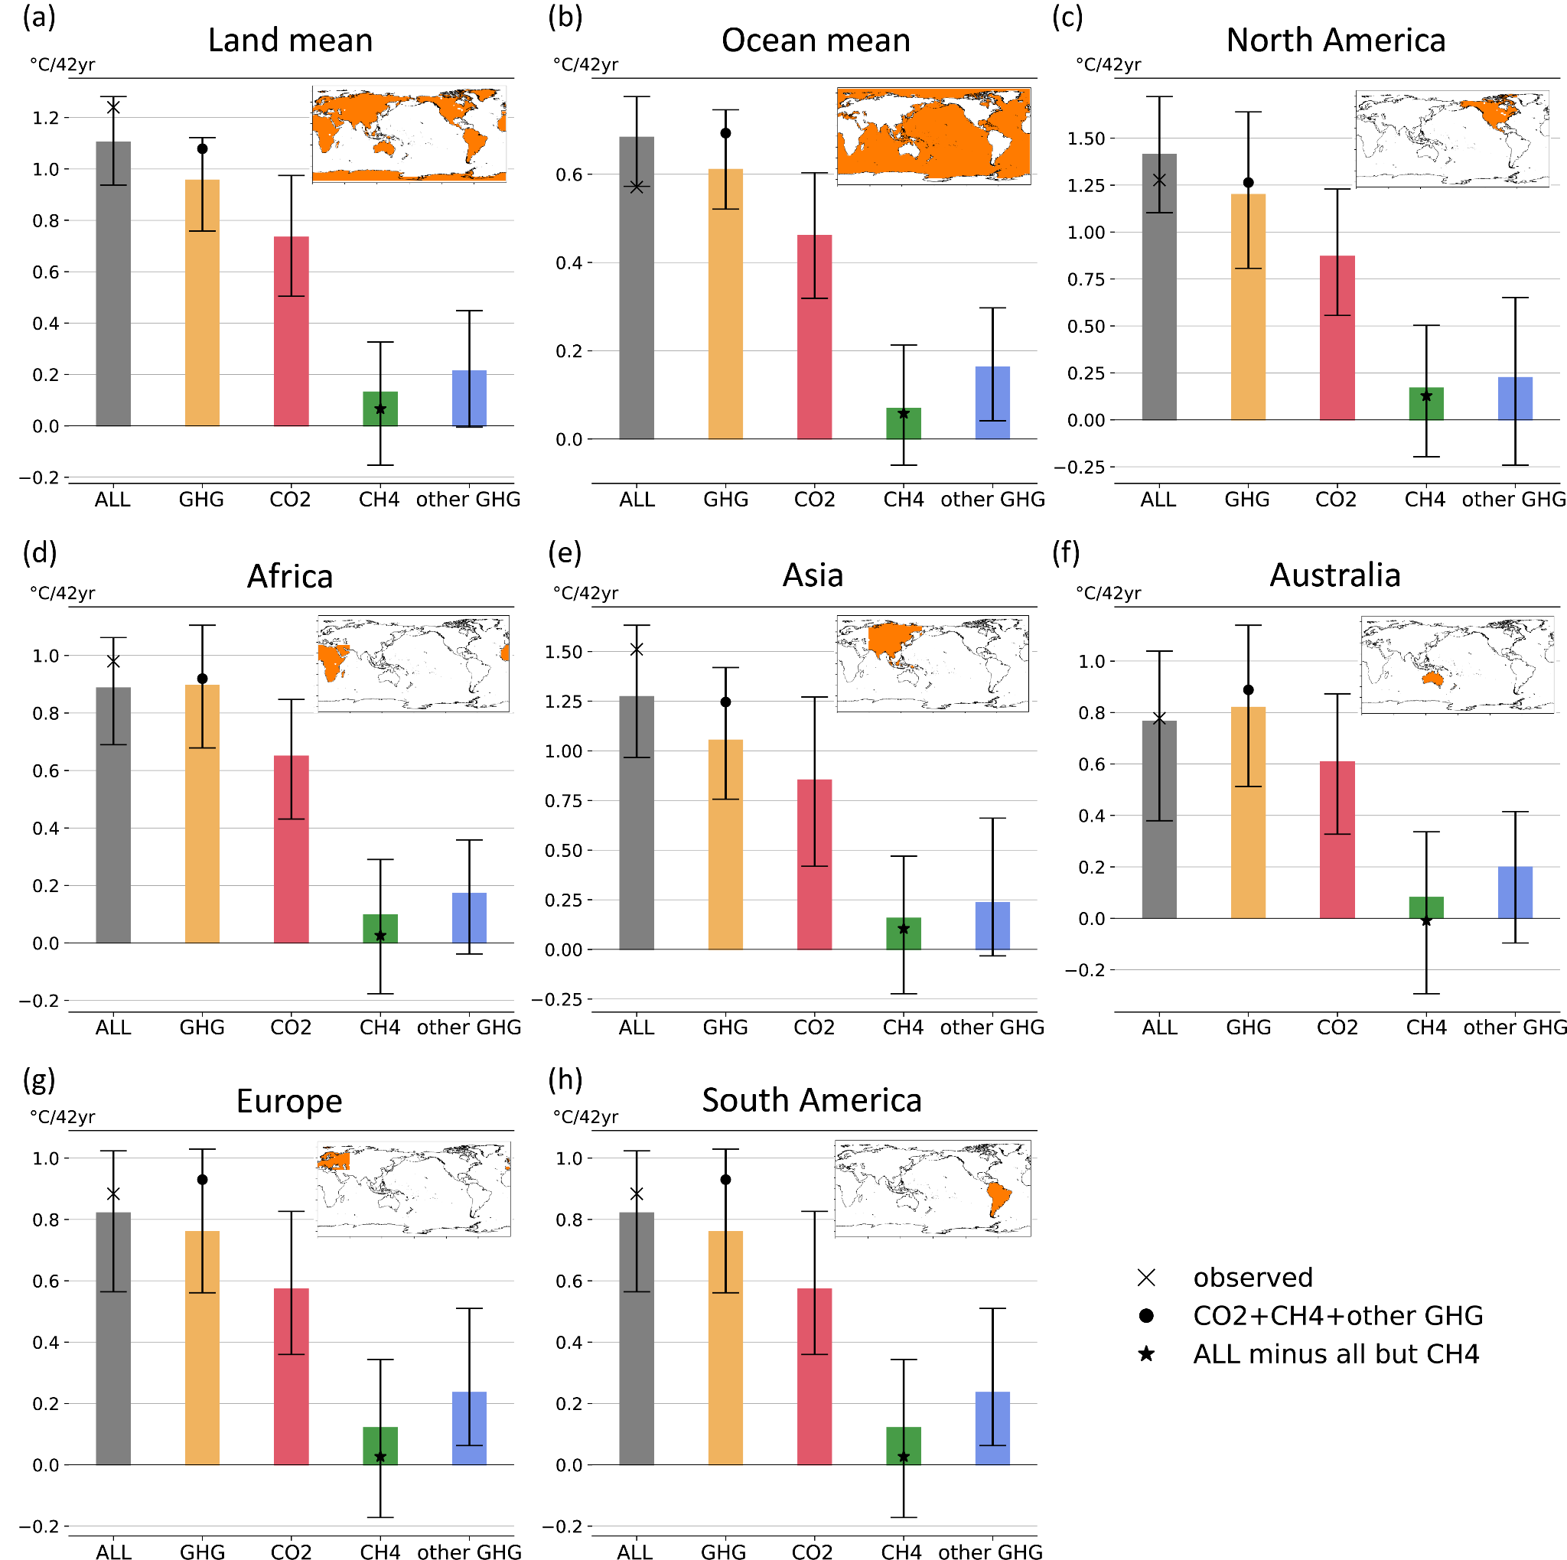
Extended Data Fig. 4 | GHG attribution of continental scale surface air temperature in the satellite era. As in Fig. 2a but for (a) global land, (b) global ocean, (c) North America, (d) Africa, (e) Asia, (f) Australia, (g) Europe, and (h) South America. Reference regions for each panel are shaded in orange in the world map of each panel.

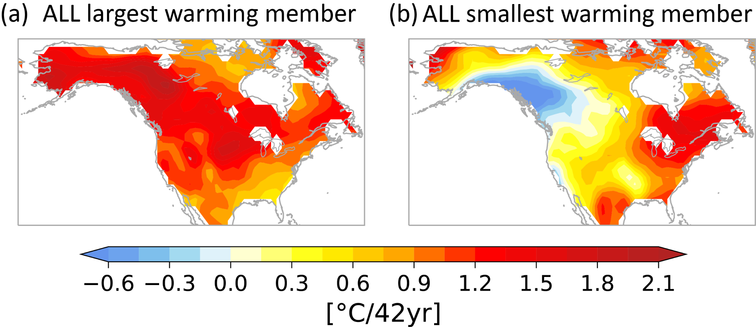
Extended Data Fig. 5 | Impact of internal variability on spatial patterns of SAT trend over North America. The spatial pattern of SAT trend (1979-2020) for the ALL ensemble member with (a) the largest warming (b) and the smallest warming averaged over North America.
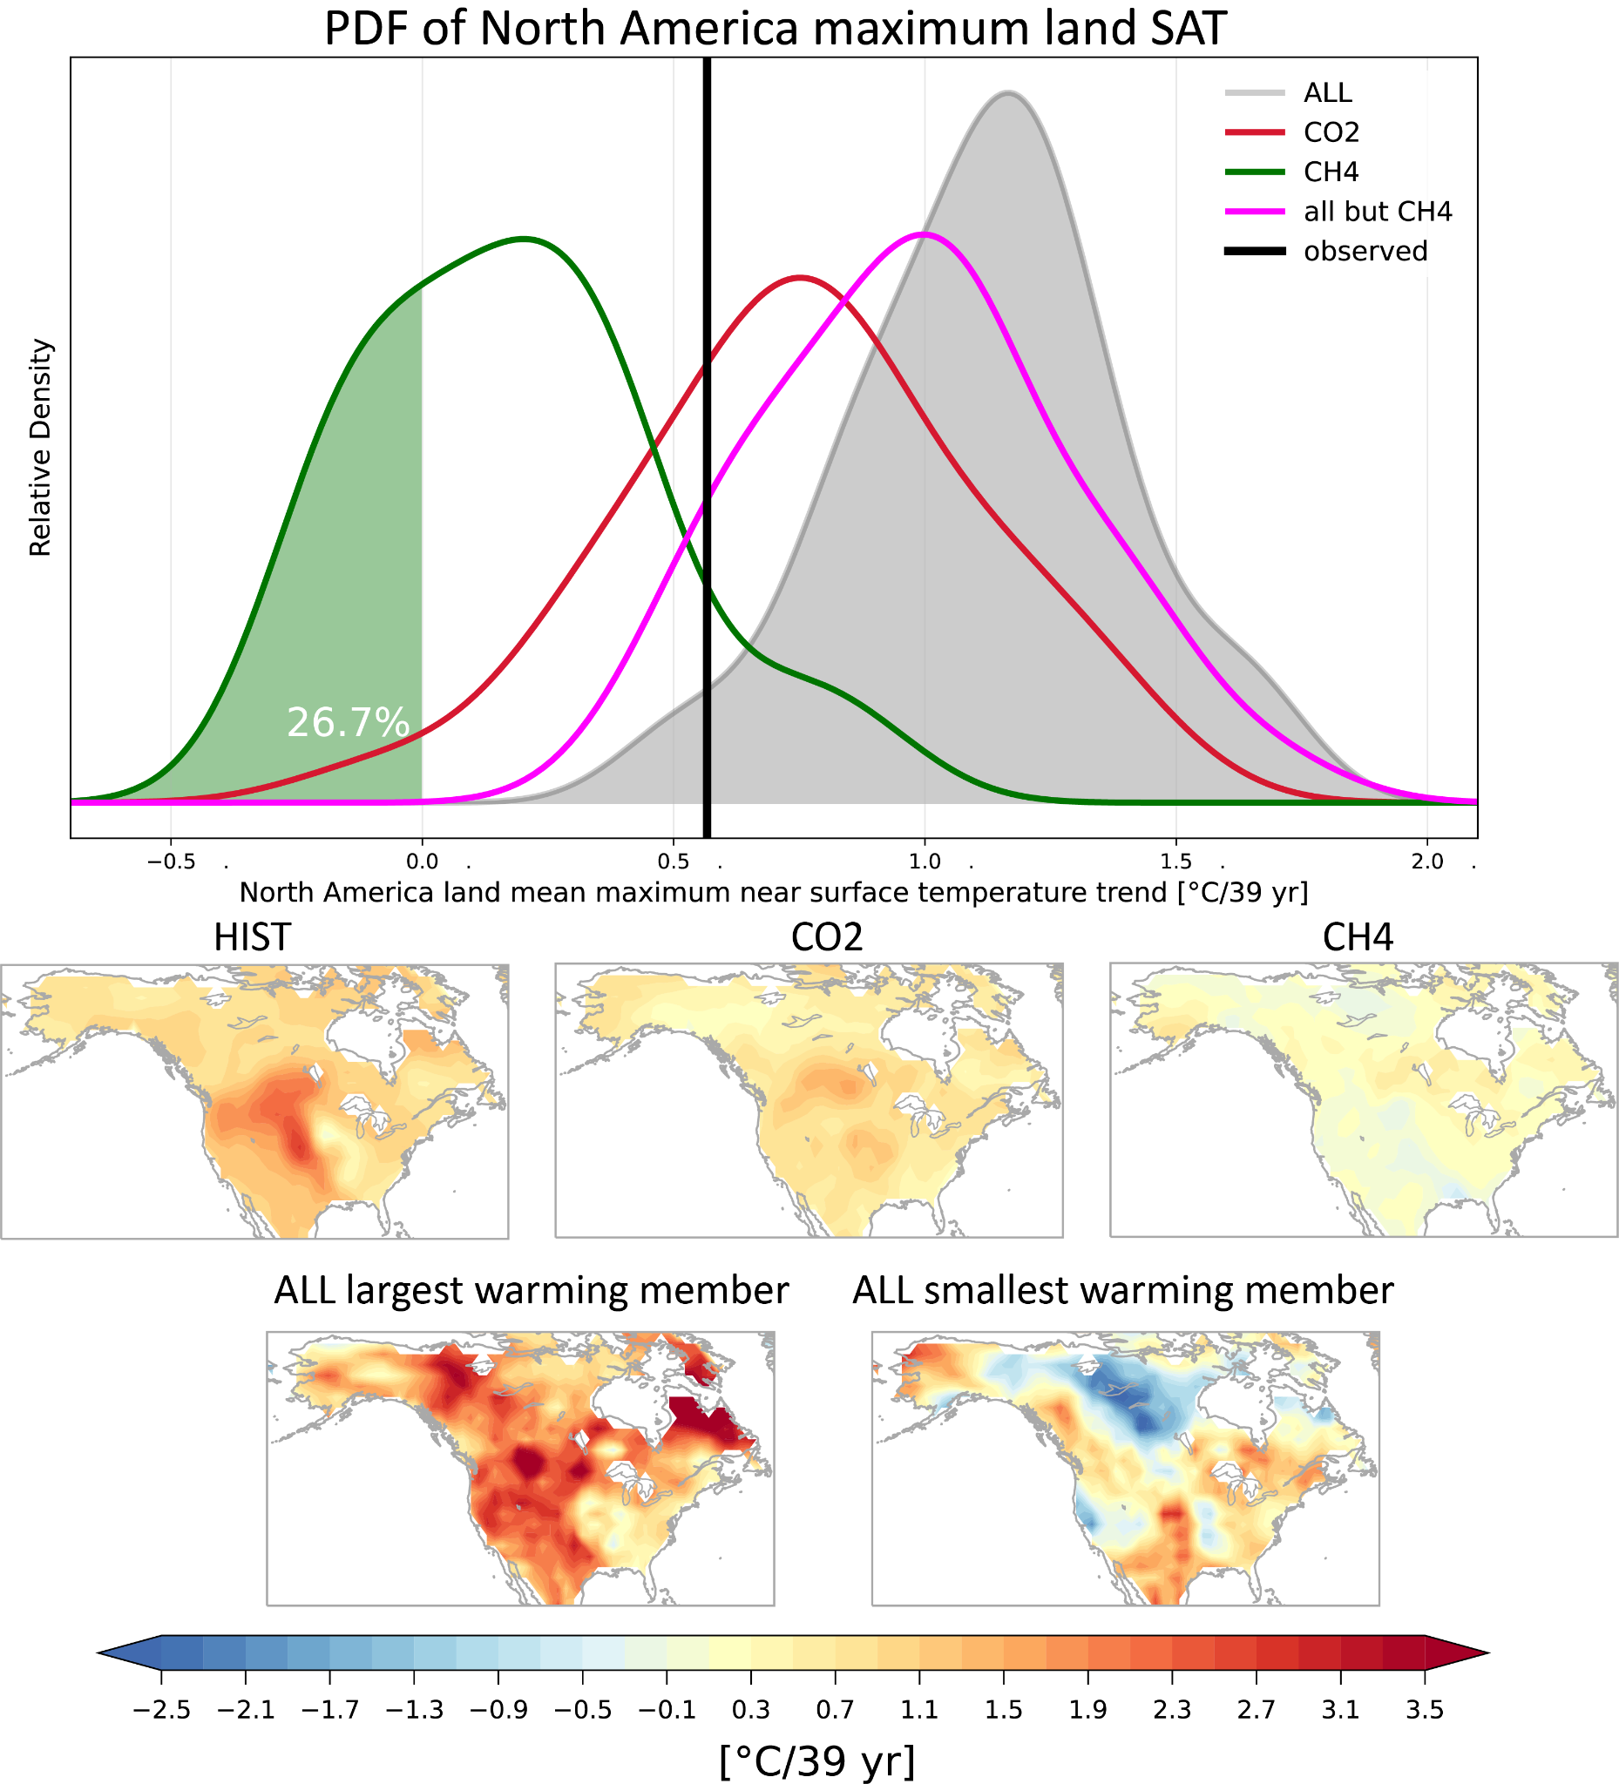
Extended Data Fig. 6 | GHG attribution of extreme hot event over North America. (a) Normalized probability distribution function (PDF) for the North America mean maximum near surface temperature trend between 1979–2017 in observations (HadEX3), and each experiment. The white text on the light green shade represents the proportion of CH4 ensemble members with the trend of 0 or below. Spatial pattern of surface air temperature trend over North America for the ensemble mean of (b) ALL, (c) CO2, (d) CH4, and ALL ensemble member with (e) the largest (f) and smallest maximum near surface temperature trend in North America.

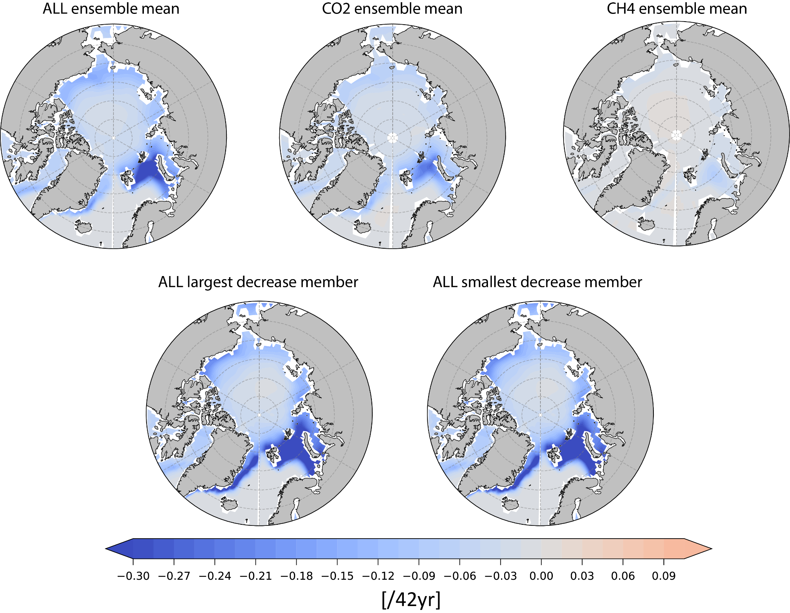

Extended Data Fig. 7 | GHG attribution of Arctic sea ice trend. Spatial distribution of Arctic ice fraction trend between 1979–2020 for the ensemble mean of (a) ALL, (b) CO2, (c) CH4, and the ALL ensemble member with (e) the largest and (f) the smallest sea ice fraction reduction in the Arctic.

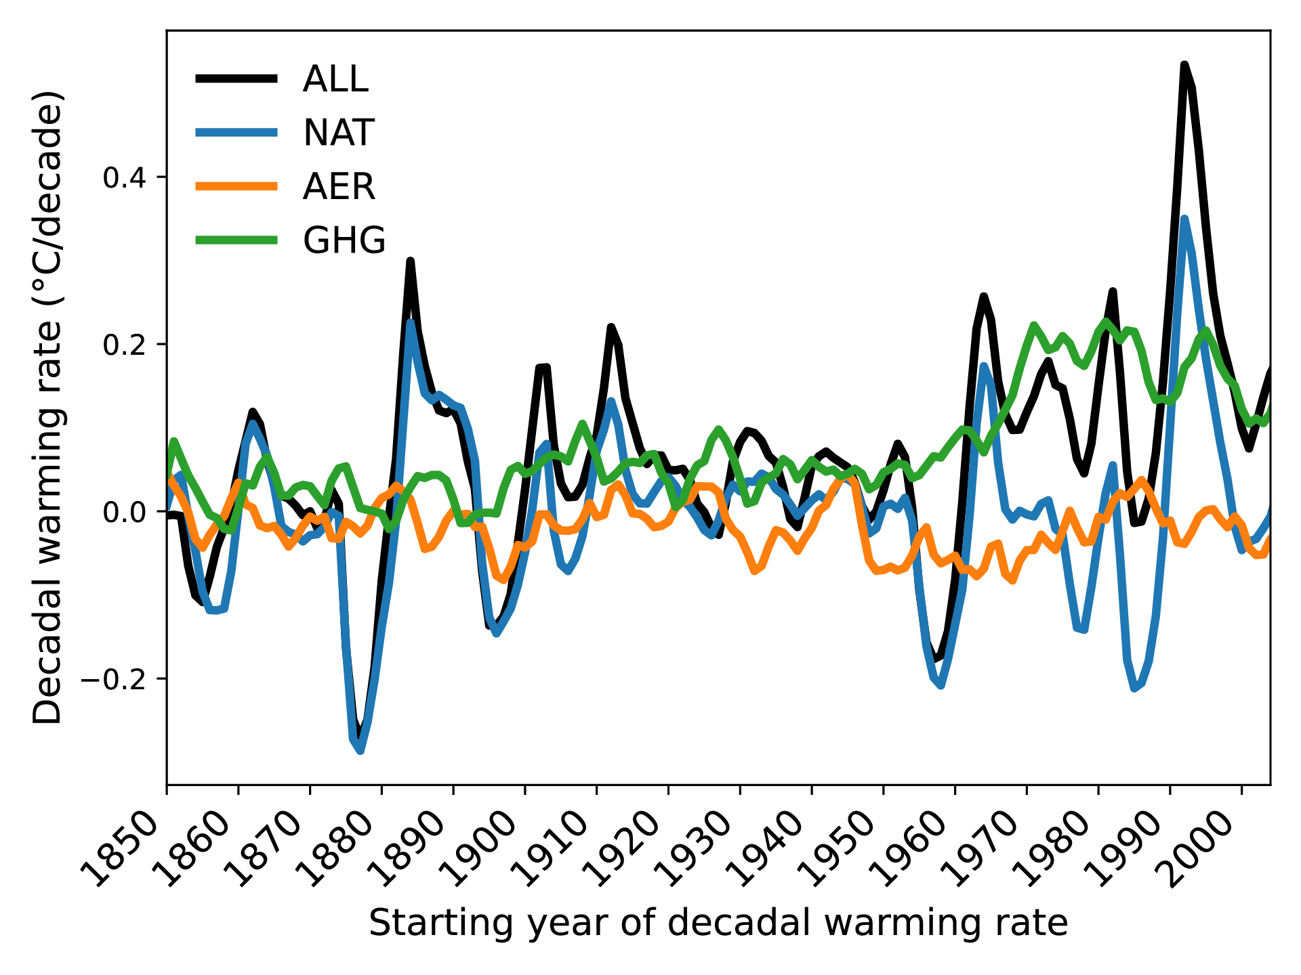
Extended Data Fig. 8 | Attribution of decadal warming rates to individual forcing agents. Temporal variation of decadal warming rate for the ensemble mean of the simulations with all historical radiative forcing (ALL, black), natural forcing (NAT, blue), anthropogenic aerosols (AER, orange) and all GHGs (GHG, green) (see Methods). The x-axis indicates the start years of the 10-year trends.

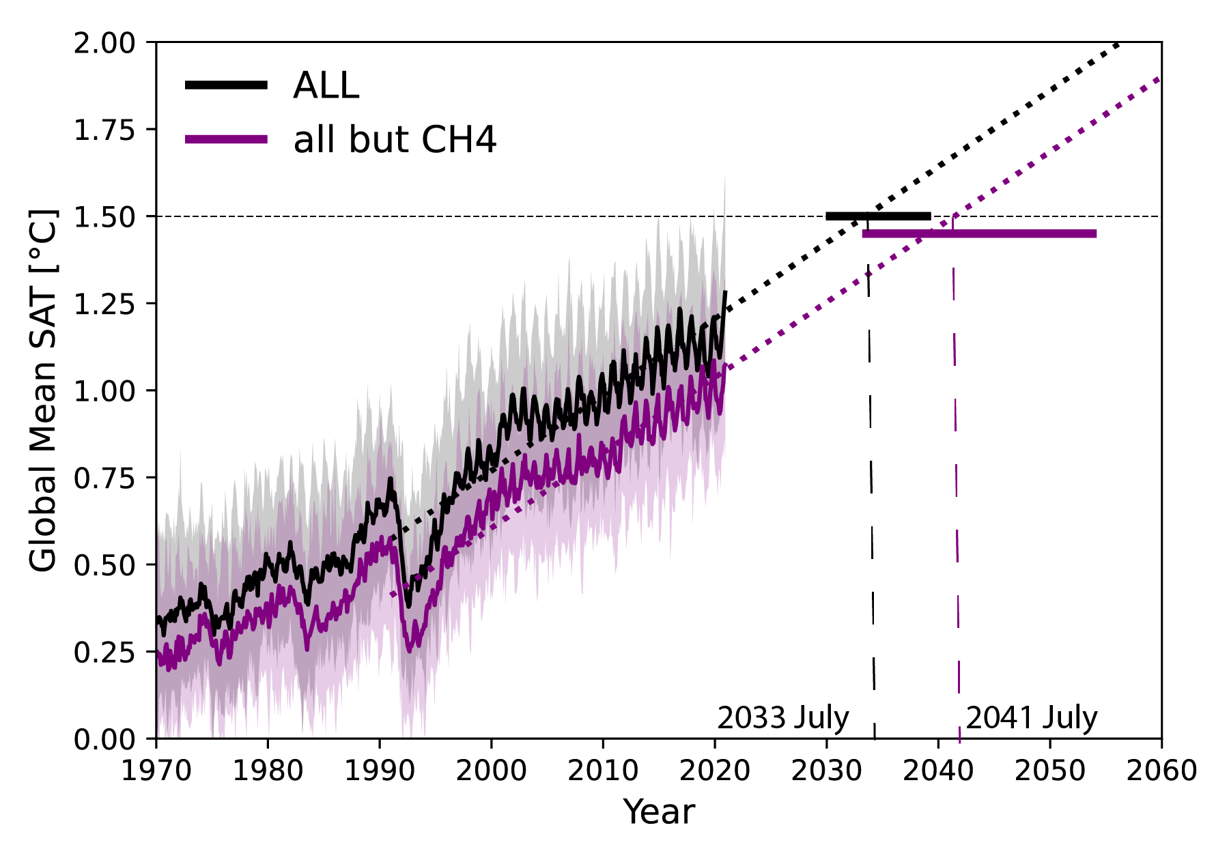
Extended Data Figure 9: Estimation of the timing for reaching the 1.5 °C threshold. Time series of global mean monthly SAT anomaly from 1850-1900. Black and purple dotted straight lines are linear extrapolations using 1991-2020 values from ALL and all but CH4, respectively. The timing at which the 1.5 °C level is reached for the ensemble-mean of each experiment is indicated at the bottom of the figure. The solid black and purple horizontal lines indicate the 5-95th percentile interval of the timing at which the 1.5 °C level is reached for each ensemble member in ALL and all but CH4, respectively (see Methods).

