Supplementary materials

A direct look into the small-scale dynamics of slow laboratory earthquakes.

G. Pozzi, G. Volpe, J. Taddeucci, C. J. Marone, M. Cocco, and C. Collettini

Contents:

SM1 – Luminosity-stress calibration
SM2 – Recovered samples
SM3 – Formation and evolution of fault structures
SM4 – Slow slip instabilities
SM5 – Plumose structures

SM1 – Luminosity-stress calibration

The test of Fig. S1 shows an attempt to calibrate the stress state as function of the average luminosity measured in the area where is observed the effective compaction of the gouge layer, which corresponds to ~85% of the nominal area where the normal load is applied (50x50 mm). In the remaining area no significative luminosity changes are observed and correspond to zones where lateral extrusion of gouge prevents the build-up of stress.
The test consists of several stages (labelled with Roman numbers): I-II) loading of normal stress from 0 to target (nominally 10 MPa), II-III) unloading to a small residual normal stress, III-IV) re-loading of normal stress to target, IV-V) application of shear motion at constant normal stress followed stop and unloading of the residual shear stress, V-VI) unloading of the normal stress.
We first observe that the change of average luminosity is mostly affected by the nominal normal stress and the initial build-up of nominal shear stress. The latter, appears not to be related to recoverable (poroelastic) deformation of the sample due to the permanent shift of luminosity recorded during unloading of the shear stress (before point V). This implies that some changes of luminosity are imputable to the formation of shear fabrics, for example, the alignment of platelets to form a S-C fabric in the boundary shear zone (Volpe et al., 2024). In turn, the dependency of luminosity to normal stress seems, for nominal values > 4 MPa, due to a poroelastic behaviour of the material.
Figs. 4,5,7 in the main text show that there is a small, but clear relationship between the change in average luminosity with the nominal shear stress, validating our qualitative estimation of the change of state of stress within the fault (see also Volpe et al., 2024). However, given the asymmetry of loading-unloading paths and minor permanent changes of luminosity, attempts to calibrate the stress state as function of average luminosity have been inconclusive. The same applies to the nominal normal stress, but we observed an interesting scaling during the unloading paths (blue fits in Fig. S1b). The exponential fit of nominal normal stress as function of average luminosity (blue fits in Fig. S1b) yields and exponential factor 𝛼 comprised between 0.15 and 0.2. This exponent very close to that found in uniaxial compression tests in montmorillonite (Mondol et al., 2008), where the nominal axial loading is exponentially proportional to the porosity. Supported by this evidence, we assess that the macroscopic change in luminosity, which is governed by frustrated total internal reflection at the slider interface, is a proxy of the porosity of the material and thus of its stress state. The caveat here is that this scaling is not usable to measure the stress on the experimental fault for the following reasons: i) we do not know the local orientation of the stress axes, ii) it is different depending on the loading path, and iii) permanent luminosity changes are recorded during the evolution of shear fabric.
A final point should be dedicated to the shear fabric evolution. The preferential orientation of platelets parallel to the slider during shear and formation of S-C fabric causes a permanent decrease of luminosity, which can lead the reader to overestimate the stress change during texturing in Fig. 2 and 3 in the main text. However, the quantification of these stress changes is beyond the scope of this paper and the interpretation of the results would not change. This is justified by the fact that the change in average luminosity observed in short time intervals is immediately affected by the change in stress and consistently maintains the directivity (inverse).
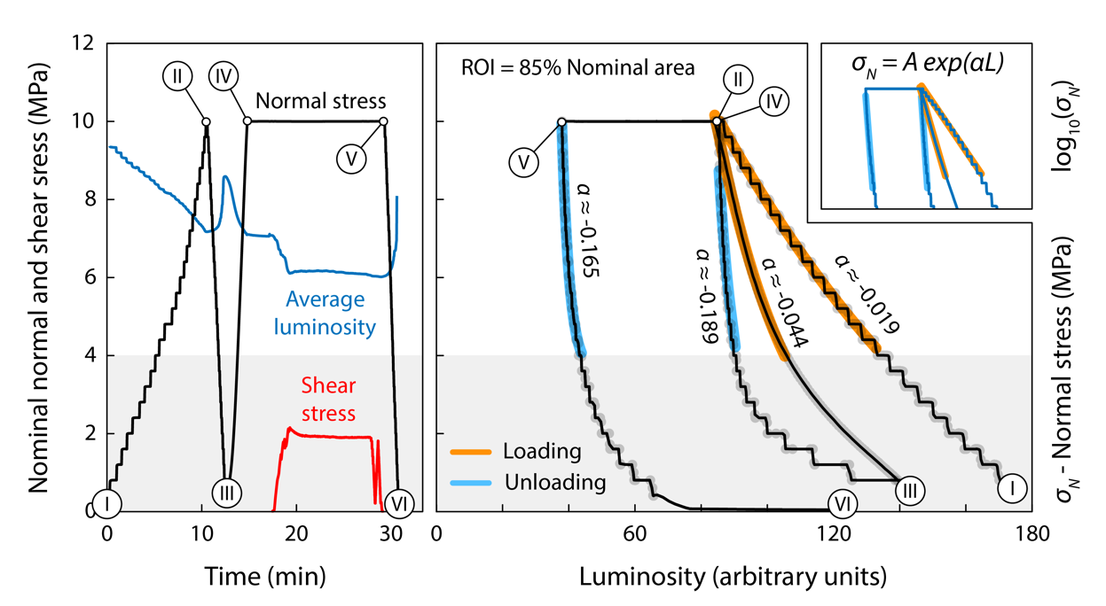

Figure S1 – Luminosity and stress: a) Stress test comprising loading, unloading and shear. b) Variation of the nominal stress with luminosity and best fits (see formula in the inset). The steps during the test are labelled using Roman numbers in both panels.

SM2 – Recovered samples

After each experiment, samples are very easily collected as they display a notable degree of cohesion. By gently pressing with the fingers, it is possible to separate the micro-lithons as displayed in Fig. S2.

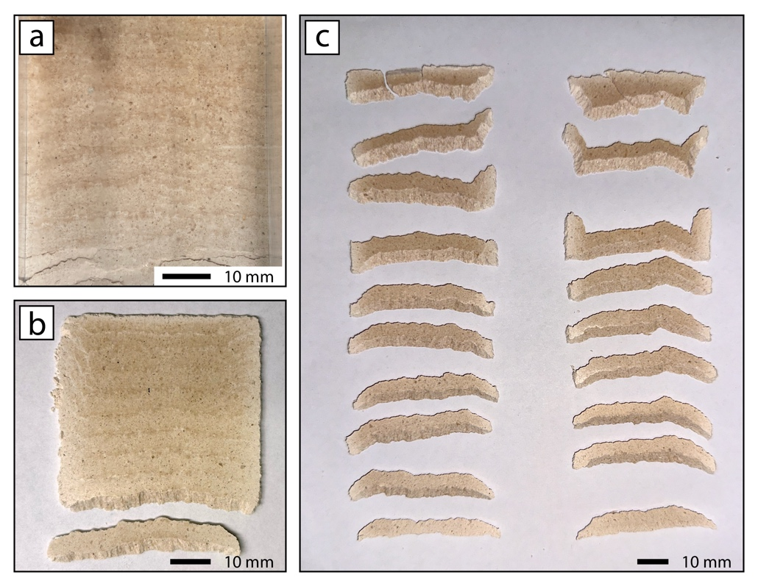

Figure S2 – Recovered sample: View of the sheared sample before a) and after b) removal of the transparent block. c) Samples split easily along the Riedel shear zones revealing the micro-lithons.
SM3 – Formation and evolution of fault structures

To detail the evolution of fault architecture and stress distribution, we focus on a thin region parallel to the slip direction (dashed lines in Fig. 1c in the main text, frame VIII). By stacking subsequent snapshots of this region, we highlight changes in luminosity and thus stress (Fig. S3b), and, by its derivative in time, the stressing rate (Fig. S3c). The shear stress increases initially at the top of the layers, close to the loading point and then extends progressively over the whole layer (frames I-III). The stress increase occurs in a narrow region (mostly < 2mm) that produces a sweeping stripe highlighted by positive stressing rates (red colours, Fig. S3c).

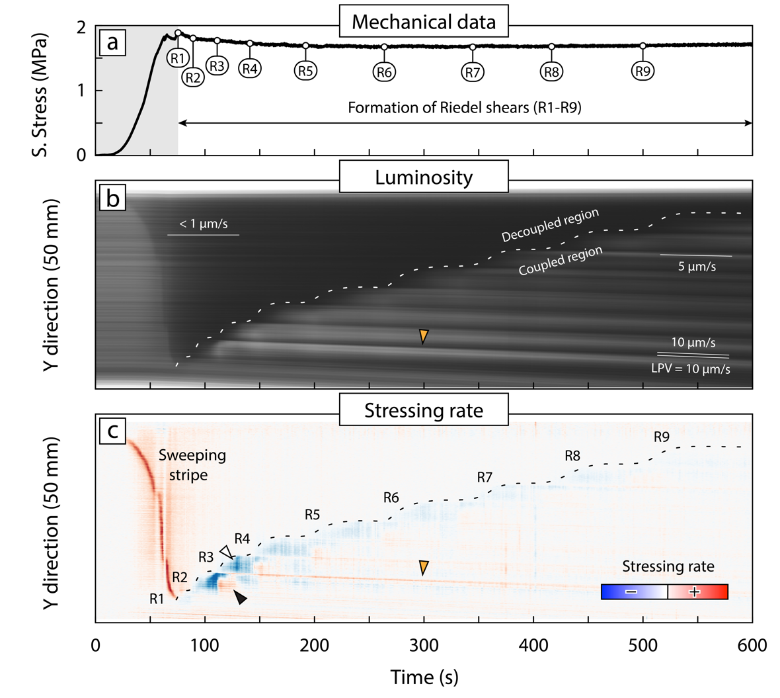

Figure S3 – Evolution of fault structures and stress state: a) Shear stress during run-in as in Fig. 1b in the main text. b) Spatial-temporal changes in luminosity along the shear direction, where luminosity is averaged in the X direction between the dashed lines in Fig. 2c in the main text, frame VIII. White and dark areas are low- and high-stress regions, respectively. Fiducial lines show propagation rates of several features and loading point velocity (LPV). c) Time derivative of the luminosity (evaluated as proxy of the stressing rate along the fault zone) of Panel b). R1-R9: locations relative to the formation of the main Riedel shears. Arrows: white, negative stressing rate during the formation of the R-shear; black, positive stressing rate related to the coupling of the micro-lithon; orange, trace of fault structures migrating with the central slider.

Immediately after the stripe has swept across the entire fault, the first R-shear (R1) forms with a sudden decrease of stress (increase of luminosity) at the bottom of the experimental fault. Progressively and in sequence, new R-shears form (R2-R9) marked by negative stressing rates (Fig. 4c, white arrow) within the newly-formed micro-lithons (Fig. 3c). When a new R-shear forms, the others are mostly abandoned and retain lighter colours associated with lower shear stress (Fig. S3c). After the new R-shear is formed, the stress is transferred from the newly-formed micro lithon both backward to the undeformed region and forward to the previous micro-lithon, where positive stressing rates are recorded (e.g., Fig. S3c, black arrow). The last micro-lithon cannot be bound by a new Riedel shear due to the proximity of the fault edge (Fig. 1c in the main text, frame VIII) and thus this fault portion remains the most stressed region throughout the rest of the experiment.
Remarkably, the R-shears migrate in time at constant speed after their formation (luminous trails, Fig. S3b and c, orange arrows). The migration speed of the R-shears decreases from ~ 100% to 50 % of the forcing velocity (loading point velocity, LPV = 10 µm/s) from R1 to R9. Traces of particles above the last R-shear (R9) are almost immobile (velocity < 1 µm/s in Fig. S3b). This means that the micro-lithons, bounded by the R-shears, adhere and become coupled with the central slider after their formation. In addition, the coupled fault area widens with time. We infer that slip is therefore initially accommodated by the upper B-shear zone (B_{L}, Fig. 3b,c) at the sample-slider interface and then it is progressively transferred through the R-shears to the lower one (B_{L}). The absence of the lower B-shear at one side of the uppermost micro-lithon (Fig. 2c in the main text) highlights the importance of strain transfer through the R-shears to partition strain between the two B-shears.
After the run-in phase, during the stick-slip tests, the fault zone structure does not change substantially due to the small amount of displacement, as revealed by the imperceptible variation of luminosity on the sample-slider interface. By analysing the position of R-shears (R1-R9) in the X direction through time (Fig. S4c), we measure the migration velocity of structures. The micro-lithon closer to the loading point is essentially locked (R9 velocity $⟶$ 0 µm/s) while the farthest is moving at the same velocity of the central slider (R1 velocity = LPV, Fig. S4b). This means that even during the stick-slip series, strain is partitioned between the two boundary shear zones, with B_{U} most active close to R9 and B_{L} close to R1.

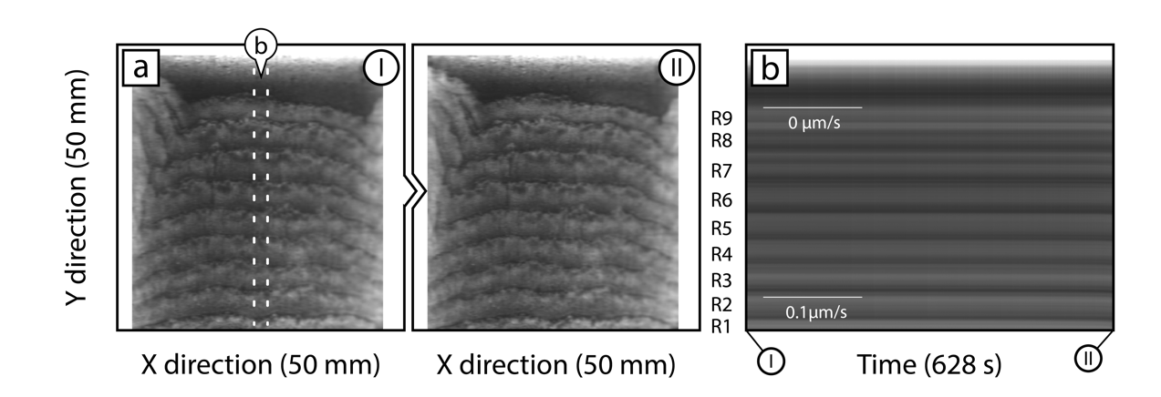

Figure S4 – Evolution of stress during the stick-slip sequence: a) Luminosity at the beginning and end of the unstable sliding test of Fig. 3 in the main text (Roman numbers indicate the time in panel b). b) Evolution of the luminosity in the shear direction (dashed stripe in panel b) during the test. Average luminosity changes less than 1% of the sensitivity range during stick slip events. R1-R9: location of Riedel shears.

SM4 – Slow slip instabilities

Here is an overview of the slip instabilities at different loading point velocities.

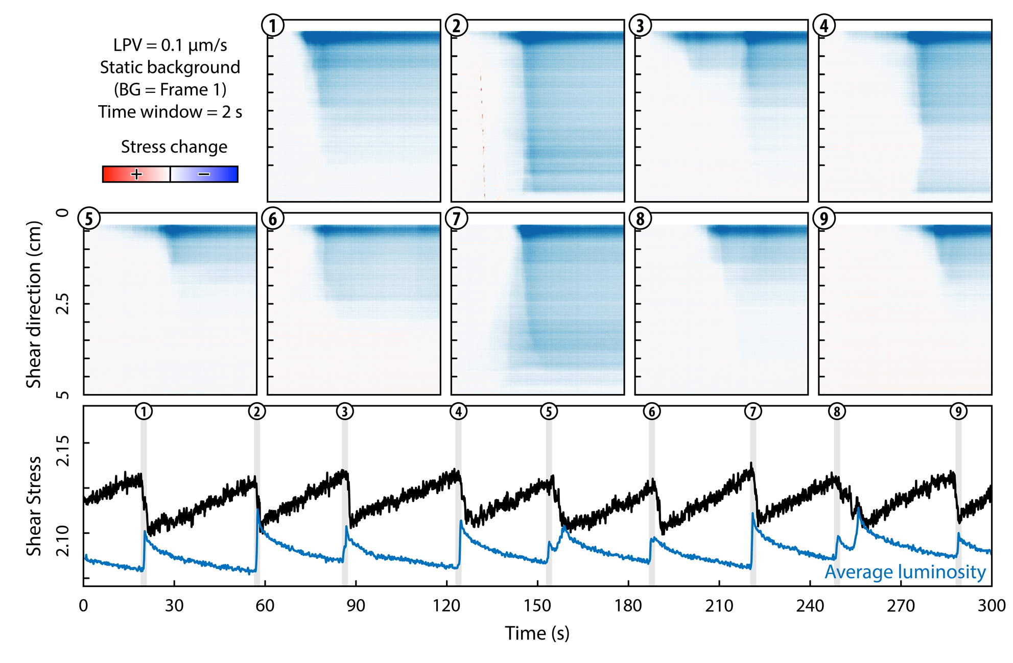
Figure S5 – Slow slip events at LPV = 0.1 µm/s.

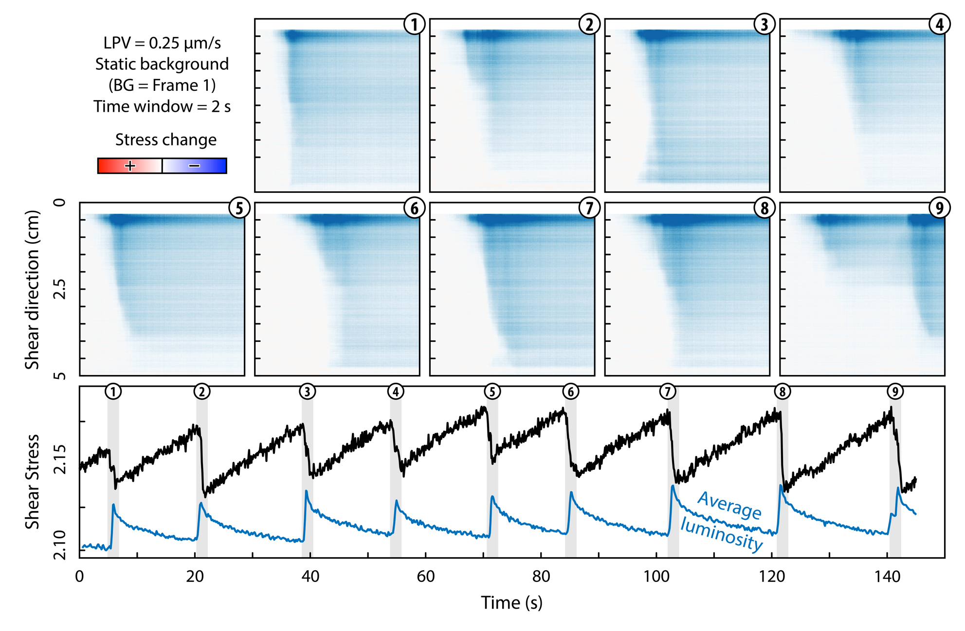
Figure S6 – Slow slip events at LPV = 0.25 µm/s.

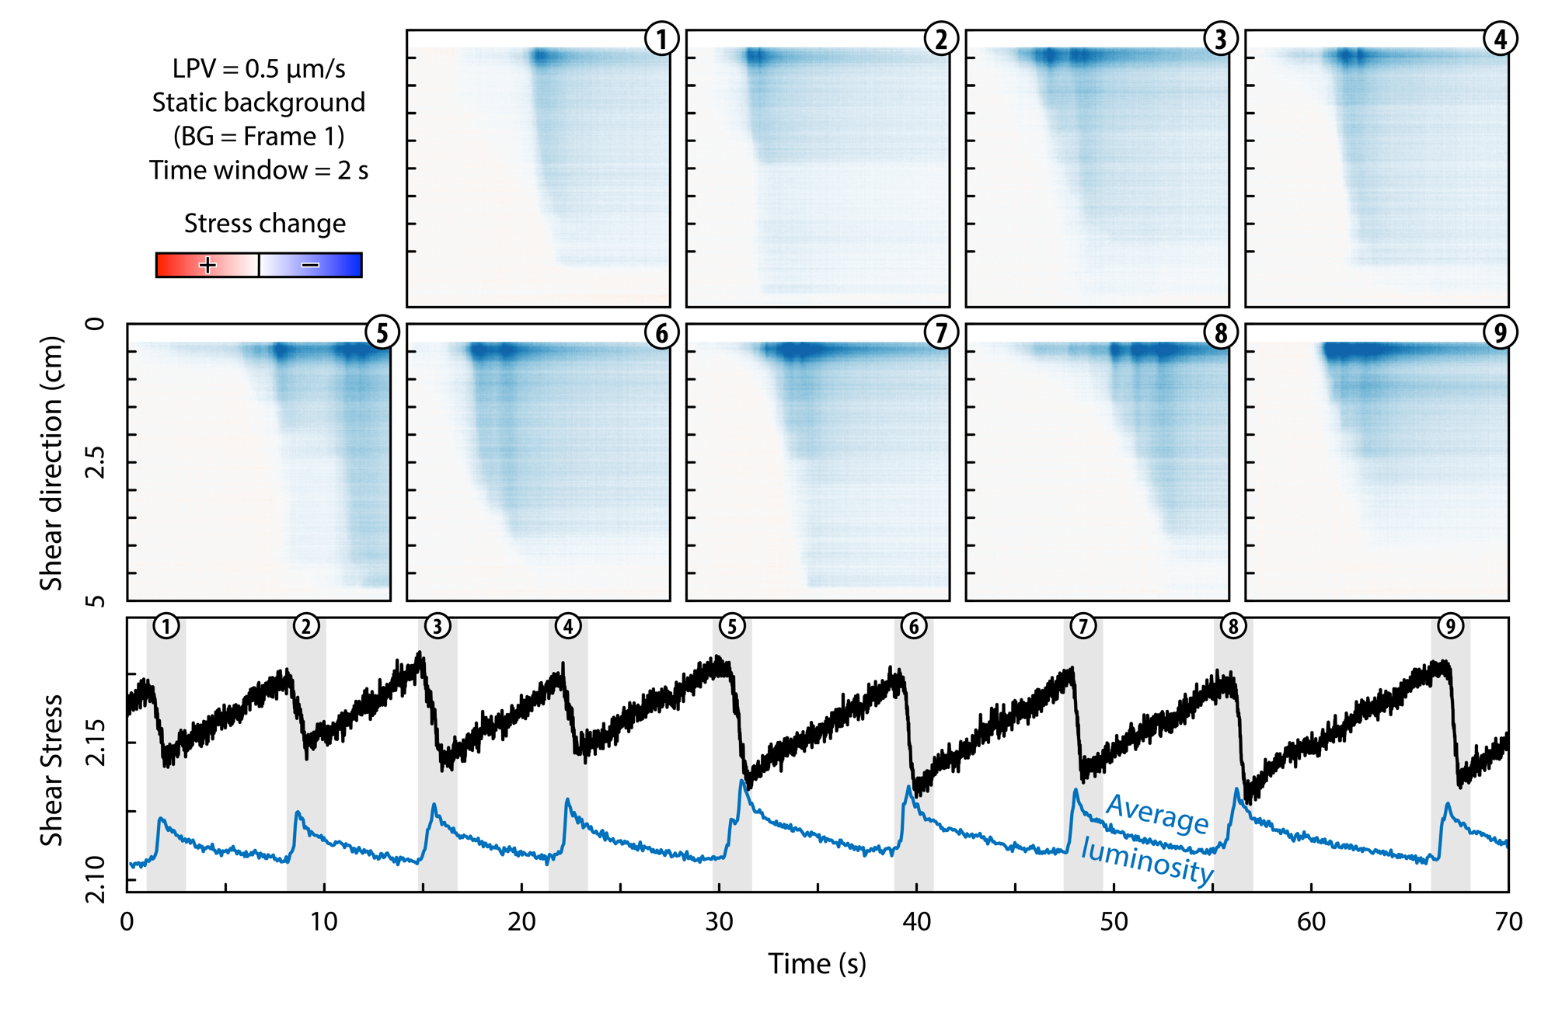
Figure S7 – Slow slip events at LPV = 0.5 µm/s.

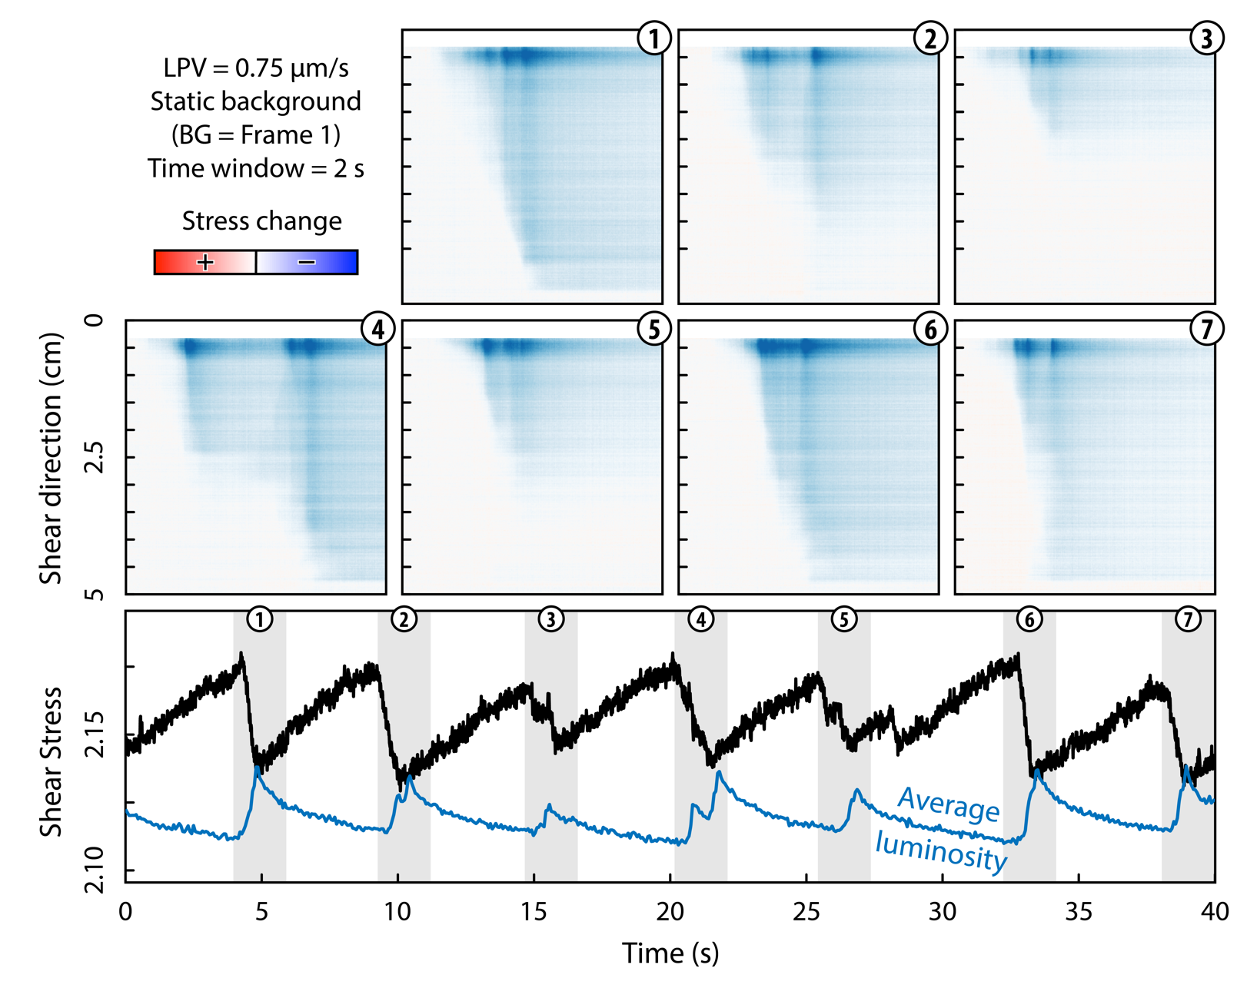
Figure S8 – Slow slip events at LPV = 0.75 µm/s.

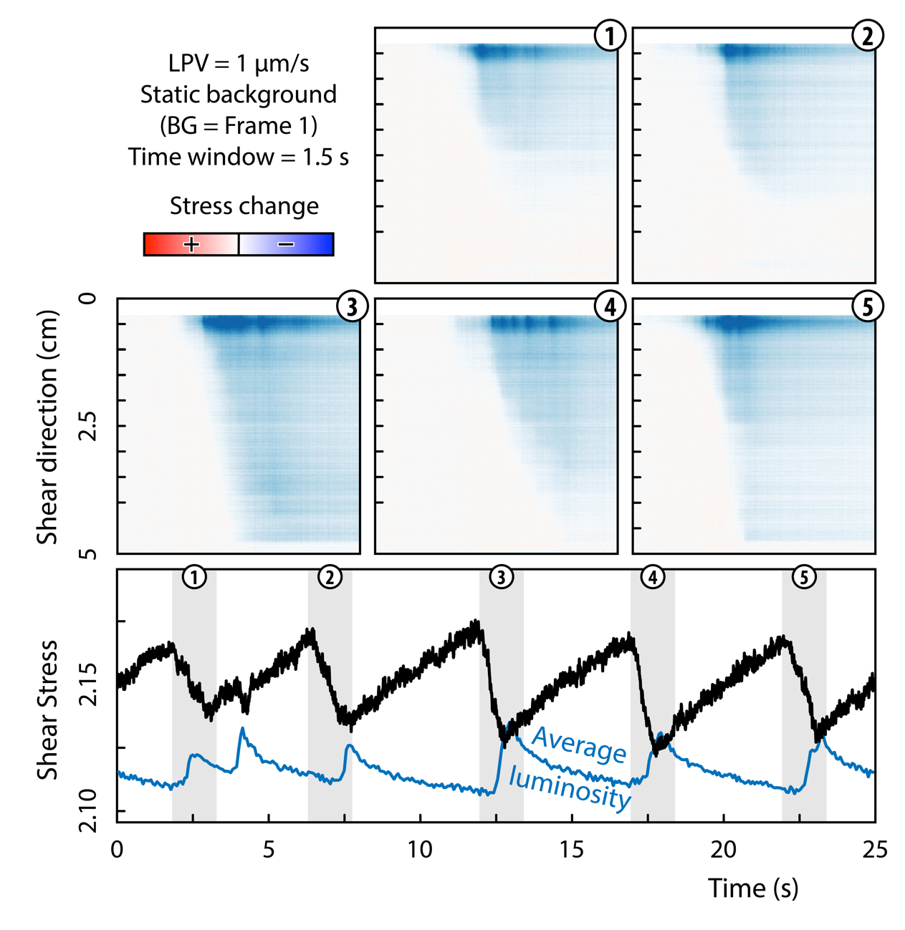
Figure S9 – Slow slip events at LPV = 1 µm/s.w

SM4 – Plumose structures

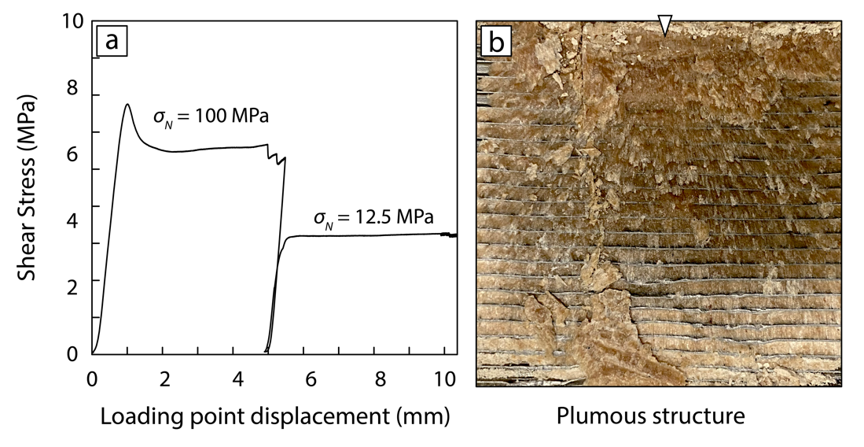

Figure S10 – Plumose structure: a) Shear experiment performed at nominal normal stress σ_{N} = 100 MPa and reactivated at σ_{N} = 12.5 MPa. b) Planar view of the leftover material from the active boundary shear zone and a small micro-lithon preserved onto the slider, in this case we used a metal one. The view shows a structure of divergent ridges starting at the side of the topmost micro-lithon (white pointer), the bounding Riedel shear zone. Unpublished experiments by G. Volpe.

