Supplementary Figures and tables

Figures
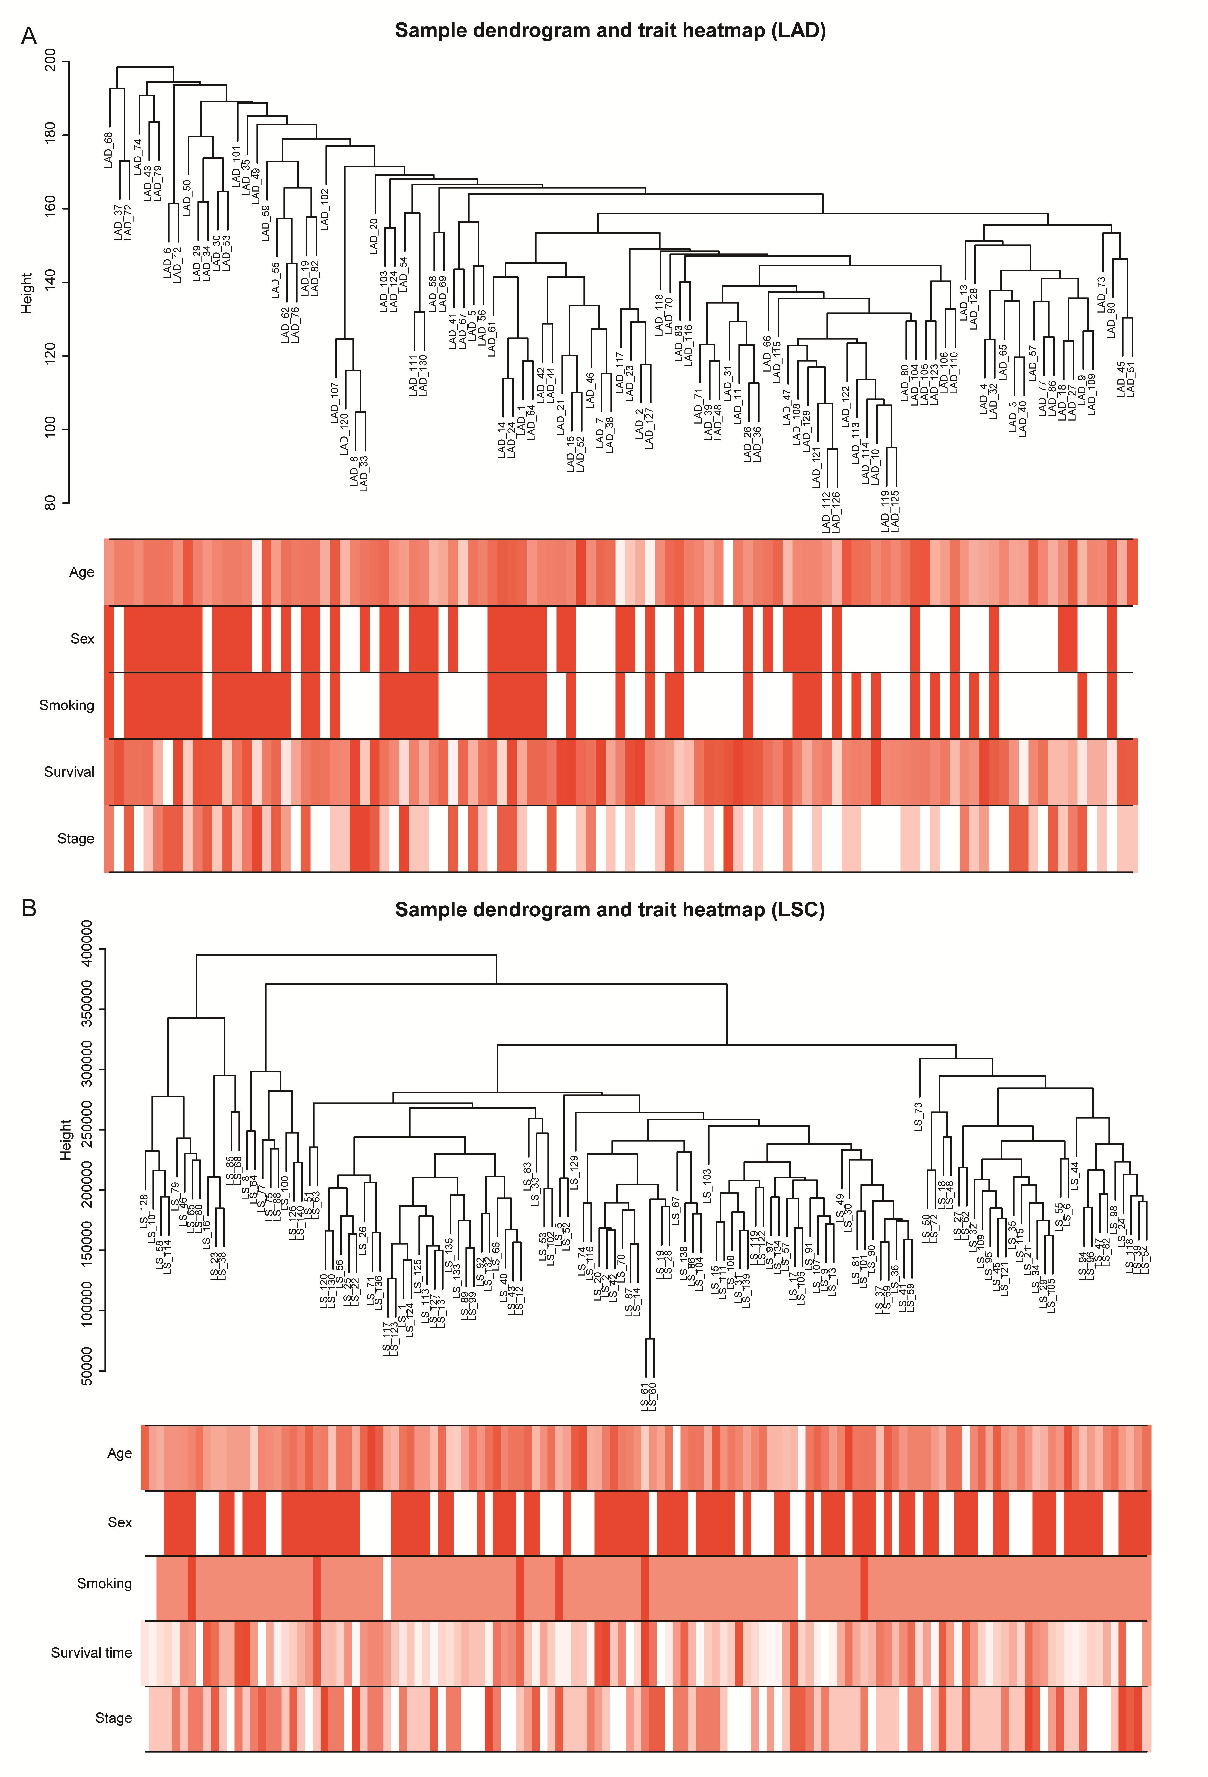
Fig S1 Sample dendrogram and trait heatmap.

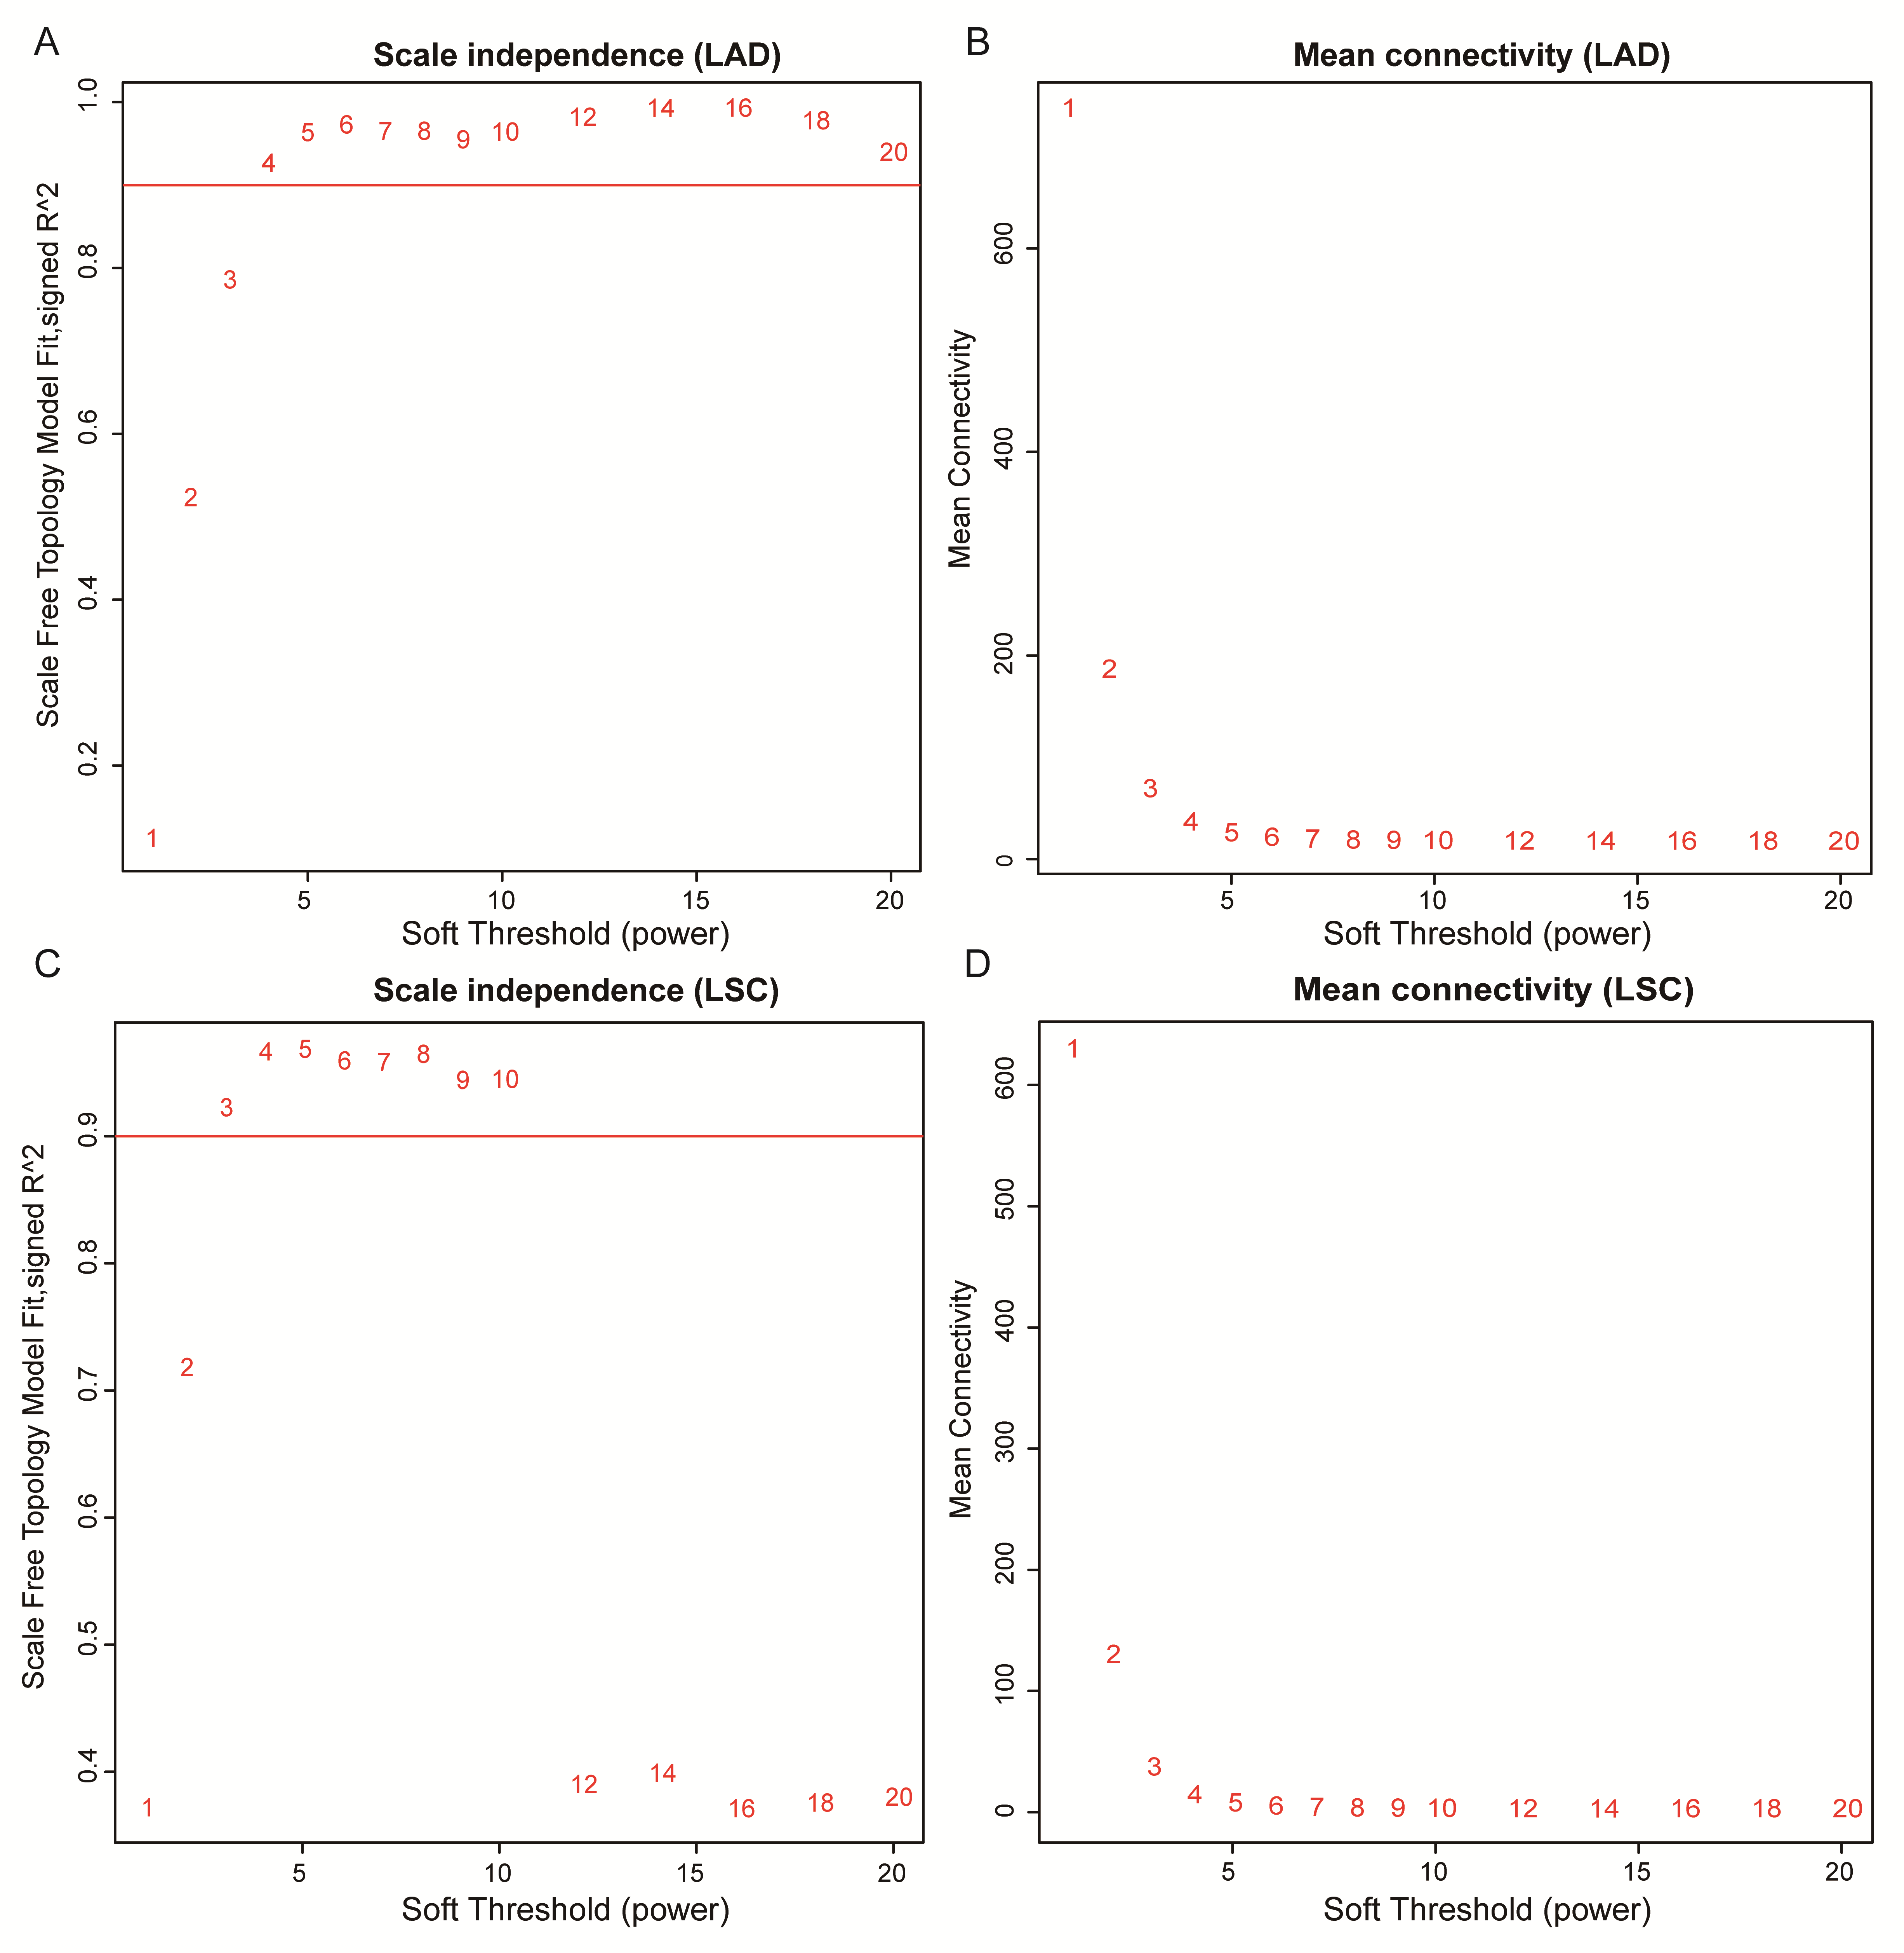
Fig S2 Choosing the soft threshold power.

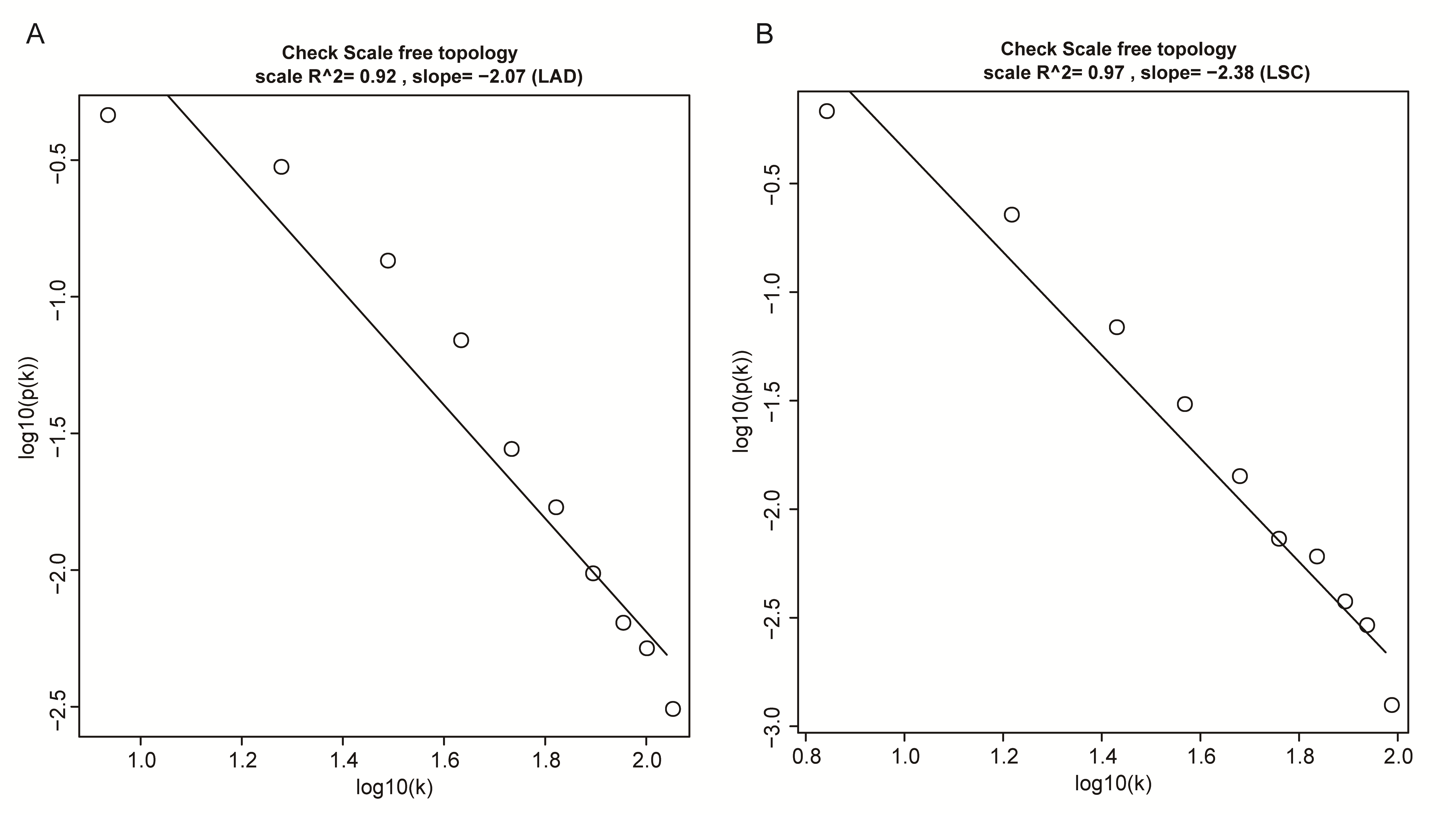
Fig S3 The confirmation of the selected soft threshold power.

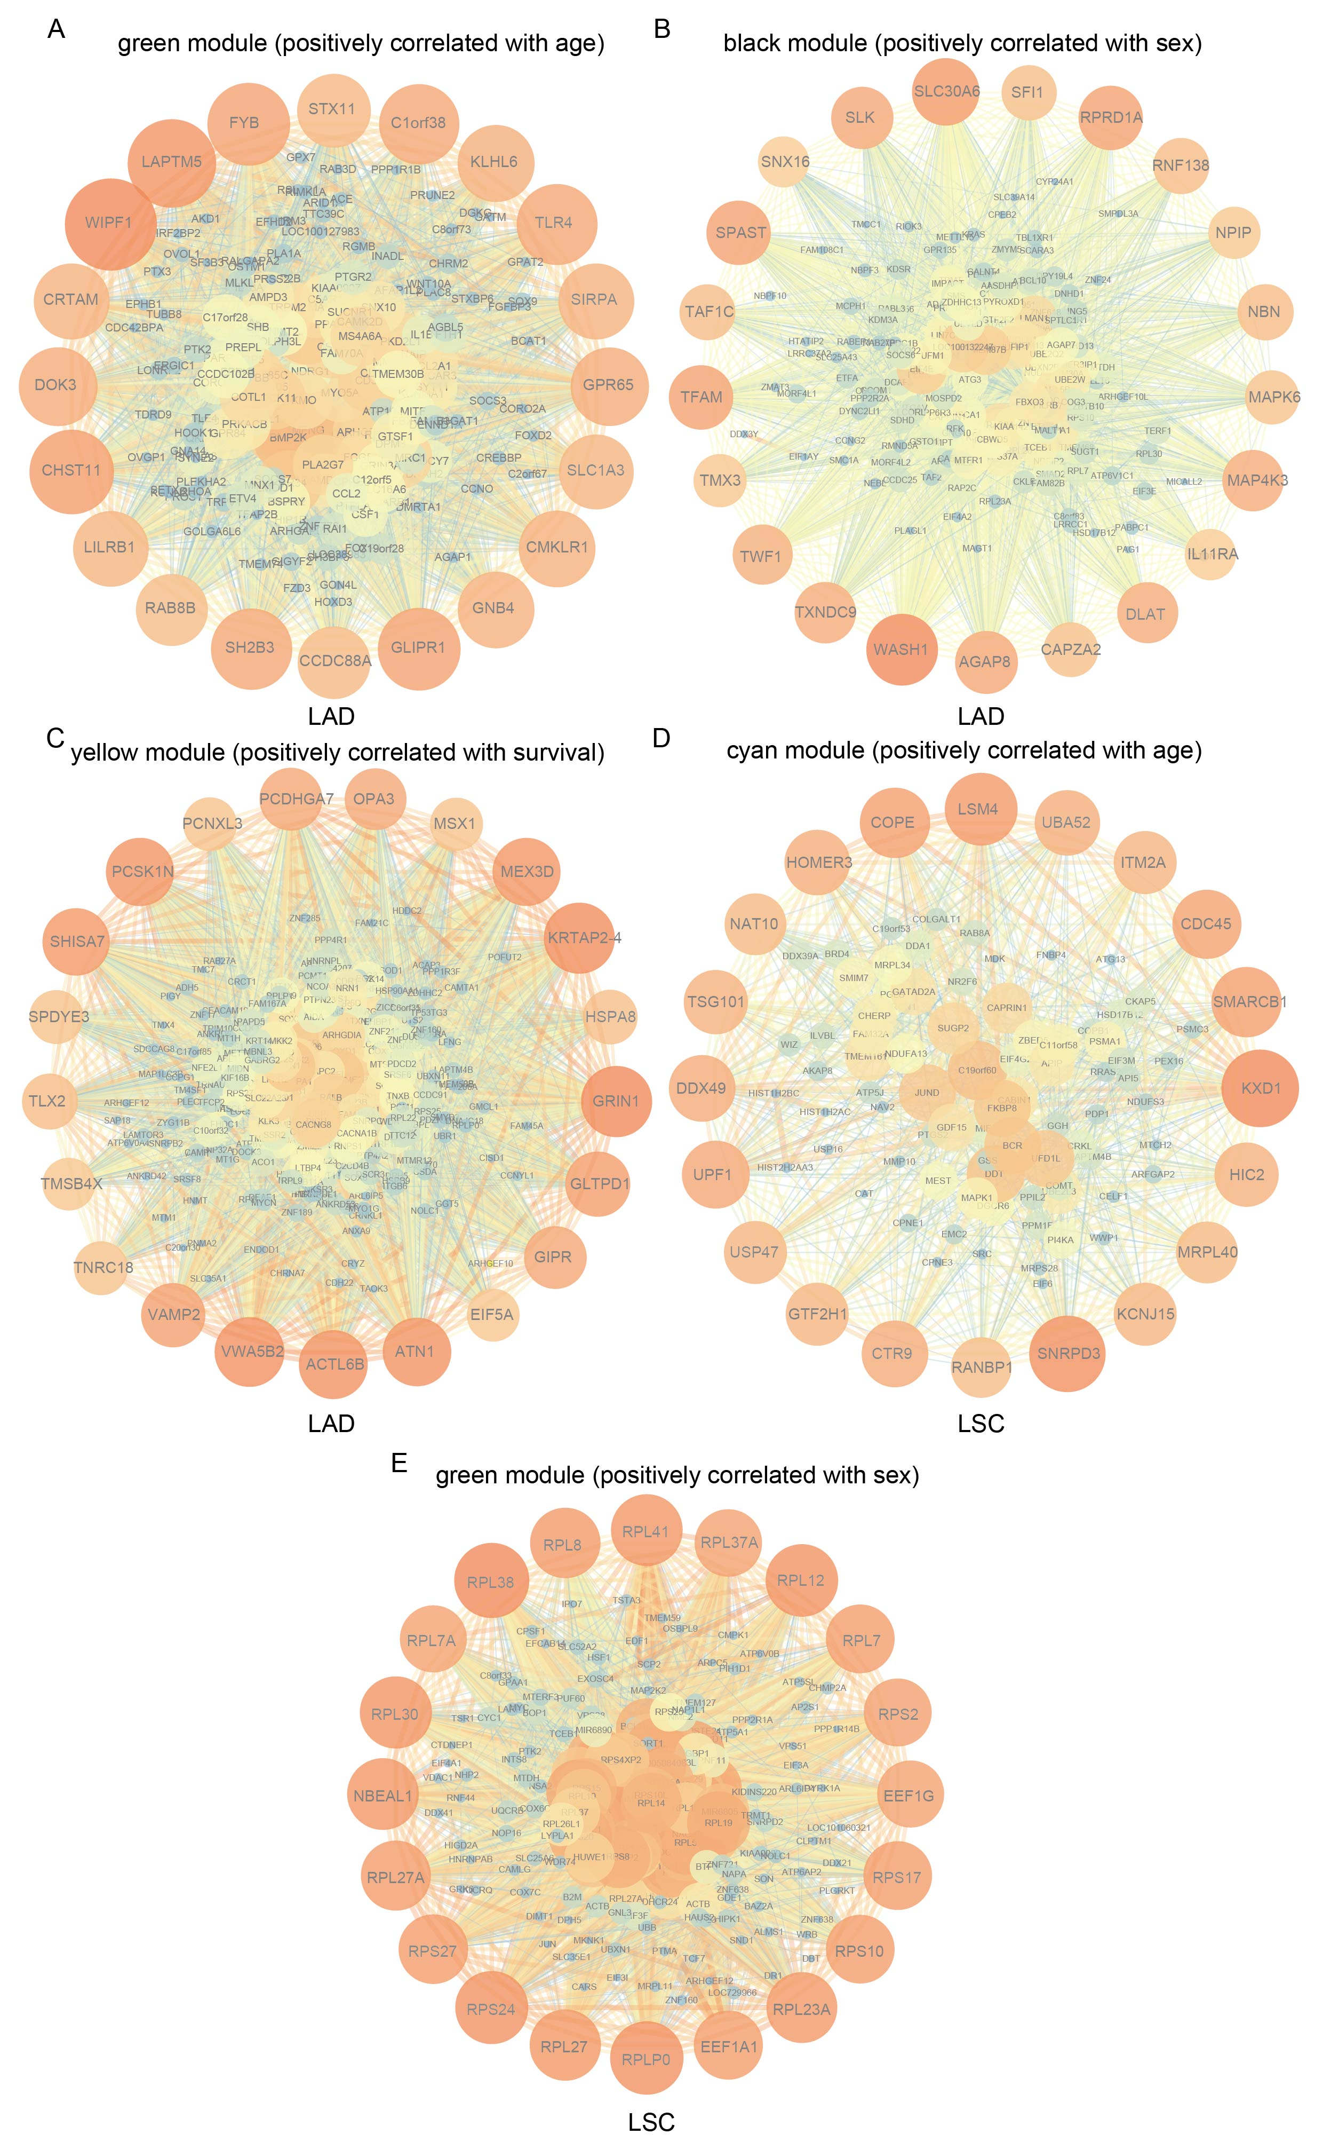
Fig S4 The network of other clinical traits related modules.
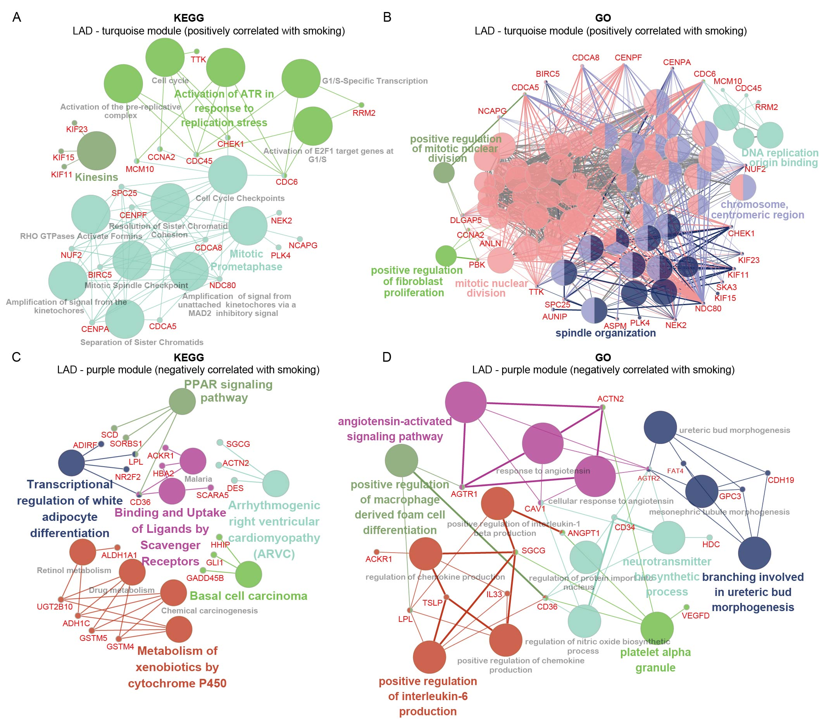 Fig S5 KEGG and GO enrichment analysis of smoking-corresponding module in LAD.
(A&C) KEGG pathways enrichment analysis was performed on genes of the smoking-related modules (turquoise and purple module); (B&D) GO function enrichment analysis was carried out for genes in the smoking-related modules (turquoise and purple module).

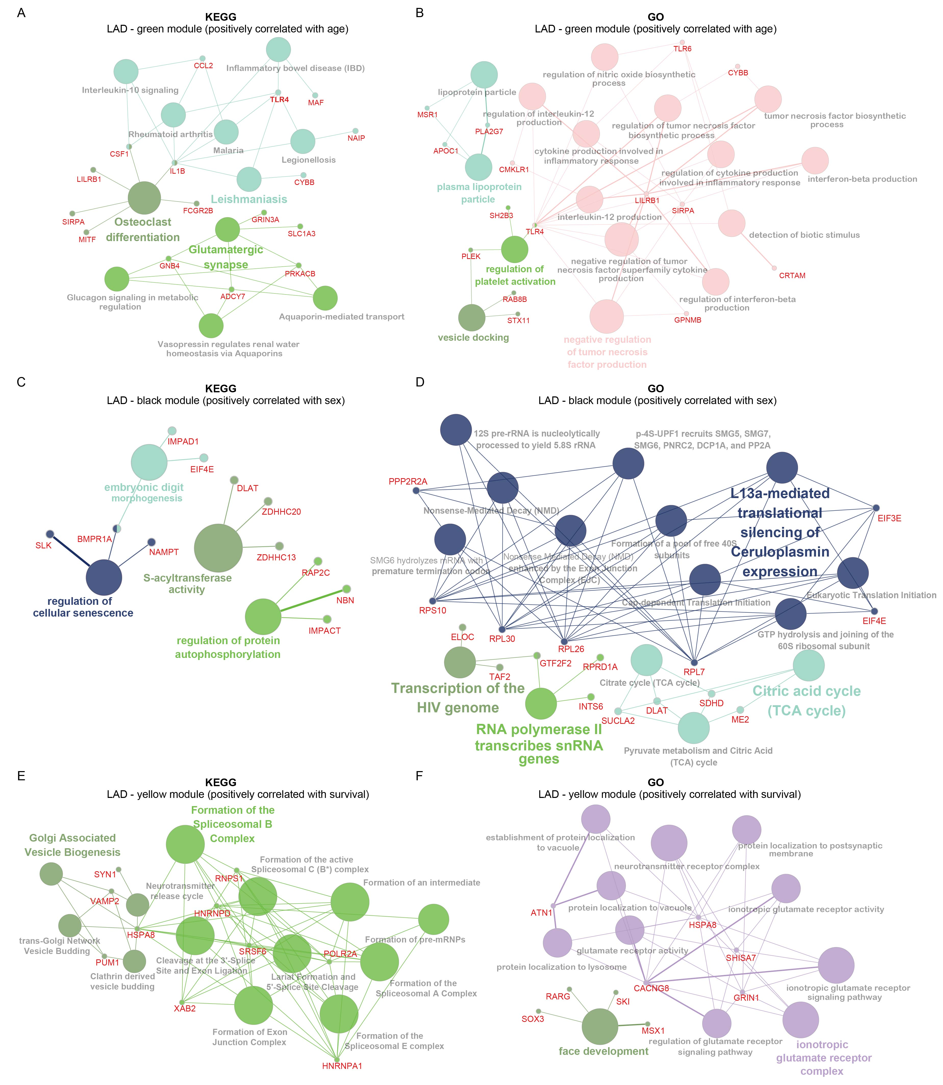
Fig S6 KEGG and GO enrichment analysis of age, sex as well as survival corresponding module in LAD
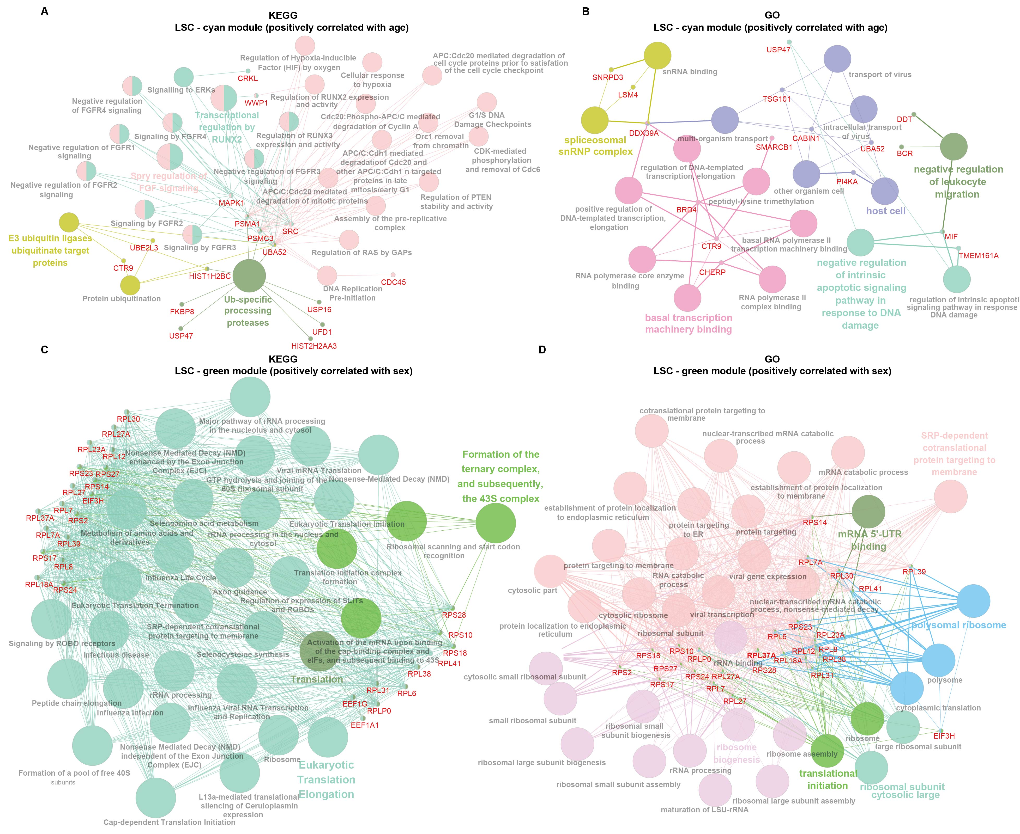

Fig S7 KEGG and GO enrichment analysis of age and sex associated modules in LSC.

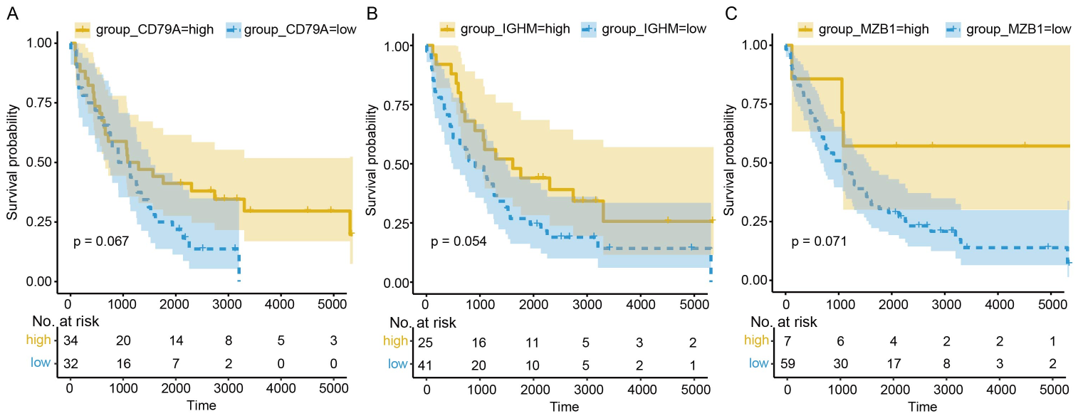
Fig S8 Overall survival analyses of 3 immune genes based on microarray GSE 37745.

Table
Table S1 Regulatory function of genes
Type | Gene symbol
Plasma cells | CD27, CD38, CD79A, GUSBP11, IGHD, IGHM, IGKC, IGLL3P, MZB1
B cells memory | CD27, CD79A, GUSBP11, IGHD, IGHM, IGKC, IGLL3P
B cells naive | CD79A, GUSBP11, IGHD, IGHM, IGKC, IGLL3P
T cells CD8 | CD27, IGKC
T cells CD4 memory resting | CD27
T cells CD4 naive | CD27
T cells follicular helper | CD27
T cells regulatory (Tregs) | CD27
Macrophages M1 | CD38

