Extended Data Figures:

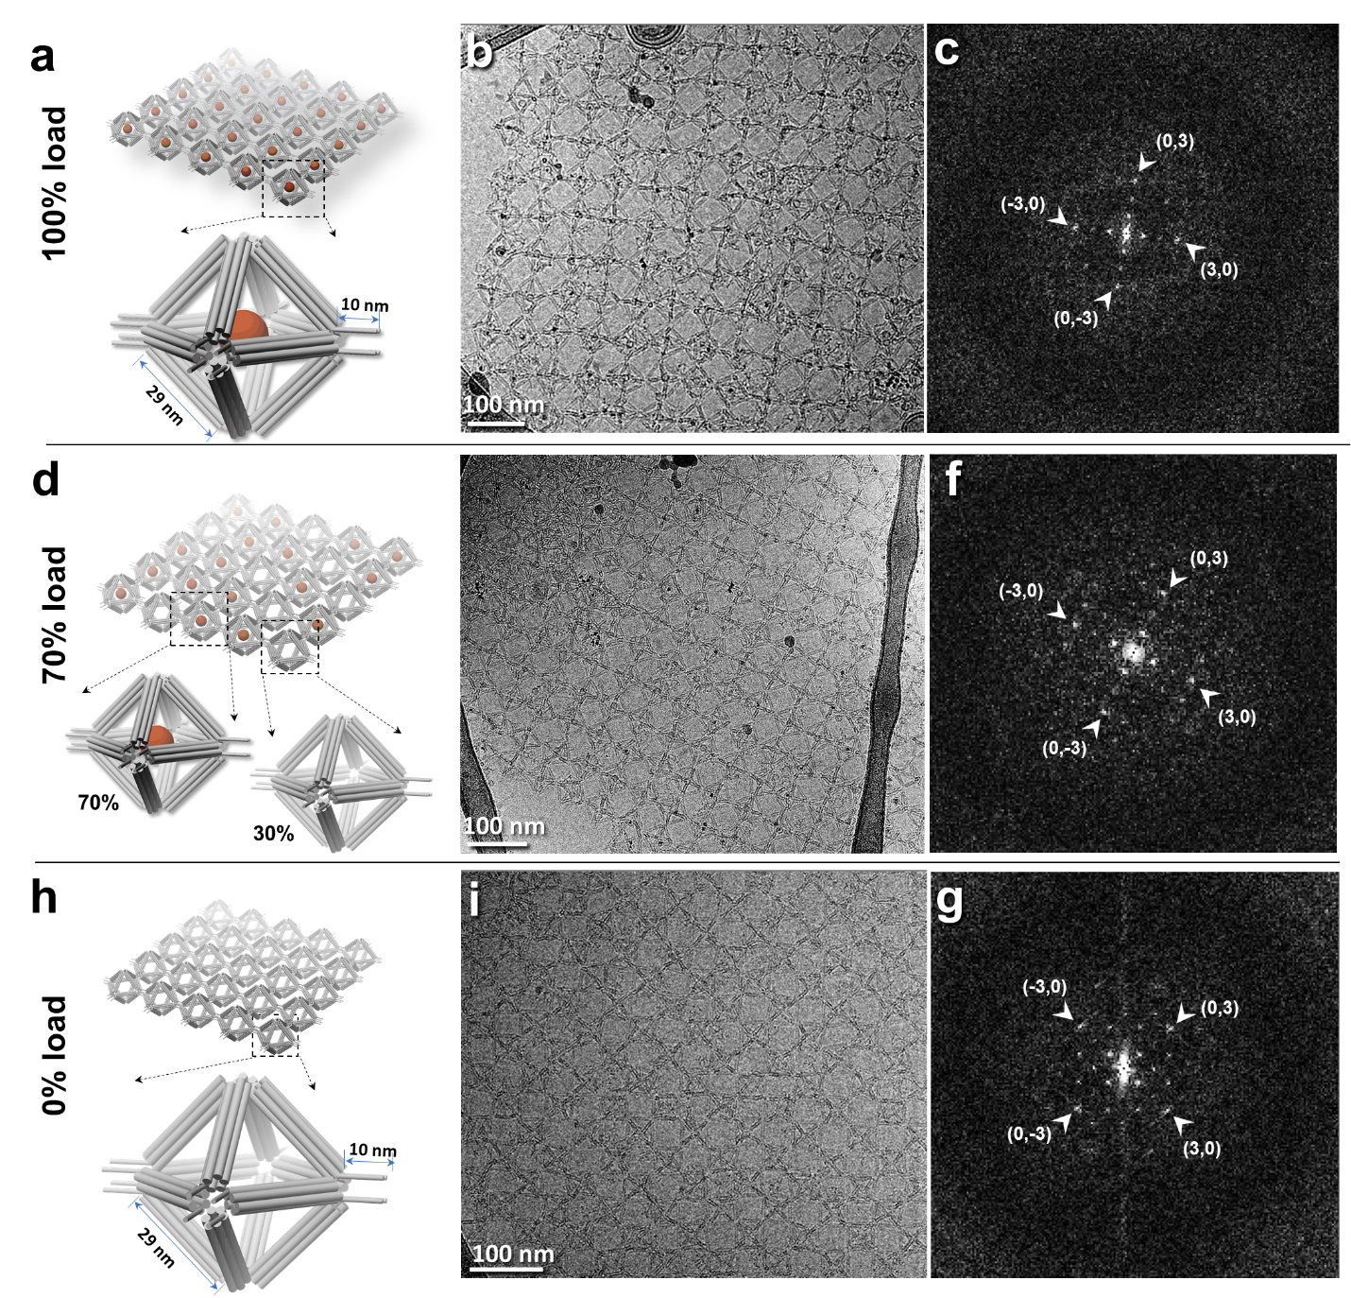
Extended Data Fig. 1: Cryo-EM images and Fourier transfer of DNA origami 2D lattices with and without ferritin loading. a, Schematic representation of origami particles loaded with 100% ferritin and arranged into a 2D lattice. b, Survey cryo-EM image of the DNA origami 2D lattice loaded with 100% ferritin particles. c, Fourier transform pattern of the lattice loaded with 100% ferritin. d-f, DNA origami 2D lattice loaded with 70% ferritin and its corresponding Fourier transform pattern. h-g, DNA origami 2D lattice without ferritin loading (empty) and its Fourier transform pattern.

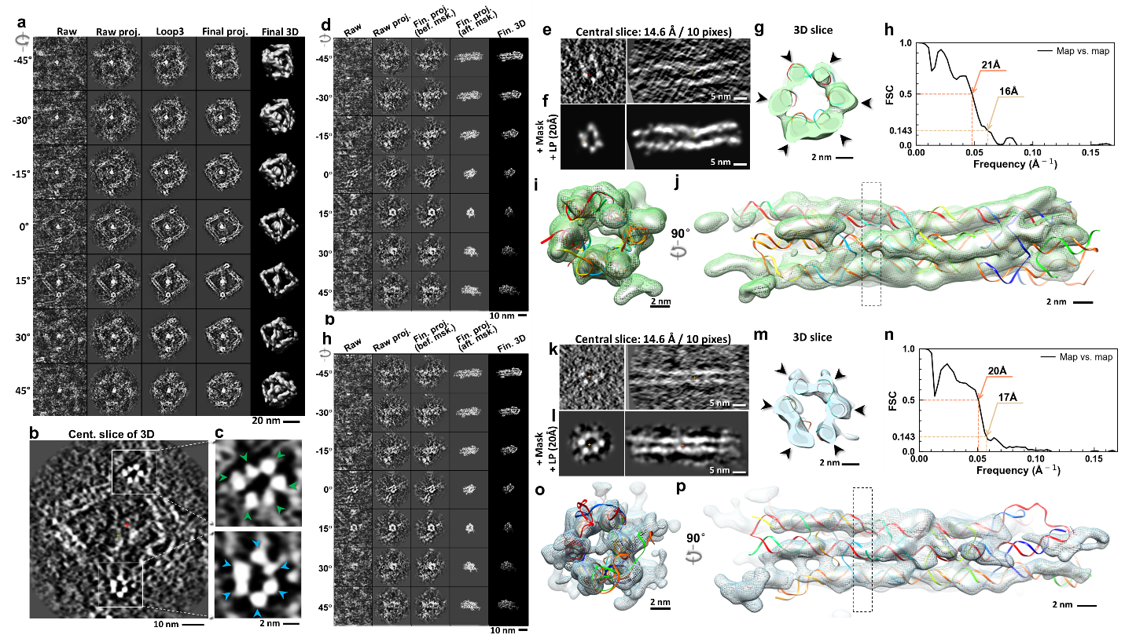
Extended Data Fig. 2: Non-averaged 3D reconstructions of an individual unit-cell particle and its two 6-helix bundles. a, Intermediates of the Cryo-ET 3D reconstruction of an individual unit-cell particle using IPET. The first column (from the left) displays seven representative tilt images of a single unit-cell particle. These tilt images are aligned to a common center using IPET through iterative refinements. The projections of the raw, intermediate, and final 3D reconstructions at the corresponding angles are shown in the next four columns. b and c, Central slices of the final 3D reconstruction, highlighting the detailed structures of two six-helix bundles (arms), indicated by orange and green arrows, respectively. d, Intermediates of the IPET 3D reconstruction of an individual 6-helix bundle (arm), shown from seven representative tilt angles. e and f, Comparison of the central slices of the 3D reconstructions before and after applying soft-boundary masks and low-pass filter (20Å), viewed from two perpendicular directions. g, The central cross-section of the final 3D map, with each helix indicated by arrows. h, The final map resolution is estimated using map-map FSC analysis method, in which each map is reconstructed from one half of the images, based on the even vs. odd indices of frames at each tilt angle. The frequencies of the FSC curve falls at 0.5 and 0.143, used as the assessed resolutions. i and j, Two orthogonal views of the final 3D maps (displayed with double contour levels—gray solid and green mesh) overlapped with its standard fitted model (rigid-body docking). The rectangular box indicates the cross-section position shown in g. k-p. IPET 3D reconstruction of another six-helix bundle within the unit-cell particle, along with its rigid-body fitted helical bundle model.

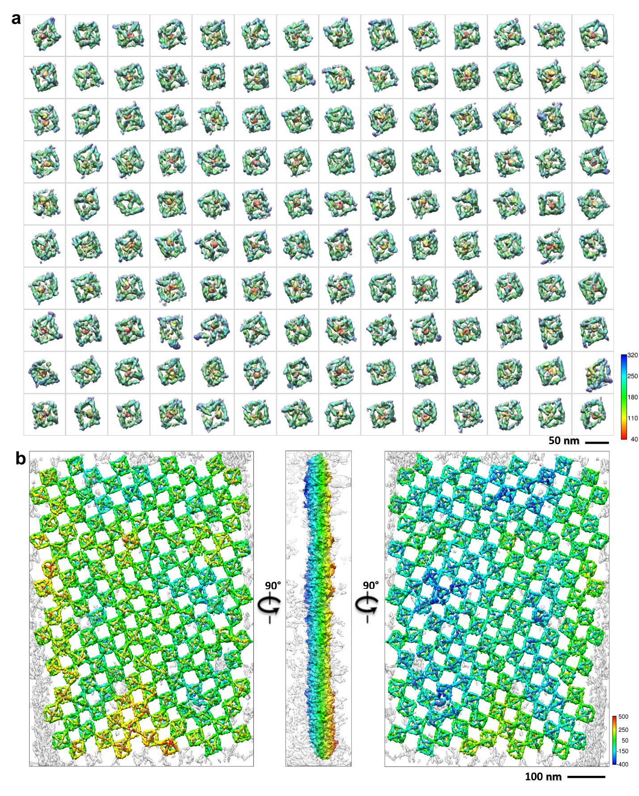Extended Data Fig. 3: Non-averaged 3D reconstructions of 140 unit-cell particles within a 2D lattice fully loaded with ferritin. a, A gallery of 140 IPET 3D maps reconstructed from 140 individual unit-cell particles within a 2D lattice fully loaded with ferritin. The detailed reconstruction process of each unit-cell particle is described in Supp. Fig. 9-153. The color scheme represents the radius from the center of each particle, depicted in a rainbow gradient. b, Three views of the final 3D reconstruction of a 2D lattice, achieved by fitting the 140 IPET 3D maps into the low-resolution 3D reconstruction of the entire lattice. The color scheme represents the depth of views.

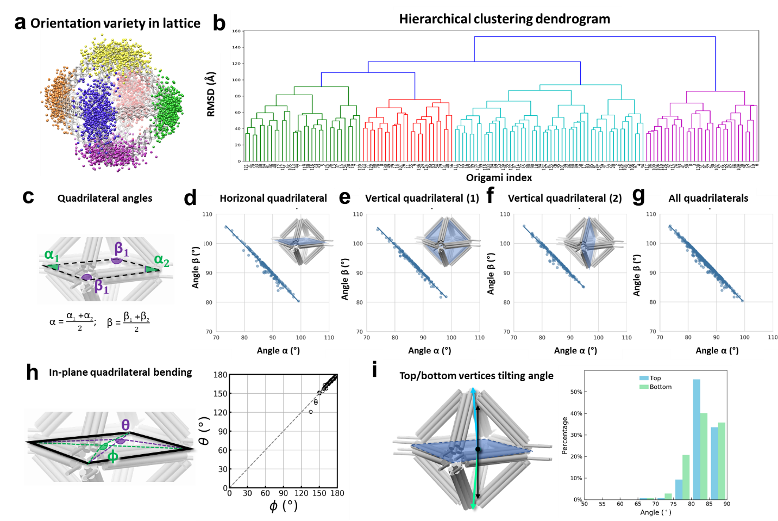
Extended Data Fig. 4: Structural flexibility analyses of 140 unit-cell particles within a 100% ferritin-loaded 2D lattice. a, Distribution of vertices of the 140 unit-cell models after aligned to a standard octahedral model. Orange, blue, green, and pink balls indicate vertices on the lattice plane, while yellow and purple balls represent vertices perpendicular to the lattice plane. b, Hierarchical clustering dendrogram of the 140 unit-cell models based on their RMSDs. c, Schematic representation of the quadrilateral angles formed by the HBs. d, Correlation analysis of the two averaged opposite inner angles α and β within the in-plane quadrilateral, e,f, within two vertical quadrilateral perpendicular to the lattice plane, and h, combined analysis of all three quadrilateral. h, Schematic of two bending angles in the in-plane quadrilateral formed by the HBs. Correlation analysis of these two dihedral angles θ and φ within the horizontal quadrilateral. i, Distribution of tilting angles of the top and bottom vertices (measured as the angle between the center of the quadrilateral and the center of the top/bottom vertices) relative to the lattice plane.

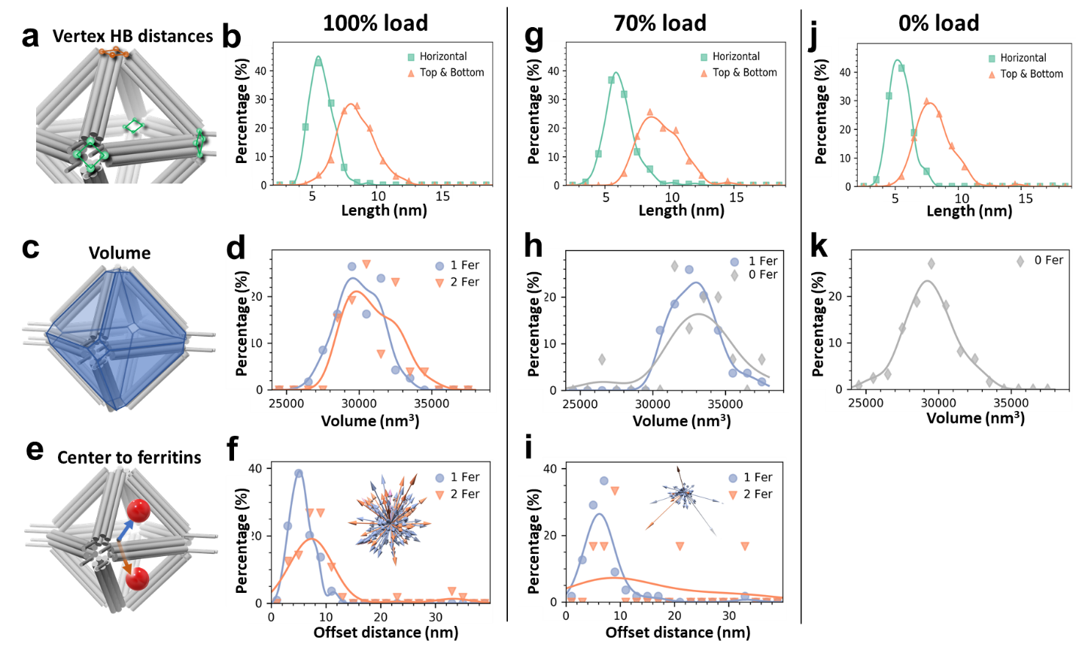
Extended Data Fig. 5: Flexibility of unit-cell particles in 100%, 70% and 0% ferritin loaded lattices. a, Schematic illustrating the measurement of port size, defined as the average distance between the distal ends of the four HBs at each vertex. b, Histogram of the pore sizes for 144 unit-cell particles within a 100% ferritin-loaded lattice. Green lines represent pore sizes within the lattice plane, while orange lines represent pore sizes at the top and bottom vertices, perpendicular to the lattice plane. c, Schematic representation of the unit-cell particle volume formed by 12 HBs. d, Histogram of particle volumes for the 144 unit-cell particles within the 100% ferritin-loaded lattice. e, Schematic illustrating the off-center vector of ferritin within each unit-cell particle. The vector is defined as the distance from the center of the unit-cell cage to the center of the ferritin. f, Histogram of off-center distances of ferritin within the 144 unit-cell particles. g-i, Histograms of vertex pore sizes, particle volumes, and ferritin off-center distances for 70 unit-cell particles in a 70% ferritin-loaded lattice. j,k, Histograms of vertex pore sizes and particle volumes for 122 unit-cell particles in a lattice without ferritin loading (0% ferritin).

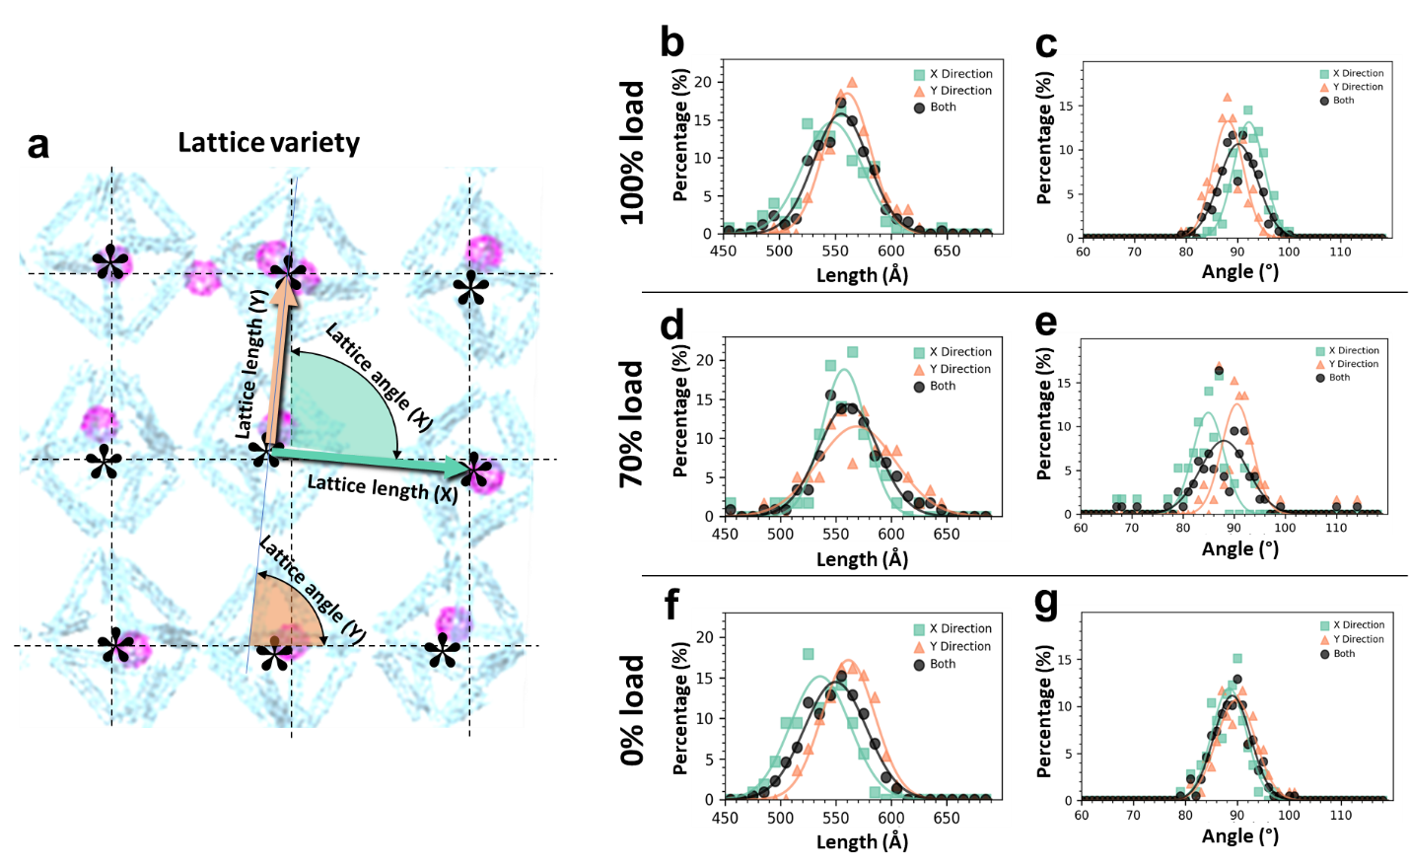
Extended Data Fig. 6: Flexibility of unit-cell lengths and angles in 100%, 70% and 0% ferritin loaded lattices. a, Schematic illustrating the measurement of unit-cell lengths and angles. The unit-cell length is defined as the distance between the centers of two adjunct unit-cell particles, while the unit-cell angle is defined as the orientation of the vector connecting adjacent unit-cell particles relative to the lattice averaged perpendicular direction. b, Histogram of the unit-cell lengths in the 100% ferritin-loaded lattice. c, Histogram of unit-cell angles in the 100% ferritin-loaded lattice. d,e, Histograms of unit-cell lengths and angles in the 70% ferritin-loaded lattice. f,g, Histograms of unit-cell lengths and angles in the lattice without ferritin loading (0% ferritin).

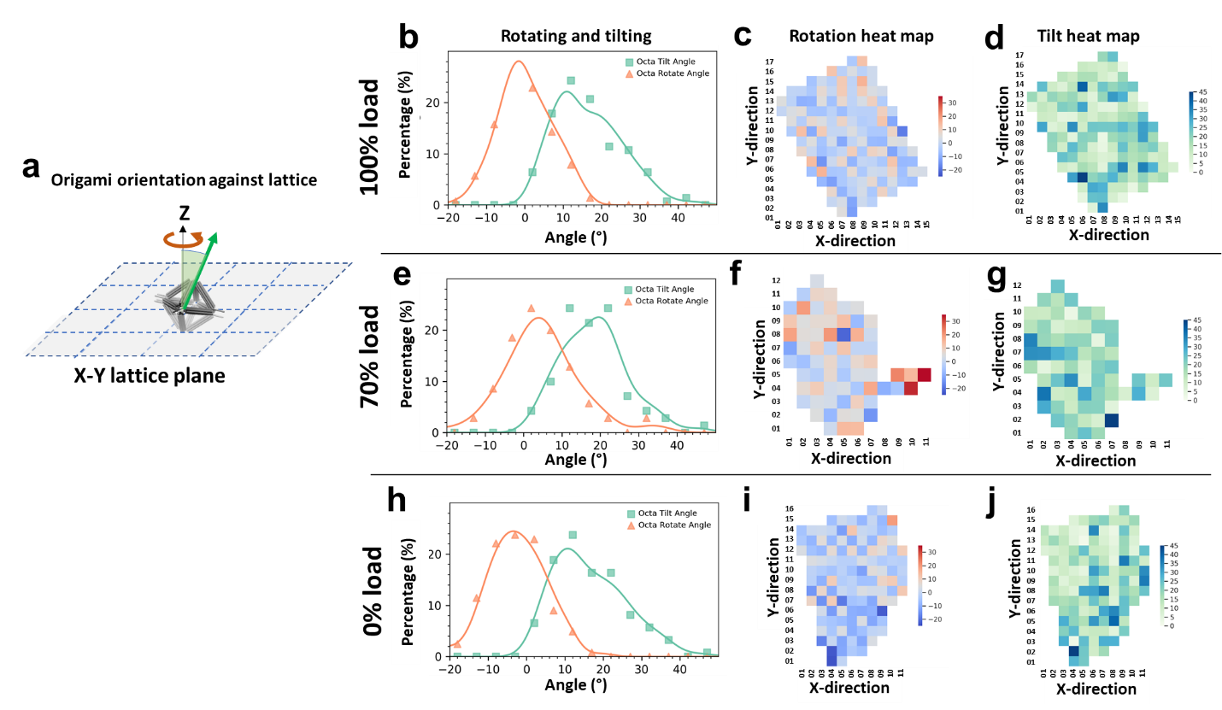
Extended Data Fig. 7: Flexibility of unit-cell particle’s in-plane rotating and tilting relative to the lattice plane of 2D lattices loaded with 100%, 70% and 0% ferritin. a, Schematic representation illustrating the in-plane rotation and tilting of unit-cell particles relative to the lattice plane. b, Histogram of tilt and rotation angles of 144 unit-cell particles in lattices loaded with 100% ferritin. c, Heat map showing the distribution of 144 unit-cell particle rotation angles in the 100% ferritin-loaded lattice. d, Heat map illustrating the distribution of unit-cell particle tilting angles in the 100% ferritin-loaded lattice. e-g. Distributions of rotation and tilt angles for 70 unit-cell particles in 70% ferritin-loaded lattices, shown as histograms and 2D heat maps. h-j. Distributions of rotation and tilt angles for 122 unit-cell particles in lattices without ferritin (0% ferritin), presented as histograms and 2D heat maps.

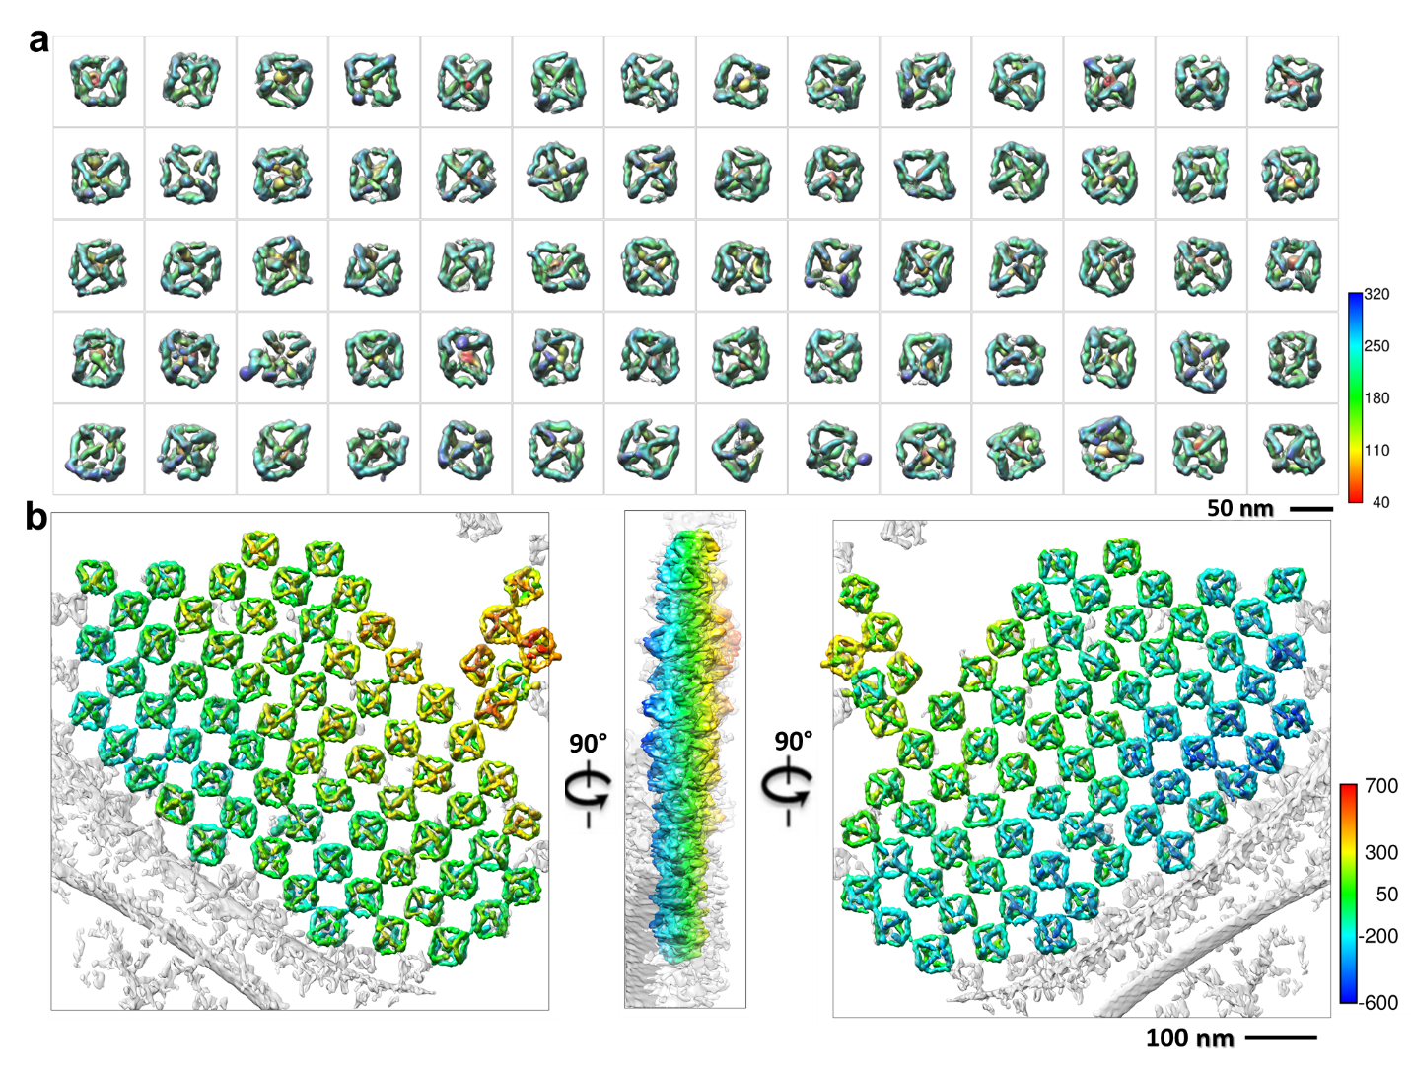
Extended Data Fig. 8: Non-averaged 3D reconstructions of 70 unit-cell particles in a 70% ferritin-loaded 2D lattice. a, A gallery of IPET 3D reconstructions of 70 individual unit-cell particles within the 2D lattice. Details of the reconstruction process are provided in Supp. Fig. 154-223. The color scheme indicates the radial distance from the center of each particle, represented using a rainbow gradient. b, Three views of the final 3D reconstruction of the 2D lattice, obtained by fitting the 70 IPET 3D maps into the low-resolution 3D reconstruction of the entire lattice. The color scheme represents depth, enhancing visualization of structural features.

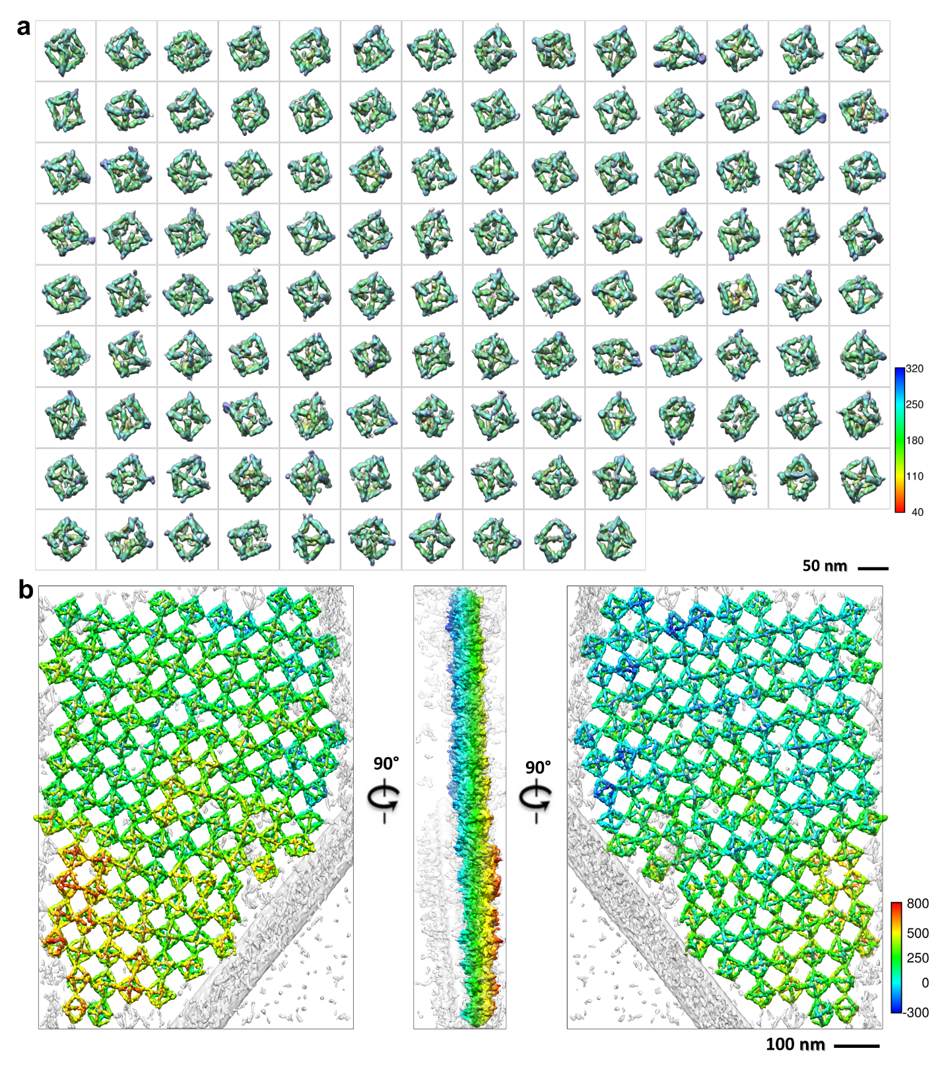
Extended Data Fig. 9: Non-averaged 3D reconstructions of 122 unit-cell particles in a 0% ferritin-loaded 2D lattice. a, A gallery of IPET 3D reconstructions of 122 individual unit-cell particles within the 2D lattice. Details of the reconstruction process are provided in Supp. Fig. 224-345. The color scheme indicates the radial distance from the center of each particle, represented using a rainbow gradient. b, Three views of the final 3D reconstruction of the 2D lattice, obtained by fitting the 122 IPET 3D maps into the low-resolution 3D reconstruction of the entire lattice. The color scheme represents depth, enhancing visualization of structural features.

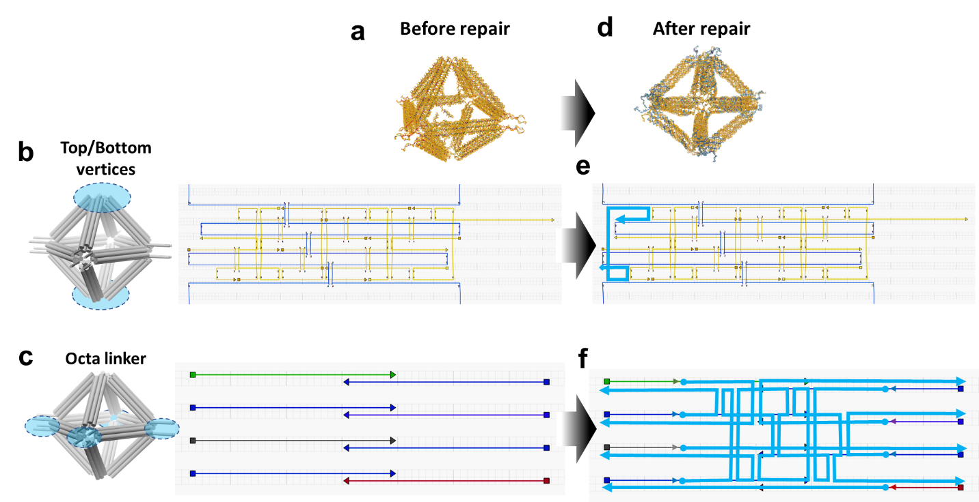
Extended Data Fig. 10: Illustration of the unit-cell particle repair strategy. a, Structural model of the unit-cell particle before repair. b, The particle contains a single-stranded DNA in both the top and bottom vertical pores. c, A single-stranded DNA is present in the linker between adjacent unit-cell particles. e, A DNA staple is added to pair with the single-stranded DNA in the top and bottom pores, highlighted in cyan. f, The linker is redesigned to include double-stranded DNA for enhanced stability, also highlighted in cyan.

