Supplementary Appendix

Supplement to: Grytaas, Upton et al: “Home measurement of 24-hour corticosteroid dynamics in primary aldosteronism”

Table of contents
Supplementary methods 3
Supplementary figures 5
Figure S1. 24-hour tissue fluid DHEAS levels. 5
Figure S2. Wavelet analysis. 6
Figure S3. Digital biomarkers in unilateral and bilateral primary aldosteronism. 7
Figure S4. Dynamic hormone profiling device satisfaction questionnaires. 8
Supplementary tables 9
Table S1. Tissue fluid hormone concentrations in primary aldosteronism and healthy participants. 9
Table S2. Somatic mutations and histopathology. 13
Table S3. Somatic mutations detected in genes KCNJ5, CACNA1D and ATP1A1. 14
Table S4. Tissue fluid hormone concentration post adrenalectomy. 15
Table S5. Assays and confirmatory test criteria in use in study centres. 16
Table S6. Adrenal vein sampling procedures. 17
Table S7. Primers used for polymerase chain reaction and Sanger sequencing. 18
References 19

Supplementary methods

Withdrawal of interfering medication prior to microdialysis tissue fluid sampling
Mineralocorticoid receptor antagonists, amiloride, triamterene and potassium wasting diuretics were withdrawn for 4 weeks before sampling, while beta-blockers, angiotensin converting enzyme inhibitors, angiotensin II receptor blockers, central α2 agonists, renin inhibitors and nonsteroidal anti-inflammatory drugs were withdrawn for two weeks. Dihydropyridine calcium channel blockers, with presumed limited effect on aldosterone levels, were allowed to be continued if evaluated necessary by the treating physician (1).
Sampling procedure with the U-RHYTHM microdialysis system
After local skin anaesthesia, a 20 kilodalton linear microdialysis catheter was placed perpendicular to the midline in periumbilical subcutaneous tissue, flushed and perfused at 1 µL per minute with sterile isotonic fluid from a microdialysis pump. The catheter outlet was, by application of 20 cm of fluorinated ethylene propylene tubing, adopted to connect to the U-RHYTHM fraction collector for automated collection. Air-bubbles were automatically produced in the U-RHYTHM sampler every 20 minutes, allowing for storage of individual samples every 20 min. The pump and fraction collector assembly were placed in a flexible waist belt, before the participants left the clinic. Every-day activities were allowed to be continued, except vigorous exercise or submersion in water.
Microdialysis samples collection, storage and analysis
Handling of microdialysis samples received from the U-RHYTHM collector after ending the sampling session, storage of samples and liquid chromatography tandem mass spectrometry (LC-MS/MS) analysis performed for all samples in Bergen, Norway, are previously described in detail (2).
Immunostaining of CYP11B2 and histopathologic assessment
Tissue sections (5 µM) were deparaffinized by incubation at 60 °C for two hours, followed by incubation in xylene for 15 minutes. Rehydration was done by five minutes incubations in decreasing concentration of ethanol; 100% - 95% - 80% - 70%, then ddH2O for five minutes. Antigen retrieval was done in by 1x Dako Target Retrieval solution, pH9 (Agilent, cat. S236784-2). The antigen retrieval solution was preheated to 96 °C and the tissue sections incubated for 20 minutes at this temperature before washed in ddH2O for 10 minutes. A PAPA-pen was used to encircle the tissue before blocking (PBS with 0.05% Tween and 3% bovine serum albumin (BSA)) was done for 20 minutes in a hydration chamber at room temperature. Mouse anti-CYP11B2, a kind gift from Professor Gomez-Sanchez was used as primary antibody at 1:20 000 dilution in PBS with 0.05 Tween and 1% BSA and incubated overnight at 4 °C (3). The next day, the slides were washed four times in PBS and the Mouse and rabbit specific HRP/DAP detection kit (Abcam, cat. ab64264) were used together with the Avidin Biotin Blocking Kit (Abcam, cat. ab64212) according to the manufacturers protocol. 3,3’-diaminobenzidine (DAB) staining was done for one minute, and the CYP11B2-positive and negative tissue were transferred from the glass-slide to 1.5 mL Eppendorf tubes for DNA extraction by the QIAamp DNA FFPE Tissue Kit (Qiagen, cat. 56404) according to the manufacturers protocol.
Histopathology of hematoxylin-eosin and of CYP11B2 immunostained adrenal tissue sections were evaluated by a pathologist and histopathological features defined according to the HISTALDO consensus (4).
Targeted gene sequencing
DNA was extracted from areas with positive and negative CYP11B2 immunostaining using the QIAmp DNA FFPE Tissue DNA Kit according to manufacturer’s instructions (Qiagen, cat. 56404) and sequenced for KCNJ5 exon 2, CACNA1D exons 8, 16 and 32, ATP1A1 exon 4, ATP2B3 exon 10 and CTNNB1 exon 3. Genes were chosen based on Seidel et. al (5) and includes genes coding for channel proteins and ATPases involved in aldosterone synthesis. Primer sequences are given in Supplementary Table S3. PCR was done using Phusion Hot Start II High-Fidelity DNA Polymerase (Thermo Scientific, cat. F-549L) with the following conditions: 5X Phusion Buffer, 10mM dNTP (Applied Biosystems, cat. 362271), 7.5% betaine (Sigma, cat. B0300-1VL), 4% DMSO (Thermo Scientific, part of cat. F-549L), ddH₂O, 10 $μM$forward primer, 10 $μM$ reverse primer and Phusion Enzyme was prepared. DNA template (1-21 ng) was added to each reaction. The samples were amplified on a Veriti 96 well thermal cycler with the following settings: one step at 98$℃$ for 10 min; 10 cycles at 98$℃$ for 15 s, 69$℃ (65℃$ for ATP1A1) for 15 s and 72$℃$ for 45 s; 30 cycles at 95$℃$ for 15 s, 50$℃$ for 15 s and 72$℃$ for 45 s, and finally for 7 minutes. Purification of the PCR-products were performed using ExoSAP-IT (Applied Biosystems, cat. 78201.1.ML) according to manufacturer’s instructions.
Sequencing was performed using the BigDye Terminator v1.1 Cycle Sequencing Kit (Applied Biosystems, cat. 4336774) using 2 $μM$ forward or reverse primer (Table S3).The samples were run on a Veriti 96 well thermal cycler with the following settings: one step at 96$℃$ for 5 min; 30 cycles at 96$℃$ for 15 s, 50$℃$ for 15 s and 60$℃$ for 2 min. Samples were Sanger sequenced at the Department of Medical Genetics, Haukeland University Hospital (Bergen, Norway) and analysed using the CLC Main Workbench 8.0.1 software (Qiagen).

Supplementary figures

Figure S1. 24-hour tissue fluid DHEAS levels.
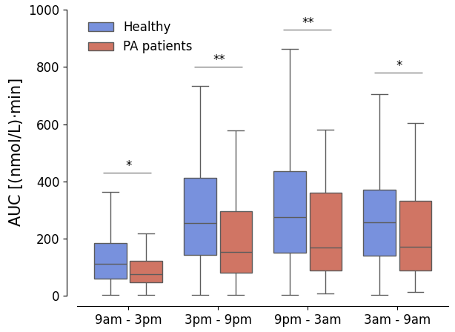

DHEAS secretion as assessed by windowed area under the curve measurements in primary aldosteronism (red) vs. healthy participants (blue) at 9am-3pm, 3pm-9pm, 9pm-3am and 3am-9pm (* = p < 0.05; ** = p < 0.01).
Abbreviations: AUC, area under the curve; DHEAS, dehydroepiandrosterone sulfate

Figure S2. Wavelet analysis.

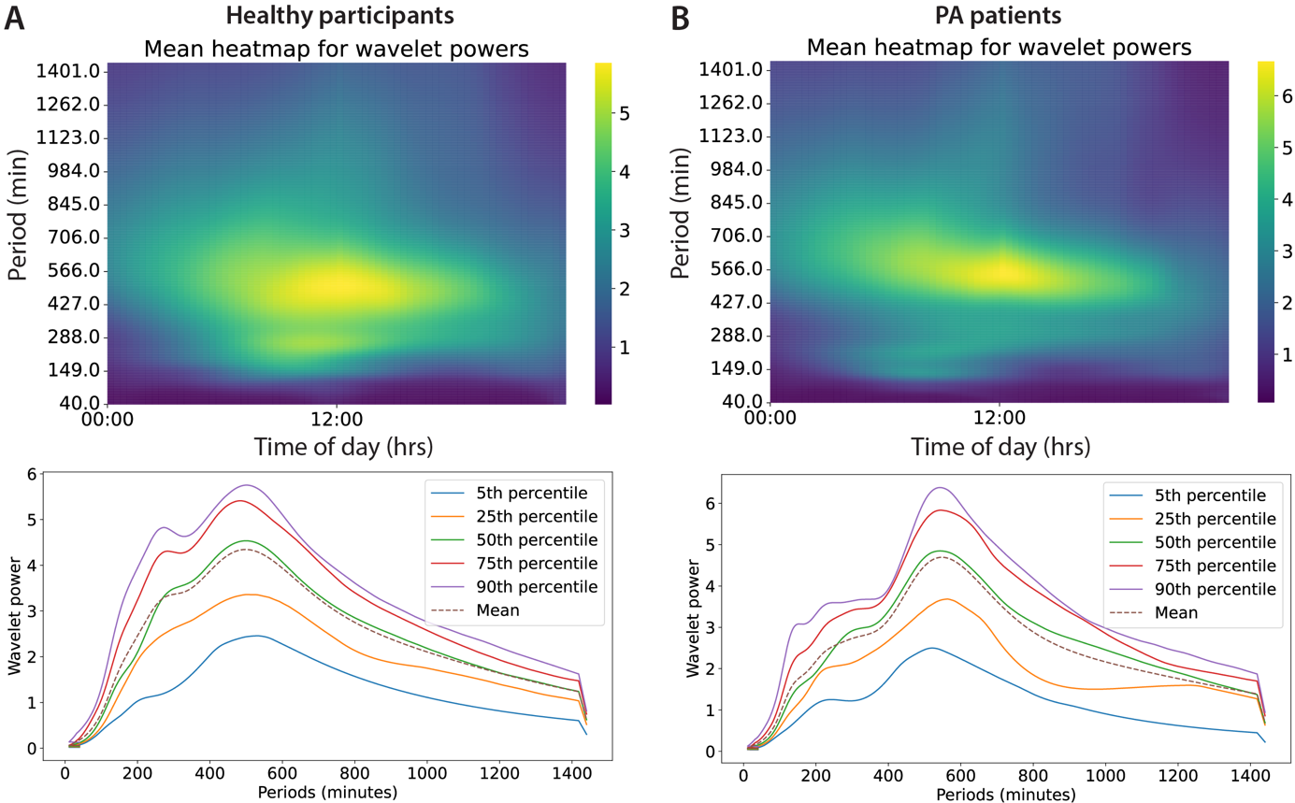

A systematic quantification of ultradian periodicity using wavelet analysis shows ultradian pulsatility of aldosterone in healthy participants (A) and patients with primary aldosteronism (PA) (B). The heatmap color intensity (top) shows the wavelet power, which is averaged over 24 hours (bottom).

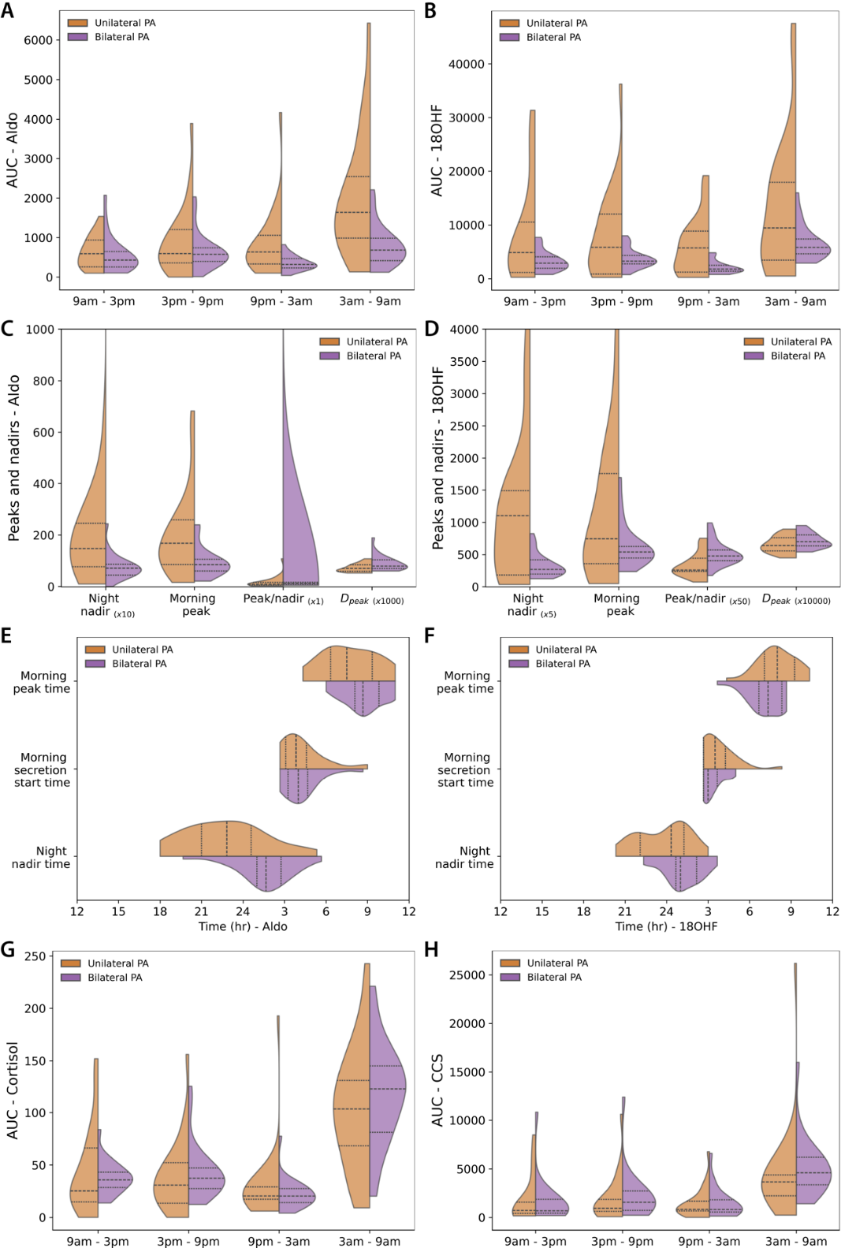
Figure S3. Digital biomarkers in unilateral and bilateral primary aldosteronism.
Digital biomarkers of tissue aldosterone and tissue 18-hydroxycortisol quantify variability between unilateral and bilateral primary aldosteronism (PA). A-B) Area under the curve (AUC) hormone concentration distributions of four 6-hour long time windows in unilateral versus. bilateral PA for A) aldosterone and B) 18-hydroxycortisol. C-D) Evening nadir (PM nadir), morning peak (AM peak), peak/nadir ratio and secretion density peak (Dpeak) for C) aldosterone and D) 18-hydroxycortisol. E-F) Evening (PM) nadir time, morning (AM) secretion start time and morning (AM) peak time distributions in unilateral vs. bilateral PA for E) aldosterone and F) 18-hydroxycortisol. G-H) Area under the curve (AUC) hormone concentration distributions of four 6-hour long time windows in unilateral vs. bilateral PA for G) cortisol and H) corticosterone.

Figure S4. Dynamic hormone profiling device satisfaction questionnaires.

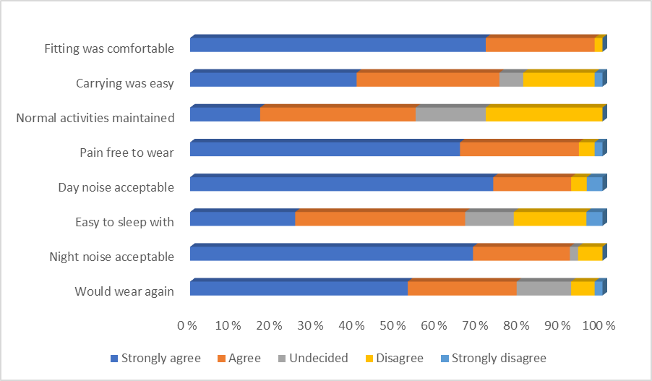

The Dynamic hormone sampling system was well tolerated among patients with primary aldosteronism, n= 53/60 primary aldosteronism participants.

Supplementary tables

Table S1. Tissue fluid hormone concentrations in primary aldosteronism and healthy participants.

A) Complete primary aldosteronism cohort, n= 60
 | mean | std | min | 25% | 50% | 75% | max
18oxoF (pmol/L) | 20.41 | 21.52 | 0.24 | 5.63 | 14.24 | 26.16 | 117.33
18OHF (pmol/L) | 384.63 | 475.23 | 7.08 | 110.98 | 234.05 | 452.98 | 4113.10
Aldosterone (pmol/L) | 53.77 | 60.58 | 0.01 | 19.52 | 34.74 | 65.64 | 682.75
Cortisol (nmol/L) | 3.46 | 3.57 | 0.04 | 1.15 | 2.18 | 4.50 | 33.39
Cortisone (nmol/L) | 2.12 | 1.63 | 0.03 | 0.92 | 1.68 | 2.89 | 13.41
DHEAS (µmol/L) | 12.32 | 8.39 | 2.50 | 5.39 | 9.30 | 19.24 | 45.35
11DOC (nmol/L) | 19.58 | 13.61 | 0.06 | 9.10 | 15.87 | 26.76 | 82.04
CCS (pmol/L) | 169.42 | 226.78 | 0.11 | 46.27 | 93.33 | 214.09 | 3680.90
aTHF (nmol/L) | 0.72 | 0.73 | 0.01 | 0.22 | 0.47 | 0.98 | 5.27
THF (nmol/L) | 0.43 | 0.47 | 0.00 | 0.14 | 0.28 | 0.54 | 4.42
THE (nmol/L) | 0.34 | 0.20 | 0.00 | 0.19 | 0.29 | 0.45 | 1.34

Stationary statistics of microdialysis tissue fluid hormone concentrations in primary aldosteronism and healthy subjects. A) the whole primary aldosteronism (PA) cohort (n= 60), B) healthy participants (n= 214/215), C) unilateral PA (n= 26) and D) bilateral PA (n= 24).
Abbreviations: 18oxoF, 18-oxocortisol; 18OHF, 18-hydroxycortisol; DHEAS, dehydroepiandrosterone sulfate; 11DOC, 11-deoxycortisol; CCS, corticosterone; aTHF, allo-tetrahydrocortisol; THF, tetrahydrocortisol; THE, tetrahydrocortisone.

B) Healthy participants (n= 214/215)
 | mean | std | min | 25% | 50% | 75% | max
18oxoF (pmol/L) | 8.73 | 4.61 | 2.02 | 5.51 | 7.86 | 11.29 | 21.19
18OHF (pmol/L) | 195.26 | 193.93 | 3.26 | 61.74 | 137.57 | 260.66 | 2527.28
Aldosterone (pmol/L) | 23.83 | 24.06 | 0.11 | 8.68 | 15.83 | 29.41 | 283.20
Cortisol (nmol/L) | 3.52 | 3.54 | 0.01 | 1.11 | 2.31 | 4.59 | 32.47
Cortisone (nmol/L | 2.56 | 1.92 | 0.03 | 1.04 | 2.06 | 3.63 | 13.47
DHEAS (µmol/L) | 16.15 | 10.00 | 2.51 | 8.34 | 14.28 | 21.83 | 82.49
11DOC (nmol/L) | 16.24 | 16.02 | 0.98 | 7.49 | 11.30 | 18.21 | 148.24
CCS (pmol/L) | 174.66 | 200.90 | 1.30 | 50.89 | 98.29 | 226.07 | 2111.61
aTHF (nmol/L) | 0.59 | 0.59 | 0.00 | 0.20 | 0.38 | 0.77 | 6.35
THF (nmol/L) | 0.46 | 0.42 | 0.00 | 0.18 | 0.34 | 0.60 | 4.96
THE (nmol/L) | 0.34 | 0.24 | 0.00 | 0.19 | 0.28 | 0.43 | 1.81

C) Unilateral primary aldosteronism, n= 26
 | mean | std | min | 25% | 50% | 75% | max
18oxoF (pmol/L) | 23.69 | 23.61 | 0.24 | 7.65 | 17.08 | 28.82 | 117.33
18OHF (pmol/L) | 529.89 | 612.51 | 7.08 | 101.83 | 318.85 | 729.61 | 4113.10
Aldosterone (pmol/L) | 71.27 | 78.84 | 0.85 | 23.52 | 45.95 | 85.72 | 682.75
Cortisol (nmol/L) | 3.53 | 3.78 | 0.04 | 1.05 | 2.15 | 4.51 | 27.43
Cortisone (nmol/L | 2.23 | 1.80 | 0.03 | 0.86 | 1.78 | 3.03 | 13.41
DHEAS (µmol/L) | 12.13 | 8.65 | 2.50 | 5.48 | 8.27 | 17.88 | 45.35
11DOC (nmol/L) | 22.93 | 15.98 | 1.38 | 9.33 | 18.71 | 34.00 | 82.04
CCS (pmol/L) | 181.30 | 274.56 | 8.51 | 48.12 | 94.25 | 215.46 | 3680.90
aTHF (nmol/L) | 0.68 | 0.62 | 0.02 | 0.25 | 0.48 | 0.89 | 3.83
THF (nmol/L) | 0.51 | 0.59 | 0.00 | 0.15 | 0.30 | 0.65 | 4.42
THE (nmol/L) | 0.33 | 0.20 | 0.00 | 0.18 | 0.29 | 0.44 | 1.34

D) Bilateral primary aldosteronism, n= 24
 | mean | std | min | 25% | 50% | 75% | max
18oxoF (pmol/L) | nd. | - | - | - | - | - | -
18OHF (pmol/L) | 242.38 | 186.81 | 24.79 | 105.91 | 197.21 | 314.87 | 1695.87
Aldosterone (pmol/L) | 38.03 | 34.51 | 0.01 | 15.75 | 28.68 | 47.62 | 240.02
Cortisol (nmol/L) | 3.54 | 3.58 | 0.12 | 1.21 | 2.25 | 4.72 | 33.39
Cortisone (nmol/L) | 1.95 | 1.43 | 0.11 | 0.89 | 1.51 | 2.73 | 7.62
DHEAS (µmol/L) | 11.49 | 7.67 | 2.51 | 5.46 | 9.21 | 16.54 | 35.41
11DOC (nmol/L) | 16.66 | 10.81 | 1.07 | 8.54 | 13.55 | 23.86 | 63.97
CCS (pmol/L) | 175.46 | 199.11 | 0.11 | 43.93 | 107.97 | 232.70 | 1708.38
aTHF (nmol/L) | 0.66 | 0.74 | 0.01 | 0.15 | 0.35 | 0.91 | 4.11
THF (nmol/L) | 0.33 | 0.29 | 0.00 | 0.12 | 0.24 | 0.43 | 1.80
THE (nmol/L) | 0.33 | 0.20 | 0.05 | 0.18 | 0.27 | 0.45 | 0.97

Table S2. Somatic mutations and histopathology.

Sample | Histopathology according to HISTALDO consensus* | Tumour size APA | Gene name | Single nucleotide mutation | Mutation | Amino acid change
1 | APA | 10 mm | KCNJ5 | c.451G>A | p.G151R | 151 GlyàArg
2 | APN |  | KCNJ5 ATP1A1 | c.532G>T  c.373C>T | p.V178F  p.P125L | 178 ValàPhe  125 ProàLeu
3 | MAPN |  | CACNA1D | c.4021T>A | p.L1341P | 1356 LeuàPro
4 | APA | 15 mm | KCNJ5 | c.503T>G | p.L168R | 168 LeuàArg
5 | APA | 15 mm | KCNJ5 | c. 433G>C | p.E145Q | 145 GluàGln
6 | APA | 15 mm | KCNJ5 | c.503T>G | p.L168R | 168 LeuàArg
7 | APA | 11 mm | KCNJ5 | c.503T>G | p.L168R | 168 LeuàArg
8 | APA | 11 mm | KCNJ5 | c.532G>A | p.V178I | 178 ValàIle
9 | APA | 13 mm | KCNJ5 | c.502C>A  c.503T>G  c.504C>A  c.505T>G | p.L168I  p.L168R  p.L168L  p.L169V | 168 LeuàIle  168 LeuàArg  168 LeuàLeu  169 LeuàVal

Overview of detected somatic mutations and histopathology in adrenal tissue from adrenalectomized unilateral primary aldosteronism patients.
Abbreviations: APA, aldosterone-producing adenoma; APN, aldosterone-producing nodule; MAPN, multiple aldosterone-producing nodules. *For HISTALDO concensus criteria, see (4).

Table S3. Somatic mutations detected in genes KCNJ5, CACNA1D and ATP1A1.

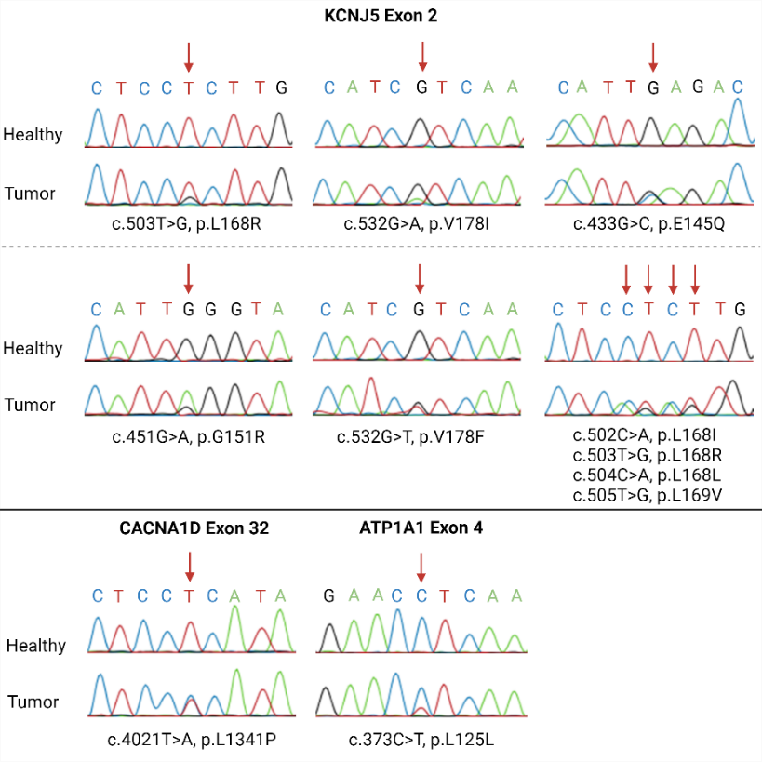
Healthy tissue sequences shown on top and tumour tissue sequences at the bottom for each gene. Red arrows indicate where the mutation is found. Created with BioRender.com.

Table S4. Tissue fluid hormone concentration post adrenalectomy.

 | mean | std | min | 25% | 50% | 75% | max
18oxoF (pmol/L) | 3.99 | 1.38 | 2.25 | 3.05 | 3.84 | 5.04 | 5.69
18OHF (pmol/L) | 150.86 | 152.41 | 4.32 | 48.76 | 106.53 | 192.51 | 1590.52
Aldosterone (pmol/L) | 15.13 | 12.76 | 2.00 | 5.88 | 11.92 | 18.87 | 76.79
Cortisol (nmol/L) | 2.73 | 2.59 | 0.04 | 0.91 | 1.94 | 3.59 | 19.57
Cortisone (nmol/L) | 1.43 | 1.10 | 0.04 | 0.63 | 1.09 | 1.99 | 7.39
DHEAS (µmol/L) | 9.52 | 7.92 | 2.50 | 3.87 | 6.03 | 13.85 | 51.45
11DOC (nmol/L) | 23.31 | 23.02 | 0.33 | 4.54 | 13.85 | 43.73 | 113.32
CCS (pmol/L) | 140.90 | 135.90 | 14.04 | 51.81 | 91.48 | 178.07 | 977.46
aTHF (nmol/L) | 0.44 | 0.43 | 0.02 | 0.14 | 0.29 | 0.60 | 2.37
THF (nmol/L) | 0.41 | 0.38 | 0.00 | 0.14 | 0.30 | 0.54 | 2.13
THE (nmol/L) | 0.30 | 0.20 | 0.07 | 0.18 | 0.25 | 0.37 | 1.25

Microdialysis tissue fluid hormone concentrations from n= 16 unilateral primary aldosteronism three months post-adrenalectomy.
Abbreviations: 18oxoF, 18-oxocortisol; 18OHF, 18-hydroxycortisol; DHEAS, dehydroepiandrosterone sulfate; 11DOC; 11-deoxycortisol; CCS, corticosterone; aTHF, allo-tetrahydrocortisol; THF, tetrahydrocortisol; THE, tetrahydrocortisone.

Table S5. Assays and confirmatory test criteria in use in study centres.

Study centre | Test method for aldosterone | Test method for renin | Test method for cortisol | Test method for ACTH | Diagnostic tests and cut-offs PA diagnosis
Bergen (before Feb 2019) | Chemiluminescent immunoassay LIAISON® Aldosterone (DiaSorin) | Chemiluminescent Immunoassay LIAISON® Direct Renin (DiaSorin) | LC-MS/MS | Chemiluminescent immunoassay Immulite 2000XPi (Siemens) | Recumbent saline infusion test: aldosterone ≥140 pmol/L (immunoassay) post-infusion
Bergen (From Feb 2019) | LC-MS/MS |  | LC-MS/MS | Chemiluminescent immunoassay Immulite 2000XPi (Siemens) | Seated saline infusion test: aldosterone ≥ 160 pmol/L (LC-MS/MS) post-infusion
Athens | Chemiluminescent immunoassay LIAISON® Aldosterone (DiaSorin) | Chemiluminescent Immunoassay LIAISON®, Direct Renin (DiaSorin) | Immunoassay Cortisol Immulite 2000 (Siemens) | Chemiluminescent immunoassay Immulite 2000XPi (Siemens) | Recumbent saline Infusion test: aldosterone >5 ng/dl post-infusion  Dexamethasone captopril valsartan test: aldosterone >3 ng/dl/>84 pmol/L
Bristol | LC-MS/MS | LC-MS/MS, plasma renin activity | Chemiluminescent immunoassay Architect (Abbott) | Chemiluminescent immunoassay Immulite 2000XPi (Siemens) | Recumbent saline infusion test: aldosterone >240 pmol/L post-infusion (probable PA)
Overview of the assays in use and confirmatory test criteria used in Bergen, Athens, and Bristol for the diagnosis of primary aldosteronism.
Abbreviations: ACTH, adrenocorticotropic hormone; PA, primary aldosteronism; LC-MS/MS, liquid chromatography tandem mass spectrometry.

Table S6. Adrenal vein sampling procedures.

Study centre | AVS Procedure | Cosyntropin Stimulation | Selectivity Index (SI) Criteria | Lateralisation Index (LI) Criteria
Bergen | Sequential cannulation | Continuous (50 µg/h) | ≥ 5 | ≥ 4
Athens | Sequential cannulation | Continuous (50 µg/h) | ≥ 3-5 | ≥ 4
Bristol – AVS performed at Imperial College Healthcare NHS Trust, London, UK | Sequential | None | ≥ 2 | aldosterone/cortisol ≥ 3 in dominant adrenal vein compared with peripheral vein, and contralateral suppression < 0.5

Overview of the adrenal vein sampling (AVS) methodologies and criteria for successful cannulation (selectivity index; SI) and lateralisation of aldosterone excess (lateralisation index; LI), used in Bergen, Athens, and Bristol.

Table S7. Primers used for polymerase chain reaction and Sanger sequencing.

Oligo name | Sequence (5’-3’)
KCNJ5_Ex2_Fw | ACTGTAAAACGACGGCCAGTGCGACCAAGAGTGGATTCCTT
KCNJ5_Ex2_Rv | ACCAGGAAACAGCTATGACCAGGGTCTCCGCTCTCTTCTT
CACNA1D_Ex8_Fw | ACTGTAAAACGACGGCCAGTTGACCCTCTCTCCTTATTAAATCC
CACNA1D_Ex8_Rv | ACTGTAAAACGACGGCCAGTAAAGCTTGTGTGGTCTTGGC
CACNA1D_Ex16_Fw | ACTGTAAAACGACGGCCAGTATTGTTGGCCGCAACGTAG
CACNA1D_Ex16_Rv | ACCAGGAAACAGCTATGACCCAACTGTTGCAGGGCTCC
CACNA1D_Ex32_Fw | ACTGTAAAACGACGGCCAGTACGGTTCTTCCTCACTGTCG
CACNA1D_Ex32_Rv | ACCAGGAAACAGCTATGACCCTTCAGCAGAGGCATTTGGCT
ATP1A1_Ex4_Fw | ACTGTAAAACGACGGCCAGTTATATTGCCTTGTAAGTGCTGG
ATP1A1_Ex4_Rv | ACCAGGAAACAGCTATGACCGAAGTGGGAGACAAAGACGG
ATP2B3_Ex10_Fw | ACTGTAAAACGACGGCCAGTTTCTTCCCTCTTCCTGTCCC
ATP2B3_Ex10_Rv | ACCAGGAAACAGCTATGACCTTCTTACCCCAGTTTCCGAG
CTNNB1_Ex3_Fw | ACTGTAAAACGACGGCCAGTCCATGGAACCAGACAGAAA
CTNNB1_Ex3_Rv | ACCAGGAAACAGCTATGACCAAAATCCCTGTTCCCACTCA

References
1. Funder JW, Carey RM, Mantero F, et al. The Management of Primary Aldosteronism: Case Detection, Diagnosis, and Treatment: An Endocrine Society Clinical Practice Guideline. The Journal of clinical endocrinology and metabolism. 2016:jc20154061.
2. Upton TJ, Zavala E, Methlie P, et al. High-resolution daily profiles of tissue adrenal steroids by portable automated collection. Sci Transl Med. 2023;15(701):eadg8464.
3. Gomez-Sanchez CE, Qi X, Velarde-Miranda C, et al. Development of monoclonal antibodies against human CYP11B1 and CYP11B2. Molecular and cellular endocrinology. 2014;383(1-2):111-7.
4. Williams TA, Gomez-Sanchez CE, Rainey WE, et al. International Histopathology Consensus for Unilateral Primary Aldosteronism. The Journal of clinical endocrinology and metabolism. 2021;106(1):42-54.
5. Seidel E, Schewe J, Scholl UI. Genetic causes of primary aldosteronism. Exp Mol Med. 2019;51(11):1-12.

