Extended data

Extended data Fig. 1. Flow chart of inclusion of patients with primary aldosteronism
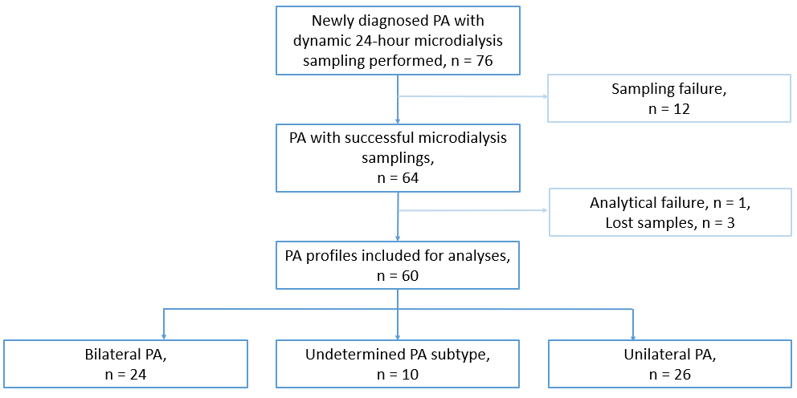

Abbreviations: PA, primary aldosteronism

Extended data Fig. 2. Distributions of tissue fluid hormones recovered in primary aldosteronism patients.

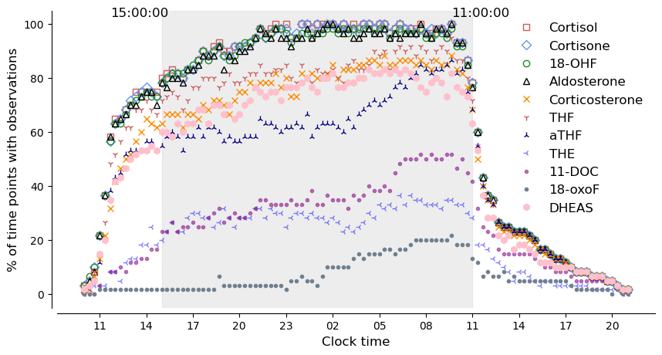
Distribution of hormones measured in microdialysate from subcutaneous tissue fluid across the day in n=60 patients with primary aldosteronism. The shaded grey area represents the period where at least 75% of the total cohort of participants had measurable cortisol observations, for reference.
Abbreviations: 18OHF, 18-hydroxycortisol; THF, tetrahydrocortisol; aTHF, allo-tetrahydrocortisol; THE, tetrahydrocortisone; 11-DOC, 11-deoxycortisol; 18OxoF, 18-oxocortisol; DHEAS, dehydroepiandrosterone sulfate.

Extended data Fig. 3. Dynamic tissue fluid hormone profiles in primary aldosteronism and healthy participants.
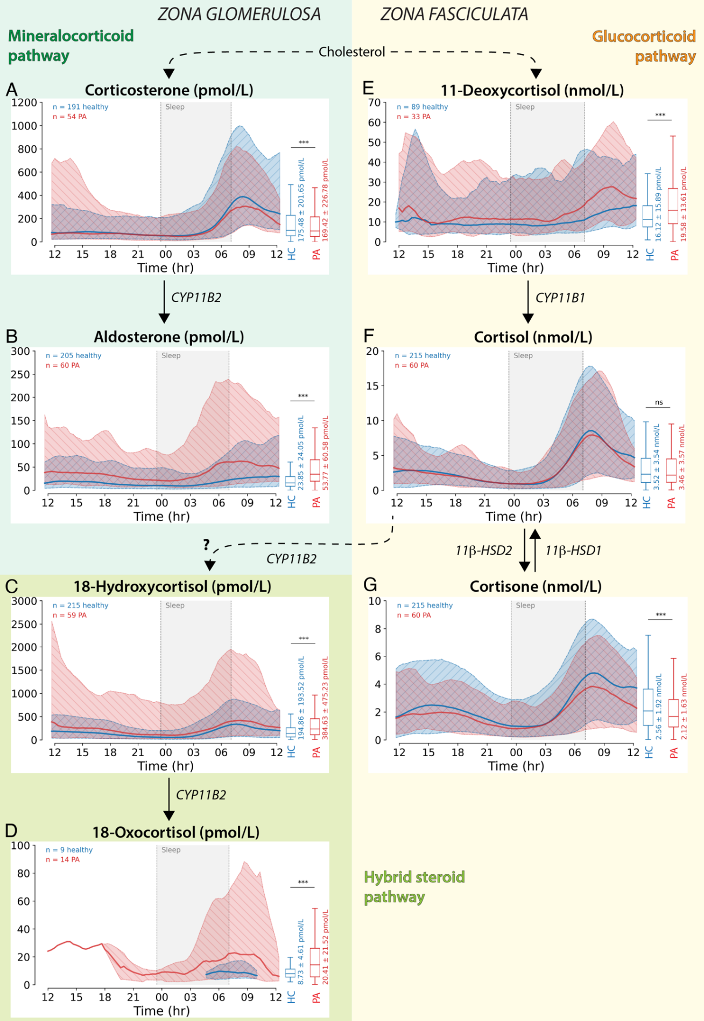

Dynamic tissue fluid profiles of corticosteroids arranged after synthetic pathway and adrenocortical zone; mineralocorticoid pathway in zona glomerulosa, glucocorticoid pathway in zona fasciculata and hybrid steroid pathway. The question mark indicates that the precursor(s) and site of synthesis of hybrid steroids are still not completely elucidated. In each panel the dynamic profiles of the whole primary aldosteronism cohort (red) are compared with healthy participants (blue). Horizontal lines represent median hormone tissue concentrations, shaded areas represent 5 - 95 % confidence intervals. Sleep periods are shown as shaded grey boxes (** = p < 0.01; *** = p < 0.001).
Abbreviations: PA, primary aldosteronism

Extended data Fig. 4. Individual 24-hour tissue fluid aldosterone profiles in unilateral, bilateral and undetermined primary aldosteronism.

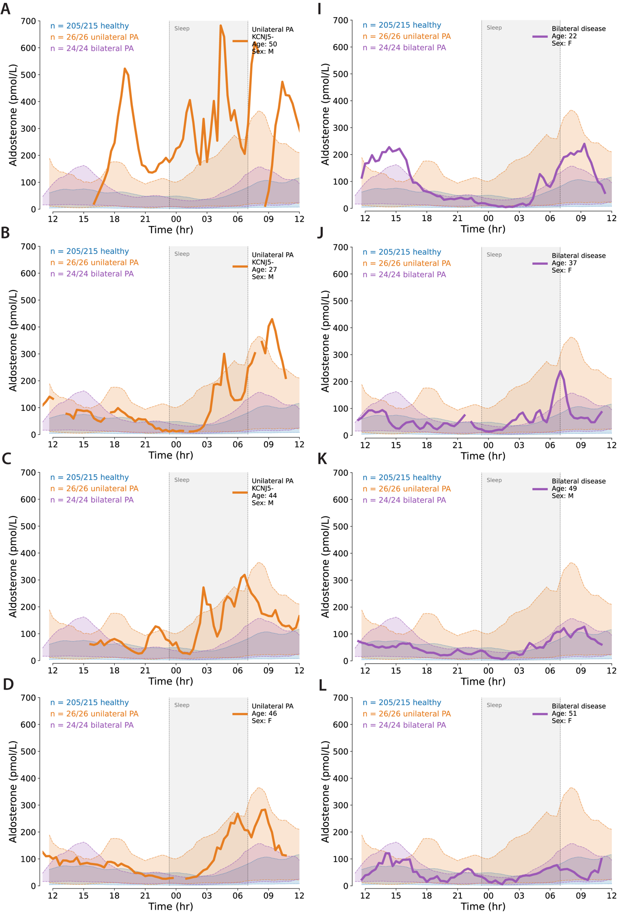
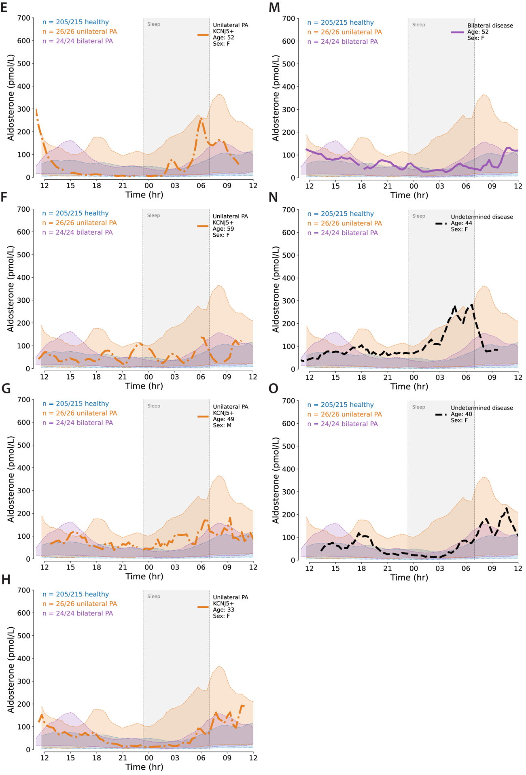

Examples of individual 24-hour tissue aldosterone profiles in patients with unilateral (orange, A-H), bilateral (purple, I-M) and with undetermined (black, N-O) primary aldosteronism (PA) subtype. Shaded areas in orange (unilateral PA), purple (bilateral PA) and blue (healthy subject) represent aldosterone 5 - 95% centiles of the respective cohorts. Shaded grey area represents mean sleep interval of the cohort. The individual dynamic profiles illustrate the large interindividual variability of aldosterone secretion.
Multiple prominent aldosterone bursts (A) and nocturnal aldosterone hypersecretion (B-E) are seen in a proportion of unilateral PA. Some unilateral PA profiles reveal aldosterone hypersecretion throughout the 24-hour period (F and G), while others demonstrated periods of aldosterone secretion within the distribution of healthy normal variation; (H) has a higher aldosterone morning spike compared with healthy participants. Individual profiles of bilateral PA illustrate a range of aldosterone dynamics. Hypersecretion during daytime and early morning (I), enhanced prominence of wake-associated morning aldosterone spike (J-K), and almost normal patterns compared with healthy subjects (L and M). In individuals with undetermined PA subtype, both patterns of nocturnal aldosterone hypersecretion (N) and predominantly morning aldosterone hypersecretion (O) were seen.

Extended data Fig. 5. Individual 24-hour 18-hydroxycortisol tissue fluid profiles in primary aldosteronism.

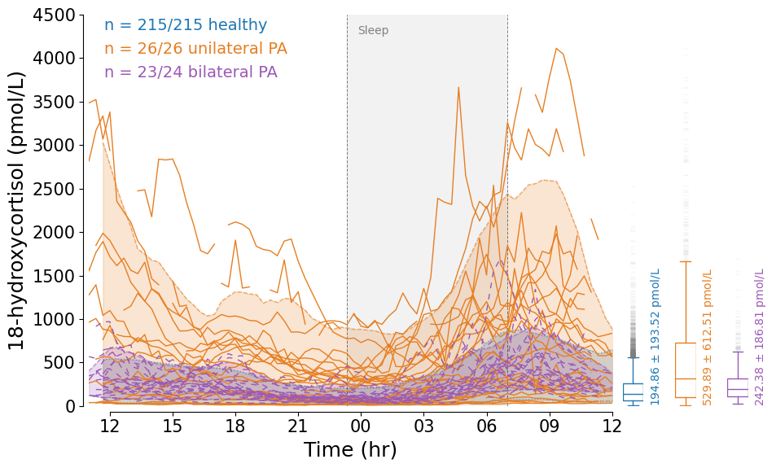
24-hour tissue fluid 18-hydroxycortisol profiles in n = 26 individuals with unilateral primary aldosteronism (PA) (orange burst lines) and n = 23 individuals with bilateral PA (purple lines) illustrating preserved daily rhythmicity, and prominent high amplitude 18-hydroxycortisol pulses in unilateral disease. Shaded areas represent the 5-95% confidence interval of the whole unilateral PA cohort (orange), bilateral PA cohort (purple) and healthy participants (blue). Sleep period is shown as shaded grey box. Median and interquartile ranges for each group are shown in the box plots to the right, with mean and standard deviation printed adjacent.
There were statistically significant differences in the median 18-hydroxycortisol concentrations between the groups, most prominently between unilateral PA and healthy participants (p < .0001), and unilateral compared with bilateral disease (p < .0001).
Extended data Fig. 6. Maximal tissue fluid 18-hydroxycortisol and 18-oxocortisol concentrations.

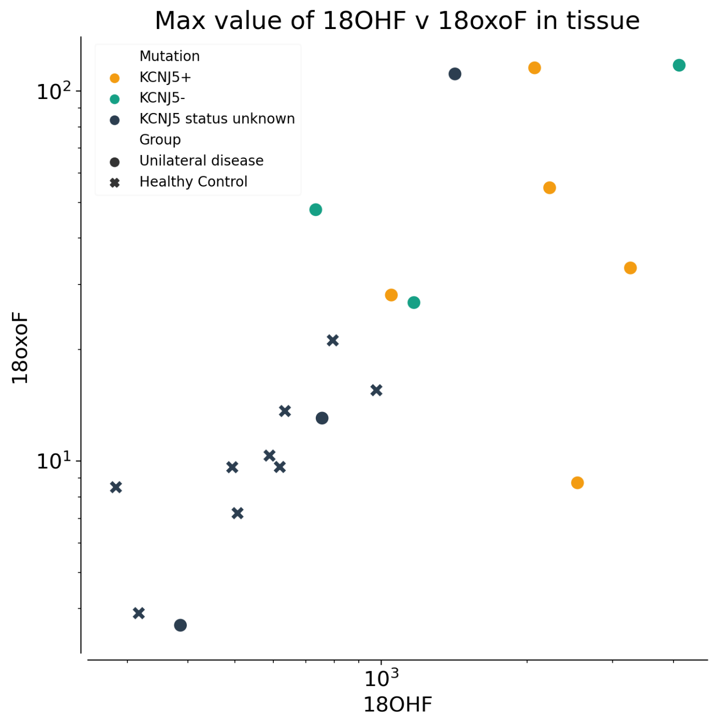
Logarithmic scale presentation of maximal tissue fluid concentration of 18-hydroxycortisol (18OHF) versus 18-oxocortisol (18oxoF) in unilateral primary aldosteronism and healthy individuals with measurable tissue 18-oxocortisol. For unilateral primary aldosteronism maximal tissue concentration values are presented according to somatic KCNJ5 genotype.

Extended data Fig. 7. Individual 24-hour dynamic tissue fluid cortisol profiles in unilateral primary aldosteronism.

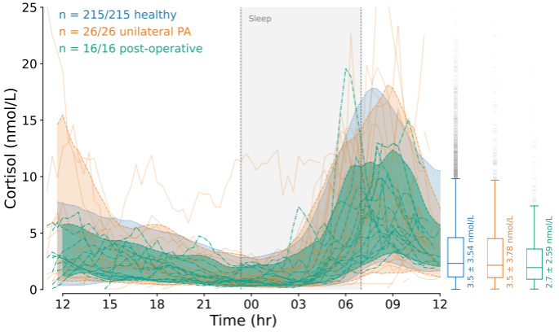

Individual 24-hour cortisol profiles in unilateral primary aldosteronism (PA) before (orange, 26 cases) and three months after adrenalectomy (green, 16 operated cases of whom two had missing results of the preoperative samplings). Shaded areas represent the 5-95% confidence interval of the preoperative (orange), and postoperative (green) cohorts, and healthy participants (blue). Sleep periods are shown as shaded grey boxes. There were statistically significant differences in median cortisol levels in post-operative compared with preoperative unilateral PA (p <.001) and with healthy participants (p <.001) but not between preoperative unilateral PA and healthy participant (p = 0.82). There was also no evidence for a difference in median cortisol between bilateral and unilateral disease (p = 0.41, not shown). The unilateral PA individual with elevated cortisol levels during afternoon/early night preoperatively had a normal dexamethasone suppression test.

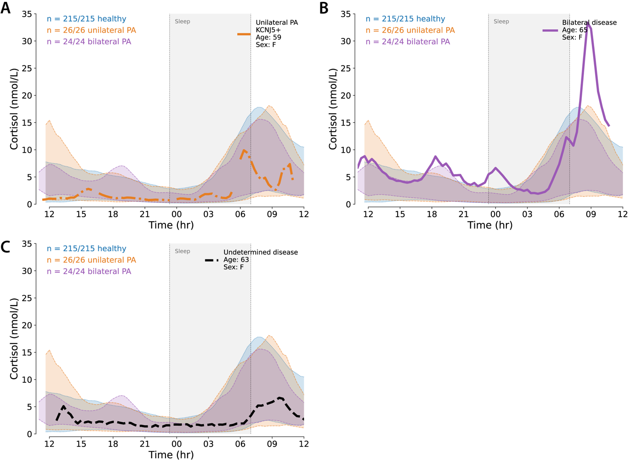
Extended data Fig. 8. Individual cortisol profiles in primary aldosteronism with mild autonomous cortisol secretion.

Tissue cortisol profiles in three individuals with mild autonomous cortisol secretion defined by and C) undetermined PA subtype. Shaded areas in orange (unilateral PA), purple (bilateral PA) and blue (healthy participants) represent cortisol 5-95% centiles. Shaded grey area represents sleep interval. Daily cortisol rhythmicity is preserved in all three individuals. The cortisol profile of individual B) has a high morning cortisol peakpositive dexamethasone suppression test (insufficient suppression). All three had ACTH < 2,5 pmol/L and unilateral adrenal tumour found on adrenal imaging. A) unilateral primary aldosteronism (PA), B) bilateral PA.

Extended data Fig. 9A-D. 24-hour corticosteroid dynamic ratios.
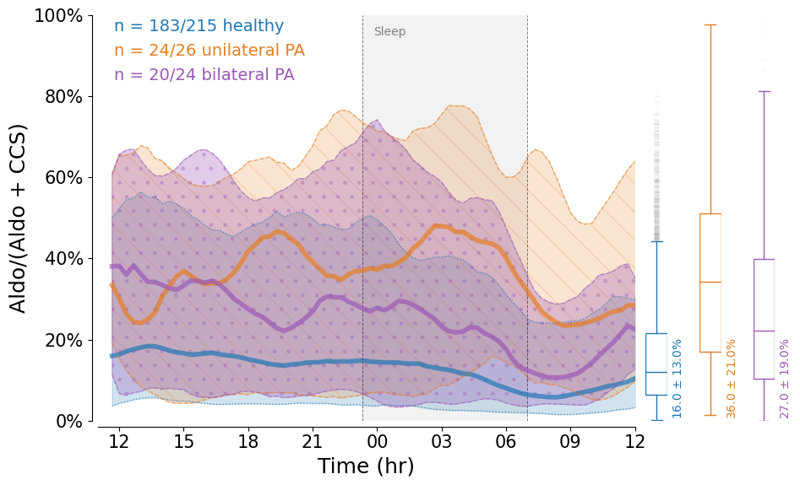
24-hour corticosteroid dynamic normalised ratios in tissue fluid in patients with unilateral (orange) and bilateral (purple) primary aldosteronism (PA) compared with healthy participants (blue). The relative proportion of each hormone is expressed as a percentage. Horizontal solid lines represent rolling mean, shaded areas represent 5-95% centiles for each cohort.

A) Relative proportion of aldosterone compared to corticosterone (CCS). Median aldosterone secretion relative to CCS was higher in unilateral primary aldosteronism (PA) than both bilateral (p <0.001) and healthy participants (p = <0.001); and higher in bilateral PA compared with healthy participants (p <0.001).

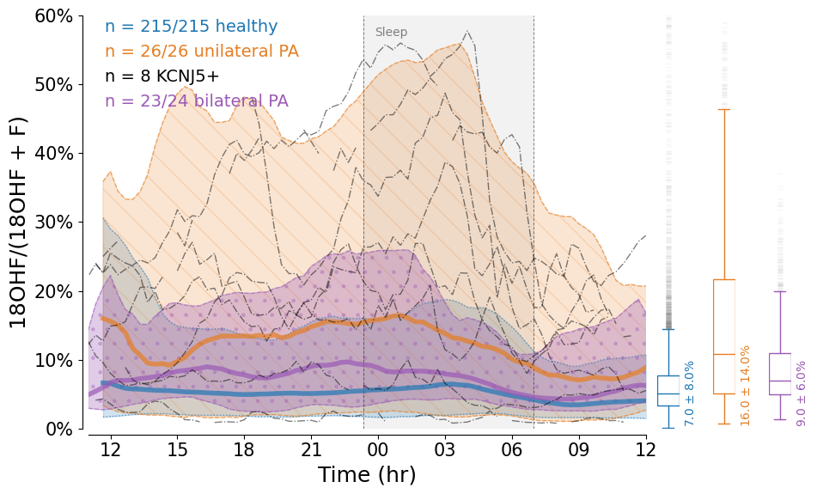

B) Relative proportion of 18-hydroxycortisol (18OHF) compared to cortisol (F). In this figure, black dotted lines represent individual profiles with unilateral primary aldosteronism (PA) and somatic KCNJ5 mutations. Median 18-hydroxycortisol secretion relative to cortisol was higher in unilateral than bilateral PA (p <0.001) and healthy participants (p = <0.0001); and higher in bilateral PA compared with healthy participants (p <0.001).

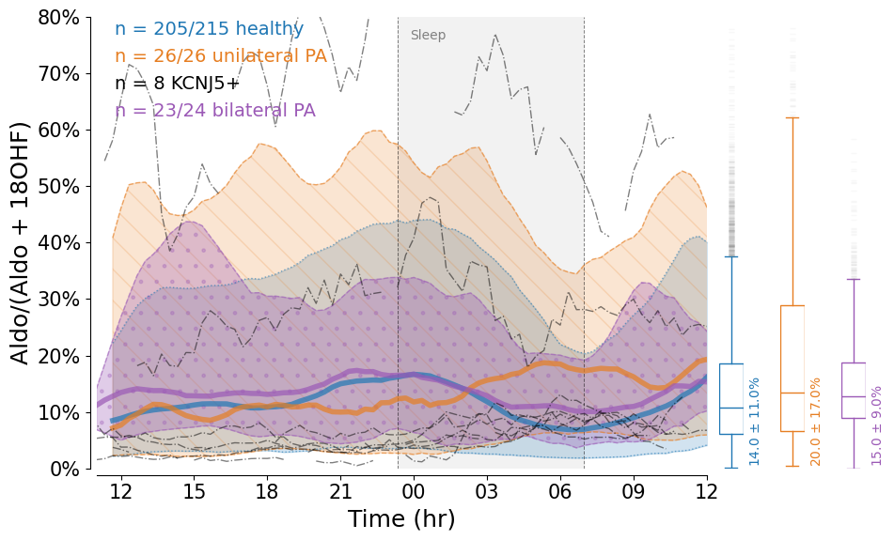
C) Relative proportion of aldosterone compared to 18-hydroxycortisol (18OHF). In this figure, black dotted lines represent individual profiles with unilateral primary aldosteronism (PA) and somatic KCNJ5 mutations. Median aldosterone secretion relative to 18-hydroxycortisol was higher in unilateral and bilateral PA than healthy participants (both p <0.001). There was no difference between the medians of bilateral and unilateral PA (p >0.9).

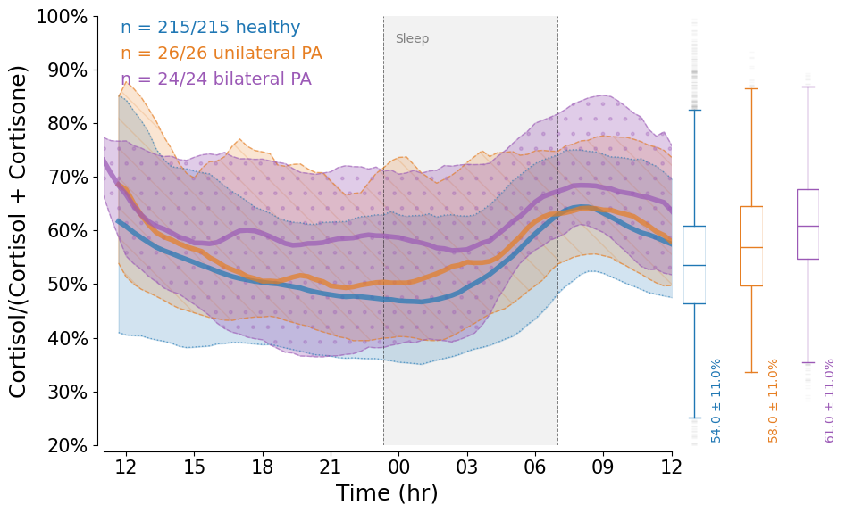
D) Relative proportion of cortisol compared to cortisone. Percentage values on the x-axis indicate the proportion as cortisol from the sum of cortisol + cortisone. Median ratios between unilateral and bilateral primary aldosteronism (PA) (p <0.001), and between both forms of PA and healthy participants (all p <0.001) were statistically significant.

Extended data Fig. 10. Digital biomarkers for primary aldosteronism and healthy participants.

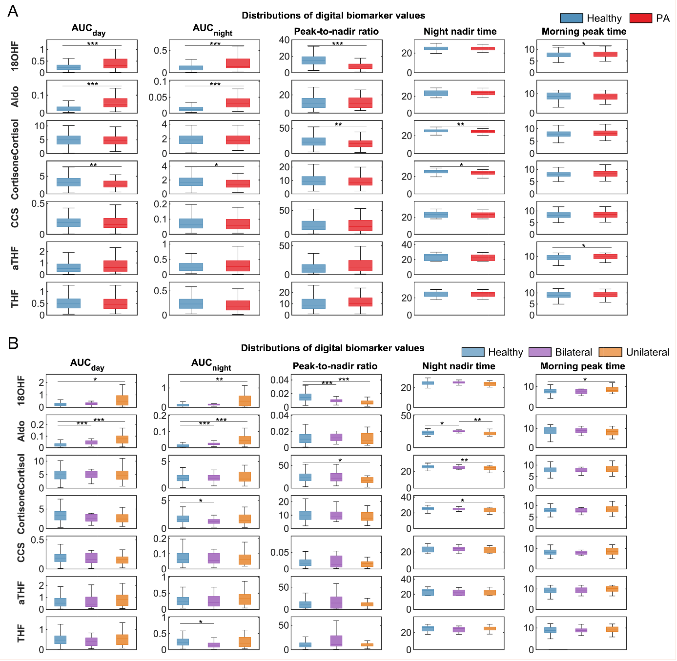

Comparison of digital biomarker values for seven adrenal hormones between healthy participants (blue) and A) whole primary aldosteronism (PA) cohort (red), or B) PA subtypes (purple bilateral PA and orange unilateral PA), using the Kruskal-Wallis test and Bonferroni post-hoc method (* = p < 0.05; ** = p < 0.01; *** = p < 0.001).

