Table of Contents for Supplementary Information
Description of Supplementary Tables
Description of Supplementary Data
Supplementary Figures

Description of Supplementary Tables
Supplementary Table 1. Single cell eQTL ground truth profile for cis-regulation inference in scQTLbase website.
Supplementary Table 2. CistromeID of TF Chip-seq served as the ground truth for trans-regulation.
Supplementary Table 3. Hyperparameters of each learning object in scTFBridge training.

Description of Supplementary Data
Supplementary Data 1-10. Results of shared and private gene sets GO enrichment in B cell, endothelial, myeloid, plasma, and T cell.
Supplementary Data 11. Results of shared and private peak set heritability enrichment in B cell, endothelial, myeloid, plasma, and T cell.

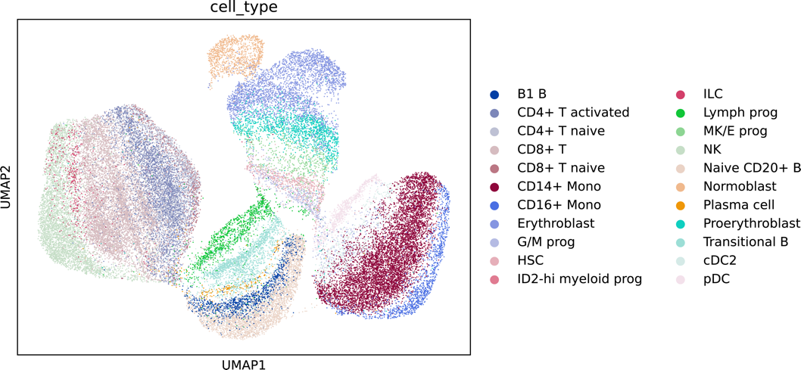
Fig. S1. UMAP visualization of ATAC-private embedding in BMMC dataset.

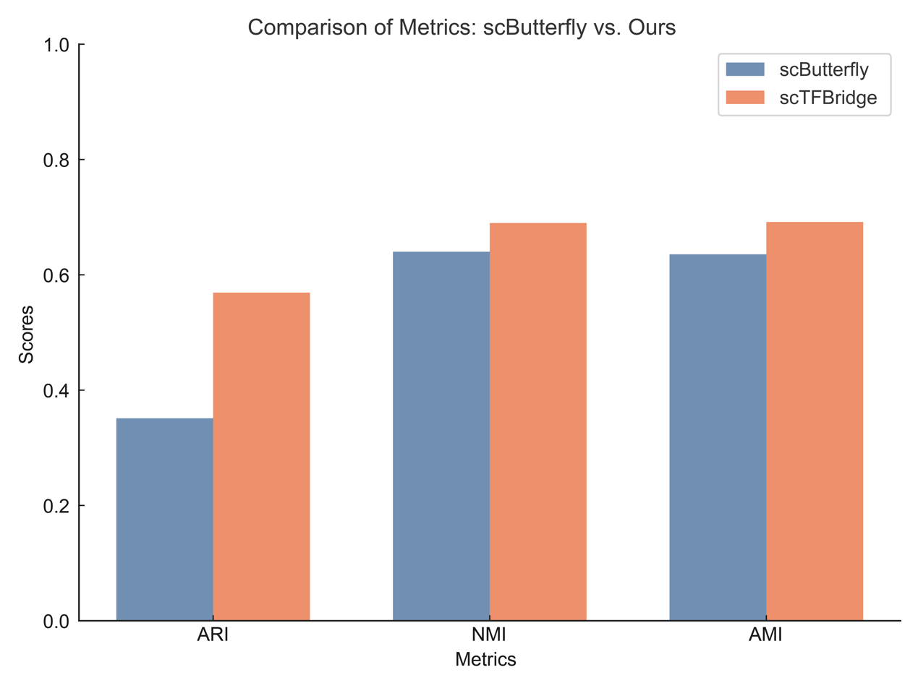
Fig. S2 Comparison of TG expression reconstruction performance across cell types. TG expression reconstruction was evaluated using ARI, NMI, and AMI metrics to assess the recovery of cell clusters based on cell type annotations, compared with scButterfly.

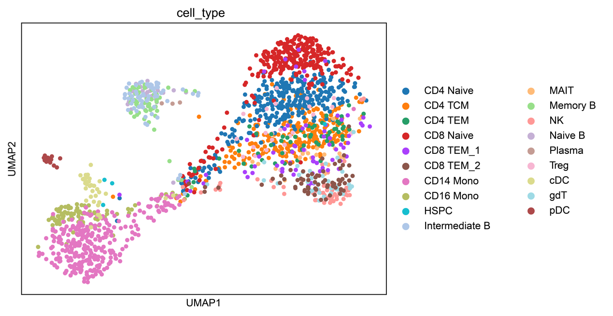
Fig. S3. Visualization of ATAC-private embedding in PBMC dataset.

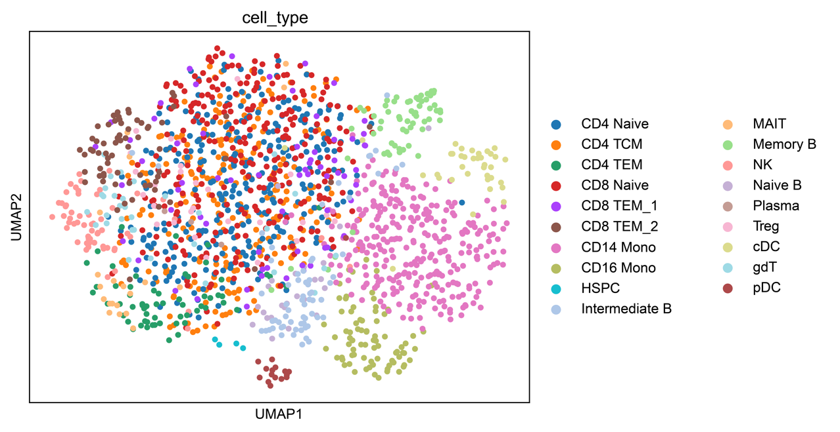
Fig. S4. Visualization of RNA-private embedding in PBMC dataset.

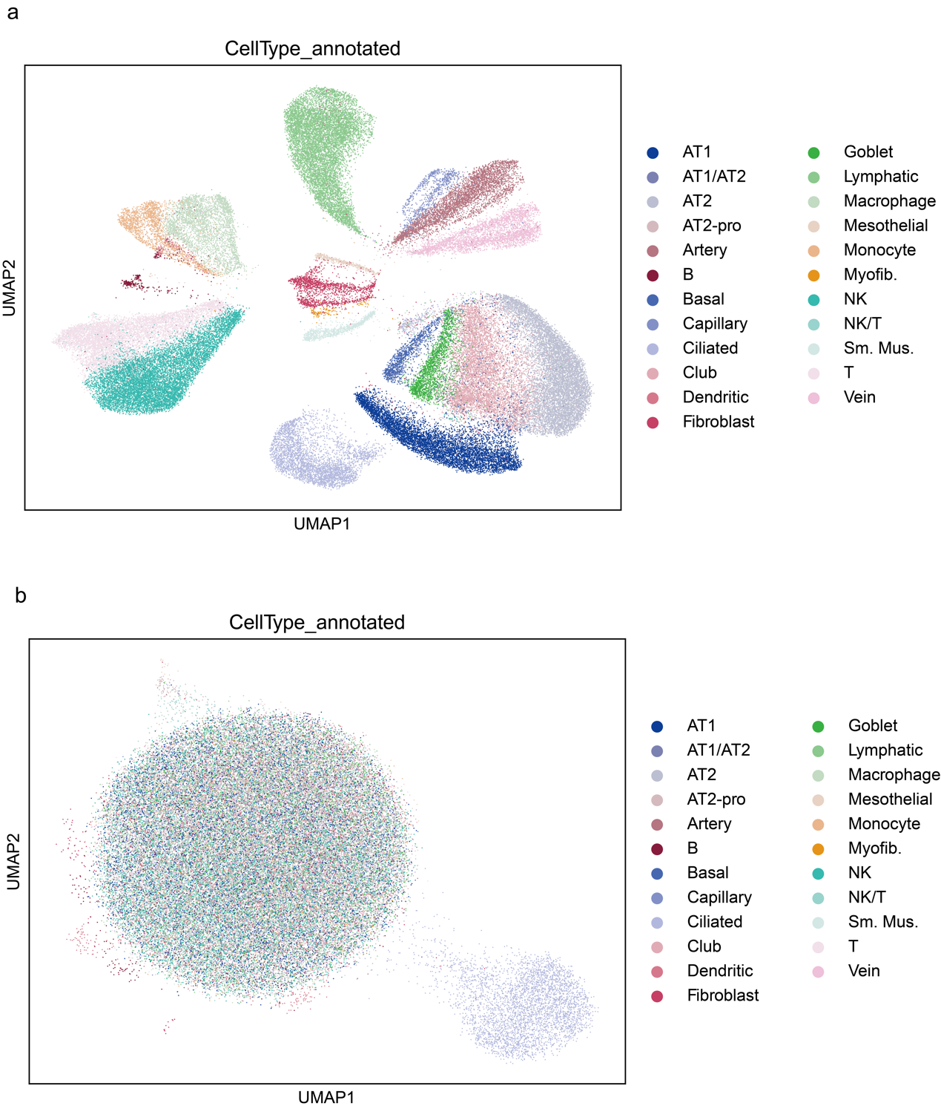
Fig S5. Visualization of ATAC-private, RNA-private embedding in lung cancer atlas dataset. (a) UMAP visualization of ATAC-private embedding. (b) UMAP visualization of RNA-private embedding.

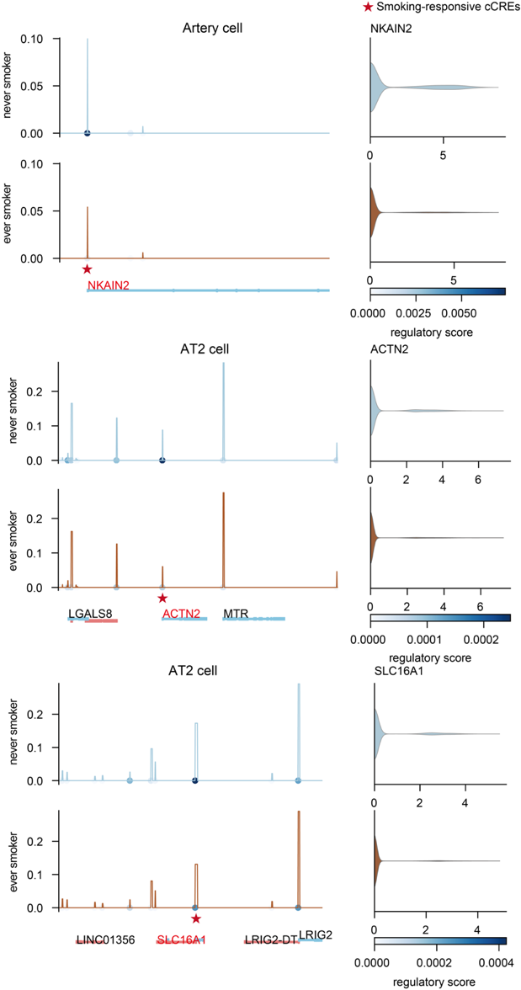
Fig. S6. Regulation of Smoking-Responsive CREs on Target Genes. Smoking-responsive CREs and their regulated target genes in ever- and never-smokers are shown for specific cell types. The expression levels of the target genes are presented, along with the corresponding linked peak regulation scores.

