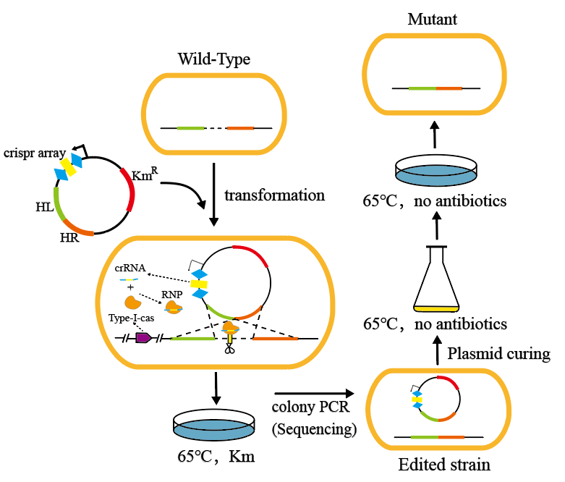
Fig. S1. Schematic diagram of endogenous CRISPR-Cas-based gene editing technology. Diamond blocks: repetitive sequences; yellow squares: spacer region sequences designed according to the target gene; KanR: kanamycin resistance gene and RNP complex: ribonucleoprotein complex from the CRISPR-Cas system.
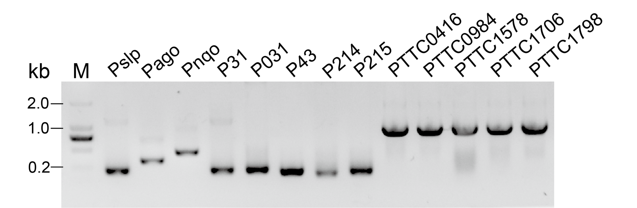
Fig. S2. Construction of reporter gene expression vectors containing different promoters; (A) Colony PCR amplicons of the promoter insertion verification image (M: 2kb DNA Marker (2000, 1000, 750, 500, 250, 100), and 13 screened promoters).
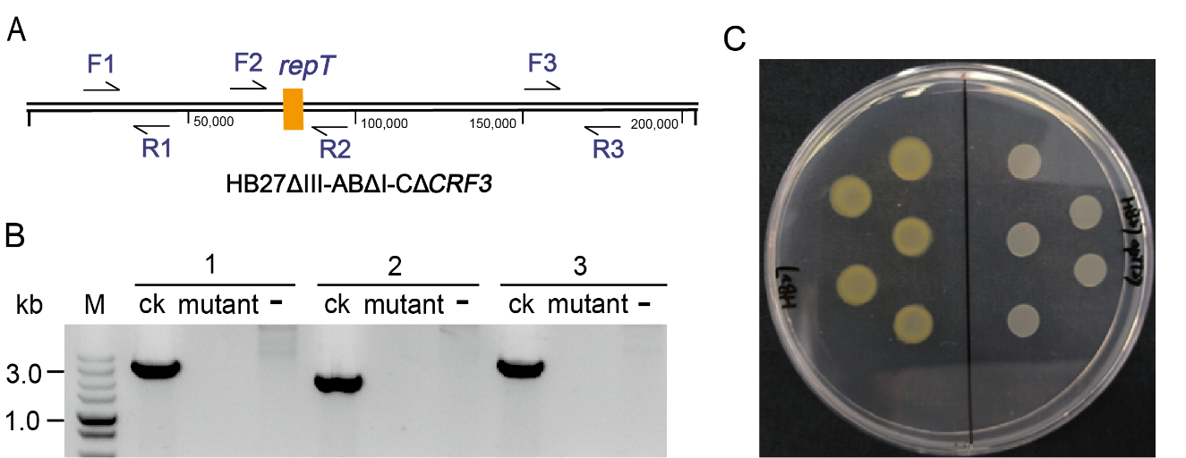
Fig. S3. Construction of HB27 giant plasmid (pTT27)-free strain; (A) position of the three pairs of primers to verify the deletion mutant; (B) colony PCR amplicons of the giant plasmid deletion verification image (M: 5kb DNA Marker (5000, 3000, 2000, 1500, 1000, 750, 500, 250, 100), CK: HB27ΔIII-ABΔI-CΔCRF3; mutant: plasmid-free stain HB27ΔpTT27 and -: negative control HB27). (C) Colony phenotyping of wild-type HB27 and giant plasmid-deficient strains HB27ΔpTT27 on the Right side.
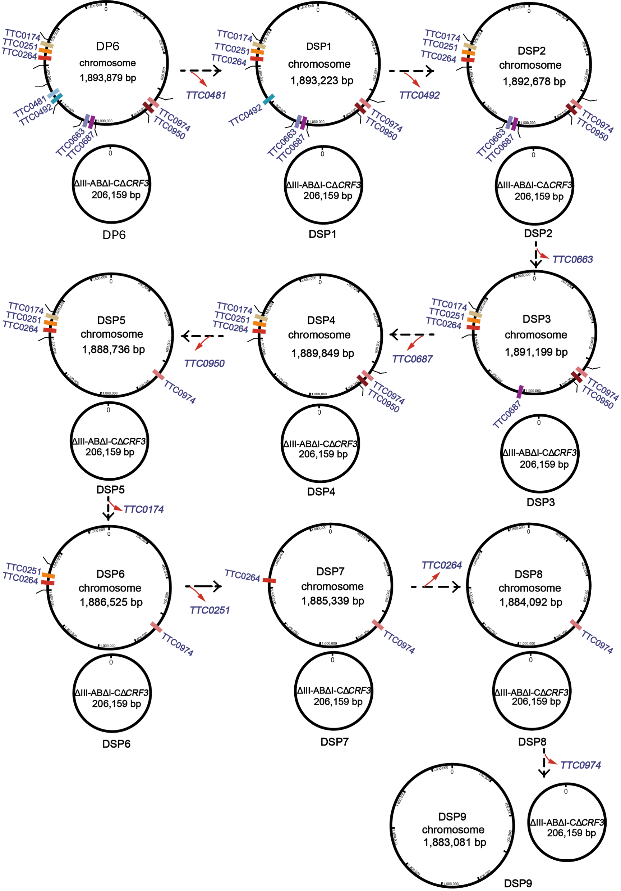
Fig. S4. Schematic diagram of the accumulated knockout protease genes validation based on endogenous CRISPR-Cas system in T. thermophilus HB27 for enhanced heterologous protein expression.
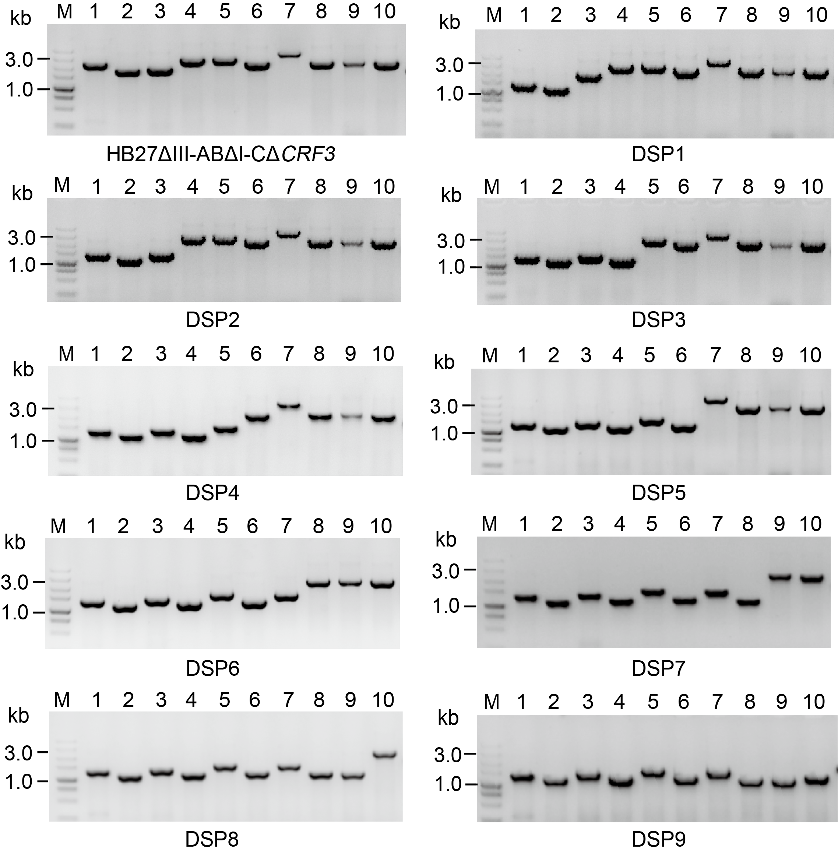
Fig. S5. Construction and validation of accumulated defect protease genes strains. Colony PCR amplicons of protease gene deletion verification image (M: 5kb DNA Marker (5000, 3000, 2000, 1500, 1000, 750, 500, 250, 100); Ctrl.: HB27ΔIII-ABΔI-CΔCRF3, DSP1-9: protease deletion strains, lanes 1-10 represent proteas genes; 1 : TTC0417; 2 : TTC0481; 3 : TTC0492; 4 : TTC0663; 5 : TTC0687; 6 : TTC0950; 7 : TTC0174; 8 : TTC0251; 9 : TTC0264; 10 : TTC0974.
Table S1. Thermus thermophilus strains used in this study.
Strain name | Strain description | Strain source
Thermus thermophilus  HB27 | Originally isolated from Japan hot springs, commonly used in our lab for thermophiles studies. | Lab stock
HB27ΔIIIABΔICΔCRF3 | T. thermophilus HB27-based deletion of type I-C, III-A & B CRISPR-Cas system and CRF3 (CRISPR-associated Rossmann Fold) | Lab stock
HB27ΔTTP0042 | T. thermophilus HB27 based deletion of the β-galactosidase main source gene | Lab stock
HB27ΔpTT27 | T. thermophilus HB27 based deletion of the giant plasmid | Current study
DP1 | HB27ΔIIIABΔICΔCRF3 based deletion of the protease gene TTC0035 | Current study
DP2 | HB27ΔIIIABΔICΔCRF3 based deletion of protease gene TTC0174 | Current study
DP3 | HB27ΔIIIABΔICΔCRF3 based deletion of the protease gene TTC0251 | Current study
DP4 | HB27ΔIIIABΔICΔCRF3 based deletion of the protease gene TTC264 | Current study
DP5 | HB27ΔIIIABΔICΔCRF3 based deletion of the protease gene TTC0265 | Current study
DP6 | HB27ΔIIIABΔICΔCRF3 based deletion of protease gene TTC0417 | Current study
DP7 | HB27ΔIIIABΔICΔCRF3 based deletion of protease gene TTC0481 | Current study
DP8 | HB27ΔIIIABΔICΔCRF3 based deletion of protease gene TTC0492 | Current study
DP9 | HB27ΔIIIABΔICΔCRF3 based deletion of protease gene TTC0663 | Current study
DP10 | HB27ΔIIIABΔICΔCRF3 based deletion of protease gene TTC0687 | Current study
DP11 | HB27ΔIIIABΔICΔCRF3 based deletion of protease gene TTC0950 | Current study
DP12 | HB27ΔIIIABΔICΔCRF3 based deletion of protease gene TTC0974 | Current study
DP13 | HB27ΔIIIABΔICΔCRF3 based deletion of the protease gene TTC1110 | Current study
DP14 | HB27ΔIIIABΔICΔCRF3 based deletion of the protease gene TTC1111 | Current study
DP15 | HB27ΔIIIABΔICΔCRF3 based deletion of the protease gene TTC1128 | Current study
DP16 | HB27ΔIIIABΔICΔCRF3 based deletion of the protease gene TTC1905 | Current study
DSP1 | HB27ΔIIIABΔICΔCRF3 based deletion of protease genes TTC0417, TTC0481 | Current study
DSP2 | HB27ΔIIIABΔICΔCRF3 based deletion of protease genes TTC0417, TC0481, TTC0492 | Current study
DSP3 | HB27ΔIIIABΔICΔCRF3 based deletion of protease genes TTC0417, TTC0481, TTC0492, TTC0663 | Current study
DSP4 | HB27ΔIIIABΔICΔCRF3 based deletion of protease genes TTC0417, TTC0481, TTC0492, TTC0663, TTC0687 | Current study
DSP5 | HB27ΔIIIABΔICΔCRF3 based deletion of protease genes TTC0417, TTC0481, TTC0492, TTC0663, TTC0687, TTC0950 | Current study
DSP6 | HB27ΔIIIABΔICΔCRF3 based deletion of protease genes TTC0417, TTC0481, TTC0492, TTC0663, TTC0687, TTC0950, TTC0174 | Current study
DSP7 | HB27ΔIIIABΔICΔCRF3 based deletion of protease genes TTC0417, TTC0481, TTC0492, TTC0663, TTC0687, TTC0950, TTC0174, TTC0251 | Current study
DSP8 | HB27ΔIIIABΔICΔCRF3 based deletion of protease genes TTC0417, TTC0481, TTC0492, TTC0663, TTC0687, TTC0950, TTC0174, TTC0251, TTC0264 | Current study
DSP9 | HB27ΔIIIABΔICΔCRF3 based deletion of protease genes TTC0417, TTC0481, TTC0492, TTC0663, TTC0687, TTC0950, TTC0174, TTC0251, TTC0264, TTC0974 | Current study
Table S2. Primers used in the current study.
Primer name | Primer sequences (5`→3`)
exam-LR-F | tgggggatacttggcaaacgc
exam-LR-R | ctacggggtctgacgctcag
pRK-TTP0042-F | atgaccgagaacgccgaaaaattcctttg
pRK-TTP0042-R | tggcgtttgccaagtatcccccatca
Pslp-F | gggatacttggcaaacgccaccgcttgacaagggcgcgtgag
Pslp-R | ttttcggcgttctcggtcatatgcctcacacctccttaagggtcgtgg
Pago-F | gggatacttggcaaacgccagtcaaagaagaagatccccacc
Pago-R | ttttcggcgttctcggtcatatcttggctcagatttgcatag
Pnqo-genome-F | cctccaggggccttctttcc
pRKSPnqo-R | ggtcccctcctttcgtgcctttc
P31-F | gggatacttggcaaacgccagaattcggcccaaggtttac
exam-42KO-R1 | ggtccaccaggcggtcgta
P031-F | cgcataccattttgatgggggatacttggcaaacgccaggtaggcccggtccctcggcc
P031-R | ccccaaaggaatttttcggcgttctcggtcatcccaaggtttacaaaatccccgccccc
P43-F | ggggatacttggcaaacgccacggtcttgtcaagtaagcttagctatggtaacatagac
P43-R | ccccaaaggaatttttcggcgttctcggtcatgagggcgaaggagggcttcaggttctc
P214-F | ccattttgatgggggatacttggcaaacgccatgcggggaaaggtactcgctgaggatt
P214-R | aaggaatttttcggcgttctcggtcatgcctcgggcaatcgctatggtacactctaagg
P215-F | tgggggatacttggcaaacgccacctgagtagcacttgacatcataaagtgcttgaggt
P215-R | ccactccccaaaggaatttttcggcgttctcggtcatcgcacggcgaactccacgctgg
P0416-F | atgggggatacttggcaaacgccacccaagtccttgcaggagcgcttcatcgctgcggt
P0416-R | caaaggaatttttcggcgttctcggtcatgggcacccccgaggaggaaggcgagttcgc
P0984-F | taccattttgatgggggatacttggcaaacgccacctggaggcgggccgggccctcaag
P0984-R | gaatttttcggcgttctcggtcatctctcacctcctcgcttctttgcccttccgggcgg
P1578-F | atgggggatacttggcaaacgccagggcaggtggaccacccgcaccgcc
P1578-R | ttcggcgttctcggtcatgcccccgagtttaggctaacctaaaaccggggtcaagggcc
pRKP31-F | aacttcatttttaatttaaaaggatctaggtgaagatc
pRKP31-R | ttaaatcaatctaaagtatatatgagtaaacttggtctgc
P1706-F | ttgatgggggatacttggcaaacgccacctcgaggacgaggacggccagatcgtgggca
P1706-R | atttttcggcgttctcggtcattcctcctcctctatccccgcttgcctcaggatgcgct
P1798-F | cattttgatgggggatacttggcaaacgccatggcgcggctttcccgggaggaaccccc
P1798-R | ccaaaggaatttttcggcgttctcggtcataccgcgaagagtctacccgccccctgcct
0035-sp-F | aaacttctggttcttcttcatgcgggcccaggggggcgcggggcag
0035-sp-R | caacctgccccgcgcccccctgggcccgcatgaagaagaaccagaa
0035-HL-F | tatactttagattgatttaaatccgccctttaagcccctcgg
0035-HL-R | cggagctattcctgccctagggtctacctcccttgccctatggtagcg
0035-HR-F | tagggcaagggaggtagaccctagggcaggaatagctccgcccg
0035-HR-R | tttaaattaaaaatgaagttgcccaggcctcggtgaaaagct
0035-verify-sp-F | tggttcttcttcatgcgggc
0174-SP-F | aaacattgacgagcttcacaccctgatcggggcgggcggggccgag
0174-SP-R | caacctcggccccgcccgccccgatcagggtgtgaagctcgtcaat
0174-HL-F | tatactttagattgatttaacccctcctccacctccatggc
0174-HL-R | ccttggccatccccaggggggctcccctctacctcacattctagcct
0174-HR-F | aatgtgaggtagaggggagcccccctggggatggccaag
0174-HR-R | cttttaaattaaaaatgaagtttctgcacggagtccacgaagagga
verify-0174-sp-F | ttcacaccctgatcggggc
0251-sp-F | aaacctggacgtgcccttcgccatcgccgacgccaccaccctcacc
0251-sp-R | caacggtgagggtggtggcgtcggcgatggcgaagggcacgtccag
0251-HL-F | tatactttagattgatttaatcttcctgggcacccccatagacg
0251-HL-R | caaaaggggcttggtcgcccctaggcctcttcacgggtcaccac
0251-HR-F | tgacccgtgaagaggcctaggggcgaccaagccccttttgg
0251-HR-R | ttttaaattaaaaatgaagttggcgccccggccctg
verify-0251-sp-F | tggacgtgcccttcgc
0264-sp-F | aaacgtgaaggtggaggccaccaagttcaccgaggtggggtacgtg
0264-sp-R | caaccacgtaccccacctcggtgaacttggtggcctccaccttcac
0264-HL-F | tactttagattgatttaagggtcaccgccctcgcc
0264-HL-R | tccttcctcctttacagccttcatgcttcccccaaagtgaggacg
0264-HR-F | tcactttgggggaagcatgaaggctgtaaaggaggaaggatgcg
0264-HR-R | ttttaaattaaaaatgaagttccttgtcccgctcgcccag
verify-0264-sp-F | aaggtggaggccaccaag
0265-sp-F | aaacgccgggggcgtggccgacgccatggccctcctggagcgcttt
0265-sp-R | caacaaagcgctccaggagggccatggcgtcggccacgcccccggc
0265-HL-F | tatatactttagattgatttaatccccacccgctacccggac
0265-HL-R | tcggcgggcgtcaggttcatgagaagggcgttaggctaggcgg
0265-HR-F | cctagcctaacgcccttctcatgaacctgacgcccgccg
0265-HR-R | cttttaaattaaaaatgaagttaggacccccatgaaggggagg
verify-0265-sp-F | gccatggccctcctgga
0417-sp-F | aaaccgggtggaggtggcggaaggcccccggggcacgggctttttc
0417-sp-R | caacgaaaaagcccgtgccccgggggccttccgccacctccacccg
0417-FL-F | atatactttagattgatttaacgggaacctgggggaggtc
0417-FL-R | ggtcctaagcgcccacgccggg
0417-FR-F | ctagcggccgtacaccacgctcggaagc
verify-0417-sp-F | aggtggcggaaggccc
0481-sp-F | aaactcctcctcgtgggcttcggctgggcgcgccccgtgcccatct
0481-sp-R | caacagatgggcacggggcgcgcccagccgaagcccacgaggagga
0481-HR-F | gtgtccgcacgtcggcttcgcag
0481-HR-R | ttttaaattaaaaatgaagttgcggtttgaggagctcgcctggc
verify-0481-sp-F | tcctcgtgggcttcggct
0492-sp-F | aaaccgccgcctcttccccgcctccttccgcgaggccgaggccctg
0492-sp-R | caaccagggcctcggcctcgcggaaggaggcggggaagaggcggcg
0492-verify-sp-F | tcttccccgcctccttcc
0492-HL-F | tatactttagattgatttaatactgcgcccacgcgggg
0492-HL-R | gactttggggaaggtttttgtcacccctgccccagggcgaag
0492-HR-F | tcgccctggggcaggggtgacaaaaaccttccccaaagtcaagggcaaag
0492-HR-R | tttaaattaaaaatgaagttcccttcttgagaagcctggcgatgg
0663-sp-F | aaacctcgggaacctctccttcacctgcccaaactccatccccacg
0663-sp-R | caaccgtggggatggagtttgggcaggtgaaggagaggttcccgag
0663-verify-sp-F | tctccttcacctgcccaaac
0663-HL-F | tatactttagattgatttaaggaggagcttggccacctcagcca
0663-HL-R | tgctccttccttcttccgccgactcgcttcccctcgaaaacagagttct
0663-HR-F | ttttcgaggggaagcgagtcggcggaagaaggaaggagcagggag
0663-HR-R | tttaaattaaaaatgaagttaaggcgtcagggaaggctacctcag
0687-sp-F | aaacctcgccctctacttcgccggggggtggcttgcggggctttcc
0687-sp-R | caacggaaagccccgcaagccaccccccggcgaagtagagggcgag
0687-verify-sp-F | gtggcttgcggggcttt
0687-HL-F | tatactttagattgatttaagttccagacccagacctcaagccccgct
0687-HL-R | gatgcccagtccttccatagcgcccttattctataggcccgcagggaa
0687-HR-F | gggcctatagaataagggcgctatggaaggactgggcatcgttttcctgg
0687-HR-R | tttaaattaaaaatgaagttccccgccccgcccaccaggc
0950-sp-F | aaacctcctcttccgggccctcccctgggaggcgggggccttgggc
0950-sp-R | caacgcccaaggcccccgcctcccaggggagggcccggaagaggag
verify-0950-sp-F | tcctcttccgggccctcc
0950-HL-F | atatactttagattgatttaaagttcaaggcgatggccccgg
0950-HL-R | catagttttgcacccccagggcctcagtataggggcgggtggg
0950-HR-F | acccgcccctatactgaggccctgggggtgcaaaactatgcggaggtga
0950-HR-R | tttaaattaaaaatgaagttcgaggagggccaggttctcggtg
0974-sp-F | aaaccgcaaccggagcgtggccgccttcttctggggcctgaagccc
0974-sp-R | caacgggcttcaggccccagaagaaggcggccacgctccggttgcg
0974-verify-sp-F | gccttcttctggggcctgaa
0974-HL-F | tatactttagattgatttaacgccatcgtggccgtggccgggccgagcc
0974-HL-R | tcggcgaggaccttccctgaggccccatgataccccttcgccc
0974-HR-F | cgaaggggtatcatggggcctcagggaaggtcctcgccgaggcc
0974-HR-R | tttaaattaaaaatgaagttccccgcccggcctcaggggggcctaccagg
1110-sp-F | aaactcctggagctccttcttgggcccacccaggtggtggccaaga
1110-sp-R | caactcttggccaccacctgggtgggcccaagaaggagctccagga
verify-1110-sp-F | cacccaggtggtggccaa
1110-HL-F | tatactttagattgatttaactccgccaccccgccaag
1110-HL-R | tgaccttcatgggccccagttcatcgcggcggaccctggc
1110-HR-F | gccagggtccgccgcgatgaactggggcccatgaaggtcaagga
1110-HR-R | tttaaattaaaaatgaagttagatagaagatctccaacaggtgttccgcg
1111-sp-F | aaacttcatcctctccgtcctctccccctacttccagcagcagtgg
1111-sp-R | caacccactgctgctggaagtagggggagaggacggagaggatgaa
verify-1111-sp-F | tctccccctacttccagcag
1111-HL-F | tatactttagattgatttaagggtgggggccttcctctcc
1111-HL-R | atgtcgtgcagggggatcatgcctcacctccggcaaggtcatttta
1111-HR-F | gaccttgccggaggtgaggcatgatccccctgcacgacatcaacc
1111-HR-R | ttttaaattaaaaatgaagttcccaggtaaaagcccgcggg
1128-sp-F | aaactcccgcaacggccgggccgggccttcggactccgccttcagc
1128-sp-R | caacgctgaaggcggagtccgaaggcccggcccggccgttgcggga
verify-1128-sp-F | ccttcggactccgccttca
1128-HL-F | tatactttagattgatttaactccaccagcttgcggaggatca
1128-HL-R | ctgcggccctttgcggggcggtcttccttcaaggtacaccggggg
1128-HR-F | ggtgtaccttgaaggaagaccgccccgcaaagggccg
1128-HR-R | ttttaaattaaaaatgaagttccctcgcggtggacaaggacc
1905-sp-F | aaacttcgtggggccgagccaggtggtcaccaactaccacgtgatc
1905-sp-R | caacgatcacgtggtagttggtgaccacctggctcggccccacgaa
verify-1905-sp-F | agccaggtggtcaccaac
1905-HL-F | atactttagattgatttaacgacaaggaggaggcggcgc
1905-HL-R | ccttcaaggtgggcatggccgggcctacattacctcaggcgcgg
1905-HR-F | gcctgaggtaatgtaggcccggccatgcccaccttgaaggagctc
1905-HR-R | ttaaattaaaaatgaagttggaaggcgtagacctcgggggc
0035-genome-F | tccccggcctcaagccacatggcggcgg
0035-exam-sp-F | ccaggtctcccggcgcttccaggttcccctg
0035-genome-R | ccttgcggtaggcctcgctctcgttcagcttccggca
0174-genome-F | cgtcctccacggggcccacgtaggtcttgaacatcatgttgaagtagcg
0174-exam-sp-F | ggggcgagtttgaggagcgcctgcggcagatcattgag
0174-genome-R | ccccgcctcctccatgcggaagaccccgatctcc
0251-genome-F | ccgcctcctcaagcgcctggtctacggggtg
0251-exam-sp-F | gagggccgcctgggtgaagcggagctctatccc
0251-genome-R | tcattgagcagacggcccgcggcgagcgc
0264-genome-F | ggcggcgtggagattcacggcaccaccatcctcg
0264-exam-sp-F | gggaaagaccgagatcgcccgccgcctcgc
0264-genome-R | gagtgtcctcgagggccagggcctgcttgaggg
0265-genome-F | cctggggtcactccatcctggacctcctggccgaccttcc
0265-exam-sp-F | tcctccgccacctccaggccatgatcgtggcc
0265-genome-R | ttgtctataaggcgctcggcgtgctggttcttcagcacctcccg
0417-genome-F | aggacctcgaggcctacctgggcgtccccaagt
0417-exam-sp-F | aggtggcggaaggcccccggggca
0417-genome-R | tttggtccttatctttttggtgctgggcacgatctttctggggcttgcc
0481-genome-F | cgctcccgccccgtcctcctcgtggagaacacc
0481-exam-sp-F | gaagagaacggcgagggccaggttcaccaggatcccgg
0481-genome-R | tggccttcctcctcggggccttcgggctcatcctcc
0492-genome-F | ctccaaagcctccggagggccctcgccctaaagcc
0492-exam-sp-F | gggcgtcctcgcccacttcctccacaacgcca
0492-genome-R | ccctgagctcctccagaaaggcctcccggaggtcctg
0663-genome-F | gatgcgccaaacccggcccaccttcactgcg
0663-exam-sp-F | gaaccccgcggagaagtcccgcaccctcacc
0663-genome-R | cggggtctggtacgccgtgcggaacaagggatggaa
0687-genome-F | ttggaccaaacgggcatcggccgtccaaaccaccttacacccccaa
0687-exam-sp-F | ccctccaggagccccaggccgcggaccaaaa
0687-genome-R | cttctccagcacggtcttggagatgcggtcggggttctccagg
0950-genome-F | agcacccagaggatgggcaggaaggacagggcgttg
0950-exam-sp-F | ggagggtctaccgggcgctcctcgccctgaggaa
0950-genome-R | aggcgttcccgcttgctgaagctgtccgggcttacc
0974-genome-F | aaggtggcggaagaacggggggcgccccttta
0974-exam-sp-F | gggggttcccggagctcaaagaccaccacgggcttc
0974-genome-R | gcttcttccgggggcggacggaggtggccatc
1110-genome-F | cccaggtggcctcgttcttgcggcggagcagatcg
1110-exam-sp-F | ctgcccgcgggcttttacctggggtactgggc
1110-genome-R | gggctggttcaggcgcttgaagataaaggccatcacctgggcc
1111-genome-F | ttcaccgcgggcaccgccctcctcttccacg
1111-exam-sp-F | gagcaggtcctgagggccatccgcctcacggac
1111-genome-R | gcacgcccaaaagcccctgcaccagctggag
1128-genome-F | gggagcgggtcctggacgtgtacagctacgtgggg
1128-exam-sp-F | atgaggaggcccacgaggaggaggggccagaggaa
1128-genome-R | gcgggcacggtgatcaccgccttggtgatcttttcccc
1905-genome-F | cctacgagaccgtcctcctggaggggcggcagatgt
1905-exam-sp-F | acctcttcaccgacgcccccctcaccgtagggaactc
1905-genome-R | gtgccgtggaagtccaggtggtcgtcggggtagaagttcacg
exam-pTT27-F1 | gcaactacctggacatctggcgcgtcctgcccttcttccactacctga
exam-pTT27-R1 | tggcctttgacatggacaaggcgcaggtggtgcggac
exam-pTT27-F2 | acacccgtcctcctgacctttgcaaggcaagcccactc
exam-pTT27-R2 | ccccgatggcgaagagggcggtcctaagttcttccaggtagtc
exam-pTT27-F3 | gcttcccttcggtccgggcctccctccgtagctt
exam-pTT27-R3 | ggcggacgcgaggcggcttggggagcttctcctttc
repT-sp-F | aaacaccaccacggcctaccagatcctcaagctcatgggcttcgac
repT-sp-R | caacgtcgaagcccatgagcttgaggatctggtaggccgtggtggt
verify-repT-sp-F | ggcctaccagatcctcaagc
Table S3. Plasmids used in the current study.
Plasmid name | Plasmid description | Source
pRKP31 | The backbone plasmid used to construct promoter screening plasmids | Lab stock
pRKP31-AC3 | The knockout plasmid based on endogenous CRISPR type I-B system | Lab stock
pRKPslp-TTP0042 | To monitor TTP0042 expression level based on the Pslp promoter | Lab stock
pRKPnqo-TTP0042 | To monitor TTP0042 expression level based on the Pnqo promoter | Current study
pRKPago-TTP0042 | To monitor TTP0042 expression level based on the Pago promoter | Current study
pRKP31-TTP0042 | To monitor TTP0042 expression level based on the P31 promoter | Lab stock
pRKP031-TTP0042 | To monitor TTP0042 expression level based on the P031 promoter | Current study
pRKP43-TTP0042 | To monitor TTP0042 expression level based on the P43 promoter | Current study
pRKP214-TTP0042 | To monitor TTP0042 expression level based on the P214 promoter | Current study
pRKP215-TTP0042 | To monitor TTP0042 expression level based on the P215 promoter | Current study
pRKP0416-TTP0042 | To monitor TTP0042 expression level based on the P0416 promoter | Current study
pRKP0984-TTP0042 | To monitor TTP0042 expression level based on the P0984 promoter | Current study
pRKP1578-TTP0042 | To monitor TTP0042 expression level based on the P1578 promoter | Current study
pRKP1706-TTP0042 | To monitor TTP0042 expression level based on the P1706 promoter | Current study
pRKP1798-TTP0042 | To monitor TTP0042 expression level based on the P1798 promoter | Current study
pRKP31-repT-AC3 | An editing plasmid for knockdown of the repT gene using the type I-B system | Current study
pRKP31-TTC0035-AC3 | An editing plasmid for knockdown of the TTC0035 gene using the type I-B system | Current study
pRKP31-TTC0174-AC3 | An editing plasmid for knockdown of the TTC0174 gene using the type I-B system | Current study
pRKP31-TTC0251-AC3 | An editing plasmid for knockdown of the TTC0251 gene using the type I-B system | Current study
pRKP31-TTC0264-AC3 | An editing plasmid for knockdown of the TTC0264 gene using the type I-B system | Current study
pRKP31-TTC0265-AC3 | An editing plasmid for knockdown of the TTC0265 gene using the type I-B system | Current study
pRKP31-TTC0417-AC3 | An editing plasmid for knockdown of the TTC0417 gene using the type I-B system | Current study
pRKP31-TTC0481-AC3 | An editing plasmid for knockdown of the TTC0481 gene using the type I-B system | Current study
pRKP31-TTC0492-AC3 | An editing plasmid for knockdown of the TTC0492 gene using the type I-B system | Current study
pRKP31-TTC0663-AC3 | An editing plasmid for knockdown of the TTC0663 gene using the type I-B system | Current study
pRKP31-TTC0687-AC3 | An editing plasmid for knockdown of the TTC0687 gene using the type I-B system | Current study
pRKP31-TTC0950-AC3 | An editing plasmid for knockdown of the TTC0950 gene using the type I-B system | Current study
pRKP31-TTC0974-AC3 | An editing plasmid for knockdown of the TTC0974 gene using a type I-B system | Current study
pRKP31-TTC1110-AC3 | An editing plasmid for knockdown of the TTC1110 gene using the type I-B system | Current study
pRKP31-TTC1111-AC3 | An editing plasmid for knockdown of the TTC1111 gene using the type I-B system | Current study
pRKP31-TTC1128-AC3 | An editing plasmid for knockdown of the TTC1128 gene using the type I-B system | Current study
pRKP31-TTC1905-AC3 | An editing plasmid for knockdown of the TTC1905 gene using the type I-B system | Current study

