Supplementary Information for

Spin-on Deposition of Amorphous Zeolitic imidazolate Framework (aZIF) Films for Lithography Applications

Yurun Miao, Shunyi Zheng, Kayley Waltz, Mueed Ahmad, Yegui Zhou, J. Anibal Boscoboinik, Qi Liu, Kumar Varoon Agrawal, Liwei Zhuang, Michael Tsapatsis

Supplementary Figures

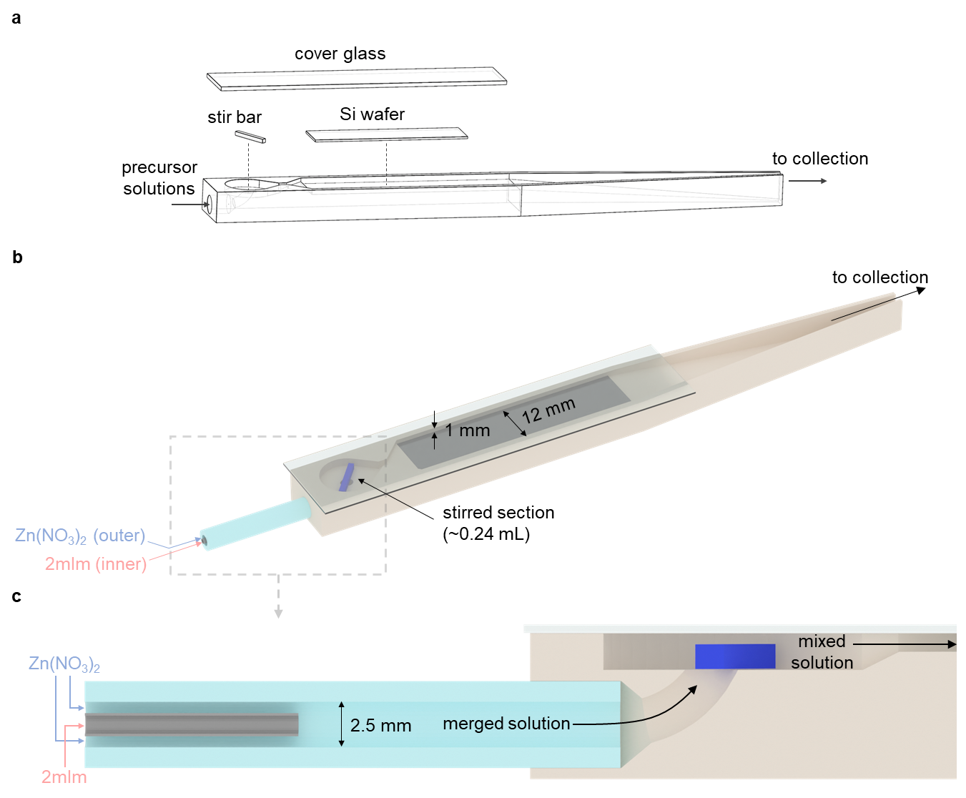
Fig. S1. (a) Exploded view of the flow coating assembly. (b) The flow coating assembly with the precursor solution feed connector. (c) Cross-sectional view of the solution feed and mixing sections.

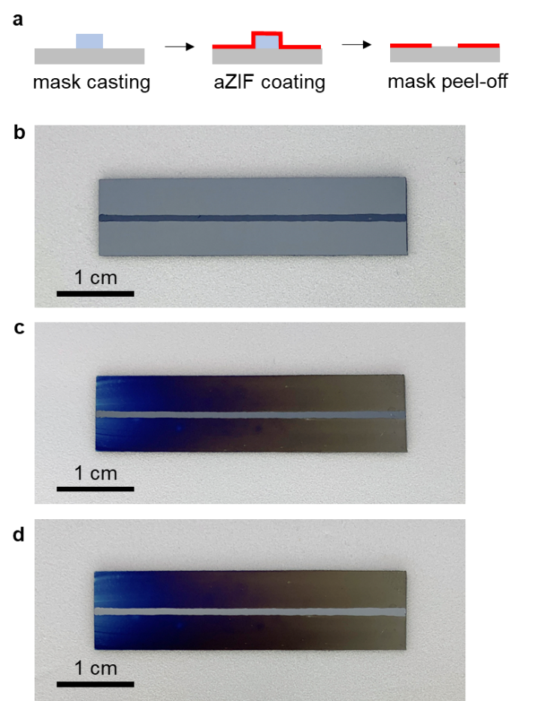
Fig. S2. (a) Cross-sectional view schematic of a masked silicon wafer (masking done by using styrene-ethylene-butadiene-styrene copolymer (SEBS) dropcast from a solution (10 wt% in toluene) along the center of the wafer), before (left) and after (center) aZIF-Zn/2mIm film deposition, and after SEBS removal (right). Each step corresponds to the photographs shown in (b-d): (b) a silicon wafer after SEBS mask casting, (c) the wafer in (b) after flow coating for 4 min with 2 mM Zn and 16 mM 2mIm with the SEBS mask, and (d) the wafer in (c) after SEBS mask removal.

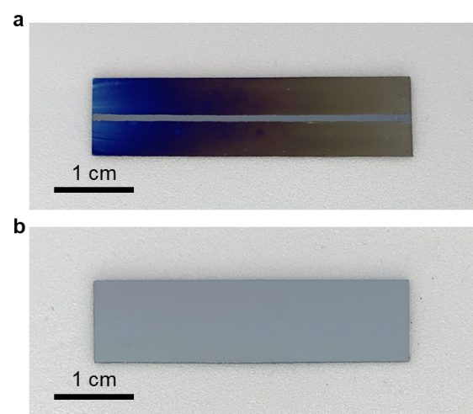
Fig. S3. Silicon wafers after flow coating with 2 mM Zn and 16 mM 2mIm for 4 min (a) with stirring and (b) without stirring in the mixing section.

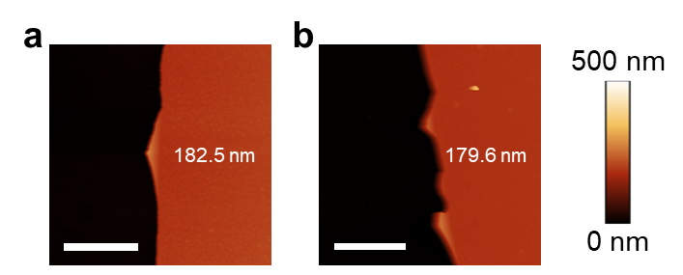
Fig. S4. (a) aZIF film flow coated using 2 mM Zn/16 mM 2mIm for 8 min. (b) The film in (a) after storage under ambient conditions for 4 months. Both AFM images are measured at 1 cm along the wafer. Thicknesses of the aZIF layers are indicated. Scale bars are 2 µm.

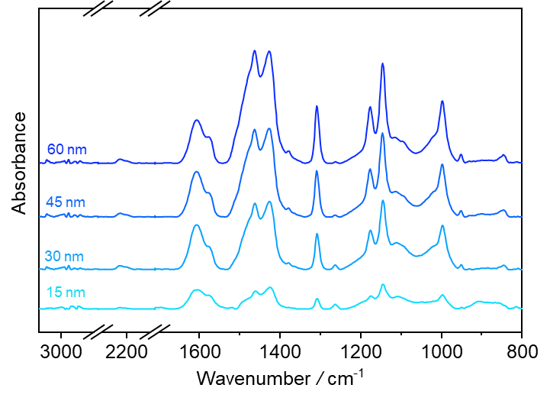
Fig. S5. IRRAS of aZIF-Zn/2mIm films with various thicknesses: 15, 30, 45, and 60 nm.

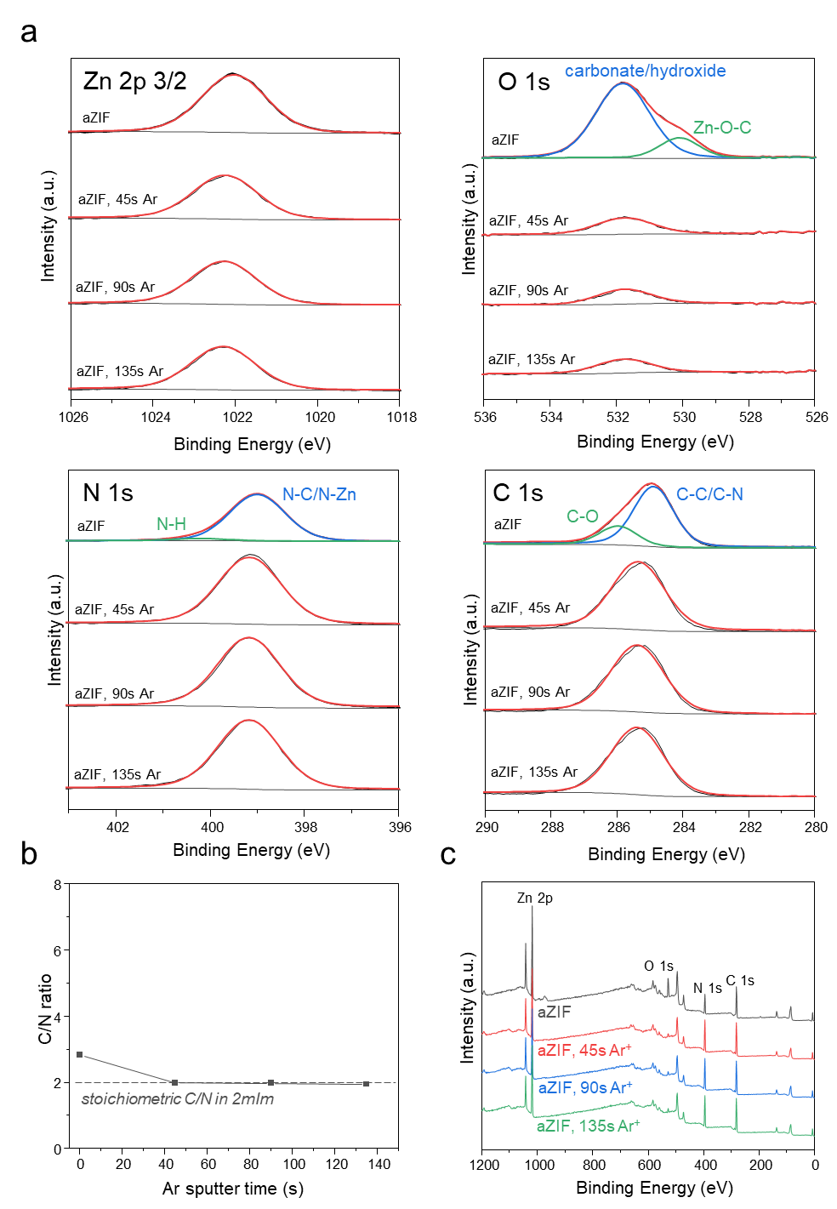
Fig. S6. (a) High resolution XPS in Zn 2p3/2, O 1s, N 1s and C 1s regions; (b) XPS atomic ratio of C/N; and (c) XPS survey scans for aZIF-Zn/2mIm film as prepared and after different Ar sputtering times.

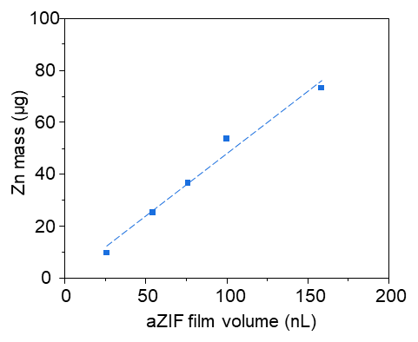
Fig. S7. Correlation between Zn mass and film volume for the calculation of density in aZIF films. aZIF films are coated to different thicknesses on silicon wafers. The volume of aZIF films is calculated by multiplying the ellipsometric thicknesses by the surface area determined from images of the aZIF-coated wafers respectively. The aZIF films are then digested in 20 mL aqueous solution of HNO₃ (5 wt%) and analyzed by ICP-OES to determine the Zn concentration, from which the mass of Zn in each aZIF film was calculated and linearly fitted (dashed line) against the volume of the films. From the linear fit, the density of Zn in aZIF is found to be 0.48 g/mL or 7.34 mol/L. The overall density of aZIF is then calculated to be 1.62 g/mL from the XPS chemical formula of Zn(C₄N₂H₅)_{1.85}(OH)_{0.15}(H₂O)_{0.15}.
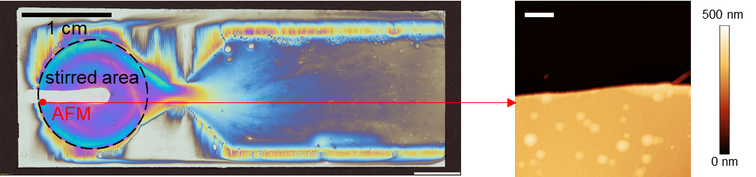
Fig. S8. Optical image of a silicon wafer placed on the top of the coating device (in place of the glass coverslip) after flow coating for 4 min with 2 mM Zn and 16 mM 2mIm. A SEBS mask was used to create a step between aZIF-coated area and bare silicon wafer surface in the left part of the stirred area for thickness measurement in AFM. The color-thickness correlation in aZIF films is found to be similar to that in SiO₂ films. The maximum thickness of the deposit is found to be 320 nm in the green colored region (determined from AFM shown on the right) in the stirred section, giving an estimation of the intrinsic deposition rate under these conditions of 80 nm/min. Scale bar is 1 µm in the AFM image.

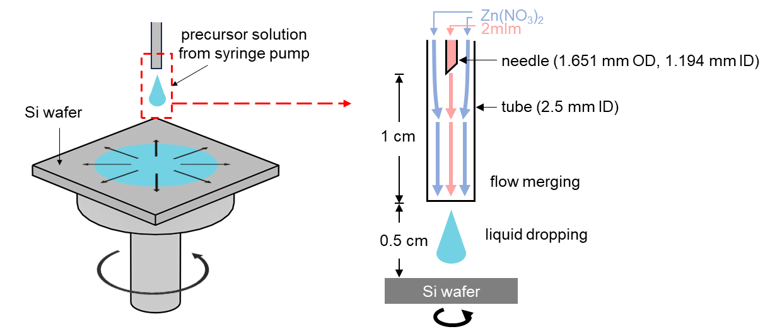
Fig. S9. The solution injection section in the spin coating process.
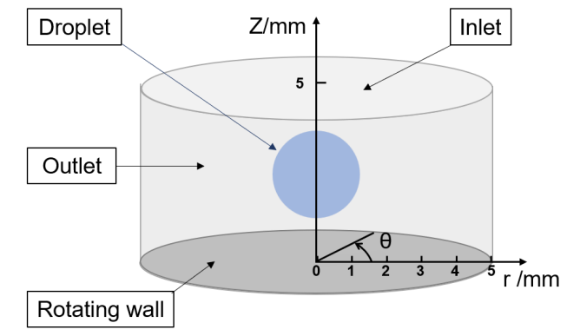
Fig. S10. Three-dimensional model of spin coating and names of different boundaries.

Fig. S11. Radial distribution of deposition rate. Simulation results with 2000 rpm, 4000 rpm, and 8000 rpm. Experimental results with 2000 rpm.

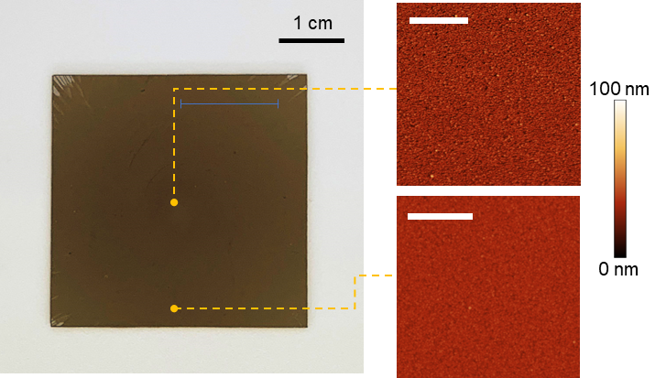
Figure S12. AFM characterization of surface roughness of the film shown in Fig. 3g. Scale bars in AFM images are 1 µm.

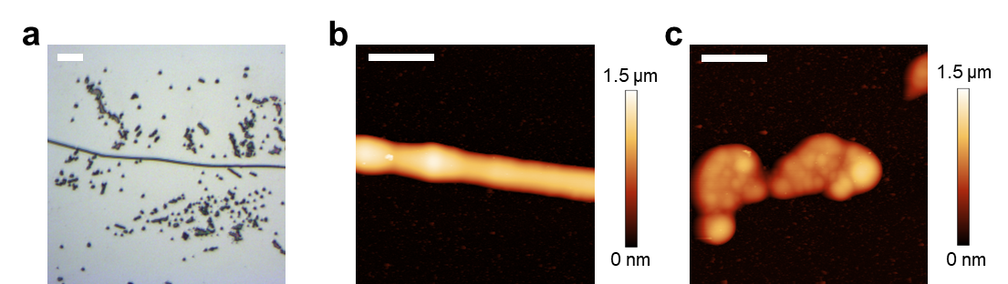
Fig. S13. (a) Optical micrograph of aZIF-Zn/dcIm on a non-functionalized Si wafer. (b) AFM image of aZIF-Zn/dcIm grown along a surface scratch. (c) AFM image of aZIF-Zn/dcIm showing a patchy growth. Scale bars are 20 µm in (a), and 5 µm in (b) and (c), respectively.

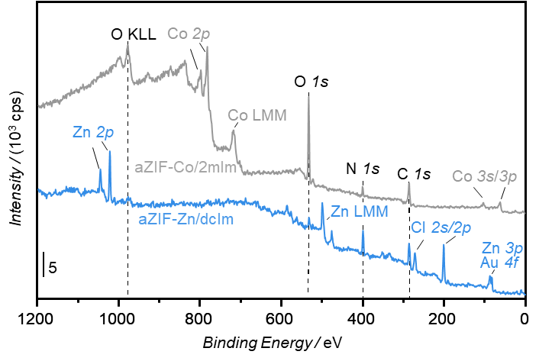
Fig. S14. XPS survey scan for aZIF-Co/2mIm and aZIF-Zn/dcIm films.

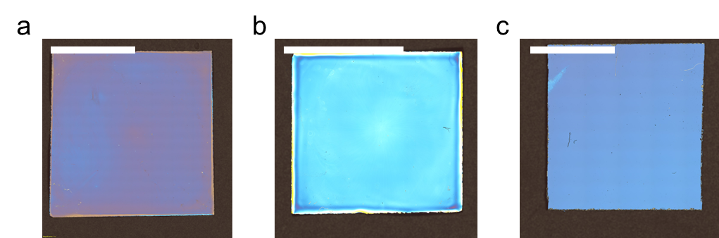
Fig. S15. Spin coating of aZIF-films. (a) aZIF-Zn/dcIm film by spin coating 1 mM Zn(CH₃CO₂)₂ and 8 mM dcIm at 7500 rpm for 2 min. (b) aZIF-Zn/BIm film by spin coating 2 mM Zn(CH₃CO₂)₂ and 4 mM BIm at 4000 rpm for 5 min. (c) aZIF-Co/2mIm film by spin coating 4 mM Co(NO₃)₂ and 128 mM 2mIm for 50 s. Precursor solutions are injected at a rate of 2 mL/min/syringe, i.e., the combined flow rate is 4 mL/min. Scale bars are 1 cm.

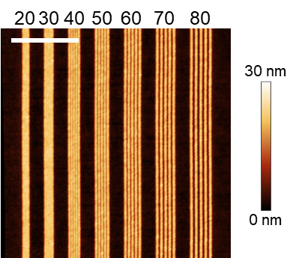
Fig. S16. AFM image of an aZIF-Zn/2mIm film patterned in negative tone with lines of different pitches in EBL. The pattern was prepared by EB irradiation at 30 kV with 80 mC/cm² dose and development using gas phase etching with hfacH. The nominal pitches are indicated in nm above the image, respectively. The nominal width of the lines is 10 nm and the scale bar is 1 µm.

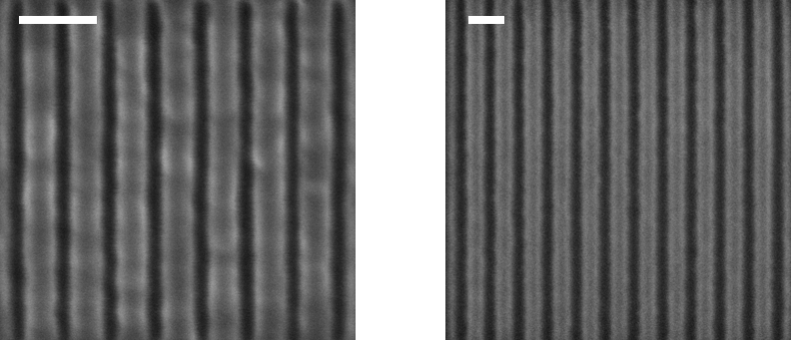
Fig. S17. SEM images of aZIF-Zn/dcIm films patterned in positive tone with (left) 60 and (right) 80 nm pitches in EBL. The patterns were prepared by EB irradiation at 20 kV with 500 µC/cm² dose and development using in DMSO for 1 min and acetone for 10 s. The nominal width of the lines is 20 nm and the scale bars are 100 nm.

