Supporting Information for
Coordinating Etching Inspired Synthesis of noble-metal-free monodisperse high-entropy oxides hollow nanocubes libraries
Lei et al.

Table of Contents
Supplementary Notes
Supplementary Note 1. Synthesis of Cu₂O nanocube.
Supplementary Note 2. Synthesis of precursor NiCoFeCdCr-OH.
Supplementary Note 3. Synthesis of precursor NiCoFeCdCrLaSnZn-OH.
Supplementary Note 4. Characterization.
Supplementary Note 5. Computational detail.
Supplementary Figures
Supplementary Figure 1 | XRD patterns of (a) NiCoFeCdCrLaSnZn-OH and (b) NiCoFeCdCrLaSnZnOH_{NaOH}.
Supplementary Figure 2 | Predicted models from DFT calculations for NiCoFe-O.
Supplementary Figure 3 | Predicted models from DFT calculations for NiCoFeCd-O.
Supplementary Figure 4 | Predicted models from DFT calculations for NiCoFeCr-O.
Supplementary Figure 5 | Predicted models from DFT calculations for NiCoFeCdCr-O.
Supplementary Figure 6 | Total and partial density of states for NiCoFeCd-O.
Supplementary Figure 7 | Total and partial density of states for NiCoFeCr-O.
Supplementary Figure 8 | The d-band center of different elements for NiCoFe-O, NiCoFeCd-O, NiCoFeCr-O, and NiCoFeCdCr-O.
Supplementary Figure 9 | Characterizations of Cu₂O.
Supplementary Figure 10 | Characterizations of Cu₂O.
Supplementary Figure 11 | Characterizations of NiCoFeCdCr-OH nanocube.
Supplementary Figure 12 | TEM images and element distribution of NiCoFeCdCr-OH nanocube.
Supplementary Figure 13 | TEM image and element distribution of NiCoFeCdCr-O_{2min} with the reaction time of NiCoFeCdCr-OH for 2 min.
Supplementary Figure 14 | (a) XRD pattern of NiCoFeCdCr-OH precursor under thermal treatment with different temperatures. (b) Schematic diagram of spinel oxide with single-phase forming driven by entropy-increasing.
Supplementary Figure 15 | Characterizations of NiCoFeCdCr-O.
Supplementary Figure 16 | XRD pattern of NiCoFeCdCr-O.
Supplementary Figure 17 | Characterizations of NiCoFeCdCr-O.
Supplementary Figure S18 | HAADF-STEM image and element mapping images of NiCoFe-O.
Supplementary Figure 19 | HAADF-STEM image and element mapping images of NiCoFeCd-O.
Supplementary Figure 20 | HAADF-STEM image and element mapping images of NiCoFeCr-O.
Supplementary Figure 21 | Characterizations of different components of oxides.
Supplementary Figure 22 | Characterizations of NiCoFe-O.
Supplementary Figure 23 | Characterizations of NiCoFeCd-O.
Supplementary Figure 24 | Characterizations of NiCoFeCr-O.
Supplementary Figure 25 | Characterizations of NiCoFeCdCrLa-O.
Supplementary Figure 26 | Characterizations of NiCoFeCdCrLaSn-O.
Supplementary Figure 27 | Characterizations of NiCoFeCdCrLaSnZn-O.
Supplementary Figure 28 | XRD pattern of NiCoFeCdCrLaSnZn-OH under thermal treatment with different temperatures to obtain the NiCoFeCdCrLaSnZn-O.
Supplementary Figure 29 | XPS survey spectrum of different components.
Supplementary Figure 30 | The XPS spectra at the Ni 2p (a) and O 1s (b).
Supplementary Figure 31 | XPS Characterizations of NiCoFeCdCr-O: Cr 2p.
Supplementary Figure 32 | XPS Characterizations of NiCoFeCdCr-O.
Supplementary Figure 33 | The high-resolution XPS spectra.
Supplementary Figure 34 | X-ray absorption fine structure analysis. XANES and FT-EXAFS spectra of Ni K-edge.
Supplementary Figure 35 | X-ray absorption fine structure analysis. XANES and FT-EXAFS spectra of Co K-edge.
Supplementary Figure 36 | X-ray absorption fine structure analysis. XANES and FT-EXAFS spectra of Fe K-edge.
Supplementary Figure 37 | X-ray absorption fine structure analysis. XANES and FT-EXAFS spectra of Cd K-edge.
Supplementary Figure 38 | X-ray absorption fine structure analysis. XANES and FT-EXAFS spectra of Cr K-edge.
Supplementary Figure 39 | X-ray absorption fine structure analysis. XANES and FT-EXAFS spectra of La L-edge.
Supplementary Figure 40 | X-ray absorption fine structure analysis. XANES and FT-EXAFS spectra of Sn K-edge.
Supplementary Figure 41 | X-ray absorption fine structure analysis. XANES and FT-EXAFS spectra of Zn K-edge.
Supplementary Figure 42 | Performance of different samples.
Supplementary Figure 43 | Performance of samples with different concentrations of 4-NP.
Supplementary Figure 44 | Performance of samples with different homologs of 2-NP and 3-NP.
Supplementary Figure 45 | Performance of samples with different conditions.
Supplementary Tables
Supplementary Table 1. The content result of the metal element from ICP-OES tests.
Supplementary Table 2. Comparison of rate constants (k) and ratio constant (K) for catalytic reduction of p-nitrophenol over NiCoFeCdCr-O with previously reported noble metal nanocatalysts.
Supplementary Table 3. Comparison of rate constants (k) of 4-NP over NiCoFeCdCr-O with previously reported high-entropy nanocatalysts at different temperatures
Supplementary References

Supplementary Notes
Supplementary Note 1. Synthesis of Cu₂O nanocube. 0.75 g CuSO₄·5H₂O and 0.3 g sodium citrate were dissolved in 200 mL ultra-pure water. Then, 2 g NaOH was added into the above solution under stirring for 0.5 h, and 100 mL of 0.03 M ascorbic acid was dropped into the above solution. After being stirred for 0.5 h, the Cu₂O nanocube were centrifugally separated and dried in a vacuum oven at 60°C.
Supplementary Note 2. Synthesis of precursor NiCoFeCdCr-OH. 40 mg of the as-prepared Cu₂O nanocube were dispersed into the mixture solution of 40 mL ultra-pure water and 40 mL ethanol. Afterward, 666.6 mg PVP-K30, 4.8 mg NiCl₂·6H₂O, 4.8 mg CoCl₂·6H₂O, 5.6 mg FeSO₄·7H₂O, 4.6 mg CdCl₂·2.5H₂O, and 8 mg Cr(NO₃)₃·9H₂O were dissolved in the above solution under stirring for 15 min. Finally, 32 mL of 1.0 M Na₂S₂O₃ was added dropwise slowly into the solution system. After being stirred for 0.5 h, the NiCoFeCdCr-OH were centrifugally separated and dried by vacuum freezing. The NiCoFe-OH, NiCoFeCd-OH, and NiCoFeCr-OH were prepared with the same method just without CdCl₂·2.5H₂O or Cr(NO₃)₃·9H₂O.
Supplementary Note 3. Synthesis of precursor NiCoFeCdCrLaSnZn-OH. 40 mg of the as-prepared Cu₂O nanocube were dispersed into the mixture solution of 40 mL ultra-pure water and 40 mL ethanol. Afterward, 666.6 mg PVP-K30, 3.6 mg NiCl₂·6H₂O, 3.6 mg CoCl₂·6H₂O, 4.2 mg FeSO₄·7H₂O, 3.4 mg CdCl₂·2.5H₂O, 6.0 mg Cr(NO₃)₃·9H₂O, 4.9 mg La(NO₃)₃·nH₂O, 3.4 mg SnCl₂·2H₂O and 4.3 mg ZnSO₄·7H₂O were dissolved in the above solution under stirring for 15 min. Finally, 32 mL of 1.0 M Na₂S₂O₃ was added dropwise into the solution system. After being stirred for 0.5 h, the NiCoFeCdCrLaSnZn-OH were centrifugally separated and dried by vacuum freezing. The NiCoFeCdCrLa-OH and NiCoFeCdCrLaSn-OH were prepared with the same method just without SnCl₂·2H₂O and ZnSO₄·7H₂O. The NiCoFeCdCrLaSnZnOH_{NaOH} were synthesized by the same synthetic route with Na₂S₂O₃ replaced by NaOH and without Cu₂O and PVP.
Supplementary Note 4. Characterization. X-ray diffraction (XRD) patterns were tested from Bruker D8 Advance (scan range of 10-80°). Scan electron microscopy (SEM) images were carried out on a JEOL TSM-7500F field emission scanning electron microscope. The transmission electron microscopy (TEM), High Angle Annular Dark Field-Scanning Transmission Electron Microscopy (‌HADDF-STEM), and corresponding elemental mappings images were obtained from the FEI Talos F200S emission scanning electron microscope. X-ray photoelectron spectroscopy (XPS) tests were obtained from Escalab 250Xi electron spectrometer with Mg Kα radiation. Metal element content images were obtained from inductively coupled plasma-optical emission spectrometer (ICP-OES). The high-resolution transmission electron microscopy (HRTEM) imaging was acquired on a JEOL JEM-ARM200CF microscope operated at 200kV with a Schottky cold-field emission gun at Wuhan University. Ultraviolet-visible Spectrophotometer (UV-Vis) spectroscopy measurements were carried out using a Shimadzu 3600 Plus. X-ray Absorption Fine Structure (XAFS) spectra were acquired under ambient conditions in transmission mode at beamline BL14W1 of the Shanghai Synchrotron Radiation Facility.
Supplementary Note 5. Computational detail. All the calculations are performed in the framework of the density functional theory with the projector augmented plane-wave method, as implemented in the Vienna ab initio simulation package. The generalzied gradient approximation proposed by Perdew, Burke, and Ernzerhof is selected for the exchange-correlation potential. The cut-off energy for plane wave is set to 400 eV. The energy criterion is set to 10⁻⁵ eV in iterative solution of the Kohn-Sham equation. A vacuum layer of 15 Å is added perpendicular to the sheet to avoid artificial interaction between periodic images. The Brillouin zone integration is performed using a 5×3×1 k-mesh. All the structures are relaxed until the residual forces on the atoms have declined to less than 0.03 eV/Å.

Supplementary Figures 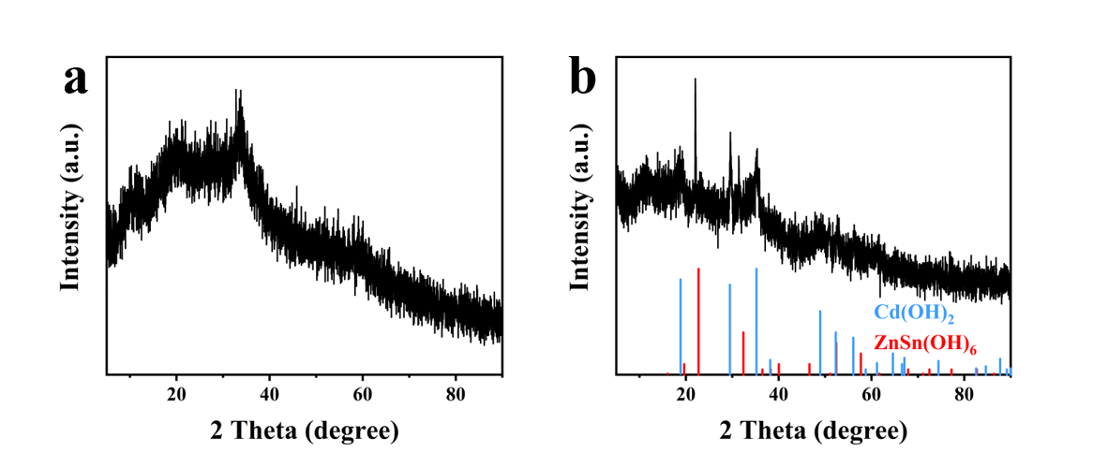
Supplementary Fig. 1 | XRD patterns of (a) NiCoFeCdCrLaSnZn-OH and (b) NiCoFeCdCrLaSnZnOH_{NaOH}.

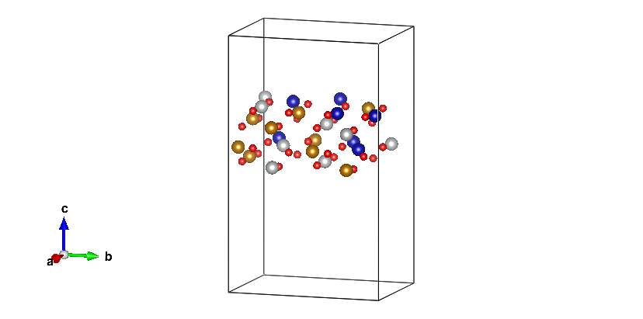
Supplementary Fig. 2 | Predicted models from DFT calculations for NiCoFe-O. The red balls represent oxygen, and the coordination bond with grey, blue, and yellow represent Ni, Co, and Fe, respectively.
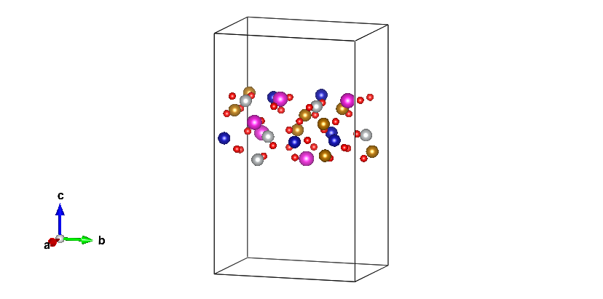
Supplementary Fig. 3 | Predicted models from DFT calculations for NiCoFeCd-O. The red balls represent oxygen, and the coordination bond with grey, blue, yellow, and pink represents Ni, Co, Fe, and Cd, respectively.
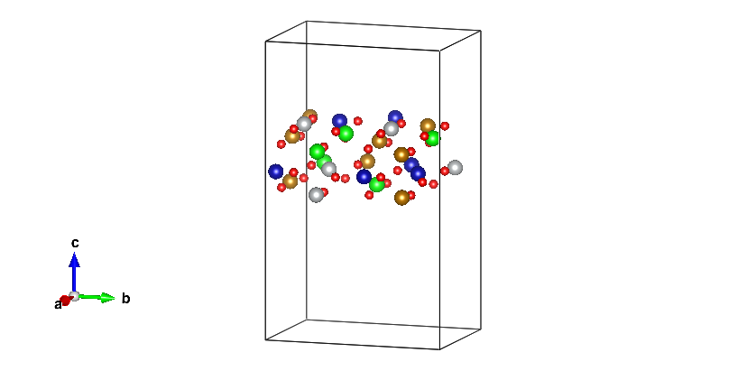
Supplementary Fig. 4 | Predicted models from DFT calculations for NiCoFeCr-O. The red balls represent oxygen, and the coordination bond with grey, blue, and green represent Ni, Co, Fe, and Cr, respectively.

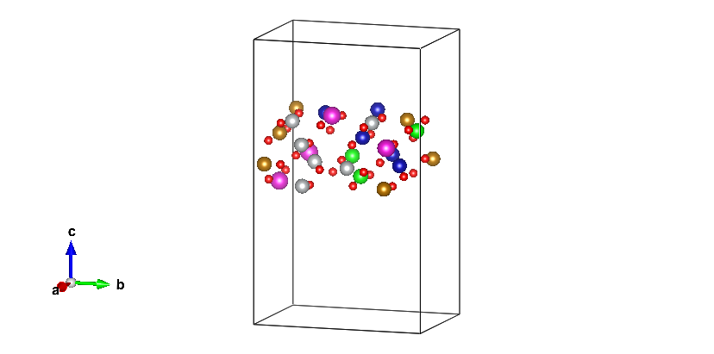
Supplementary Fig. 5 | Predicted models from DFT calculations for NiCoFeCdCr-O. The red balls represent oxygen, and the coordination bond with grey, blue, yellow, pink, and green represents Ni, Co, Fe, Cd, and Cr, respectively.
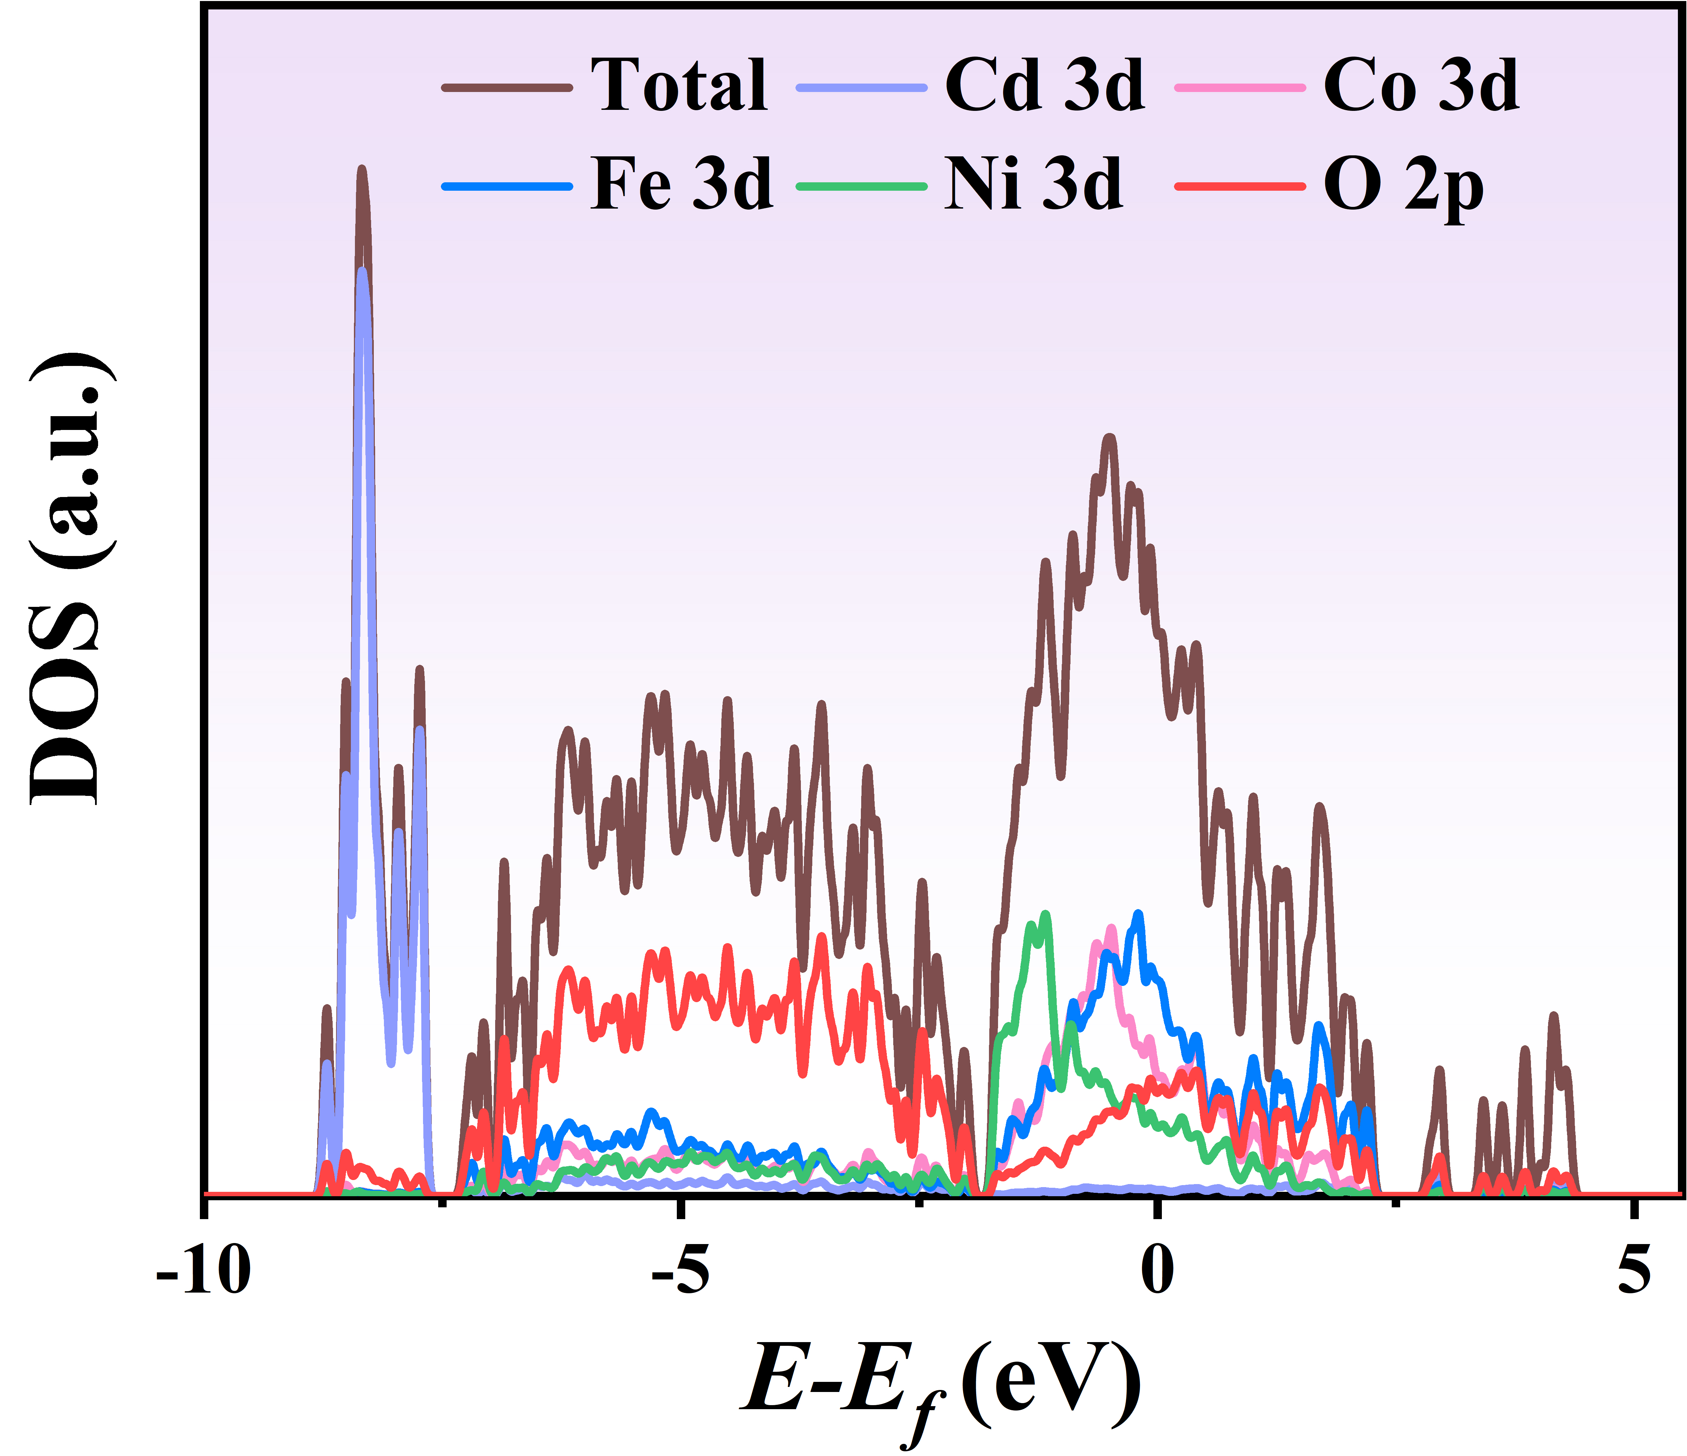
Supplementary Fig. 6 | Total and partial density of states for NiCoFeCd-O.

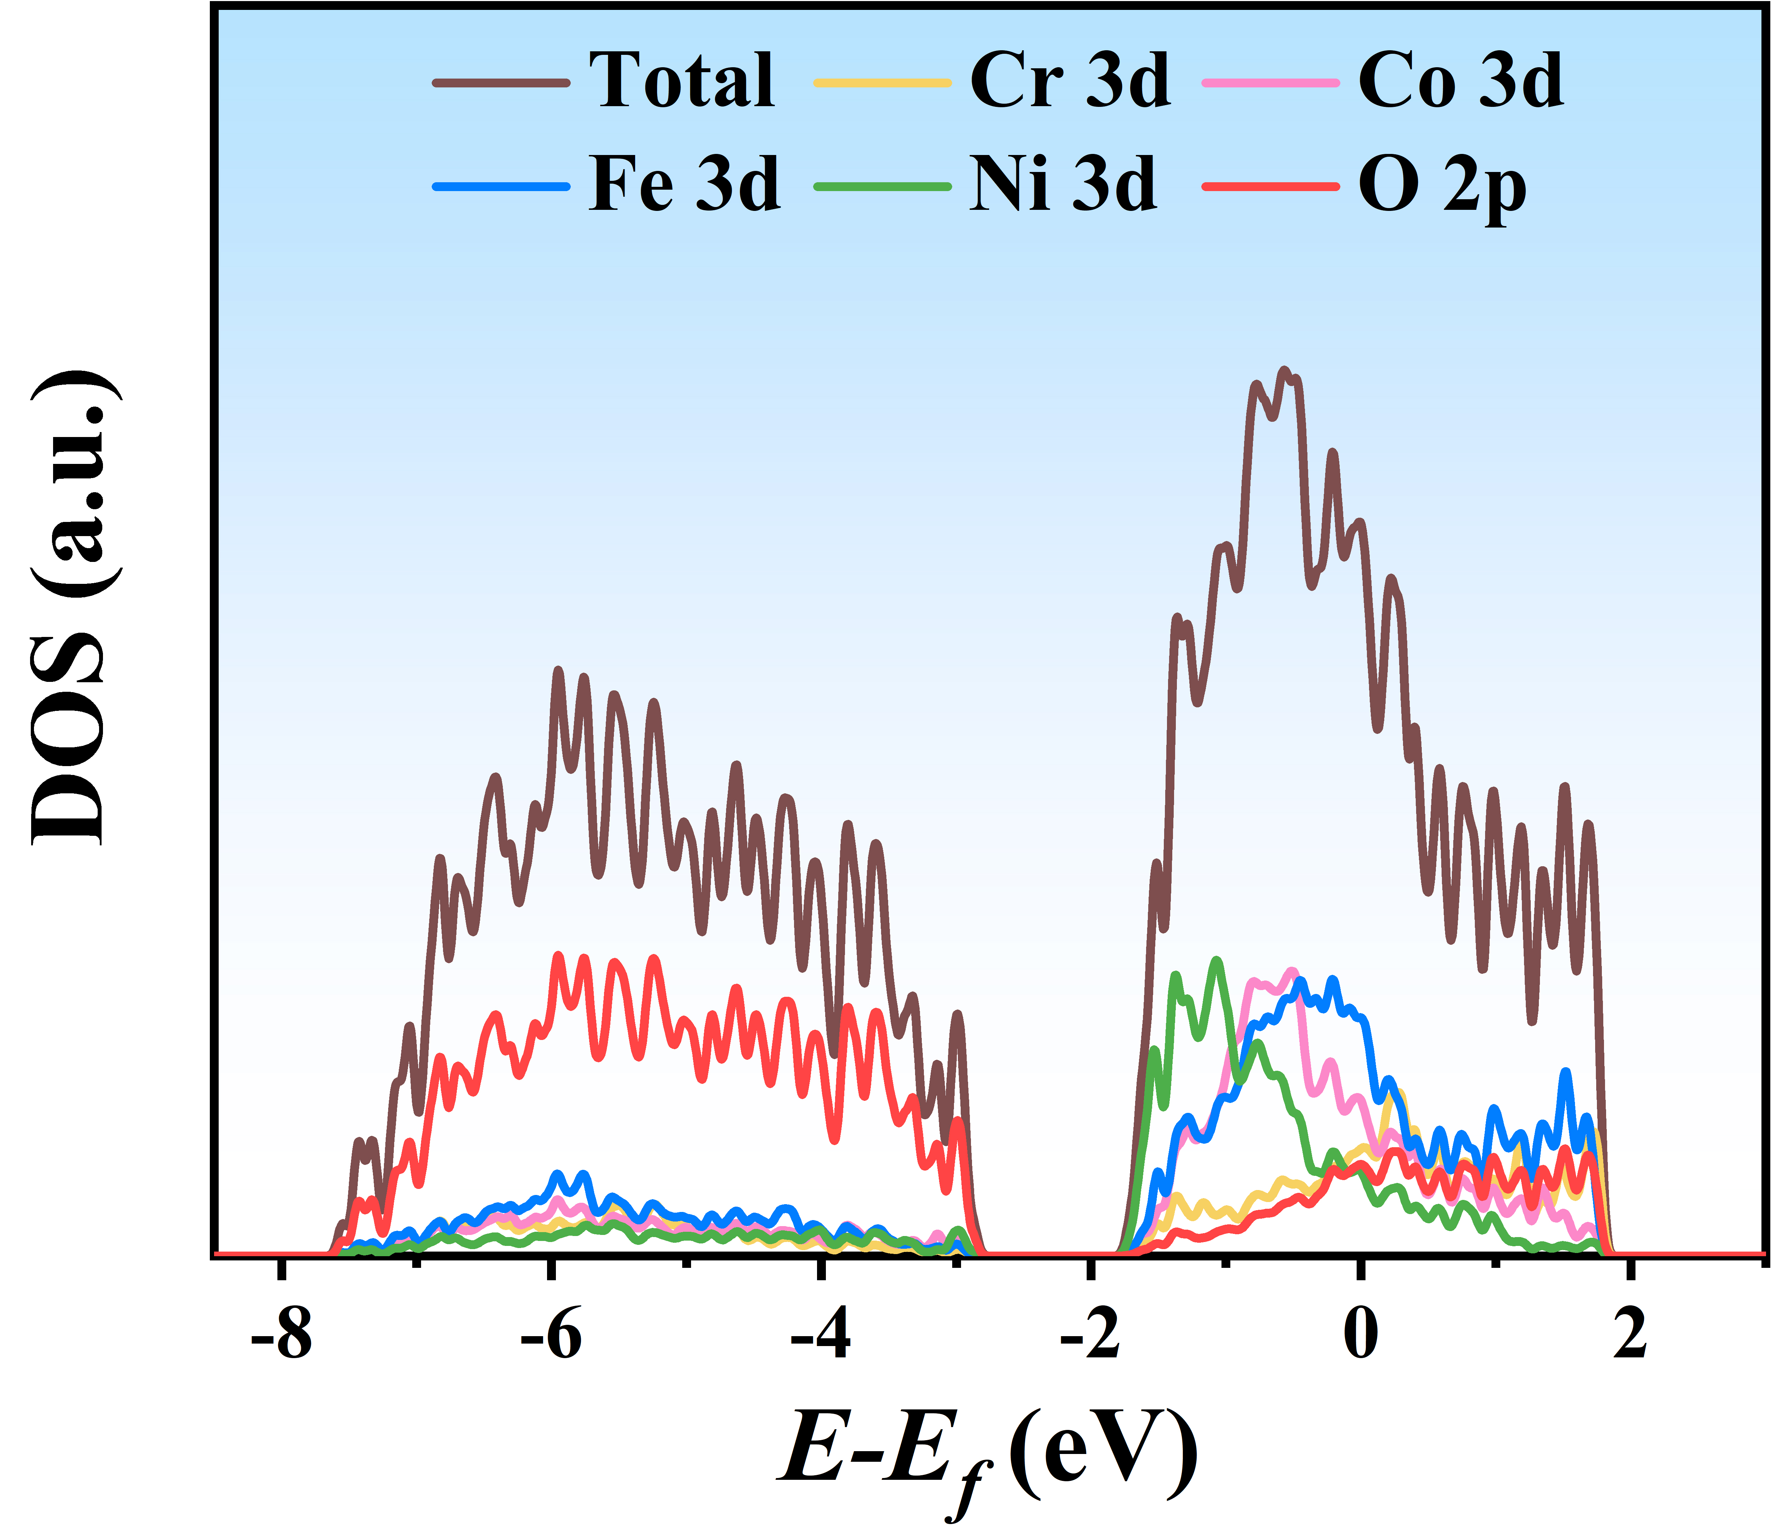
Supplementary Fig. 7 | Total and partial density of states for NiCoFeCr-O.

Supplementary Fig. 8 | The d-band center of different elements for NiCoFe-O, NiCoFeCd-O, NiCoFeCr-O, and NiCoFeCdCr-O.

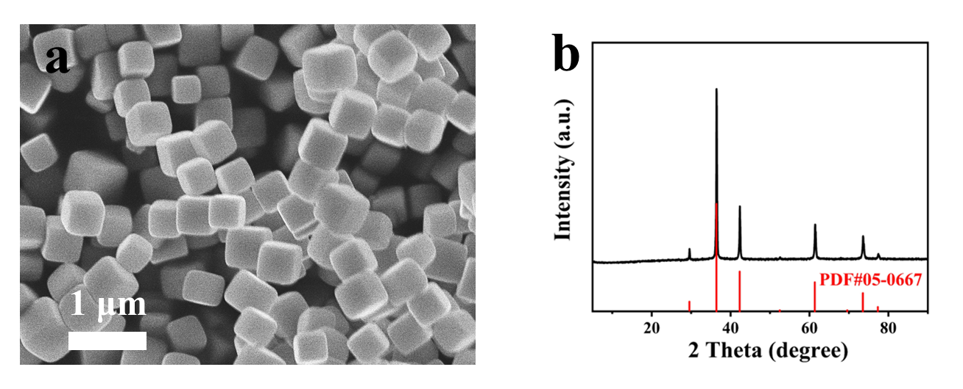
Supplementary Fig. 9 | Characterizations of Cu₂O. (a) SEM images and (b) XRD patterns.

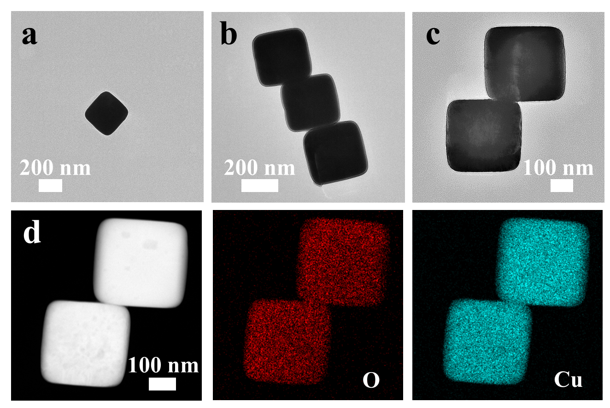
Supplementary Fig. 10 | Characterizations of Cu₂O. (a-c) TEM images and (d) element mapping of nanocube Cu₂O.

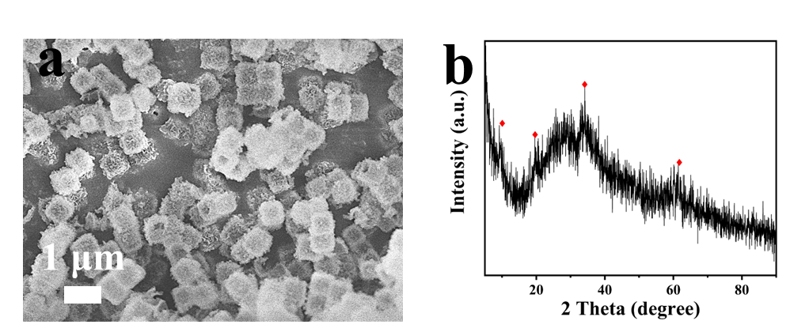
Supplementary Fig. 11 | Characterizations of NiCoFeCdCr-OH nanocube. (a) SEM images and (b) XRD patterns.

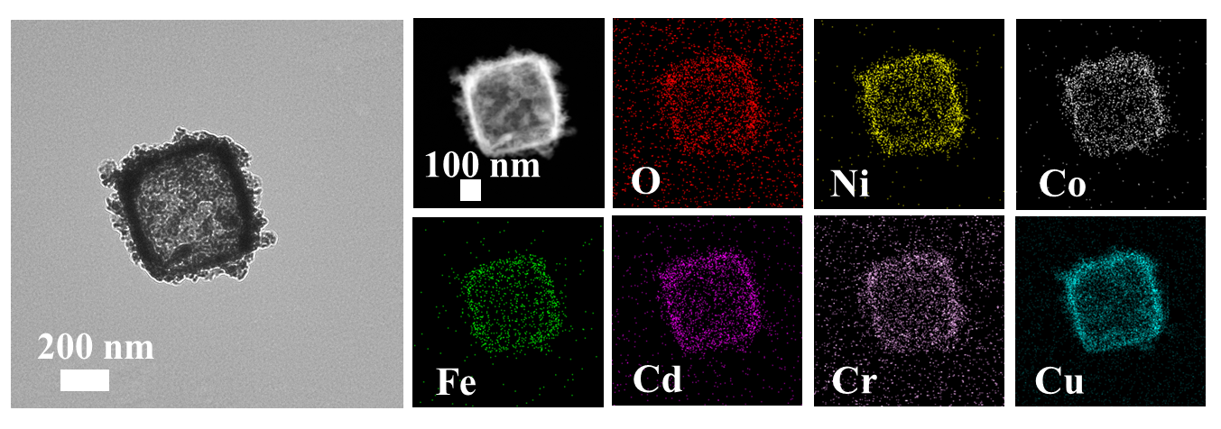
Supplementary Fig. 12 | TEM images and element distribution of NiCoFeCdCr-OH nanocube.

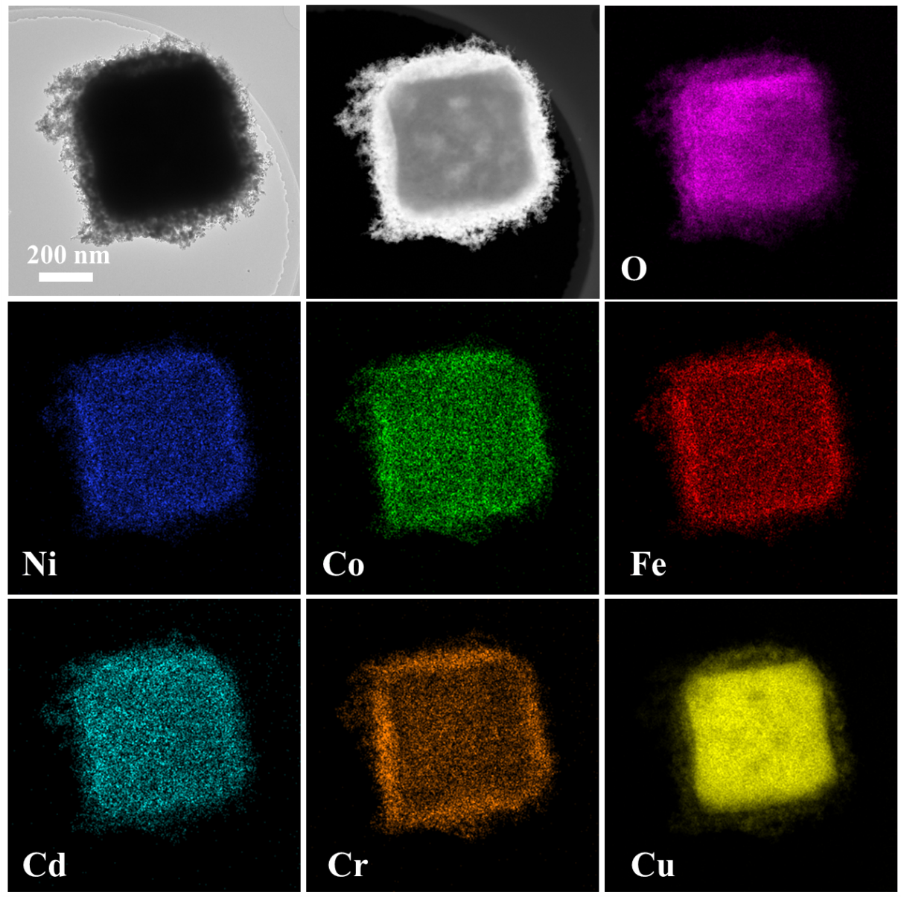
Supplementary Fig. 13 | TEM image and element distribution of NiCoFeCdCr-O_{2min} with the reaction time of NiCoFeCdCr-OH for 2 min.

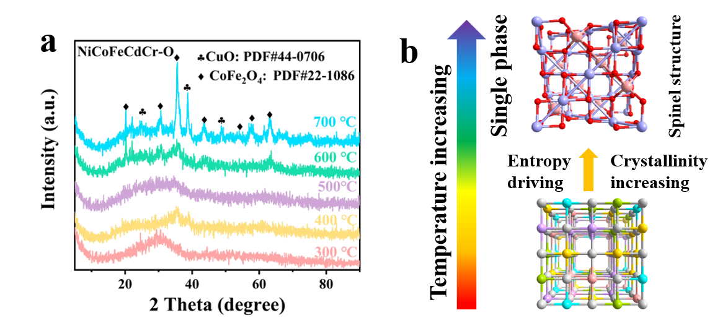
Supplementary Fig. 14 | (a) XRD pattern of NiCoFeCdCr-OH precursor under thermal treatment with different temperatures. (b) Schematic diagram of spinel oxide with single-phase forming driven by entropy-increasing.

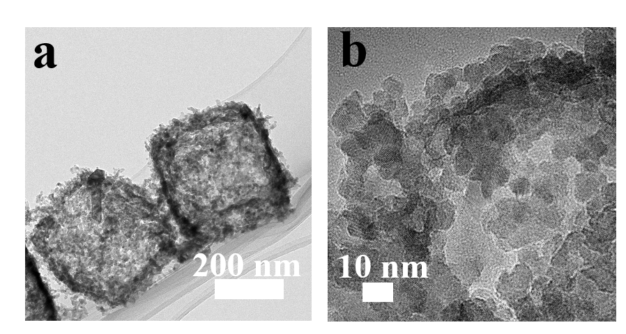
Supplementary Fig. 15 | Characterizations of NiCoFeCdCr-O. TEM images of NiCoFeCdCr-O nanocube with polycrystalline structure.
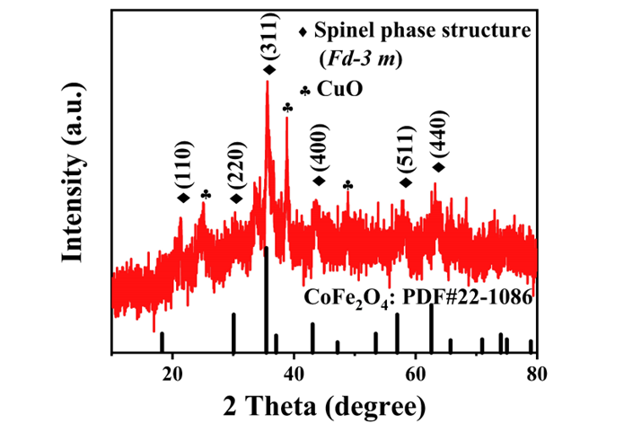
Supplementary Fig. 16 | XRD pattern of NiCoFeCdCr-O.

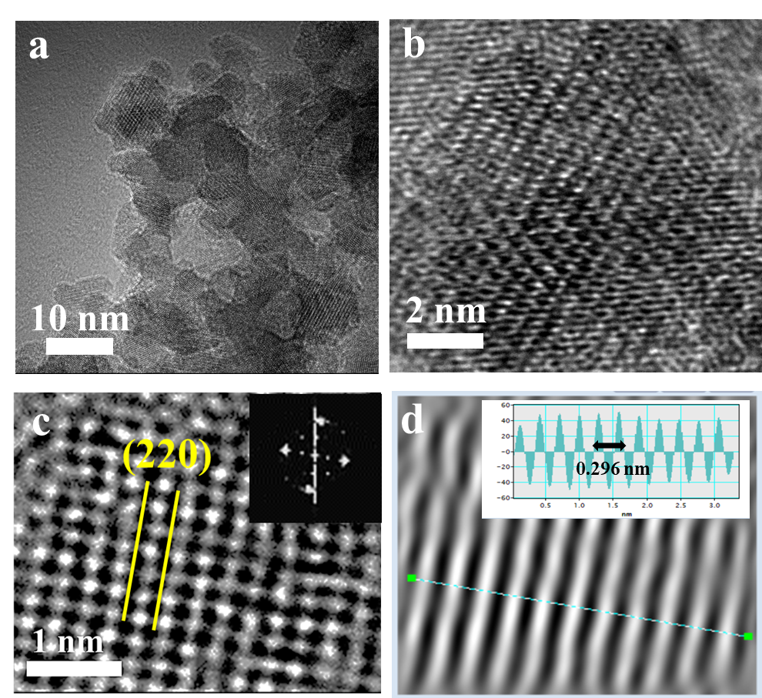
Supplementary Fig. 17 | Characterizations of NiCoFeCdCr-O. (a, b) TEM and (c) enlarge TEM image (insert pattern: FFT image), (d) IFFT patterns and lattice spacing profiles from (b).

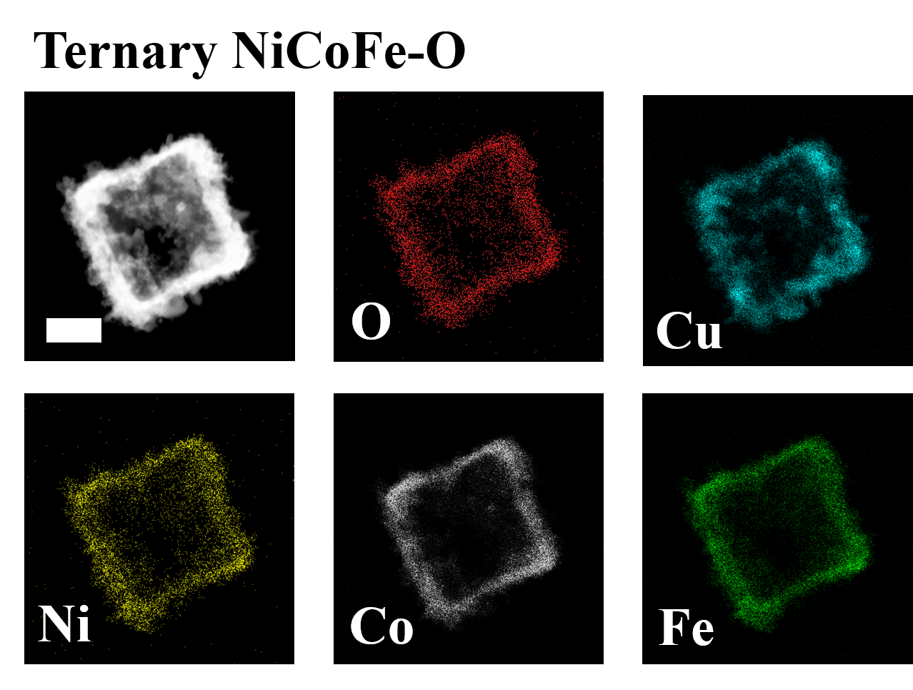
Supplementary Fig. 18 | HAADF-STEM image and element mapping images of NiCoFe-O.

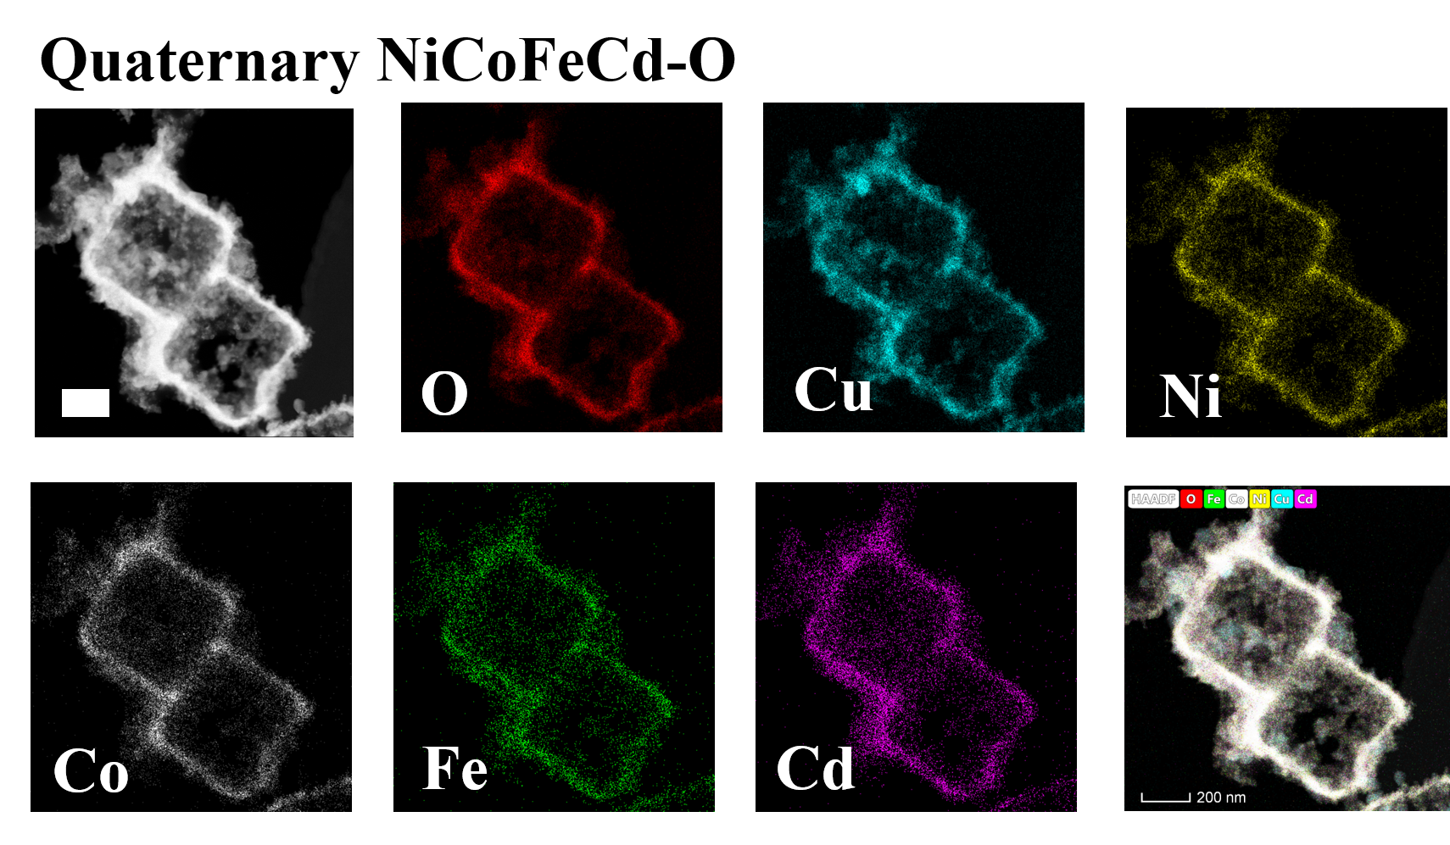
Supplementary Fig. 19 | HAADF-STEM image and element mapping images of NiCoFeCd-O.
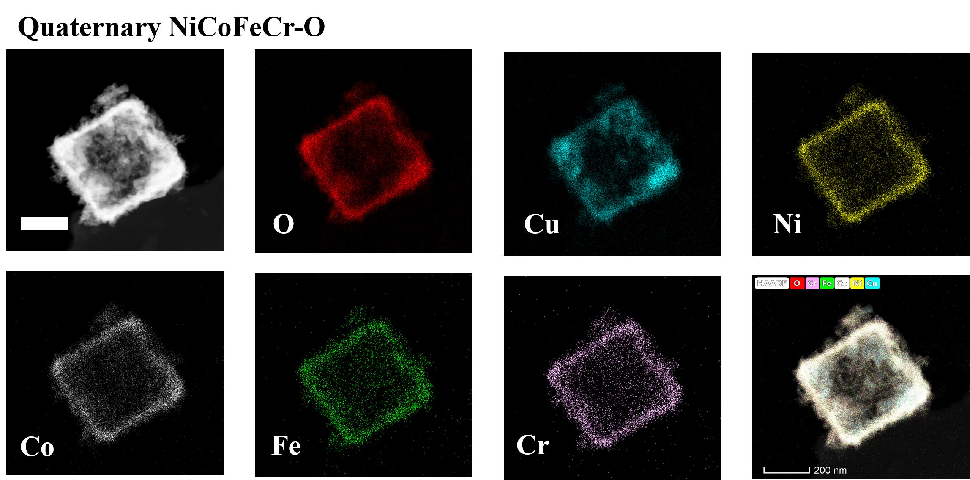
Supplementary Fig. 20 | HAADF-STEM image and element mapping images of NiCoFeCr-O.

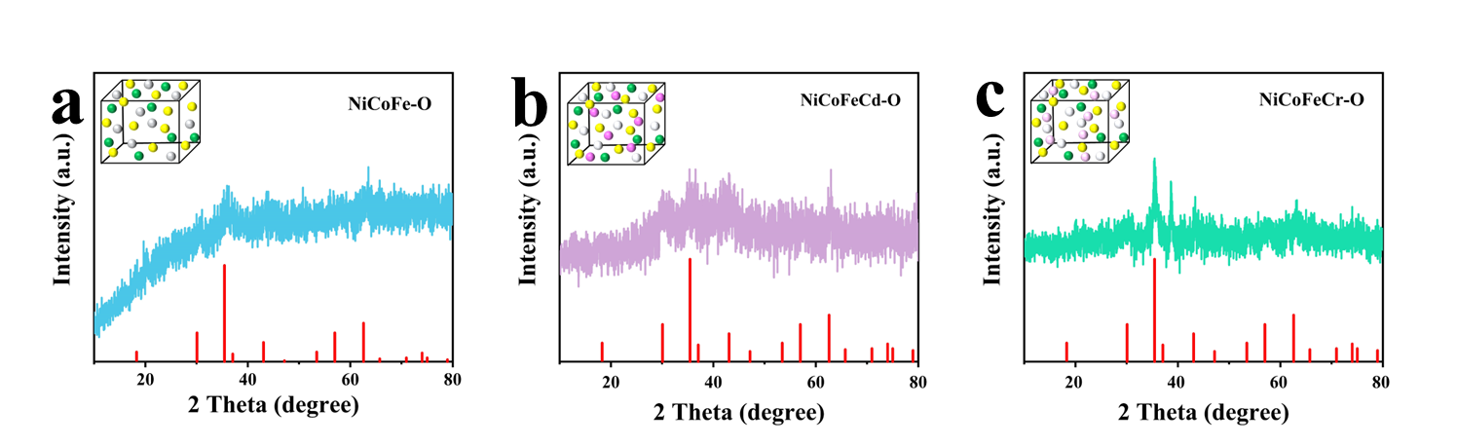
Supplementary Fig. 21 | Characterizations of different components of oxides. XRD patterns (indexed to CoFe₂O₄ (powder diffraction file PDF#22-1086)) of (a) NiCoFe-O, (b) NiCoFeCd-O, (c) NiCoFeCr-O.

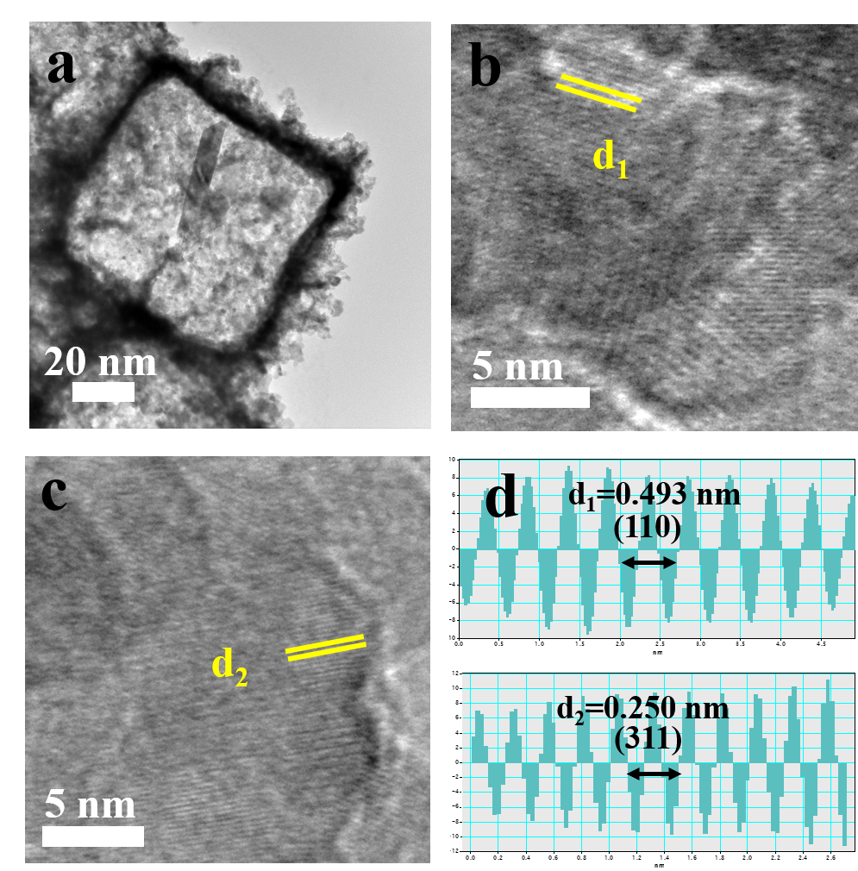
Supplementary Fig. 22 | Characterizations of NiCoFe-O. (a) TEM and (b-c) enlarged TEM image, (d) IFFT patterns and lattice spacing profiles from (b and c).

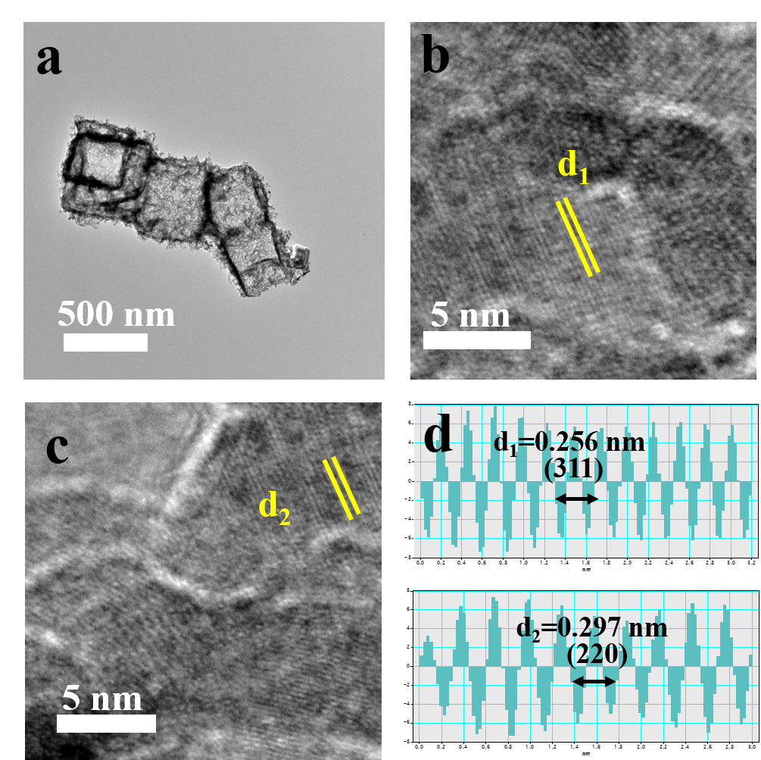
Supplementary Fig. 23 | Characterizations of NiCoFeCd-O. (a) TEM and (b-c) enlarge TEM image, (d) IFFT patterns and lattice spacing profiles from (b and c).

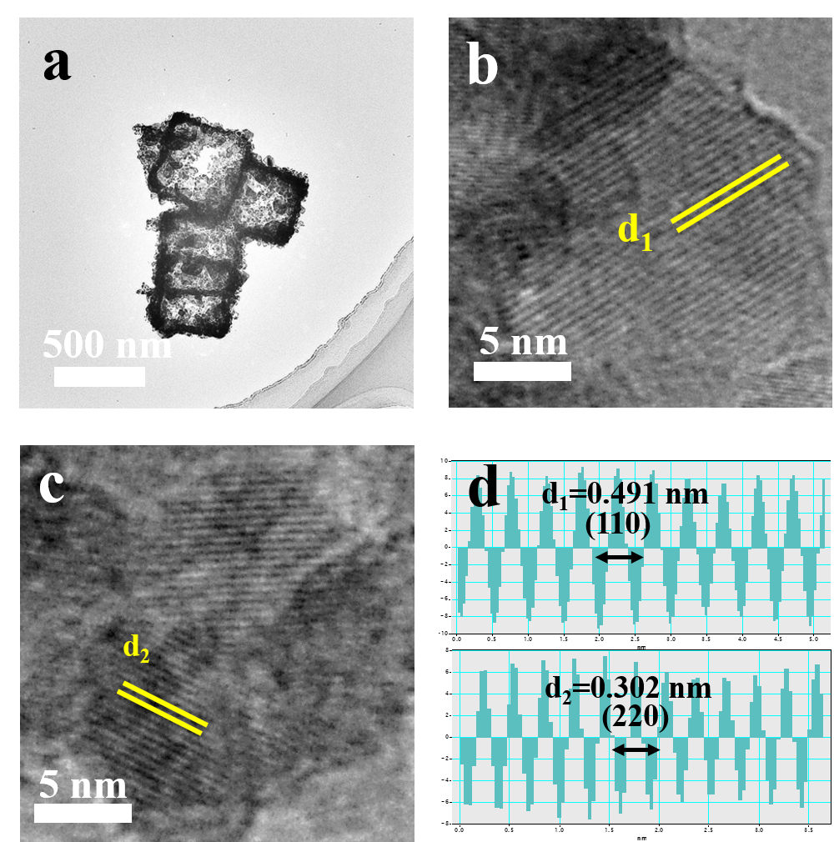
Supplementary Fig. 24 | Characterizations of NiCoFeCr-O. (a) TEM and (b-c) enlarged TEM image, (d) IFFT patterns and lattice spacing profiles from (b and c).

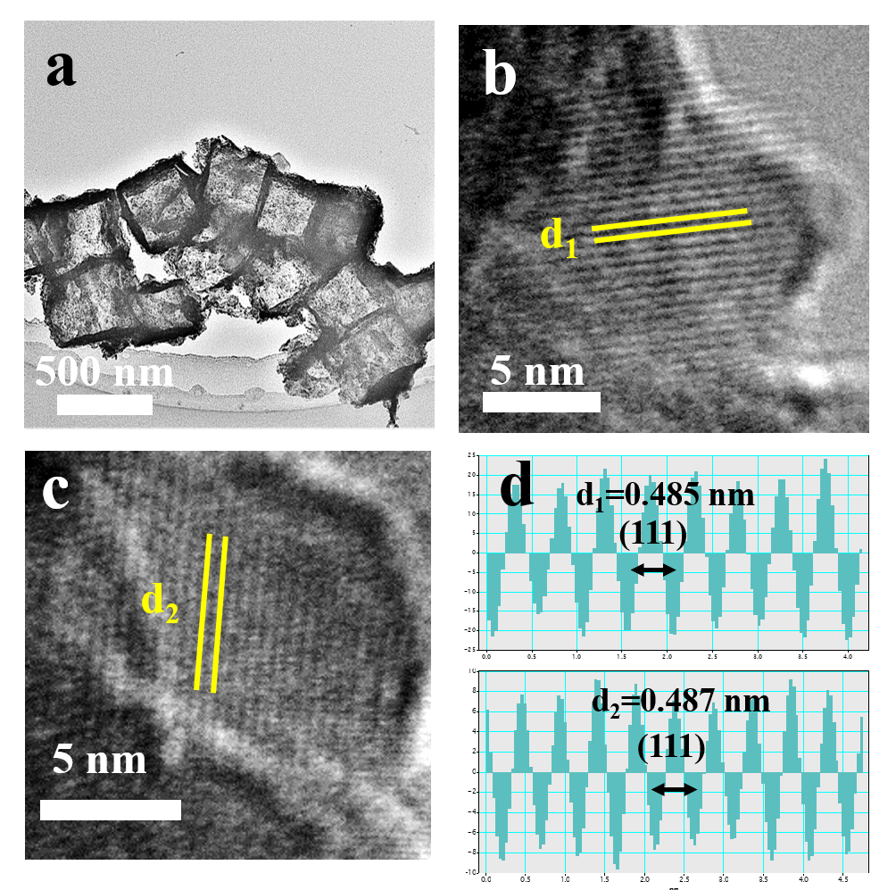
Supplementary Fig. 25 | Characterizations of NiCoFeCdCrLa-O. (a) TEM and (b-c) enlarge TEM image, (d) IFFT patterns and lattice spacing profiles from (b and c).

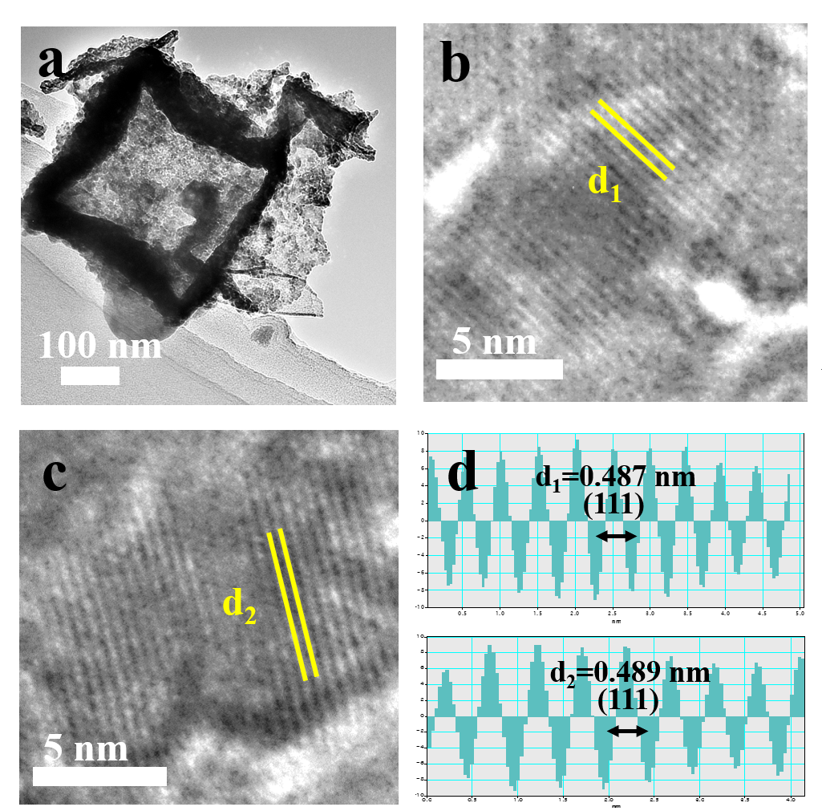
Supplementary Fig. 26 | Characterizations of NiCoFeCdCrLaSn-O. (a) TEM and (b-c) enlarge TEM image, (d) IFFT patterns and lattice spacing profiles from (b and c).

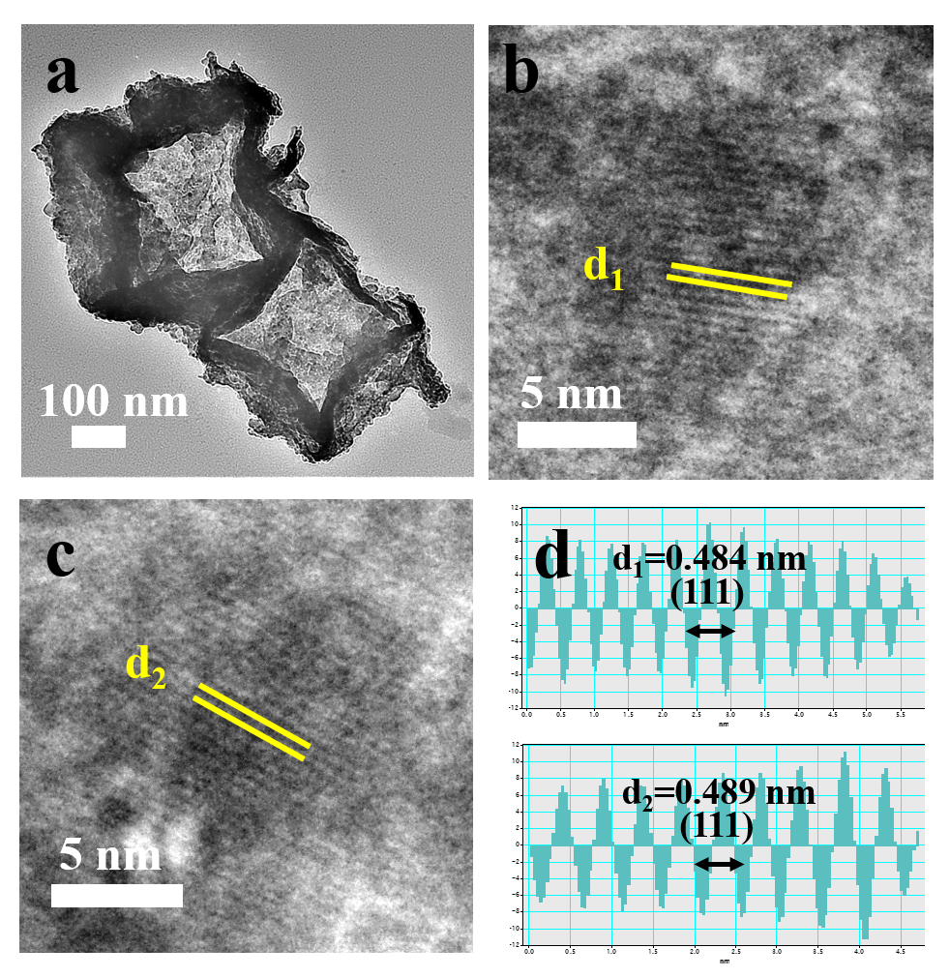
Supplementary Fig. 27 | Characterizations of NiCoFeCdCrLaSnZn-O. (a) TEM and (b-c) enlarge TEM image, (d) IFFT patterns and lattice spacing profiles from (b and c).
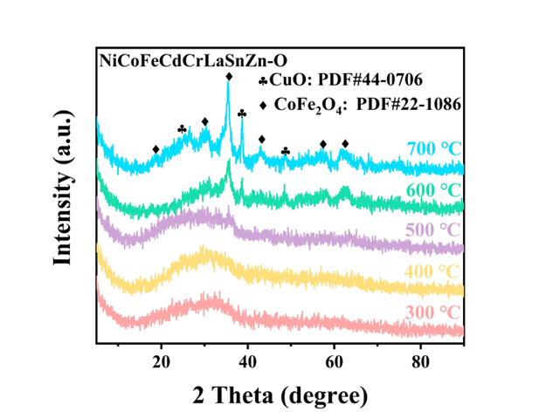
Supplementary Fig. 28 | XRD pattern of NiCoFeCdCrLaSnZn-OH under thermal treatment with different temperatures to obtain the NiCoFeCdCrLaSnZn-O.

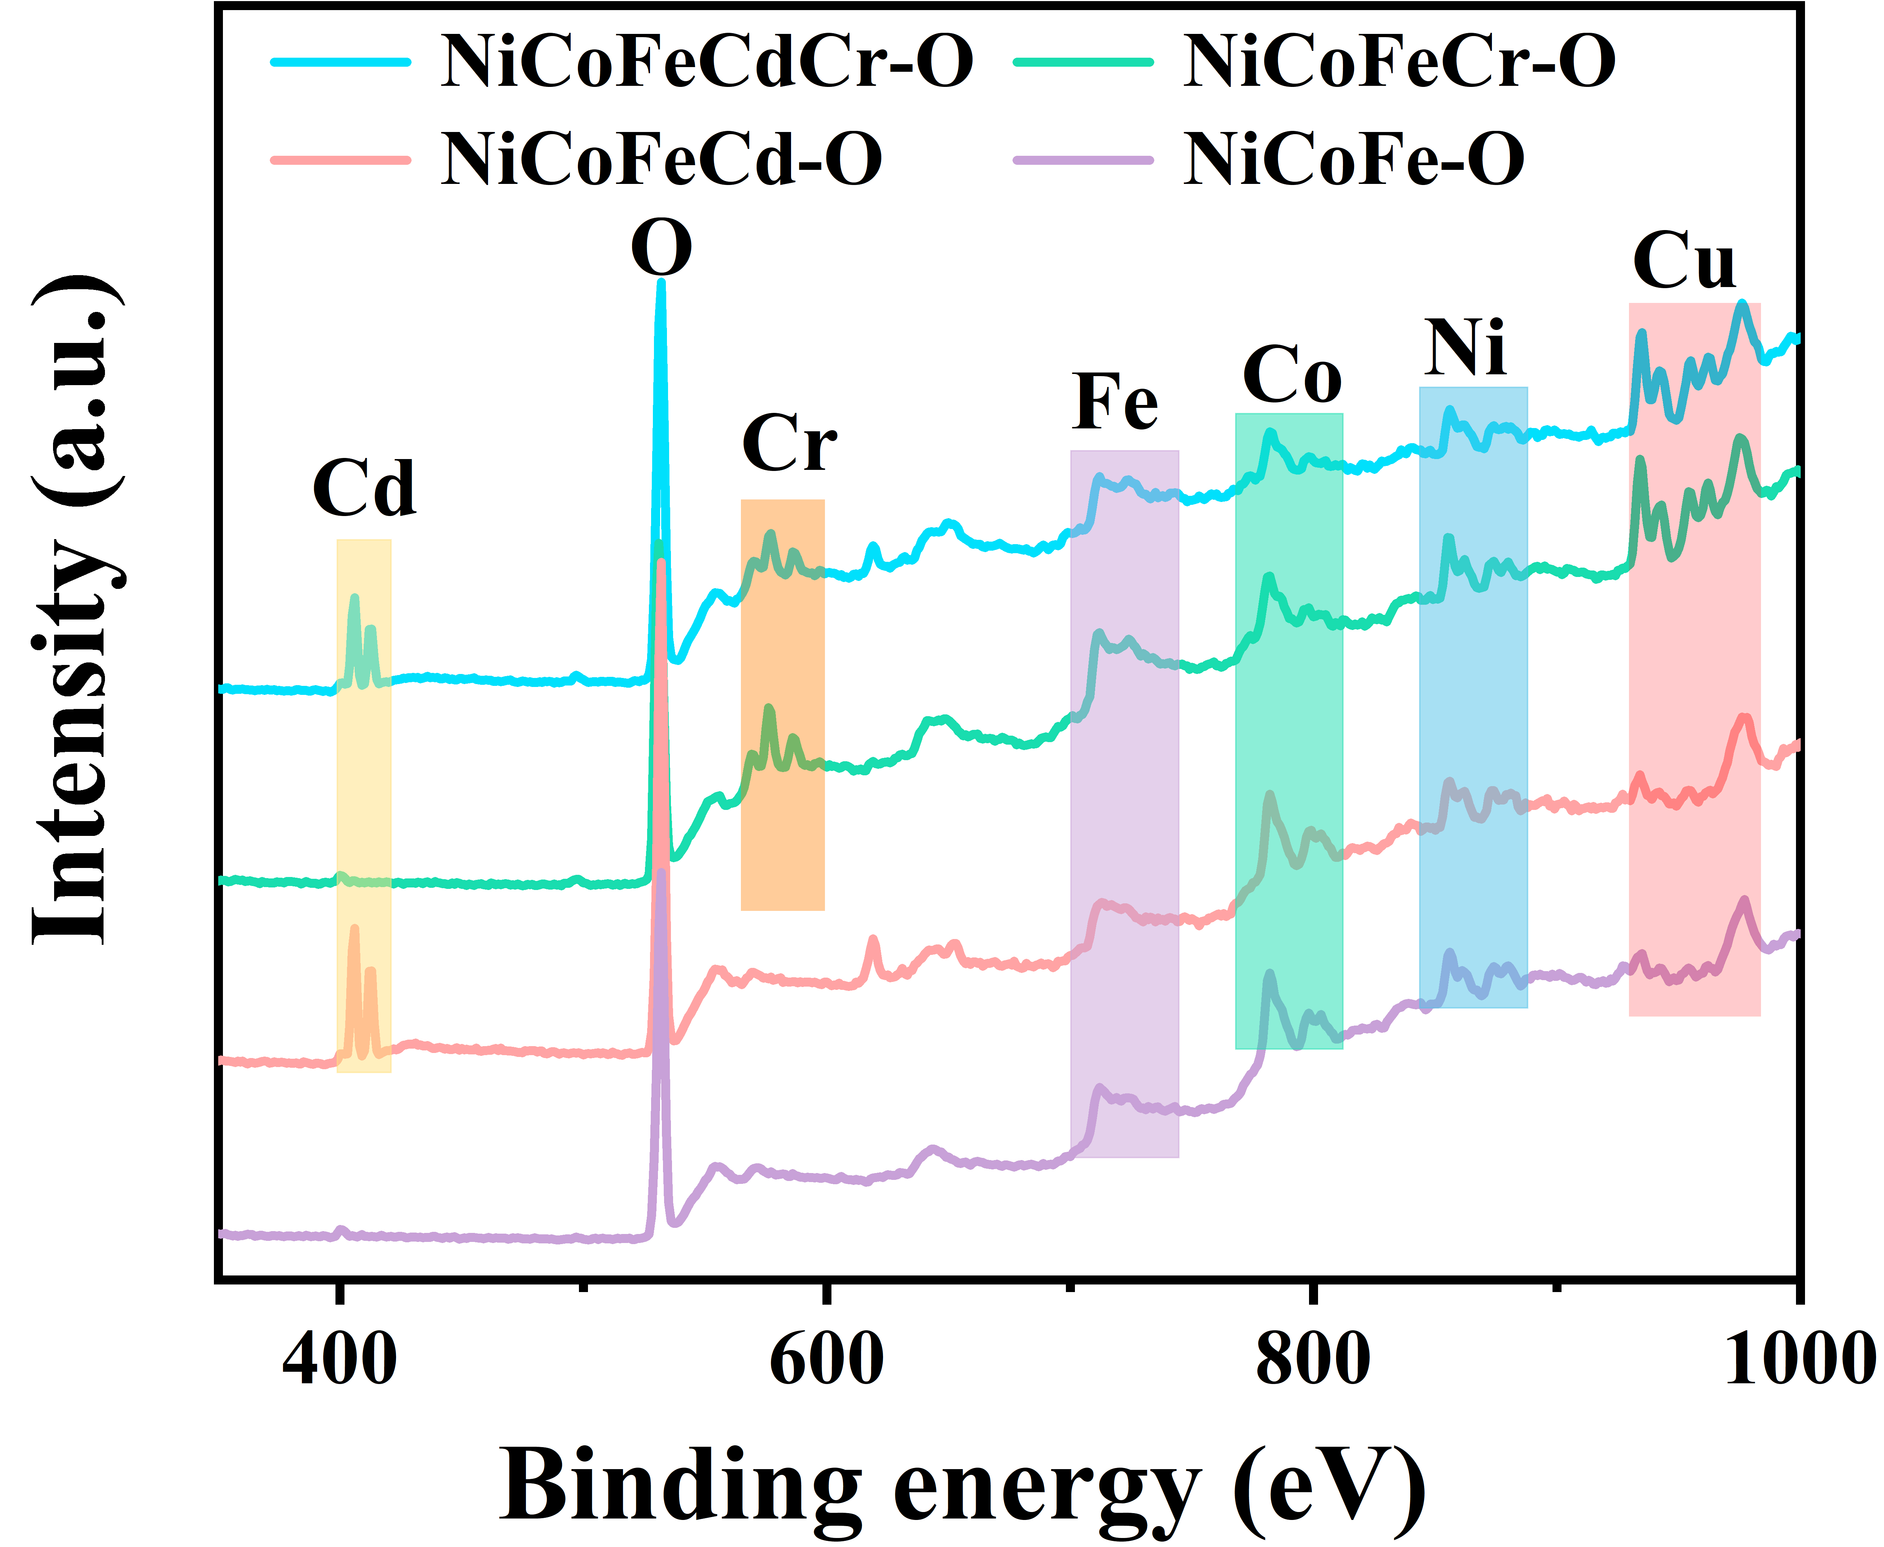
Supplementary Fig. 29 | XPS survey spectrum of different components. In Supplementary Fig. 29, the XPS survey spectrum confirms the coexistence of Cu, Co, Ni, Fe, Cd, Cr, and O elements in NiCoFeCdCr-O.

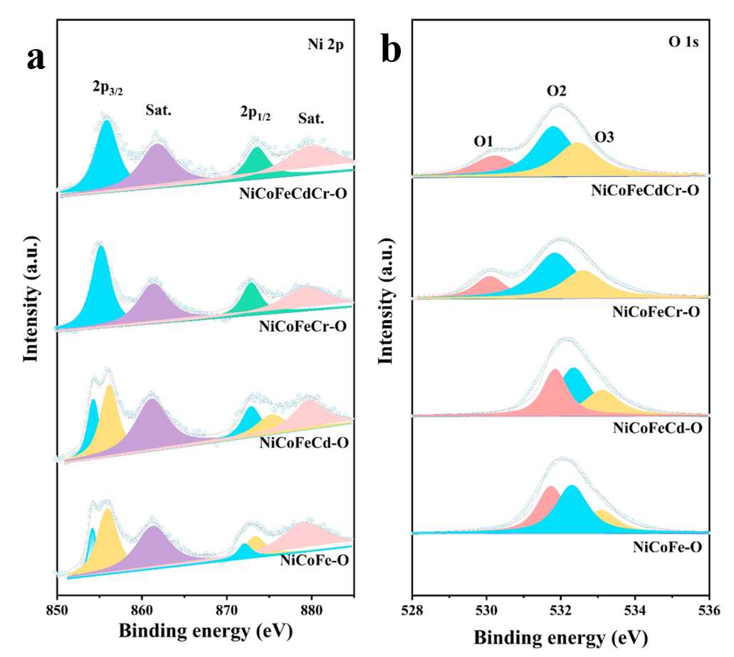
Supplementary Fig. 30 | The XPS spectra at the Ni 2p (a) and O 1s (b). In Supplementary Fig. 30a, Ni 2p spectra show a binding energy Δ~18 eV between two spin-orbit peaks Ni 2p_{1/2} and Ni 2p_{3/2}, and the peak located at 855.9 and 873.6 eV indicates the existence of Ni²⁺ from Ni-O.^{1, 2} The peak of O 1s is deconvoluted into four peaks at 530.2, 531.8, and 532.5 eV for M-O(O1), O-Vacancy(O2), and M-OH(O3), respectively (Supplementary Fig. 30b).³

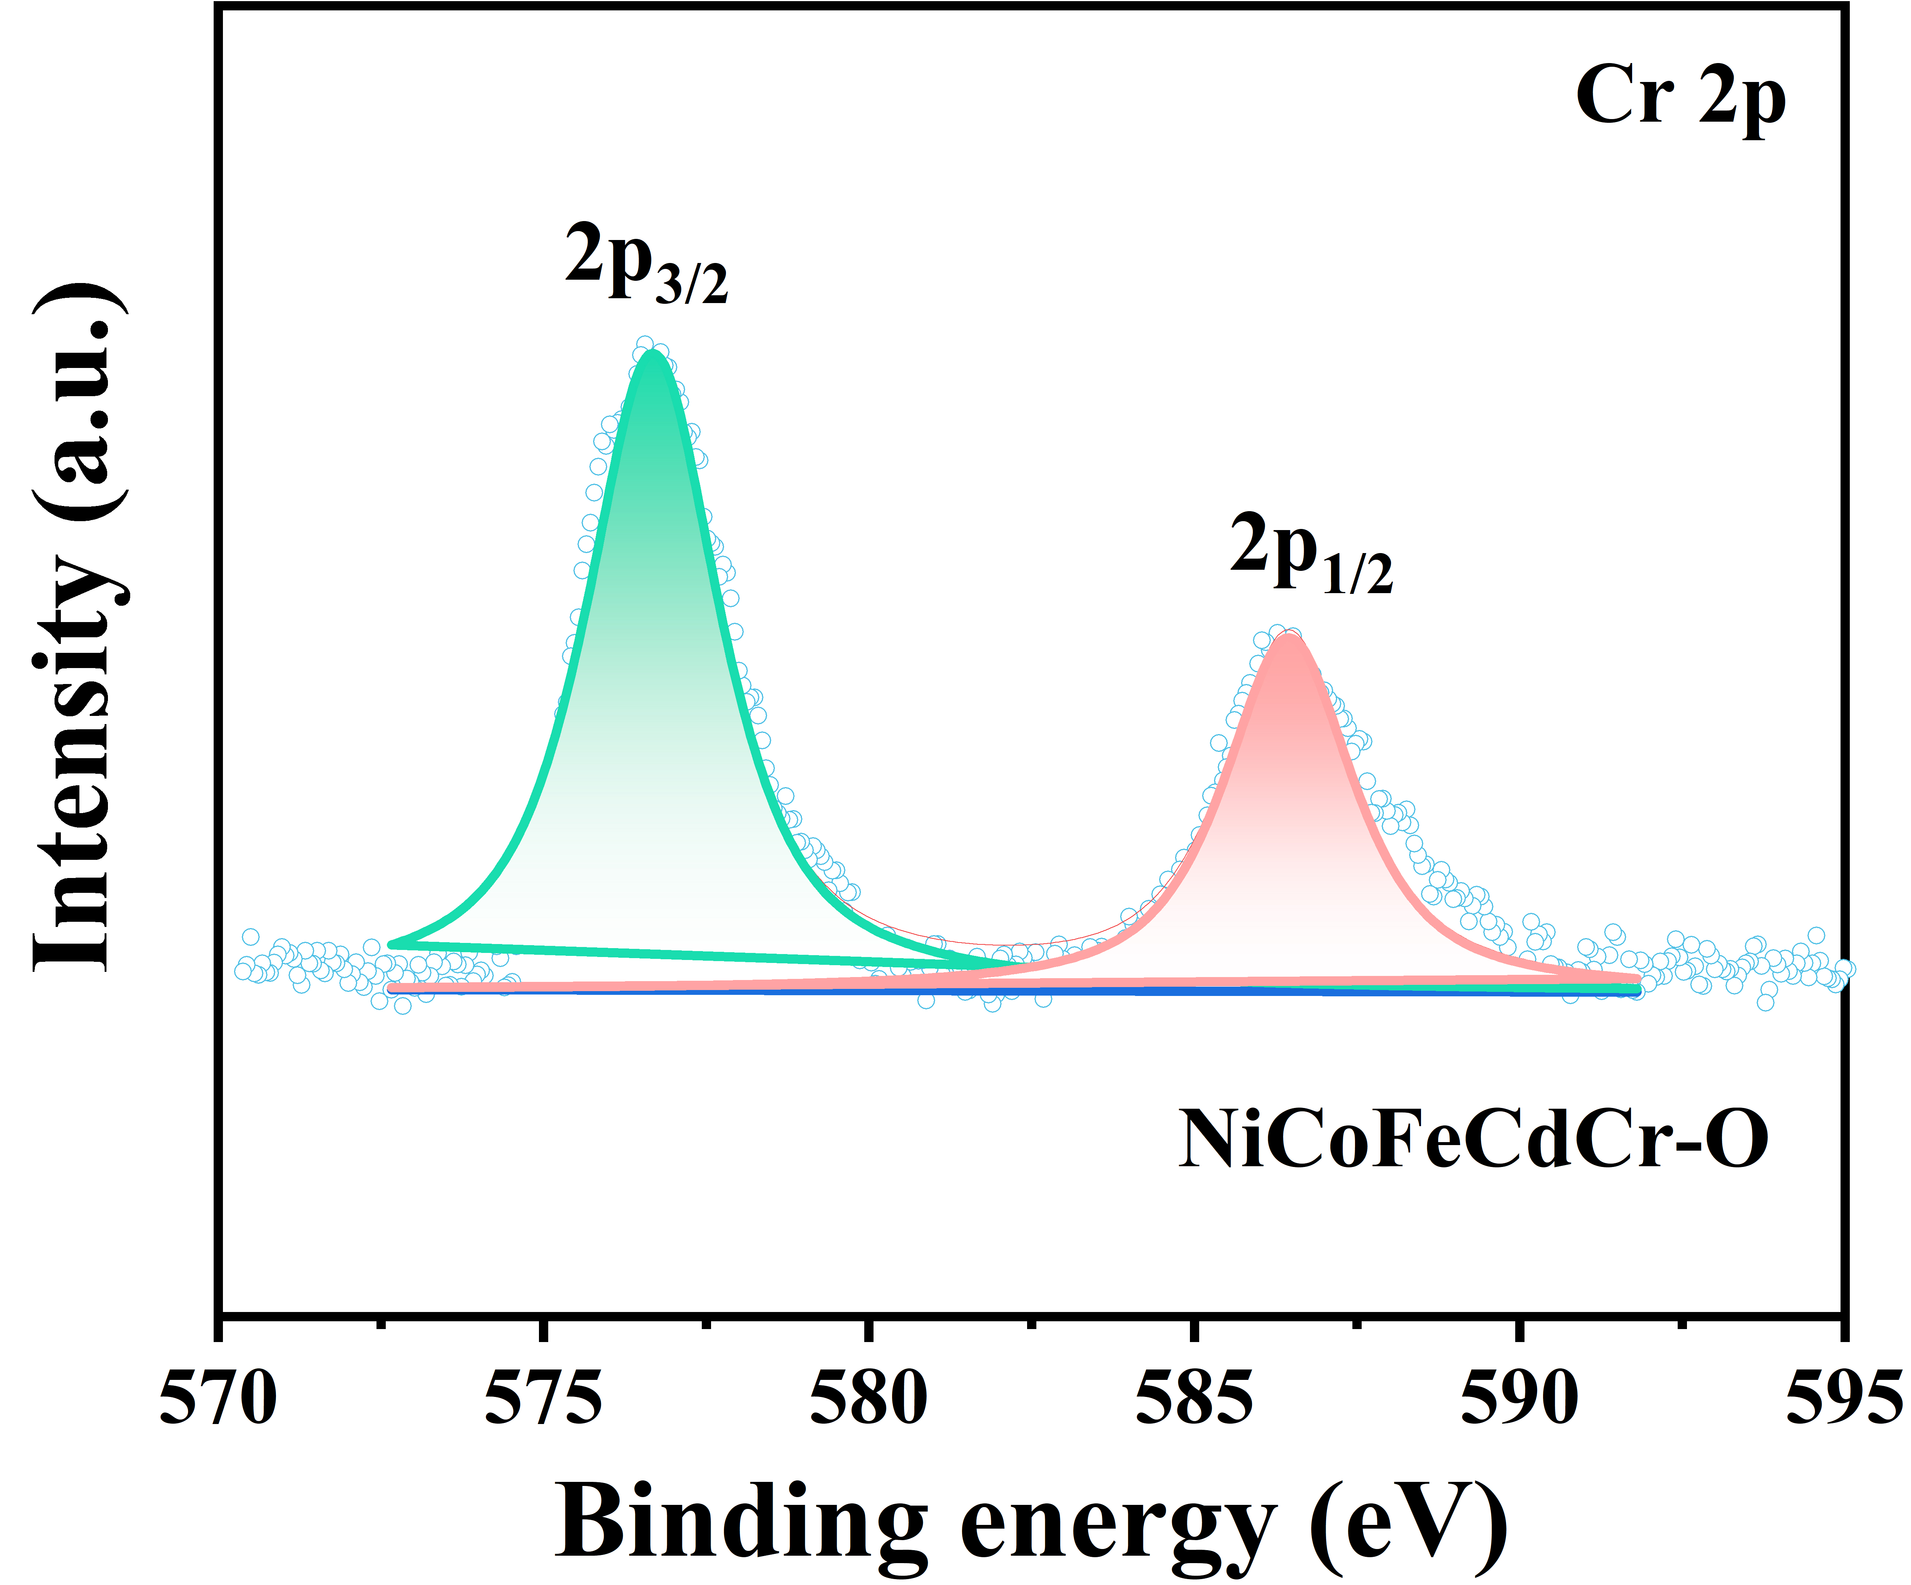
Supplementary Fig. 31 | XPS Characterizations of NiCoFeCdCr-O: Cr 2p. The Cr 2p spectrum in Supplementary Fig. 31 shows two main peaks, which are from Cr³⁺ 2p_{3/2} (∼576.6 eV) and 2p_{1/2} (∼586.5 eV).

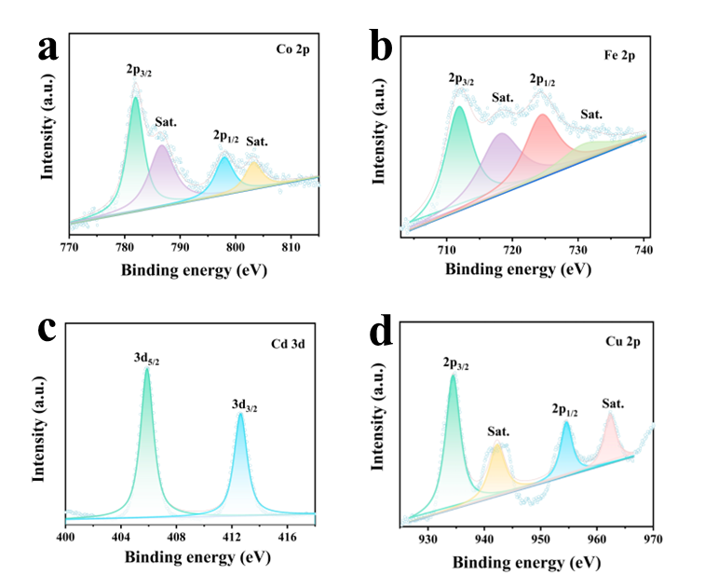
Supplementary Fig. 32 | XPS Characterizations of NiCoFeCdCr-O. The high-resolution XPS spectra of NiCoFeCdCr-O: (a) Co 2p, (b) Fe 2p, (c) Cd 3d, (d) Cu 2p. In the Co 2p spectrum (Supplementary Fig. 32a), the peaks at 781.9 eV and 798.3 eV can be ascribed to Co²⁺ 2p_{3/2} and 2p_{1/2}, respectively.⁴ The Fe 2p peaks at 724.6 and 711.9 eV confirm Fe species exists in the form of Fe³⁺ (Supplementary Fig. 32b).⁵ In the Cd 3d spectrum of NiCoFeCdCr-O, the 3d_{5/2} at 405.9 eV and 3d_{3/2} at 412.7 eV, which are characteristics of Cd in the valance state of +2 (Supplementary Fig. 32c). In Fig. S32d, the doublets of Cu 2p spectra located at 934.46 and 954.59 eV are attributed to the 2p_{3/2} and 2p_{1/2} of Cu²⁺ for the CuO phase.⁶

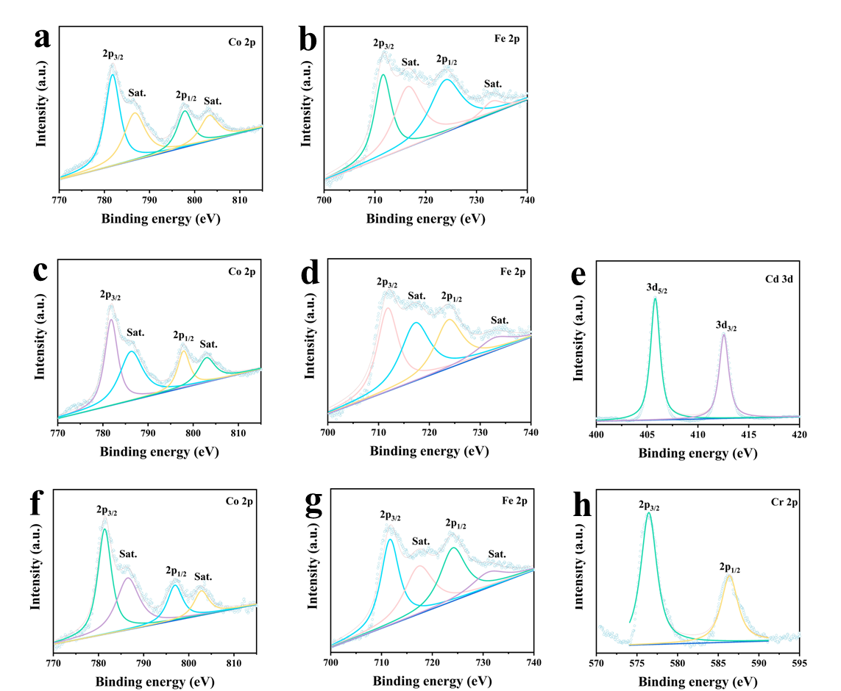
Supplementary Fig. 33 | The high-resolution XPS spectra. (a) Co 2p, (b) Fe 2p of NiCoFe-O; (c) Co 2p, (d) Fe 2p and (e) Cd 3d of NiCoFeCd-O; (f) Co 2p, (g) Fe 2p and (h) Cr 2p of NiCoFeCr-O. Supplementary Fig. 33 illustrated that the valence state of the metal element in ternary and quaternary oxides is same with that of NiCoFeCdCr-O, revealing the similar structure of the sample synthesized by this strategy.

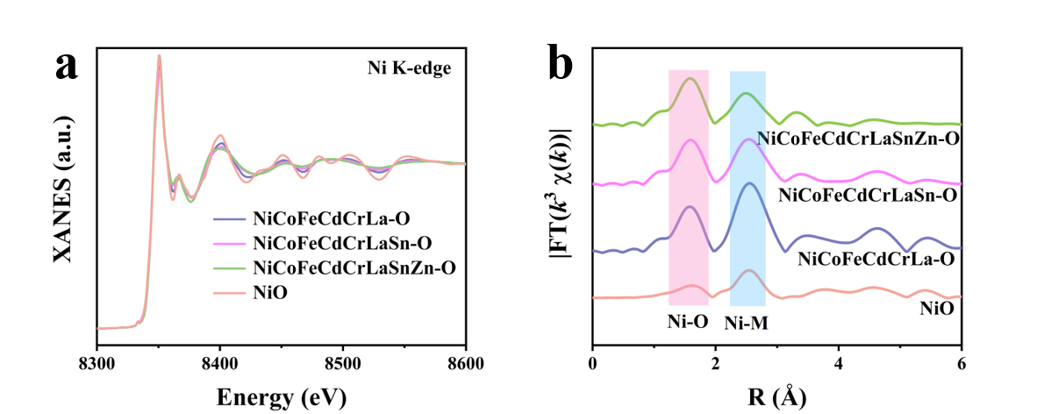
Supplementary Fig. 34 | X-ray absorption fine structure analysis. XANES and FT-EXAFS spectra of Ni K-edge.

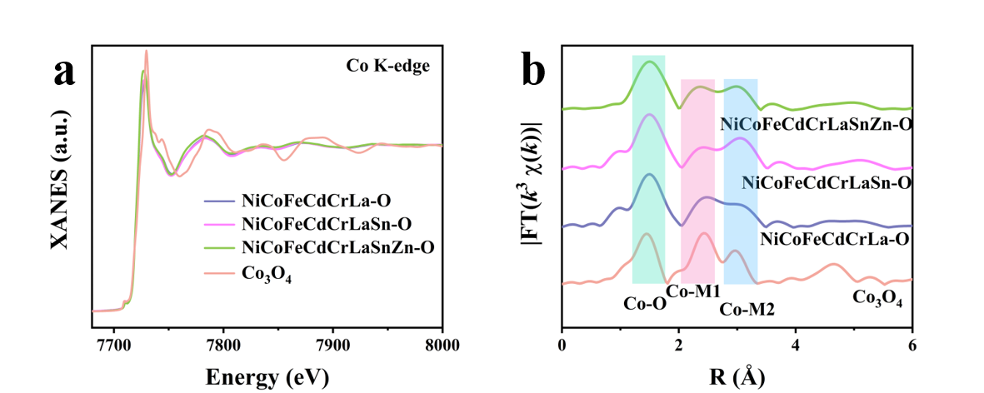
Supplementary Fig. 35 | X-ray absorption fine structure analysis. XANES and FT-EXAFS spectra of Co K-edge.

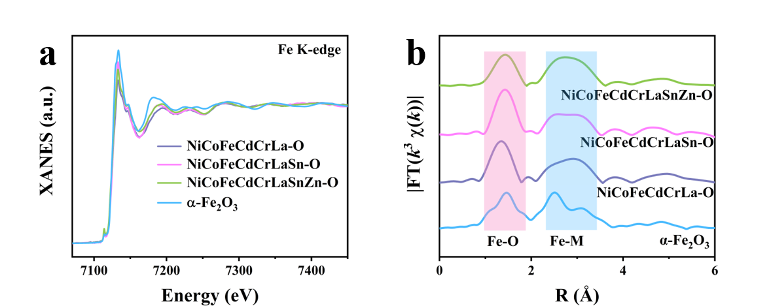
Supplementary Fig. 36 | X-ray absorption fine structure analysis. XANES and FT-EXAFS spectra of Fe K-edge.

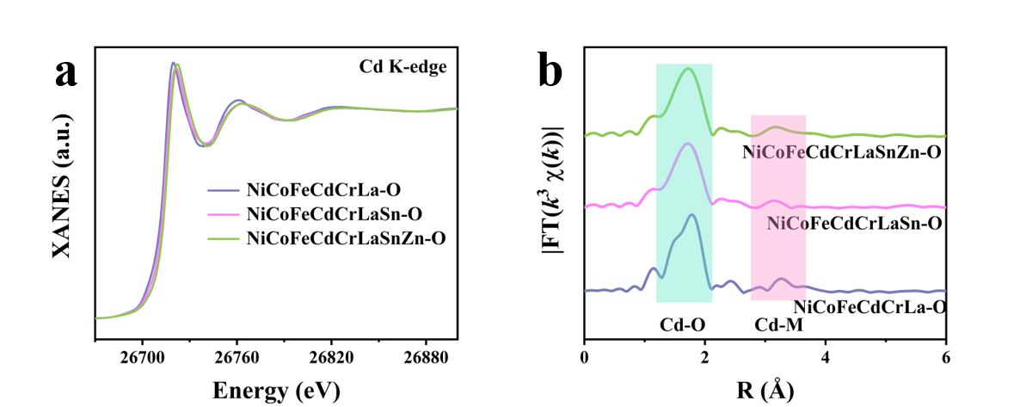
Supplementary Fig. 37 | X-ray absorption fine structure analysis. XANES and FT-EXAFS spectra of Cd K-edge.

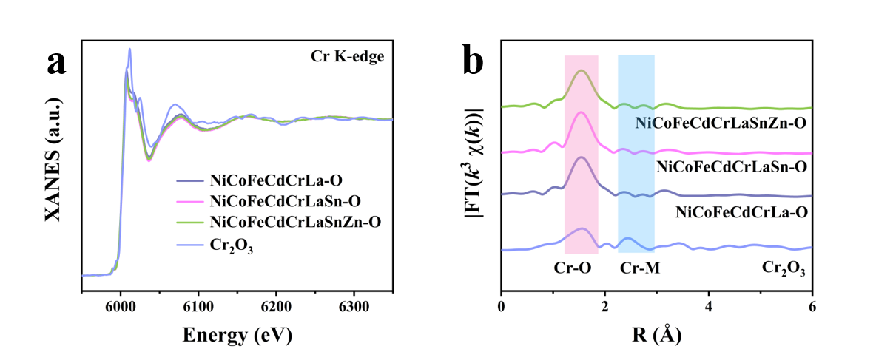
Supplementary Fig. 38 | X-ray absorption fine structure analysis. XANES and FT-EXAFS spectra of Cr K-edge.

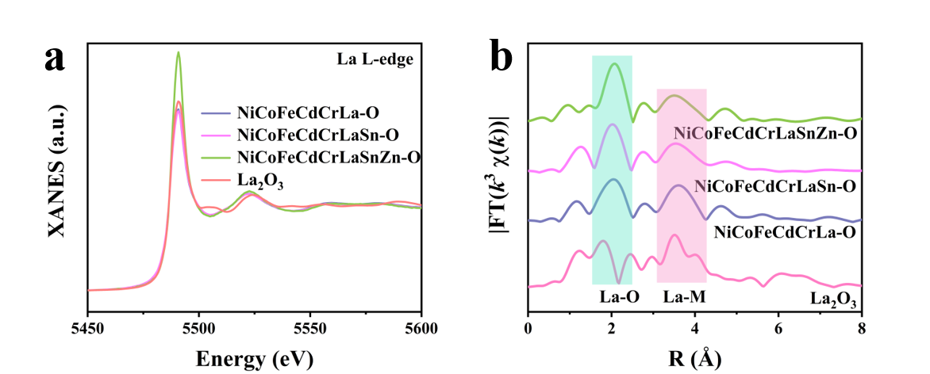
Supplementary Fig. 39 | X-ray absorption fine structure analysis. XANES and FT-EXAFS spectra of La L-edge.

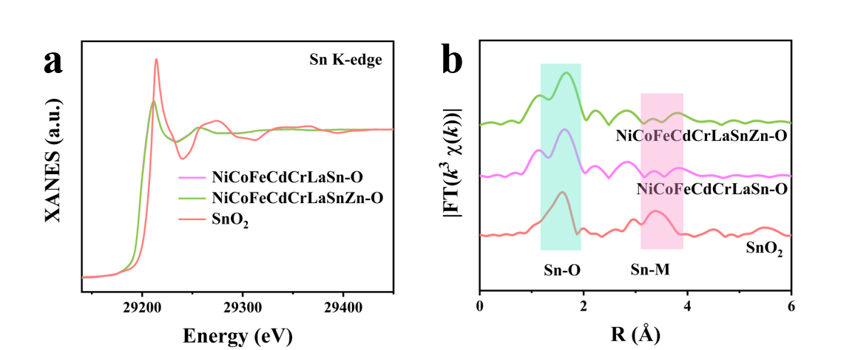
Supplementary Fig. 40 | X-ray absorption fine structure analysis. XANES and FT-EXAFS spectra of Sn K-edge.

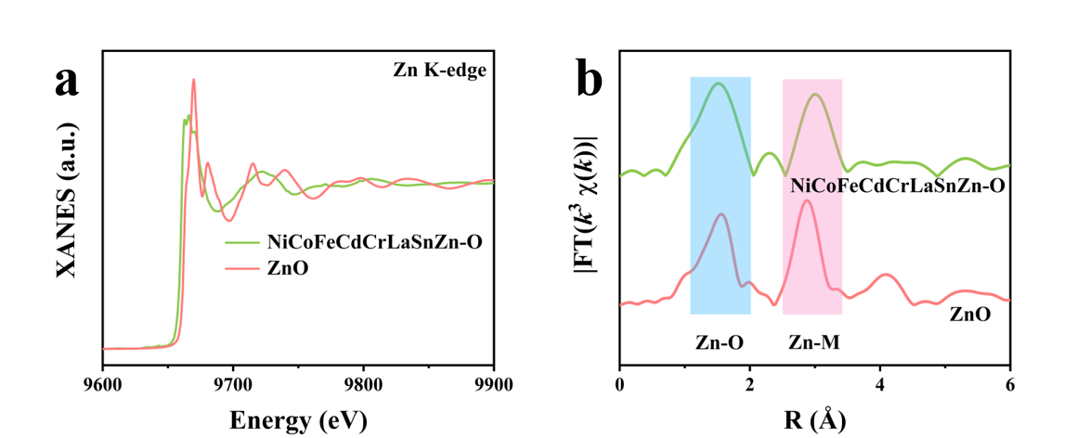
Supplementary Fig. 41 | X-ray absorption fine structure analysis. XANES and FT-EXAFS spectra of Zn K-edge.

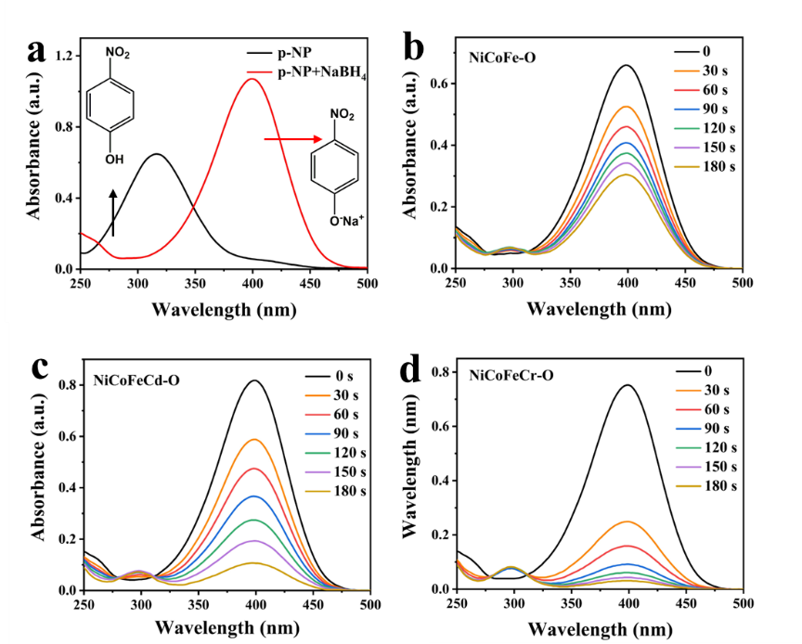
Supplementary Fig. 42 | Performance of different samples. (a) UV–vis absorption spectra with the photo images for the conversion of 4-NP to nitrophenolate ions in the presence of NaBH₄. UV–vis absorbance spectra for the catalytic reduction of 4-NP to 4-AP over as-prepared catalysts at ambient temperature (b) NiCoFe-O, (c) NiCoFeCd-O, and (d) NiCoFeCr-O, respectively.

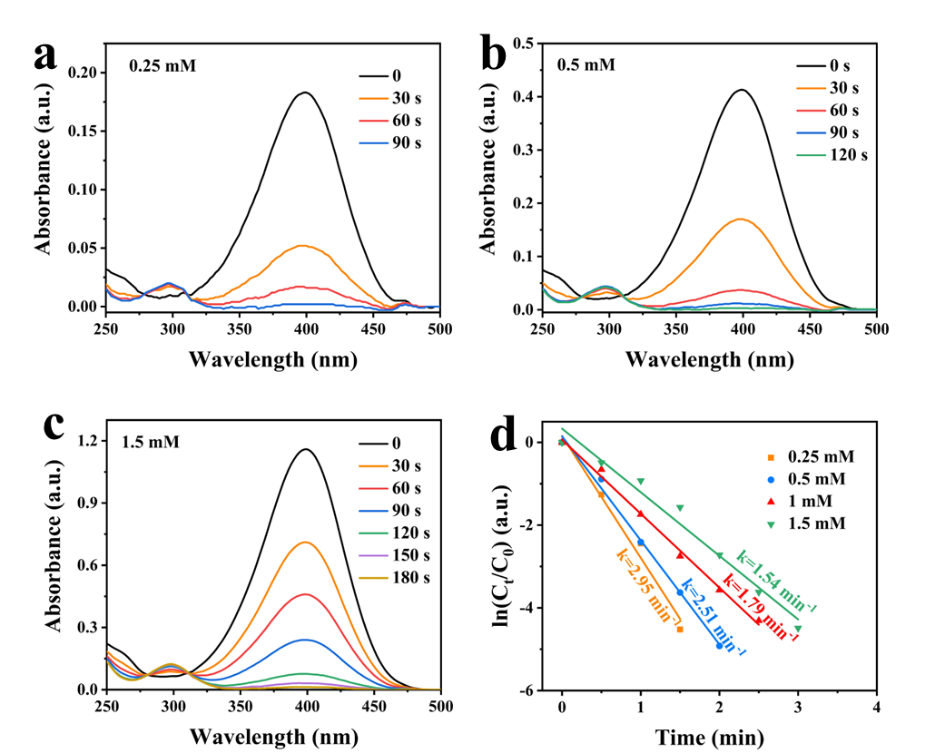
Supplementary Fig. 43 | Performance of samples with different concentrations of 4-NP. UV–vis absorbance spectra for the catalytic reduction of 4-NP to 4-AP over as-prepared catalysts at 25℃. The absorbance of 4-NP solutions at different system concentrations with a change of reaction time for (a) 0.25 mM, (b) 0.5 mM, and (c) 1.5 mM. (d) Plots of ln(C_{t}/C₀) against the reaction time of as-measured concentration. As shown in Supplementary Fig. 43a-c, the change absorbance of 4-NP solutions at different concentrations for 0.25 mM, 0.5 mM, and 1.5 mM, and the absorbance peak intensity gradually decreased to 0 within 90, 120, and 180s, respectively. The plots of ln(C_{t}/C₀) against the reaction time of the as-measured concentration, as can be seen in Supplementary Fig. 43d, the k value gradually increases with the rising concentration, which is attributed to the enhancement of the collision probability between the catalyst and reaction substrate during catalytic reaction, thereby the reaction rate k gradually increases.

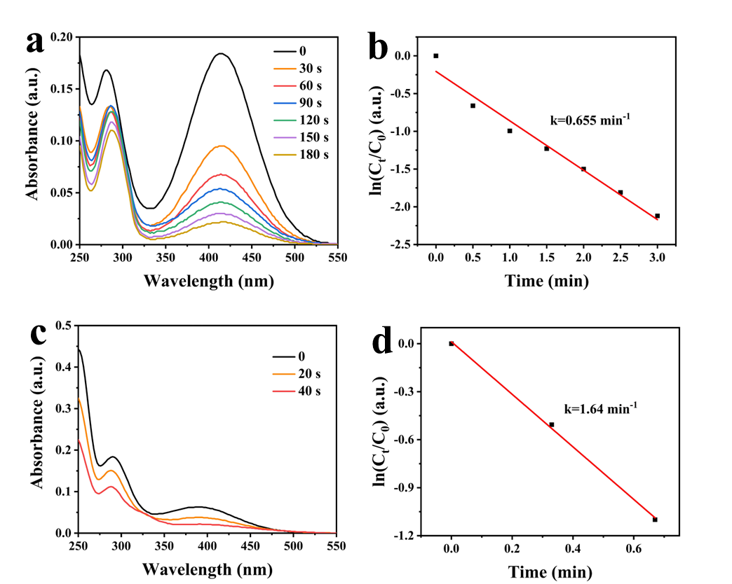
Supplementary Fig. 44 | Performance of samples with different homologs of 2-NP and 3-NP. (a) UV–vis absorbance spectra for the catalytic reduction of 2-NP to 2-AP over NiCoFeCdCr-O at 25℃. (b) Plots of ln(C_{t}/C₀) against the reaction time. (c) UV–vis absorbance spectra for the catalytic reduction of 3-NP to 3-AP over NiCoFeCdCr-O at 25℃. (d) Plots of ln(C_{t}/C₀) against the reaction time. As shown in Supplementary Fig. 44a and c, it was obviously observed from a series of successive UV–vis spectra that NiCoFeCdCr-O facilitated the reduction of nitrophenol to corresponding aminophenol products in the presence of NaBH₄, and the absorbance peak intensity of the nitrophenol (2-NP at 416 nm and 3-NP at 394 nm) gradually decreased with reaction time in 180 and 40 s, respectively. The reduction of nitrophenol was recorded by using the maximum absorbance of wavelength as a signal. It was acquired from plots of ln(C_{t}/C₀) against reaction time in Supplementary Fig. 44b and d, indicating that the conversion of nitrophenol to corresponding aminophenol products was achieved by NiCoFeCdCr-O and the large value of k for 0.655 and 1.64 min⁻¹ implying superior catalytic performance. The difference in reaction rate for the reduction of those nitrophenol compounds by NaBH₄ using the same catalyst can be related to the conjugation effect, inductive effect, and steric effect of the substituent group.^{7, 8} It was also concluded that NiCoFeCdCr-O exhibited remarkable catalytic efficiency and was more suitable for the reduction of nitrophenol compounds.

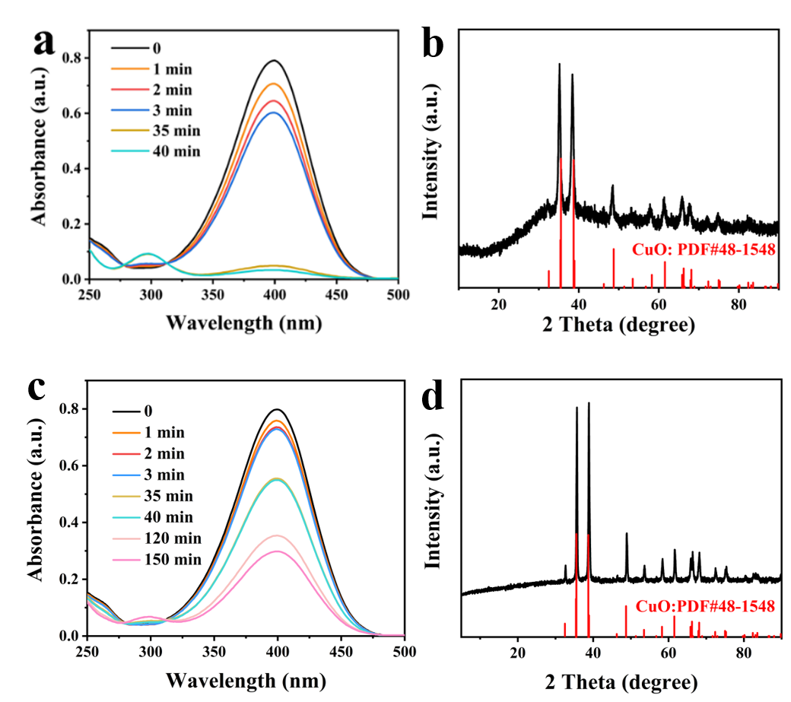
Supplementary Fig. 45 | Performance of samples with different conditions. (a) The absorbance of 4-NP solutions with a change of reaction time at 25℃ for NiCoFeCdCrO_{NaOH}. (b) XRD patterns of NiCoFeCdCrO_{NaOH}. (c) The absorbance of p-nitrophenol solutions with a change of reaction time at 25℃ for CuO. (d) XRD patterns of CuO.

Supplementary Tables

Supplementary Table 1. The content result of the metal element from ICP-OES tests.
Element  Content(%) |  | Ni |  | Co |  | Fe |  | Cd | Cr | Cu | Ratio constant (K) (min⁻¹ g⁻¹)
 | 7.22 |  | 6.09 |  | 5.71 |  | 6.01 |  | 4.19 | 16.4 | 1.53×10⁶

Supplementary Table 2. Comparison of rate constants (k) and ratio constant (K) for catalytic reduction of p-nitrophenol over NiCoFeCdCr-O with previously reported noble metal nanocatalysts.
Catalyst | Kinetic rate constant  k (min⁻¹) | Ratio constant  K (min⁻¹ g⁻¹) | Reference
Fe₃O₄/Ag@NFC | 0.1980 | 1.477 × 10³ | ⁹
Ag@CeO₂ | 1.9560 | 1.345 × 10⁵ | ¹⁰
Ag-OMS-C | 1.8 | 9.000 × 10³ | ¹¹
Pd/C | 0.52980 | 6.915 ×10² | ¹²
PdPt nanotubes | 0.5 | 33 | ¹³
Au/EPA | 0.96 | 1.92×10³ | ¹⁴
Ag-NSs | 0.277 | 28.83 | ¹⁵
Au/CN-EPI | 0.188 | 376 | ¹⁶
AuNCs@C-lotus leaf | 0.561 | 22.44 | ¹⁷
Eggshell/Ag | 1.560 | 260 | ¹⁸
NiCoFeCdCr-O | 1.79 | 1.53×10⁵ | This work

Supplementary Table 3. Comparison of rate constants (k) of 4-NP over NiCoFeCdCr-O with previously reported high-entropy nanocatalysts at different temperatures.
Catalyst | Temperature (℃) | Kinetic rate constant  k (min⁻¹) | Reference
AlCoCrFeNiV(550) | 23 | 0.0258 | ¹⁹
AlCoCrFeNiV(550) | 39 | 0.0301 | ¹⁹
AlCoCrFeNiV(550) | 53 | 0.0478 | ¹⁹
Etched CrMnFeCoNi | 30 | 0.051 | ²⁰
Etched CrMnFeCoNi | 40 | 0.084 | ²⁰
Etched CrMnFeCoNi | 50 | 0.11 | ²⁰
Etched CrMnFeCoNi | 60 | 0.17 | ²⁰
AlCoCrFeNi(RDT) | 16 | 0.019 | ²¹
AlCoCrFeNi(RDT) | 25 | 0.0324 | ²¹
AlCoCrFeNi(RDT) | 32 | 0.174 | ²¹
CrMnFeCoNi(600) | 25 | 0.096 | ²²
CrMnFeCoNi(600) | 34 | 0.439 | ²²
CrMnFeCoNi(600) | 56 | 1.069 | ²²
CrMnFeCoNi(700) | 24 | 0.04 | ²²
CrMnFeCoNi(700) | 34 | 0.09 | ²²
CrMnFeCoNi(700) | 55 | 0.421 | ²²
CrMnFeCoNi(800) | 1 | 0.019 | ²²
CrMnFeCoNi(800) | 25 | 0.108 | ²²
CrMnFeCoNi(800) | 56 | 0.991 | ²²
NiCoFeCdCr-O | 20 | 1.43
NiCoFeCdCr-O | 25 | 1.79 | This work
NiCoFeCdCr-O | 30 | 2.67 | This work
NiCoFeCdCr-O | 35 | 3.68 | This work

Supplementary References
1. Qiu Z, Ma Y, Edvinsson T. In operando Raman investigation of Fe doping influence on catalytic NiO intermediates for enhanced overall water splitting. Nano Energy 66, 104118 (2019).
2. Yu Z-Y, et al. Tuning single-phase medium-entropy oxides derived from nanoporous NiCuCoMn alloy as a highly stable anode for Li-ion batteries. Rare Metals 42, 2982-2992 (2023).
3. Gu K, et al. Defect-Rich High-Entropy Oxide Nanosheets for Efficient 5-Hydroxymethylfurfural Electrooxidation. Angew. Chem. Int. Ed. 60, 20253-20258 (2021).
4. Katzbaer RR, dos Santos Vieira FM, Dabo I, Mao Z, Schaak RE. Band Gap Narrowing in a High-Entropy Spinel Oxide Semiconductor for Enhanced Oxygen Evolution Catalysis. J. Am. Chem. Soc. 145, 6753-6761 (2023).
5. Du M, et al. High-Entropy Prussian Blue Analogues and Their Oxide Family as Sulfur Hosts for Lithium-Sulfur Batteries. Angew. Chem. Int. Ed. 61, e202209350 (2022).
6. Li Y, et al. Cu-based high-entropy two-dimensional oxide as stable and active photothermal catalyst. Nat. Commun. 14, 3171 (2023).
7. Wang C, Zou W, Wang J, Ge Y, Lu R, Zhang S. Insight into the mechanism of gold-catalyzed reduction of nitroarenes based on the substituent effect and in situ IR. New J. Chem. 41, 3865-3871 (2017).
8. Zhang Y, Fulajtárová K, Kubů M, Mazur M, Hronec M, Čejka J. Electronic/steric effects in hydrogenation of nitroarenes over the heterogeneous Pd@BEA and Pd@MWW catalysts. Catal. Today 345, 39-47 (2020).
9. Xiong R, Lu C, Wang Y, Zhou Z, Zhang X. Nanofibrillated cellulose as the support and reductant for the facile synthesis of Fe₃O₄/Ag nanocomposites with catalytic and antibacterial activity. J. Mater. Chem. A 1, 14910-14918 (2013).
10. Shi Y, Zhang X, Zhu Y, Tan H, Chen X, Lu Z-H. Core–shell structured nanocomposites Ag@CeO₂ as catalysts for hydrogenation of 4-nitrophenol and 2-nitroaniline. RSC Adv. 6, 47966-47973 (2016).
11. Fan H-T, et al. Ordered mesoporous silica cubic particles decorated with silver nanoparticles: a highly active and recyclable heterogeneous catalyst for the reduction of 4-nitrophenol. Dalton Trans. 48, 2692-2700 (2019).
12. Fang Y, Wang E. Simple and direct synthesis of oxygenous carbon supported palladium nanoparticles with high catalytic activity. Nanoscale 5, 1843-1848 (2013).
13. Wang Y, et al. One-pot green synthesis of bimetallic hollow palladium-platinum nanotubes for enhanced catalytic reduction of p-nitrophenol. J. Colloid Interface Sci. 539, 161-167 (2019).
14. Lai G-H, Huang B-S, Yang T-I, Tsai M-H, Chou Y-C. Preparation of highly stable and recyclable Au/electroactive polyamide composite catalyst for nitrophenol reduction. Polymer 213, 123200 (2021).
15. Fatima U, et al. Facile green synthesis of Phyllanthus emblica extract based Ag-NPs for antimicrobial and response surface methodology based catalytic reduction applications. J. Clean. Prod.‌‌ 434, 140003 (2024).
16. Chen Y-S, Shi W-Z, Yeh J-M, Tsai M-H. In-situ synthesis of Au/Carbonized Botanical Leaf Functionalized-Electroactive Polyimide nanocomposites and their application in enhanced catalytic activity for reduction 4-nitrophenol. J. Environ. Chem. Eng. 111455 (2023).
17. Zhang A, et al. Novel approach to immobilize Au nanoclusters on micro/nanostructured carbonized natural lotus leaf as green catalyst with highly efficient catalytic activity. Chem. Eng. J. 371, 876-884 (2019).
18. Huang X, et al. Plant-mediated synthesis of dual-functional Eggshell/Ag nanocomposites towards catalysis and antibacterial applications. Mater. Sci. Eng: C 113, 111015 (2020).
19. Kobayashi Y, Suzuki D, Yokoyama S, Shoji R. Molten salt synthesis of high-entropy alloy AlCoCrFeNiV nanoparticles for the catalytic hydrogenation of p-nitrophenol by NaBH4. Int. J. Hydrogen Energ. 47, 3722-3732 (2022).
20. Peng H, et al. Large-scale and facile synthesis of a porous high-entropy alloy CrMnFeCoNi as an efficient catalyst. J. Mater. Chem. A 8, 18318-18326 (2020).
21. Kobayashi Y, Teah HY, Yokoyama S, Shoji R, Hanada N. Environmentally friendly molten salt synthesis of high-entropy AlCoCrFeNi alloy powder with high catalytic hydrogenation activity. Int. J. Hydrogen Energ. 48, 30963-30973 (2023).
22. Kobayashi Y, Teah HY, Yokoyama S, Shoji R, Hanada N. A Molten Salt Synthesis Method of the High-Entropy Alloy CrMnFeCoNi for High Catalytic Performance and Low Life Cycle GHG Emissions. ACS Sustain. Chem. Eng. 10, 15046-15057 (2022).

