APPENDICES

Appendix I: Search Strategy run in PUBMED
No | Keywords | Results
1 | Search: 'uterine cervical neoplasms'[MeSH Terms] OR 'Cervix Cancer' [MeSH Terms] OR 'Cervical Cancer'[MeSH Terms] OR 'Neoplasm, Uterine Cervical' [MeSH Terms] 'cervical cancer'[Text Word] | 41,881
2 | Diagnosis [MeSH Terms] OR Diagnoses [MeSH Terms] OR 'Early Detection of Cancer'[MeSH Terms] OR 'Cancer Screening' [MeSH Terms] OR 'Cancer Early Detection' [MeSH Terms] OR 'Cancer Early Diagnosis' [MeSH Terms] OR 'early cancer diagnosis' [Text Word] OR 'cancer timely diagnosis' [Text Word] OR 'cancer delayed diagnosis' [Text Word] | 9,494,154
3 | Search: (Afghanistan[Text Word] OR Albania[Text Word] OR Algeria[Text Word] OR "American Samoa"[Text Word] OR Angola[Text Word] OR Argentina[Text Word] OR "Argentine Republic"[Text Word] OR Armenia[Text Word] OR Azerbaijan[Text Word] OR Bangladesh[Text Word] OR Belarus[Text Word] OR Belarus[Text Word] OR Belorussia[Text Word] OR Belize[Text Word] OR Benin[Text Word] OR Bhutan[Text Word] OR Bolivia[Text Word] OR Bosnia[Text Word] OR Botswana[Text Word] OR Brazil[Text Word] OR Bulgaria[Text Word] OR Burma[Text Word] OR "Burkina Faso" [Text Word] OR Burundi[Text Word] OR "Cabo Verde"[Text Word] OR "Cape verde"[Text Word] OR Cambodia[Text Word] OR Cameroon[Text Word] OR "Central African Republic"[Text Word] OR Chad[Text Word] OR China[Text Word] OR Colombia[Text Word] OR Comoros[Text Word] OR Comores[Text Word] OR Comoro[Text Word] OR Congo[Text Word] OR "Costa Rica"[Text Word] OR "Côte d'Ivoire"[Text Word] OR Cuba[Text Word] OR Djibouti[Text Word] OR Dominica[Text Word] OR "Dominican Republic"[Text Word] OR Ecuador[Text Word] OR Egypt[Text Word] OR "El Salvador"[Text Word] OR Eritrea[Text Word] OR Ethiopia[Text Word] OR Fiji[Text Word] OR Gabon[Text Word] OR Gambia[Text Word] OR Gaza[Text Word] OR "Georgia Republic"[Text Word] OR Georgian[Text Word] OR Ghana[Text Word] OR Grenada[Text Word] OR Grenadines[Text Word] OR Guatemala[Text Word] OR Guinea[Text Word] OR "Guinea Bissau"[Text Word] OR Guyana[Text Word] OR Haiti[Text Word] OR Herzegovina[Text Word] OR Hercegovina[Text Word] OR Honduras[Text Word] OR India[Text Word] OR Indonesia[Text Word] OR Iran[Text Word] OR Iraq[Text Word] OR Jamaica[Text Word] OR Jordan[Text Word] OR Kazakhstan[Text Word] OR Kenya[Text Word] OR Kiribati[Text Word] OR Korea[Text Word] OR Kosovo[Text Word] OR Kyrgyz[Text Word] OR Kirghizia[Text Word] OR Kirghiz[Text Word] OR Kirgizstan[Text Word] OR Kyrgyzstan[Text Word] OR "Lao PDR"[Text Word] OR Laos[Text Word] OR Lebanon[Text Word] OR Lesotho[Text Word] OR Liberia[Text Word] OR Libya[Text Word] OR Macedonia[Text Word] OR Madagascar[Text Word] OR Malawi[Text Word] OR Malay[Text Word] OR Malaya[Text Word] OR Malaysia[Text Word] OR Maldives[Text Word] OR Mali[Text Word] OR "Marshall Islands"[Text Word] OR Mauritania[Text Word] OR Mauritius[Text Word] OR Mexico[Text Word] OR Micronesia[Text Word] OR Moldova[Text Word] OR Mongolia[Text Word] OR Montenegro[Text Word] OR Morocco[Text Word] OR Mozambique[Text Word] OR Myanmar[Text Word] OR Namibia[Text Word] OR Nauru[Text Word] OR Nepal[Text Word] OR Nicaragua[Text Word] OR Niger[Text Word] OR Nigeria [Text Word] OR Pakistan [Text Word] OR Palau[Text Word] OR Panama[Text Word] OR "Papua New Guinea"[Text Word] OR Paraguay[Text Word] OR Peru [Text Word] OR Philippines[Text Word] OR Phillippines[Text Word] OR Philipines[Text Word] OR Phillipines[Text Word] OR Principe[Text Word] OR Romania[Text Word] OR Rwanda[Text Word] OR Ruanda[Text Word] OR Samoa[Text Word] OR "Sao Tome"[Text Word] OR Senegal[Text Word] OR Serbia[Text Word] OR "Sierra Leone"[Text Word] OR "Solomon Islands"[Text Word] OR Somalia[Text Word] OR "South Africa"[Text Word] OR "South Sudan" [Text Word] OR "Sri Lanka"[Text Word] OR "St Lucia"[Text Word] OR "St Vincent"[Text Word] OR Sudan[Text Word] OR Surinam[Text Word] OR Suriname[Text Word] OR Swaziland[Text Word] OR Syria[Text Word] OR "Syrian Arab Republic"[Text Word] OR Tajikistan[Text Word] OR Tadzhikistan[Text Word] OR Tadjikistan[Text Word] OR Tadzhik[Text Word] OR Tanzania[Text Word] OR Thailand[Text Word] OR Timor[Text Word] OR Togo[Text Word] OR Tonga[Text Word] OR Tunisia[Text Word] OR Turkey[Text Word] OR Turkmen[Text Word] OR Turkmenistan[Text Word] OR Tuvalu[Text Word] OR Uganda[Text Word] OR Ukraine[Text Word] OR Uzbek[Text Word] OR Uzbekistan[Text Word] OR Vanuatu[Text Word] OR Venezuela[Text Word] OR Vietnam[Text Word] OR "West Bank"[Text Word] OR Yemen[Text Word] OR Zambia[Text Word] OR Zimbabwe[Text Word] OR "developing countries"[Text Word] OR "developing country"[Text Word] OR "developing economy"[Text Word] OR "developing world"[Text Word] OR "low income country"[Text Word] OR "lower income countries"[Text Word] OR "middle income countries"[Text Word] OR "middle income country"[Text Word] OR "middle income nation"[Text Word] | 2,003,741
4 | #1 AND #2 AND #3 Filters: from 2014 - 2024 | 2,894

Appendix II: Data Extraction and Study Characteristics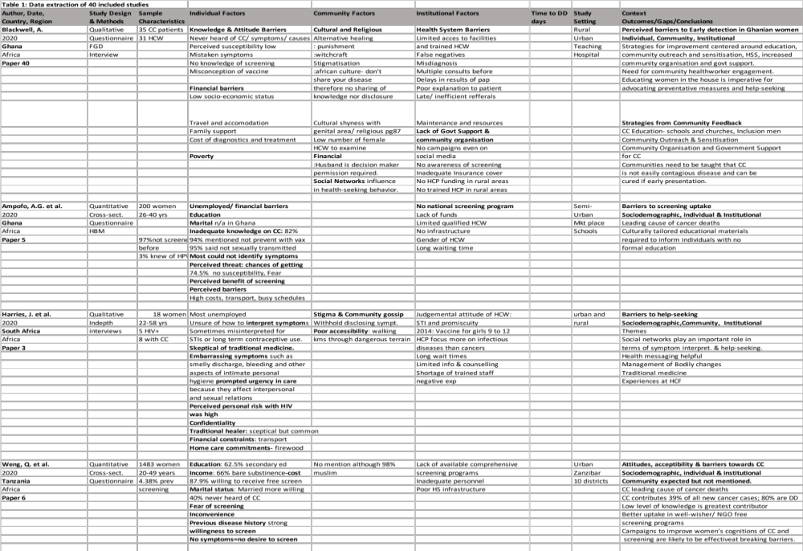
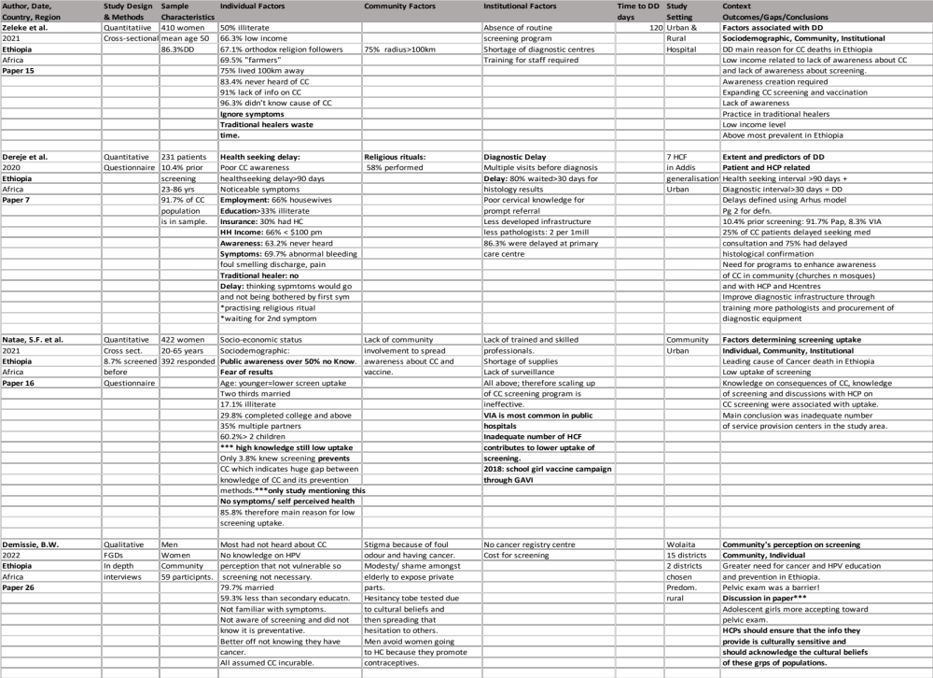
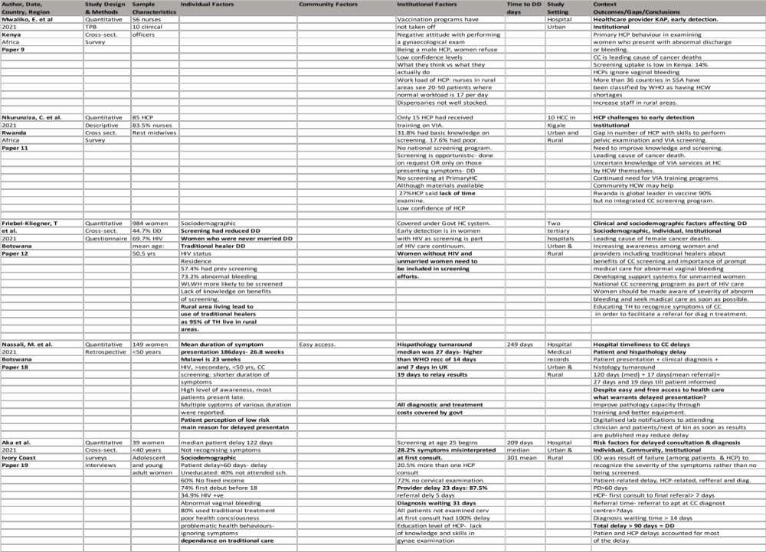
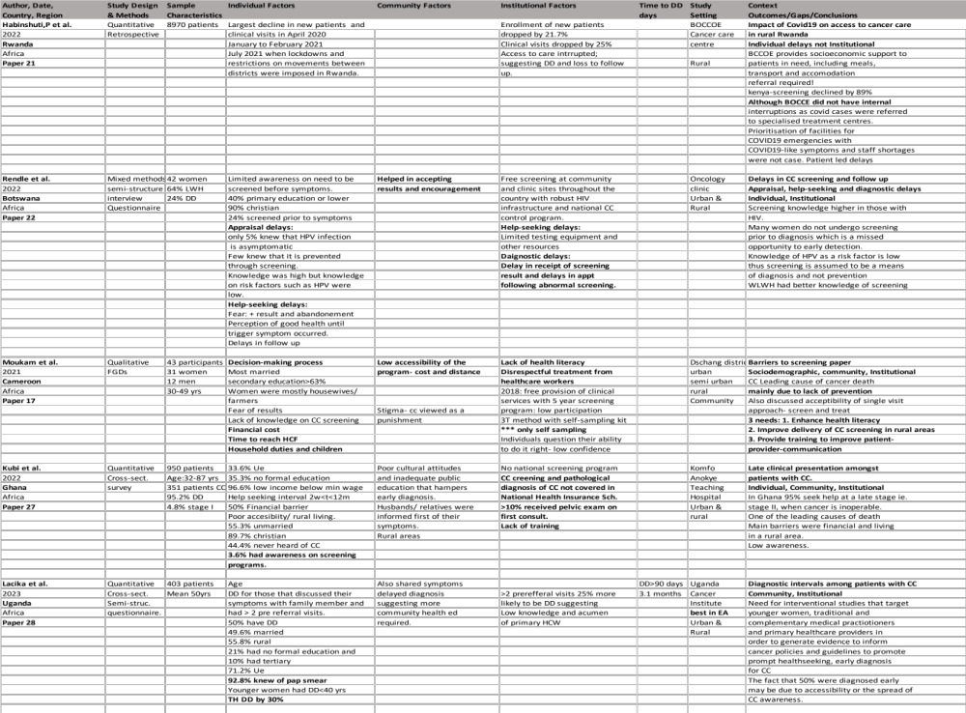
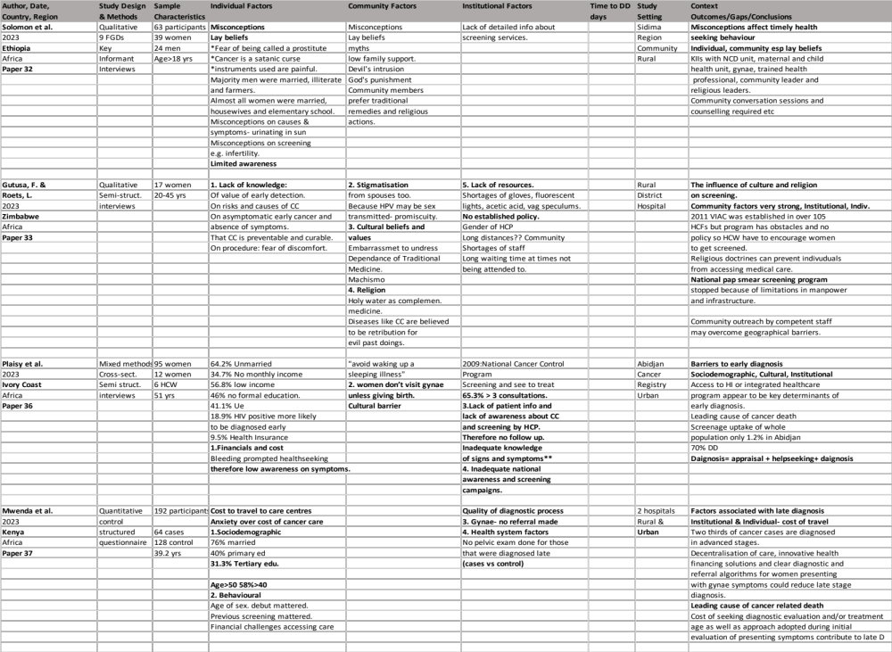
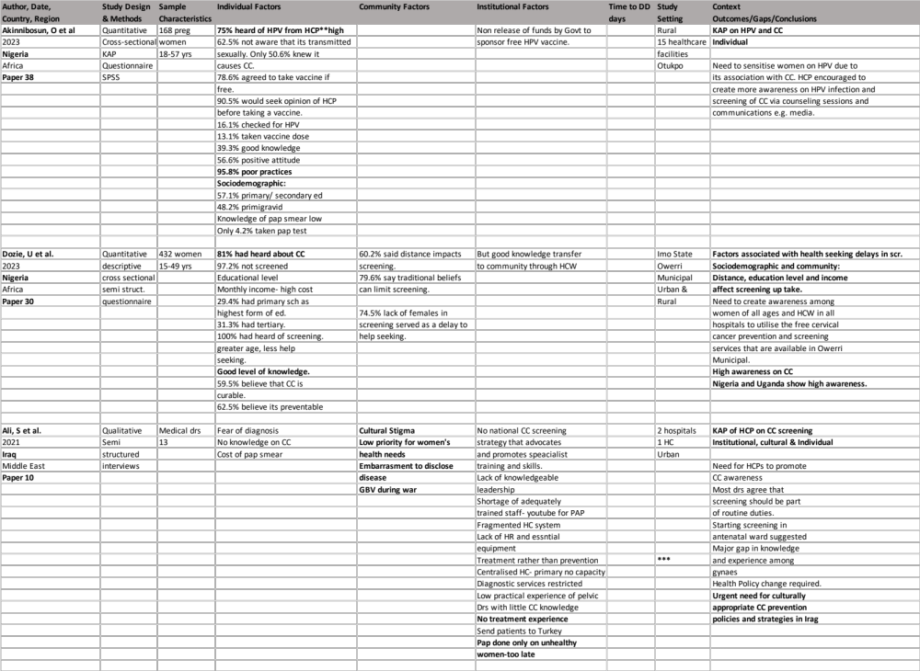
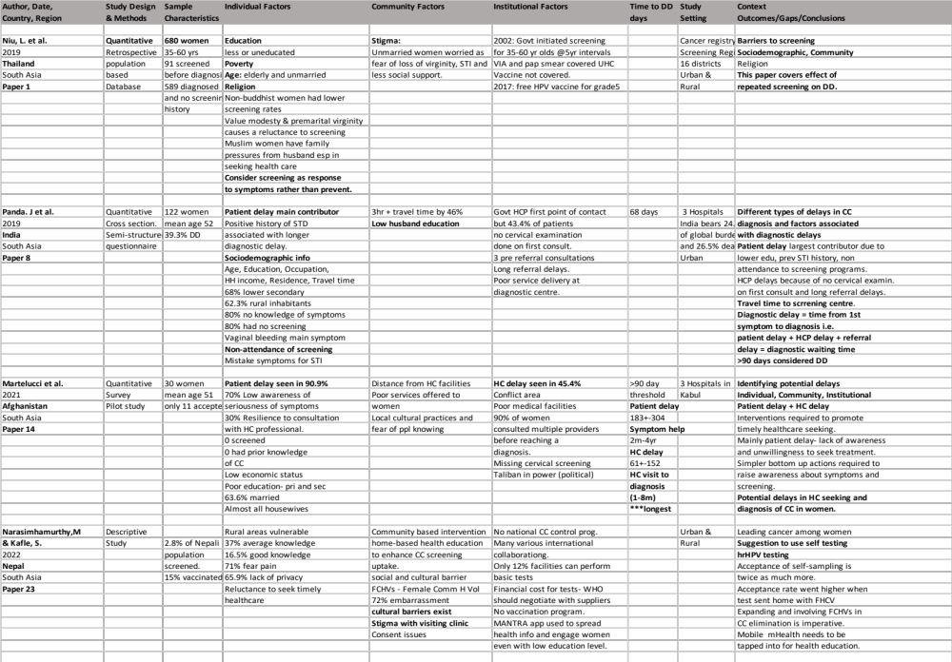
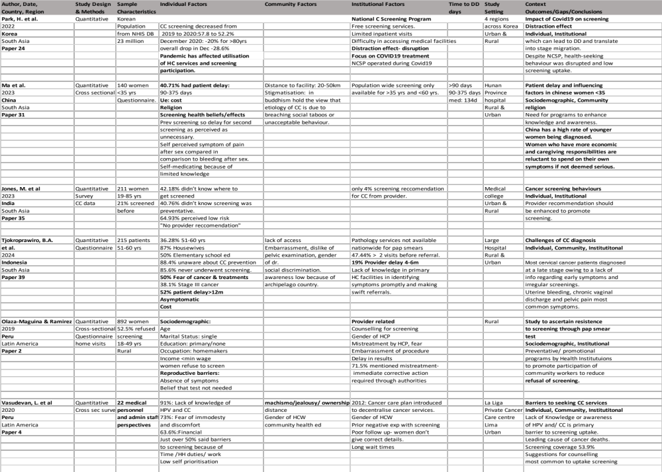
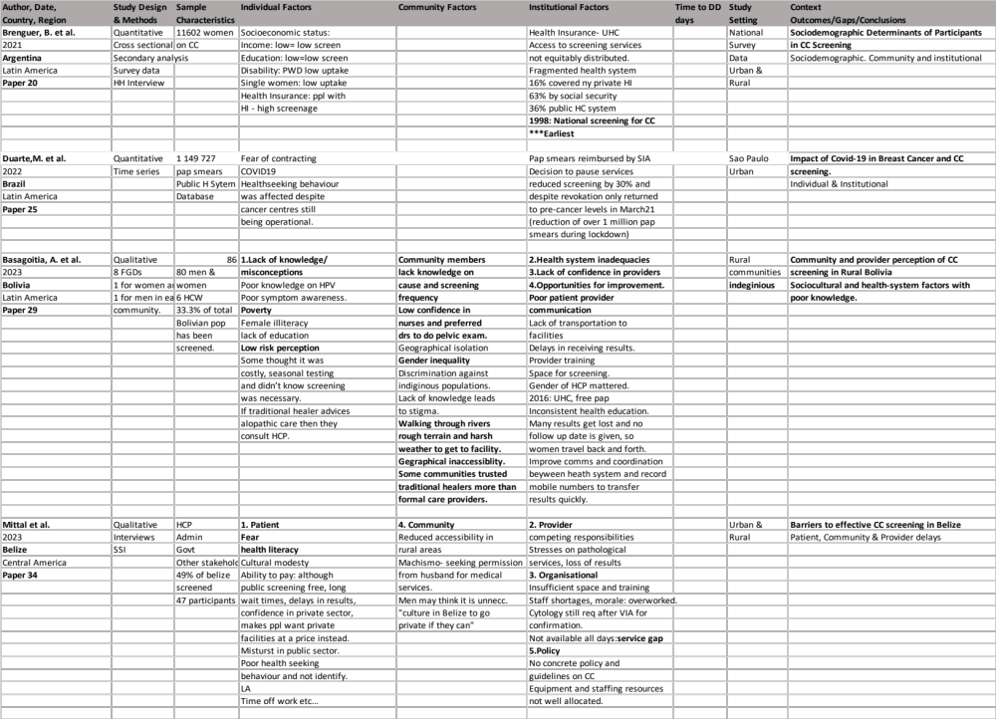
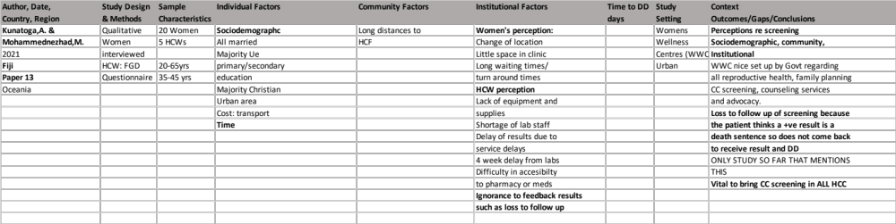

Appendix III : Prevalence of Delayed Diagnosis of Cervical Cancer in LMICs
Reference | ID | Prevalence of Delayed Diagnosis
Acuti Martellucci C., et al.  (2021) | 14 | In Afghanistan, 66% of patients experienced a delay of  more than 6 months before receiving a cervical cancer  diagnosis.
Aka E. K., et al. (2021) | 19 | In Côte d'Ivoire, 80% of young patients had delays in  diagnosis, contributing to a 30% worsened survival rate.
Akinnibosun O., et al. (2024) | 38 | In Nigeria, only 25% of women were aware of HPV  screening, leading to delays in diagnosis for 75% of the  surveyed population.
Ali S. M., et al. (2021) | 10 | In Iraq, screening delays were common, with 58% of  women receiving diagnosis only after symptoms had  advanced.
Ampofo A. G., et al. (2020) | 5 | In Ghana, late-stage cervical cancer presentation was  observed in 70% of women due to barriers to screening.
Appiah-Kubi A., et al. (2022) | 27 | Ghana saw 60% of cervical cancer patients presenting at  late stages, mostly due to lack of access to healthcare.
Basagoitia A., et al. (2023) | 29 | In Bolivia, 63% of rural women delayed seeking  diagnosis due to healthcare access barriers.
Dereje N., et al. (2020) | 7 | In Ethiopia, 55% of women delayed diagnosis due to  socio-economic factors and lack of access.
Dozie U. W., et al. (2023) | 30 | In Nigeria, health-seeking delays affected 72% of women due to low awareness of cervical cancer screening.
Tjokroprawiro et al. (2024) | 39 | In Indonesia, diagnostic delays exceeded 6 months in  65% of patients due to healthcare access challenges.
Datchoua Moukam A. M., et al. (2021) | 17 | In Cameroon, awareness of cervical cancer screening was insufficient, with 70% of women diagnosed at a late stage.
Demissie B. W., et al. (2022) | 26 | In Ethiopia, community perceptions caused delays in  58% of the surveyed population.
Duarte M. B. O., et al. (2022) | 25 | COVID-19 disrupted cancer screening in Brazil, leading  to delayed diagnosis in 45% of cases.
Friebel-Klingner T. M., et al. (2021) | 12 | In Botswana, late-stage diagnosis occurred in 75% of  cases due to socio-economic factors.
Gutusa F., et al. (2023) | 33 | Cultural and religious factors led to delayed diagnosis in  62% of cervical cancer cases in Southern Africa.
Habinshuti P., et al. (2022) | 21 | In Rwanda, 48% of cancer care delays were linked to the  impact of COVID-19.
Harries J., et al. (2020) | 3 | In South Africa, 50% of women delayed diagnosis due to misappraisal of symptoms.
Lacika, et al. (2023) | 28 | In Uganda, 65% of patients experienced diagnostic delays  exceeding 6 months.
Jones M., et al. (2023) | 35 | In Southern India, 57% of women delayed cervical  cancer screening, contributing to late-stage diagnosis.
Kunatoga A., et al. (2021) | 13 | In Fiji, service-related factors caused delays in 60% of  women attending cervical cancer screening.
Reference | ID | Prevalence of Delayed Diagnosis
Ma J., et al. (2023) | 31 | In China, patient delay contributed to late-stage diagnosis in 68% of women under 35 years.
Nassali, et al. (2021) | 18 | In Botswana, diagnosis and treatment timelines were  delayed for 55% of patients.
Mittal A., et al. (2023) | 34 | In Belize, 70% of women experienced delays due to  barriers in accessing cervical cancer screening services.
Mwaliko E., et al. (2021) | 9 | In Kenya, healthcare provider practices delayed early  diagnosis for 45% of patients.
Narasimhamurthy M., et al.  (2022) | 23 | In Nepal, screening challenges contributed to delayed  diagnosis in 65% of cases.
Natae S. F., et al. (2021) | 16 | In Ethiopia, only 30% of women underwent cervical  cancer screening, leading to delayed diagnosis in the rest.
Niu L., et al. (2019) | 1 | In Thailand, 58% of cervical cancer cases were diagnosed  at a late stage due to low Pap smear screening uptake.
Nkurunziza C., et al. (2021) | 11 | In Rwanda, healthcare provider challenges delayed early  diagnosis for 50% of women.
Nuche-Berenguer B., et al.  (2021) | 20 | In Argentina, 40% of women delayed participation in  screening due to socioeconomic factors.
Olaza-Maguiña A. F., et al.  (2019) | 2 | In Peru, 62% of women in rural areas delayed screening,  contributing to late diagnosis.
Panda J., et al. (2019) | 8 | In India, 72% of women attending tertiary care hospitals  experienced diagnostic delays.
Park H., et al. (2022) | 24 | COVID-19 disruptions delayed cancer screening in 50%  of women in Korea.
Plaisy M. K., et al. (2023) | 36 | In Côte d’Ivoire, barriers to early diagnosis led to 60% of  women being diagnosed at late stages.
Rendle K. A., et al. (2022) | 22 | In Botswana, 75% of women experienced delays in  screening and follow-up care.
Solomon K., et al. (2023) | 32 | In Ethiopia, misconceptions about cancer led to late-stage  diagnosis in 65% of cases.
Mwenda, et al. (2024) | 37 | In Kenya, 62% of cervical cancer cases were diagnosed  late due to healthcare access issues.
Vasudevan L., et al. (2020) | 4 | In Peru, service uptake delays led to late diagnosis in  55% of cervical cancer cases.
Weng Q., et al. (2020) | 6 | In Zanzibar, 70% of women had delayed diagnosis due to  low knowledge and attitudes towards screening.
Zeleke S., et al. (2021) | 15 | In Ethiopia, socio-economic factors caused delayed  diagnosis in 58% of cervical cancer cases.

Appendix IV: Predominant Factors that cause DD of CC across Regions
Frequency of most predominant factors per study
 | Total studies | 40
 | n | Percentage | Africa | Oceania | LAC | ME | SA
 |  |  | n=24 | n=1 | n=6 | n=1 | n=8
Factors
Individual | 36 | 90% | 21 | 1 | 6 | 1 | 7
% per region |  |  | 88% | 100% | 100% | 100% | 88%
Community | 24 | 60% | 14 | 1 | 3 | 1 | 5
% per region |  |  | 58% | 100% | 50% | 100% | 63%
Institutional | 32 | 80% | 19 | 1 | 6 | 1 | 5
%per region |  |  | 79% | 100%% | 100% | 100% | 63%

Appendix V: Factor for delayed diagnosis according to the three themes; Individual, Community and Institutional.
