  - Supplementary information

Jointly modelling multiple ancestral populations using GWAS summary data improves causal inference

Yoonsu Cho et al.
Table of Contents
Supplementary Table 1. Sources of data used in this study. 2
Supplementary Table 2. Assessment of heterogeneity and specificity of the chosen instruments for the exposure where EAS population is used as reference. 4
Supplementary Figure 1. Instrument selection in CAMERA. 5
Supplementary figure 2: Agreement of instrument associations between European GWAS and Biobank Japan 6
Supplementary figure 3: Agreement of instrument effect sizes for LDL cholesterol levels across populations. 7
Supplementary figure 4: Consistency of horizontal pleiotropy in MR analyses across populations 8
Supplementary figure 5: Distribution of MR GxE estimates of horizontal pleiotropy for LDL cholesterol instruments. 9
Supplementary figure 6: Distribution of MR GxE estimates of horizontal pleiotropy for four exposures. 10

Supplementary Table 1. Sources of data used in this study.
Consortium/Studies | Use | Study population | Imputation | Unit | Covariates
Exposures
UK Biobank | SNP-BMI  SNP-SBP | 681,275 EUR individuals  436,419 EUR individuals | IMPUTE2  (Ref: HRC v1.1 panel and UK10K) | Rank-based INT  SD | Age, sex, the first 10 PCs and genotyping array
UK Biobank  CARDIoGRAMplusC4D | SNP-LDLC | 440,546 EUR individuals | IMPUTE2  (Ref: HRC v1.1 panel, UK10K, and 1KG Phase 3v5) | SD | Age, sex, and genotyping array
GSCAN consortium | SNP-Smoking | 1,232,091 EUR individuals | Minimac3 or IMPUTE2  (Ref: HRC v1.1 panel) | Standardised log OR | age, age², sex, and PCs
Biobank Japan | SNP-BMI  SNP-LDLC | 158,284 EAS individuals  72,866 EAS individuals | MaCH, Minimac  (Ref: 1KG Phase 1v3) | INT  Z-score | Sex, age, the first 10 PCs, 47 diseases
Biobank Japan | SNP-SBP | 145,505 EAS individuals | Minimac  (Ref: 1KG Phase 3v5) | Z-score | Age, age², sex, age × sex, age² × sex and the first 20 PCs
Biobank Japan | SNP-Smoking | 83,810 cases and 81,626 controls of EAS individuals | MaCH, Minimac  (Ref: 1KG Phase 1v3) | Log OR | Age, age², the first 10 PCs, 47 diseases
Outcomes
UK Biobank | SNP-AST | 342,990 EUR individuals | IMPUTE2  (Ref: HRC v1.1 panel and UK10K) | Quantile | Age, sex, the first 10 PCs and genotyping array
UK Biobank | SNP-CAD | 122,733 cases, and 424,528 controls of EUR individuals | SHAPEIT3, IMPUTE2  (Ref: HRC v1.1 panel) | Log OR | Age, sex, the first 30 PCs and genotyping array
DIAGRAM | SNP-T2D | 74,124 cases and 824,006 controls of EUR individuals | Minimac, IMPUTE4  (Ref: HRC v1.1 panel) | Log OR | Sex and study-specific covariates (e.g., PCs)
BCAC and DRIVE consortium | SNP-Breast cancer | 122,977 cases and 105,974 controls of EUR females | SHAPEIT2, IMPUTE2, MACH, or Minimac  (Ref: HRC v1.1 panel) | Log OR | Country and 10 PCs
UK Biobank | SNP-Colon cancer | 5,657 cases and 372,016 controls of EUR individuals | IMPUTE2  (Ref: HRC v1.1 panel and UK10K) | Absolute risk | Age, sex, the first 10 PCs and genotyping array
TRICL consortium | SNP-Lung Cancer | 11,348 cases and 15,861 controls of EUR individuals | MaCH, IMPUTE2  (Ref: 1KG Phase 1v3) | Log OR | PCs
Biobank Japan | SNP-AST | 134,154 EAS individuals | MaCH, Minimac  (Ref: 1KG Phase 1v3) | Z-score | Sex, age, the first 10 PCs, 47 diseases
Biobank Japan | SNP-CAD  SNP-Breast cancer  SNP-Colon cancer  SNP-lung Cancer | 29,319 cases and 183,134 controls of EAS individuals  5,552 cases and 89,731 controls of EAS females  7,062 cases and 195,745 controls of EAS individuals  4,050 cases and 208,403 controls of EAS individuals | SHAPEIT2, Minimac3  (Ref: 1KG Phase 3) | Log OR  Log OR  Log OR  OR | Age, sex, and the first 5 PCs
Asian Genetic Epidemiology Network | SNP- T2D | 77,418 cases and 356,122 controls of EAS individuals | IMPUTE2, Minimac3  (Ref: 1KG Phase 1 or 3) | Log OR | Age, sex, and study-specific covariates (e.g., PCs)
GSCAN, GWAS & Sequencing Consortium of Alcohol and Nicotine use; BCAC , Breast Cancer Association Consortium; DRIVE, Discovery, Biology and Risk of Inherited Variants in Breast Cancer Consortium; TRICL, Transdisciplinary Research Into Cancer of the Lung; BMI, body mass index; SBP, systolic blood pressure; LDLC, low density lipoprotein cholesterol; AST, aspartate aminotransferase; CAD, coronary artery disease; T2D, type 2 diabetes; EUR, European ancestry; EAS, East Asian ancestry; INT, inverse-normal transformation; OR, odds ratio; SD, standard deviation; PC, principal component.

Supplementary Table 2. Assessment of heterogeneity and specificity of the chosen instruments for the exposure where EAS population is used as reference.

Method¹ |  | Heterogeneity of the instruments |  |  |  |  | Instrument specificity across the populations
 |  |  |  |  |  |  | Effect direction⁶ |  |  |  | Effect significance⁶
 |  | Total  N SNPs² | Degree of agreement (SE)³ | P-value for heterogeneity⁴ | I-sq ⁴ |  | Expected replication⁷ | Observed replication⁸ | P-value difference⁹ |  | Expected replication⁷ | Observed replication⁸ | P-value difference⁹
Example 1. Instruments for BMI in EUR and EAS populations
 | Raw | 55 | 0.885 (0.066) | 0.00E+00 | 0.975 |  | 52.60 | 54.00 | 0.734 |  | 42.76 | 54.00 | 2.73e-05
 | Max Z | 75 | 0.860 (0.036) | 1.68E-226 | 0.943 |  | 72.36 | 75.00 | 0.117 |  | 61.20 | 74.00 | 7.70e-06
 | SUSIE | 67 | 0.811 (0.042) | 1.08E-205 | 0.944 |  | 64.56 | 66.00 | 0.522 |  | 53.66 | 63.00 | 0.002
 | PAINTOR | 50 | 0.826 (0.826) | 3.49E-226 | 0.959 |  | 48.06 | 50.00 | 0.267 |  | 40.17 | 50.00 | 4.03e-05
Example 2. Instruments for SBP in EUR and EAS populations
 | Raw | 36 | 0.628 (0.086) | 5.12E-210 | 0.968 |  | 35.25 | 33.00 | 0.039 |  | 29.22 | 29.00 | 0.834
 | Max Z | 44 | 0.829 (0.042) | 2.24E-49 | 0.874 |  | 43.07 | 44.00 | 1 |  | 36.52 | 42.00 | 0.025
 | SUSIE | 42 | 0.700 (0.067) | 1.69E-161 | 0.953 |  | 41.19 | 40.00 | 0.194 |  | 35.12 | 40.00 | 0.037
 | PAINTOR | 31 | 0.741 (0.741) | 1.05E-56 | 0.912 |  | 28.67 | 29.00 | 1 |  | 17.05 | 22.00 | 0.103
Example 3. Instruments for LDL in EUR and EAS populations
 | Raw | 29 | 0.654 (0.149) | < 2.2e-16 | 0.995 |  | 27.49 | 25.00 | 0.062 |  | 23.12 | 27.00 | 0.102
 | Max Z | 34 | 0.812 (0.091) | < 2.2e-16 | 0.989 |  | 32.71 | 33.00 | 1 |  | 29.08 | 31.00 | 0.468
 | SUSIE | 33 | 0.472 (0.159) | < 2.2e-16 | 0.996 |  | 31.60 | 26.00 | 0.0004 |  | 28.06 | 31.00 | 0.220
 | PAINTOR | 19 | 0.471 (0.471) | < 2.2e-16 | 0.993 |  | 17.88 | 15.00 | 0.023 |  | 14.79 | 18.00 | 0.096
Example 4. Instruments for smoking initiation in EUR and EAS populations
 | Raw | 8 | 0.622 (0.066) | 7.41E-05 | 0.738 |  | 7.60 | 8.00 | 1 |  | 6.72 | 8.00 | 0.370
 | Max Z | 14 | 0.583 (0.039) | 2.16E-03 | 0.567 |  | 13.16 | 14.00 | 1 |  | 11.15 | 14.00 | 0.089
 | SUSIE | 11 | 0.591 (0.043) | 8.05E-03 | 0.538 |  | 10.36 | 11.00 | 1 |  | 8.70 | 11.00 | 0.135
 | PAINTOR | 8 | 0.586 (0.586) | 7.07E-07 | 0.806 |  | 7.51 | 8.00 | 1 |  | 6.26 | 7.00 | 1

¹ Instruments were obtained using four different methods such as Raw (choosing SNPs that have strong associations with the exposure in each population), Max Z (searching for SNPs with the largest effect on the exposure within the selected genomic regions that includes the original SNPs), and fine-mapping methods (SUSIE and PAINTOR). ² Total number of the instruments obtained from each method. ³ Similarity of the beta estimates for the chosen instruments and exposure associations between the populations. ⁴ Heterogeneity of the genetic instruments between the populations was tested using the Q test and I squared. ⁵ Number of the SNPs that reached the Bonferroni-corrected significance threshold (P < 0.05 / Total N SNPs) in discovery (East Asian population). ⁶ Estimates of the number of the SNPs that are replicated across the populations in terms of statistical significance (Bonferroni-corrected significance threshold; P < 0.05 / Total N SNPs) and effect direction assuming effect sizes are the same. ⁷ Estimated number of the SNPs that are expected to be replicated in replication (European population). The winners’ curse bias was corrected. ⁸ Number of the SNPs that were observed to be replicated in replication (European population). ⁹ P-value differences of the number of expected SNPs and observed SNPs to be replicated (P < 0.05).

Supplementary Figure 1. Instrument selection in CAMERA.
The figure demonstrates how the instruments for the exposure were chosen from each selected region: (A) Instruments for systolic blood pressure, (B) body mass index, and (C) C-reactive protein. Three different methods were applied to select instruments for multiple populations (EUR, European populations; EAS, East Asian populations). The x-axis indicates the base pair position of the SNPs on the chromosome. Y axis indicates the Z score of the SNP-exposure association. The red dots indicate the Z scores for the European population in the selected region that includes the original SNP (column name), whilst the green dots indicate the Z scores for the East Asian population. The Blue dots represent the sum of Z scores across the populations. Black circles, purple squares, orange circles and brown diamonds indicate the SNPs chosen by the “raw” method, Max Z method, SUSIE and PAINTOR, respectively.

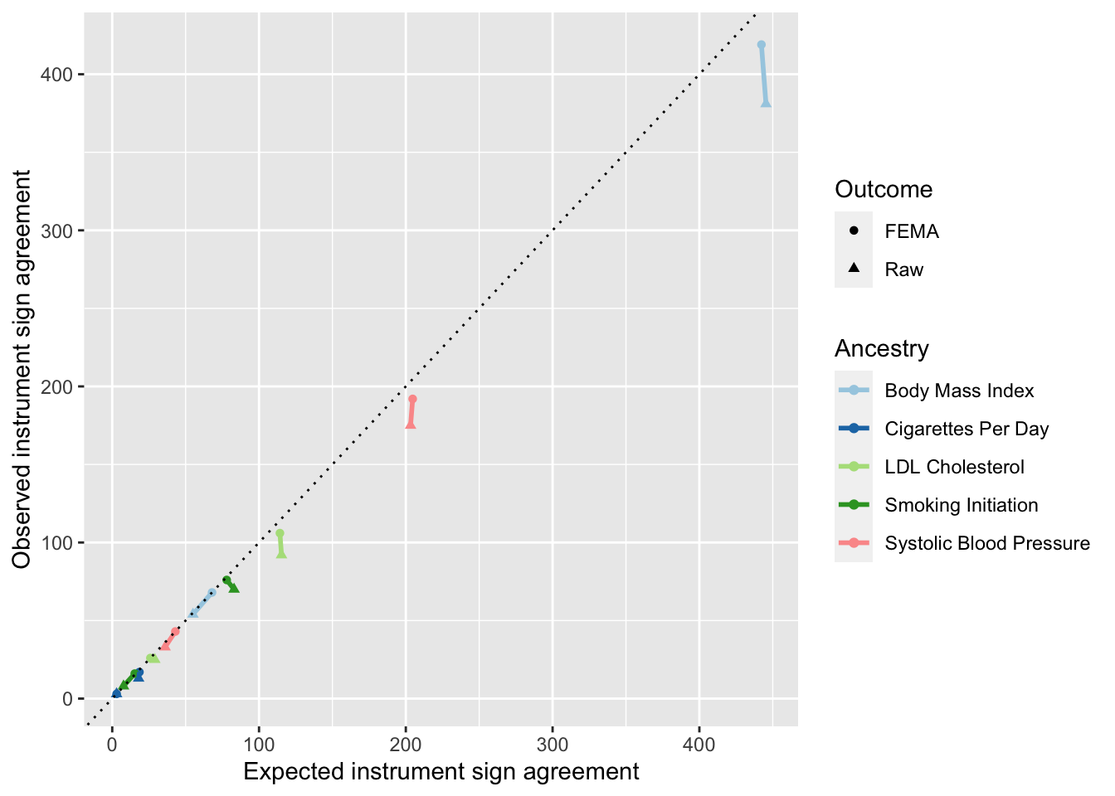

Supplementary figure 2: Agreement of instrument associations between European GWAS and Biobank Japan

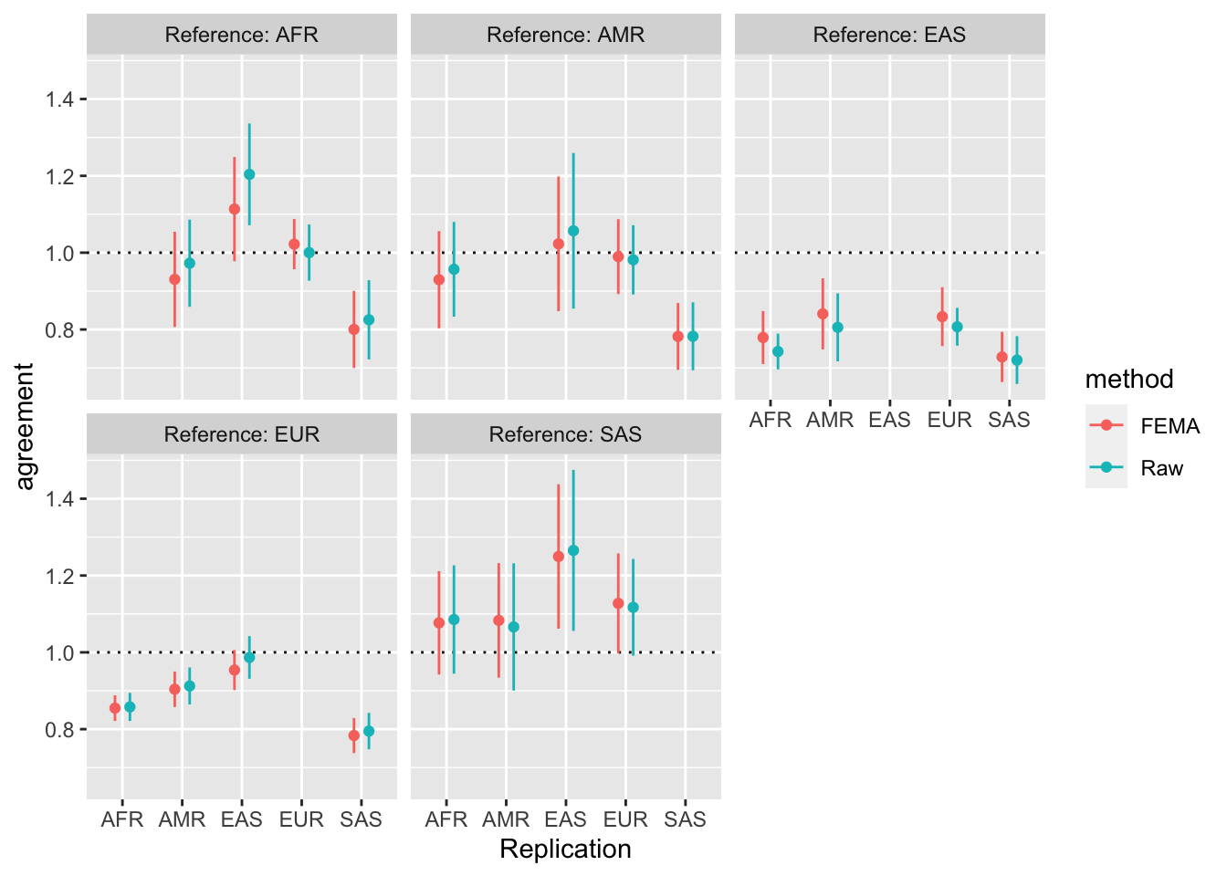

Supplementary figure 3: Agreement of instrument effect sizes for LDL cholesterol levels across populations.

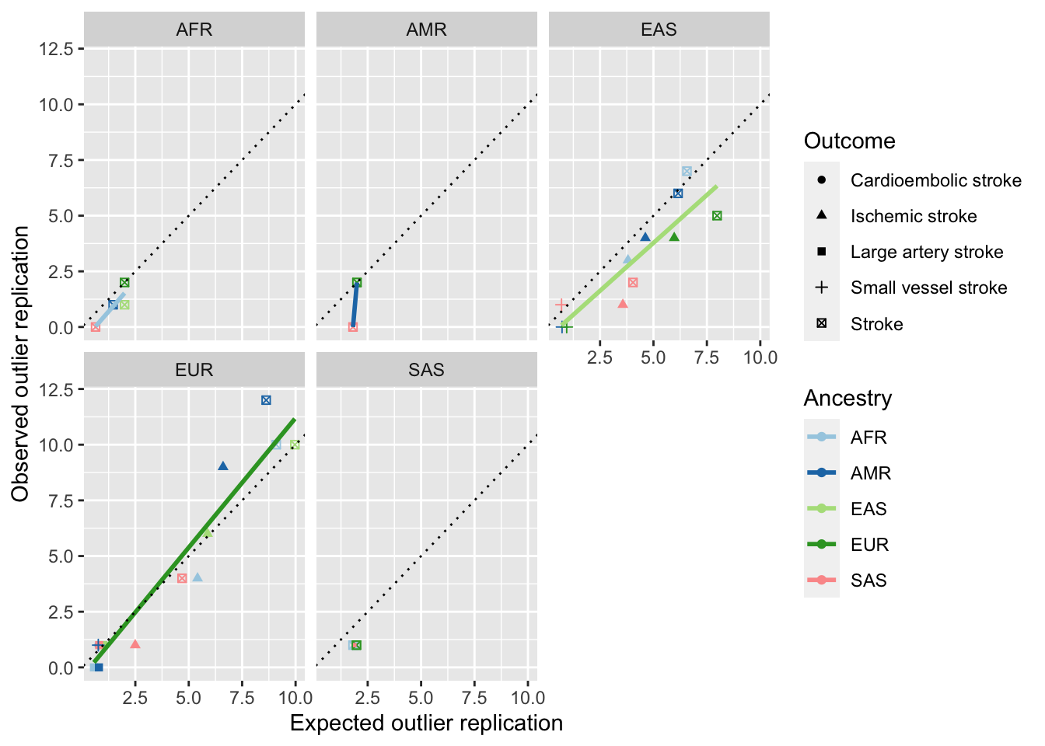

Supplementary figure 4: Consistency of horizontal pleiotropy in MR analyses across populations

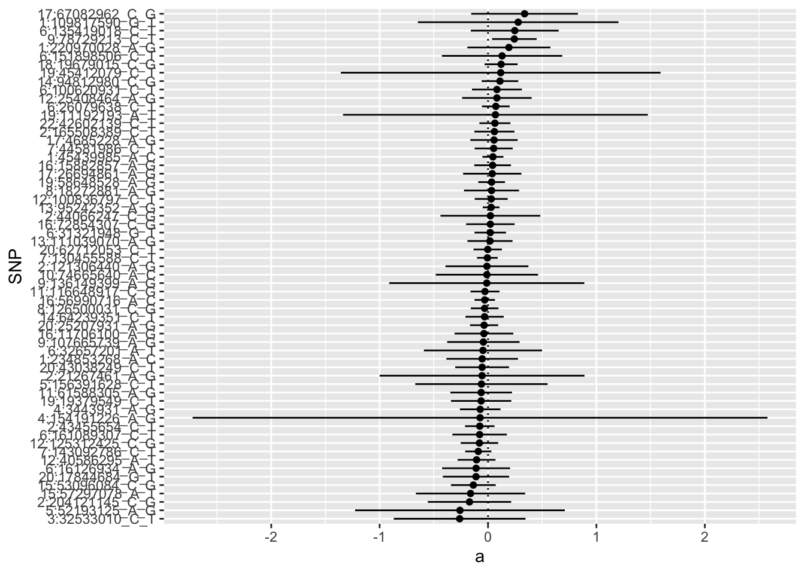

Supplementary figure 5: Distribution of MR GxE estimates of horizontal pleiotropy for LDL cholesterol instruments.
This analysis is restricted to those instruments that showed evidence of SNP-exposure heterogeneity across populations (Q statistic p-value < 0.05). The x-axis represents the MR GxE estimate of the horizontal pleiotropic effect.
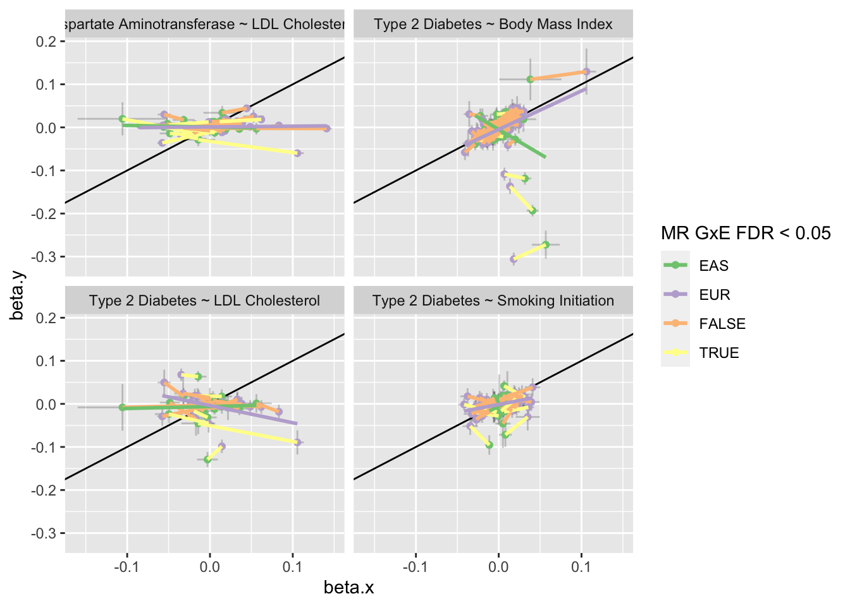

Supplementary figure 6: Distribution of MR GxE estimates of horizontal pleiotropy for four exposure-outcome associations.
The SNP-exposure effect (x-axis) and the SNP-outcome effect (y-axis) are plotted for instruments showing SNP-exposure effect estimate heterogeneity between European samples and Biobank Japan. Lines represent the MR GxE estimate, with the slope between the estimates from the two populations representing the estimated causal effect and the intercept on the y-axis being the estimated horizontal pleiotropic effect.

