SUPPLEMENTARY MATERIAL

Molecular Insights into AG73@Syndecan-4 Interactions: Implications for Cancer Cell Adhesion, Migration, and Therapeutic Potential.
Francisco das Chagas Pereira de Andrade^{1,2} - ORCID: 0000-0003-0141-2341
Anderson Nogueira Mendes^{1,2*}- ORCID: 0000-0002-9778-3667
- Laboratory of Innovation in Science and Technology – LACITEC, Department of Biophysics and Physiology, Federal University of Piauí, 64049-550, Teresina, Piauí, Brazil
- Department of Biophysics and Physiology, Federal University of Piauí, Teresina 64049-550, Brazil

*Corresponding author: Dr. Anderson Nogueira Mendes, Laboratory of Innovation in Science and Technology – LACITEC, Department of Biophysics and Physiology, Federal University of Piauí, Teresina, Piauí, PI, Brazil phone number: +55 86 32372105, e-mail address: anderson.mendes@ufpi.edu.br

Running Title: Cell adhesion; Cancer cell migration; PKCα activation; Syndecan 4.
Supplement 1. AG73 in silico ADMET properties. (A) Druglikeness porperties. (B) Toxicity properties. the AG73 peptide demonstrates poor drug similarity due to its high molecular weight, significant flexibility, and high hydrogen bonding capacity and low toxicity. These ADME characteristics suggest strong interaction potential with biomacromolecules, and they also imply challenges in solubility and permeability, which could limit oral bioavailability like moderate intestinal permeability, low human intestinal absorption (HIA) and bioavailability, which suggests poor absorption when administered orally, That may imply alternative delivery methods, such as intravenous administration, or through drug carriers to enhance its effectiveness in therapeutic potential.By ADMETSAR 3.0

Supplement 2. Ramachandran and HBond contact plots. (A) Unbonded Syndecan 4; (B) Syndecan-4@AG73 complex; Amino acids are represented in green; blue lines delimit the most favourable regions; magenta lines delimit the more permissive additional regions; and non-permissive regions correspond to unbounded regions. (C) Unbonded Syndecan 4; (D) Syndecan-4@AG73; the mayor number of HBondes of the complex (D) identify the functional stability of the complex. Graphics were generated in Software Discovery Studio 2020.

Supplement 1.
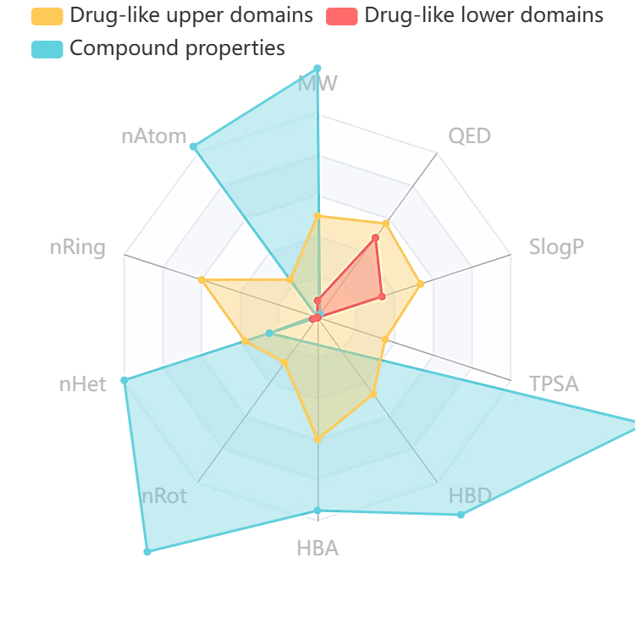
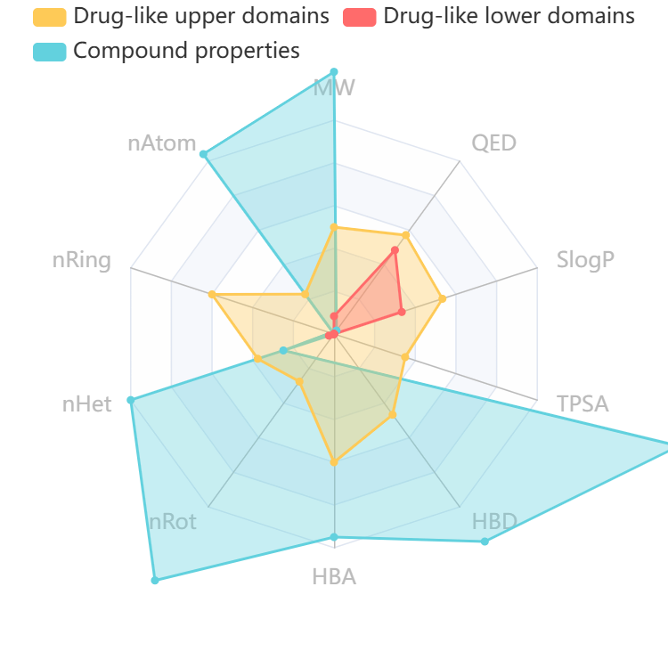
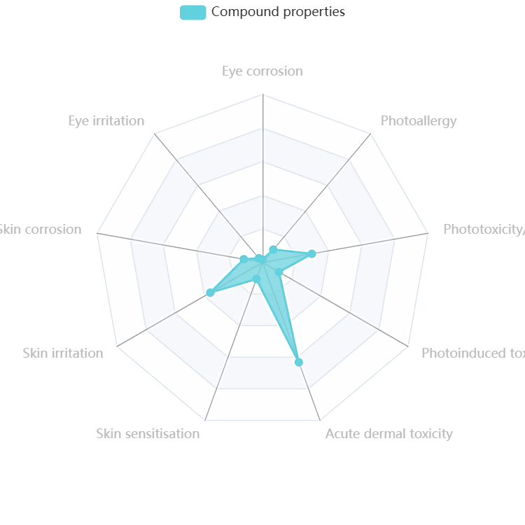
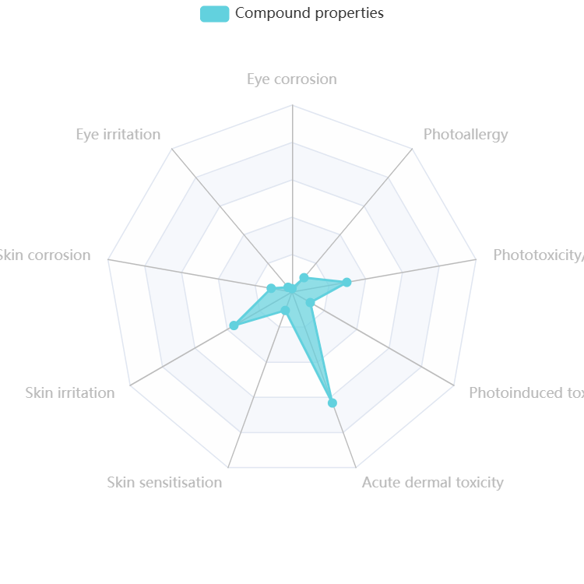

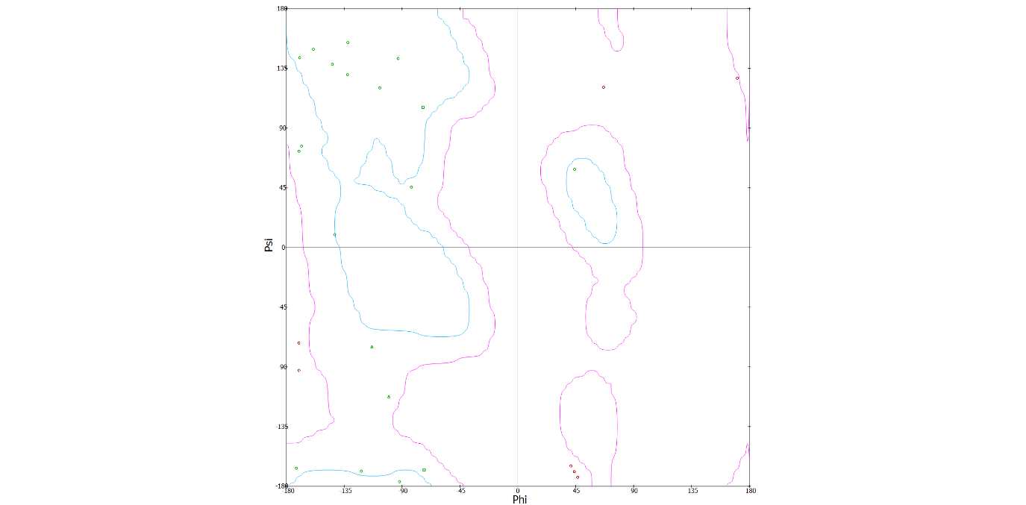
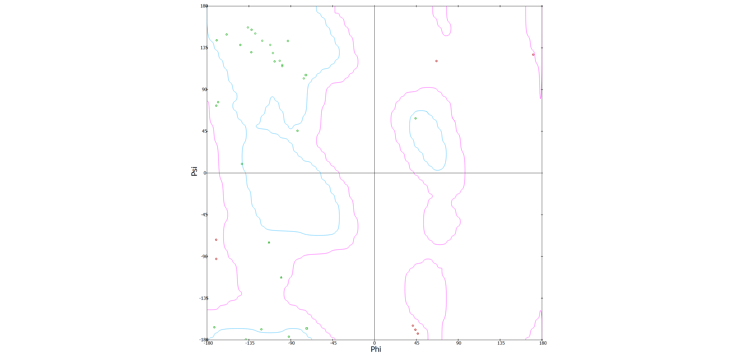
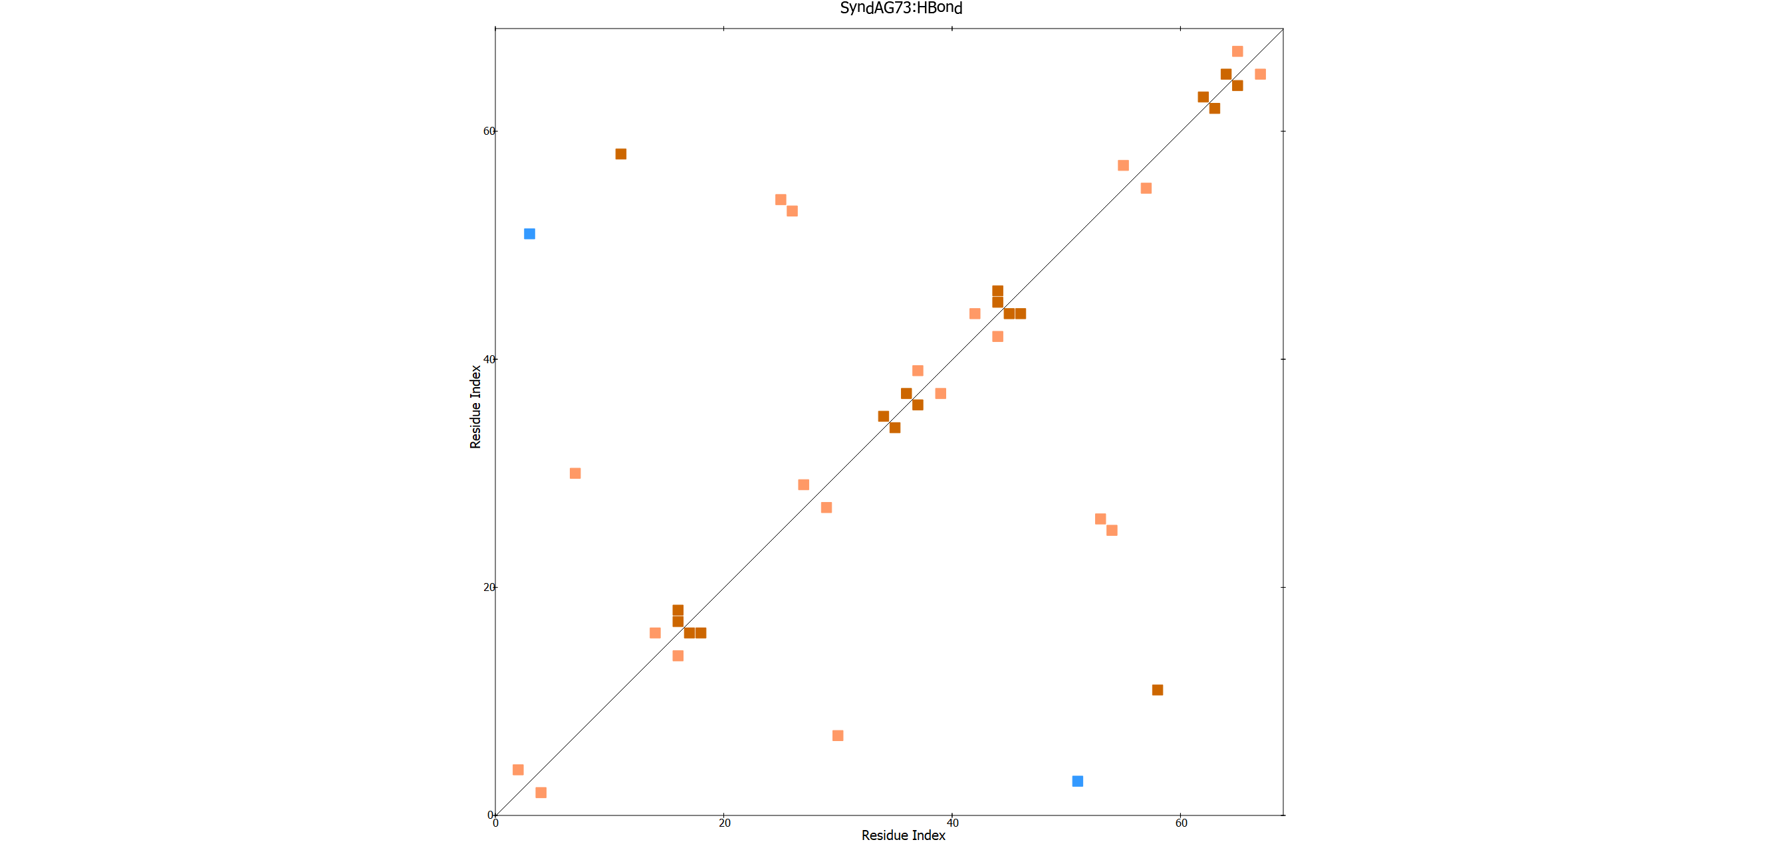
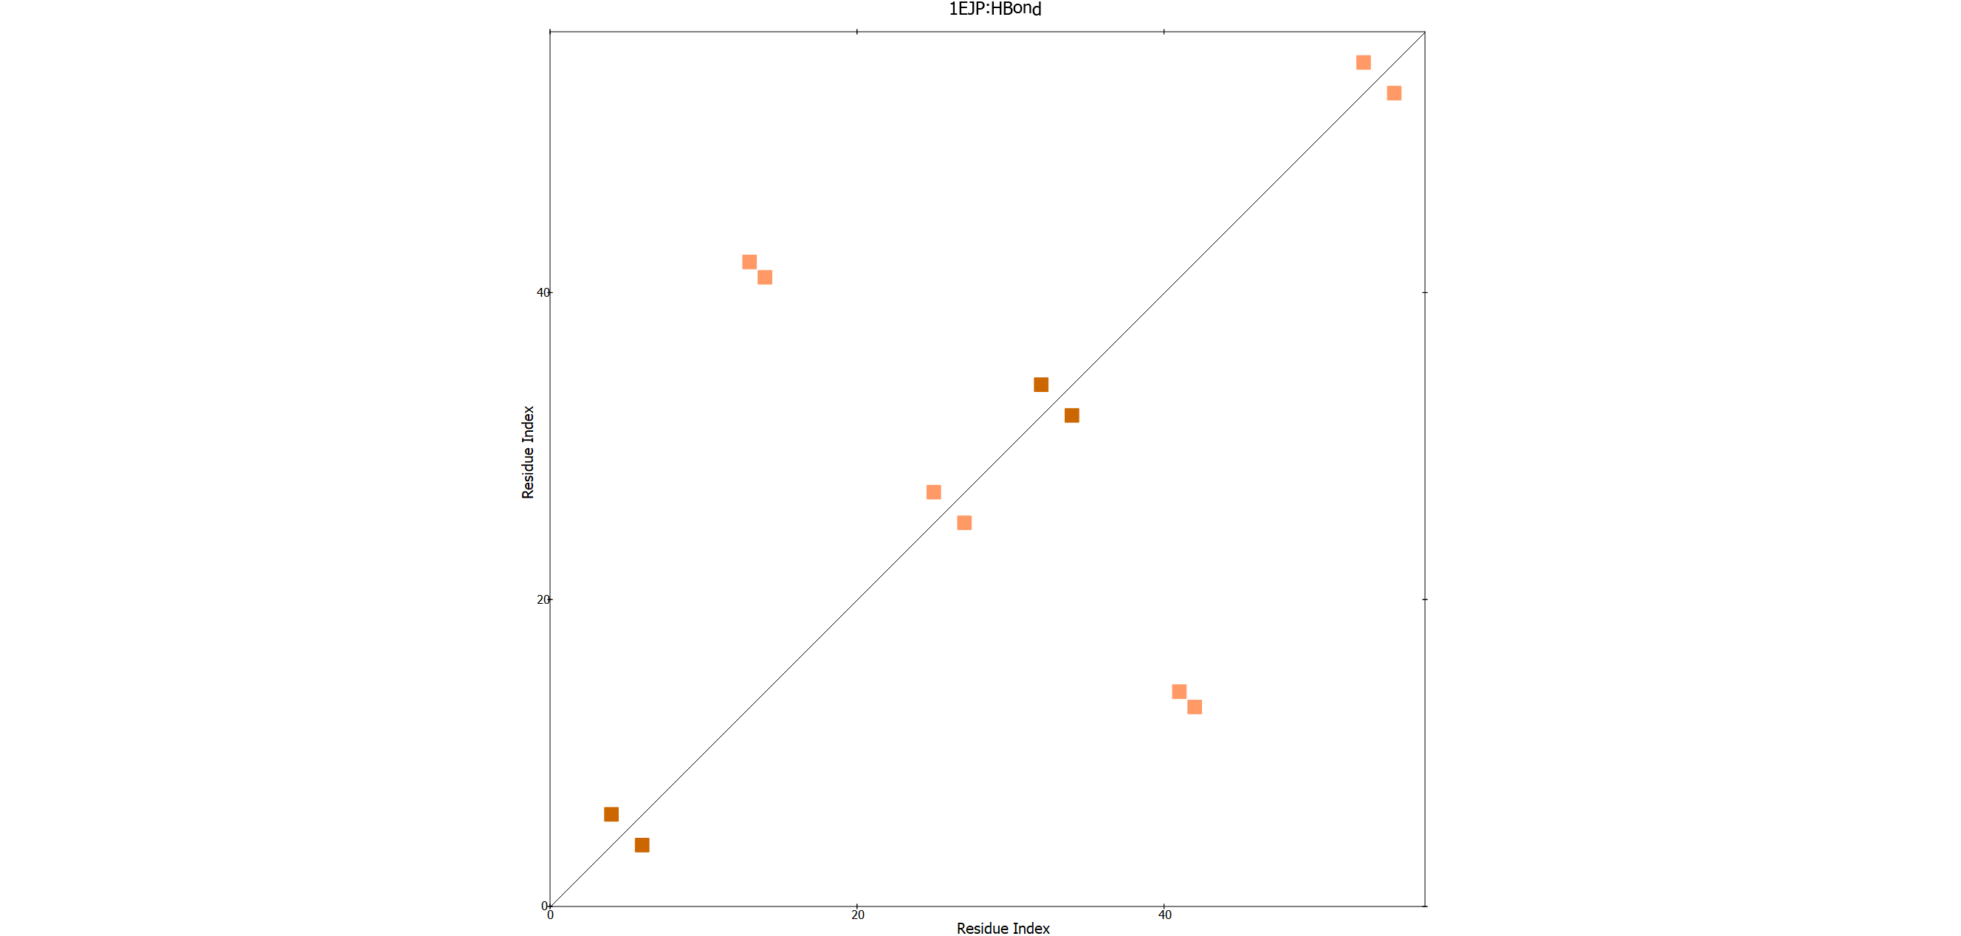
Supplement 2
A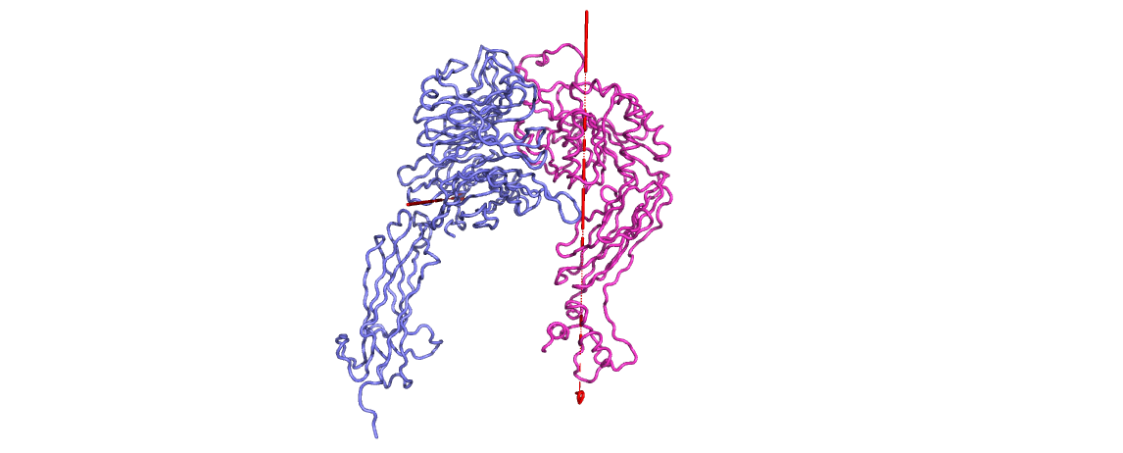
B
C
D

