Supplementary Figure S1
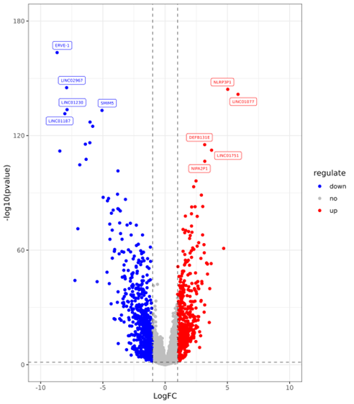
Figure S1. Volcano plot of TCGA renal clear cell carcinoma.

Supplementary Figure S2
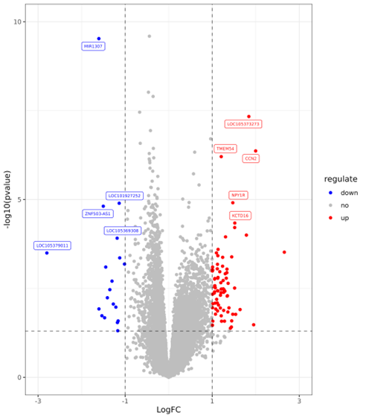
Figure S2. Volcano plot of BMI.

Supplementary Figure S3
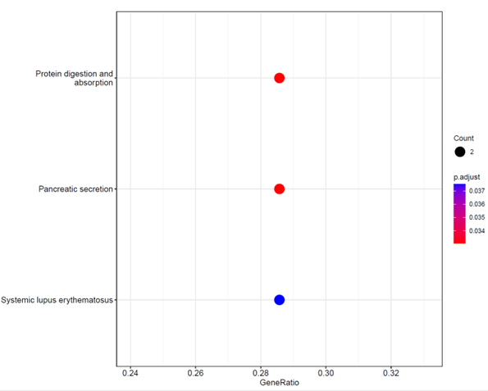
Figure S3. KEGG enrichment results of SLPI-related-genes.

