All-purpose nanostrategy based on dose deposition enhancement, cell cycle arrest, DNA damage and ROS production as prostate cancer radiosensitizer for potential clinical translation
Xiao-xiao Guo ^{a, d}, Zhen-hu Guo ^{b}, Meng Wu ª, Jing-song Lu ^{b}, Wen-sheng Xie ^{b}, Qiu-zi Zhong ^{c}, Yong-jie Chi ^{b}, Xiao-dan Sun ^{b}, Xiu-mei Wang^{b} , Jian-ye Wang ^{a,}*, Ming Liu ^{a,}*, and Ling-yun Zhao ^{b,}*
ª Department of Urology, National Center of Gerontology, Institute of Geriatric Medicine, Beijing Hospital, Chinese Academy of Medical Science, Beijing, 100730, China
^{b} Key Laboratory of Advanced Materials, Ministry of Education of China, School of Materials Science and Engineering, Tsinghua University, Beijing, 100084, China
^{c} Department of Radiotherapy, National Center of Gerontology, Institute of Geriatric Medicine, Beijing Hospital, Chinese Academy of Medical Science, Beijing, 100730, China
^{d} Graduate School of Peking Union Medical College, Beijing, 100730, China
* Corresponding authors

Synthesis of Au core
0.25 mmol of gold chloride trihydrate (HAuCl₄·3H₂O) was dissolved in the mixture solution of hexane (10 mL) and oleylamine (10 mL) in a four-necked flask. The system was stirred at 5℃ under argon atmosphere. Then, 0.25 mmol of borane-tert-butylamine complex was dissolved in the mixture solution of hexane (1 mL) and oleylamine (1 mL) and added into the system. The mixture was stirred for 2h at 5℃ before acetone was added to collect AuNPs via centrifugation at 10000 rpm for 8 min. The products were washed for 3 times by ethanol and finally re-dispersed in hexane for future use. TEM image shows the uniform size of Au NPs.
Figure S1. TEM imaging of 5nm naked Au nanospheres
Figure S2. The amphipathy of Au-DUPA NPs. (a) Au -DUPA NPs were dissolved in dichlormethane, the supernate was water. (b) Au -DUPA NPs dissolved in water, the subnatant is dichlormethane.

Figure S3. Cumulative DTX release from Au@DTX-DUPA NPs at the indicated times (Solvent: Hank’s Balanced Salt Solution [HBSS]; temperature = 37 °C; pH=7.4).

Figure S4. Immunohistochemical validation of prostate specific membrane antigen (PSMA) expression in (a) PC3 cell line; (b) 22RV1 cell line. Brown stain represents the expression of PSMA.

Figure S5. Survival curves of 22RV1 cells incubated with Au-DUPA NPs or Au@DOC-DUPA NPs at various concentrations under 4 Gy electron irradiation. Data are represented as mean ± SD (n=5), * P < 0.05.

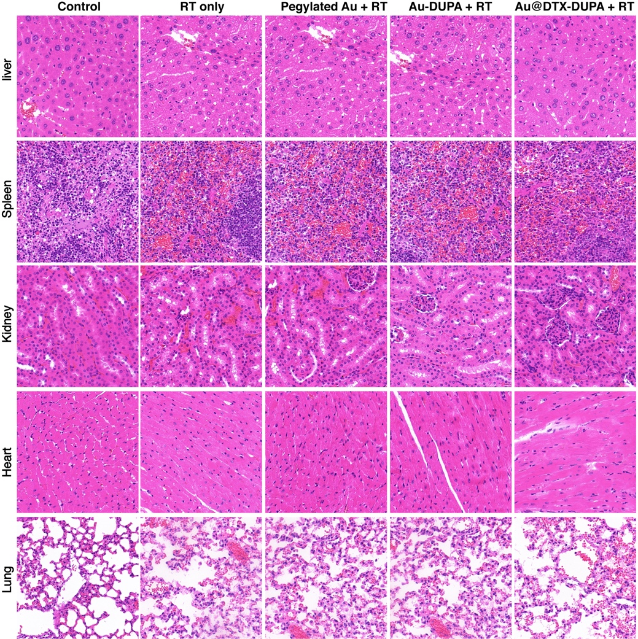
Figure S6. H&E staining slices of liver, spleen, kidney, heart, and lung, at the 15th day following various treatments. Neither prominent damage nor inflammation were observed.

Figure S7. The Au content of main viscus and tumor at 24 h after injection of Au@DTX-DUPA NPs. Data are represented as mean ± SD (n=5).

