Zinc and Manganese Impact on Cabbage (Brassica rapa) Cadmium Tolerance: Comparative Transcriptomic and Metabolomic Study
WanYu Li ^{a,b}, FanXin Qin ^{a,b,*}, BangLin Luo^{c}, Qiu Huang ^{a,b}, AnQi Xu ^{a,b} and Rui Wu ^{a,b}
ª School of Life Sciences, Guizhou Normal University, 550025 Guiyang, China.
^{b} Guizhou Key Laboratory of Plant Physiology and Developmental Regulation, Guizhou Normal University, 550025 Guiyang, China.
^{c} College of Resources and Environment/Key Laboratory of Eco-environment in Three Gorges Region (Ministry of Education), Southwest University, 400715 Chongqing, China.
* Corresponding Author:
FanXin Qin* Email: qinfanxin@gznu.edu.cn
Mail address: Dongqing Road 1, Guizhou, 550025, China.
Tel: +0851-83227351
Fax number: +0851-8322735

Table S1.The KEGG pathway of significant enrichment DAMs in cabbage roots under Zn, Mn and ZnMn treatment.
Treatment | pathway | Total | Expected | Hits | Raw p | #NAME? | Holm adjust | FDR | Impact | Fold Enrichment | #NAME? | Description
Zn | ko00970 | 52 | 1.3236 | 10 | 5.056e-07 | 14.498 | 8.3423e-05 | 8.3423e-05 | 0.31429 | 7.5552 | 6.2962 | Aminoacyl-tRNA biosynthesis
Zn | ko01232 | 56 | 1.4254 | 10 | 1.0441e-06 | 13.772 | 0.00017124 | 8.6142e-05 | 0.21239 | 7.0155 | 5.9812 | Nucleotide metabolism
Zn | ko01230 | 128 | 3.2581 | 14 | 3.4018e-06 | 12.591 | 0.0005545 | 0.0001871 | 0.13245 | 4.297 | 5.4683 | Biosynthesis of amino acids
Zn | ko00410 | 25 | 0.63634 | 6 | 2.8649e-05 | 10.46 | 0.0046411 | 0.0011818 | 0.24138 | 9.4289 | 4.5429 | beta-Alanine metabolism
Zn | ko00600 | 21 | 0.53453 | 5 | 0.00014444 | 8.8427 | 0.023254 | 0.0047664 | 0.26471 | 9.354 | 3.8403 | Sphingolipid metabolism
Zn | ko00470 | 56 | 1.4254 | 7 | 0.00047993 | 7.6419 | 0.076789 | 0.013198 | 0.13043 | 4.9109 | 3.3188 | D-Amino acid metabolism
Zn | ko00460 | 45 | 1.1454 | 6 | 0.00086896 | 7.0482 | 0.13817 | 0.020483 | 0.1087 | 5.2383 | 3.061 | Cyanoamino acid metabolism
Zn | ko00230 | 85 | 2.1636 | 8 | 0.0013076 | 6.6395 | 0.20661 | 0.024186 | 0.10853 | 3.6976 | 2.8835 | Purine metabolism
Zn | ko00340 | 33 | 0.83997 | 5 | 0.0013192 | 6.6307 | 0.20712 | 0.024186 | 0.25714 | 5.9526 | 2.8797 | Histidine metabolism
Zn | ko00330 | 69 | 1.7563 | 7 | 0.001699 | 6.3777 | 0.26505 | 0.028034 | 0.23864 | 3.9856 | 2.7698 | Arginine and proline metabolism
Zn | ko00564 | 52 | 1.3236 | 6 | 0.0018788 | 6.2771 | 0.29121 | 0.028181 | 0.1625 | 4.5331 | 2.7261 | Glycerophospholipid metabolism
Zn | ko00240 | 62 | 1.5781 | 6 | 0.0046146 | 5.3785 | 0.71065 | 0.063451 | 0.17391 | 3.802 | 2.3359 | Pyrimidine metabolism
Zn | ko00310 | 46 | 1.1709 | 5 | 0.0058563 | 5.1402 | 0.89601 | 0.07433 | 0.2 | 4.2703 | 2.2324 | Lysine degradation
Zn | ko00260 | 47 | 1.1963 | 5 | 0.0064226 | 5.0479 | 0.97624 | 0.075695 | 0.24242 | 4.1795 | 2.1923 | Glycine, serine and threonine metabolism
Zn | ko00945 | 18 | 0.45817 | 3 | 0.0099293 | 4.6123 | 1 | 0.10922 | 0.1 | 6.5478 | 2.0031 | Stilbenoid, diarylheptanoid and gingerol biosynthesis
Zn | ko00940 | 56 | 1.4254 | 5 | 0.013346 | 4.3165 | 1 | 0.13297 | 0.13636 | 3.5078 | 1.8747 | Phenylpropanoid biosynthesis
Zn | ko00590 | 37 | 0.94179 | 4 | 0.013797 | 4.2833 | 1 | 0.13297 | 0.054054 | 4.2472 | 1.8602 | Arachidonic acid metabolism
Zn | ko00480 | 38 | 0.96724 | 4 | 0.015123 | 4.1915 | 1 | 0.13297 | 0.22807 | 4.1355 | 1.8204 | Glutathione metabolism
Zn | ko00430 | 21 | 0.53453 | 3 | 0.015312 | 4.1791 | 1 | 0.13297 | 0.083333 | 5.6124 | 1.815 | Taurine and hypotaurine metabolism
Zn | ko00220 | 23 | 0.58544 | 3 | 0.019652 | 3.9296 | 1 | 0.16213 | 0.26667 | 5.1244 | 1.7066 | Arginine biosynthesis
Mn | ko00230 | 85 | 2.2522 | 11 | 1.1819e-05 | 11.346 | 0.0019501 | 0.0010576 | 0.15504 | 4.884 | 4.9274 | Purine metabolism
Mn | ko01232 | 56 | 1.4838 | 9 | 1.282e-05 | 11.265 | 0.0021024 | 0.0010576 | 0.20354 | 6.0654 | 4.8921 | Nucleotide metabolism
Mn | ko00600 | 21 | 0.55644 | 5 | 0.00017466 | 8.6526 | 0.02847 | 0.0096065 | 0.26471 | 8.9858 | 3.7578 | Sphingolipid metabolism
Mn | ko00564 | 52 | 1.3778 | 7 | 0.00038545 | 7.8611 | 0.062443 | 0.011518 | 0.1875 | 5.0804 | 3.414 | Glycerophospholipid metabolism
Mn | ko00970 | 52 | 1.3778 | 7 | 0.00038545 | 7.8611 | 0.062443 | 0.011518 | 0.2 | 5.0804 | 3.414 | Aminoacyl-tRNA biosynthesis
Mn | ko00410 | 25 | 0.66242 | 5 | 0.00041882 | 7.7781 | 0.067011 | 0.011518 | 0.24138 | 7.548 | 3.378 | beta-Alanine metabolism
Mn | ko00140 | 89 | 2.3582 | 9 | 0.00051452 | 7.5723 | 0.081808 | 0.012128 | 0.1068 | 3.8164 | 3.2886 | Steroid hormone biosynthesis
Mn | ko00460 | 45 | 1.1924 | 6 | 0.001073 | 6.8373 | 0.16953 | 0.02213 | 0.13043 | 5.032 | 2.9694 | Cyanoamino acid metabolism
Mn | ko00330 | 69 | 1.8283 | 7 | 0.0021413 | 6.1463 | 0.33619 | 0.039258 | 0.14773 | 3.8287 | 2.6693 | Arginine and proline metabolism
Mn | ko01240 | 304 | 8.0551 | 16 | 0.0060426 | 5.1089 | 0.94265 | 0.097243 | 0.057325 | 1.9863 | 2.2188 | Biosynthesis of cofactors
Mn | ko01230 | 128 | 3.3916 | 9 | 0.0064829 | 5.0386 | 1 | 0.097243 | 0.07947 | 2.6536 | 2.1882 | Biosynthesis of amino acids
Mn | ko00340 | 33 | 0.8744 | 4 | 0.010613 | 4.5457 | 1 | 0.14064 | 0.11429 | 4.5746 | 1.9742 | Histidine metabolism
Mn | ko00945 | 18 | 0.47695 | 3 | 0.011081 | 4.5025 | 1 | 0.14064 | 0.1 | 6.29 | 1.9554 | Stilbenoid, diarylheptanoid and gingerol biosynthesis
Mn | ko00750 | 23 | 0.60943 | 3 | 0.021848 | 3.8237 | 1 | 0.25261 | 0.22222 | 4.9226 | 1.6606 | Vitamin B6 metabolism
Mn | ko00240 | 62 | 1.6428 | 5 | 0.023417 | 3.7543 | 1 | 0.25261 | 0.1087 | 3.0436 | 1.6305 | Pyrimidine metabolism
Mn | ko00780 | 24 | 0.63593 | 3 | 0.024496 | 3.7093 | 1 | 0.25261 | 0.11538 | 4.7175 | 1.6109 | Biotin metabolism
Mn | ko00310 | 46 | 1.2189 | 4 | 0.032554 | 3.4248 | 1 | 0.31597 | 0.17778 | 3.2818 | 1.4874 | Lysine degradation
Mn | ko00260 | 47 | 1.2454 | 4 | 0.034876 | 3.356 | 1 | 0.31904 | 0.19697 | 3.2119 | 1.4575 | Glycine, serine and threonine metabolism
Mn | ko00250 | 28 | 0.74192 | 3 | 0.036738 | 3.3039 | 1 | 0.31904 | 0.21053 | 4.0436 | 1.4349 | Alanine, aspartate and glutamate metabolism
Mn | ko00470 | 56 | 1.4838 | 4 | 0.060008 | 2.8133 | 1 | 0.47149 | 0.065217 | 2.6957 | 1.2218 | D-Amino acid metabolism
ZnMn | ko00564 | 52 | 1.3453 | 8 | 4.6361e-05 | 9.9791 | 0.0076495 | 0.0066202 | 0.2125 | 5.9467 | 4.3339 | Glycerophospholipid metabolism
ZnMn | ko01232 | 56 | 1.4488 | 8 | 8.0245e-05 | 9.4304 | 0.01316 | 0.0066202 | 0.16814 | 5.5219 | 4.0956 | Nucleotide metabolism
ZnMn | ko00600 | 21 | 0.54329 | 5 | 0.000156 | 8.7657 | 0.025428 | 0.0085799 | 0.26471 | 9.2031 | 3.8069 | Sphingolipid metabolism
ZnMn | ko00410 | 25 | 0.64678 | 5 | 0.00037484 | 7.889 | 0.060725 | 0.015462 | 0.24138 | 7.7306 | 3.4261 | beta-Alanine metabolism
ZnMn | ko00240 | 62 | 1.604 | 7 | 0.00098795 | 6.9199 | 0.15906 | 0.032602 | 0.16304 | 4.3641 | 3.0053 | Pyrimidine metabolism
ZnMn | ko00260 | 47 | 1.2159 | 6 | 0.0011963 | 6.7285 | 0.19141 | 0.032899 | 0.21212 | 4.9345 | 2.9221 | Glycine, serine and threonine metabolism
ZnMn | ko00340 | 33 | 0.85375 | 5 | 0.0014189 | 6.5579 | 0.22561 | 0.033079 | 0.25714 | 5.8565 | 2.848 | Histidine metabolism
ZnMn | ko01230 | 128 | 3.3115 | 10 | 0.0016038 | 6.4354 | 0.25341 | 0.033079 | 0.10596 | 3.0198 | 2.7948 | Biosynthesis of amino acids
ZnMn | ko01240 | 304 | 7.8648 | 17 | 0.0019151 | 6.258 | 0.30066 | 0.033686 | 0.066879 | 2.1615 | 2.7178 | Biosynthesis of cofactors
ZnMn | ko00970 | 52 | 1.3453 | 6 | 0.0020415 | 6.194 | 0.31848 | 0.033686 | 0.2 | 4.46 | 2.69 | Aminoacyl-tRNA biosynthesis
ZnMn | ko00460 | 45 | 1.1642 | 5 | 0.0057052 | 5.1664 | 0.88431 | 0.083521 | 0.086957 | 4.2948 | 2.2437 | Cyanoamino acid metabolism
ZnMn | ko00230 | 85 | 2.199 | 7 | 0.0060742 | 5.1037 | 0.93543 | 0.083521 | 0.10078 | 3.1832 | 2.2165 | Purine metabolism
ZnMn | ko00330 | 69 | 1.7851 | 6 | 0.0084165 | 4.7776 | 1 | 0.10682 | 0.14773 | 3.3612 | 2.0749 | Arginine and proline metabolism
ZnMn | ko00945 | 18 | 0.46568 | 3 | 0.010381 | 4.5678 | 1 | 0.12235 | 0.1 | 6.4422 | 1.9838 | Stilbenoid, diarylheptanoid and gingerol biosynthesis
ZnMn | ko00470 | 56 | 1.4488 | 5 | 0.014243 | 4.2515 | 1 | 0.15031 | 0.086957 | 3.4512 | 1.8464 | D-Amino acid metabolism
ZnMn | ko00590 | 37 | 0.95723 | 4 | 0.014575 | 4.2284 | 1 | 0.15031 | 0.054054 | 4.1787 | 1.8364 | Arachidonic acid metabolism
ZnMn | ko00480 | 38 | 0.9831 | 4 | 0.015972 | 4.1369 | 1 | 0.15502 | 0.22807 | 4.0688 | 1.7966 | Glutathione metabolism
ZnMn | ko00780 | 24 | 0.62091 | 3 | 0.023012 | 3.7718 | 1 | 0.21094 | 0.19231 | 4.8317 | 1.6381 | Biotin metabolism
ZnMn | ko00650 | 44 | 1.1383 | 4 | 0.026101 | 3.6458 | 1 | 0.22667 | 0.10909 | 3.5139 | 1.5833 | Butanoate metabolism
ZnMn | ko00310 | 46 | 1.1901 | 4 | 0.030169 | 3.5009 | 1 | 0.2489 | 0.066667 | 3.3612 | 1.5204 | Lysine degradation

Table S2. The table of correlation between differential genes and differential metabolites expressions under Zn, Mn and ZnMn treatment.
Treatment | Gene | Cpd | r_value | p_value
Zn | Bra008242 | M779T148 | 1 | 0.002777778
Zn | Bra017656 | M779T148 | 1 | 0.002777778
Zn | Bra021451 | M779T148 | 1 | 0.002777778
Zn | Bra027121 | M779T148 | 1 | 0.002777778
Zn | Bra010529 | M779T148 | 1 | 0.002777778
Zn | Bra024328 | M779T148 | 1 | 0.002777778
Zn | Bra023403 | M779T148 | 1 | 0.002777778
Zn | Bra013165 | M779T148 | 1 | 0.002777778
Zn | Bra017795 | M779T148 | 1 | 0.002777778
Zn | Bra004144 | M779T148 | 1 | 0.002777778
Mn | Bra000613 | M779T148 | 1 | 0.002777778
Mn | Bra017702 | M779T148 | 1 | 0.002777778
Mn | Bra039047 | M779T148 | 1 | 0.002777778
Mn | Bra033480 | M779T148 | 1 | 0.002777778
Mn | Bra006808 | M779T148 | 1 | 0.002777778
Mn | Bra015227 | M779T148 | 1 | 0.002777778
Mn | Bra028400 | M779T148 | 1 | 0.002777778
Mn | Bra027121 | M779T148 | 1 | 0.002777778
Mn | Bra011540 | M779T148 | 1 | 0.002777778
Mn | Bra016002 | M779T148 | 1 | 0.002777778
ZnMn | Bra039749 | M779T148 | 1 | 0.002777778
ZnMn | Bra015208 | M779T148 | 1 | 0.002777778
ZnMn | Bra040819 | M779T148 | 1 | 0.002777778
ZnMn | Bra025664 | M779T148 | 1 | 0.002777778
ZnMn | Bra039508 | M779T148 | 1 | 0.002777778
ZnMn | Bra001874 | M355T168 | 1 | 0.002777778
ZnMn | Bra007890 | M355T168 | 1 | 0.002777778
ZnMn | Bra040833 | M355T168 | 1 | 0.002777778
ZnMn | Bra001875 | M355T168 | 1 | 0.002777778
ZnMn | Bra038516 | M355T168 | 1 | 0.002777778

Table S3. The KEGG co-enrichment pathway of differential genes and differential metabolites in cabbage roots under Zn, Mn and ZnMn treatment.
 | mapID | Description | Transcriptome Pvalue | Combination Pvalue
Zn | 00062 | Fatty acid elongation | 0.000019 | 0.000230
Zn | 00073 | Cutin, suberine and wax biosynthesis | 0.000518 | 0.004440
Zn | 00940 | Phenylpropanoid biosynthesis | 0.000759 | 0.006211
Zn | 00280 | Valine, leucine and isoleucine degradation | 0.002867 | 0.019651
Zn | 00040 | Pentose and glucuronate interconversions | 0.004749 | 0.030155
Mn | 01250 | Biosynthesis of nucleotide sugars | 0.000022 | 0.000253
Mn | 00380 | Tryptophan metabolism | 0.000044 | 0.000485
Mn | 00630 | Glyoxylate and dicarboxylate metabolism | 0.000100 | 0.001018
Mn | 00480 | Glutathione metabolism | 0.002062 | 0.014816
Mn | 00941 | Flavonoid biosynthesis | 0.006421 | 0.038835
Mn | 00520 | Amino sugar and nucleotide sugar metabolism | 0.006853 | 0.041003
ZnMn | 00480 | Glutathione metabolism | 0.000001 | 0.000019
ZnMn | 00966 | Glucosinolate biosynthesis， | 0.000007 | 0.000092
ZnMn | 00062 | Fatty acid elongation | 0.000174 | 0.001680
ZnMn | 00999 | Biosynthesis of various plant secondary metabolites | 0.000858 | 0.006919
ZnMn | 00945 | Stilbenoid, diarylheptanoid and gingerol biosynthesis | 0.001389 | 0.010527
ZnMn | 00920 | Sulfur metabolism | 0.001658 | 0.012272
ZnMn | 00380 | Tryptophan metabolism | 0.001667 | 0.012331
ZnMn | 00270 | Cysteine and methionine metabolism | 0.002337 | 0.016496
ZnMn | 00400 | Phenylalanine, tyrosine and tryptophan biosynthesis | 0.003547 | 0.023558
ZnMn | 00908 | Zeatin biosynthesis | 0.005817 | 0.035758
ZnMn | 00941 | Flavonoid biosynthesis | 0.009471 | 0.053600
ZnMn | 00960 | Tropane, piperidine and pyridine alkaloid biosynthesis | 0.009056 | 0.051658

Figure S1. The number of up-regulated and down-regulated genes in each GO Terms in the three comparison groups, Zn-vs-CK (A), Mn-vs-CK (B), and ZnMn-vs-CK (C).

Figure S2. The number of up-regulated and down-regulated genes in each KEGG pathway in the three comparison groups, Zn-vs-CK (A), Mn-vs-CK (B), and ZnMn-vs-CK (C).
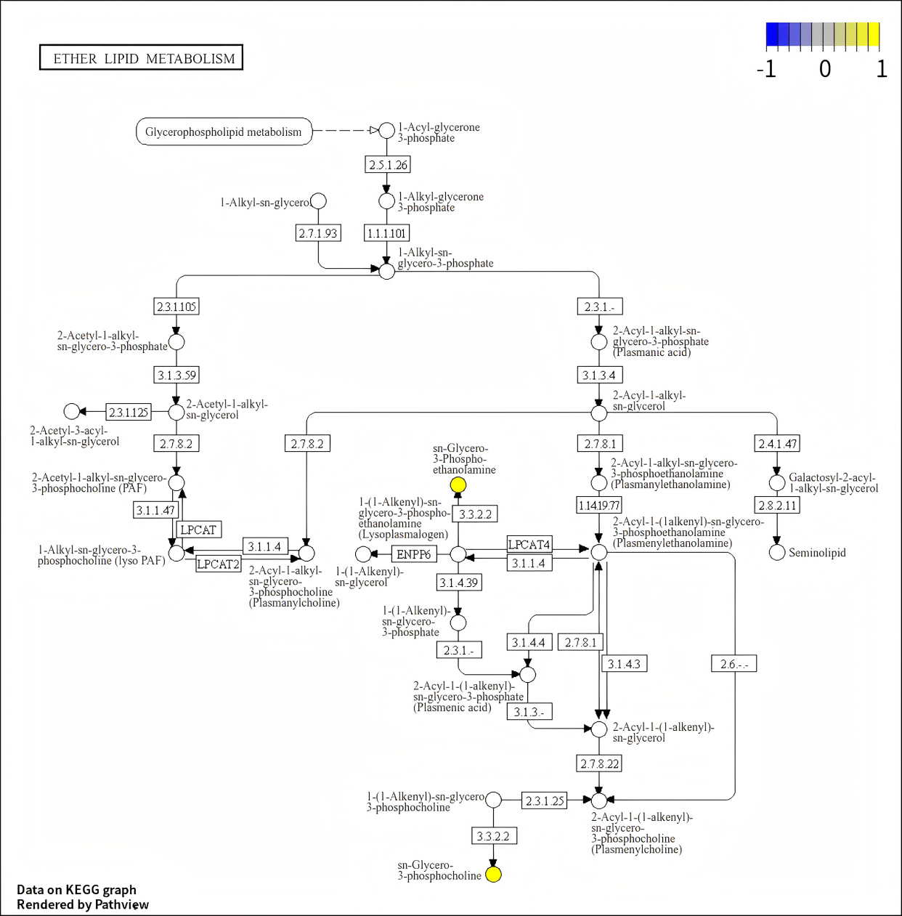
Figure S3. The KEGG pathway map for synthesis of lipid metabolism in the three comparison groups.

Figure S4. The Map of correlation network between differential genes and differential metabolites in the three comparison groups, Zn-vs-CK (A), Mn-vs-CK (B), and ZnMn-vs-CK (C).
Figure S5. The KEGG pathway map for Phenylpropanoid biosynthesis (A), Tryptophan biosynthesis (B), and Circadian rhythm plant (C)
Zn-vs-CK, Mn-vs-CK, and ZnMn-vs-CK comparison groups respectively.

