Extended data: The economic strategies of superorganisms
8 Figures/tables
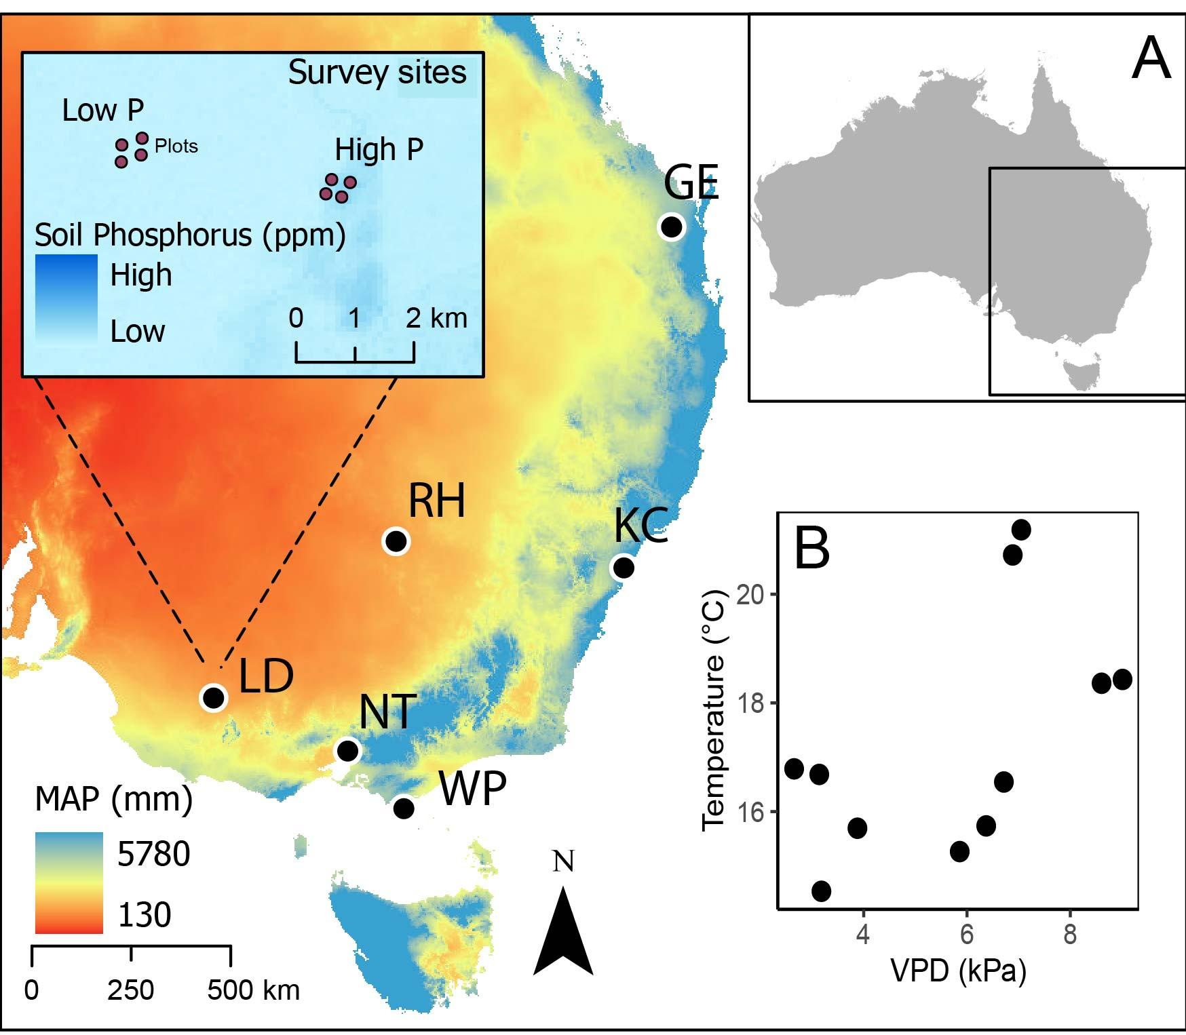
Extended data figure 1: A) Map of six locations representing low to high precipitation and temperature across the south-eastern region of Australia, inset indicates layout of sites (high phosphorus and low phosphorus) and plot survey design within each location, all locations were represented by two sites expect for NT represented by one high phosphorus site (total sites = 11), WP = Wilson’s Promontory, KC = Ku-ring-gai Chase National Park, GE = Glen Echo, NT = Nangak Tamboree Wildlife Sanctuary, LD = Little Desert National Park, RH = Round Hill Nature Reserve, B) Mean annual microclimate temperature (T_{m}) and vapor pressure deficit (VPD_{m}) for eleven sites.

Extended data table 1: Economic traits of worker ants, abbreviations, units, % trait coverage across species sampled (n = 123), and equivalent trait in the Leaf Economics Spectrum (LES).
Trait | Term | Units | % coverage | Parallel to LES
Worker mass density | Mass density | mg/mm³ | 94.31 | Leaf mass per unit area
Mass-specific assimilation rate | A_{mass} | mg/day/mg | 13.82 | Photosynthetic capacity
Worker N concentration | N | % | 92.68 | Leaf N concentration
Worker P concentration | P | % | 28.46 | Leaf P concentration
Mass-specific metabolic rate | MR_{mass} | µW/hr/mg | 91.06 | Dark respiration
Lifespan | Lifespan | days | 54.47 | Lifespan
Colony size | Colony size | No. workers | 13.82 | NA
Body mass | Mass | mg | 94.31 | NA

Extended data table 2. Mean posterior correlation coefficients from multi-response phylogenetic mixed model (Table S2). Showing the phylogenetic correlation (upper triangular) and independent correlation (lower triangular) of each pairwise trait combination. Significance at 95% credible interval (CI) indicated by *, correlations significant at 50-90% CI shown in bold.
 | Mass | Mass density | Lifespan | % N | % P | A_{mass} | MR_{mass} | Colony size
Mass |  | 0.60* | 0.57* | 0.68* | -0.46 | -0.72* | -0.86* | -0.70*
Mass density | 0.13 |  | 0.42 | 0.49* | -0.41 | -0.54 | -0.63* | -0.49
Lifespan | 0.09 | -0.09 |  | 0.55* | -0.43 | -0.49 | -0.61* | -0.63*
% N | 0.16 | 0.02 | 0.01 |  | -0.57 | -0.51 | -0.76* | -0.67*
% P | -0.24 | -0.15 | -0.02 | -0.07 |  | 0.35 | 0.54 | 0.51
A_{mass} | -0.58 | -0.12 | -0.009 | -0.14 | 0.18 |  | 0.67 | 0.57
MR_{mass} | -0.55* | -0.11 | -0.04 | -0.19 | 0.17 | 0.46 |  | 0.74*
Colony size | 0.18 | 0.08 | -0.03 | 0.04 | -0.07 | -0.18

Extended data figure 2: Decomposition of trait variance (partial R²) attributed to different levels in the model hierarchy. Phylogenetic = phylogenetically structured between-genus effects. Non-phylogenetic = non-phylogenetic (independent) between-species effects. Site effects = between survey locations. Fixed effects = variables of site-specific mean annual microclimate temperature, mean annual microclimate vapor pressure deficit (representing aridity), and soil phosphorus. Residual = residual variance unexplained by the model.

Extended data table 3: Posterior quantiles (0.5, 0.025, 0.975) of phylogenetic signal (λ) for each economic trait.
Trait | λ (±95% CI)
Mass | 0.84 (0.69 – 0.91)
Mass density | 0.63 (0.29 – 0.80)
Lifespan | 0.36 (0.09 – 0.63)
Phosphorus | 0.65 (0.23 – 0.89)
Nitrogen | 0.41 (0.16 – 0.66)
A_{mass} | 0.68 (0.30 – 0.89)
MR_{mass} | 0.62 (0.28 – 0.78)
Colony size | 0.77 (0.42 – 0.93)

Extended data figure 3. Posterior summaries of independent (non-phylogenetic) correlation coefficients from multi-response phylogenetic mixed model showing the posterior mean (point), 50% (heavy wick) and 95% (light wick) credible intervals.

Extended data table 4: Linear OLS models of varimax-rotated PCA axes 1 and 2 representing two dimensions of the worker economic spectrum with climate and soil phosphorus as predictor variables.
Model | Adj. R² | Coef. (± SE) | p-value
Axis 1 ~ log₁₀ (Soil P) | 0.01 | -0.10 (0.07) | 0.153
Axis 2 ~ log₁₀ (Soil P) | 0.01 | 0.09 (0.07) | 0.192
Axis 1 ~ MAT_{m} | 0.01 | -1.05 (0.81) | 0.199
Axis 2 ~ MAT_{m} | 0.00 | 0.23 (0.82) | 0.783
Axis 1 ~ VPD_{m} | 0.00 | -0.09 (0.24) | 0.707
Axis 2 ~ VPD_{m} | 0.00 | 0.12 (0.24) | 0.611

Extended data figure 4: The worker economic spectrum does not vary with climate and soil phosphorus. Showing varimax-rotated PCA axes 1 and 2 representing two dimensions of the worker economic spectrum with climate and soil phosphorus as predictor variables, points represent species, lines and 95% CI from model fits (Table S5). Microclimate temperature (MATm) is mean annual microclimate. Aridity gradient represented by microclimate vapor pressure deficit (VPDm).

