Total X-ray Scattering and Big-Box Modeling of Pressure-Induced Local Disorder and Partial Amorphization in CsPbBr₃
Supplementary Information
Anna Celeste^{1,2}, Samuel P. Girdzis³, Bernadette R. Cladek⁴, Christina R. Deschene⁵, Nathan R. Wolf⁵, Karena W. Chapman⁶, Hemamala I. Karunadasa^{2,5}, Matthew G. Tucker⁷, Wendy L. Mao^{1,2}, Yu Lin^{2*}
¹ Department of Earth and Planetary Sciences, Stanford University, Stanford, California 94305, United States
² Stanford Institute for Materials and Energy Sciences, SLAC National Accelerator Laboratory, Menlo Park, California 94025, United States
³ Department of Applied Physics, Stanford University, Stanford, California 94305, United States
⁴ Materials Science and Engineering Department, University of Tennessee, Knoxville, Tennessee 37996, United States
⁵ Department of Chemistry, Stanford University, Stanford, California 94305, United States
⁶ Department of Chemistry, Stony Brook University, Stony Brook, New York 11794, United States
⁷ Neutron Scattering Division, Oak Ridge National Laboratory, Oak Ridge, Tennessee 37831, United States
*Corresponding author. E-mail: lyforest@slac.stanford.edu

Sample characterization at ambient conditions
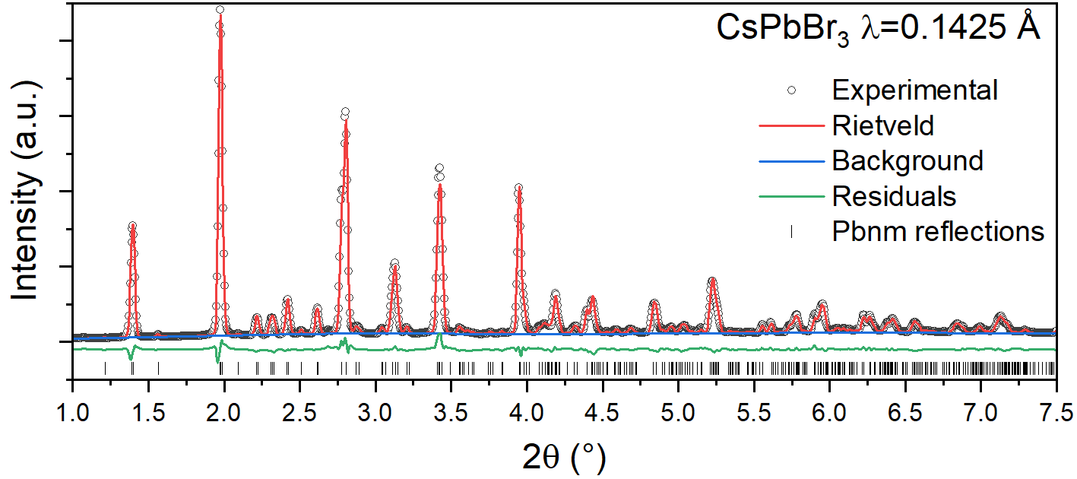
Figure S1 Rietveld refinement of the measured X-ray diffraction (XRD) pattern for CsPbBr₃ in a capillary taken at the 11-ID-B beamline, the Advanced Photon Source.
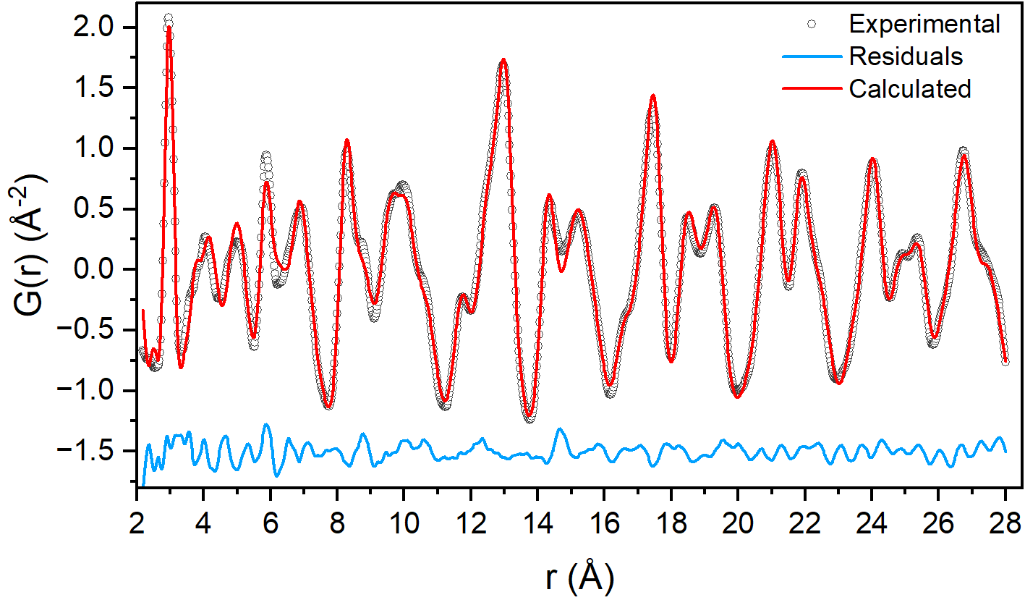
Figure S2 Fit of the X-ray pair distribution function (PDF) of CsPbBr₃ measured in a capillary at the 11-ID-B beamline, the Advanced Photon Source. Fitting procedure was performed using PDFgui and Pbnm space group and instrument parameters Q_{damp} = 0.0358 and Q_{broad} = 0.01946 were used.
High-pressure XRD analysis
We performed a structural analysis on the powder XRD of CsPbBr₃ on compression and extrapolated the lattice parameters as function of pressure. Rietveld refinement was performed up to 1.6 GPa, starting at 2.0 GPa we switched to Le Bail refinement due to the broadening observed in the diffraction patterns. Figure S3 shows the lattice parameters obtained as a function of pressure.
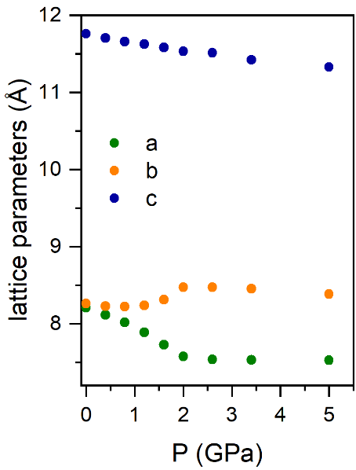
Figure S3 Pressure dependence of CsPbBr₃ lattice parameters a (green symbols), b (orange symbols), and c (blue symbols) up to 5 GPa. Error bars are within the symbol size.

Comparison with pressure-released sample
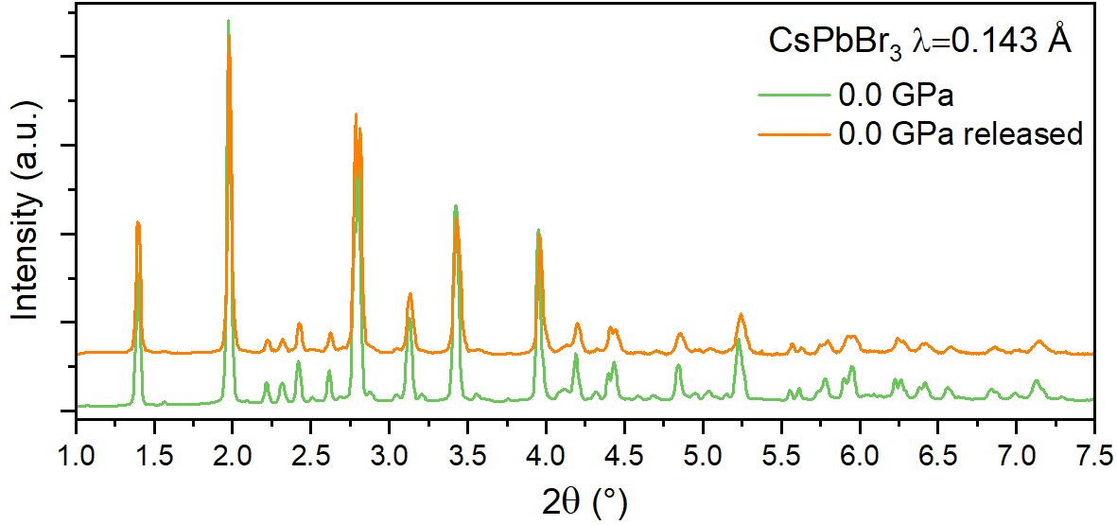
Figure S4 Experimental XRD patterns of CsPbBr₃ collected in the diamond anvil cell (DAC) before increasing pressure (green line) and after pressure release (orange line).
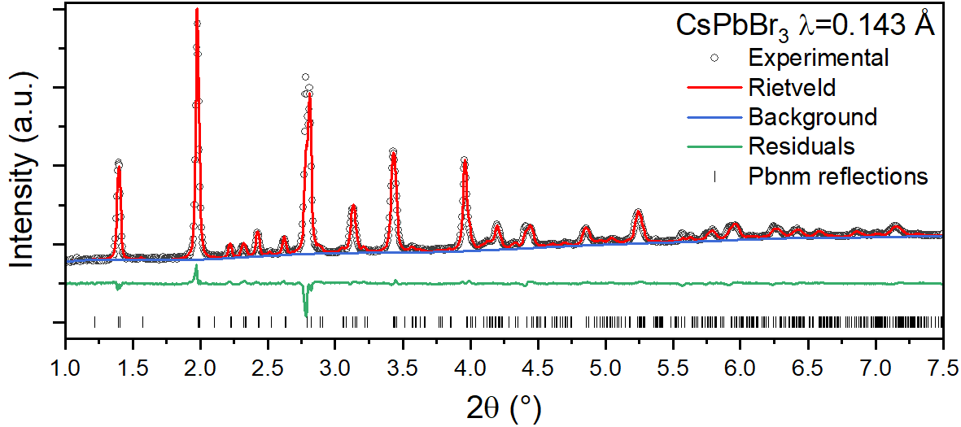
Figure S5 Rietveld refinement of the measured XRD pattern for CsPbBr₃ in a DAC after pressure release.

Table S1 Comparison of lattice parameters and unit cell volumes for CsPbBr₃ obtained at 0.0 GPa before and after compression.
 | 0.0 GPa before P | 0.0 GPa after P
a (Å) | 8.20845 | 8.19985
b (Å) | 8.26267 | 8.26012
c (Å) | 11.76199 | 11.75567
V (Å³) | 797.742 | 796.232

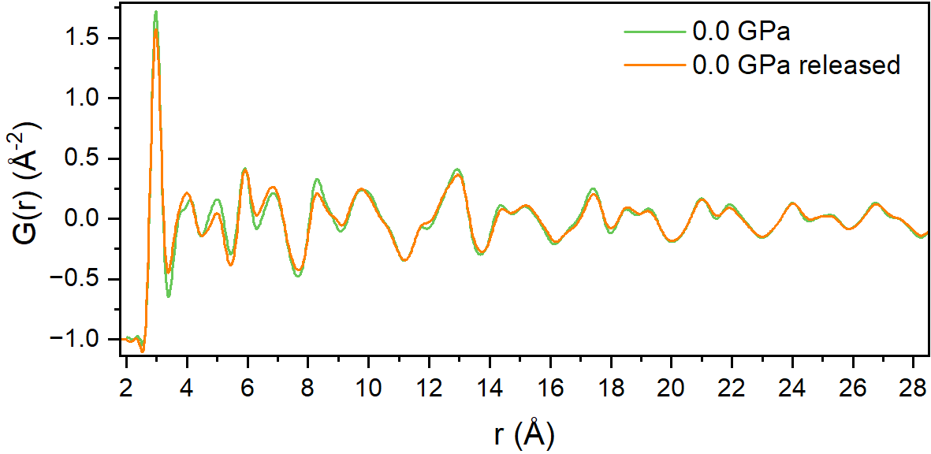
Figure S6 Experimental G(r) functions of CsPbBr₃ obtained from total X-ray scattering data collected in the DAC before increasing pressure (green line) and after pressure release (orange line).

PDFgui fits of CsPbBr₃ PDFs at high pressure
We fitted the X-ray PDFs with a Pbnm model in PDFgui, as shown in Figure S4. It is worth noting that the values of the refined lattice parameters tended to become unstable and unphysical above 2.0 GPa.
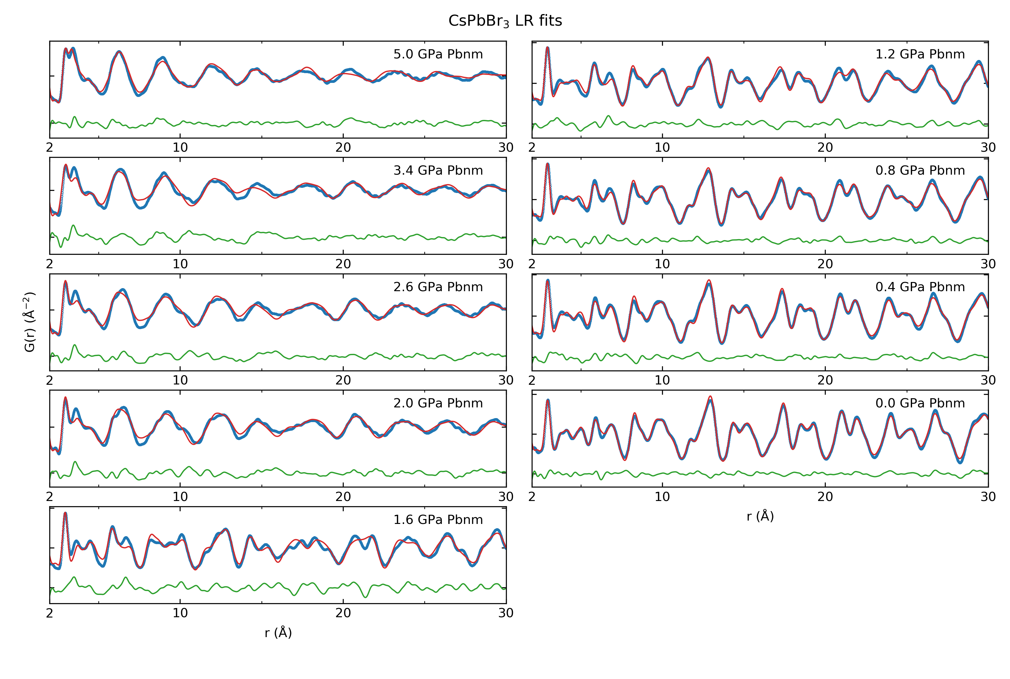
Figure S7 Long range PDFgui fits for CsPbBr₃ along compression
First RMCProfile simulation attempts
In our initial reverse Monte Carlo (RMC) simulations, we applied polyhedral constraints to maintain the integrity of the PbBr₆ octahedra. Below, we report the detailed G(r) fits with the partials PDFs at selected pressures. We observed poor fitting results above 2 GPa, which deteriorated further at pressures of 2.6 GPa and beyond. To address this, we conducted a test in which we constrained only the Pb-Pb distances and removed the polyhedral constraints, particularly at higher pressures (see Figure S12). This adjustment revealed unphysical shapes in the partial PDFs, with distributions skewed towards shorter distances, especially notable in the Br-Cs and Cs-Cs pairs.
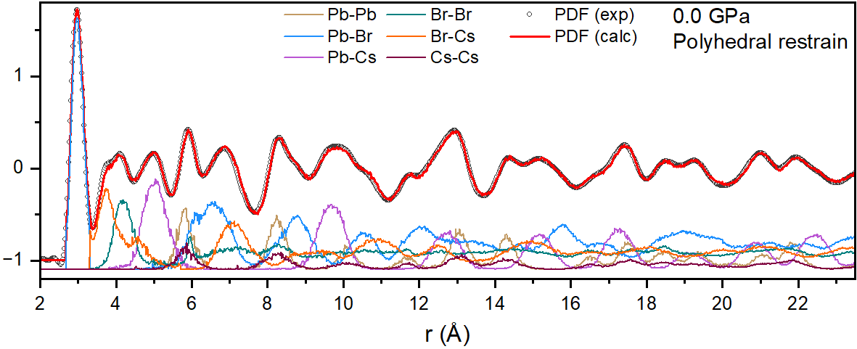
Figure S8 Experimental PDF (open black circles) and calculated PDF from big-box RMC modeling (solid red line) of CsPbBr₃ are compared over the full r-range at 0.0 GPa when the polyhedral constraint is used. Partial atomic pair contributions (Pb-Pb, Pb-Br, Br-Br, Br-Cs, Pb-Cs, and Cs-Cs) are reported as well in distinguished colors.
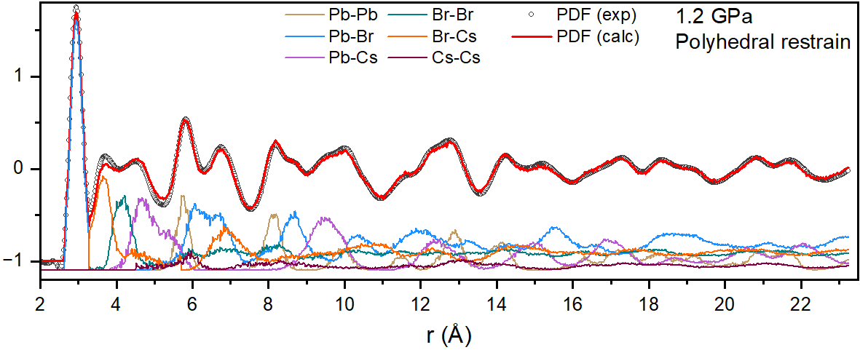
Figure S9 Experimental PDF (open black circles) and calculated PDF from big-box RMC modeling (solid red line) of CsPbBr₃ are compared over the full r-range at 1.2 GPa when the polyhedral constraint is used. Partial atomic pair contributions (Pb-Pb, Pb-Br, Br-Br, Br-Cs, Pb-Cs, and Cs-Cs) are reported as well in distinguished colors.
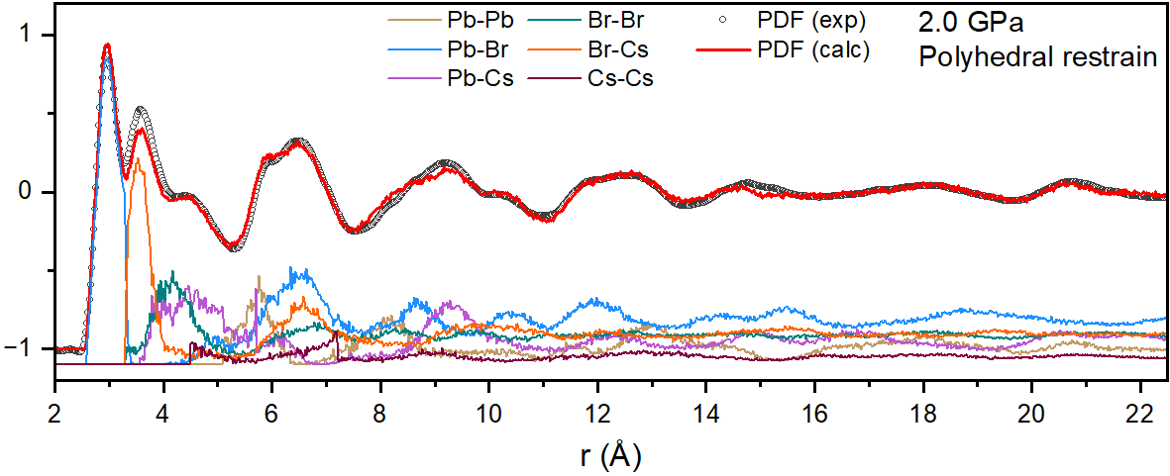
Figure S10 Experimental PDF (open black circles) and calculated PDF from big-box RMC modeling (solid red line) of CsPbBr₃ are compared over the full r-range at 2.0 GPa when the polyhedral constraint is used. Partial atomic pair contributions (Pb-Pb, Pb-Br, Br-Br, Br-Cs, Pb-Cs, and Cs-Cs) are reported as well in distinguished colors.
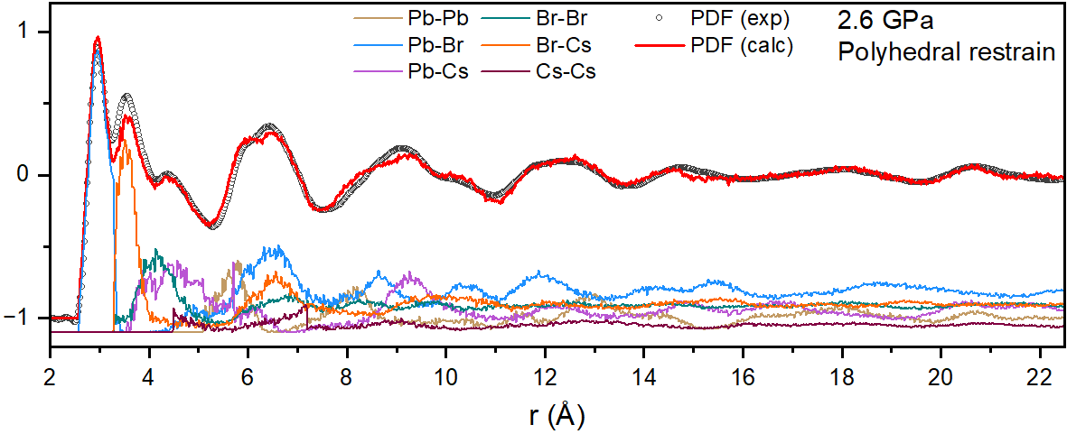
Figure S11 Experimental PDF (open black circles) and calculated PDF from big-box RMC modeling (solid red line) of CsPbBr₃ are compared over the full r-range at 2.6 GPa when the polyhedral constraint is used. Partial atomic pair contributions (Pb-Pb, Pb-Br, Br-Br, Br-Cs, Pb-Cs, and Cs-Cs) are reported as well in distinguished colors.
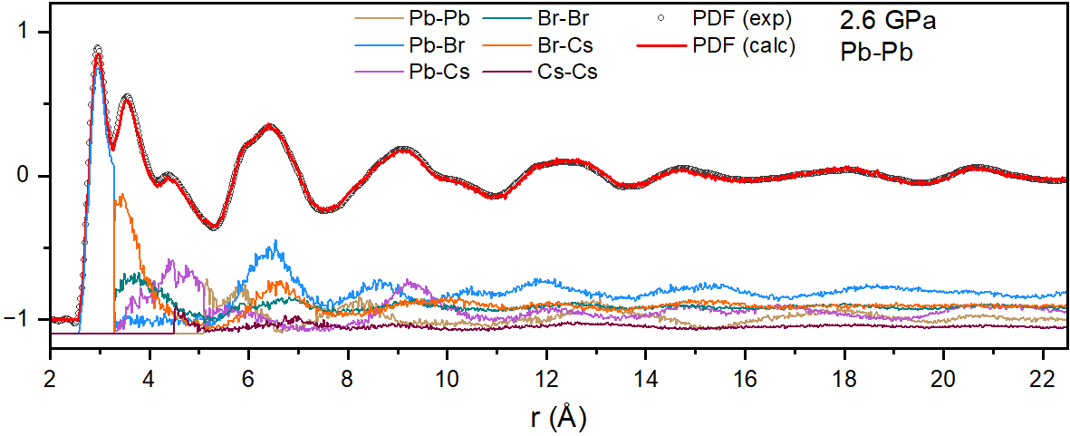
Figure S12 Experimental PDF for CsPbBr₃ at 2.6 GPa (open black circles) compared to the calculated PDF from big-box RMC modeling (solid red line), with only Pb-Pb distances constrained. Partial atomic pair contributions (Pb-Pb, Pb-Br, Br-Br, Br-Cs, Pb-Cs, and Cs-Cs) are reported as well in distinguished colors.
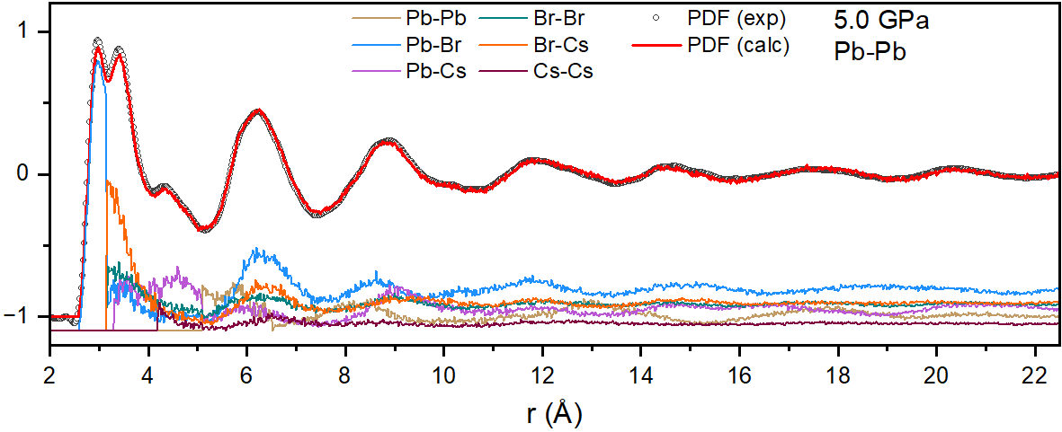
Figure S13 Experimental PDF for CsPbBr₃ at 5.0 GPa (open black circles) compared to the calculated PDF from big-box RMC modeling (solid red line), with only Pb-Pb distances constrained. Partial atomic pair contributions (Pb-Pb, Pb-Br, Br-Br, Br-Cs, Pb-Cs, and Cs-Cs) are reported as well in distinguished colors.

RMCProfile simulations using bond valence sum constraints
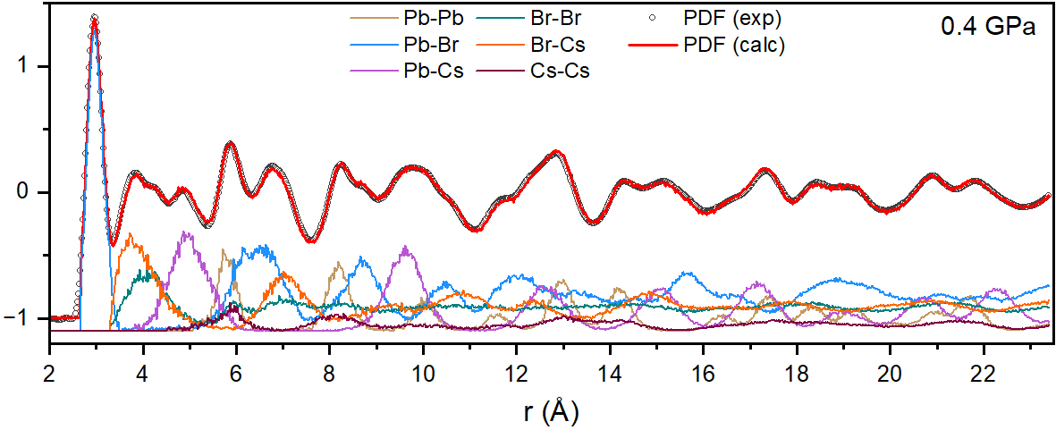
Figure S14 Experimental PDF for CsPbBr₃ at 0.4 GPa (open black circles) compared to the calculated PDF from big-box RMC modeling (solid red line) obtained applying bond valence sum constraints. Partial atomic pair contributions (Pb-Pb, Pb-Br, Br-Br, Br-Cs, Pb-Cs, and Cs-Cs) are reported as well in distinguished colors.
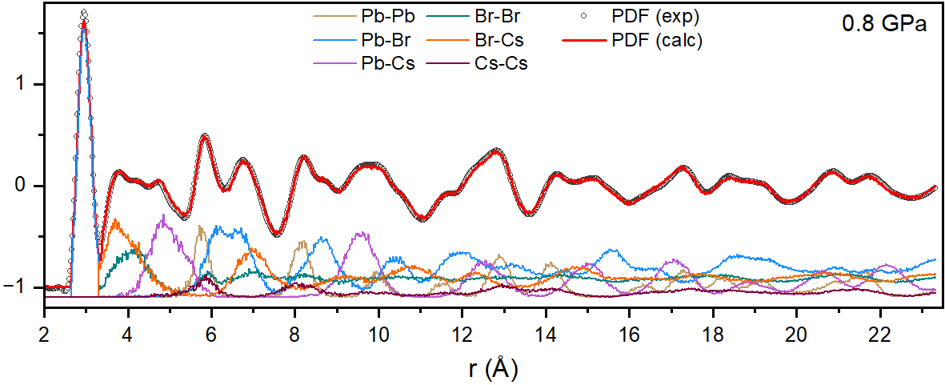
Figure S15 Experimental PDF for CsPbBr₃ at 0.8 GPa (open black circles) compared to the calculated PDF from big-box RMC modeling (solid red line) obtained applying bond valence sum constraints. Partial atomic pair contributions (Pb-Pb, Pb-Br, Br-Br, Br-Cs, Pb-Cs, and Cs-Cs) are reported as well in distinguished colors.
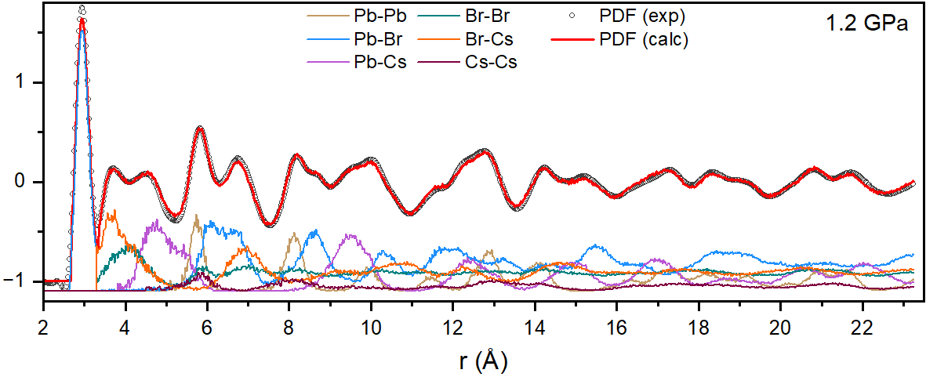
Figure S16 Experimental PDF for CsPbBr₃ at 1.2 GPa (open black circles) compared to the calculated PDF from big-box RMC modeling (solid red line) obtained applying bond valence sum constraints. Partial atomic pair contributions (Pb-Pb, Pb-Br, Br-Br, Br-Cs, Pb-Cs, and Cs-Cs) are reported as well in distinguished colors.
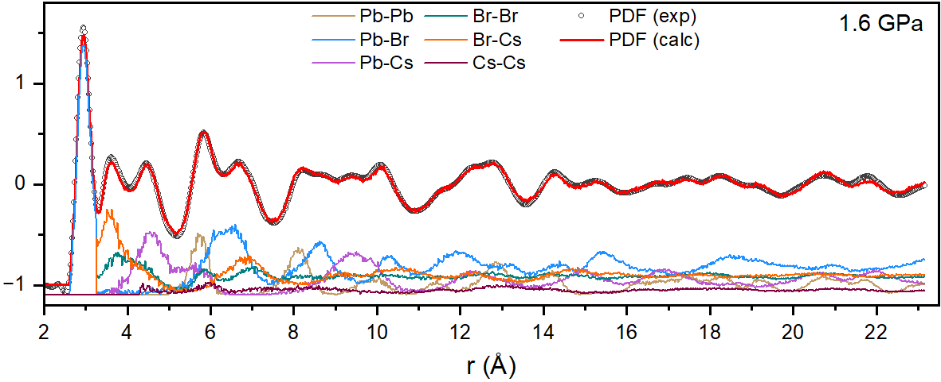
Figure S17 Experimental PDF for CsPbBr₃ at 1.2 GPa (open black circles) compared to the calculated PDF from big-box RMC modeling (solid red line) obtained applying bond valence sum constraints. Partial atomic pair contributions (Pb-Pb, Pb-Br, Br-Br, Br-Cs, Pb-Cs, and Cs-Cs) are reported as well in distinguished colors.
Figure S18 Experimental PDF for CsPbBr₃ at 1.6 GPa (open black circles) compared to the calculated PDF from big-box RMC modeling (solid red line) obtained applying bond valence sum constraints. Partial atomic pair contributions (Pb-Pb, Pb-Br, Br-Br, Br-Cs, Pb-Cs, and Cs-Cs) are reported as well in distinguished colors.
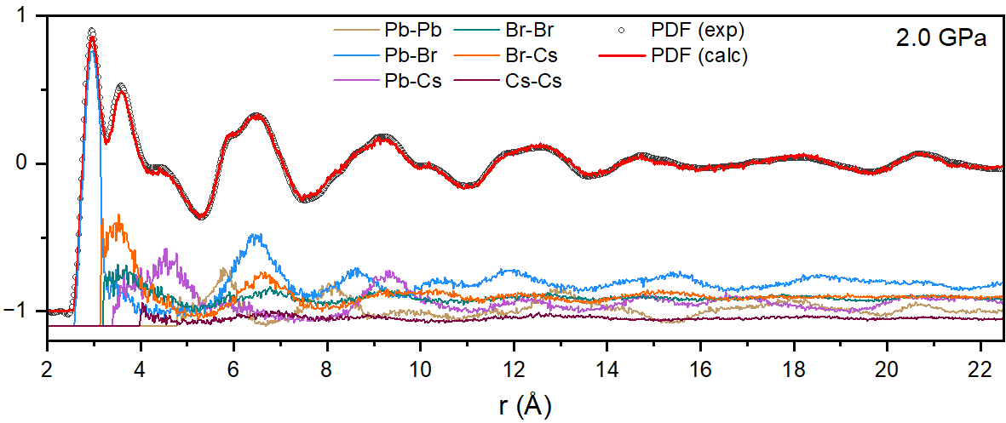
Figure S19 Experimental PDF for CsPbBr₃ at 2.0 GPa (open black circles) compared to the calculated PDF from big-box RMC modeling (solid red line) obtained applying bond valence sum constraints. Partial atomic pair contributions (Pb-Pb, Pb-Br, Br-Br, Br-Cs, Pb-Cs, and Cs-Cs) are reported as well in distinguished colors.
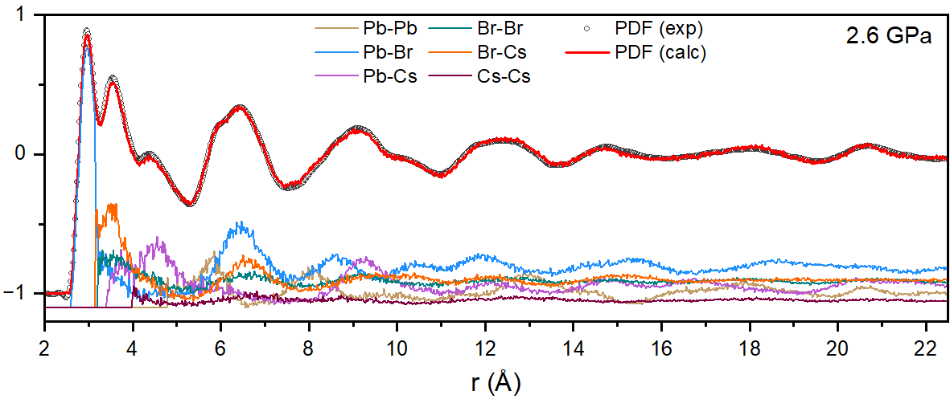
Figure S20 Experimental PDF for CsPbBr₃ at 2.6 GPa (open black circles) compared to the calculated PDF from big-box RMC modeling (solid red line) obtained applying bond valence sum constraints. Partial atomic pair contributions (Pb-Pb, Pb-Br, Br-Br, Br-Cs, Pb-Cs, and Cs-Cs) are reported as well in distinguished colors.
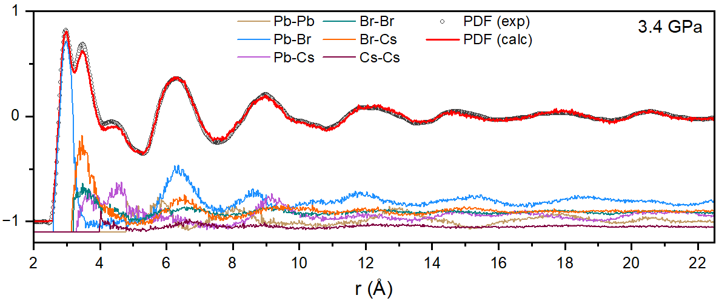
Figure S21 Experimental PDF for CsPbBr₃ at 3.4 GPa (open black circles) compared to the calculated PDF from big-box RMC modeling (solid red line) obtained applying bond valence sum constraints. Partial atomic pair contributions (Pb-Pb, Pb-Br, Br-Br, Br-Cs, Pb-Cs, and Cs-Cs) are reported as well in distinguished colors.
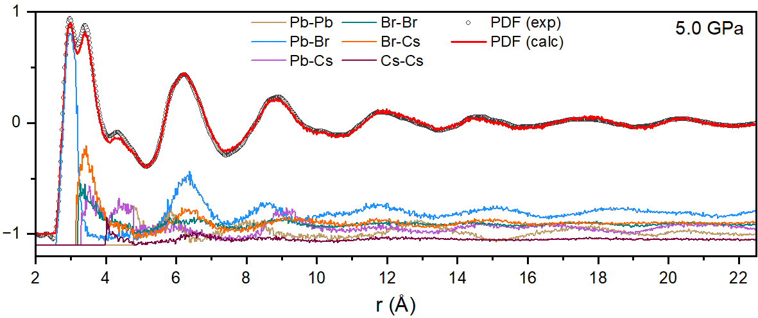
Figure S22 Experimental PDF for CsPbBr₃ at 5.0 GPa (open black circles) compared to the calculated PDF from big-box RMC modeling (solid red line) obtained applying bond valence sum constraints. Partial atomic pair contributions (Pb-Pb, Pb-Br, Br-Br, Br-Cs, Pb-Cs, and Cs-Cs) are reported as well in distinguished colors.

Absorption spectra
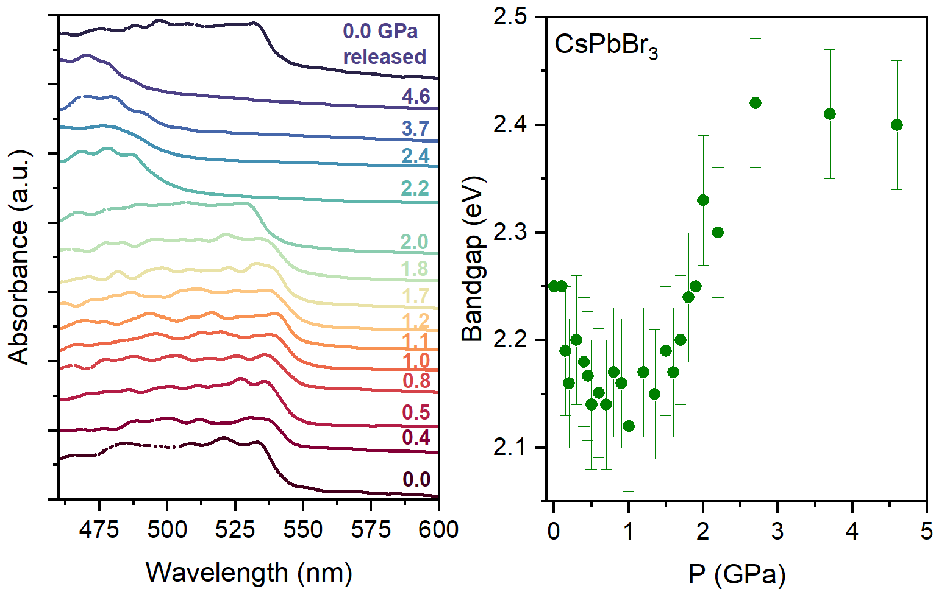
Figure S23 Left panel: absorption spectra of CsPbBr₃ at selected pressures, collected at the Infrared Laboratory (Beamline 22-IR-1) of the National Synchrotron Light Source II (NSLS II), Brookhaven National Laboratory (BNL). Right panel: Bandgap values derived from Tauc plot analysis as a function of pressure, with error bars indicating fitting accuracy.
Partials PDFs
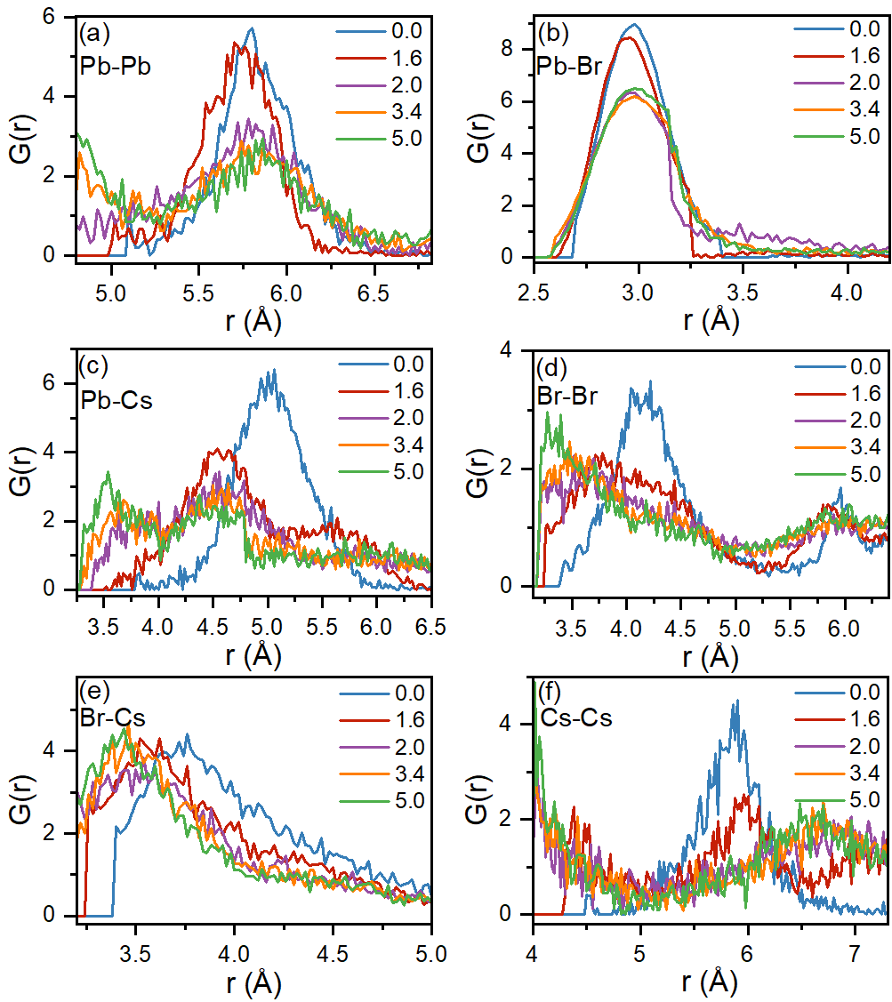
Figure S24 CsPbBr₃ partial PDFs for Pb–Pb (a), Pb–Br (b), Pb–Cs (c), Br–Br (d), Br-Cs (e) and Cs-Cs (f) atomic pairs at 0.0 GPa, 1.6 GPa, 2.0 GPa, 3.4 GPa, and 5.0 GPa.
Supercell snapshots 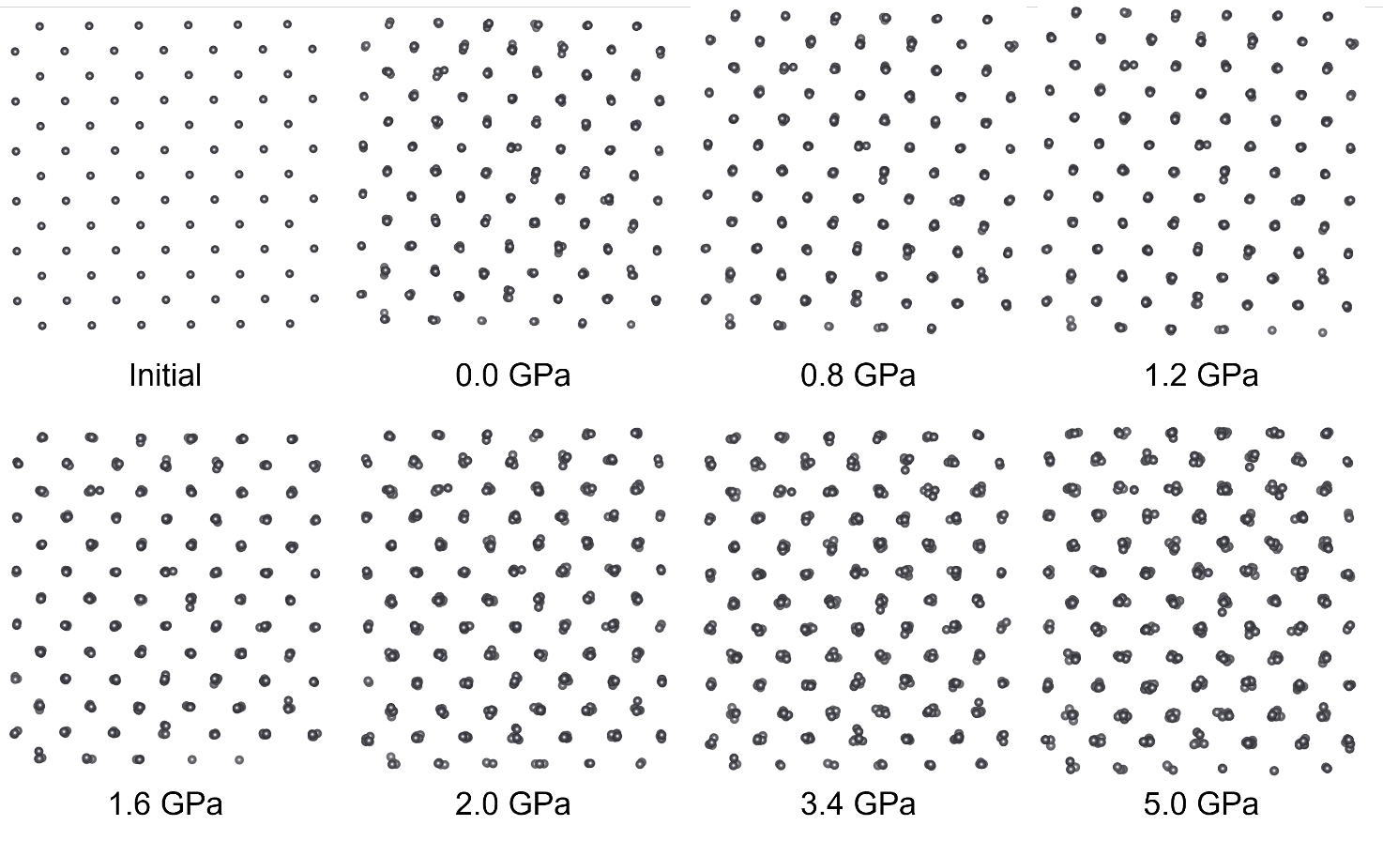
Figure S25 Snapshots of the 6x6x4 supercells representing the Pb sublattice configurations obtained through RMCProfile modeling of CsPbBr₃ along the c-axis at different pressures: the ideal structure ("Initial"), 0.0 GPa, 0.8 GPa, 1.2 GPa, 1.6 GPa, 2.0 GPa, 3.4 GPa, and 5.0 GPa.
Atomeye plots
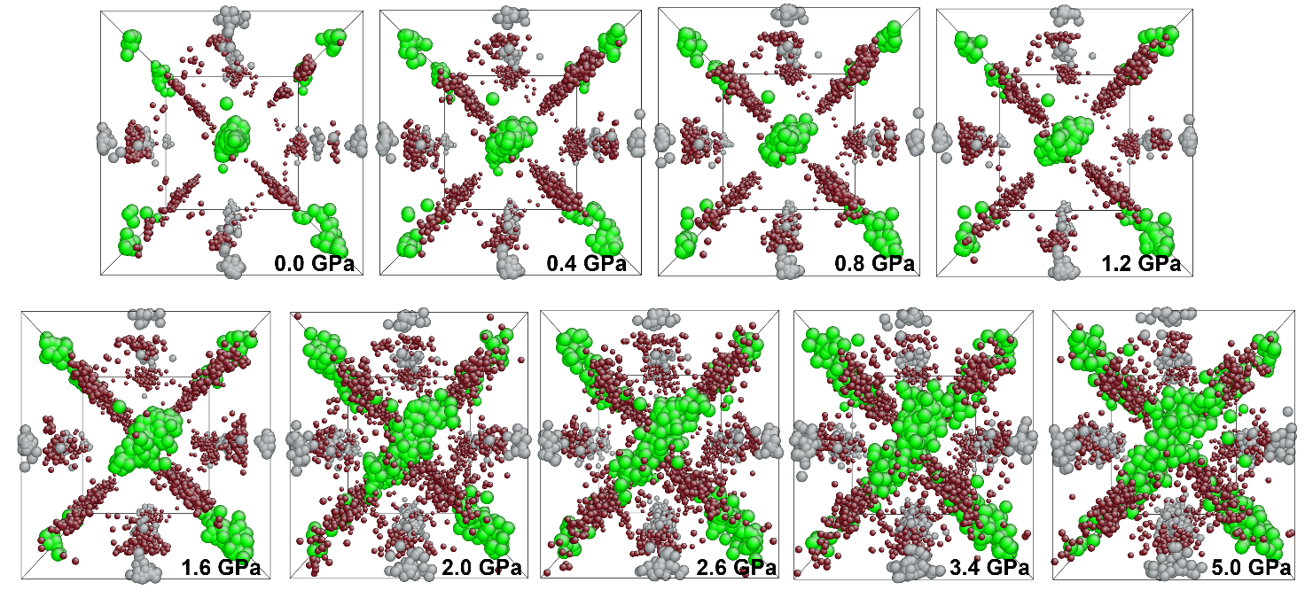
Figure S26 Atomic positions in the CsPbBr₃ unit cell obtained through RMCProfile modeling of the PDF functions. The large-box configurations are collapsed back to a single unit cell. Cs atoms are depicted in green, Br in deep red, and Pb in gray.

Planes associated with Bragg reflections observed in the partially amorphous phase
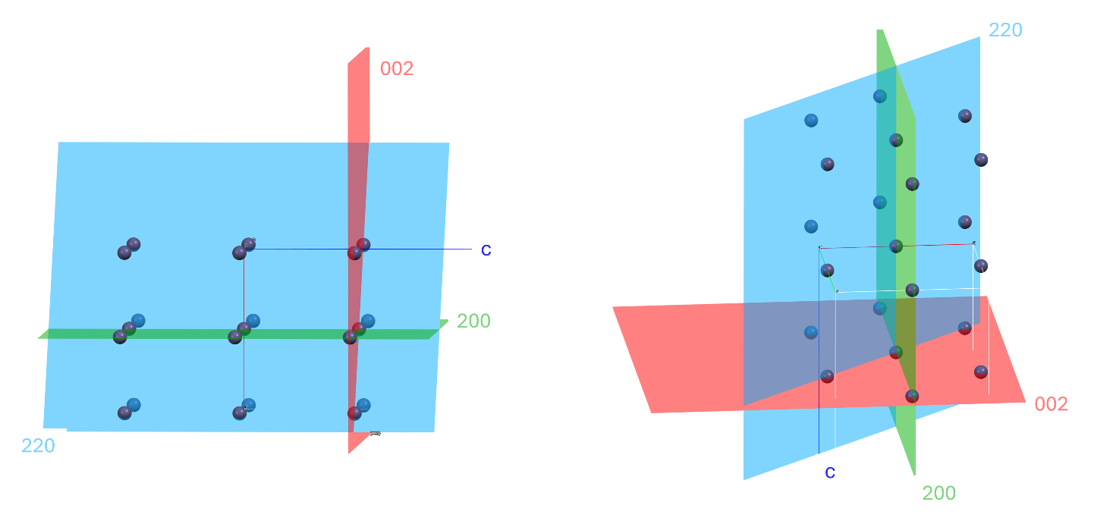
Figure S26 Crystallographic planes intersecting Pb atoms in CsPbBr₃: the left panel shows the arrangement along the b-axis with the red (002), green (200), and blue (220) planes, while the right panel shows a rotated perspective highlighting the three-dimensional intersections of these planes with the Pb atoms.
RMCProfile results for the recovered phase
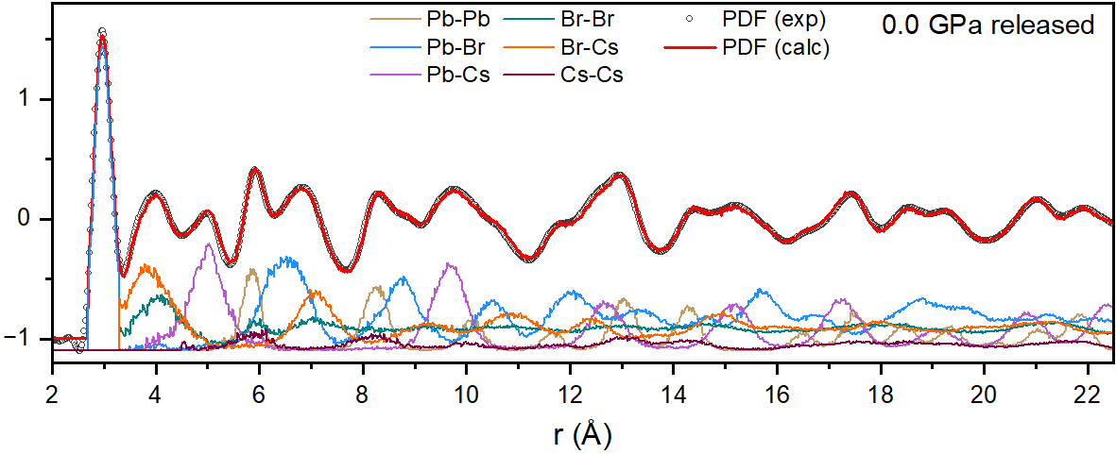
Figure S27 Experimental PDF for CsPbBr₃ at 0.0 GPa after pressure release (open black circles) compared to the calculated PDF from big-box RMC modeling (solid red line) obtained applying bond valence sum constraints. Partial atomic pair contributions (Pb-Pb, Pb-Br, Br-Br, Br-Cs, Pb-Cs, and Cs-Cs) are reported as well in distinguished colors.
Figure S28 Snapshots of the 6x6x4 supercells representing the atomic configurations obtained through RMCProfile modeling of CsPbBr₃ along the c-axis at 0.0 GPa after the pressure release. Cs atoms are shown in green, Br in deep red, and Pb in gray.
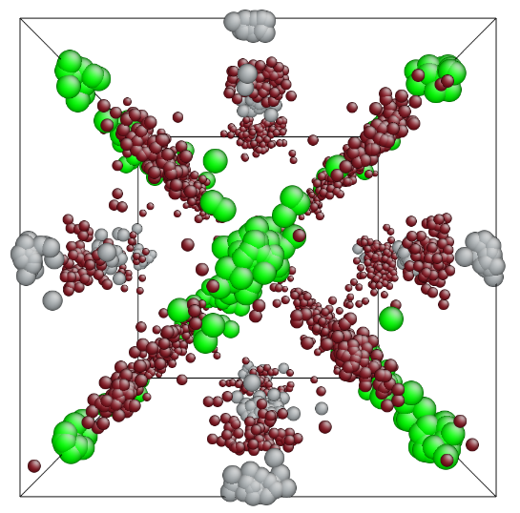
Figure S29 Atomic positions in the CsPbBr₃ unit cell obtained through RMCProfile modeling of the PDF function at 0.0 GPa after pressure release. The large-box configurations are collapsed back to a single unit cell. Cs atoms are depicted in green, Br in deep red and Pb in gray.

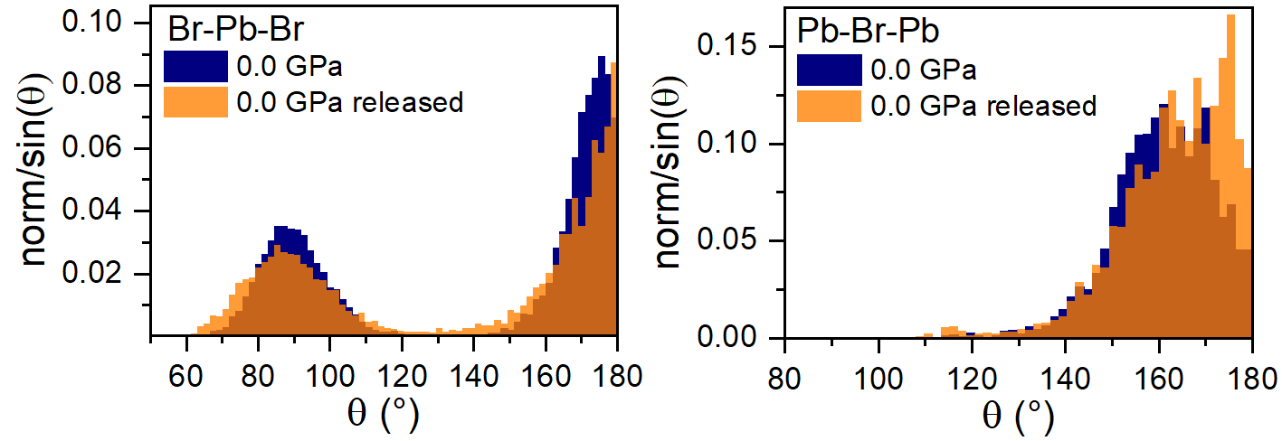
Figure S30 Comparison between the angular distributions for Br–Pb–Br (left) and Pb–Br–Pb (right) bond angles obtained before applying pressure and after the pressure release. Overlapped area is in dark orange.

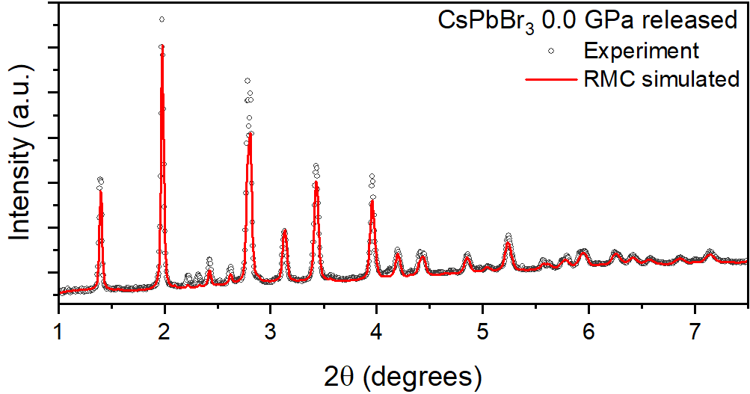
Figure S31 Experimental and RMCProfile calculated XRD data after pressure release.

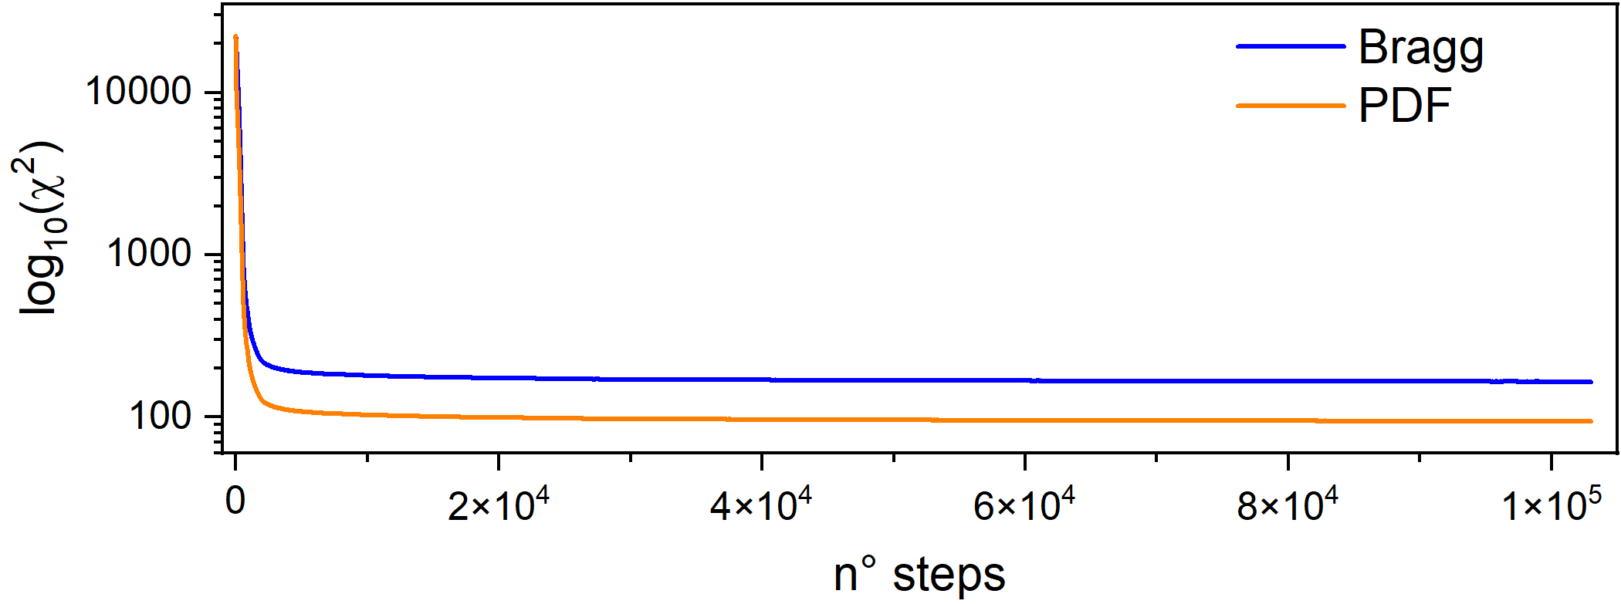
RMCProfile convergence for 0.0 GPa
Figure S32 Representative evolution of χ² in an RMCProfile run, in this case for CsPbBr₃ at 0.0 GPa.

