Supplemental Notes
Contents:
- Overview
- Example
- Pseudocode
- Clique Occurrence Results

1. Branchpoint Clique Removal Pseudocode
VesselVio analyzes vascular networks by skeletonizing the datasets, identifying edges between centerline points (based on 26-neighborhood connectivity), and creating undirected graphs with the resulting points and edges. Vessel endpoints, segments, and branch points can be identified from this graph by examining the degree of connectivity of each vertex (i.e., how many neighbors each vertex has).
An issue with identifying branch points from these naïve graphs is that vertices at branch point junctions often form small loops, or ‘cliques’, because of their proximity in digital space. This leads to artificially inflated branch point counts. VesselVio filters spuriously labeled branch points by weighting branch point cliques based on radius, neighbor radius, and degree of connectivity to select remaining branchpoint candidates. Examination of numerous types of datasets led to the identification of 13 common cliques, dubbed classes. Filters were built for each class.
Each identified clique is classified and passed through the appropriate clique filter. From examination of the inferior colliculus segmentation results, class 1-4 cliques represent over 95% of identified cliques.

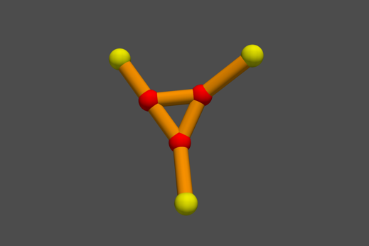
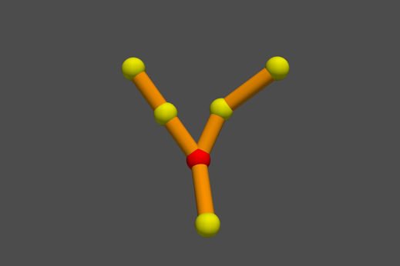
2. Example Class 1 Clique Correction
Naïve Graph
Filtered Graph
Correction
Red – Branch point
Yellow – Segment point

3. Clique Filter Pseudocode
Branchpoints = Subgraph of main graph containing only branchpoints
Cliques = Subgraph of Branchpoints containing only Cliques

FUNCTION Delete_Edges(vertices):
IF largest radius exists among vertices:
Remove edges between smallest vertices
ENDIF
ELSE:
Find radius of vertex neighbors from main graph
Sort vertices based on self-radius and neighbor radius weighting
Delete edges between smallest two vertices
ENDELSE
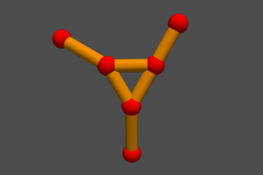
Class 1
FOR each Clique in Cliques:
IF Clique class is 1: # Three 3-degree branchpoints
CALL Delete_Edges with clique
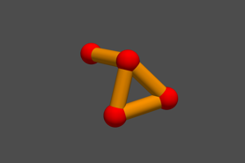
END IF
Class 2
IF Clique class is 2: # One 3-degree, one 1-degree, and two 2-degree
Find radius of each branchpoint candidate with degree greater than 1
CALL Delete_Edges with candidates
ENDIF
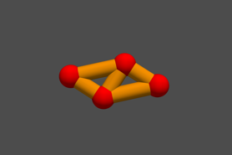
IF Clique class is 3: # Two 2-degree and two 3-degree branchpoints
Find radius of each branchpoint candidate with degree of 3
CALL Delete_Edges with candidates
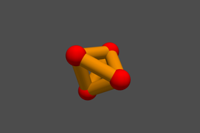
ENDIF
Class 3
IF Clique class if 4: # Four 3-degree branchpoints
Find radius of each branchpoint candidate in Clique
CALL Delete_Edeges with candidates
Class 4
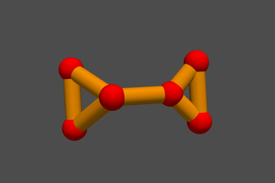
ENDIF
IF Clique class is 5: # Two 3-degree, four 2-degree branchpoints
FOR branchpoints in Clique:
IF degree of branchpoint is 3:
Class 5
Small_Clique = branchpoint + 2-degree neighbors
CALL Delete_Edges with Small_Clique
ENDIF
ENDFOR
ENDIF
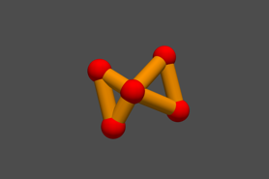
IF Clique class is 6: # One 4-degree and four 2-degree branchpoints
FOR branchpoints in Clique:
IF degree of branchpoint is 2:
Small_Clique = connected neighborhood
Class 6
CALL Delete_Edges with Small_Clique
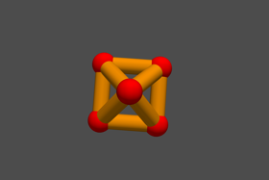
ENDIF
ENDFOR
ENDIF
IF Clique class is 7 or 8: # One 4-degree and four 3-degree branchpoints
Find 4-degree branchpoint
Class 7
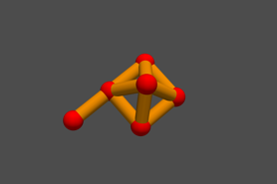
Delete edges between 3-degree points.
ENDIF
IF Clique class is 9 or 10: # 1-, 2-, 3-, and 4-degree branchpoints
FOR branchpoint in Clique:
Class 8
Small_Clique = Branchpoint + 2-degree neighbors
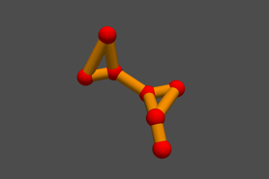
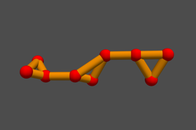
IF size(Small_Clique) == 3:
CALL Delete_Edges with Small_Clique
ENDIF
ENDFOR
Class 10
Class 9
ENDIF
IF Clique class is 11 or 12: # 3-, 4-, and 5-degree branchpoints
FOR branchpoint in Clique:
Delete edges between 2-degree branchpoints
ENDFOR
ENDIF
IF Clique class is 13: 2-, 3-, and 5-degree branchpoints
Delete edges between 3-degree and 2-degree branchpoints
ENDIF
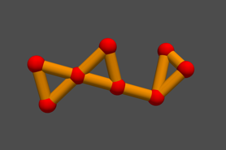
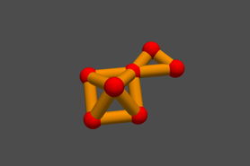
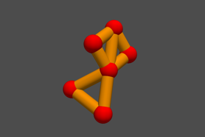
Class 11
Class 12
Class 13

4. Clique results from inferior colliculus segmentations

