Breaking Barriers in Biofilm Control: ZnS and Au@ZnS Core-Shell Nanoconjugates Target ESKAPE Pathogens
Shaikh Imran Ibrahim,¹† Ajith Manayil Parambil,^{2,3}† Neha Jha,² Anuj Kumar Tomar,² Paulraj Rajamani,² Xiao Jian,⁴ Eepsita Priyadarshini,^{2,5*} Shao Chuxiao^{1*}
¹Department of Pharmacy, Central Laboratory of The Lishui Hospital of Wenzhou Medical University, The First Affiliated Hospital of Lishui University, Lishui 323000, Zhejiang, China
²School of Environmental Sciences, Jawaharlal Nehru University, New Delhi, India-110067
³Nanotechnology Centre, Centre for Energy and Environmental Technologies, VSB-Technical University of Ostrava, Ostrava Poruba, Czech Republic-70800
⁴Molecular Pharmacology Research Center, School of Pharmaceutical Sciences, Wenzhou Medical University, Wenzhou, People’s Republic of China
⁵ School of Biosciences and Technology, Galgotias University, Greater Noida, India-203201

† These authors contributed equally
*Corresponding authors’ E-mail ID: lisa.eepsita@gmail.com (Dr. Eepsita), ChuxiaoShao2000@126.com (Prof. Chuxiao)

Supplementary File
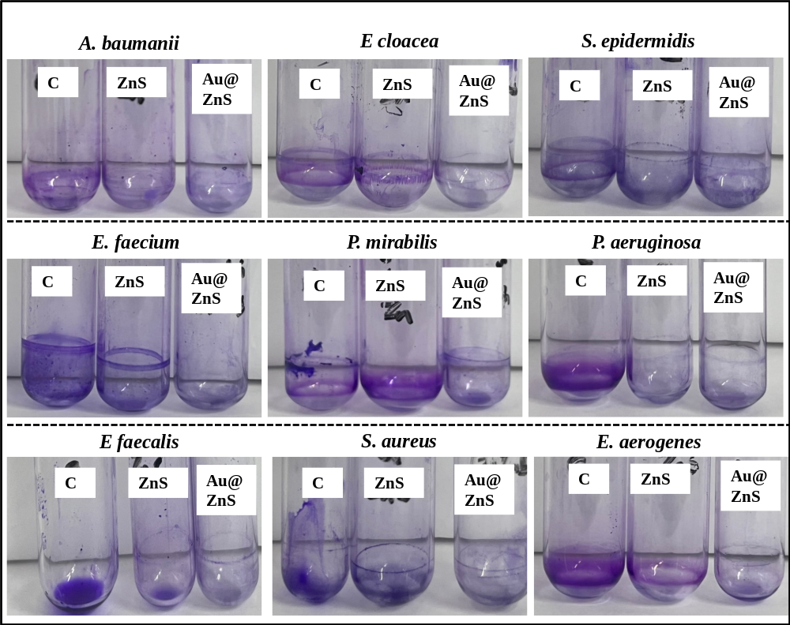
Supplementary Figure 1. Antibiofilm assay by tube staining method, after treatment with ZnS QD and Au@ZnS QDs.

